Power Operations Bulletin # 1024

ERCOT has posted/revised the Reliability Risk Desk manual.

A copy of the procedure can be found at:

http://www.ercot.com/mktrules/guides/procedures/index.html

4.5 Severe Weather Operations

Procedure Purpose: To monitor the wind forecast during operations with severe weather conditions.

Protocol Reference
Guide Reference
NERC Standard | EOP-011-1  R1, R1.1, R1.2, R1.2.6, R2, R2.1, R2.2, R2.2.9

Version: 1 | Revision: 3 | Effective Date: February 1, 2022

Step | Action

Loss of Wind Farm Turbines due to Severe Weather
NOTE | Significant weather events can consist of, but are not limited to the following:  - Tornados  - Strong straight line winds  - Flooding  - Freezing precipitation
Manually Override Short Term Wind Power Forecast | The ERCOT Operator will contact the Operations Analysis Engineer to conduct further analysis and to override system:  IF:  - A severe weather related de-rate has occurred at a given wind farm, and  - The telemetry, Outage Scheduler and COP have not been correctly updated by the QSE.  Contact Operations Analysis Engineer to do further analysis and potentially override the forecast given the description above after checking the following:  - Number of turbines online  - Number of turbines offline  - Outage scheduler  - Telemetered wind speed (MPH)
NOTE | The QSE should:  - Update wind generating unit’s telemetry to reflect the number of turbines lost.  - NTON – number of turbines online  - NTOF – number of turbines offline  - NTUN – number of turbines unknown  - Update ERCOT Outage Scheduler for updated HSL information that correctly reflects the number of turbines lost. This follows procedure for forced outages and should be done immediately.  - Update unit’s COP in relation to the most recent forecast for the next hour(s) that pertains to the duration the turbines will be lost and accurately reflects the number of turbines lost.  Notification to the QSE may be necessary if the above are not complete within the designated time frame.
Post | Coordinate with the Real-Time Operator for making hotline calls and the posting of the notices on the ERCOT Website.
Cancel Posting | Coordinate with the Real-Time Operator for the cancelation of the postings on the ERCOT Website and making hotline calls.
LOG | Log all actions.

High Wind Output Forecast with Forecasted Severe Weather in a Region
Manually Override Short Term Wind Power Forecast | The ERCOT Operator will contact the Operations Analysis Engineer to conduct further analysis and to override the system if all of the following conditions are met:  - The wind forecast is persistently higher than the actual output (the over-forecast error will exceed 20% of installed capacity of wind farms affected or 1000 MW in a region) for a future period of time.  - Weather forecasts from multiple sources indicate a winter/tropical storm will occur in the same time-line as the high forecasted output.
ACTION | Further analysis could potentially reduce the forecasted value of the region in question to a lower output.
EXAMPLE | Below is an example of the STWPF being much higher due to turbines freezing. You will see the light blue line much lower than the multiple colored lines that are forecasts. When the actual output begins to dip away from the forecast and icing conditions exist, it is likely an override is needed.  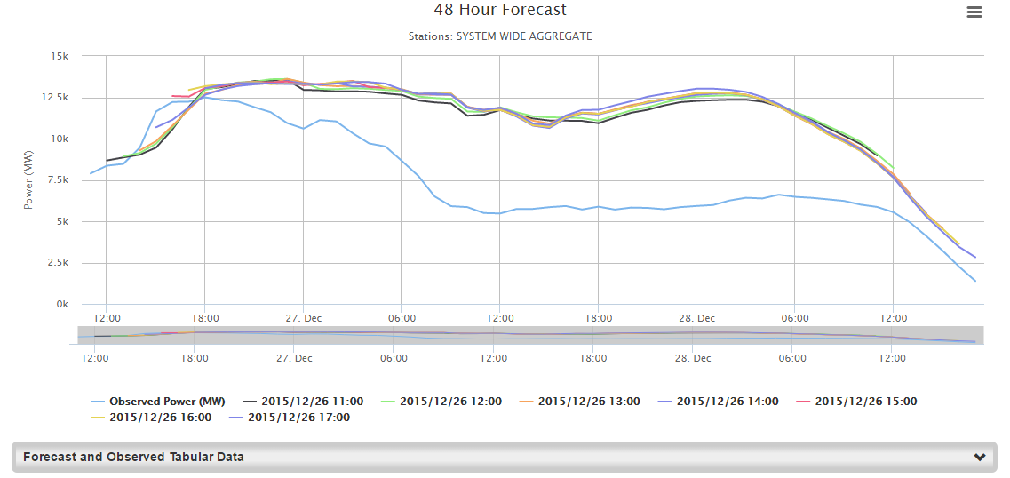
LOG | Log all actions.

Document Control

Preparation
Prepared by | Role | Date Completed
Hartmann, Gaddy, Self, and Frosch | Preparers | January 24, 2017
Hartmann, Gaddy and Frosch | Procedure writers and editors | March 27, 2017
Hartmann, Gaddy and Ballew | Procedure writers and editors | May 26, 2017
Hartmann, Gaddy and Ballew | Procedure writers and editors | June 23, 2017
Hartmann, Gaddy and Ballew | Procedure writers and editors | July 24, 2017
Hartmann, Gaddy and Ballew | Procedure writers and editors | September 27, 2017
Hartmann, Gaddy and Ballew | Procedure writers and editors | December 22, 2017
Hartmann, Gaddy and Ballew | Procedure writers and editors | February 22, 2018
Hartmann, Gaddy, Ballew and Frosch | Procedure writers and editors | March 26, 2018
Hartmann, Gaddy, Ballew and Frosch | Procedure writers and editors | April 27, 2018
Hartmann, Gaddy and Ballew | Procedure writers and editors | May 25, 2018
Hartmann, Gaddy and Ballew | Procedure writers and editors | August 24, 2018
Hartmann, Gaddy and Ballew | Procedure writers and editors | December 21, 2018
Hartmann, Gaddy and Ballew | Procedure writers and editors | January 25, 2019
Hartmann, Gaddy and Pence | Procedure writers and editors | July 29, 2019
Hartmann, Gaddy and Cyphers | Procedure writers and editors | October 29, 2019
Hartmann, Gaddy and Cyphers | Procedure writers and editors | December 20, 2019
Hartmann, Gaddy and Cyphers | Procedure writers and editors | January 27, 2020
Hartmann, Gaddy and Cyphers | Procedure writers and editors | February 24, 2020
Hartmann, Gaddy and Cyphers | Procedure writers and editors | June 25, 2020
Hartmann, Gaddy and Cyphers | Procedure writers and editors | September 23, 2020
Hartmann, Gaddy, Cyphers, and Sheets | Procedure writers and editors | December 23, 2020
Hartmann, Gaddy, Cyphers, and Sheets | Procedure writers and editors | April 29, 2021
Hartmann, Gaddy, Cyphers, and Sheets | Procedure writers and editors | June 11, 2021
Hartmann, Gaddy, Cyphers, and Sheets | Procedure writers and editors | August 27, 2021
Hartmann, Gaddy, Cyphers and Frosch | Procedure writers and editors | December 17, 2021
Hartmann, Gaddy and Cyphers | Procedure writers and editors | January 27, 2022

Manual Change History
Procedure | Ver/Rev | Reason for Issue | Effective Date
All | 1.0 / 0 | New procedures | January 30, 2017
2.1  3.1  4.4  5.1  7.1  7.2  9.1 | 1.0 / 1  1.0 / 1  1.0 / 1  1.0 / 1  1.0 / 1  1.0 / 1  1.0 / 1 | Updated System Operator Responsibility and Authority  Updated Up Ramp Event step 2  Updated Panhandle Region  Updated Reliability Risk Desk performs STNET Study  Updated title and all 1st steps  Updated Implement EEA Level 3 steps  Updated Title | March 31, 2017
3.1 | 1.0 / 2 | Updated Down Ramp Event step 1, 2 & 3  Updated Up Ramp Event step 1 & 2 | June 1, 2017
3.1  7.2 | 1.0 / 3  1.0 / 2 | Updated Down Ramp Event step 2  Updated 1st note, step 1 changed to EEA Level 3 | June 30, 2017
7.2 | 1.0 / 3 | Added note Implement EEA Level 2 and Level 3 | July 28, 2017
7.2 | 1.0 / 4 | Updated Implement EEA Level 3 | September 29, 2017
8.1 | 1.0 / 1 | All procedures in this manual have been reviewed  Updated Primary Control Center 4th note | December 28, 2017
3.3 | 1.0 / 1 | Updated Day Ahead RRS Sufficiency Monitoring, moved Real-time RRS Sufficiency Monitoring down, added Look Ahead Critical Inertia Level Sufficiency Monitoring and Real-time Critical Inertia Level Sufficiency Monitoring | February 28, 2018
9.1 | 1.0 / 2 | Updated Note | March 30, 2018
2.2 | 1.0 / 1 | Updated procedure purpose | May 1, 2018
5.1 | 1.0 / 2 | Added Phase Angles steps | May 31, 2018
5.1 | 1.0 / 3 | Updated and named step to Voltage contingencies | August 31, 2018
4.1  4.2 | 1.0 / 1  1.0 / 1 | Updated procedure purpose, added note and updated step  Updated procedure purpose, added note and updated step  All procedures in this manual have been reviewed | December 28, 2018
4.2 | 1.0 / 2 | Updated steps | January 31, 2019
3.1  4.1 | 1.0 / 3  1.0 / 2 | Deleted all steps Monitor Large Ramp Events  Added Intra-Hour Wind Forecast and added Note  Updated STWPF Selection Change due to forecast vs. output deviation and added Note | August 1, 2019
4.1  4.7  5.1 | 1.0 / 3  1.0 / 0  1.0 / 4 | Removed Weather Forecast  Created section Weather Forecast Errors  Updated Voltage Contingencies | November 1, 2019
7.2  7.3 | 1.0 / 5  1.0 / 1 | Updated MSSC  Updated MSSC  All procedures in this manual have been reviewed | January 1, 2020
3.3  5.1  7.3  8.1 | 1.0 / 2  1.0 / 5  1.0 / 2  1.0 / 2 | Clarified RUC-commits/decommits  Clarified RUC-commits/decommits  Clarified RUC-commits/decommits  Updated Primary Control Center steps 1 & 3 | January 31, 2020
3.4  4.1  4.3  4.4  4.5  4.6  8.1 | 1.0 / 1  1.0 / 4  1.0 / 1  1.0 / 2  1.0 / 1  1.0 / 1  1.0 / 3 | Updated 3rd Note  Updated 1st Note  Updated Procedure Purpose & steps  Updated Procedure Purpose & steps  Updated Procedure Purpose  Updated Procedure Purpose, Title & steps  Updated Title and removed Alternate Control Center | February 28, 2020
2.1  7.1 | 1.0 / 2  1.0 / 2 | Added Advance Action Notice per NPRR930  Added Advance Action Notice section per NPRR930 | July 1, 2020
2.1 | 1.0 / 3 | Updated System Operator Responsibility and Authority | October 1, 2020
4.5  6.1  7.1  9.1 | 1.0 / 2  1.0 / 1  1.0 / 3  1.0 / 3 | Updated for NPRR1039  Updated for NPRR1039  Updated for NPRR1039 & added Note  Updated for NPRR1039  All procedures in this manual have been reviewed | December 31, 2020
3.3 | 1.0 / 3 | Updated Real-time Critical Inertia Level Sufficiency Monitoring step 3 | May 6, 2021
4.6  4.7 | 1.0 / 2  1.0 / 1 | Updated for SCR 811  Updated Load Forecast email | June 16, 2021
7.2 | 1.0 / 6 | Updated 1st Note | September 1, 2021
2.2  7.1  7.2 | 1.0 / 2  1.0 / 4  1.0 / 7 | Updated step 1  Updated all steps  Updated steps 1 & 2  All procedures in this manual have been reviewed | December 31, 2021
4.5 | 1.0 / 3 | Updated Note | February 1, 2022

