Power Operations Bulletin # 787

ERCOT has posted/revised the Reliability Risk Desk manual.

A copy of the procedure can be found at:

http://www.ercot.com/mktrules/guides/procedures/index.html

3.1 Monitor Large Ramp Events

Procedure Purpose: The ERCOT Large Ramp Alert System (ELRAS) is designed to monitor the probability of large wind output ramps in the ERCOT region and provide ERCOT Operators with further situational awareness.

Protocol Reference
Guide Reference
NERC Standard

Version: 1 | Revision: 2 | Effective Date: June 1, 2017

Step | Action
NOTE | ERCOT Large Ramp Alert System (ELRAS) link:  AWS primary web server site: http://products.meso.com/elras_dev  AWS backup web server site: http://products2.meso.com/elras_dev  The potential for a large ramp can be identified using the “Graphical Forecast” page of ELRAS forecast Real-Time Mode. An example of the page is in figure 1 below. The “Graphical Forecast” page plots the probability of a ramp rate event starting at a given time during the next 6 hours. The graphical displays are broken up into three timeframes; 15-minute probabilities, 60-minute probabilities, and 180-minute probabilities, and Up and Down ramp rate events are split up for each time frame. These displays are interpreted by first looking at a particular interval on a given display. The value for that interval on that display is characterized as the probability of a given MW change occurring over a specified amount of time starting at the specified interval. For example, looking again at figure 1, the “Graphical Forecast” is showing a 50% probability of at least a 2,000 MW increase occurring over 180 minutes starting at 18:00. In other words, between 18:00 and 21:00 there is a 50% chance that the aggregate wind output will increase by at least 2,000 MW.  For the purpose of this procedure, the forecasted ramp rates to be considered significant are those that are indicated in Red; 1,000 MW in 15-minutes, 2,000 MW in 60-minutes, and 4,000 MW in 180-minutes. In the event that one of these ramp rates is forecasted to have at least a 30% probability of occurring, determine if the system has the ramp rate to keep up with the wind ramp.  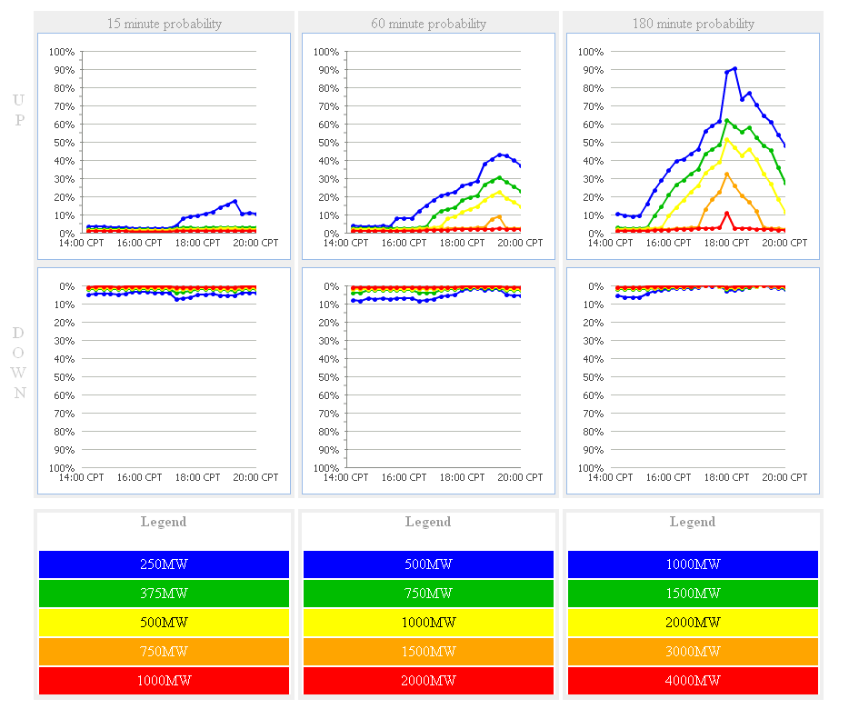
1 | IF:  - The ELRAS tool does not forecast a ramp that you believe it should have;  THEN:  - Send an e-mail to “Operations Analysis” and “shiftsupv”

Down Ramp Event
1 | PERIODICALLY REVIEW:  - EMS Applications>Frequency>Frequency Dashboard  - Splunk Dashboard Viewer under the MOS folder:  - “Monitor Large Ramp Events”
2 | IF:  - There is a 30% probability of a projected system wide down-ramp of 4,000 MW within the next 180 minutes, OR  - There is a 30% probability of a projected system wide down-ramp of 2,000 MW within the next 60 minutes;  THEN:  - Refer to the “180 min. HASL(COP) - LF or 60 min. HASL(COP) - LF” on the 60 to 180 minute Splunk Dashboard to determine if system ramp rate capability is sufficient, AND  - Make a Hotline call to provide situational awareness about a possible down-ramp event of 2,000 MW or greater within the next 60 minutes or 4,000 MW or greater within the next 180 minutes.  IF:  - System ramp rate is not sufficient;  THEN:  - Discuss with Shift Supervisor,  - Notify RUC Operator to procure Resources as needed,  - Notify Resource Operator to post a message on MIS Public,  - Notify Transmission Operator to make Hotline call to TOs.  Q#26 - Typical Hotline Script for OCN for Forecasted Probability of a Large Down Ramp
3 | IF:  - There is a 30% probability of a projected system wide down-ramp of 1,000 MW within the next 15 minutes;  THEN:  - Refer to the “HDL-Gen” on the 15 minute Splunk Dashboard and the available Regulation UP Service in the EMS Display,  IF:  - The margin is less than available to adequately maintain the potential system ramp rate;  THEN:  - Discuss with Shift Supervisor and Coordinate with the Resource Operator,  - Deploy Non-Spin as needed, and  - Continue to monitor frequency and “HDL-Gen”

Up Ramp Event
NOTE | Up ramps should be self-mitigating since a majority of the wind generators have governor response capabilities.
1 | PERIODICALLY REVIEW:  - EMS Applications>Frequency>Frequency Dashboard  - Splunk Dashboard Viewer under the MOS folder:  - “Monitor Large Ramp Events”
2 | IF:  - There is a 50% probability of a projected system wide up-ramp of 1,000 MW within the next 15 minutes;  THEN:  - Refer to the “Gen - LASL” on the 15 minute Splunk Dashboard and the available Regulation DOWN Service in the EMS Display,  IF:  - The margin is less than available to adequately maintain the potential system ramp rate;  THEN:  - Monitor frequency, Reg-Down and coordinate with Real-Time Desk Operator the necessity to run SCED as often as required.
LOG | Log all actions.

Document Control

Preparation
Prepared by | Role | Date Completed
Hartmann, Gaddy, Self, and Frosch | Preparers | January 24, 2017
Hartmann, Gaddy and Frosch | Procedure writers and editors | March 27, 2017
Hartmann, Gaddy and Ballew | Procedure writers and editors | May 26, 2017

Manual Change History
Procedure | Ver/Rev | Reason for Issue | Effective Date
All | 1.0 / 0 | New procedures | January 30, 2017
2.1  3.1  4.4  5.1  7.1  7.2  9.1 | 1.0 / 1  1.0 / 1  1.0 / 1  1.0 / 1  1.0 / 1  1.0 / 1  1.0 / 1 | Updated System Operator Responsibility and Authority  Updated Up Ramp Event step 2  Updated Panhandle Region  Updated Reliability Risk Desk performs STNET Study  Updated title and all 1st steps  Updated Implement EEA Level 3 steps  Updated Title | March 31, 2017
3.1 | 1.0 / 2 | Updated Down Ramp Event step 1, 2 & 3  Updated Up Ramp Event step 1 & 2 | June 1, 2017

