Power Operations Bulletin # 773

ERCOT has posted/revised the Reliability Risk Desk manual.

A copy of the procedure can be found at:

http://www.ercot.com/mktrules/guides/procedures/index.html

2.1 System Operator Responsibility and Authority

Procedure Purpose: To ensure the System Operators know their roles, responsibility and authority.

Protocol Reference | 6.5.1.1 | 6.5.1.2(3) | 6.5.2 | 6.5.3(1)
Guide Reference | 4.5.2(1)
NERC Standard

Version: 1 | Revision: 1 | Effective Date: March 31, 2017

ERCOT ISO as a Transmission Operator (TOP), the single Balancing Authority (BA), and only Reliability Coordinator (RC) registered within the ERCOT Interconnection shares all information between these roles simultaneously and acts concurrently as a single entity, satisfying coordination between the TOP, BA and RC.

The System Operator (SO) shall, in accordance with NERC Reliability Standards and ERCOT Protocols, have clear decision-making authority to act to address the reliability of its Reliability Coordinator Area by direct actions or by issuing Operating Instructions during both normal and emergency conditions. These actions shall be taken without delay and may include the shedding of firm load to prevent or alleviate System Operating Limits (SOLs) and the Interconnection Reliability Operating Limit (IROL) without obtaining approval from higher-level personnel.

The SO on duty is, in accordance with the ERCOT Protocols, Operating Guides, and NERC Reliability Standards, and acting as the Balancing Authority, Transmission Operator, and Reliability Coordinator shall request and receive information required to continually monitor the operating conditions which will assure the security and reliability of the ERCOT System.

The SO issues Dispatch Instructions / Operating Instructions for the Real-Time Operation of Transmission Facilities to a TO and to a QSE for the Real-Time Operation of a Resource.

The SO shall, on an ERCOT-wide basis, coordinate the ERCOT System Restoration (Black Start) Plan. The SO shall implement the Black Start Plan and shall direct the reconnection efforts of the islands, established by restoration activities.

The SO shall consider all equipment operating limits when issuing Dispatch Instructions / Operating Instructions. During Emergency Conditions, the SO may verbally request QSEs to operate its Resources outside normal operating parameters. If a Dispatch Instruction / Operating Instruction conflicts with a restriction placed on equipment by a TO or QSE to protect the integrity of equipment, ERCOT shall honor the restriction.

The SO performs security analyses on a Day Ahead and Real-Time basis and ensures that all Forced Outages are entered into the Outage Scheduler. The SO shall obtain or arrange to provide Emergency Energy over the DC Tie(s) on behalf of ERCOT.

The SO shall issue appropriate OCN’s, Advisories, Watches, and Emergency Notices, and coordinate the reduction or cancellation of clearances, re-dispatch of generation, and request, order, or take other action(s) that the SO determines necessary to maintain safe and reliable operating conditions on the ERCOT System in accordance with ERCOT Protocols, Operating Guides, and NERC Reliability Standards. The SO will implement and terminate ERCOT Time Corrections, and will determine the need for and implement the operation of a QSE on Constant Frequency Control for loss of ERCOT’s Load Frequency Control System.

3.1 Monitor Large Ramp Events

Procedure Purpose: The ERCOT Large Ramp Alert System (ELRAS) is designed to monitor the probability of large wind output ramps in the ERCOT region and provide ERCOT Operators with further situational awareness.

Protocol Reference
Guide Reference
NERC Standard

Version: 1 | Revision: 1 | Effective Date: March 31, 2017

Step | Action
NOTE | ERCOT Large Ramp Alert System (ELRAS) link:  AWS primary web server site: http://products.meso.com/elras_dev  AWS backup web server site: http://products2.meso.com/elras_dev  The potential for a large ramp can be identified using the “Graphical Forecast” page of ELRAS forecast Real-Time Mode. An example of the page is in figure 1 below. The “Graphical Forecast” page plots the probability of a ramp rate event starting at a given time during the next 6 hours. The graphical displays are broken up into three timeframes; 15-minute probabilities, 60-minute probabilities, and 180-minute probabilities, and Up and Down ramp rate events are split up for each time frame. These displays are interpreted by first looking at a particular interval on a given display. The value for that interval on that display is characterized as the probability of a given MW change occurring over a specified amount of time starting at the specified interval. For example, looking again at figure 1, the “Graphical Forecast” is showing a 50% probability of at least a 2,000 MW increase occurring over 180 minutes starting at 18:00. In other words, between 18:00 and 21:00 there is a 50% chance that the aggregate wind output will increase by at least 2,000 MW.  For the purpose of this procedure, the forecasted ramp rates to be considered significant are those that are indicated in Red; 1,000 MW in 15-minutes, 2,000 MW in 60-minutes, and 4,000 MW in 180-minutes. In the event that one of these ramp rates is forecasted to have at least a 30% probability of occurring, determine if the system has the ramp rate to keep up with the wind ramp.  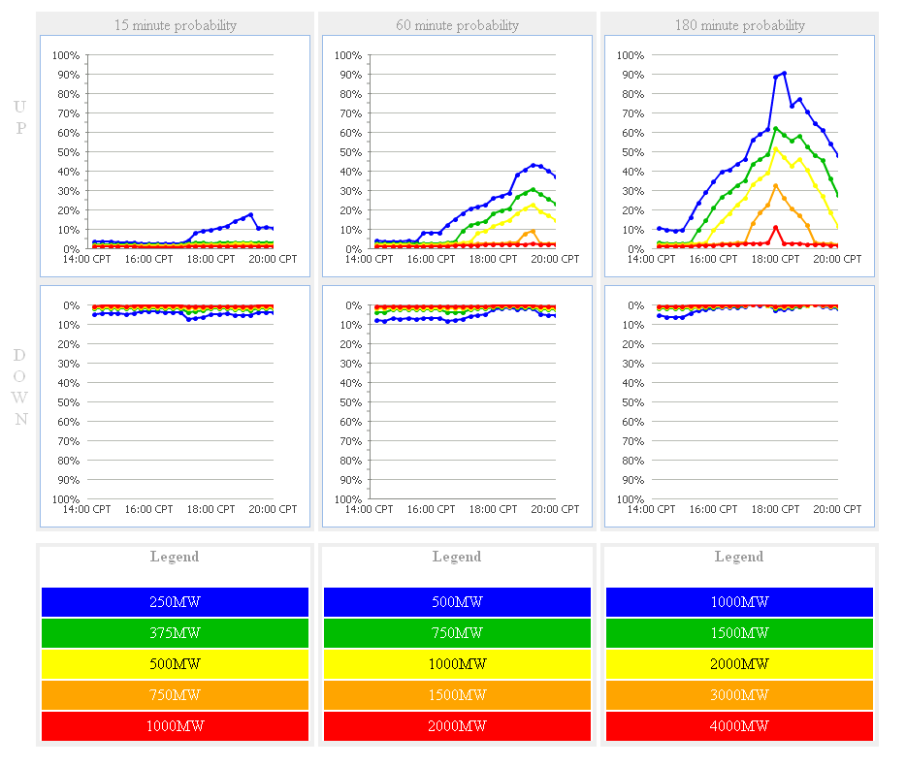
1 | IF:  - The ELRAS tool does not forecast a ramp that you believe it should have;  THEN:  - Send an e-mail to “Operations Analysis” and “shiftsupv”

Down Ramp Event
1 | PERIODICALLY REVIEW:  - EMS Applications>Frequency>Frequency Dashboard  - OpsMon Dashboard Viewer under the MOS folder:  - “Monitor Large Ramp Events”
2 | IF:  - There is a 30% probability of a projected system wide down-ramp of 4,000 MW within the next 180 minutes, OR  - There is a 30% probability of a projected system wide down-ramp of 2,000 MW within the next 60 minutes;  THEN:  - Refer to the “180 min. HASL(COP) - LF or 60 min. HASL(COP) - LF” on the 60 to 180 minute OpsMon Dashboard to determine if system ramp rate capability is sufficient, AND  - Make a Hotline call to provide situational awareness about a possible down-ramp event of 2,000 MW or greater within the next 60 minutes or 4,000 MW or greater within the next 180 minutes.  IF:  - System ramp rate is not sufficient;  THEN:  - Discuss with Shift Supervisor,  - Notify RUC Operator to procure Resources as needed,  - Notify Resource Operator to post a message on MIS Public,  - Notify Transmission Operator to make Hotline call to TOs.  Q#26 - Typical Hotline Script for OCN for Forecasted Probability of a Large Down Ramp
3 | IF:  - There is a 30% probability of a projected system wide down-ramp of 1,000 MW within the next 15 minutes;  THEN:  - Refer to the “HDL-Gen” on the 15 minute OpsMon Dashboard and the available Regulation UP Service in the EMS Display,  IF:  - The margin is less than available to adequately maintain the potential system ramp rate;  THEN:  - Discuss with Shift Supervisor and Coordinate with the Resource Operator,  - Deploy Non-Spin as needed, and  - Continue to monitor frequency and “HDL-Gen”

Up Ramp Event
NOTE | Up ramps should be self-mitigating since a majority of the wind generators have governor response capabilities.
1 | PERIODICALLY REVIEW:  - EMS Applications>Frequency>Frequency Dashboard  - OpsMon Dashboard Viewer under the MOS folder:  - “Monitor Large Ramp Events”
2 | IF:  - There is a 50% probability of a projected system wide up-ramp of 1,000 MW within the next 15 minutes;  THEN:  - Refer to the “Gen - LASL” on the 15 minute OpsMon Dashboard and the available Regulation DOWN Service in the EMS Display,  IF:  - The margin is less than available to adequately maintain the potential system ramp rate;  THEN:  - Monitor frequency, Reg-Down and coordinate with Real-Time Desk Operator the necessity to run SCED as often as required.
LOG | Log all actions.

4.4 Operations in the Panhandle region

Procedure Purpose: To monitor AWS Truepower wind forecast in the instance of a capacity shortage in the Panhandle region.

Protocol Reference
Guide Reference
NERC Standard

Version: 1 | Revision: 1 | Effective Date: March 31, 2017

Step | Action

Panhandle region is high export and wind is also forecasted to be above 75% of regional capacity.
REVIEW | IF:  - The AWS Panhandle wind forecast seems invalid, OR  - IRR generation is not meeting the AWS Panhandle wind forecast that could cause a reliability concern,  THEN:  - Notify an Operations Analysis Engineer for adjustments,  - E-mail the information to:  - Operations Analysis  - 1 ERCOT Shift Supervisors
Manually Override Short Term Wind Power Forecast | Contact the Operations Analysis Engineer to do further analysis and to possible override the AWS Forecast.
ACTION | Further analysis could potentially reduce the forecasted value of the region in question to the WGRPP value or another lower output that should allow the system to have adequate reserves given an under forecast.
LOG | Log all actions.

5.1 STNET Study

Procedure Purpose: To review and analyze future voltage violations.

Protocol Reference
Guide Reference
NERC Standand | VAR-001-4.1  R2, R3

Version: 1 | Revision: 1 | Effective Date: March 31, 2017

Step | Action

Reliability Risk Desk performs STNET Study
NOTE | Each hour run a STNET study for four hours out (example it is 0100, run study for 0500) to review voltage violations.
IF:
- Voltage contingencies or unsolved contingencies exist;
THEN:
- Check “Voltage Tracking Issues spreadsheet” on Sharepoint to ensure the contingency is not listed.
- If not listed, convey the voltage violations to the Transmission and Security Operator
- Create a savecase, use naming convention “SC_RRD(HE)_(DATE)
- Make at least one detailed log entry per shift that the studies are being executed. If any new voltage violations are identified that do not have a solution, log the information and notify the Transmission and Security Operator of the new violation(s).
Violated  Constraints | REVIEW REFERENCE DISPLAYS:  Market Operation>Reliability Unit Commitment>HRUC Displays>DSP Displays> DSP Binding Constraint Summary  Market Operation>Reliability Unit Commitment>HRUC Displays>DSP Displays> DSP Constraint Summary  REVIEW:  - Violated constraints. If needed, notify Operations Support Engineer to determine the validity;  IF:  - Invalid, no further action is required;  IF:  - Valid; AND  - Related to a phase shifter tap settings,  THEN:  - Notify Operations Support Engineer to determine and determine if adjusting a Phase Shifter would reduce the flow,  - Create Suggestion Plan for Constraint,  - Manually commit resources as needed  - Refer to Desktop Guide Reliability Risk Desk Section 2.5 and 2.6.
LOG | Log actions taken.

7.1 Market Notifications

Procedure Purpose: Guidelines for issuing Emergency Conditions and the four possible levels: Operating Condition Notices (OCN), Advisories, Watches, and Emergency Notices.

Protocol Reference | 6.3.3 | 6.5.9.3 | 6.5.9.3.1 | 6.5.9.3.2
Protocol Reference | 6.5.9.3.3 | 6.5.9.3.4
Guide Reference | 4.2.1 | 4.2.2 | 4.2.3 | 4.2.4
NERC Standard | EOP-011-1  R1.1, R2.1

Version: 1 | Revision: 1 | Effective Date: March 31, 2017

Step | Action

OCN
NOTE | Consider the severity of the potential Emergency Condition. The severity of the Emergency Condition could be limited to an isolated local area, or the condition might cover large areas affecting several entities, or the condition might be an ERCOT-wide condition potentially affecting the entire ERCOT System.
1 | As instructed by the Shift Supervisor or when appropriate, issue an Operating Condition Notice (OCN). The OCN can be issued for any of the following reasons or to obtain additional information from TOs and QSEs.  - There is a projected reserve capacity shortage that could affect reliability and may require more Resources  - When extreme cold weather is forecasted approximately 5 days away  - When extreme hot weather is forecasted approximately 5 days away  - When an approaching Hurricane / Tropical Storm is approximately 5 days away  - Unplanned transmission Outages that may impact reliability  - When adverse weather conditions are expected, ERCOT may confer with TOs and QSEs regarding the potential for adverse reliability impacts and contingency preparedness

ADVISORY
1 | As instructed by the Shift Supervisor or when appropriate, issue an Advisory. The Advisory can be issued for any of the following reasons or to obtain additional information from TOs and QSEs.  - When an approaching Hurricane / Tropical Storm is approximately 3 days away  - When extreme cold weather is forecasted approximately 3 days away  - When extreme hot weather is forecasted approximately 1 to 3 days away  - When conditions are developing or have changed and more Ancillary Services will be needed to maintain current or near-term reliability  - ERCOT may exercise its authority to increase Ancillary Service requirements above the quantities originally specified in the Day-Ahead Market (DAM) in accordance with ERCOT Procedures  - When extreme weather or conditions require more lead-time than the normal Day-Ahead Market (DAM) allows  - Transmission system conditions are such that operations within security criteria are not likely or possible because of Forced Outages or other conditions unless a CMP exists  - Loss of communications or control condition is anticipated or significantly limited  - ERCOT may require information from QSEs representing Resources regarding the Resources’ fuel capabilities. Requests for this type of information shall be for a time period of no more than seven days from the date of the request

WATCH
1 | As instructed by the Shift Supervisor or when appropriate, issue a Watch. The Watch can be issued for any of the following reasons or to obtain additional information from TOs and QSEs.  - A projected reserve capacity shortage is projected with no market solution available that could affect reliability  - When an approaching Hurricane / Tropical Storm is approximately 1 day away  - When extreme cold weather is projected for next day or current day  - When extreme hot weather is projected for next day or current day  - Conditions have developed such that additional Ancillary Services are needed in the Operating Period  - Insufficient Ancillary Services or Energy Offers in the DAM  - Market-based congestion management techniques embedded in SCED will not be adequate to resolve transmission security violations  - Forced Outages or other abnormal operating conditions have occurred, or may occur that require ERCOT to operate with active transmission violations of security criteria as defined in the Operating Guides unless a CMP exists  - The SCED process fails to reach a solution, whether or not ERCOT is using one the measures in Failure of the SCED Process.  - The need to immediately procure Ancillary Services from existing offers  - ERCOT may instruct TOs to reconfigure transmission elements as necessary to improve the reliability of the system

EMERGENCY NOTICE
1 | As instructed by the Shift Supervisor or when appropriate, issue an Emergency Notice. The Emergency Notice can be issued for any of the following reasons or to obtain additional information from TOs and QSEs.  - Loss of Primary Control Center functionality  - Load Resource deployment for North-Houston voltage stability  - ERCOT cannot maintain minimum reliability standards (for reasons including fuel shortages) during the Operating Period using every Resource practically obtainable from the market  - Immediate action cannot be taken to avoid or relive a Transmission Element operating above its Emergency Rating  - ERCOT forecasts an inability to meet applicable reliability standards and it has exercised all other reasonable options  - A transmission condition has been identified that requires emergency energy from any of the DC-Ties or curtailment of schedules  - The Transmission Grid is such that a violation of security criteria as defined in the Operating Guides presents the threat of uncontrolled separation or cascading outages, large-scale service disruption to Load (other than Load being served from a radial transmission line) and/or overload of Transmission Elements and no timely solution is obtainable through SCED or CMP  - When extreme cold weather is beginning to have an adverse impact on the System  - When extreme hot weather is beginning to have an adverse impact on the System  - When Hurricane / Tropical Storm is in the ERCOT Region and is beginning to have an adverse impact on the System

Operating Condition Script
Hotline | Notify QSEs of Notice  #46 - Typical Hotline Script for Operating Condition [OCN/Advisory/Watch/Emergency]  .
Post | - All notices must be posted on MIS.  - For “free form” messages, the “Notice Priority” will be specified as follows:  - Operational Information/OCN type messages – low priority  - Advisory/Watch type messages – medium priority  - Emergency type messages – high priority
Hotline Cancellation | #47 - Typical Hotline Script to Cancel Operating Condition [OCN/Advisory/Watch/Emergency]
LOG | Make log entry.

7.2 Implement EEA Levels

Procedure Purpose: To provide for maximum possible continuity of service while maintaining the integrity of the ERCOT system to reduce the chance of cascading outages. If required to assist other Desk during an EEA event refer to appropriate Operating Procedures.

Protocol Reference | 6.5.7.6.2.2(1)(b) & (13) | 6.5.9.4 | 6.5.9.4.2
Guide Reference | 4.5.3 | 4.5.3.1 | 4.5.3.2 | 4.5.3.3
Guide Reference | 4.5.3.4
NERC Standard | EOP-011-1  R2.1, R2.2.3, R2.2.3.1, R2.2.3.4

Version: 1 | Revision: 1 | Effective Date: March 31, 2017

 | Step |  | Action
 | NOTE |  | - IF steady state system frequency falls below 59.8 Hz, ERCOT CAN immediately implement EEA 3.  - IF steady state system frequency falls below 59.5 Hz, ERCOT SHALL immediately implement EEA 3.
 | TCEQ |  | When increased generation is requested during EEA events, Texas Commission on Environmental Quality (TCEQ) will exercise enforcement discretion for exceedances of emission limits as well as operational limits for power generating plants for Generators who exceed air permit limits in order to maximize generation for the duration of the EEA event. ERCOT General Council will send out a Market Notice each time ERCOT enters into an EEA with this reminder.

Implement EEA Level 1
1 |  | IF:  - PRC < 2300 MW;
2 |  | Assist Control Room as needed and monitor Intermittent Renewable Resources (IRR).
LOG |  | Log all actions.

Implement EEA Level 2
 | 1 |  | IF:  - PRC < 1750 MW or unable to maintain system frequency at 59.91 Hz and is not projected to be recovered above 1750 MW within 30 minutes without the use of EEA Level 2;
 | 2 |  | Assist Control Room as needed and monitor Intermittent Renewable Resources (IRR).
 | LOG |  | Log all actions.

Implement EEA Level 3
 | EEA3  PRC <1375 MW |  | ERCOT will declare an EEA Level 3 when PRC cannot be maintained above 1,375 MW.
 | 1 |  | IF:  - PRC <1000 MW or Unable to maintain system frequency at 59.80 Hz;  THEN:  - Assist Control Room as needed and monitor wind generation.
 | LOG |  | Log all actions.

9.1 Responding to QSE Issues

Procedure Purpose: To provide a mutually agreed process for resolving Real-Time data issues between ERCOT and the Entities that provide data to ERCOT. Also to record when a QSE is operating from their backup Control Center and to notify the ERCOT Transmission Operator when a QSE notifies ERCOT of a change in status with any PSS or AVR.

Protocol Reference | 6.5.7.1.13(4)
Guide Reference
NERC Standard | IRO-010-2  R3.2 | TOP-003-3  R5.2

Version: 1 | Revision: 1 | Effective Date: March 31, 2017

 | Step | Action

Real-Time Data Issues known by the QSE
NOTE |  |  | Manually replaced telemetry data is data entered by a QSE on their systems that is transmitted to ERCOT via ICCP in place of the normal points experiencing an issue. If Reliability issues can’t be resolved in a timely manner, ERCOT reserves the right to order the Resource off-line until the problem is resolved.
Notification of Telemetry  Data  Issue |  |  | IF:  - Notified of a telemetry data issue (telemetry data will not be available or is unreliable for operational purposes;  THEN:  - The QSE should correct the telemetry data as soon as practicable, or,  - Manually replace the data, if available.
Cannot  Resolve |  |  | IF:  - The QSE cannot resolve the telemetry data issue within two Business Day, fix the issue in a timely manner;  THEN:  - The QSE shall provide an estimated time of resolution.

Backup/Alternate Control Center Transfer
1 |  |  | When notified by a QSE that they will be transferring to or from their backup/alternate control center,  - Identify the [QSE] in the email notification  Send e-mail to “1 ERCOT System Operators”
Log |  |  | Log all actions.

QSE Issues
1 |  | If a QSE is not satisfied with ERCOT Operations responses to their issues, refer them to their Wholesale Client Representative for clarification/resolution.
2 |  | If the System Operator believes the issue is with ERCOT systems applications (ICCP down, etc.), notify the ERCOT Help Desk.
3 |  | If a QSE is having an issue with ERCOT system applications (unable to access the portal, outage scheduler, etc.), instruct them to call the ERCOT Help Desk.
4 |  | As time permits, notify the Shift Supervisor of any actions taken and unresolved issues.
LOG |  | Log all actions.

Missing Data from MIS Postings
1 |  | IF:  - A call is received about data missing or data being incorrect,  THEN:  - Transfer call to the Help Desk, and  - Notify the Shift Supervisor and Operations Support Engineer.
 | LOG | Log the information.

Courtesy Hotline calls for ERCOT Application Issues
1 |  | WHEN:  - Notified from IT support of application(s) issues that are causing Market Participants an inability to submit data to ERCOT;  THEN:  - Make a courtesy hotline to inform them.  Q#76 - Typical Hotline script for Application Issues

Power System Stabilizers (PSS) & Automatic Voltage Regulators (AVR)
1 |  | WHEN:  - Notified by a QSE of a change in status with any PSS or AVR;  THEN:  - Transfer call to the ERCOT Transmission Operator.

Document Control

Preparation
Prepared by | Role | Date Completed
Hartmann, Gaddy, Self, and Frosch | Preparers | January 24, 2017
Hartmann, Gaddy and Frosch | Procedure writers and editors | March 27, 2017

Manual Change History
Procedure | Ver/Rev | Reason for Issue | Effective Date
All | 1.0 / 0 | New procedures | January 30, 2017
2.1  3.1  4.4  5.1  7.1  7.2  9.1 | 1.0 / 1  1.0 / 1  1.0 / 1  1.0 / 1  1.0 / 1  1.0 / 1  1.0 / 1 | Updated System Operator Responsibility and Authority  Updated Up Ramp Event step 2  Updated Panhandle Region  Updated Reliability Risk Desk performs STNET Study  Updated title and all 1st steps  Updated Implement EEA Level 3 steps  Updated Title | March 31, 2017

