Power Operations Bulletin # 661

ERCOT has posted/revised the Inadvertent Energy Procedure for DC Tie

The Various Changes are shown below.

A copy of the procedure can be found at:

http://www.ercot.com/mktrules/guides/procedures/index.html

Document Control

Preparation
Prepared by | Role | Date Completed
Colleen Frosch | Manager, System Operations | January 4, 2008
Colleen Frosch | Manager, System Operations | February 15, 2008
Colleen Frosch | Manager, System Operations | June 20, 2008
Colleen Frosch | Manager, System Operations | September 25, 2009
Colleen Frosch | Manager, System Operations | March 12, 2012
Colleen Frosch, Jimmy Hartmann | Procedure writers and editors | February 3, 2014

Approval

Distribution List
Name | Organization
Lanny Nickell  Shari Brown | SPP
Daniel Paniagua  Cynthia Sanchez | CFE
Dennis Kunkel  Bill Thompson | AEP
Karl Tammar  Larry Edward | Sharyland

Change History
Issue | Reason for issue | Effective Date
Version 1, Rev 0 | New Inadvertent Procedure | January 4, 2008
Version 1, Rev 1 | Reviewed. Updated with CFEs revisions | February 15, 2008
Version 1, Rev 2 | Reviewed. Updated Introduction | June 20, 2008
Version 1, Rev 3 | Reviewed. Changed “Inadvertent” to “Inadvertent Energy” throughout document | October 1, 2009
Version 1, Rev 4 | Updated ERCOT Protocol link and CFEs inadvertent balance in section 3. | March 15, 2012
Version 1, Rev 5 | Updated to change the DC-Tie Operator for Railroad DC-Tie | February 3, 2014

Contents

1. Introduction

2. Hourly and Daily Inadvertent Energy

3. Daily Settlement Meter Data

4. Monthly Settlement of Inadvertent Energy

5. Inadvertent Energy Pay Back

1. Introduction

This document outlines the process that ERCOT, SPP, the DC-Tie Operator’s and Comision Federal de Electricidad (CFE) will follow for Inadvertent Energy accounting.

ERCOT is the NERC designated Reliability Coordinator and Balancing Authority for the ERCOT Region. The interactions between ERCOT, CFE, and the DC-Tie Operators for the purposes of Inadvertent Energy accounting for transactions of energy across the DC-Ties, are covered within this document. This document shall be reviewed at least every three years.

This ERCOT procedure supports the ERCOT Protocols, and Operating Guides.

All verbal and written communications with ERCOT for commercial or emergency operations of the DC-Ties will be in English. For verbal communications between ERCOT and CFE (and vice versa), the DC-Tie Operator will be the primary contact. The DC-Tie Operator will coordinate any operational issues between ERCOT and CFE.

The communication among CFE, the DC-Tie Operator and ERCOT will be according to the ERCOT Operating Procedures located at the following link, which include:
  - ERCOT DC Tie Operations
  - Inadvertent Energy Procedure
  - Operating Procedure Manual: DC-Tie Desk

http://www.ercot.com/mktrules/guides/procedures/index.html

2. Hourly and Daily Inadvertent Energy

ERCOT uses OATI webTrans to checkout with the DC-Tie Operator’s and the accounting authority at the other end of ERCOT’s DC-Ties. AEP TO in Columbus, Ohio is the DC-Tie Operator for the East and North DC-Ties, AEP TO in Corpus Christi is the DC-Tie Operator for the Laredo VFT and Eagle Pass DC-Tie, and Sharyland TO in Amarillo is the DC-Tie Operator for the Railroad DC-Tie. Comision Federal de Electricidad (CFE) is the accounting authority for the Laredo VFT, Eagle Pass, and Railroad DC-Ties.

The ERCOT Control Room DC-Tie Procedure includes intraday monitoring of all hourly DC-Tie Inadvertent Energy flows on a periodic basis.

Before the start of each hour, the ERCOT Operator will confirm with each DC-Tie Operator the next hour’s schedule.

After each hour, the ERCOT Operator will check the actual SCADA data with each DC-Tie Operator. The DC-Tie Operators will monitor the same real-time telemetry points as ERCOT for each DC Tie. The ERCOT Operator will override any actual SCADA data as necessary to check out with the DC-Tie Operators. These are the Actual Flows on which Inadvertent Energy will be calculated initially, prior to the final upload of the ERCOT Polled Settlement (EPS) meter data in the OATI webTrans system.

Any discrepancies in Actuals 10 MWh or more will trigger investigation, in both ERCOT and the DC-Tie-Operator, and escalation to the SCADA/metering team. If ERCOT detects that there is a known SCADA related problem, then ERCOT will use the AEP or Sharylands value.

After midnight each day, the ERCOT Operator will check out with each DC-Tie Operator the total ‘In and Out Scheduled MWh’ and the total ‘In and Out Actual MWh’ flows, for the past day. If the totals do not match, the Operators will check each hour until the discrepancy is found. If needed, the ERCOT Operator will provide a summary of all the E-tags that were scheduled in the current day for further analysis until the discrepancy is solved. The ERCOT Operator will mark in the ERCOT OATI webTrans for each hour all of the agreed upon schedules.

After the midnight check out, the ERCOT Operator will send to each DC-Tie Operator a snapshot of the agreed upon daily checkout (screen shot below).

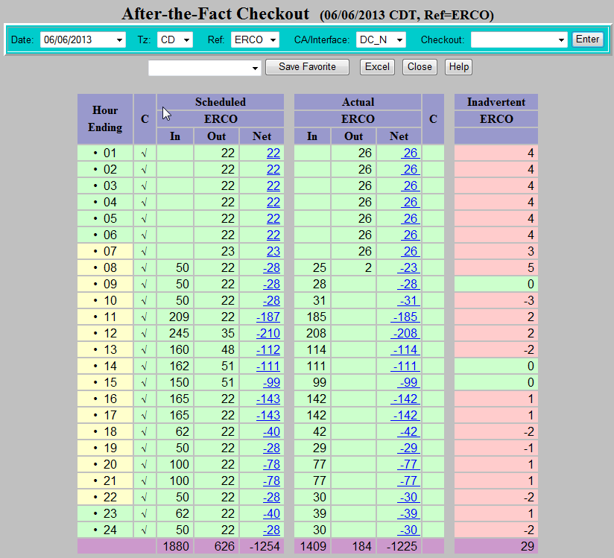

3. Daily Settlement Meter Data

ERCOT will use, for the final check out, ERCOT Settlement metering data from the EPS meters assigned to each DC-Tie. The meters have the following identifiers:

ERCOT EPS Meter Identification
DC-Tie Name | webTrans Name | Resource ID | Meter Serial Number
East DC-Tie | DC_E | TXUMONTOPDC00 | 0604A076
North DC-Tie | DC_N | AEPOKLUGPDC00 | 0109A064
Eagle Pass DC-Tie | DC_S | AEPEGPSOPDC00 | 32211867
Laredo VFT Tie | DC_L | CPLLAREGP0400 | 701A603
(Rail)road DC-Tie (Cumbres) | DC_R | CPLSHRYGP0100 | 0612A011

Seven days after the fact, EPS Settlement metering data is uploaded to the ERCOT OATI webTrans system, which supersedes the initial SCADA values checked out by the Operators. ERCOT will e-mail the hourly meter data for each day once the EPS Settlement metering data has been populated in webTrans.

Example below:

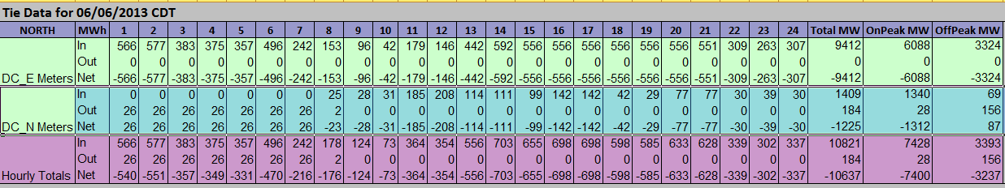

4. Monthly Settlement of Inadvertent Energy

The seventh day after the last operating day of the month or the next business day and no later than the 14th of the month, ERCOT will send to the accounting authority and each DC-Tie Operator, the Monthly Inadvertent Energy Report for each DC-Tie. A Monthly Inadvertent Energy Report will also be provided that combines the ties so an accurate accumulative Inadvertent Energy total will be given (as shown below). The East and North DC-Tie will be combined, Laredo VFT, Eagle Pass and the Railroad DC-Tie will be South ties will be combined.

The accounting authority will provide acknowledgement of agreement with the monthly settlement report via email within the next 5 business days. In case of disagreement they will provide clear explanation and supporting documentation of their observed discrepancies.

Any Outstanding discrepancies will be escalated to ERCOT System Operations Management immediately to facilitate the resolution.

If the discrepancy cannot be resolved, the issue will be referred to the ERCOT Legal Department for advice and arbitration.

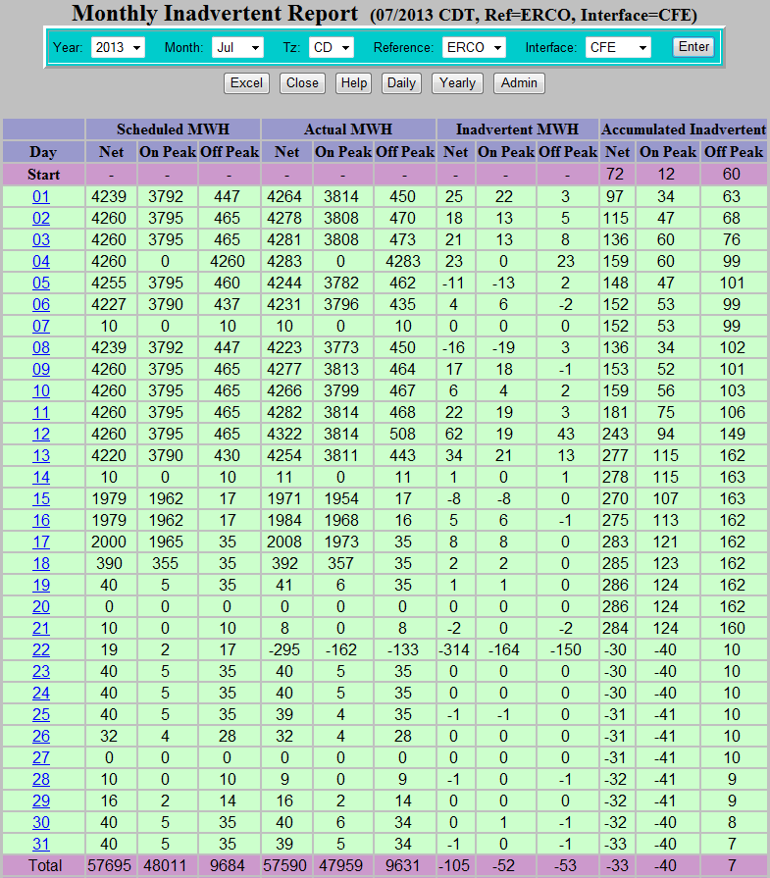

5. Inadvertent Energy Pay Back

Inadvertent Energy pay back on the North and East DC-Ties will be approved by ERCOT, the DC-Tie Operator, and the Balancing Authority. Inadvertent Energy due will be paid back “in-kind”. Accumulated On-Peak Inadvertent Energy will be paid back On-Peak. On-Peak periods as defined by the NAESB Business Practice Standards are Monday through Saturday Hour-Ending 0700 – 2200. The accumulated Off-Peak Inadvertent Energy will be paid back Off-Peak. Off-Peak periods as defined by the NAESB Business Practice Standards are Monday through Saturday Hour-Ending 2300 – 0600 and Sundays and special holidays. The Inadvertent Energy account should be as close to zero as possible. In any case, the Inadvertent Energy balance should not go beyond 1,000 MWh for the North and East DC-Ties.

Inadvertent Energy pay back on the Laredo VFT, Eagle Pass, and Railroad DC-Ties will be approved by ERCOT, the DC-Tie Operators, and CFE (the CENACE Centro Nacional de Control de Energía). Inadvertent Energy will be paid back “in-kind”. Accumulated On-Peak Inadvertent Energy will be paid back On-Peak. On-Peak periods as defined by the NAESB Business Practice Standards are Monday through Saturday Hour-Ending 0700 – 2200. The accumulated Off-Peak Inadvertent Energy will be paid back Off-Peak. Off-Peak periods as defined by the NAESB Business Practice Standards are Monday through Saturday Hour-Ending 2300 – 0600 and Sundays and special holidays. The Inadvertent Energy account should be as close to zero as possible every month. Inadverent Energy payback should not exceed 25 MWh for each hour. In any case, the balance should not go beyond 150 MWh total for the Laredo VFT, Eagle Pass, and Railroad DC-Tie. Any Inadvertent Energy on the South DC-Ties that is not scheduled 3 months after the settlement month will be considered as paid.

