Power Operations Bulletin # 466

ERCOT has revised the Shift Supervisor Desk Procedure Manual.

The Various Changes are shown below.

A copy of the procedure can be found at:

http://www.ercot.com/mktrules/guides/procedures/index.html

1.3.2 ERCOT System Operator Responsibility and Authority

Procedure Purpose: To ensure the System Operators know their roles, responsibility and authority.

Protocol Ref.
Guide Ref. | 1.7.1 | 2.1 | 2.3
NERC Std. | EOP-002  R1 | PER-001  R1 | IRO-001  R3 | TOP-001  R1
NERC Std. | TOP-002  R4

Approved by: |  |  | Effective Date: March 9, 2010
Version: | 4.0 | Revision: | 3

English shall be used as the language for all communications between and among operating personnel responsible for the real-time generation control and operation of the interconnected Bulk Electric System.

The System Operator (SO) shall, in accordance with NERC Reliability Standards, have the responsibility and authority to implement real-time actions to ensure the stable and reliable operation of the Bulk Electric System during both normal and emergency conditions. These actions shall include shedding of firm load without obtaining approval from higher-level personnel. The ERCOT System Operator represents the following NERC functional entities collectively for the ERCOT ISO at any time:

- Reliability Coordinator.
- Balancing Authority
- Transmission Operator
- Interchange Coordinator

The SO on duty is, in accordance with the ERCOT Protocols, Operating Guides, and NERC Reliability Standards, and acting as the Balancing Authority, Transmission Operator, Regional Reliability Coordinator, and Interchange Authority shall request and receive information required to continually monitor the operating conditions and request that individual Market Participants (MPs) make changes, which will assure security and reliability of the ERCOT system.

The SO shall, on an ERCOT-wide basis, coordinate the ERCOT System Restoration (Black Start) Plan. The SO shall implement the Black Start Plan and shall direct the reconnection efforts of the islands, established by restoration activities. The SO shall coordinate the mutual assistance activities of the ERCOT participants during system restoration activities.

The SO shall review the ERCOT Daily Operations Plan (DOP) and calculate and post the allocated Responsive Reserve and other Ancillary Services Obligations. The SO shall ensure compliance with the ERCOT Protocols and Operating Guides on identified transfer limits. The SO receives all specified notifications for the MPs with regard to energy transactions (Balanced Schedules), AGC control modes, routine adjustments, and equipment limitations or outages.

The SO processes all Balanced Schedules and Resource Plans. The SO performs security analyses on a Day Ahead and real-time basis and ensures all Forced Outages are entered into the Outage Scheduler. The SO shall obtain or arrange to provide emergency energy over the DC Tie(s) on behalf of ERCOT.

The SO shall issue appropriate advisories and watches, emergency notices, and coordinate the reduction or cancellation of clearances, re-dispatch of generation, and request, order, or take other action(s) that the SO determines is necessary to maintain safe and reliable operating conditions on the ERCOT system in accordance with ERCOT Protocols, Operating Guides, and NERC Reliability Standards. The SO will implement and terminate ERCOT Time Corrections, and will determine the need for and implement the operation of a Qualified Scheduling Entity (QSE) on Constant Frequency Control for loss of ERCOT’s frequency control system.

As the Reliability Coordinator, ERCOT ISO shall comply with its Regional Reliability Plan that has been approved by the NERC Operating Committee.

The SPP DC-Tie processes, procedures, or plans that support or affect SPP shall be reviewed at least once every 3 years and updated if needed. These would include any DC-Tie procedures, inadvertent energy procedures, and emergency procedures.

1.3.6 Disseminating Information

Procedure Purpose: To communicate information concerning disturbances or unusual occurrences to appropriate parties in the Interconnection.

Protocol Ref.
Guide Ref. | 2.7.2.3 | 3.1.4.7 | 3.1.5.3.4
NERC Std. | CIP-001  R1, R2, R3 | EOP-004  OE-417

Approved by: |  |  | Effective Date: March 9, 2010
Version: | 4.0 | Revision: | 4

Step | Action
NOTE: | The SSRG e-mail exploder list is used to disseminate information to the SSRG members of the ERCOT Region when an SSRG conference call is not necessary. Some of this information is intended for use within the industry and not for public release. Ensure that all correspondence state a Confidentiality Notice and include your signature on e-mail.
NOTE: | The Reliability Coordinator Information System (RCIS) is used to disseminate information to other RCs in NERC.
1 | Types of disturbances or unusual occurrences include but are not limited to the following:  - Copper thefts  - Substation break-in  - Vandalism  - Malicious mischief  - Suspicious photos  - Suspected Sabotage (cyber or physical)
2 | Once notified by a QSE or TO of a disturbance or unusual occurrence, ask the following:  - Is the occurrence considered “theft of property”? (proceed to Step 3)  - Is the occurrence being investigated as a “suspected sabotage event” (proceed to Step 4)
3 | If “theft of property” can be reasonably determined and the incident is not related to a suspected sabotage event:  - Ensure that local Law Enforcement Agencies (LEAs) have been notified. If the event is not considered a form of suspected sabotage event.  - Send an SSRG e-mail stating the event is not considered as an act of suspected sabotage.
4 | If the entity has determined the disturbance or unusual occurrence to be a “suspected sabotage event”:  - Verify that Federal Bureau of Investigation (FBI) field office closest to the event location has been notified. If entity will not notify FBI, notify the appropriate Director or Manager of ERCOT Security (Cyber/Physical).  - Notify the appropriate Director or Manager of ERCOT Security of each occurrence.  - Send an SSRG e-mail stating the event is considered as an act of suspected sabotage.  - Post on the RCIS, use the “Dept Homeland Security Form”  - Refer to 2.2.9 NERC and DOE Disturbance Reporting in a timely manner for additional reporting notifications  - Coordinate with the Manager, System Operations or designee and follow procedure 1.3.3 to initiate an SSRG conference call as deemed necessary
5 | When the “suspected sabotage event” is determined to be closed by the entity:  - Send an SSRG e-mail  - Post follow-up on the RCIS, use the “Dept Homeland Security Form”
NOTE: | For suspected sabotage at the ERCOT facilities, refer to ERCOT Guideline GL7.8.1 located under the “Sabotage Event Recognition” tab in each procedure manual. RCIS and SSRG will also be required.
Cyber | When notified by Cyber Security of a reportable event, collect the information to post under “CIP Free Form” on the RCIS.

2.1 Providing Technical and Operational Support

Procedure Purpose: Technical and operational support duties for the Shift Supervisor

Protocol Ref.
Guide Ref.
NERC Std. | TOP-003  R3

Approved by: |  |  | Effective Date: March 9, 2010
Version: | 4.0 | Revision: | 2

The Shift Supervisor is responsible for ensuring operations are in compliance with ERCOT Protocols, NERC Reliability Standards, Operating Guides, and Operating Procedures. The Shift Supervisor must have a very good understanding of the ERCOT Protocols, Operating Guides, and NERC Reliability Standards.
The Shift Supervisor may consult with Operations Support, Operations Planning, Market Operations, or any resource he deems necessary to resolve and clarify market related issues. He/She will assist the System Operators in resolving market issues.
The Shift Supervisor, representing the RC function, has the authority to veto any planned outages to analysis tools, including final approval for planned maintenance such as database loads, site failovers, etc. This authority to veto also applies to Market Participants planned outages of telemetering, control equipment, and associated communication channels when reliability of the grid is in jeopardy.
The Shift Supervisor also monitors and ensures that adequate coordination between the ERCOT Region, SPP and CFE is maintained. To this effect the Shift Supervisor monitors the communications and coordination between the DC-Tie Desk and SPP and CFE.
The Shift Supervisor is responsible for running primary operations from the Alternate Control Center once per month. This is to ensure all desks are functional in the case of an emergency.
The Shift Supervisor has the authority to coordinate additional support to assist during emergencies, system and weather related disturbances, and high demand periods as deemed necessary. Support may be required from Operations Support, Operations Planning, Market Operations, Outage Coordinators, and System Operators assigned to the Alternate Control Center. The Shift Supervisor also has the authority to assign temporary duties to this additional support staff.
Finally, other Shift Supervisor duties may require the on-shift Shift Supervisor to leave the Control Center from time to time. On these occasions, the Shift Supervisor may delegate his duties to another system operator on a temporary basis. The Shift Supervisor shall remain in contact and accessible to the control center via available communication means.

2.1.14 Monitoring of Large Ramps and Events Evaluation

Procedure Purpose: The ERCOT Large Ramp Alert System (ELRAS) is designed to monitor the probability of large wind output ramps in the ERCOT region and provide ERCOT Operators with further situational awareness.

Protocol Ref.
Guide Ref.
NERC Std.

Approved by: |  |  | Effective Date: March 9, 2010
Version: | 4.0 | Revision: | 0

Step | Action
1 | The potential for a large ramp can be indentified using the “Graphical Forecast” page of ELRAS in the Real-Time Viewing Mode. An example of the page is in figure 1 below. The “Graphical Forecast” page plots the probability of a ramp rate event starting at a given time during the next 6 hours. The graphical displays are broken up into three timeframes; 15-minute probabilities, 60-minute probabilities, and 180-minute probabilities, and Up and Down ramp rate events are split up for each time frame. These displays are interpreted by first looking at a particular interval on a given display. The value for that interval on that display is characterized as the probability of a given MW change occurring over a specified amount of time starting at the specified interval. For example, looking again at figure 1, the “Graphical Forecast” is showing a 50% probability of at least a 2000 MW increase occurring over 180 minutes starting at 18:00. In other words, between 18:00 and 21:00 there is a 50% chance that the aggregate wind output will increase by at least 2000 MW.  For the purpose of this procedure, the forecasted ramp rates to be considered significant are those that are indicated in Yellow; 500 MW in 15-minutes, 1000 MW in 60-minutes, and 2000 MW in 180-minutes. In the event that one of these ramp rates is forecasted to have at least a 30% probability of occurring, Operations Support staff should be contacted for verification and analysis.  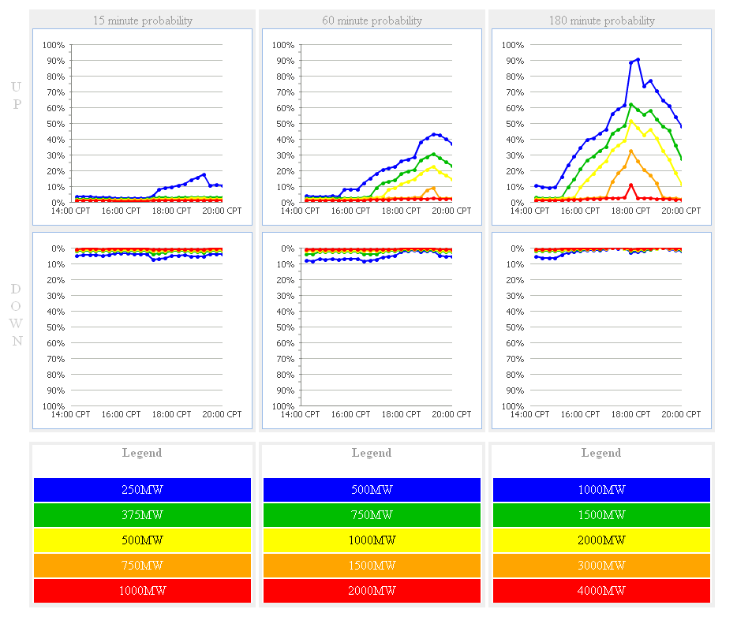  Once the validation has been completed, the Operations Support staff member will contact the Control Room and communicate whether the forecast is deemed as a reasonable possibility. In instances in which a forecasted large ramp was first observed by the Operations Support staff, the shift supervisor will be contacted to be made aware of the possibility of a large ramp event.

2.7.1 Monitor and Report Building Security and fire Alarms

Procedure Purpose:

Protocol Ref.
Guide Ref.
NERC Std.

Approved by: |  |  | Effective Date: March 9, 2010
Version: | 4.0 | Revision: | 1

Step | Action
NOTE: | Other control room systems include, computer access to corporate systems (public Internet and e-mail), weather monitoring systems (TV), telecommunications, fax machines, HVAC systems, building security and fire warning systems, etc.  Failures in some of these systems such as telecommunications can be critical to ERCOT System Operations.
1 | DISCUSS any fire alarms or building security with the ERCOT Facilities Security staff.
2 | DETERMINE criticality and impact of the alarms jointly with the ERCOT Facilities Security staff.
3 | IF the criticality and impact of alarms is such that the building may need to be evacuated and Market Operations are or will be affected before the problem can be resolved, TRANSFER control of the system to the ERCOT Alternate Control Center.
4 | REQUEST additional assistance from other support staff.

2.9.2 Deliver Oral Shift Report to Entering Shift Supervisor

Procedure Purpose:

Protocol Ref.
Guide Ref.
NERC Std.

Approved by: |  |  | Effective Date: March 9, 2010
Version: | 4.0 | Revision: | 1

Step | Action
1 | OUTLINE comments on the following areas:  - Forced Outages  - System Reserves  - System Conditions  - Market Conditions  - Forecasted Congestion  - System Disturbances, if any occurred  - New or modified operating procedures  - Shift Staffing information including staff assigned to alternate control center
2 | REQUEST understanding and acknowledgement from entering Shift Supervisor.

