ERCOT Power Operations Bulletin #343

ERCOT has revised the Day Ahead Desk Procedure Manual

The changes include updating URL links in Appendix 1 and added new condition for Non-Spin procurement in Appendix 4.

A copy of the procedure is at:

http://www.ercot.com/mktrules/guides/procedures/index.html

3.3 Appendix 1: Method for Posting Messages to the Message Board

For the following:
Login = ercotoperator
Password = (obtain current password from Shift Supervisor)

I. POSTING A MESSAGE
- In Internet Explorer, go to:
http://oldercot.ercot.com/ercotPublicWeb/Messageadmin/index.htm
Select “Create Message”
a. Type the message subject in the “Subject” field
b. Tab to (or click in) the “Message” field and enter the message
Caution: In the next step selecting “Reset” will clear all fields on the form.
c. From the drop-down list, select the message type
d. Select “Submit” to post the message to the public messages area on the Texas
Market Link.
e. Log the posting number displayed. (Logging this number will make it easier to
find the message later if it’s status needs changing. Refer to Step II)
- (OPTIONAL) To see the message, as the public will view it, go to:
- http://oldercot.ercot.com/ercotPublicWeb/Message/MessageSearch.asp

II. UPDATING A MESSAGE (e.g., change status to either valid or invalid)
- In Internet Explorer, go to:
http://oldercot.ercot.com/ercotPublicWeb/Messageadmin/index.htm
- Select “Update Message Status”
a. Enter the “Posting Number”
b. Select the desired status
c. Select “Submit”
- (OPTIONAL) To see the message, as the public will view it, go to: http://oldercot.ercot.com/ercotPublicWeb/Message/MessageSearch.asp

Appendix 4: Methodology for Determining Non-Spin Procurement

Methodolog for Determining Non-Spin Procurement

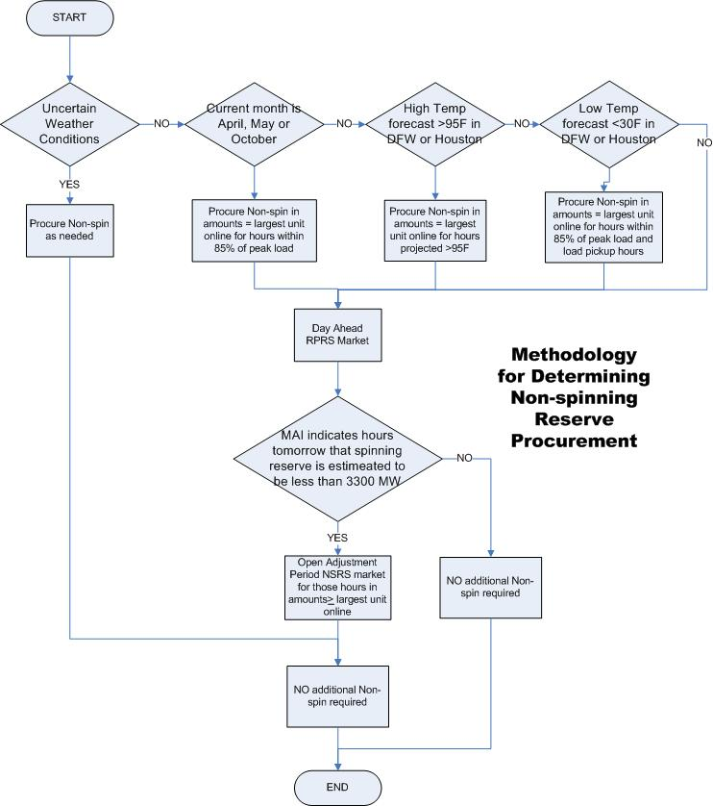

Appendix 4: Methodology for Determining Non-Spin Procurement (cont’d)

Use the following in determining the amount of NSRS needed:

- If weather conditions for the next day are uncertain, procure Non-spin as needed.
- IF the current month is April, May or October, then purchase NSRS in amounts equal to the largest unit online for the hours projected within 85% of peak hour.
- For other months of the year,
- IF today’s and tomorrow’s ERCOT high temperature is projected above 95 degrees in Dallas/Ft. Worth or Houston, THEN PURCHASE NSRS in amounts equal to the largest unit online for the hours projected warmer than 95 degrees.
OR
- If tomorrow’s low temperature forecast is projected below 30 degrees in Dallas/Ft. Worth or Houston, THEN PURCHASE NSRS in amounts equal to the largest unit online for
  - the projected morning load pickup hours and
  - hours projected within 85% of peak hour.
OR
- After the Day Ahead RPRS study or market is complete, the Resource Plan appears to have been updated, and an accurate determination of the need for additional Non-Spin Reserves for the next day can be made, open a secondary NSRS market as needed for hours in which the Market Analyst Interface (MAI) “Capacity Impact” tab indicates less than 3300 MW of spinning reserve.

Reference:
www.ercot.com “ERCOT Methodologies for Determining Ancillary Service Requirements – Current”

