ERCOT Operations Bulletin 306

ERCOT has revised the Frequency Control Desk. Revision includes updating sections 2.7.1, 2.7.2, 2.7.4, 2.7.5 and adding a new Appendix 11. All steps have been revised and rewritten.

Approve NERC Tags for DC Ties
Step # | Procedural Steps
PURPOSE: | A NERC Tag received in the OATI WebTrans regarding DC Tie flows into or out of ERCOT will be validated for accuracy, and should be in agreement with the Market Operating System (MOS) except for changes made during the Operating Period such as curtailments.
1 | When a new or updated tag is received in the OATI WebTrans system, compare the tag data and the schedule.  - If the tag is greater than the MOI schedule, then the MOI schedule does not have enough generation to cover the tag. The “Mismatched” value box will be red and the MW difference will be a negative amount. Deny the tag.  - If the tag is less than the MOI schedule, which means there is enough generation scheduled, the “Mismatched” box will be yellow and the MW amount will be a positive amount. Continue to Step 2.  - If the tag equals the MOI schedule, which means there is enough generation scheduled; the “Mismatched” box will be green with a value of “0”. Continue to Step 2.  WebTrans Reference Display:  QSE Summary
2. | Determine if the tag passed or failed validation.  - If the tag passes validation and the auto-approval function is enabled, the WebTrans system will approve the tag. When all tag-approval authorities have approved the tag, it will go into an “Implemented” state. No further action is required.  - If the tag fails validation and the validation criteria display has been enabled, the WebTrans system will deny the tag. If the QSE does not make corrections to the tag by the end of the approval timeline, the tag will go “Dead”. No further action is required.  - If corrections are made to a tag that has been denied, it will be re-validated in the WebTrans system. Step 2 will be repeated.  WebTrans Reference Displays:  Tag Validation Summary  Tag Validation Criteria  Tag Auto-Approval Set-up
NOTE: | If the auto-approval and/or the auto-denial functions are disabled in the WebTrans system, tags will need to be manually approved or denied. This manual tag approval or denial should be in reference, but is not limited to, the validation that was performed by the WebTrans system in step 2.  WebTrans Reference Displays:  Tag Validation Summary  Tag Approval Monitor
NOTE: | Prior to the start of the Operating Period, tag totals should match the schedules in the WebTrans system.

2.7.2 Managing and Documenting Daily Inadvertent and Payback East and North DC Tie
Step # | Procedural Steps
OVERVIEW: | Inadvertent Energy flows across the DC Ties need to be monitored frequently enough during the day to ensure that large inadvertent flows don’t accumulate
NOTE: | Payback will only be scheduled when there is room on the tie. Power schedules of market participants will supersede any inadvertent payback schedule.
1 | Fill out the appropriate data on the “New Schedule” display (Appendix 11) and then enter the schedule in WebTrans.  - WebTrans will adjust the Total Schedule depending on which direction the tie is flowing.  WebTrans Reference Display:  New Schedule  Schedule Summary
2 | Periodically, call AEP and obtain values for the hourly accumulated totals (also known as “Actual Flows”) and verify the payback schedule.  WebTrans Reference Displays:  BTF Checkout  Schedule Summary
3 | Enter the data into WebTRans.  WebTrans Reference Display:  Tie Data
4 | Prior to 2400 confirm the next day’s DC Tie schedules.
5 | During the last update call to AEP for the day:  - Determine if the daily values in WebTrans agree with the AEP total. If, not, then correct WebTrans as necessary.  WebTrans Reference Displays:  ATF Checkout  Tie Data

Appendix 11: WebTrans “New Schedule” form for Inadvertent Payback

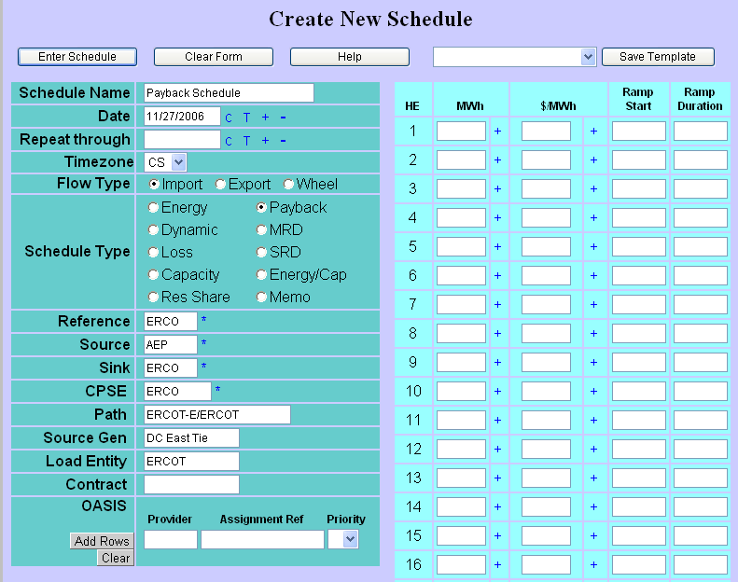
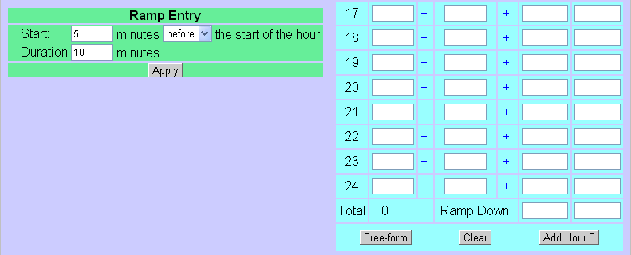
NOTE: The order of steps in this Appendix is a recommendation. The system operator will determine the sequence of steps.

- For Schedule Name enter “PAYBACK SCHEDULE”.
- Ensure date is correct. If not, enter the correct date that the payback schedule will flow.
- Ensure Timezone (CS or CD) is correct.
- For Flow Type, check Import or Export depending on the direction of flow for payback schedule.
- For Schedule Type, check Payback.
- Reference is ERCO.
- Source is AEP if payback is an import.
Source is ERCO if payback is an export.
- Sink is ERCO if payback is an import.
Sink is AEP if payback is an export.
- CPSE is ERCO
- Path is ERCOT-E/ERCOT for payback across the East DC Tie.
Path is ERCOT-N/ERCOT for payback across the North DC Tie.
- Source Gen is East DC Tie for import payback across the East DC Tie.
Source Gen is North DC Tie for import payback across the North DC tie.
Source Gen is ERCO for export payback.
- Load Entity is ERCO for import payback
Load Entity is DC East Tie for export payback across the East DC Tie
Load Entity is DC North Tie for export payback across the North DC Tie.
- Enter the MW amount under MWh column corresponding to the correct HE that
the payback schedule will flow.
- Enter and confirm the schedule.

2.7.4 Adjustment of DC Ties
Step # | Procedural Steps
1 | When an adjustment alarm is received in WebTrans,  - Determine if the tag passed or failed validation.  - If the tag adjustment passes validation and the auto-approval function is enabled, the WebTrans system will approve the tag. When all tag-approval authorities have approved the tag adjustment, it will go into an “Implemented” state. No further action is required.  - If the tag fails validation and the validation criteria display has been enabled, the WebTrans system will deny the tag. If the QSE does not make corrections to the tag adjustment by the end of the approval timeline, the tag will go “Dead”. No further action is required.  - If corrections are made to the tag that has been denied, it will be re-validated in the WebTrans system. Step 1 will be repeated.  WebTrans Reference Displays:  Tag Validation Summary  Tag Validation Criteria  Tag Auto-Approval Set-up
NOTE: | If the schedule in WebTrans does not match the Adjusted NERC Tag, and the adjustment is NOT relieving an overload, the Tag may be denied.  WebTrans Reference Display:  QSE Summary
NOTE: | If the auto-approval and/or the auto denial functions are disabled in the WebTrans system, the tag-adjustment will need to be manually approved or denied. This manual tag-adjustment approval or denial should be in reference, but is not limited to, the validation that was performed by the WebTrans system in step 1.  WebTrans Reference Displays:  Tag Approval Summary  Tag Approval Monitor

2.7.5 Curtailment of DC Ties
Step # | Procedural Steps
NOTE: | Curtailments are customarily scheduled for one hour at a time. Therefore a curtailment that occurs several hours in a row may require that this procedure be repeated hourly.
NOTE: | The WebTrans system should be set to auto-approve all curtailments that are not initiated by ERCOT. If the auto-approval has been disabled, the tag curtailment will need to manually approved as described in step 1 below.
1 | When a curtailment alarm is received in WebTrans,  - Ensure that the tag curtailment has passed validation.  - Approve the tag curtailment.  Webtrans Reference Displays:  Tag Validation Summary  Tag Approval Monitor

A copy of the procedure is available at http://www.ercot.com/mktrules/guides/procedures/index.html.

