ERCOT Operations Bulletin 269
CN# 352 – Instructions on “SCALING” of the MTLF
Effective Date: May 30, 2006

Expiration Date: August 30, 2006
Updated: July 11, 2006

Day Ahead Desk

Procedure

The procedure is detailed in the attached pages.

Discussion

The standard deviation of error will be provided by Operations Engineering. Write in the value in the table below when it is received.

The following list of instructions will help the Day Ahead Operator in accounting for the standard deviation in day ahead MTLF for RPRS study purposes.

The functionality we will be using to increase the forecast by one standard deviation is the “SCALING” function in MTLF.

Standard deviation of error | Date Received | Received from | Operator initials

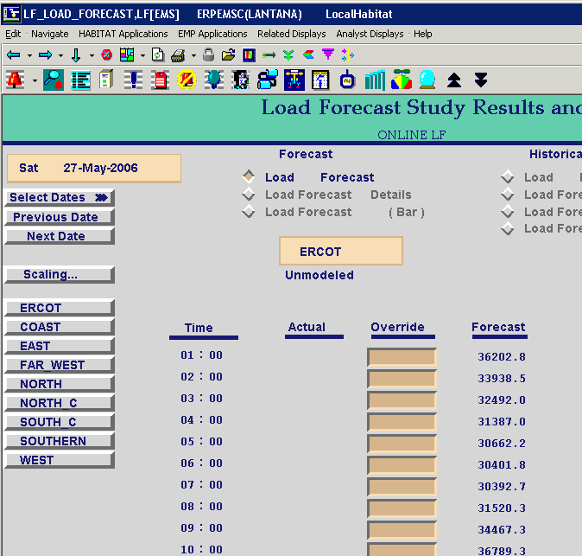
Click here.

Clicking on the “SCALING” button will cause a pop up window to appear. The pop up window will enable different ways in which to scale the load for a particular load area.
Enter the appropriate forecast area and start and end times.

NOTE: The start and end times are off by 1 hour. So if you enter 27-may-2006 09:00. The load will start scaling from 27- May -2006 10:00

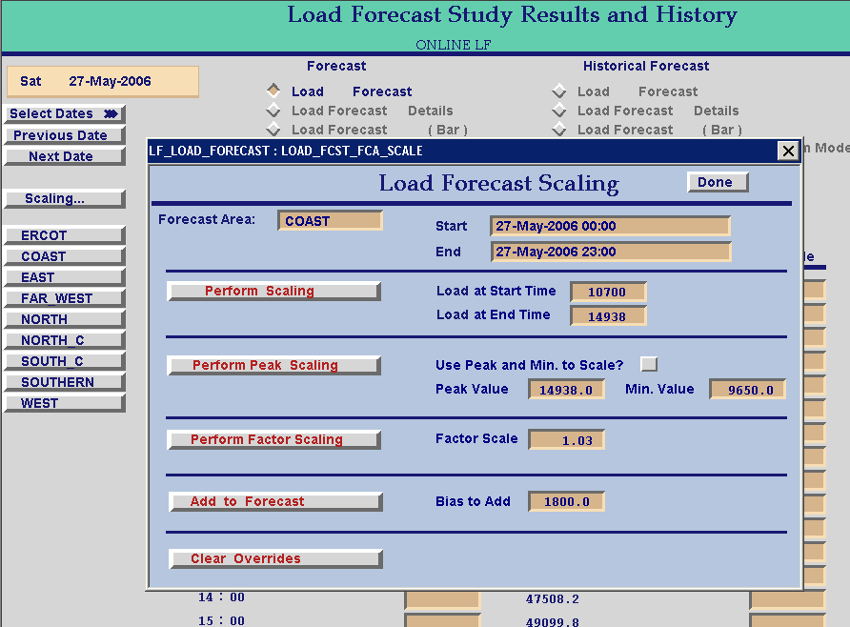
Enter Forecast Load Area that needs to be scaled.
Boxes to enter start and end times. Remember the times are 1 hour off.

To reduce the time and effort of the operator, one should use “Perform Factor Scaling” feature. To enable the use of this feature, we need to calculate the factor by which to increase the forecast.

Factor = [1800/original ERCOT peak MW]+1

Calculate the factor up to 3 significant decimal places.

It is adequate to perform the scaling for peak hours of the day i.e. between 10:00 and 22:00. That implies that the hours to be entered in the scaling display are 9:00 and 21:00.
Enter the factor calculated in the box called “Factor Scale”. Enter appropriate forecast areas and Start and End times. Once done, click the “PERFORM FACTOR SCALING” button. Repeat this procedure for all the eight load areas.
NOTE: The value to enter in the “Factor Scale” box remains same for all load areas and needs to be calculated only one using the ERCOT Peak MW.
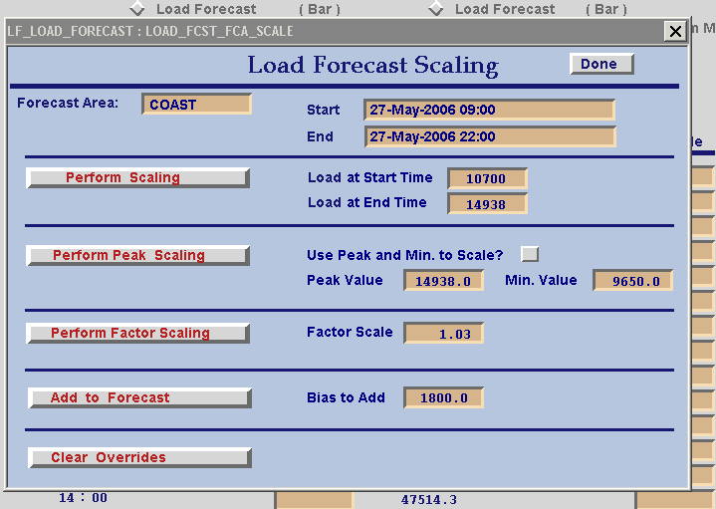
Enter value here.
Enter value here.
Enter value here.
Click here.

After all the eight load areas are overridden with the factored value, go to the “Load Forecast Master” display from related displays and click on “Run Refined Forecast” to notice the changes made.

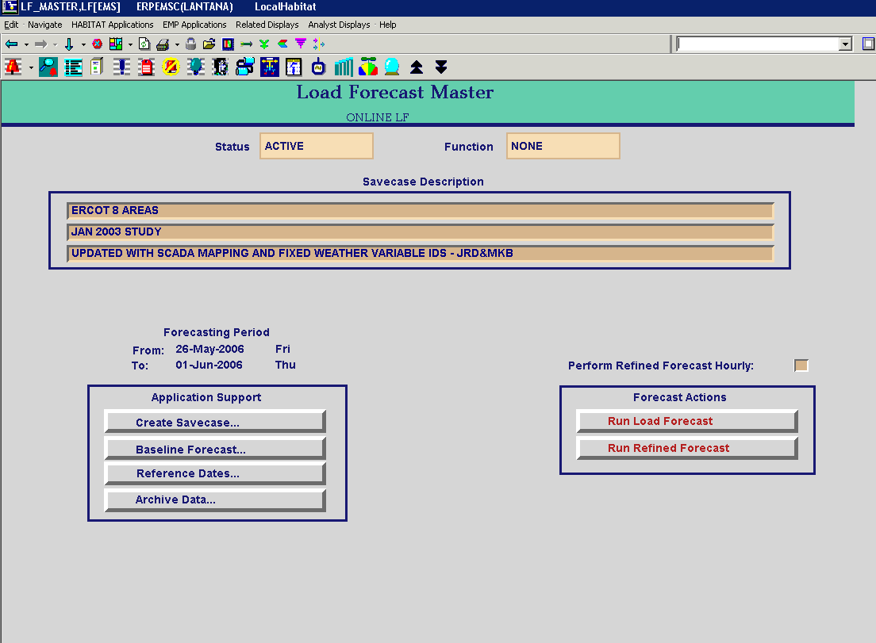
Click here.

Please do this task everyday around 2:00 PM before RPRS runs. After midnight when the new day sets in, it is advisable to clear the overrides for all the load areas and let the forecast update itself.

