ERCOT Operations Bulletin 251

ERCOT has revised the Transmission & Security Desk section of the Operating Procedure Manual.

Changes include updating Appendix 2 pp. 64-65.

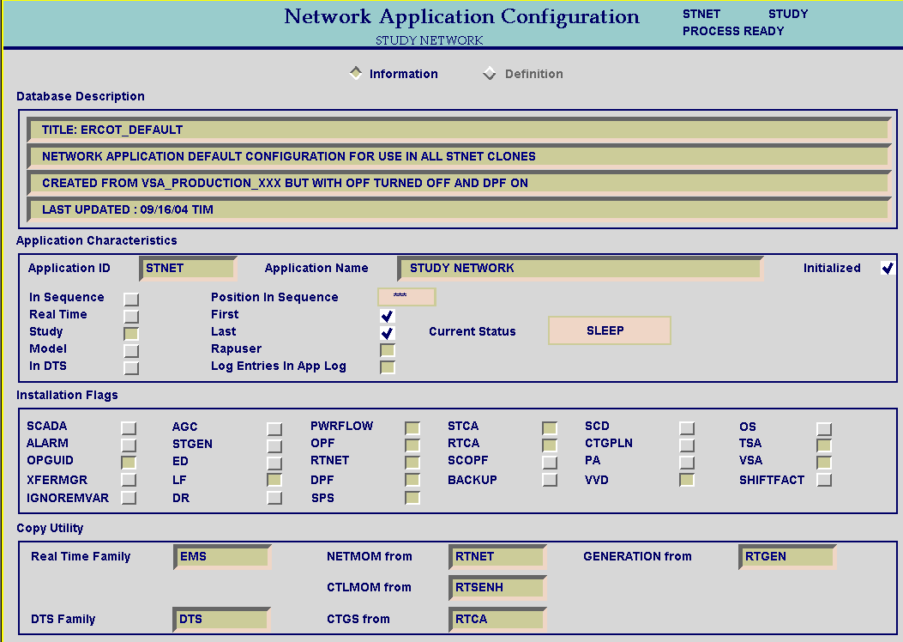

If the button is not pushed in, push it in, and then STOP and re-START STNET, and run the process. If the SPS button does not show up, STOP STNET, and go to the Case Type NETAPP. Retrieve the case ERCOT_DEFAULT. Start STNET, and go back to “Network Application Configuration” and push in the button next to the word SPS. Re-Start STNET and run the process. If it appears that SPSs are still not being processed in STNET, contact the EMMS Production Support Engineer On-Call, and have them fix the application.

At times it is necessary to change ERCOT load in a snapshot study. An example of the need for such a study is to adjust ERCOT load a few thousand MW to determine appropriate timing for releasing or committing generation for a specific outage requirement.

WARNING: Using this option requires extra care in analyzing the results of the study because the following effects of using this method must be taken into account by the operator:

- Private Network Loads will be zeroed out, forcing private network generation to exit the private networks and flow into the rest of the ERCOT system so overloads can appear near private networks that you will not see in RTCA due to this effect.
- All unit voltage set points will be reset to their default values (as in the XXX Basecase) instead of the current RTNET estimated voltage levels. You may see overloads near large generating units that you will not see in RTCA due to this effect.

To change the ERCOT load in a snapshot, the following method can be used after the normal steps have been taken to prepare a standard snapshot study:

- From the main STNET display, select “OPTIONS” and push the “UPDATE TIME DEPENDENT DATA” button shown below.



- Now you will be able to change the ERCOT load on the normal STNET load summary displays.
- Once the study requiring the load change is completed, unselect the “UPDATE TIME
DEPENDENT DATA” button shown above and perform normal snapshot studies once again.

A copy of the procedure is available at http://www.ercot.com/services/comm/mkt_notices/pobs/index.html.

