ERCOT Operations Bulletin 234

ERCOT has revised the Transmission & Security Desk section of the Operating Procedure Manual.

Changes include updating section 2.5.8, revising scripts in step 1, adding SCADA condition in step 3, revised steps 4 and 5 by combining them, and adding a new step 7.

2.5.8 Emergency Site Failover Operating Procedure
Step # | Procedural Steps
NOTE: | If communication with the primary control center is lost during normal business hours and support is unavailable from the primary control center, personnel at the backup site will serve as support.  If communication with the primary control center is lost during non business hours, on-call personnel should be notified.
NOTE: | The following indicates a loss of communication from the active site:  When the EMS (WebFG) fails, this message immediately appears:  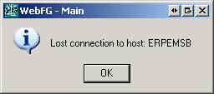  When the MOI fails, an hour glass and (Not Responding) will appear on the top edge of the window:  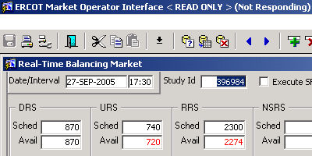  If the EMS and MOI fail at the same time, it is an indicator a catastrophic failure at the active site.  Loss of the primary control center may occur with the EMMS running from the backup site. When this occurs, the loss will not be apparent until such things as an offset number, lack of frequency control, congestion management, or telecommunication reveal the situation.
1 | IF the primary control center becomes inoperative, place a hotline call to the TOs advising them of ERCOT’s control center status.  Typical Script: “This is <state your name> at the ERCOT Transmission and Security Desk in Austin. ERCOT is in the process of transferring system operation from the primary control center to the backup control center due to <define situation>. Further information will be forthcoming as necessary. Until further notice, all phone calls to ERCOT should be directed to (512) 225-7130. Are there any questions?”
2 | If RTCA is inoperative and Operations Engineering Support is available, REQUEST them to provide local limits ASAP.
3 | If Operations Engineering Support is unavailable, OR if the required limits cannot be provided in a timely manner, OR if SCADA is unavailable go to Step 4. Otherwise, go to step 5.
4 | Issue a hotline call using the following guidelines to control power flows:  - Thermal limits @ 85% of the static rating  - Zonal transfers and West_North Stability limits @ 85%  - ISSUE fleet or unit specific dispatch instructions as necessary to control these limits.  Typical Script: “This is the ERCOT Transmission Security Operator. SCADA is currently unreliable; until further notice, inform ERCOT when thermal limits reach 85% of the static rating. Zonal transfers and the West_North stability limits are to be reported when power flows reach 85% of their respective limits. All calls should still be directed to (512) 225-7130. Are there any questions.”
5 | Ensure the following are notified:  - IT support  - The Chief System Operator  - Engineering Support  - ERCOT Security  - TCC1 - Ext. 7000  - TCC2 - Ext. 6400  - ACC - Ext. 3000  - SPP ISO  - NERC  Typical Script: “This is <state your name> at the Transmission and Security Desk in Austin. ERCOT is in the process of transferring system operation from the primary control center to the backup control center due to <define situation>. Further information will be forthcoming as necessary. Until further notice, all phone calls to ERCOT should be directed to (512) 225-7130. Are there any questions?”
6 | Once the Shift Supervisor arrives at the backup site, he/she will coordinate the restoration of the EMMS.
7 | Once the EMMS has been restored, make a hot line call to notify the TOs:  Typical script: “This is <state your name> at the Transmission and Security Desk in Austin. The ERCOT computer systems are now operational. All calls should still be directed to (512) 225-7130. Are there any questions.”

A copy of the procedure is available at http://www.ercot.com/mktrules/guides/procedures/index.html.

