ERCOT Operations Bulletin 224

ERCOT has revised the Transmission & Security Desk section of the Operating Procedure Manual.

- Changes include adding new Note after step 6 in section 2.1.2.

RTCA Congestion Management
Step # | Procedural Steps
6 | IF the SCADA is of similar magnitude to the pre-contingency value and no SPS, RAP, PCAP, TOAP, or MP exist, go to step 8.
NOTE: | When making any changes to the SCADA database, document the changes using the SCADA tagging function. Refer to Addendum 1 for guidance.

- Adding a Note to Appendix 3

Appendix 3: Conduct Future Security Analysis

The following steps are recommended for performing a Contingency Analysis.

NOTE: When making any changes to the SCADA database, document the changes using the SCADA tagging function. Refer to Addendum 1 for guidance.

- Adding a new Addendum

3.10 Addendum 1: SCADA Tagging Maintenance, Creating SCADA Tags

SCADA Tagging Maintenance

Creating SCADA Tags

Any time a manual entry is made into the SCADA database, either a status change or an analog change, a SCADA Tag must be entered into the system as record of that manual override. The SCADA Tag provides all users an explanation of why a measurement has been overridden in the database. The process for creating a SCADA Tag is as follows:

Status points

- Click on the device on the SCADA oneline to bring up the SCADA_SWITCH_POPUP message box.
- Click on the button labeled Tag…

The picture below shows the pop-up for disconnect 6974 at PUTN station.
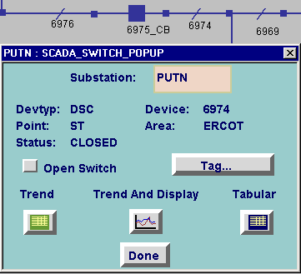

- After clicking on the Tag… button, another message box will appear, TG_POINT_POPUP. Click on the INFO button.
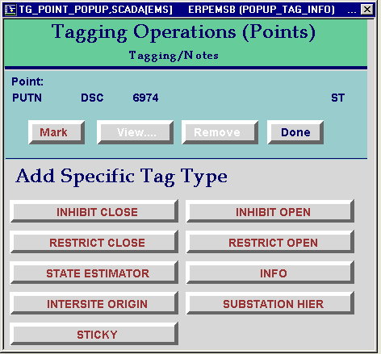

- Another message box will appear. This is the SCADA Tag itself. Fill out the SCADA Tag accordingly:
  - Order # = Operator’s EMS Clone Name (TRANSMSN, SUPV, etc)
  - Created By = Operator’s first initial, last name (CTHOMPSON, JGAYTAN, etc)
  - Created For = may be left blank
  - Comments = add all necessary comments related to why the manual change has been made
- When finished, click on the Process List button.
- If at any time, you wish to cancel the action, click on the Cancel Tag Creation button. Closing the window will still leave the SCADA Tag marked.

Below is an example of a completed SCADA Tag. Note that this is a STATE ESTIMATOR Tag, which is orange. INFO tags are white.
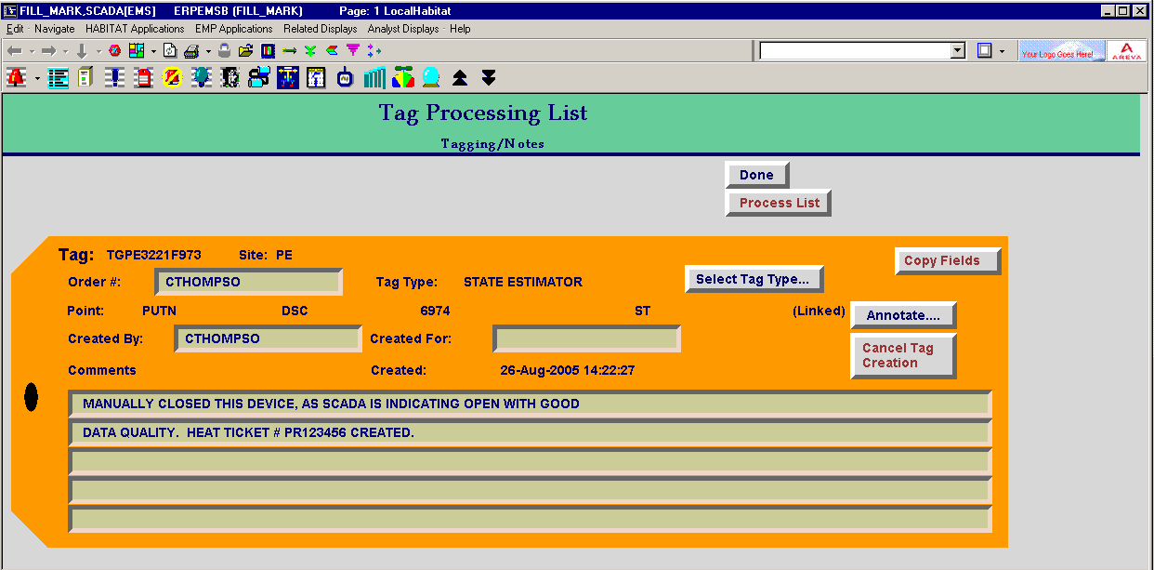

Analog Points

- From the Substation Tabular display, scroll to the measurement in question, and click on the button to the right of that analog measurement that looks like a baggage tag:

- After clicking on the Tag button, another message box will appear, TG_ANALOG_POPUP. Click on the INFO button.
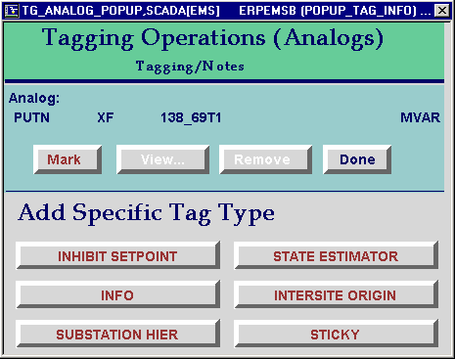

- Another message box will appear. This is the SCADA Tag itself. Fill out the SCADA Tag accordingly:
  - Order # = Operator’s EMS Clone Name (TRANSMSN, SUPV, etc)
  - Created By = Operator’s first initial, last name (CTHOMPSON, JGAYTAN, etc)
  - Created For = may be left blank
  - Comments = add all necessary comments related to why the manual change has been made
- When finished, click on the Process List button.
- If at any time, you wish to cancel the action, click on the Cancel Tag Creation button. Closing the window will still leave the SCADA Tag marked.

Editing an Existing SCADA Tag

- From the SCADA Tabular display, click on the Tag symbol (looks like a baggage tag). On the pop-up menu, click on the View… button. See below.

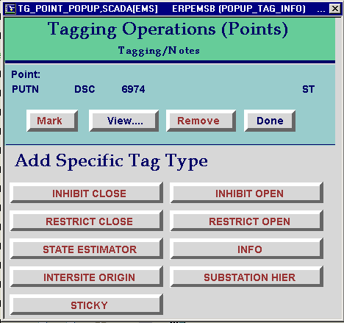

- This will bring up the TG_POINT_LIST window, shown below. To edit the SCADA Tag, click on the button under the “Details” column.
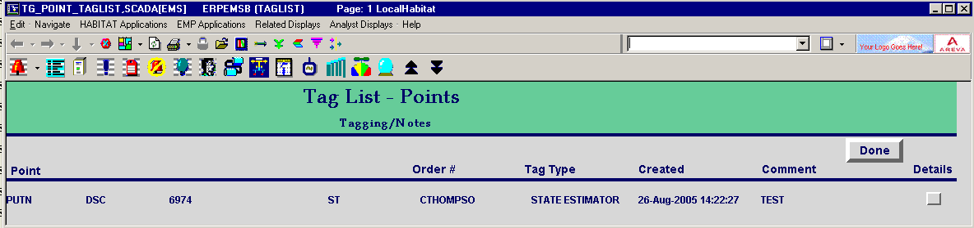

- An adjusted version of the SCADA Tag will show up. Make changes to the SCADA Tag as necessary, making sure to fill out the following fields:

- Modified By = Operator’s EMS Clone Name (TRANSMSN, SUPV, etc)
- Modified for = may be left blank
- Comments = add all necessary comments related to why the manual change has been made

- When finished, click on the Done button.

The completed, updated, SCADA Tag should look as follows:
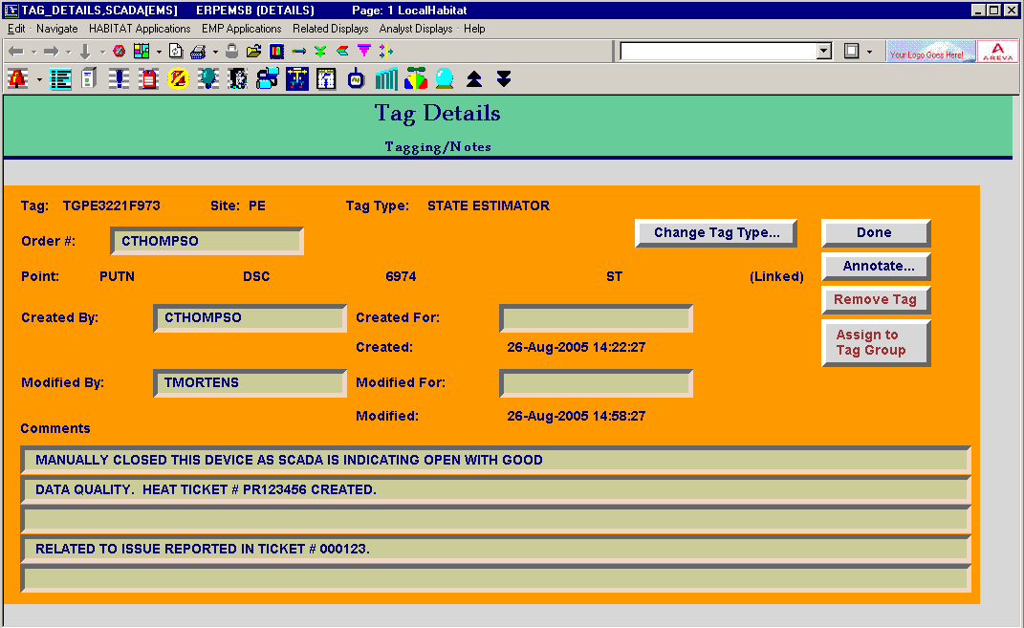

Removing an existing SCADA Tag

- From the SCADA Tabular display, click on the Tag symbol (looks like a baggage tag). On the pop-up menu, click on the Remove button. See below.

- This will bring up the TG_POINT_LIST window, shown below. To edit the SCADA Tag, click on the button under the “Details” column.

- An adjusted version of the SCADA Tag will show up. (see below) Make changes to the SCADA Tag as necessary, making sure to fill out the following fields:

- Removed By = Operator’s EMS Clone Name (TRANSMSN, SUPV, etc)
- Removed for = may be left blank
- Comments = add all necessary comments related to why the SCADA Tag is to be removed.

- When finished, click on the Process List button. DO NOT click on the Remove button.

A copy of the procedure is available at http://www.ercot.com/AboutERCOT/PublicDisclosure/ERCOTProcedures.htm.

The SCADA Tag to be removed should look as follows:
