XXX. Emergency Site Failover Operating Procedure (Transmission)

ERCOT Operations Bulletin 222

ERCOT has revised the Transmission & Security Desk section of the Operating Procedure Manual.

Changes include removing step prior to Step 1 in section 2.4.1.

Step # | Procedural Steps
NOTE: | The Frequency Operator at the backup control center will ensure the proper personnel are notified should the primary control center become inoperative.
NOTE: | The following indicates a loss of communication from the active site:  When the EMS (WebFG) fails, this message immediately appears:  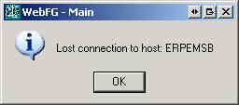  When the MOI fails, an hour glass and (Not Responding) will appear on the top edge of the window:  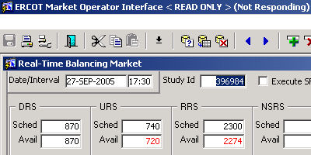  If the EMS and MOI fail at the same time, it is an indicator a catastrophic failure at the active site.  Loss of the primary control center may occur with the EMMS running from the backup site. When this occurs, the loss will not be apparent until such things as an offset number, lack of frequency control, congestion management, or telecommunication reveal the situation.
1 | IF the primary control center becomes inoperative, place a hotline call to the TOs advising them of ERCOT’s control center status.  Typical Script: “This is the ERCOT system operator. ERCOT is in the process of transferring system operation from the primary control center to the backup control center due to <define the situation>. Further information will be forthcoming as necessary.”
2 | If RTCA is inoperative and Ops Engineering Support is available, REQUEST them to provide local limits ASAP.
3 | If Ops Engineering Support is unavailable or if the required limits cannot be provided timely manner, proceed.
4 | Make a hotline call and request that TOs provide feedback on system status if thermal limits reach 85% of their static rating.  Typical Script: “This is the ERCOT Transmission Security Operator. SCADA is currently unreliable; until further notice, inform ERCOT when thermal limits reach 85% of the static rating.”
5 | ENSURE Zonal transfers and the West-North Stability values remain within the required limits.  - ISSUE fleet or unit specific dispatch instructions as necessary to control these limits.
6 | If the MOI is unavailable, ISSUE fleet or unit specific dispatch instructions as necessary to manage congestion.
7 | Once the Shift Supervisor arrives at the backup site, he/she will coordinate the restoration of any MOS & POS systems that have been lost.

A copy of the procedure is available at http://www.ercot.com/AboutERCOT/PublicDisclosure/ERCOTProcedures.htm.

