ERCOT Operations Bulletin 219

ERCOT has revised the Frequency Control Desk section of the Operating Procedure Manual.

Changes include updating section 2.6.8 “Emergency Site Failover:”
- Updated first Note
- Added new third Note prior to Step 1
- Added Note prior to Step 5

A copy of the procedure is available at http://www.ercot.com/AboutERCOT/PublicDisclosure/ERCOTProcedures.htm.

XXX. Emergency Site Failover (Frequency Control Desk)
Step # | Procedural Steps
NOTE: | This procedure addresses the catastrophic loss of the primary control center. In the absence of the Shift Supervisor, the Frequency Operator located at the backup control center shall enact this procedure.
NOTE: | If the primary control center is lost during normal business hours and support is unavailable from the primary control center, personnel at the backup site will serve as support.  If the primary control center is lost during non business hours, on-call personnel should be notified.
NOTE: | The following indicates a loss of communication from the active site:  When the EMS (WebFG) fails, this message immediately appears:  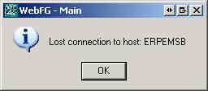  When the MOI fails, an hour glass and (Not Responding) will appear on the top edge of the window:  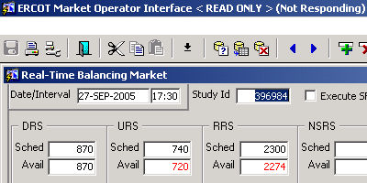  If the EMS and MOI fail at the same time, it is an indicator a catastrophic failure at the active site.  Loss of the primary control center may occur with the EMMS running from the backup site. When this takes place, the loss will not be apparent until such things as no offset number, lack of frequency control and/or congestion management or loss of telecommunication reveal the situation.
1 | If the primary control center becomes inoperative, determine if the EMMS infrastructure is running.  - A & B indicate the EMMS is running from Taylor  - C & D indicate the EMMS is running from Austin
2 | Communicate the EMMS status to EMMS Production Support.
3 | If you are unable to contact EMMS Production Support, contact Development.
4 | IF frequency control is lost, initiate FCD Procedure 2.5.1 step 2 and go on Constant Frequency Control.
5 | - Ensure the backup control center is staffed with the following personnel:  - 1 Shift Supervisor  - 2 Frequency Control  - 2 Transmission Security  - 1 Operating Period  - 1 Day Ahead  ** A callout list for system operators is maintained in a separate tab in the Operating Procedure Manual.  - Notify:  - IT support  - The Chief System Operator  - Engineering Support  - ERCOT Security  - SPP ISO  ** Callout and notification duties may be delegated as necessary to facilitate the execution of this procedure.  - Place a hotline call to the QSEs advising them of ERCOT’s control center status.  Typical Script: “This is the ERCOT system operator. ERCOT is in the process of transferring system operation from the primary control center to the backup control center due to <define the situation>. Further information will be forthcoming as necessary.”
6 | Once the Shift Supervisor arrives at the backup site, he/she will coordinate the restoration of any MOS & POS systems that have been lost.

