ERCOT Operations Bulletin 211

ERCOT has revised the Transmission & Security Desk section of the Operating Procedure Manual.

V2R55 Updated Appendix 2 “Contingency Analysis”

Appendix 2: Contingency Analysis Using a Powerflow Base Case – Typical

The following steps are recommended for performing a contingency analysis:

Basic process for using a RTNET (SE) solved case in STNET and STCA
- In STNET, select Stop Process
- Go to Data Retrieval, select “Savecase Directory”
- Go to Case Type DPFOPTS, retrieve the file SOLVE_RTNET_SNAPSHOT
- Go to Case Type PFOPTS, retrieve the file SOLVE_RTNET_SNAPSHOT
- Go to Case Type CTGS, retrieve the latest CTG_PRODUCTION_MMDDYY_XXX.
- Go to Case Type SPSMOM, retrieve the latest SPS_PRODUCTION_MMDDYY_XXX.
- The above steps do not need to be repeated as long as no other studies are loaded into this clone. You can do the following set of steps again and again throughout the day
- Go to Data Retrieval again, select Network Copy
- In STNET, start the process.
- In Copy Options, verify that the “Copy Clone of Database” field is set to NETMOM, “from Application” field is set to RTNET, and “of Family” field is set to EMS (these fields will only have to be entered once). If not, change the fields accordingly.
- Select COPY (This copies the SE Network Model directly into STNET)
- In STNET, select Stop Process
- Under EMS Applications, go to MODEL/DATA TRANSFER (MDXFER) and copy the GenPlan from “SE Solution” to “STNET Study” with a threshold of 3MW. Also, make sure that the button next to “Remove Units that are not in the Source” is pushed in (tan colored).
- In STNET, start the process and solve the power flow

If the solution is valid check and clear any Base overloads then run STCA.

If the powers flow solution is not Valid (Max Iteration or Diverge), go to Powerflow Solution Iteration and determine units that are not converging in the MVAR column on the right side of the display. Go to that unit and turn off unit AVR and run a power flow again.

If the solution is still not valid, use the last valid saved case. Describe the problem to the Operations Planning On-Call Engineer via email along with a saved STNET type case.

If the STCA solution results indicate that the SPS code has not executed in CA, verify that STNET is set up to process SPSs. To verify that STNET is set up to process SPSs, under Analyst Displays, go to “Network Application Configuration.” The button to the right of the word “SPS” should be pressed in (tan-colored) as indicated in the picture below:
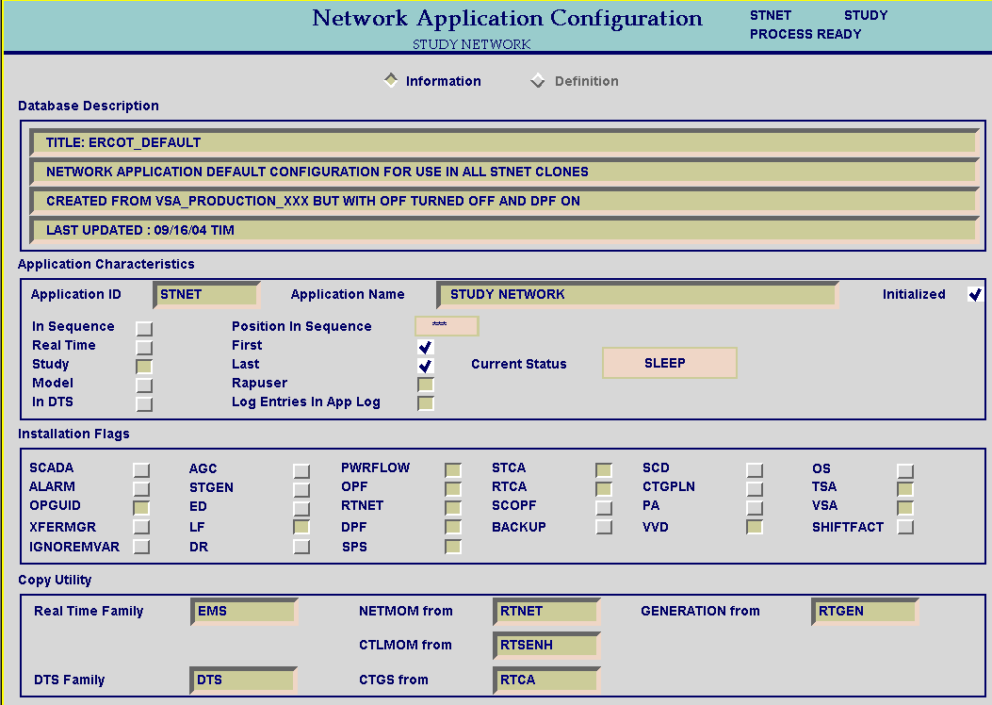

If the button is not pushed in, push it in, and then STOP and re-START STNET, and run the process. If the SPS button does not show up, STOP STNET, and go to the Case Type NETAPP. Retrieve the case ERCOT_DEFAULT. Start STNET, and go back to “Network Application Configuration” and push in the button next to the word SPS. Re-Start STNET and run the process. If it appears that SPSs are still not being processed in STNET, contact the EMMS Production Support Engineer On-Call, and have them fix the application.
V2R56 Added new section 2.5.8 “Emergency Site Failover.”

2.5.8 Emergency Site Failover Operating Procedure
Step # | Procedural Steps
NOTE: | The Frequency Operator at the backup control center will ensure the proper personnel are notified should the primary control center become inoperative.
1 | IF the primary control center becomes inoperative, place a hotline call to the TOs advising them of ERCOT’s control center status.  Typical Script: “This is the ERCOT system operator. ERCOT is in the process of transferring system operation from the primary control center to the backup control center due to <define the situation>. Further information with be forthcoming as necessary.”
2 | If RTCA is inoperative and Ops Engineering Support is available, REQUEST them to provide local limits ASAP.
3 | If Operations Engineering Support is unavailable or if the required limits cannot be provided timely manner, proceed.
4 | Make a hotline call and request that TOs provide feedback on system status if thermal limits reach 85% of their static rating.  Typical Script: “This is the ERCOT Transmission Security Operator. SCADA is currently unreliable; until further notice, inform ERCOT when thermal limits reach 85% of the static rating.”
5 | ENSURE Zonal transfers and the West-North Stability values remain within the required limits.  - ISSUE fleet or unit specific dispatch instructions as necessary to control these limits.
6 | If the MOI is unavailable, ISSUE fleet or unit specific dispatch instructions as necessary to manage congestion.
7 | Once the Shift Supervisor arrives at the backup site, he/she will coordinate the restoration of any MOS & POS systems that have been lost.

V2R57 Updated section 2.1.4 “OOME – VDI Guidelines” step 5.

OOME – VDI Guidelines
Step # | Procedural Steps
5 | When a TO informs ERCOT of an SPS activation and the SPS activation de-rates a resource or takes a resource off line, issue a VDI to the affected QSE.  - Record the generation level immediately after the duration.  - Only list the beginning of the interval, the ending interval is not necessary.  - If the resource is a DC tie, include the name and zone of the tie.  - Record the time the SPS was cleared.

V2R58 Updated section 2.5.6 “Implement EECP” step 4b.

Implement EECP
Step # | Procedural Steps
4.b | In addition to measures listed above:  - ERCOT will instruct, in 100 MW blocks, all TDSPs having control over distribution feeder breakers and/or control of breakers serving retail customer to shed load in order to maintain a steady state system frequency of 59.8 Hz. Block amounts are shown in the ERCOT Operating Guides.  Typical Script: “ERCOT is instructing all Transmission Operators to shed their share of <amount> MWs. Transmission Operators are to report to ERCOT when this task is complete and give the amount of load shed.”

V2R59 Updated section 2.6.2 “VDI Instructions”

2.6.2 Issue Verbal Dispatch Instructions (VDI)
Step # | Procedural Steps
PURPOSE: | ISSUE a VDI to QSE(s) specifying changes to generation.
NOTE: | VDIs should not re-iterate an instruction given via XML.
1 | Communicate required information to QSE(s) via telephone (using the hotline if  appropriate).
NOTE: | VDI numbers as described here are only required for VDIs documented using the  paper form. VDIs documented using the OOM tool (post EMMS Release 4) will not  have a number available to the operator.
2 | As time permits, complete the VDI form (Appendix 3).  The following are required fields on all VDIs:  - VDI #  - EXAMPLE: For the 4th VDI issued by the Frequency Control Desk on July 22, 2005 the number would appear as “F-072205-4”  - Operating Day  - ERCOT System Operator  - Receiving Entity  - Receiving Entity’s Operator  - Time & Date  - Instruction  - Reason for Instructions  - Intervals  - ERCOT Operator’s signature  Blank fields are to have N/A entered.
3 | As time permits, forward the VDI form to the Shift Supervisor.
4 | LOG in the Operator’s Log the VDI information and information relevant to the  decision for issuing the VDI.

A copy of the procedure, Transmission & Security Desk V3R58, is available at http://www.ercot.com/AboutERCOT/PublicDisclosure/ERCOTProcedures.htm.

