ERCOT Operations Bulletin 31

ERCOT has revised the Transmission & Security Desk section of the Operating Procedure Manual. The change is located in section 2.1.2 on page 8. The title of the revision is “Procedure for Control of transmission system loading within N-1 Thermal Contingency Criteria using Real Time Contingency Analysis.”

Transmission & Security Desk, Version 2 Rev. 9, is attached.

Procedure for Control of transmission system loading within N-1 Thermal Contingency Criteria using Real Time Contingency Analysis

  - Determine if Real Time Contingency Analysis has run within the last hour by referring to screen “Real-Time Network Sequence” and examining the last time RTCA ran. This screen can be reached through the ems :

EMP Applications > Real-Time Network Analysis

Confirm that the “ENABLE” buttons are engaged for ESTIMATE and CA. If not engaged, then engage them as shown.
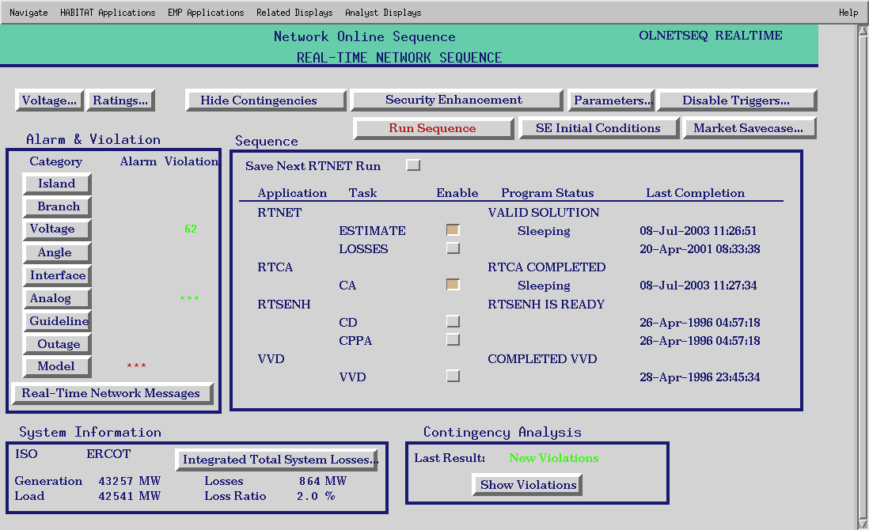
  - If the RTCA has solved within the last 2 hours as shown under “Last Completion”, and no unreasonable branch violations appear (observe branch violations by selecting “Alarm & Violation” category “Branch”); then examine 1st contingency violations by selecting “Show Violations” at the base of the display. IF RTCA has not solved within the last 2 hours call the on-call Operations Planning & Analysis Engineer and request it be corrected. (Note – If RTCA has not solved within the last 4 hours, call the Operations Engineer on call and request local limits to use in place of RTCA UNLESS a set of backup limits have been previously provided)
  - Examine the RTCA contingency violations “branch” summary as shown below, and confirm that no post contingency overloads greater then 110% of emergency rating exists. If post-contingency overloads > 110% exist, confirm that no SPS exists to alleviate the loading post contingency AND the precontingency loading listed on the violation summary is similar in magnitude to the SCADA reported loading. If post contingency overloads over 110% exist without a SPS in place to relieve, either activate a constraint to correct the loading, or instruct generation adjustments to eliminate the post contingency overloading. To identify remedial actions for a post-contingency overload, refer to the book of shift factors provided.
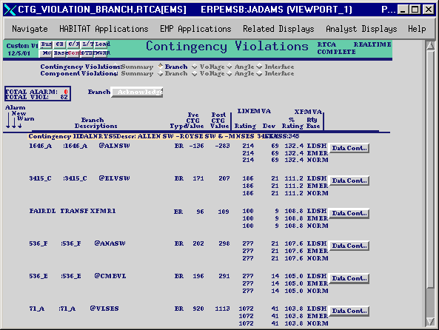

This document refers to displays using the convention: top menu name > sub menu name > sub-sub menu name. etc.
If branch overloads exist, consult SCADA and decide if the overload is real. If you determine that the overload in not real, examine if the line involved is in an insignificant location. (i.e. does not effect the Real Time Contingency Analysis results) If the branch overload error is in a significant location, call the on-call Operations Planning & Analysis Engineer to resolve.
If the SCADA loading does NOT match the pre-contingency loading reported on the RTCA Contingency Violations page, examine Scada at the opposite end of the line to determine if there is just a bad scada point. If you conclude that the RTCA solution is not valid, then do not take action. Consult the shift supervisor to decide if an engineer should be called in.
via either OOME or Verbal Dispatch Instructions

