ERCOT Operations Bulletin 164

ERCOT has revised the Transmission & Security Desk section of the Operating Procedure Manual.

Changes include updating section 2.12.

Procedure for Control of Transmission System Loading Within N-1 Thermal Contingency Criteria Using Real Time Contingency Analysis

- Determine if Real Time Contingency Analysis has run within the twenty minutes by referring to the “RTCA Branch Overload” or “Real-Time Network Sequence” displays and examining the last time RTCA ran. This screen can be reached through WebFG by going to EMP Applications → Real-Time Network Analysis.

Confirm that the RTNET and RTCA Processes are enabled by making sure that the boxes to the right of Estimate and CA are checked. If they are not, click on the checkbox to enable them. Refer to the image below:
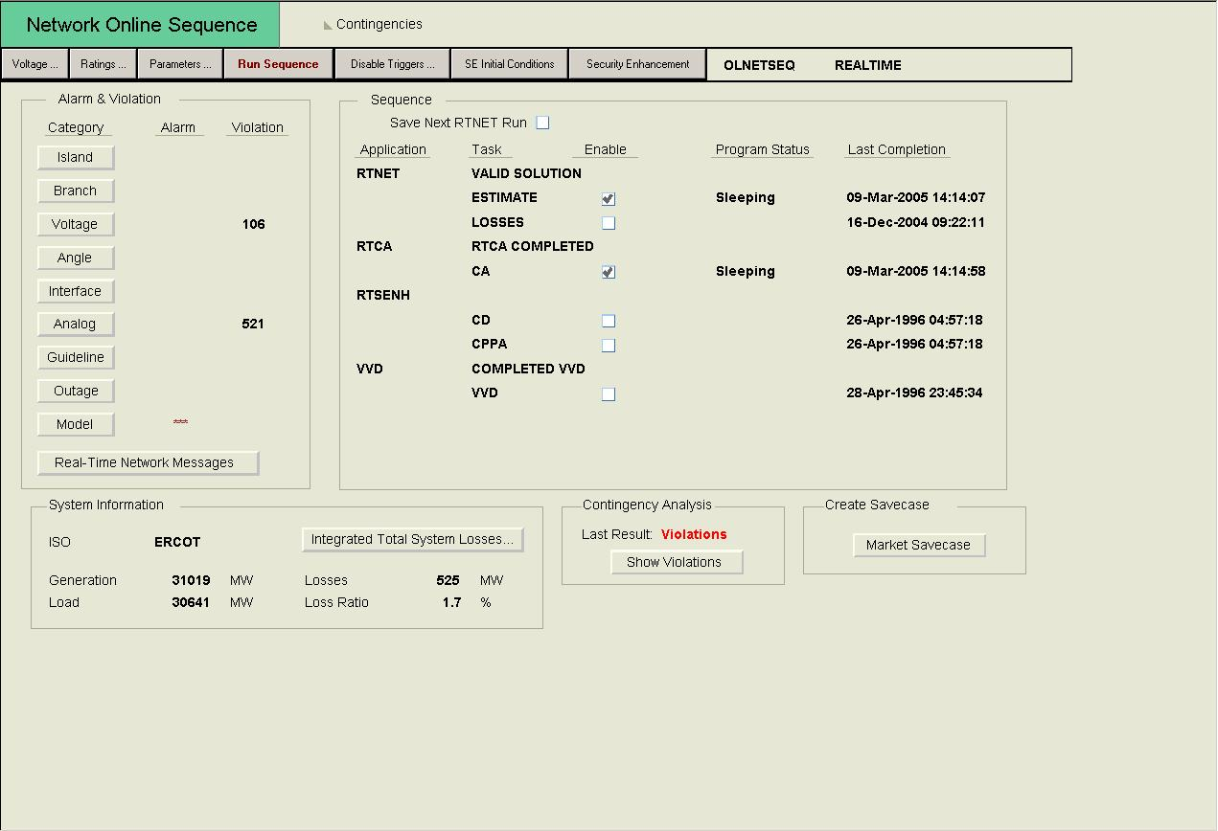
- Determine the reliability of the RTCA Solution

  - Normal Business Hour Operations

    - Refer to the time stamp in the “Last Completion” column on the right-hand side of the screen. If RTCA has solved within the last twenty minutes, examine the branch violations by clicking the Branch button in the “Alarm & Violation” section on the left-hand side of the screen. If no unreasonable violations exist, then examine the contingency violations by selecting “Show Violations” in the section under Contingency Analysis at the bottom of the screen. If RTCA has not solved within the last twenty minutes, call the on-call Operations Planning and Analysis Engineer and request this be corrected.

NOTE – If RTCA has not solved within the last four hours, call the Operations Support Engineer on-call and request local limits to use in place of RTCA UNLESS a set of backup limits have been previously provided.

  - After Hour and Weekend/Holiday Operations

    - Refer to the time stamp in the “Last Completion” column on the right-hand side of the screen. If RTCA has solved within the last twenty minutes, examine the branch violations by clicking the Branch button in the “Alarm & Violation” section on the left-hand side of the screen. If no unreasonable violations exist, then examine the contingency violations by selecting “Show Violations” in the section under Contingency Analysis at the bottom of the screen. If RTCA has not solved within the last twenty minutes, investigate why it has not solved, using the list of State Estimator Checks outlined in Appendix 9 at the back of this document. If, after trying all the Checks RTCA still has not solved, call the on-call Operations Planning and Analysis Engineer and request this be corrected.

NOTE – If RTCA has not solved within the last four hours, call the Operations Support Engineer on-call and request local limits to use in place of RTCA UNLESS a set of backup limits have been previously provided.

- Examine the RTCA contingency violations “branch” summary as shown below, and confirm that no post contingency overloads greater than 100% of the emergency rating exist. If post-contingency overloads > 100% exist, confirm that no SPS, Remedial Action Plan (RAP), Pre-Contingency Action Plan (PCAP) or Mitigation Plan (MP), exists to alleviate the loading post contingency AND the pre-contingency loading listed on the violation summary is similar in magnitude to the SCADA reported loading.

- If post contingency overloads over 100% exist without an SPS, RAP, PCAP, or MP in place to relieve, either activate a constraint to correct the loading, or instruct generation adjustments to eliminate the post contingency overloading.

- If post contingency overloads over 100% of the 15-minute rating exist with a RAP in place to relieve, either activate a constraint to correct the loading, or instruct generation adjustments to reduce the post contingency overloading to 100% of the 15-minute rating.

- Any RTCA results that predict a Facility Rating to exceed, post-contingency, 125% or greater of the facility’s Emergency Rating for more than 30 minutes is considered to be a potential IROL violation. Report such results via e-mail to the on-call Operations Support Engineer for assessment and reporting.

- At least once each hour, monitor the RTCA “Contingency Solution Results” display. This display can be reached through WebFG by going to Analyst Displays → Contingency Analysis Displays → Contingency Solution Results. Check for any unsolved (pink colored) contingencies. Report such unsolved contingencies via e-mail to the On-Call Operations Support Engineer for analysis and correction. However, if there are more than five (5) unsolved contingencies, run the State Estimator again, and watch this page. If more than five are unsolved, call the On-Call Operations Planning Engineer.

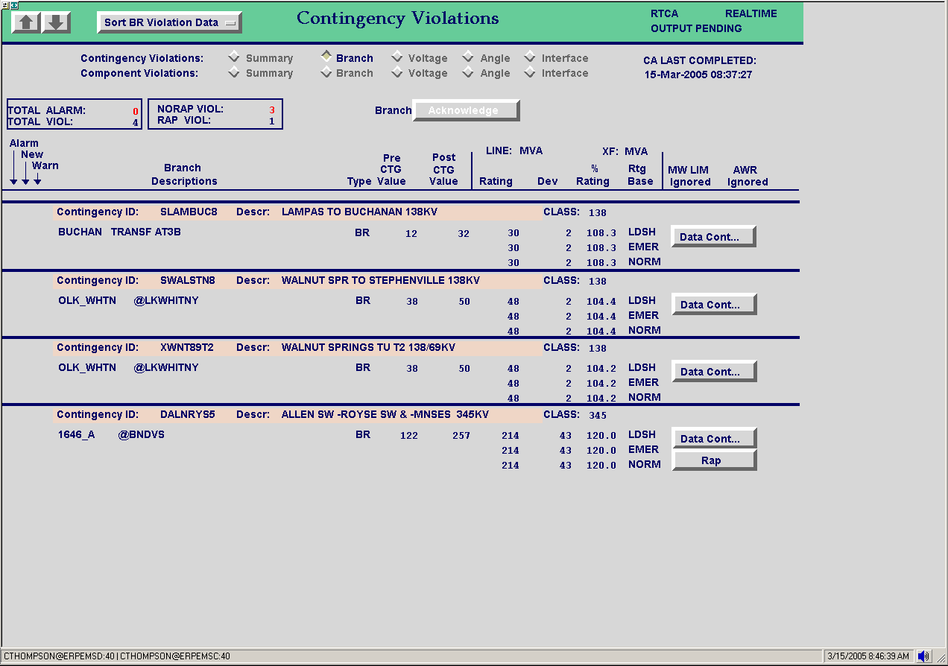
3.9 Appendix 9: State Estimator and RTCA Quick Reference

The intent of this Appendix is to provide some quick troubleshooting actions that the Operators can perform themselves to avoid unnecessary call-outs to SE Support Staff. If the State Estimator or Real-Time Contingency Analysis remain unsolved after trying these actions, a call out to the State Estimator Support Engineer is needed.

- RTNET Solved with Excess Mismatch
  - Go to Related Displays → State Estimator → State Estimator Displays → Real-Time Network Solution Analysis and click on the button labeled “Bus Mismatch.” The buses causing the excessive mismatch will show up at the top of this display. Bring up the SCADA display for the station(s) with the highest mismatches in MW and MVAR.
    - Check to see if any or all device status measurements have suspect data quality.
    - Check to see if any or all device analog measurements have suspect data quality.
    - Check to see if any line breakers are open but the lines they are connected to have non-zero values, and vice versa.
    - Check to see if any generator breakers are open but the units they are connected to have non-zero values.
  - Verify that all ICCP links are up and running.
    - To verify the ICCP links are up, go to EMP Applications → SCADA → OAG Link Status
- Invalid State Estimator Solution
  - Cold Start RTNET by clicking on SE Initial Conditions from the “Real-Time Network Sequence” page
    - Make the following setting changes
      - Push in the buttons next to COLDINIT and FLATSTART
      - Change the “Iteration Type” to Refactor
    - Push the “Run Sequence” button to run RTNET
  - The Bus Mismatch display does not update when an invalid solution is reached, so that display will not be useful in this case.
- “Ready” Status
  - On the main “Network Oneline Sequence” display, if RTNET or RTCA or both show the “Program Status” as “RTNET Ready” or “RTCA Ready,” push the “Run Sequence” button. If this does not resolve the condition, RTNET and/or RTCA is crashing. Call the On-Call EMMS Production Support Engineer.

A copy of the updated procedure, Transmission & Security Desk V3R38, is available at http://www.ercot.com/AboutERCOT/PublicDisclosure/ERCOTProcedures.htm.

