
September 2026 ERCOT Monthly Operations Report
Reliability and Operations Subcommittee Meeting
November 5, 2026

Table of Contents
1. Report Highlights 2
2. Frequency Control 3
2.1. Frequency Events 3
2.2. Automatic/Manual Load Resource Deployments 4
3. Reliability Unit Commitment 5
4. IRR, Wind, and Solar Generation as a Percent of Load 7
5. Energy Storage Resource (ESR) Output and State of Charge (SOC) Profile 9
6. Largest Net-Load Ramps 10
7. Congestion Analysis 11
7.1. Notable Constraints 11
7.2. Generic Transmission Constraint Congestion 26
7.3. Manual Overrides 26
7.4. Congestion Costs for Calendar Year 2026 26
8. System Events 28
8.1. ERCOT Peak Load 28
8.2. Load Shed Events 28
8.3. Stability Events 28
8.4. Notable PMU Events 28
8.5. DC Tie Curtailment 28
8.6. TRE/DOE Reportable Events 28
8.7. New/Updated Constraint Management Plans 28
8.8. New/Modified/Removed RAS 28
8.9. New Procedures/Forms/Operating Bulletins 28
9. Emergency Conditions 29
9.1. OCNs 29
9.2. Advisories 29
9.3. Watches 29
9.4. Emergency Notices 29
10. Application Performance 29
10.1. TSAT/VSAT Performance Issues 29
10.2. Communication Issues 29
10.3. Market System Issues 29
11. Model Updates 29
Appendix A: Real-Time Constraints 32

Report Highlights
The unofficial ERCOT peak load for September 2026 was 86,647 MW and occurred on 9/12/2026 during hour ending 17:00, this is 6,698 MW higher than the September 2025 peak demand of 79,949 MW on 9/4/2025.
On 15-minute settlement interval basis, maximum demand of 86,782 MW occurred on 9/12/2026 during interval ending 16:45 and minimum demand of 51,330 MW occurred on 9/26/2026 during interval ending 05:00.
- There were 2 frequency events.
- There were no events which required automatic/manual deployment of Load Resources that were controlled by an Under-Frequency Relays.
- There were 0 DC Tie Curtailment Notices.
- There were 0 OCNs.
- There were 3 Advisories: ERCOT postponed the deadline for posting of the DAM solution due to long run time on 9/15/2026, 9/28/2026, and 9/29/2026.
- There were 0 Watches.
- There were 0 Emergency Notices.
- There were 43 RUC commitments.
- The following GTCs saw congestion in September:
GTC | Days Congestion
East Texas | 23
Nelson Sharpe - Rio Hondo | 22
South Texas Export Pawnee - Spruce | 21
South Texas Export Pawnee - Tango | 20
North Edinburg - Lobo | 17
North - Houston | 10
Panhandle | 8
West Texas | 7
South Texas Import Katoen - Lonhill | 4
Zapata Starr | 4
South Texas Import Pawnee - Spruce | 1

Frequency Control

Frequency Events
The ERCOT Interconnection experienced 2 frequency events.
A summary of the frequency events is provided below. The reported frequency events meet one of the following criteria: Delta Frequency is 60 mHz or greater; the MW loss is 350 MW or greater; resource trip event triggered ECRS deployment. Frequency events that have been identified as Frequency Measurable Events (FME) for purposes of BAL-001-TRE-2 analysis are highlighted in blue. When analyzing frequency events, ERCOT evaluates PMU data according to industry standards. Events with an oscillating frequency of less than 1 Hz are inter-area, while higher frequencies indicate local events. Industry standards specify that damping ratio for inter-area oscillations should be 3.0% or greater. For the frequency event listed below, the ERCOT system met these standards and transitioned well after the disturbance. In the case of negative delta frequency, the MW Loss column could refer to load loss.

Date and Time | Delta Frequency | Max/  Min Frequency | Duration of Event | PMU Data |  | MW Loss | Load | IRR | Inertia
Date and Time | (Hz) | (Hz) | Duration of Event | Oscillation Mode (Hz) | Damping Ratio | MW Loss | (MW) | % | (MW-s)
9/6/2026 2:11:38 | 0.047 | 59.959 | 00:03:11 | 0.56 | 14% | 664 | 60,172 | 20% | 325,638
9/27/2026 1:27:27 | 0.018 | 59.967 | 00:03:05 | 0.6 | 11% | 477 | 56,152 | 20% | 321,061

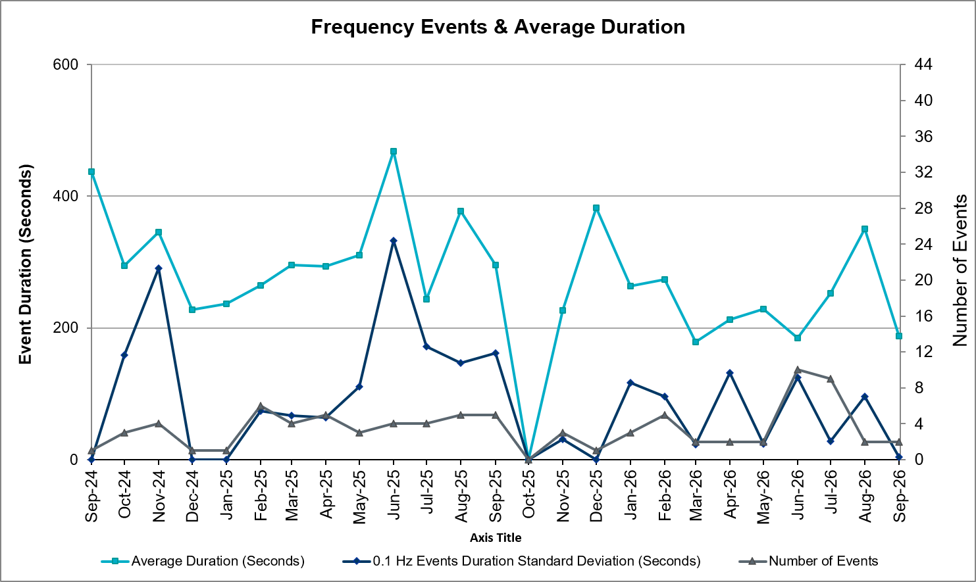
(Note: All data on this graph encompasses frequency event analysis based on BAL-001-TRE-2.)

Automatic/Manual Load Resource Deployments
There were no events which required automatic/manual deployment of Load Resources that were controlled by an Under-Frequency Relays.

Reliability Unit Commitment
ERCOT reports on Reliability Unit Commitments (RUC) monthly. Commitments are reported grouped by operating day and weather zone. The total number of hours committed is the sum of the hours for all the units in the specified region. Additional information on RUC commitments can be found on the MIS secure site at Grid Generation Reliability Unit Commitment.
There were 43 RUC commitments.
Resource Location | # of Resources | Operating Day | Total # of Hours Committed | Total MWhs | Reason for Commitment
NORTH_CENTRAL | 4 | September 1, 2026 | 43 | 6,083.5 | Capacity AS
EAST, NORTH_CENTRAL | 4 | September 2, 2026 | 26 | 2,718.8 | Capacity AS
SOUTHERN | 1 | September 6, 2026 | 8 | 1,948.9 | Capacity AS
NORTH_CENTRAL | 2 | September 7, 2026 | 16 | 1,167.2 | Capacity AS
NORTH_CENTRAL | 5 | September 8, 2026 | 67 | 12,539.3 | Capacity AS
NORTH_CENTRAL | 2 | September 9, 2026 | 12 | 366.4 | Capacity AS
NORTH_CENTRAL, SOUTH_CENTRAL | 2 | September 10, 2026 | 16 | 3,265.7 | A/S Shortage, E_PASP
NORTH_CENTRAL | 1 | September 15, 2026 | 4 | 1,739.6 | Capacity AS
NORTH_CENTRAL | 3 | September 16, 2026 | 25 | 1,710.2 | DWCSRAM5
NORTH_CENTRAL | 2 | September 17, 2026 | 12 | 407.7 | DWCSRAM5
NORTH_CENTRAL | 1 | September 18, 2026 | 8 | 358.0 | Capacity AS
NORTH, NORTH_CENTRAL, SOUTHERN | 3 | September 20, 2026 | 17 | 1,084.6 | Capacity AS, Capactity AS, DHILMAR5
NORTH_CENTRAL, SOUTHERN | 3 | September 21, 2026 | 18 | 1,387.7 | Capacity AS, DHILMAR5
NORTH_CENTRAL, SOUTHERN | 2 | September 22, 2026 | 11 | 1,049.0 | Capacity AS, DHILMAR5
EAST, NORTH_CENTRAL | 3 | September 24, 2026 | 16 | 2,413.8 | DCMBCPS8, Energy Uncertainty
NORTH_CENTRAL | 2 | September 27, 2026 | 16 | 678.5 | Capacity AS
NORTH_CENTRAL | 3 | September 28, 2026 | 24 | 1,638.0 | Capacity AS

IRR, Wind, and Solar Generation as a Percent of Load
The graph below shows the maximum, minimum and average aggregate solar, wind and IRR output as a percentage of total ERCOT load when evaluated as 10-minute averaged intervals, over the past 13 months. Current wind and solar generation and penetration records are listed in the footnote below. Maximum IRR penetration for September 2026 was 71.94% on 9/15/2026 interval ending 09:40 and minimum IRR penetration for September 2026 was 6.41% on 9/6/2026 interval ending 07:10.
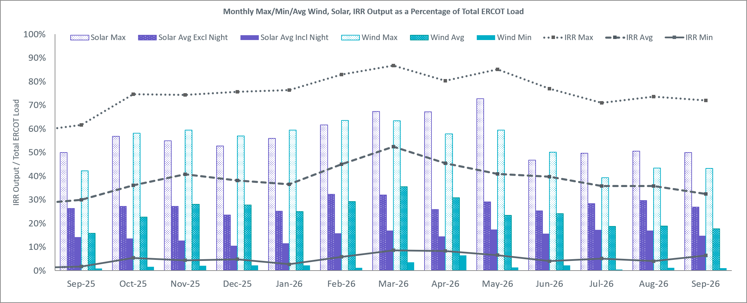
The following graph shows the maximum and average ESR charging and discharging as a percentage of total ERCOT load when evaluated as 10-minute averaged intervals, over the past 13 months. Current ESR charging and discharging records are listed in the footnote below. Maximum ESR discharge generation for September 2026 was 12,627 MW on 9/1/2026 interval ending 20:00 and maximum ESR charge load for September 2026 was 12,123 MW on 9/10/2026 interval ending 09:30.
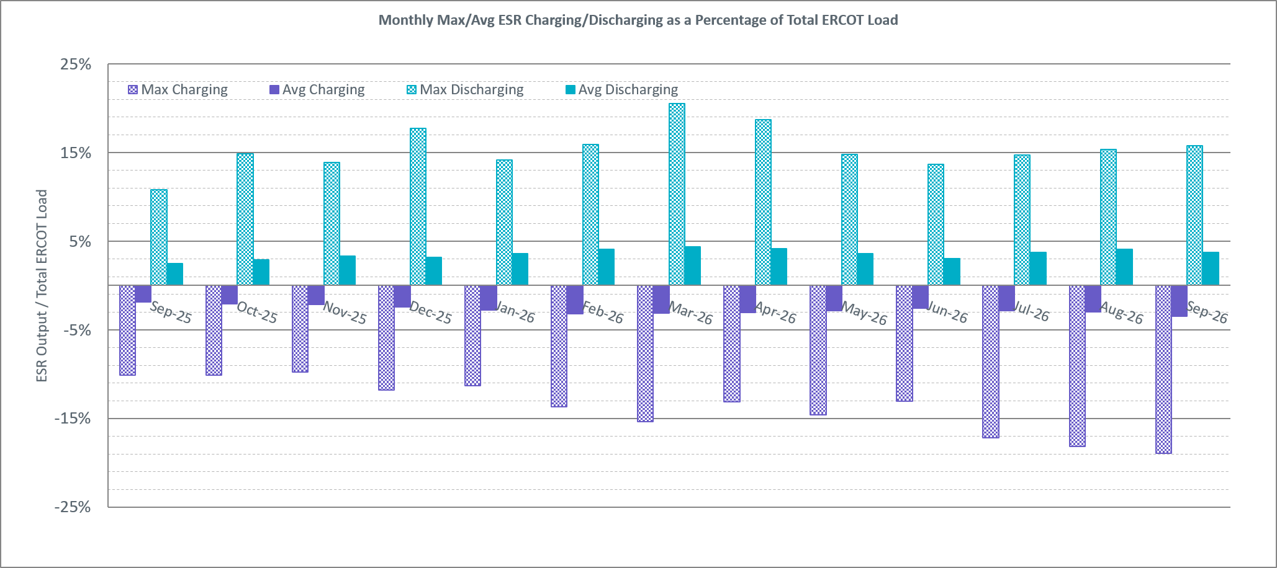
The graph below shows the wind, solar, IRR, and ESR penetration percentage during the hour of the peak load in the last 13 months. Positive values for ESRs indicate discharging while negative values indicate charging. During the hour of peak load for the month, hourly integrated wind generation was 7,405 MW and solar generation was 29,705 MW. The ESR injection during the peak load hour was -539 MW.
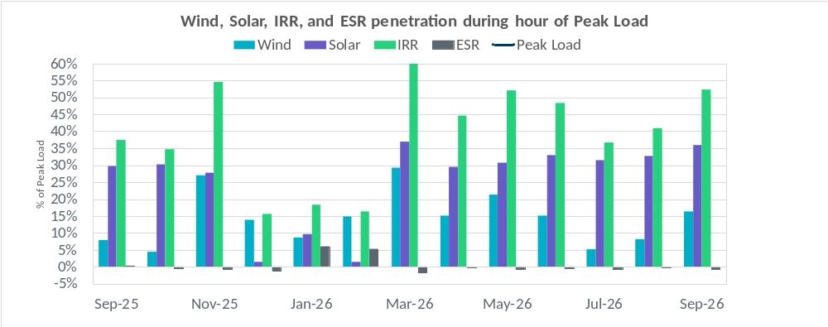
The following graph shows the minimum wind, solar, and IRR output during the peak load hour as a percentage of the daily peak load for every day in the month.
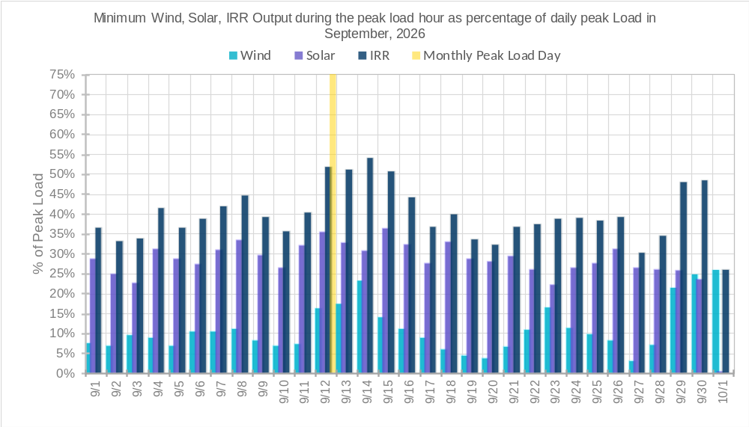
Lastly, the chart below shows the total ESR charging/discharging and efficiency over the past 13 months. Efficiency is defined as total discharging divided by total charging. Total ESR charging and discharging for September 2026 were 1,001,673 MWh and 789,299 MWh, respectively, and efficiency was 78.80%.
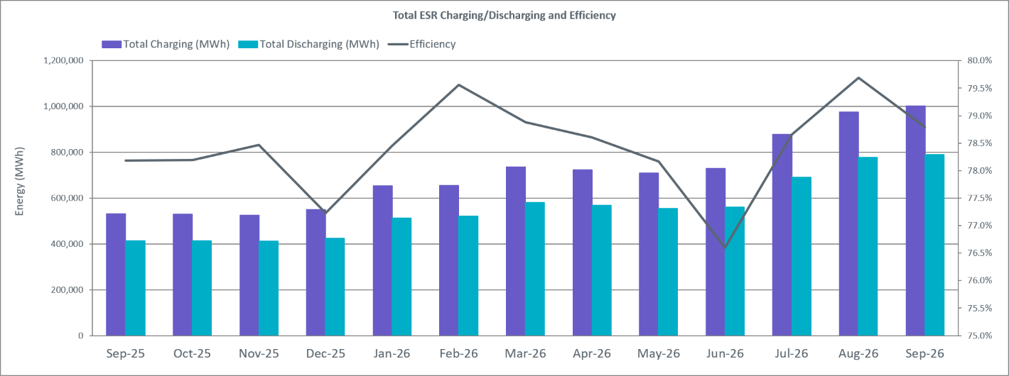

Energy Storage Resource (ESR) Output and State of Charge (SOC) Profile
The graph below shows how ESR SOC varies by Hour Ending (HE). The SOC is generally higher during the day and lower during night. During the month of September 2026, ESRs operated below 20% SOC for 15.62% of the time and below 10% SOC for 2.27% of the time. The minimum observed SOC was 6.24% on 9/22/2026 at interval ending 23:36, while the maximum was 95.47% on 9/8/2026 at interval ending 17:15.
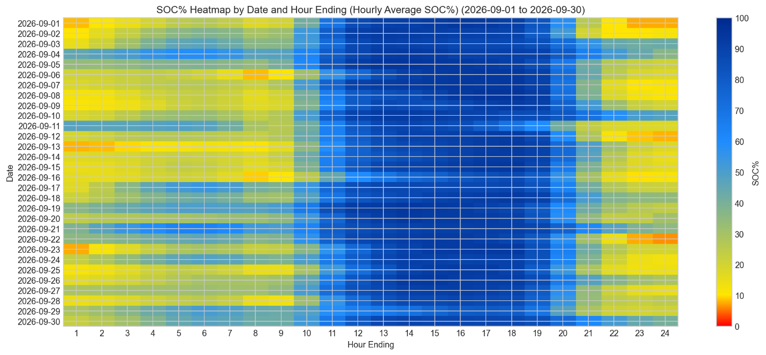
The chart below shows the maximum ESR output as a percentage of the total ERCOT Net Load. ESR penetration reached a maximum of 19.68% on 9/12/2026 at interval ending 19:35. The net load reached a peak of about 71210 MW on 9/2/2026 at interval ending 19:35.
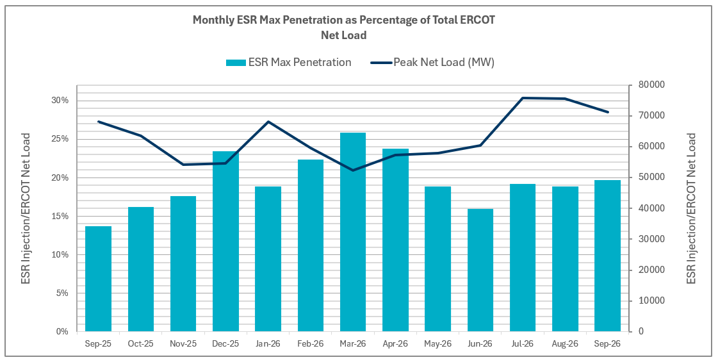

Largest Net-Load Ramps
The net-load ramp is defined as the change in net-load (load minus wind and PVGR generation) during the defined time horizon. Such a variation in net-load needs to be accommodated in grid operations to ensure that the reliability of the grid is satisfactorily maintained. The largest net-load ramps over 5-minute, 10-minute, 15-minute, 30-minute, and 60-minute intervals in August 2026 were 1,777 MW, 3,348 MW, 4,671 MW, 8,447 MW, and 15,338 MW respectively. A comparison with historical values is provided in the table below.
Month and Year | 5 min | 10 min | 15 min | 30 min | 60 min
14-Sep | 1,054 MW | 1,531 MW | 1,695 MW | 2,628 MW | 4,898 MW
15-Sep | 993 MW | 1,457 MW | 1,779 MW | 2,952 MW | 5,659 MW
16-Sep | 827 MW | 1,260 MW | 1,688 MW | 2,880 MW | 5,464 MW
17-Sep | 730 MW | 1,251 MW | 1,758 MW | 3,298 MW | 5,716 MW
18-Sep | 1,129 MW | 1,991 MW | 2,372 MW | 3,391 MW | 6,015 MW
19-Sep | 867 MW | 1,207 MW | 1,643 MW | 3,134 MW | 5,716 MW
20-Sep | 776 MW | 1,285 MW | 1,763 MW | 2,728 MW | 5,087 MW
21-Sep | 1,251 MW | 1,655 MW | 1,972 MW | 3,519 MW | 6,629 MW
22-Sep | 887 MW | 1,391 MW | 1,818 MW | 3,099 MW | 5,351 MW
23-Sep | 1,018 MW | 1,642 MW | 2,416 MW | 4,129 MW | 7,947 MW
24-Sep | 2,163 MW | 3,028 MW | 3,456 MW | 5,918 MW | 10,401 MW
25-Sep | 1,637 MW | 2,824 MW | 3,944 MW | 6,492 MW | 12,268 MW
 | 1,918 MW | 3,326 MW | 4,661 MW | 8,092 MW | 14,234 MW
26-Sep | 9/8/2026 | 9/7/2026 | 9/12/2026 | 9/7/2026 | 9/12/2026
 | (IE 18:21) | (IE 18:38) | (IE 18:29) | (IE 18:47) | (IE 19:07)
All Months in 2014-2026 | 3,797 MW | 3,562 MW | 4,671 MW | 8,901 MW | 16,522 MW
All Months in 2014-2026 | 5/28/2025 | 5/28/2025 | 8/27/2026 | 1/29/2024 | 1/29/2024
All Months in 2014-2026 | (IE 10:27) | (IE 10:27) | (IE 18:56) | (IE 17:11) | (IE 17:17)

Congestion Analysis

Notable Constraints
Nodal protocol section 3.20 specifies that ERCOT shall identify transmission constraints that are binding in Real-Time three or more Operating Days within a calendar month. As part of this process, ERCOT reports congestion that meets this criterion to ROS. In addition, ERCOT also highlights notable constraints that have an estimated congestion rent exceeding $1,000,000 for a calendar month. These constraints are detailed in the table below, including approved transmission upgrades from TPIT that may provide some congestion relief based on ERCOT’s engineering judgement. Rows highlighted in blue indicate the congestion was affected by one or more outages. For a list of all constraints activated in SCED, please see Appendix A at the end of this report.

Element Key | Contingency Name | Overloaded Element | Contingency Desc | Overloaded Element Desc | # of Days Constraint Binding | Congestion Rent | Transmission Project
PKRSW_HCKSW_35100__A | DWCSRAM5 | 35100__A | WCSWS TO RAMSW 345 DBLCKT TRPLCKT 3 of 3 | Parker Switch - Hicks Switch 345kV | 4 | $41,819,804.55 | Oncor Southern DFW Load Interconnection and General Grid Strengthening Project (25RPG004)
FORSW_FORSW_FORSW_MR3H | SCNRFOR5 | FORSW_MR3H | CENTERVILLE ROAD SWITCH to FORNEY SWITCH LIN _A | Forney Switch 345kV | 2 | $23,466,291.82 | Oncor Forney 345/138-kV Switch Rebuild Project (24RPG021)
LA_PALMA_LA_PALMA_LA_PALMA_XF1A | MKNGSTE5 | LA_PALMA_XF1A | manual double NEDIN_KNG2 and NEDIN_STEWAR1 345KV line | La Palma 345kV | 6 | $16,170,984.86
SCRCV_KNAPP_6437__F | DMTSCOS5 | 6437__F | DMTSW TO SCOSW 345 DBLCKT | Knapp - Scurry Chevron 138kV | 16 | $10,215,544.97 | Dermott Area 138 kV Like Upgrades (26RPG014)
STP_WAP_STPWAP39_1 | DWPWFWP5 | STPWAP39_1 | TWR(345) WAP-WLF64 & WAP-WLY72 | South Texas Project - Wa Parish 345kV | 16 | $9,120,265.72
SMPST_BNTDR_3170__B | DWTRWLV5 | 3170__B | WTRML TO WLVEE and TO SARRD 345KV | Buntin Drive - Simpson Stuart 138kV | 4 | $8,124,352.92
JN_BI_BI_JN_64_A | DWAP_BI5 | BI_JN_64_A | TWR (345) WAP-BI50 & SMITHERS-BI98 | Bellaire - Jeanetta 345kV | 10 | $5,841,001.82 | TPIT#87479 upgrades this line Normal and emergency ratings of 1614 MVA and 1792 MVA
MULBERRY_ABINDUST_ABINDU_MULBER1_1 | SABSBLU8 | ABINDU_MULBER1_1 | BLUFF CREEK to ABILENE SOUTH LIN 1 | Abilene Industrial Park - Abilene Mulberry Creek 138kV | 4 | $5,509,187.08
n/a_n/a_EASTEX | BASE CASE | EASTEX | Basecase | EASTEX GTC | 14 | $5,301,408.54
SEA_SEA_SEA_AAT1 | DFRYBC58 | SEA_AAT1 | DOUBLE KNBSW-SALSW 345 & FRYSW-BELCNTY 138 | Seaton 138kV | 16 | $5,208,416.82
LA_PALMA_LA_PALMA_LA_PALMA_XF1A | BASE CASE | LA_PALMA_XF1A | Basecase | La Palma 345kV | 1 | $5,051,448.17
SALDS_SONTERRA_1710__A | DSALHUT5 | 1710__A | SALSW - HUTTO 345KV | Salado South - Sonterra 138kV | 24 | $4,976,897.35 | Oncor & LCRA TSC Resubmission for Salado Switch to Hutto Switch 138-kV Line Project (25RPG006, TPIT #80546D)
MV_HBRG4_MV_WESL4_WESLCO_HIDLBRG_1 | MHARNED5 | WESLCO_HIDLBRG_1 | Manual dbl ckt for NEDIN-BONILLA 345kV & RIOH-PRIM138kV | Heidelburg Sub - Weslaco Sub 138kV | 15 | $4,821,291.48 | STEC_71928_Heidelberg_AEPWeslaco_Upgrade (MOD 71928)
MESQE_OATES_1395__A | DFORCN85 | 1395__A | FORNEY SWITCH to LAKE HUBBARD SES and Centerville Rd 345 and 138 | Oates - Mesquite East 138kV | 2 | $4,553,105.54
PAWNEE_CALAVERS_PAWNEE_SPRUCE_1 | DELMSAN5 | PAWNEE_SPRUCE_1 | Elmcreek-Sanmigl 345kV | Pawnee Switching Station - Calaveras 345kV | 16 | $4,026,434.20 | San Antonio South Reliability II Project (23RPG032) : Project rebuilds the existing Pawnee to Spruce 345-kV line with normal and emergency rating of 1746MVA
LAGOVI_NAMELE_228T333_1 | DROUCHI8 | 228T333_1 | RNDRK-CHIEBR & SPANOA 138kV | Lago Vista - Nameless 138kV | 2 | $3,610,609.22 | TPIT#72576A Lago Vista to Nameless Transmission Line Upgrade
PK_DT_DT_PK_91_A | DWO5_EU8 | DT_PK_91_A | TWR (345/138) EU-SF09 & WO-JN72 | Downtown - Polk 138kV | 17 | $3,503,244.21
n/a_n/a_WESTEX | BASE CASE | WESTEX | Basecase | WESTEX GTC | 5 | $3,281,615.53 | Permian Basin Relibility Plan (765-kV import paths) (The PUCT approved ,helps improve, but not fully exit, the GTC yet.)
MDO_PHR_MDOPHR99_A | DWAP_OB5 | MDOPHR99_A | TWR (345) OB-WAP98 & OB-WAP99 | Meadow - Ph Robinson 345kV | 17 | $3,139,134.38 | CNP_28TPIT103344_PH_Robinson_to_WA_Parish_Hardening (MOD 103344 Phase 103435, 25RPG028)
WAP_OB_OB_WAP98_A | SOBWAP5 | OB_WAP98_A | WA PARISH to OBRIEN LIN A | Wa Parish - Obrien 345kV | 12 | $3,075,274.99
KLNSW_KLNSW_KLNSW_MR1H | DSALKLN5 | KLNSW_MR1H | SALSW TO KLNSW 345 DBLCKT | Killeen Switch 345kV | 5 | $2,550,205.83
MULBERRY_ABINDUST_ABINDU_MULBER1_1 | DBLUBUF8 | ABINDU_MULBER1_1 | BLUF_CRK - SOUTHABI & BUFF_GAP 138 KV | Abilene Industrial Park - Abilene Mulberry Creek 138kV | 2 | $2,147,250.51
TMPSW_FRYSW_1715__B | DSALHUT5 | 1715__B | SALSW - HUTTO 345KV | Temple Switch - Fryers Creek 138kV | 18 | $2,130,006.99 | Temple Area Project (24RPG001). Note that Fryers Creek is named Boggy Creek in planning cases.
BIGHIL_OERSTED_225T558_1 | DBAKCED5 | 225T558_1 | BAKESW-CEDACA 345kV & BAKESW-CEDACA 345kV | Big Hill - Orsted 345kV | 2 | $2,051,743.26
GN_PZ_GN_PZ_08_A | SMDOOAS5 | GN_PZ_08_A | MEADOW to OASIS LIN A | Grant - Plaza 138kV | 16 | $2,028,924.62
MGSES_CATSW_6945__A | SRGRMGS5 | 6945__A | MORGAN CREEK SES to RANGER CAMP SWITCH LIN _A | Morgan Creek Ses - Cattleman Switch 345kV | 14 | $2,011,376.58 | West Texas 345-kV Infrastructure Rebuild Project (23RPG034)
SNDSW_SNDSW_SNDSW_MR1H | MSNDWCR5 | SNDSW_MR1H | MANUAL SANDOW SW TO WALLEYE CREEK SW | Sandow Switch 345kV | 11 | $1,963,202.46 | TPIT#109874 Rebuild Sandow 345 kV Switch
TYPRK_PLYAM_6200__F | DCDHTVW5 | 6200__F | TVWSW TO CDHSW 345 AND CDHSW TO VENSW 345 DBLCKT | Poly-America - Tyre Park Sub 138kV | 7 | $1,961,868.18
ZEN_THW_THWZEN98_A | SZENTHW5 | THWZEN98_A | TH WHARTON to Zenith LIN A | Th Wharton - Zenith 345kV | 7 | $1,852,495.91
PILONCIL_NLARSW_NLARSW_PILONC1_1 | MLOFOAV5 | NLARSW_PILONC1_1 | Manual Double LOBO - FOWLERTON & AVANZADA | North Laredo Switch - Piloncillo 138kV | 12 | $1,806,928.88
PGTP1_PDSES_3610__G | DWTRWLV5 | 3610__G | WTRML TO WLVEE and TO SARRD 345KV | Parkdale Switch - Pleasant Grove Tap 1 138kV | 2 | $1,564,991.67
SARDIS_WXHNW_950__B | XVE2N58 | 950__B | VENUS SWITCH TRX VENSW_3_3 345/138 | Sardis - Waxahachie Northwest 138kV | 7 | $1,459,827.15
SAMSW_VENSW_35055__A | SVENFTS5 | 35055__A | FORT SMITH SWITCH to FORT SMITH SWITCH LIN _B | Sam Switch - Venus Switch 345kV | 4 | $1,448,429.59 | Venus Switch to Sam Switch 345-kV Line Project (24RPG017)
WEAVERRD_GREENLK_GREENL_WEAVER1_1 | SBIGV_D8 | GREENL_WEAVER1_1 | VICTORIA DUPONT SWITCH to BIG THREE LIN 1 | Greenlake - Weaver Road 69kV | 11 | $1,419,654.33
n/a_n/a_NELRIO | BASE CASE | NELRIO | Basecase | NELRIO GTC | 20 | $1,296,141.04 | The Lower Rio Grande Valley (LRGV) System Enhancement Project (21RPG017)
DUNLAP_DECKER_CKT_1027_1 | DSALHUT5 | CKT_1027_1 | SALSW - HUTTO 345KV | Decker Power Plant - Aen Dunlap 138kV | 10 | $1,285,041.09
ZEN_THW_THWZEN98_A | DRNS_TB5 | THWZEN98_A | Rns-Rtw & Sng-Tb 345kV | Th Wharton - Zenith 345kV | 8 | $1,111,487.03
LPLMK_LPLNE_LPLMK_LPLNE_1 | SBWDDBM5 | LPLMK_LPLNE_1 | BLACKWATER DRAW SWITCH to DOUBLE MOUNTAIN SWITCH LIN 1 | Mackenzie Substation - Northeast Substation 115kV | 13 | $1,050,950.82
LHM_LY_LHMLY_08_A | DBCVPSA8 | LHMLY_08_A | TWR (138) BCV-CV03 & GBY-PSA03 | Lyondell - Lychem 138kV | 3 | $1,015,839.38
BERGHE_BERGHE_BERGHE_AT1H | DZORHAY5 | BERGHE_AT1H | ZORN - HAYSEN 345KV | Bergheim 345kV | 5 | $946,919.52
VERS_SANDROAD_SANDRO_VERS1_1 | SVEROK28 | SANDRO_VERS1_1 | OKLAUNION to OKLAUNION LIN 1 | Southwest Vernon - Sand Road 69kV | 4 | $941,344.77
ORNGROV_SNDIEGS_SND_ORAN_1 | SCALBAN9 | SND_ORAN_1 | BANQUETE to BANQUETE LIN 1 | San Diego Sub - Orange Grove Switching Station 69kV | 6 | $928,703.00
n/a_n/a_NE_LOB | BASE CASE | NE_LOB | Basecase | NE_LOB GTC | 9 | $829,764.30 | San Antonio South Reliability I Project (22RPG048)  LRGV Transmission Improvement Project (21RPG017)  San Antonio South Reliability II Project (23RPG032)
MEXTP_ITALY_2270__B | SBLURDH8 | 2270__B | BLUM to RED HILL SWITCH LIN _G | Milford Exxon Tap - Italy 69kV | 14 | $792,286.43
FLTSW_PRSSW_1545__A | SPRSPAR8 | 1545__A | PARIS SWITCH to PARIS LIN _A | Paris Switch - Flying Tiger Switch 138kV | 25 | $785,926.61
PALOUSE_WOLFCAMP_PALOUS_WOLFCA1_1 | SFTLMES8 | PALOUS_WOLFCA1_1 | FORT LANCASTER to FORT LANCASTER LIN 1 | Palouse - Wolfcamp 138kV | 8 | $727,750.70
BALLINGE_BALLINGE_BALLINGE_FMRL | SCOLBAL8 | BALLINGE_FMRL | BALLINGER to COLEMAN LAKE IVIE TAP LIN 1 | Ballinger 69kV | 5 | $709,908.42
n/a_n/a_E_PASP | BASE CASE | E_PASP | Basecase | E_PASP GTC | 18 | $702,057.20 | San Antonio South Reliability I Project (22RPG048)  LRGV Transmission Improvement Project (21RPG017)  San Antonio South Reliability II Project (23RPG032)
BLESSING_BLESSING_BLESSING_1382 | DSTPSTA5 | BLESSING_1382 | Double STP to HLJ & Static 345 KV | Blessing 345kV | 8 | $698,120.32
WLY_WAP_WAPWLY72_A | DBLW2JC5 | WAPWLY72_A | TWR (345) JCK-WAT62 & BLY-JCK57 | Wa Parish - Whaley 345kV | 13 | $687,718.60
VICTORIA_MAGRUDER_MAGRUD_VICTOR2_1 | XVIC89 | MAGRUD_VICTOR2_1 | VICTORIA TRX 69A2 138/69 | Magruder - Victoria 138kV | 8 | $670,818.13
LENSW_PUTN_LENSW_PUTN2_1 | SCISPUT8 | LENSW_PUTN2_1 | CISCO to CISCO LIN 1 | Leon Switch - Putnam 138kV | 5 | $654,906.98
PALOUSE_WOLFCAMP_PALOUS_WOLFCA1_1 | DBIGSCH5 | PALOUS_WOLFCA1_1 | Big Hill - Schneeman Draw & Big Hill - Schneeman Draw 2 | Palouse - Wolfcamp 138kV | 6 | $609,067.79
DUNLAP_DECKER_CKT_1027_1 | SDAFAUS8 | CKT_1027_1 | AUSTROP to DAFFIN GIN LIN 1 | Decker Power Plant - Aen Dunlap 138kV | 8 | $551,420.35
NLARSW_PILONCIL_NLARSW_PILONC1_1 | DFOAVLO5 | NLARSW_PILONC1_1 | FOWLERTON to LOBO & AVANZADA | North Laredo Switch - Piloncillo 138kV | 7 | $542,322.71
OAKC_PERSHING_OAKC_PERSHI1_1 | SABSBLU8 | OAKC_PERSHI1_1 | BLUFF CREEK to ABILENE SOUTH LIN 1 | Oak Creek Aep - Pershing Tap 138kV | 3 | $534,565.71
BRUNI_BRUNI_BRUNI_69_1 | DFOAVLO5 | BRUNI_69_1 | FOWLERTON to LOBO & AVANZADA | Bruni Sub 138kV | 10 | $495,647.89
HIGH36_BRENNO_215T215_1 | SGIDLIN8 | 215T215_1 | GIDDINGS to GIDDINGS LIN 1 | Highway 36 - Brenham North 138kV | 3 | $436,472.15
ELMOT_MCTYE_1020__A | DELMWWE8 | 1020__A | ELMOT TO WWEST 138 AND ELMOT TO WEAST 69 DBLCKT | Elm Mott - Mclennan County East 138kV | 9 | $432,239.46
ASHERTON_CATARINA_ASHERT_CATARI1_1 | MLOFOAV5 | ASHERT_CATARI1_1 | Manual Double LOBO - FOWLERTON & AVANZADA | Asherton - Catarina 138kV | 14 | $380,252.99
BGRSW_SNDSW_455__A | SBCESN35 | 455__A | BELL COUNTY EAST SWITCH to BELL COUNTY EAST SWITCH LIN _A | Badger Switch - Sandow Switch 345kV | 9 | $375,578.50
ORNGROV_SNDIEGS_SND_ORAN_1 | MLOFOAV5 | SND_ORAN_1 | Manual Double LOBO - FOWLERTON & AVANZADA | San Diego Sub - Orange Grove Switching Station 69kV | 5 | $360,619.08
VICTORIA_MAGRUDER_MAGRUD_VICTOR2_1 | SPAWCAL5 | MAGRUD_VICTOR2_1 | CALAVERAS to CALAVERAS LIN 1 | Magruder - Victoria 138kV | 3 | $342,123.23
FMRVL_RYSSW_400__A | SFMRRYS5 | 400__A | Farmersville Switch to Farmersville Switch LIN _A | Royse Switch - Farmersville Switch 345kV | 7 | $311,654.57
FRONTERA_S_MISSIN_BENTS_FRTER_1B_1 | SBENS_M8 | BENTS_FRTER_1B_1 | SOUTH MCALLEN to BENTSEN LIN 1 | Frontera - South Mission 138kV | 20 | $308,828.52
KNBSW_SALSW_36040__A | DSNDBGR5 | 36040__A | DOUBLE SNDSW TO BCESW & BGRSW | Salado Switch - Knob Creek Switch 345kV | 6 | $286,808.69
n/a_n/a_PNHNDL | BASE CASE | PNHNDL | Basecase | PNHNDL GTC | 3 | $283,519.64
SOLSTICE_SOLSTICE_SOLSTICE_PST1 | STARLEO8 | SOLSTICE_PST1 | LEON CREEK TNP to TARBUSH TNP LIN 1 | Solstice 138kV | 15 | $275,071.41 | Fort Stockton Switch: Expand 345 kV Station (MOD 93226)
SEA_SEA_SEA_AAT1 | DFRYTM58 | SEA_AAT1 | DOUBLE FRYSW-TMPSW 138 & KNBSW-SALSW 345 | Seaton 138kV | 5 | $250,007.06
LA_PALMA_HAINE_DR_HAINE__LA_PAL1_1 | MHARNED5 | HAINE__LA_PAL1_1 | Manual dbl ckt for NEDIN-BONILLA 345kV & RIOH-PRIM138kV | Haine Drive - La Palma 138kV | 11 | $236,075.96
NUECES_B_WHITE_PT_NUECES_WHITE_2_1 | SMAYWHI8 | NUECES_WHITE_2_1 | GILA to MAYO LIN 1 | Nueces Bay - Whitepoint 138kV | 7 | $234,105.03
CRDSW_OLNEY_6830__B | DGRMGRS8 | 6830__B | FIREROCK TO BRNWD 138 AND FIREROCK TO BANGS 69 DBLCKT | Cottonwood Road Switch - Olney Pod 69kV | 11 | $220,815.20
GIDEON_SETTLE_196T171_1 | DAUSLOS5 | 196T171_1 | Lostpi-Austro&Dunlap 345kV | Settlers - Sim Gideon 138kV | 7 | $218,675.13
HECKER_RESNIK_HECKER_RESNIK1_1 | DMCDUPS8 | HECKER_RESNIK1_1 | MCCAMPBE - RESNIK & I_DUPSW 138kV | Hecker - Resnik 138kV | 7 | $216,597.63
BRUNI_BRUNI_BRUNI_69_1 | SLAQLOB8 | BRUNI_69_1 | LAQUINTA to LOBO LIN 1 | Bruni Sub 138kV | 15 | $211,503.46
SONR_ATSO_ATSO_SONR1_1 | SCARFRI8 | ATSO_SONR1_1 | Carver to Carver LIN 1 | Atlantic Sonora - Sonora 69kV | 12 | $202,780.30
FLTSW_PRSSW_1545__A | DPRSHWK8 | 1545__A | PRSSW-HWKSW 138 DBLCKT | Paris Switch - Flying Tiger Switch 138kV | 6 | $189,833.13
POTEETS_OAKS9_POT_OAKS_1 | DELMSAN5 | POT_OAKS_1 | Elmcreek-Sanmigl 345kV | Poteet Sub - Oaks Sub 69kV | 10 | $183,836.41
NORTMC_CROSSOVE_CROSSO_NORTMC1_1 | SFTLMES8 | CROSSO_NORTMC1_1 | FORT LANCASTER to FORT LANCASTER LIN 1 | North Mccamey - Crossover 138kV | 3 | $176,957.29
HOWARD_LEON_CRK_D5_S1_1 | SP5CAG8 | D5_S1_1 | CAGNON to CAGNON LIN 1 | Leon Creek - Howard 138kV | 6 | $175,063.53
BCESW_SNDSW_421__A | SSNDBGR5 | 421__A | SANDOW SWITCH to BADGER SWITCH LIN _A | Sandow Switch - Bell County East Switch 345kV | 6 | $172,595.78
AE_STR_AE_STR26_A | SPETSNU8 | AE_STR26_A | PETSON to Snug LIN A | Angleton - Stratt 138kV | 3 | $114,325.46
TMPSW_TMPSE_610__B | DPPRTEC8 | 610__B | PEPPER CREEK SW TO TEMPLE ELM CREEK 138 KV DOUBLE | Temple Switch - Temple Southeast 138kV | 3 | $110,382.49 | Temple Area Project (24RPG001).
ENWSW_TMPTN_940__A | SPEBTRU8 | 940__A | GAMMA to GAMMA LIN _D | Ennis West Switch - Templeton 138kV | 14 | $108,591.02
BEVO_CARIZOS_CARIZOSPG_BEVO_1 | XASH89 | CARIZOSPG_BEVO_1 | ASHERTON TRX 69A1 138/69 | Carrizo Springs Sub - Bevo 69kV | 12 | $100,703.31
RAYBURN_RAYBURN_RAYBURN_69_2 | SFURVAN8 | RAYBURN_69_2 | FURHMAN to VANDERBILT SWITCHING STATION LIN 1 | Sam Rayburn Switchyd 138kV | 7 | $89,838.86
BIG_FOOT_BIG_FOOT_BIG_FOOT_69A1 | SHONMOO8 | BIG_FOOT_69A1 | MOORE SWITCHING STATION to HONDO CREEK SWITCHING STATION LIN 1 | Big Foot 138kV | 3 | $88,868.99
POTEETS_OAKS9_POT_OAKS_1 | SMOOPEA8 | POT_OAKS_1 | MOORE SWITCHING STATION to MOORE SWITCHING STATION LIN 1 | Poteet Sub - Oaks Sub 69kV | 6 | $79,039.72
TREADWEL_YELWJCKT_TREADW_YELWJC1_1 | DBIGKEN5 | TREADW_YELWJC1_1 | Bighil-Kendal 345kV | Yellow Jacket - Treadwell 138kV | 4 | $78,029.48
RDHSW_BLUMS_810__G | DCPSES12 | 810__G | Comanche Peak 1 & 2 | Red Hill Switch - Blum 138kV | 7 | $70,492.17
CMNSW_CMNTP_651__B | SCMNCPS5 | 651__B | COMANCHE PEAK SES to COMANCHE SWITCH (Oncor) LIN _A | Comanche Tap - Comanche Switch (Oncor) 138kV | 3 | $69,760.74
NVKSW_ANARN_6840__B | DMGSRIC8 | 6840__B | DBL_CKT_GRSES-RICSW_138 kV and GRSES-SGRAS_138 kV | Anarene - Navy Kickapoo Switch 69kV | 5 | $65,331.15
PALOUSE_CROSSOVE_CROSSO_PALOUS1_1 | SWOLPAL8 | CROSSO_PALOUS1_1 | PALOUSE to Wolfcamp LIN 1 | Crossover - Palouse 138kV | 5 | $64,829.75
GABRIE_GABRIE_GABRIE_AT1 | DSALHUT5 | GABRIE_AT1 | SALSW - HUTTO 345KV | Gabriel 138kV | 5 | $60,817.82
ORNGROV_ORNGROV_ORNGROV_69_1 | SGEOORN8 | ORNGROV_69_1 | GEORGE WEST to GEORGE WEST LIN 1 | Orange Grove Switching Station 138kV | 3 | $58,669.30
TNNALVIN_ALVIN_138_ALV_NAL_1 | SMDOPHR5 | 138_ALV_NAL_1 | MEADOW to PH ROBINSON LIN A | North Alvin Tnp - Alvin Tnp 138kV | 21 | $50,291.76
LAKENASW_SAMATHIS_LAKENA_SAMATH1_1 | SWOLPAL8 | LAKENA_SAMATH1_1 | PALOUSE to Wolfcamp LIN 1 | Lake Nasworthy - San Angelo Mathis Field 69kV | 4 | $47,211.67
n/a_n/a_E_PATA | BASE CASE | E_PATA | Basecase | E_PATA GTC | 7 | $43,132.36
REVEILLE_COTULLA_COTULL_REVEIL1_1 | DFOWSMG5 | COTULL_REVEIL1_1 | FOWLRTON TO SAN MIGUEL DOUBLE CIRCUIT CONTINGENCY | Cotulla - Reveille 138kV | 4 | $34,098.48
FTST_LEONCRK_138_FTS_LNC_1 | BASE CASE | 138_FTS_LNC_1 | Basecase | Leon Creek Tnp - Fort Stockton Plant 138kV | 7 | $32,774.90
LEONCRK_FTST_138_FTS_LNC_1 | STARLEO8 | 138_FTS_LNC_1 | LEON CREEK TNP to TARBUSH TNP LIN 1 | Leon Creek Tnp - Fort Stockton Plant 138kV | 3 | $27,134.37
RS_FB_FB_RS_60_A | SEBATH8 | FB_RS_60_A | Athena to EAST BERNARD LIN A | Fort Bend - Rosenberg 138kV | 6 | $23,460.64
LEON_CRK_V4_TAP_D5_V4TP_1 | DLEOPEA8 | D5_V4TP_1 | Medinabs-Quintana&Leon_Crk-Pearsal 138KV | Leon Creek - Palo Alto Tap 138kV | 6 | $22,447.48
CRDSW_OLNEY_6830__B | SGRMGRS8 | 6830__B | GRAHAM EAST to GRAHAM EAST LIN _A | Cottonwood Road Switch - Olney Pod 69kV | 3 | $20,667.94
FTST_LEONCRK_138_FTS_LNC_1 | DTNFBCA8 | 138_FTS_LNC_1 | TNFXTAIL TO TARBUSH to BCATOKA 138KV | Leon Creek Tnp - Fort Stockton Plant 138kV | 11 | $20,026.09
FRONTERA_S_MISSIN_BENTS_FRTER_1B_1 | SSHAFRO8 | BENTS_FRTER_1B_1 | FRONTERA to SHARYLAND LIN 1 | Frontera - South Mission 138kV | 10 | $19,073.14
V4_B4_B4_V4_1 | BASE CASE | B4_V4_1 | Basecase | Chavanea - Palo Alto 138kV | 4 | $18,127.32
V_DUPSW_BIGTRE_BIGTRE_V_DUPS1_1 | DVICDUP8 | BIGTRE_V_DUPS1_1 | VICTORIA DUPONT SWITCH TO VICTORIA DOUBLE CKT 138KV | Big Three - Victoria Dupont Switch 138kV | 4 | $17,231.78
FURHMAN_MOURSUND_MOURSUND_FUR_1 | SFURVAN8 | MOURSUND_FUR_1 | FURHMAN to VANDERBILT SWITCHING STATION LIN 1 | Moursund - Furhman 138kV | 5 | $13,456.03
WDBSW_HLSBR_1275__A | SBLURDH8 | 1275__A | BLUM to RED HILL SWITCH LIN _G | Hillsboro - Woodbury Switch 138kV | 10 | $12,728.06
RAYBURN_RAYBURN_RAYBURN_69_2 | SL_4RAY8 | RAYBURN_69_2 | LOOP 463 SUB to LOOP 463 SUB LIN 1 | Sam Rayburn Switchyd 138kV | 4 | $12,505.03
CRD_CRD_CRD_CRD2 | XCMB58 | CRD_CRD2 | CARMICHAEL BEND SWITCH TRX CMBSW_3_1 345/138 | Concord 345kV | 3 | $11,399.60
YELWJCKT_HEXT_HEXT_YELWJC1_1 | SJUNYEL9 | HEXT_YELWJC1_1 | MENARD PHILLIPS TAP to MENARD PHILLIPS TAP LIN 1 | Yellow Jacket - Hext Lcra 69kV | 5 | $10,755.10
MRVLY_ESTLD_6635__G | SCLCGTN8 | 6635__G | COLONY CREEK to GHOST TOWN SWITCH LIN _A | Morton Valley (Oncor) - Eastland 69kV | 3 | $10,062.56
IH20_TNCOLIET_138_IH2_COT_1 | SSTAWIC8 | 138_IH2_COT_1 | STAGHORN TNP to WICKETT TNP LIN 1 | Ih 20 Tnp - Collie Field Tap Tnp 138kV | 8 | $10,060.02
LA_PALMA_HAINE_DR_HAINE__LA_PAL1_1 | SRAYRI38 | HAINE__LA_PAL1_1 | LAS PULGAS to RAYMONDVILLE 2 LIN 1 | Haine Drive - La Palma 138kV | 5 | $9,595.61
FTST_LEONCRK_138_FTS_LNC_1 | DALASOA8 | 138_FTS_LNC_1 | Manual From ALAMO_ST To SOAPTREE 138kV | Leon Creek Tnp - Fort Stockton Plant 138kV | 8 | $7,002.88
FRONTERA_S_MISSIN_BENTS_FRTER_1B_1 | SPALFRO8 | BENTS_FRTER_1B_1 | FRONTERA to KEY SWITCH LIN 1 | Frontera - South Mission 138kV | 5 | $6,308.56
SN_STR_SN_STR26_A | SVLGLO8 | SN_STR26_A | VELASCO to GLOBAL LIN A | Sintek - Stratt 138kV | 3 | $6,036.78
HUBRD_HAN1_1210__B | SBLURDH8 | 1210__B | BLUM to RED HILL SWITCH LIN _G | Hubbard - Haney Bepc 138kV | 3 | $5,254.38
GANSO_ESCONDID_ESCOND_GANSO1_1 | SBRAPIN8 | ESCOND_GANSO1_1 | BRACKETTVILLE to BRACKETTVILLE LIN 1 | Escondido - Ganso 138kV | 3 | $4,911.29
VICTORIA_OCONNOR_REFUG_VICTO_1C_1 | SGRIRAP5 | REFUG_VICTO_1C_1 | Grissom to RAPTOR LIN 1 | Oconnor - Victoria 69kV | 3 | $4,757.61
ESCONDID_GANSO_ESCOND_GANSO1_1 | SBRAHAM8 | ESCOND_GANSO1_1 | BRACKETTVILLE to HAMILTON ROAD LIN 1 | Escondido - Ganso 138kV | 6 | $4,482.82
FRWYPARK_MAINLAND_138_FWP_MNL_1 | SALVTNN8 | 138_FWP_MNL_1 | ALVIN TNP to ALVIN TNP LIN 1 | Mainland Tnp - Freeway Park Tnp 138kV | 3 | $4,226.64
NLARSW_UNITEC_NLARSW_UNITEC1_1 | SDELLAR8 | NLARSW_UNITEC1_1 | DEL MAR to DEL MAR LIN 1 | Unitec - North Laredo Switch 138kV | 4 | $3,218.55
ANGLETON_WCOLLOCL_G138_15_1 | SWCOWCO8 | G138_15_1 | WEST COLUMBIA MAIN TNP to ANGLETON TNP LIN 1 | West Columbia Local Tnp - Angleton Tnp 138kV | 15 | $2,793.52
MPPOI_KEYSB_6217__B | SBUZHMP8 | 6217__B | BUZZARD DRAW SWITCH to HARDY MORGAN POI LIN _B | Mushaway Peak Poi - Key Sub 138kV | 3 | $2,012.22
HEXT_MASONSW_HEXT_MASONS1_1 | SJUNYEL9 | HEXT_MASONS1_1 | MENARD PHILLIPS TAP to MENARD PHILLIPS TAP LIN 1 | Mason Switching Station - Hext Lcra 69kV | 6 | $1,386.83
HEXT_MASONSW_HEXT_MASONS1_1 | DYETRJU8 | HEXT_MASONS1_1 | Double for YellowJacket - Treadwell & Junction | Mason Switching Station - Hext Lcra 69kV | 3 | $192.68
PILONCIL_NLARSW_NLARSW_PILONC1_1 | DFOAVLO5 | NLARSW_PILONC1_1 | FOWLERTON to LOBO & AVANZADA | North Laredo Switch - Piloncillo 138kV | 7 | $187.01
YELWJCKT_HEXT_HEXT_YELWJC1_1 | DYETRJU8 | HEXT_YELWJC1_1 | Double for YellowJacket - Treadwell & Junction | Yellow Jacket - Hext Lcra 69kV | 3 | $161.04
ESCONDID_GANSO_ESCOND_GANSO1_1 | SBRAPIN8 | ESCOND_GANSO1_1 | BRACKETTVILLE to BRACKETTVILLE LIN 1 | Escondido - Ganso 138kV | 3 | $18.91

Generic Transmission Constraint Congestion
GTC | Days Congestion
East Texas | 23
Nelson Sharpe - Rio Hondo | 22
South Texas Export Pawnee - Spruce | 21
South Texas Export Pawnee - Tango | 20
North Edinburg - Lobo | 17
North - Houston | 10
Panhandle | 8
West Texas | 7
South Texas Import Katoen - Lonhill | 4
Zapata Starr | 4
South Texas Import Pawnee - Spruce | 1

There was no activity on the remaining GTCs during the month.
Note: This is how many times a constraint has been activated to avoid exceeding a GTC limit, it does not imply an exceedance of the GTC occurred or that the GTC was binding.

Manual Overrides
- None

Congestion Costs for Calendar Year 2026
The following table represents the top twenty active constraints for the calendar year based on the estimated congestion rent attributed to the congestion. ERCOT updates this list on a monthly basis.

Contingency Name | Overloaded Element | # of 5-min SCED | Estimated | Transmission
BASE CASE | WESTEX | 18295 | $102,325,256.76 | Permian Basin Relibility Plan (765-kV import paths) (The PUCT approved ,helps improve, but not fully exit, the GTC yet.)
DWPWFWP5 | STPWAP39_1 | 10746 | $70,943,942.51
MHCKRA25 | HCKSW_MR2L | 1363 | $51,703,803.38
DBAKCED5 | 6965__A | 13081 | $50,101,641.18 | Oncor_FW_81268_Longshore – Consavvy 345 kV Double-Circuit Line Rebuild (MOD 81268)
BASE CASE | EASTEX | 12545 | $43,568,286.85
DWCSRAM5 | 35100__A | 386 | $42,503,054.47 | Oncor Southern DFW Load Interconnection and General Grid Strengthening Project (25RPG004)
SRGRMGS5 | 6945__A | 7238 | $34,959,268.92 | West Texas 345-kV Infrastructure Rebuild Project (23RPG034)
SVENFTS5 | 35055__A | 5620 | $34,824,077.83 | Venus Switch to Sam Switch 345-kV Line Project (24RPG017)
MRNKDHM5 | 587__A | 6658 | $34,162,852.87
DMTSCOS5 | 6437__F | 15526 | $33,605,304.01 | Oncor_FW_102849_Union 138 kV Switch (MOD 102849)
SBWDDBM5 | LPLMK_LPLNE_1 | 9938 | $32,285,434.20
DSALKLN5 | 641__A | 2796 | $31,304,486.27 | ONCOR_SE_87703_Belton_Killeen_138 kV Line (via Nolanville) (MOD 87703, 24RPG001)
DSALHUT5 | 1715__B | 5468 | $27,476,036.48 | Temple Area Project (24RPG001). Note that Fryers Creek is named Boggy Creek in planning cases.
DNAVOUT5 | 50__A | 504 | $26,063,843.65 | ONCOR_SE_99622_PIN_OAK_SWITCH (MOD 99622, 25RPG004)
SCNRFOR5 | FORSW_MR3H | 313 | $23,466,291.82 | Oncor Forney 345/138-kV Switch Rebuild Project (24RPG021)
DBAKCED5 | HARGRO_TWINBU1_1 | 5089 | $23,430,138.42
BASE CASE | NE_LOB | 23716 | $23,315,082.42 | San Antonio South Reliability I Project (22RPG048)  LRGV Transmission Improvement Project (21RPG017)  San Antonio South Reliability II Project (23RPG032)
BASE CASE | E_PASP | 12724 | $22,524,624.61 | San Antonio South Reliability I Project (22RPG048)  LRGV Transmission Improvement Project (21RPG017)  San Antonio South Reliability II Project (23RPG032)
BASE CASE | HHGTOM_1 | 9303 | $21,498,853.14
BASE CASE | NELRIO | 27085 | $18,845,933.69 | The Lower Rio Grande Valley (LRGV) System Enhancement Project (21RPG017)

System Events

ERCOT Peak Load
The unofficial ERCOT peak load for September 2026 was 86,647 MW and occurred on 9/12/2026 during hour ending 17:00, this is 6,698 MW greater than the September 2025 demand of 79,949 MW on 9/4/2025 during hour ending 18:00. Instantaneous peak for September 2026 was 86,777 MW. Actual instantaneous peak for the same month last year was 80,356 MW.

Load Shed Events
- None.

Stability Events
- None.

Notable PMU Events
ERCOT analyzes PMU data for any significant system disturbances that do not fall into the Frequency Events category reported in section 2.1. The results are summarized in this section once the analysis has been completed.
There were no PMU events outside of those reported in section 2.1.

DC Tie Curtailment
- None.

TRE/DOE Reportable Events
- Porter Solar submitted a DOE-417 for 09/05/2026 for Damage or destruction of a Facility.
- Oncor submitted an EOP-004-4 for 09/29/2026 for Complete loss of monitoring or control capability at its staffed Bulk Electric System control center for 30 continuous minutes or more.
- Oncor submitted a DOE-417 for 09/29/2026 for Complete loss of monitoring or control capability at its staffed Bulk Electric System control center for 30 continuous minutes or more.

New/Updated Constraint Management Plans
MOD: MP_2025_13 REV4

New/Modified/Removed RAS
- None

New Procedures/Forms/Operating Bulletins
Date | Subject | Bulletin No.
9/30/2026 | Shift Supervisor V2 Rev 5 | 2040
9/30/2026 | Reliability Unit Commitment V2 Rev 6 | 2039

Emergency Conditions

OCNs
- None

Advisories
Date and Time | Message
September 15, 2026, 1:22 PM | DAM Notice: ERCOT has postponed the deadline for the posting of the DAM solution for Operating Day 09/16/2026 due to long run time.
September 28, 2026, 1:25 PM | DAM Notice: ERCOT has postponed the deadline for the posting of the DAM solution for Operating Day 09/29/2026 due to long run time.
September 29, 2026, 1:16 PM | DAM Notice: ERCOT has postponed the deadline for the posting of the DAM solution for Operating Day 09/30/2026 due to long run time.

Watches
- None

Emergency Notices
- None

Application Performance

TSAT/VSAT Performance Issues
- None.

Communication Issues
- None.

Market System Issues
- None.

Model Updates
The Downstream Production Change (DPC) process allows ERCOT to make changes in the one-line Network Operations Model without loading a completely new model. The purpose of this process is to allow for reliable grid operations as system conditions change between designated Network Operations Model database loads. The DPC process is limited in scope to just those items listed below, with equipment ratings updates being the most common. ERCOT has seen a rise in the use of the DPC process to make on-line updates to the Network Operations Model in recent years, instead of through the standard Network Operations Model Change Request process.
- Static Line ratings (Interim Update)
- Dynamic Line ratings (non-Interim Update)
- Autotransformer ratings (non-Interim Update)
- Breaker and Switch Normal status (Interim Update)
- Contingency Definitions (Interim Update)
- RAP and RAS changes or additions (Interim Update)
- Net Dependable and Reactive Capability (NDCRC) values (Interim Update)
- Impedance Updates (non-Interim)
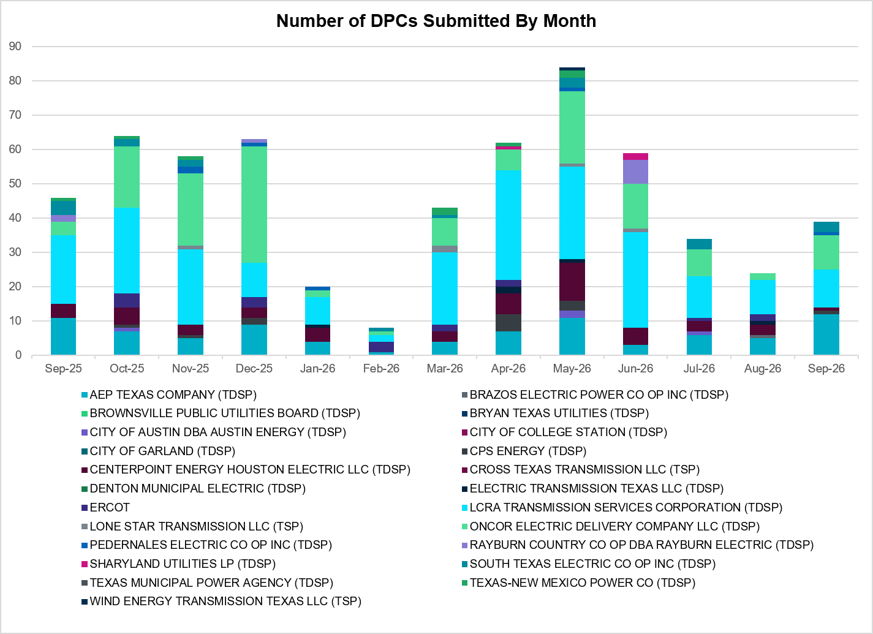
A total of 39 DPCs were implemented in September 2026. 373 DPCs have been implemented year to date. DPCs submitted by TDSPs are mainly updates to transmission element ratings. DPCs submitted by ERCOT are mainly updates to manual contingency definitions.
Transmission Operator | Number of DPCs
AEP TEXAS COMPANY (TDSP) | 12
BRAZOS ELECTRIC POWER CO OP INC (TDSP) | 0
BROWNSVILLE PUBLIC UTILITIES BOARD (TDSP) | 0
BRYAN TEXAS UTILITIES (TDSP) | 0
CENTERPOINT ENERGY HOUSTON ELECTRIC LLC (TDSP) | 1
CITY OF AUSTIN DBA AUSTIN ENERGY (TDSP) | 0
CITY OF COLLEGE STATION (TDSP) | 0
CITY OF GARLAND (TDSP) | 0
CPS ENERGY (TDSP) | 1
CROSS TEXAS TRANSMISSION LLC (TSP)) | 0
DENTON MUNICIPAL ELECTRIC (TDSP) | 0
ELECTRIC TRANSMISSION TEXAS LLC (TDSP) | 0
ERCOT | 0
LCRA TRANSMISSION SERVICES CORPORATION (TDSP) | 11
LONE STAR TRANSMISSION LLC (TSP) | 0
ONCOR ELECTRIC DELIVERY COMPANY LLC (TDSP) | 10
PEDERNALES ELECTRIC CO OP INC (TDSP) | 1
RAYBURN COUNTRY CO OP DBA RAYBURN ELECTRIC (TDSP) | 0
SHARYLAND UTILITIES LP (TDSP) | 0
SOUTH TEXAS ELECTRIC CO OP INC (TDSP) | 3
TEXAS MUNICIPAL POWER AGENCY (TDSP) | 0
TEXAS-NEW MEXICO POWER CO (TDSP) | 0
WIND ENERGY TRANSMISSION TEXAS LLC (TSP) | 0

Appendix A: Real-Time Constraints
The following is a complete list of constraints activated in SCED. Full contingency descriptions can be found in the Standard Contingencies List located on the MIS secure site at Grid Generation Reliability Unit Commitment.
Year | Month | Contingency Name | Overloaded Element | From Station | To Station | Count of Days
2026 | September | SPRSPAR8 | 1545__A | FLTSW | PRSSW | 27
2026 | September | SMDOPHR5 | 138_ALV_NAL_1 | TNNALVIN | ALVIN | 27
2026 | September | DSALHUT5 | 1715__B | TMPSW | FRYSW | 24
2026 | September | DSALHUT5 | 1710__A | SALDS | SONTERRA | 24
2026 | September | BASE CASE | EASTEX | n/a | n/a | 23
2026 | September | SBENS_M8 | BENTS_FRTER_1B_1 | FRONTERA | S_MISSIN | 23
2026 | September | BASE CASE | NELRIO | n/a | n/a | 22
2026 | September | BASE CASE | E_PASP | n/a | n/a | 21
2026 | September | BASE CASE | E_PATA | n/a | n/a | 20
2026 | September | DWAP_OB5 | MDOPHR99_A | MDO | PHR | 19
2026 | September | SWCOWCO8 | G138_15_1 | ANGLETON | WCOLLOCL | 19
2026 | September | DFRYBC58 | SEA_AAT1 | SEA | SEA | 19
2026 | September | SWCOWCO8 | G138_15_1 | WCOLLOCL | ANGLETON | 19
2026 | September | DMTSCOS5 | 6437__F | SCRCV | KNAPP | 19
2026 | September | SFURVAN8 | MOURSUND_FUR_1 | MOURSUND | FURHMAN | 18
2026 | September | SFURVAN8 | MOURSUND_FUR_1 | FURHMAN | MOURSUND | 18
2026 | September | SBWDDBM5 | LPLMK_LPLNE_1 | LPLMK | LPLNE | 18
2026 | September | DWO5_EU8 | DT_PK_91_A | PK | DT | 18
2026 | September | SBLURDH8 | 1275__A | WDBSW | HLSBR | 18
2026 | September | DWPWFWP5 | STPWAP39_1 | STP | WAP | 18
2026 | September | BASE CASE | NE_LOB | n/a | n/a | 17
2026 | September | STARLEO8 | SOLSTICE_PST1 | SOLSTICE | SOLSTICE | 17
2026 | September | SMDOOAS5 | GN_PZ_08_A | GN | PZ | 17
2026 | September | DELMSAN5 | PAWNEE_SPRUCE_1 | PAWNEE | CALAVERS | 16
2026 | September | DBLW2JC5 | WAPWLY72_A | WLY | WAP | 16
2026 | September | SPEBTRU8 | 940__A | ENWSW | TMPTN | 16
2026 | September | SLAQLOB8 | BRUNI_69_1 | BRUNI | BRUNI | 15
2026 | September | SRGRMGS5 | 6945__A | MGSES | CATSW | 15
2026 | September | MHARNED5 | WESLCO_HIDLBRG_1 | MV_HBRG4 | MV_WESL4 | 15
2026 | September | MLOFOAV5 | ASHERT_CATARI1_1 | CATARINA | ASHERTON | 14
2026 | September | SBLURDH8 | 2270__B | MEXTP | ITALY | 14
2026 | September | SSTAWIC8 | 138_IH2_COT_1 | IH20 | TNCOLIET | 14
2026 | September | MLOFOAV5 | ASHERT_CATARI1_1 | ASHERTON | CATARINA | 14
2026 | September | SOBWAP5 | OB_WAP98_A | WAP | OB | 13
2026 | September | MSNDWCR5 | SNDSW_MR1H | SNDSW | SNDSW | 13
2026 | September | DTNFBCA8 | 138_FTS_LNC_1 | FTST | LEONCRK | 13
2026 | September | DELMSAN5 | POT_OAKS_1 | POTEETS | OAKS9 | 13
2026 | September | SBIGV_D8 | GREENL_WEAVER1_1 | WEAVERRD | GREENLK | 12
2026 | September | MHARNED5 | HAINE__LA_PAL1_1 | LA_PALMA | HAINE_DR | 12
2026 | September | MLOFOAV5 | NLARSW_PILONC1_1 | PILONCIL | NLARSW | 12
2026 | September | BASE CASE | 138_FTS_LNC_1 | LEONCRK | FTST | 12
2026 | September | SBCESN35 | 455__A | BGRSW | SNDSW | 12
2026 | September | MLOFOAV5 | NLARSW_PILONC1_1 | NLARSW | PILONCIL | 12
2026 | September | SCARFRI8 | ATSO_SONR1_1 | SONR | ATSO | 12
2026 | September | DWAP_BI5 | BI_JN_64_A | JN | BI | 12
2026 | September | BASE CASE | 138_FTS_LNC_1 | FTST | LEONCRK | 12
2026 | September | XASH89 | CARIZOSPG_BEVO_1 | BEVO | CARIZOS | 12
2026 | September | SSHAFRO8 | BENTS_FRTER_1B_1 | FRONTERA | S_MISSIN | 11
2026 | September | DFOAVLO5 | BRUNI_69_1 | BRUNI | BRUNI | 11
2026 | September | SEBATH8 | FB_RS_60_A | RS | FB | 11
2026 | September | SSHAFRO8 | BENTS_FRTER_1B_1 | S_MISSIN | FRONTERA | 11
2026 | September | DGRMGRS8 | 6830__B | CRDSW | OLNEY | 11
2026 | September | DALASOA8 | 138_FTS_LNC_1 | FTST | LEONCRK | 10
2026 | September | BASE CASE | N_TO_H | n/a | n/a | 10
2026 | September | SFMRRYS5 | 400__A | FMRVL | RYSSW | 10
2026 | September | DSALHUT5 | CKT_1027_1 | DUNLAP | DECKER | 10
2026 | September | DELMWWE8 | 1020__A | ELMOT | MCTYE | 10
2026 | September | DCPSES12 | 810__G | RDHSW | BLUMS | 9
2026 | September | SHLSWDB8 | 810__G | RDHSW | BLUMS | 9
2026 | September | DRNS_TB5 | THWZEN98_A | ZEN | THW | 9
2026 | September | SDAFAUS8 | CKT_1027_1 | DUNLAP | DECKER | 9
2026 | September | XVE2N58 | 950__B | SARDIS | WXHNW | 9
2026 | September | DSNDBGR5 | 36040__A | KNBSW | SALSW | 8
2026 | September | SSNDBGR5 | 421__A | BCESW | SNDSW | 8
2026 | September | DFRYTM58 | SEA_AAT1 | SEA | SEA | 8
2026 | September | DAUSLOS5 | 196T171_1 | GIDEON | SETTLE | 8
2026 | September | DFOAVLO5 | NLARSW_PILONC1_1 | NLARSW | PILONCIL | 8
2026 | September | SFTLMES8 | PALOUS_WOLFCA1_1 | PALOUSE | WOLFCAMP | 8
2026 | September | SJUNYEL9 | HEXT_MASONS1_1 | HEXT | MASONSW | 8
2026 | September | DFOAVLO5 | NLARSW_PILONC1_1 | PILONCIL | NLARSW | 8
2026 | September | BASE CASE | PNHNDL | n/a | n/a | 8
2026 | September | DSTPSTA5 | BLESSING_1382 | BLESSING | BLESSING | 8
2026 | September | MKNGSTE5 | LA_PALMA_XF1A | LA_PALMA | LA_PALMA | 8
2026 | September | XVIC89 | MAGRUD_VICTOR2_1 | VICTORIA | MAGRUDER | 8
2026 | September | SL_4RAY8 | RAYBURN_69_2 | RAYBURN | RAYBURN | 8
2026 | September | DCDHTVW5 | 6200__F | TYPRK | PLYAM | 8
2026 | September | SCLCGTN8 | 6635__G | MRVLY | ESTLD | 7
2026 | September | SJUNYEL9 | HEXT_YELWJC1_1 | YELWJCKT | HEXT | 7
2026 | September | DFOAVLO5 | ASHERT_CATARI1_1 | CATARINA | ASHERTON | 7
2026 | September | DZORHAY5 | BERGHE_AT1H | BERGHE | BERGHE | 7
2026 | September | DYETRJU8 | HEXT_YELWJC1_1 | YELWJCKT | HEXT | 7
2026 | September | SZENTHW5 | THWZEN98_A | ZEN | THW | 7
2026 | September | SBRAHAM8 | ESCOND_GANSO1_1 | ESCONDID | GANSO | 7
2026 | September | SMAYWHI8 | NUECES_WHITE_2_1 | NUECES_B | WHITE_PT | 7
2026 | September | SP5CAG8 | D5_S1_1 | HOWARD | LEON_CRK | 7
2026 | September | DMCDUPS8 | HECKER_RESNIK1_1 | HECKER | RESNIK | 7
2026 | September | DBIGSCH5 | PALOUS_WOLFCA1_1 | PALOUSE | WOLFCAMP | 7
2026 | September | SFURVAN8 | RAYBURN_69_2 | RAYBURN | RAYBURN | 7
2026 | September | MLOFOAV5 | SND_ORAN_1 | ORNGROV | SNDIEGS | 7
2026 | September | SALVTNN8 | 138_FWP_MNL_1 | FRWYPARK | MAINLAND | 7
2026 | September | BASE CASE | WESTEX | n/a | n/a | 7
2026 | September | DFOAVLO5 | ASHERT_CATARI1_1 | ASHERTON | CATARINA | 7
2026 | September | SRAYRI38 | HAINE__LA_PAL1_1 | LA_PALMA | HAINE_DR | 6
2026 | September | SPALFRO8 | BENTS_FRTER_1B_1 | FRONTERA | S_MISSIN | 6
2026 | September | DLEOPEA8 | D5_V4TP_1 | LEON_CRK | V4_TAP | 6
2026 | September | SMOOPEA8 | POT_OAKS_1 | POTEETS | OAKS9 | 6
2026 | September | SBLURDH8 | 1210__B | HUBRD | HAN1 | 6
2026 | September | DLEOPEA8 | D5_V4TP_1 | V4_TAP | LEON_CRK | 6
2026 | September | SCISPUT8 | LENSW_PUTN2_1 | LENSW | PUTN | 6
2026 | September | DPRSHWK8 | 1545__A | FLTSW | PRSSW | 6
2026 | September | BASE CASE | 138_ALV_NAL_1 | TNNALVIN | ALVIN | 6
2026 | September | SPETSNU8 | AE_STR26_A | AE | STR | 6
2026 | September | SBRAPIN8 | ESCOND_GANSO1_1 | ESCONDID | GANSO | 6
2026 | September | SBRAPIN8 | ESCOND_GANSO1_1 | GANSO | ESCONDID | 6
2026 | September | SWOLPAL8 | LAKENA_SAMATH1_1 | LAKENASW | SAMATHIS | 6
2026 | September | SCALBAN9 | SND_ORAN_1 | ORNGROV | SNDIEGS | 6
2026 | September | SBUZHMP8 | 6217__B | MPPOI | KEYSB | 5
2026 | September | SWOLPAL8 | CROSSO_PALOUS1_1 | PALOUSE | CROSSOVE | 5
2026 | September | DFOWSMG5 | COTULL_REVEIL1_1 | REVEILLE | COTULLA | 5
2026 | September | SCOLBAL8 | BALLINGE_FMRL | BALLINGE | BALLINGE | 5
2026 | September | STARLEO8 | 138_FTS_LNC_1 | LEONCRK | FTST | 5
2026 | September | DPPRTEC8 | 610__B | TMPSW | TMPSE | 5
2026 | September | DSALKLN5 | KLNSW_MR1H | KLNSW | KLNSW | 5
2026 | September | DWCSRAM5 | 35100__A | PKRSW | HCKSW | 5
2026 | September | SVEROK28 | SANDRO_VERS1_1 | VERS | SANDROAD | 5
2026 | September | DSALHUT5 | GABRIE_AT1 | GABRIE | GABRIE | 5
2026 | September | SDELLAR8 | NLARSW_UNITEC1_1 | NLARSW | UNITEC | 5
2026 | September | DDL_KR_8 | SIEWAP05_A | WAP | SIE | 5
2026 | September | DBIGKEN5 | TREADW_YELWJC1_1 | TREADWEL | YELWJCKT | 5
2026 | September | SGEOORN8 | ORNGROV_69_1 | ORNGROV | ORNGROV | 5
2026 | September | SVENFTS5 | 35055__A | SAMSW | VENSW | 5
2026 | September | DMGSRIC8 | 6840__B | NVKSW | ANARN | 5
2026 | September | DWTRWLV5 | 3170__B | SMPST | BNTDR | 4
2026 | September | BASE CASE | I_KALO | n/a | n/a | 4
2026 | September | DVICDUP8 | BIGTRE_V_DUPS1_1 | V_DUPSW | BIGTRE | 4
2026 | September | SHONMOO8 | BIG_FOOT_69A1 | BIG_FOOT | BIG_FOOT | 4
2026 | September | DELMSAN5 | MAGRUD_VICTOR2_1 | VICTORIA | MAGRUDER | 4
2026 | September | BASE CASE | B4_V4_1 | V4 | B4 | 4
2026 | September | BASE CASE | ZAPSTR | n/a | n/a | 4
2026 | September | SABSBLU8 | ABINDU_MULBER1_1 | MULBERRY | ABINDUST | 4
2026 | September | BASE CASE | B4_V2_1 | B4 | V2 | 4
2026 | September | SSNYCGR8 | SNYDR_FMR1 | SNYDR | SNYDR | 4
2026 | September | SFMRRY25 | 381__A | FMRVL | RYSSW | 4
2026 | September | BASE CASE | D5_V4_1 | LEON_CRK | V4 | 4
2026 | September | DBCVPSA8 | LHMLY_08_A | LHM | LY | 4
2026 | September | SPAWCAL5 | MAGRUD_VICTOR2_1 | VICTORIA | MAGRUDER | 4
2026 | September | SFTLMES8 | CROSSO_NORTMC1_1 | NORTMC | CROSSOVE | 4
2026 | September | SFTCGAR8 | BALLINGE_FMRL | BALLINGE | BALLINGE | 4
2026 | September | SI_2RES8 | I_DUPS_RESNIK3_3 | I_DUPSW | RESNIK | 4
2026 | September | SHLSWH28 | 1210__B | HUBRD | HAN1 | 3
2026 | September | SABSBLU8 | OAKC_PERSHI1_1 | OAKC | PERSHING | 3
2026 | September | MBULNAV5 | 35045__A | SAMSW | FVLSW | 3
2026 | September | SGRIRAP5 | REFUG_VICTO_1C_1 | VICTORIA | OCONNOR | 3
2026 | September | SVLGLO8 | SN_STR26_A | SN | STR | 3
2026 | September | SMOOPEA8 | UVALDE_W_BATE1_1 | W_BATESV | UVALDE | 3
2026 | September | SCMNCPS5 | 651__B | CMNSW | CMNTP | 3
2026 | September | SGRMGRS8 | 6830__B | CRDSW | OLNEY | 3
2026 | September | DGABGEA8 | GABRIE_AT1 | GABRIE | GABRIE | 3
2026 | September | DLIMHOR5 | 722T782_1 | CANYON | ROHR | 3
2026 | September | SHONMOO8 | BIG_FO_PLEASA1_1 | BIG_FOOT | PLEASANT | 3
2026 | September | XCMB58 | CRD_CRD2 | CRD | CRD | 3
2026 | September | SANGSTA5 | BLESSING_1382 | BLESSING | BLESSING | 3
2026 | September | SLARLAS8 | DEL_MA_UNIVER1_1 | DEL_MAR | UNIVERSI | 3
2026 | September | DYETRJU8 | HEXT_MASONS1_1 | HEXT | MASONSW | 3
2026 | September | DBLUBUF8 | OAKC_PERSHI1_1 | OAKC | PERSHING | 3
2026 | September | SHLSWH28 | 1210__B | HAN1 | HUBRD | 3
2026 | September | DHLYTRC5 | ELKTN_MR3H | ELKTN | ELKTN | 3
2026 | September | DWPWFWP5 | 155T217_1 | BELLSO | PT | 3
2026 | September | DLONPK25 | 6375__A | GRSES | GRMES | 3
2026 | September | DENWSTE8 | ROC_ROCK_1 | ROCKETT | ROCKETSW | 3
2026 | September | DSALGA58 | GABRIE_AT1 | GABRIE | GABRIE | 3
2026 | September | DBAKCED5 | LAKENA_SAMATH1_1 | LAKENASW | SAMATHIS | 3
2026 | September | SBWDDBM5 | LPLNW_LPLMD_1 | LPLNW | LPLMD | 3
2026 | September | SGIDLIN8 | 215T215_1 | HIGH36 | BRENNO | 3
2026 | September | DPHRCTR5 | MDOPHR99_A | MDO | PHR | 2
2026 | September | DSCOTKW5 | 6215__A | BCKSW | CGRSW | 2
2026 | September | DMTSCOS5 | 6240__C | SACRC | DPCRK | 2
2026 | September | SECRDMT8 | 6437__F | SCRCV | KNAPP | 2
2026 | September | SRICGRS8 | 6840__A | ANARN | CRDSW | 2
2026 | September | DLYTZOR5 | 722T782_1 | CANYON | ROHR | 2
2026 | September | SANGSTA5 | BLESSI_PALACI1_1 | BLESSING | PALACIOS | 2
2026 | September | DCHBJO25 | CBYCVN86_A | CBY | CVN | 2
2026 | September | DNP_PLA8 | HB_KW_66_A | HB | KW | 2
2026 | September | STNFTAR8 | 138_FTS_LNC_1 | FTST | LEONCRK | 2
2026 | September | SBTPBNT8 | 2115__B | TOWER | BNTSW | 2
2026 | September | DEVRHLS8 | 6293__C | MARSW | DEVIT | 2
2026 | September | XVE2N58 | 951__A | STERT | SARDIS | 2
2026 | September | DFRYBC58 | BELCNTY_XFMR | BELCNTY | BELCNTY | 2
2026 | September | DBIGSCH5 | CROSSO_NORTMC1_1 | NORTMC | CROSSOVE | 2
2026 | September | SBIGOR45 | FORTMA_YELWJC1_1 | FORTMA | YELWJCKT | 2
2026 | September | SBIGOR45 | FORTMA_YELWJC1_1 | YELWJCKT | FORTMA | 2
2026 | September | SGA2ROM8 | GARZA_XF1H | GARZA | GARZA | 2
2026 | September | DMCEBUT8 | MKLT_TRNT1_1 | TRNT | MKLT | 2
2026 | September | SSPUASP8 | SPUR_69_1 | SPUR | SPUR | 2
2026 | September | DCC1DUKE | WESLCO_HIDLBRG_1 | MV_HBRG4 | MV_WESL4 | 2
2026 | September | SDBLBN28 | 12010__A | GRSSW | WTHSW | 2
2026 | September | DFORCN85 | 1395__A | MESQE | OATES | 2
2026 | September | DPRSHWK8 | 1535__B | TNSKA | TCOSW | 2
2026 | September | MNLFIWO8 | 904T485_1 | GOODWIN | FRONTERA | 2
2026 | September | SKITGEO9 | ARGENTA_AMATH_1 | MATHIS | ARGENTA | 2
2026 | September | BASE CASE | BENTS_FRTER_1B_1 | FRONTERA | S_MISSIN | 2
2026 | September | SLARLAS8 | GATEET_UNIVER1_1 | UNIVERSI | GATEETP | 2
2026 | September | SMCEESK8 | MKLT_TRNT1_1 | MKLT | TRNT | 2
2026 | September | SRVRSLK5 | SLKSW_AX1L | SLKSW | SLKSW | 2
2026 | September | DWTRWLV5 | 3610__G | PGTP1 | PDSES | 2
2026 | September | MKNGSTE5 | BENTS_FRTER_1B_1 | FRONTERA | S_MISSIN | 2
2026 | September | MKNGSTE5 | LA_PALMA_XF1B | LA_PALMA | LA_PALMA | 2
2026 | September | DBLBYWF5 | STPWAP39_1 | STP | WAP | 2
2026 | September | DBAKCED5 | 225T558_1 | BIGHIL | OERSTED | 2
2026 | September | DROUCHI8 | 228T333_1 | LAGOVI | NAMELE | 2
2026 | September | SILLFTL8 | CARVER_TINSLE1_1 | CARVER | TINSLEY | 2
2026 | September | DCMBCPS8 | CRD_CRD2 | CRD | CRD | 2
2026 | September | SDELLAR8 | GATEWT_WORMSE1_1 | GATEWTP | WORMSER | 2
2026 | September | SCROPAL8 | LAKENA_SAMATH1_1 | LAKENASW | SAMATHIS | 2
2026 | September | DWO5_EU8 | MIDGT_90_A | GT | MID | 2
2026 | September | DDORELK5 | SCSES_MR1H | SCSES | SCSES | 2
2026 | September | SSAMTCR5 | 505__B | FBRSW | THSES | 2
2026 | September | MTRYBRO8 | 6217__B | MPPOI | KEYSB | 2
2026 | September | SCNRFOR5 | FORSW_MR3H | FORSW | FORSW | 2
2026 | September | BASE CASE | HENWAP01_A | WAP | HEN | 2
2026 | September | DCBYJOR5 | HOPWRN84_A | HOP | WRN | 2
2026 | September | BASE CASE | WESLCO_HIDLBRG_1 | MV_HBRG4 | MV_WESL4 | 2
2026 | September | DMLSE123 | 31__A | RCHBR | TRSES | 2
2026 | September | MNLFIWO8 | 904T485_1 | FRONTERA | GOODWIN | 2
2026 | September | DJCY_CC1 | BOW_FMR1 | BOW | BOW | 2
2026 | September | SBRAPIN8 | HAMILT_MAVERI1_1 | HAMILTON | MAVERICK | 2
2026 | September | SHONF38 | HON_DEVI_1 | HONDOCK | DEVINESW | 2
2026 | September | SMCEESK8 | MKLT_TRNT1_1 | TRNT | MKLT | 2
2026 | September | SRVRSLK5 | SLKSW_AX1H | SLKSW | SLKSW | 2
2026 | September | SWCOW2C8 | _WC_WCO_1 | WC | WCOLMAIN | 2
2026 | September | DMTSCOS5 | 6437__A | KNAPP | BCKSW | 2
2026 | September | DBLUBUF8 | ABINDU_MULBER1_1 | MULBERRY | ABINDUST | 2
2026 | September | DKG_NB_5 | BCVPSA03_A | PSA | BCV | 2
2026 | September | SEL_ARR8 | BLESSING_69A1 | BLESSING | BLESSING | 2
2026 | September | SA4LEO8 | D5_V4TP_1 | LEON_CRK | V4_TAP | 2
2026 | September | BASE CASE | FTST_SOLSTI1_1 | FTST | SOLSTICE | 2
2026 | September | SDELLAR8 | GATEWT_UNITEC1_1 | UNITEC | GATEWTP | 2
2026 | September | BASE CASE | HAINE__LA_PAL1_1 | LA_PALMA | HAINE_DR | 2
2026 | September | DTPCTHS5 | LCSES_MR1H | LCSES | LCSES | 2
2026 | September | SGEOHU48 | 221T355_1 | CHIEBR | GEORGE | 1
2026 | September | SHLSWH28 | 2270__B | MEXTP | ITALY | 1
2026 | September | SBTPBNT8 | 583__E | KRMSW | KRUMS | 1
2026 | September | DMBDRKC5 | 651__B | CMNSW | CMNTP | 1
2026 | September | SRICGRS8 | 6840__B | NVKSW | ANARN | 1
2026 | September | DBEANOR5 | 6965__A | LNGSW | PRLSW | 1
2026 | September | DLIMHOR5 | 7T246_1 | ZORN | LYTTON_S | 1
2026 | September | SGRIRAP5 | BIGTRE_V_DUPS1_1 | V_DUPSW | BIGTRE | 1
2026 | September | SMDOOAS5 | BI_KB_37_A | BI | KB | 1
2026 | September | BASE CASE | BURNS_RIOHONDO_1 | RIOHONDO | MV_BURNS | 1
2026 | September | BASE CASE | HHGTOM_1 | HHGT | OMEGA | 1
2026 | September | DHUTLIM5 | HUTTO_MR2H | HUTTO | HUTTO | 1
2026 | September | DDL_KR_8 | IM_WAP05_A | WAP | IM | 1
2026 | September | DLOBCEN5 | LON_HI_ORNGRO1_1 | LON_HILL | ORNGROV | 1
2026 | September | SKITGEO9 | ORNGROV_69_1 | ORNGROV | ORNGROV | 1
2026 | September | SMOOPEA8 | PALDRO_DILLEY_1 | PALODURO | DILLEYSW | 1
2026 | September | SFORRAY8 | RAYBURN_69_2 | RAYBURN | RAYBURN | 1
2026 | September | MDCQCLK5 | SANDRO_VERS1_1 | VERS | SANDROAD | 1
2026 | September | DLOFOAV5 | SND_ORAN_1 | ORNGROV | SNDIEGS | 1
2026 | September | XFOR58 | 200__A | FORSW | RYSSW | 1
2026 | September | DCAGCO58 | 583T583_1 | BANDER | MASOCR | 1
2026 | September | SSPRVAL8 | 595__A | BNTSW | DCATR | 1
2026 | September | SMGPBRN8 | 650__B | PNKNY | BRNWD | 1
2026 | September | SCARLVO8 | ATSO_SONR1_1 | SONR | ATSO | 1
2026 | September | SSTPSTA5 | BLESSING_1382 | BLESSING | BLESSING | 1
2026 | September | DSTOGAR8 | CKT_943_1 | LYTTON_S | PILOT | 1
2026 | September | DRAFOMI8 | E3_X2_1 | E3 | X2 | 1
2026 | September | SCARFRI8 | FDR_OZNC_1 | OZNC | FRIEND_R | 1
2026 | September | STARLEO8 | FTST_SOLSTI1_1 | FTST | SOLSTICE | 1
2026 | September | SCT2CAR8 | HAMILT_MAXWEL1_1 | MAXWELL | HAMILTON | 1
2026 | September | SMDOPHR5 | MDO_AT1 | MDO | MDO | 1
2026 | September | DRNS_TB5 | NB_THW97_A | THW | NB | 1
2026 | September | SFTLMES8 | SANTAR_WOLFCA1_1 | WOLFCAMP | SANTARIT | 1
2026 | September | BASE CASE | SOLSTICE_PST1 | SOLSTICE | SOLSTICE | 1
2026 | September | SPIGSOL8 | 138_FTS_LNC_1 | FTST | LEONCRK | 1
2026 | September | SBLAWDB8 | 2270__B | MEXTP | ITALY | 1
2026 | September | SMYRSPR8 | 583__D | DCRSW | ALISN | 1
2026 | September | DDHMLWS5 | 595__A | BNTSW | DCATR | 1
2026 | September | DCMNFUL8 | 660__B | MGPSW | ZEPHYR | 1
2026 | September | SABSBLU8 | 6940__D | CLCTY | PLOWB | 1
2026 | September | SCITWEI8 | CLARK__LON_HI1_1 | LON_HILL | CLARK_WD | 1
2026 | September | SGARBAL8 | CONCHO_HARI1_A | CONCHO | HARI | 1
2026 | September | XBAL89 | CONCHO_HARI1_A | CONCHO | HARI | 1
2026 | September | SPAUSAR8 | CONCHO_SAEM1_1 | CONCHO | SAEM | 1
2026 | September | DNLPIMI8 | DEL_MA_UNIVER1_1 | DEL_MAR | UNIVERSI | 1
2026 | September | SHELKEN8 | F2_11_1 | KENEDSW | F2 | 1
2026 | September | DBIGKEN5 | FORTMA_YELWJC1_1 | YELWJCKT | FORTMA | 1
2026 | September | SABSBLU8 | LENSW_PUTN2_1 | LENSW | PUTN | 1
2026 | September | SBOSWHT8 | LKW_WHT_1 | LKWHITNY | WHTNY | 1
2026 | September | SANGSTA5 | MOURSUND_FUR_1 | FURHMAN | MOURSUND | 1
2026 | September | XBLU58 | ORNT_REDCRE1_1 | REDCREEK | ORNT | 1
2026 | September | SBIGOR45 | TREADW_YELWJC1_1 | TREADWEL | YELWJCKT | 1
2026 | September | SFURMOU8 | VAN_VNDB_1 | VANBLTSS | VANBLT69 | 1
2026 | September | DHWKRCS8 | 1545__A | FLTSW | PRSSW | 1
2026 | September | DTRSTRC5 | 1852__A | TRSES | NPKTP | 1
2026 | September | DFRYBC58 | 2395__B | PGE | TMPTV | 1
2026 | September | SODETES5 | 6052__C | QALSW | TESSW | 1
2026 | September | DCDHTVW5 | 6200__E | PRKRW | TYPRK | 1
2026 | September | DCRLCY28 | 710__B | CRLNW | CYPSW | 1
2026 | September | SLYTZOR5 | 722T782_1 | CANYON | ROHR | 1
2026 | September | DHLYTRC5 | 985__A | FGLSW | ATHNW | 1
2026 | September | SCARFRI8 | ATSO_OZNC1_1 | ATSO | OZNC | 1
2026 | September | DWAP_JN5 | BI_WAP50_A | WAP | BI | 1
2026 | September | SANGSTA5 | BLESSING_69A1 | BLESSING | BLESSING | 1
2026 | September | SLOLFOR8 | BROOKT_JOSLIN1_1 | JOSLIN | BROOKTAP | 1
2026 | September | SWAATH8 | FB_RS_60_A | RS | FB | 1
2026 | September | DDNEDBP5 | FREER_LOBO1_1 | LOBO | FREER | 1
2026 | September | SHASTNN8 | G138_8A_1 | PHR | HDNLAKES | 1
2026 | September | SGA2ROM8 | GARZA_XF1L | GARZA | GARZA | 1
2026 | September | BASE CASE | I_PASP | n/a | n/a | 1
2026 | September | DSALHUT5 | KLNSW_MR1H | KLNSW | KLNSW | 1
2026 | September | XBLU58 | ORNT_TENNYS1_1 | ORNT | TENNYSON | 1
2026 | September | SANGSTA5 | REFUG_VICTO_1C_1 | VICTORIA | OCONNOR | 1
2026 | September | BASE CASE | RYSSW_FMR1 | RYSSW | RYSSW | 1
2026 | September | DAE_AE_8 | RZ_WML26_A | WML | RZ | 1
2026 | September | MBONNED5 | WESLCO_HIDLBRG_1 | MV_HBRG4 | MV_WESL4 | 1
2026 | September | SCOMKEN8 | 115T123_1 | KENDAL | KERRST | 1
2026 | September | SHWKLBL8 | 1545__A | FLTSW | PRSSW | 1
2026 | September | SQALTES5 | 6054__B | ODEHV | TESSW | 1
2026 | September | MDBHRSA5 | 6085__E | WFSSW | NSTAR | 1
2026 | September | SCR2CRL8 | 710__B | CRLNW | CYPSW | 1
2026 | September | SCRLHKB5 | 710__B | CRLNW | CYPSW | 1
2026 | September | SBROCOC9 | ALPINE_BRONCO1_1 | BRONCO | ALPINE | 1
2026 | September | DSALHUT5 | BALLIN_PAINTR1_1 | BALLINGE | PAINTROC | 1
2026 | September | XBA2N89 | BANDER_AT2 | BANDER | BANDER | 1
2026 | September | SPETSNU8 | BFPCAV82_A | CAV | BFP | 1
2026 | September | SV_DVI28 | BIGTRE_V_DUPS1_1 | V_DUPSW | BIGTRE | 1
2026 | September | SDANBLE8 | BLESSING_69A1 | BLESSING | BLESSING | 1
2026 | September | SOAKNIC8 | CEDRHI_SILT1_1 | SILT | CEDRHILL | 1
2026 | September | DDECWAC8 | CKT_1021_1 | BERGSTRO | KINGSBER | 1
2026 | September | XMDO58 | GN_PZ_08_A | GN | PZ | 1
2026 | September | SMDOOAS5 | GT_KB_37_A | KB | GT | 1
2026 | September | BASE CASE | HI_LONE_TLINE_1 | HI_LONE | CEDACA | 1
2026 | September | DHUNMED8 | J0_R1_1 | J0 | R1 | 1
2026 | September | DBIGKEN5 | MADDUX_TREADW1_1 | MADDUX | TREADWEL | 1
2026 | September | DWPWFCK5 | STPWAP39_1 | STP | WAP | 1
2026 | September | DSNG_TB5 | THWZEN98_A | ZEN | THW | 1
2026 | September | BASE CASE | X5_ALAMO1_1 | OCI_ALM1 | X5 | 1
2026 | September | SWORBRD8 | 138_WIC_STG_1 | WICKETT | STAGHORN | 1
2026 | September | DCAGCI58 | 255T279_1 | PIPECR | MEDILA | 1
2026 | September | SGRIRAP5 | 2992_1 | OCONNOR | GRETA | 1
2026 | September | DCDHMCS8 | 3150__A | CDCSW | OKCLS | 1
2026 | September | DBCEBGR5 | 36040__A | KNBSW | SALSW | 1
2026 | September | DHILMAR5 | 361T361_1 | SCHERT | PARKWA | 1
2026 | September | SECRDMT8 | 6215__A | BCKSW | CGRSW | 1
2026 | September | DBUCRGP5 | 651__B | CMNSW | CMNTP | 1
2026 | September | DCPSST58 | 651__B | CMNSW | CMNTP | 1
2026 | September | SSCLWF18 | 6840__B | NVKSW | ANARN | 1
2026 | September | DCMBCLB8 | 950__B | SARDIS | WXHNW | 1
2026 | September | DBAKCED5 | ATSO_SONR1_1 | SONR | ATSO | 1
2026 | September | SA4LEO8 | B4_V4_1 | V4 | B4 | 1
2026 | September | DSTEXP12 | BALLIN_PAINTR1_1 | BALLINGE | PAINTROC | 1
2026 | September | XBAN89 | BANDER_AT3 | BANDER | BANDER | 1
2026 | September | SA4LEO8 | D5_J0_1 | LEON_CRK | J0 | 1
2026 | September | DSKYNAC8 | FRA_PAR_1 | PARKWA | S4 | 1
2026 | September | DBLBYWF5 | JCKSTP18_A | STP | JCK | 1
2026 | September | DNOESGT5 | LAKENA_SAMATH1_1 | LAKENASW | SAMATHIS | 1
2026 | September | SCARLVO8 | LAKENA_SAMATH1_1 | LAKENASW | SAMATHIS | 1
2026 | September | BASE CASE | LA_PALMA_XF1A | LA_PALMA | LA_PALMA | 1
2026 | September | SMOOPEA8 | NBA_S_BA_1 | S_BATES | NBATSVS | 1
2026 | September | SAILAB48 | OILMIT_SAWGRA1_1 | SAWGRASS | OILMITAP | 1
2026 | September | SP5CAG8 | R2_U4_1 | R2 | U4 | 1
2026 | September | SFURMOU8 | RAYBURN_69_2 | RAYBURN | RAYBURN | 1
2026 | September | DOASSEB5 | WAPWLY72_A | WLY | WAP | 1
2026 | September | MKNGSTE5 | WESLCO_HIDLBRG_1 | MV_HBRG4 | MV_WESL4 | 1
2026 | September | SSOAHOL8 | 138_FTS_LNC_1 | FTST | LEONCRK | 1
2026 | September | DSALHUT5 | 1710__B | SONTERRA | JREST | 1
2026 | September | DSTBELB5 | 35045__A | SAMSW | FVLSW | 1
2026 | September | SSUNRGR8 | 6240__C | SACRC | DPCRK | 1
2026 | September | DMTSCOS5 | 6426__A | DMTSW | ECRSW | 1
2026 | September | DMGSBTR5 | 6437__F | SCRCV | KNAPP | 1
2026 | September | SMGPBRN8 | 650__A | CMNSW | PNKNY | 1
2026 | September | DPRSPAC5 | 874__A | CRSSW | COMSW | 1
2026 | September | XVE2N58 | 945__B | GLNHT | STERT | 1
2026 | September | SABSBLU8 | ABNTHW_SERDEV1_1 | ABNTHWST | ABNTHWST | 1
2026 | September | SHAMMAX8 | ATSO_SONR1_1 | SONR | ATSO | 1
2026 | September | SCOLBAL8 | BALLIN_HUMBLT1_1 | BALLINGE | HUMBLTAP | 1
2026 | September | DGABGEA8 | BELCNTY_XFMR | BELCNTY | BELCNTY | 1
2026 | September | DCE_OB28 | BM_WD_73_A | BM | WD | 1
2026 | September | SABSBLU8 | CALLAH_PERSHI1_1 | PERSHING | CALLAHAN | 1
2026 | September | SSACBUR9 | CEDRHI_SILT1_1 | CEDRHILL | SILT | 1
2026 | September | BASE CASE | DT_PK_91_A | PK | DT | 1
2026 | September | SMCEESK8 | ESKSW_TRNT1_1 | TRNT | ESKSW | 1
2026 | September | SFURMOU8 | FURHMAN_VANDB_1 | FURHMAN | VANBLTSS | 1
2026 | September | DBI_GT_8 | HT_TAP24_1 | HT | HT | 1
2026 | September | XMDO58 | MDO_AT1 | MDO | MDO | 1
2026 | September | DBWN_AM5 | ORNT_REDCRE1_1 | REDCREEK | ORNT | 1
2026 | September | SFURVAN8 | RAY_MOURSUND_1 | MOURSUND | RAYBURN | 1
2026 | September | SWALWLN8 | SWI_OLIN_1 | OLINGR | SWINDELL | 1
2026 | September | DELMWWE8 | 1210__A | HAN1 | REVSW | 1
2026 | September | SBOSELM5 | 1210__A | HAN1 | REVSW | 1
2026 | September | DELMWWE8 | 1210__B | HUBRD | HAN1 | 1
2026 | September | SWORBRD8 | 138_PYT_STG_1 | STAGHORN | PYOTE | 1
2026 | September | SSTAPYO8 | 138_WOR_HRT_1 | HARPOONT | WORSHAM | 1
2026 | September | SMCCCNR5 | 1395__A | MESQE | OATES | 1
2026 | September | SWDDMNS5 | 403__A | PRSSW | VLYSO | 1
2026 | September | DDHMLWS5 | 587__A | ARGYL | LWSVH | 1
2026 | September | DMTSCOS5 | 6217__B | MPPOI | KEYSB | 1
2026 | September | DFRYTM58 | 630__A | BLTON | BLTSW | 1
2026 | September | SHAYZO25 | 6T227_1 | HAYSEN | ZORN | 1
2026 | September | DBLUBUF8 | ABNTHW_SERDEV1_1 | ABNTHWST | ABNTHWST | 1
2026 | September | DLEOPEA8 | B4_V4_1 | V4 | B4 | 1
2026 | September | DYELHE89 | BALLIN_PAINTR1_1 | BALLINGE | PAINTROC | 1
2026 | September | DLOBCEN5 | CALLIC_PORTIL1_1 | CALLICOA | PORTILLA | 1
2026 | September | MLOFOAV5 | CATARI_PILONC1_1 | CATARINA | PILONCIL | 1
2026 | September | SMCEESK8 | ESKSW_TRNT1_1 | ESKSW | TRNT | 1
2026 | September | SGRSMNW8 | MIL_LIPAN_1 | LONG | LIPAN | 1
2026 | September | DLOFOAV5 | NLARSW_PILONC1_1 | PILONCIL | NLARSW | 1
2026 | September | DCAGPIN8 | P5_X1_1 | P5 | X1 | 1
2026 | September | SFURVAN8 | RAY_L_46_1 | RAYBURN | L_463S | 1

Current Wind Generation Record: 29,031 MW on 06/29/2026 at 02:00 | Current Wind Penetration Record: 69.15% on 04/10/2022 at 01:43 Current Solar Generation Record: 35,427 MW on 07/30/2026 at 13:33 | Current Solar Penetration Record: 72.74% on 05/02/2026 at 11:28
Current ESR Discharge Record: 13,300 MW on 08/23/2026 at 19:45 | Current ESR Discharge Penetration Record: 20.61% on 03/13/2026 at 19:31 Current ESR Charge Record: 12,392 MW on 09/10/2026 09:19 | Current ESR Charge Penetration Record: 18.91% on 09/10/2026 at 09:18

