

Electric Reliability Council of Texas

Retail IT Services
Service Level Agreement

Summary:

Availability targets and related service information for the IT services provided by ERCOT that facilitate retail customer choice in the ERCOT market.

EFFECTIVE: TBD

VERSION: 17.0

Document Revisions
Date | Version | Description | Author(s)
March 23rd, 2006 | .9 | First draft | Aaron Smallwood
March 28th, 2006 | .91 | Revised draft | Aaron Smallwood
June 1st, 2006 | 1.0 | Final Version | Aaron Smallwood
June 15th, 2006 | 1.1 | Revised final version | Aaron Smallwood
May 1, 2007 | 2.0 | 2007 annual review revisions with ERCOT business and Market input | Aaron Smallwood
June 25th, 2007 | 2.1 | Revised following further Market input | Aaron Smallwood
June 18th, 2008 | 2.2 | Revised for 2008 | Trey Felton
July 31st, 2008 | 2.21 | Updated | Trey Felton
Aug 28th, 2008 | 2.22 | Revisions from TDTWG | Trey Felton
Sept 25th, 2008 | 2.3 | Final revisions for TDTWG | Trey Felton
Oct 1st, 2008 | 2.4 | TDTWG approval with changes | Trey Felton
Oct 15th, 2008 | 3.0 | Approved by RMS | Trey Felton
Feb 22nd, 2009 | 3.1 | Quarterly Update | Trey Felton
Apr 15th, 2009 | 3.2 | Approved by RMS | Kyle Patrick
Jun 5th, 2009 | 3.3 | Initial updates for 2010. Added release weekend chart for 2010. Added Appendix with definitions. Clarified wordings. Recommendations for Incident Log. | Trey Felton
Sep 28th, 2009 | 3.4 | Updates:  Dual-tiered SLA metric for Retail Processing. New graphs for outage windows. | Trey Felton
Oct 10th, 2009 | 3.5 | TDTWG Updates to graph colors, wording in 2.1.2, and chart sizes | TDTWG
Nov 2nd, 2009 | 3.6 | Updated definitions based on feedback from TDTWG. Updated MT verbiage section 2.2.3. Updates Outage definitions. Corrected error in Availability calculations for Retail. | Trey Felton
Nov 5th, 2009 | 3.7 | TDTWG Updates: revised outage definition. | Trey Felton
Nov 13th, 2009 | 3.8 | Changed 20% to 15% in outage definition | Trey Felton
Dec 2nd, 2009 | 3.9 | Review by TDTWG; minor changes | TDTWG
Dec 9th, 2009 | 4.0 | Approved by RMS | RMS
Sep 28th, 2010 | 4.1 | Updates for 2011 – new maintenance outage schedule, performance and availability monitoring changes, scope not changed. | Trey Felton
Aug 1st, 2011 | 5.0 | Updates for 2012 – added Release windows (same as prior to Nodal Go-Live, changed core hours SLA target. | Trey Felton
Sept 3rd, 2011 | 5.1 | Updated 2.1.2, 2.2.2, and 4.0 | Trey Felton
Oct 3rd, 2012 | 6.0 | Revised Sec 2.1.1, updated outage/release windows and added 2013 calendar, removed references to TXSET4.0 implementation and Windows 7 Browser support | Trey Felton
Nov 7th, 2012 | 6.1 | 2013 Draft SLA to TDTWG | Trey Felton
Sept 4th, 2013 | 7.1 | 2014 Draft – updates to SLA Exception process
Oct 2nd, 2013 |  | Updated release calendar for 2014 – not complete | Trey Felton
November 2014 | 9.1 | Updated 2015 release calendar – Section 2.1.2 | Dave Pagliai
January 2015 | 9.2 | Updates - Section 2.1.2 | Dave Pagliai
November 2015 | 10.0 | Updated Section 2.1.2 – 2016 Release Calendar  Updated Section 2.2.2 – Removed SLO chart  Updated Section 4 – Browser Compatibility  General Update – replaced TDTWG with TDTMS | Dave Pagliai
July 2016 | 10.1 | Updated Section 2.2.2 – added SLO chart  General Update – updated ERCOT logo throughout | Dave Pagliai
January 2017 | 10.2 | Updated Section 2.1.2 – 2017 Release Calendar | Dave Pagliai
January 2018 | 10.3 | Updated Section 2.1.2 – 2018 Release Calendar  Updated Section 2.2.2 – Service Availability | Dave Pagliai
January 2019 | 10.4 | Removed Appendix B and all references  Updated Section 2.1.2 – 2019 Release Calendar  Updated Section 2.2.2 – Example of monthly MarkeTrak API and GUI performance reporting | Dave Pagliai
January 2020 | 10.5 | Updated Section 2.1.2 – 2020 Release Calendar | Dave Pagliai
September 2020 | 10.6 | Updated Section 2.1.2 – 2021 Release Calendar and minor updates | Mick Hanna
September 2021 | 11.0 | Updated Section 2.1.2 – 2022 Release Calendar. Added updates regarding 1 extended release. Added Section 2.3 on ListServ SLAs. | Mick Hanna
January 2023 | 12.0 | Updated Section 2.1.2 – 2023 Release Calendar. | Mick Hanna
October 2023 | 13.0 | Updated Section 2.1.2 – 2024 Release Calendar added RMTE objective and expectations statement and Section 6 regarding approvals were updated to reflect roles and not individuals. . | Mick Hanna
December 2023 | 14.0 | RMS approved with minor edits clarifying the blank release date. | Mick Hanna
December 2024 | 15.0 | Updated Section 2.1.2 – 2025 Release Calendar | Mick Hanna
October 2025 | 16.0 | Remove Section 2.3 – ListServ to it’s own document.  Update Section 2.1.3 and 2.2.3 to update Reporting information.  Update Section 2.1.2 with the release calendar.
October 2026 | 17.0 | Update Section 2.1.2 with the release calendar.  Update Section 2.2.2 with MarkeTrak UI and API reporting | Vikram Gupta
- Introduction
- Retail Market IT Services
  - Retail Transaction Processing
    - Service Scope
    - Service Availability
    - Market Notification and Reporting
  - MarkeTrak
    - Service Scope
    - Service Availability
    - Market Notification and Reporting
- Retail Market IT Services Reporting
- Service Availability Renegotiations and Change Control Process
- Annual Review Process
- Approvals

Appendix A: Definitions

1. Introduction
This document describes the service availability targets, operating hours and reporting mechanisms for several IT services provided by ERCOT to the Texas competitive retail electric market.

Where applicable, these service targets build upon the requirements outlined in ERCOT Protocols Section 15 and the Retail Market Guide to provide additional guidance to Competitive Retailers and Transmission/Distribution Service Providers (TDSPs).

In the event of a conflict between this document and the ERCOT Protocols, Retail Market Guide or PUCT Substantive Rules, the Protocols or PUCT Substantive Rules take precedence over this document.

2. Retail Market IT Services

2.1 Retail Transaction Processing

2.1.1 Service Scope
Retail Transaction Processing is the flow of retail transactions between ERCOT and Market Participants. The service is provided by an integrated group of applications and includes the following components:
- NAESB Proxy Servers
- NAESB
- Electronic Data Interchange (EDI)
- Registration Application
- ERCOT maintained infrastructure supporting retail transaction processing
Excluded from the scope of the retail transaction processing service are systems that communicate with, but are not a primary component of, retail market transaction processing services. These services are covered by the Market Data Transparency SLA:
- External Web Services (EWS)
- Market Information System (MIS)

2.1.2 Service Availability
ERCOT targets retail transaction processing services to be available at least 99.9% of the time from 7am to 7pm (core hours) Monday through Friday, and outside of scheduled maintenance outage windows. ERCOT targets retail transaction processing to be available at least 99% of the time 7pm to 7am (non-core hours) Monday through Friday, and all day Saturday and Sunday, excluding scheduled maintenance outage windows. Outages included in the retail transaction processing service availability metrics will be reported as follows:

Any outage regardless of duration
- NAESB Proxy Servers
- NAESB
- ERCOT maintained infrastructure supporting NAESB processes

Outages greater than 30 minutes*
- Electronic Data Interchange (EDI)
- Registration Application
- ERCOT maintained infrastructure supporting retail transaction processing

*Market Notices will be sent in accordance with ERCOT’s Business Practice Manual

Outages greater than 1 hour during core hours (7am to 7pm Monday-Friday) and Saturday 7am to 7pm, will be defined as an Extended Unplanned Outage.
- ERCOT will hold a Retail Market Call within 2 hours of initial market notice to provide updates, estimated outage duration, and possible restoration timeframe.

Maintenance Window:
ERCOT reserves the following times as maintenance outage windows:
- Every Sunday—6:00am until 9:00pm (15 hours)
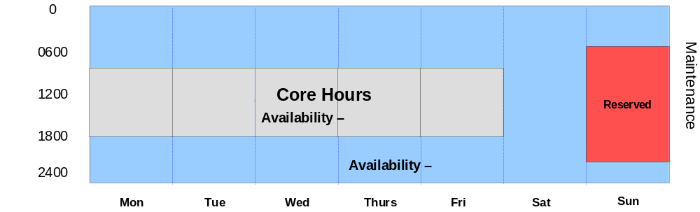

Release Window:
- ERCOT will schedule 11 planned application releases per year during the following timeframe. Changes to this schedule are handled as exceptions, below.
- Weekends 7:00pm Saturday until 12:00am Monday (29 hours)
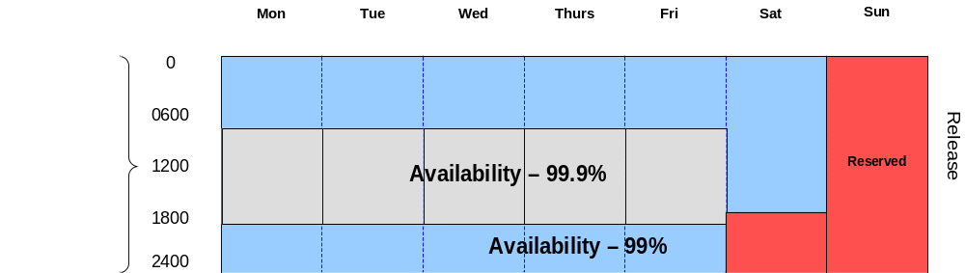

Annual Extended Release Window:
- If needed ERCOT will schedule 1 planned extended application releases per year during the following timeframe. Changes to this schedule are handled as exceptions, below. An extended release is planned for 2027.
- Weekends 2:00pm Saturday until 12:00am Monday (34 hours)

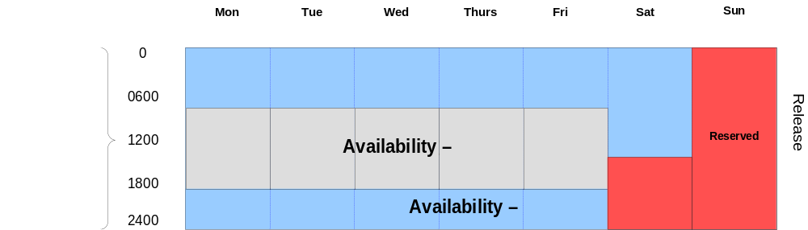

2027 APPLICATION RELEASE SCHEDULE

*Exceptions:
ERCOT will update and communicate maintenance and release expectations via the stakeholder process. Exception requests to the maintenance and release windows included in this SLA will first be addressed at the Texas Data Transport and MarkeTrak Systems (TDTMS) Working Group. TDTMS will be responsible for providing a recommendation to RMS based upon the consensus of the working group. RMS has the responsibility for approving or disapproving the exception request.

Changes or postponement to release dates require a 15 day notice. Cancellation of release dates requires a minimum 10 day notice.
If the timeframe between a TDTMS meeting where an exception is requested and the subsequent RMS meeting is greater than the required 15 days, an e-mail vote will be requested of RMS to address the exception request.

As part of on-cycle releases and system changes, ERCOT may schedule changes during business hours that have limited impact on production systems (i.e. security patch or minor configuration change). These changes will be communicated via Market Notice in a “Notes” section.

Retail Market Test Environment (RMTE)

RMTE does not have an official SLA, but the expectation and objectives for environment support will be Monday-Thursday 9AM-4:00PM and 9:00AM-1:00PM on Friday.

Note: Should you have any specific questions, please contact your ERCOT Account Manager or the ERCOT Service Desk for clarifications at (512) 248-6800 or servicedesk@ercot.com. A ticket will be generated by ERCOT and the issue will be tracked to completion.

Release Calendar

Release ID | Release Type | Prod Release | Retail Weekday | Retail Weekend Release
R1 | Application | 1/27 - 1/28 | 1/28 – 4:30PM-5:30PM | 7-Feb
R2 | Application | 2/24 - 2/25 | 2/25 – 4:30PM-5:30PM | 7-Mar
R3 | Application | 3/24 - 3/25 | 3/25 – 4:30PM-5:30PM | 11-Apr
R4 | Application | 4/28 - 4/29 | 4/29 – 4:30PM-5:30PM | 9-May
R5 | Application | 5/26 - 5/27 | 5/27 – 4:30PM-5:30PM | 13-Jun
R6 | Application | 6/23-6/24 | 6/24 – 4:30PM-5:30PM | 11-Jul
R7 | Application | 7/28 - 7/29 | 7/29 – 4:30PM-5:30PM | 8-Aug
R8 | Application | 8/25 - 8/26 | 8/26 – 4:30PM-5:30PM | 12-Sep
R9 | Application | 9/29 - 9/30 | 9/30 – 4:30PM-5:30PM | 10-Oct
R10 | Application | 10/27 - 10/28 | 10/28 – 4:30PM-5:30PM | 7-Nov
R11 | Application | 12/15 - 12/16 | 12/16 – 4:30PM-5:30PM | 5-Dec

Availability Breakdown:
Service availability will be measured as a percentage of minutes that the service is available compared to the total number of minutes, excluding planned maintenance outage window time.

ERCOT will report SLA availability metrics for both core hours (99.9%) and non-core hours (99%).

Core Hours: Gross minutes per year at 99.9% = 187,200 (7am-7pm, 5 days/week, 52 weeks/year)

99.9% availability = 187.2 unplanned outage minutes per year, or 3.12 hours

Non-core Hours: Gross minutes per year at 99% = 338,400
- Reserved maintenance outage minutes per year = 39,240
- 338,400 – 39,240= 299,160 net availability minutes per year

99% availability = 2,992 unplanned outage minutes per year, or 49.86 hours

2.1.3 Market Notification and Reporting

ERCOT will measure and report monthly retail transaction processing service availability and track annual service availability for each calendar year. These results will be reported monthly through the ERCOT governance process that includes the Texas Data Transport and MarkeTrak Systems Working Group, the Retail Market Subcommittee, Technical Advisory Committee, and ERCOT Board of Directors.

ERCOT will maintain a log containing retail transaction processing incidents that will be updated monthly and made available on the ERCOT Market Notice Archives website (http://www.ercot.com/services/ comm/mkt_notices/archives/). This log will include service availability and detailed information regarding each incident related to retail transaction processing. ERCOT IT Management will make initial classification of each incident, based on criteria in Appendix A. Upon review through the stakeholder process, this classification may be changed.

2.2 MarkeTrak

2.2.1 Service Scope

The MarkeTrak tool is a web-based application used to track, manage, and store data utilized by ERCOT and Market Participants (MPs). This tool is the supported method to track ERCOT Retail market issue management and data discrepancies in the market.

Included in the scope of the MarkeTrak service are the user interfaces that MPs use to create, contribute to, and resolve issues. These are the API (application programmatic interface) and the GUI (graphical user interface).

2.2.2 Service Availability

ERCOT targets MarkeTrak and its user interfaces, both the GUI and API, to be available 99% of the time from 7:00am – 7:00pm during business days and Saturday 8:00am – 12:00pm. ERCOT intends for MarkeTrak and its user interfaces to be available outside of this time frame, however this time will not be included in the service availability metric for MarkeTrak.

Outages of any duration that occur within the operating window specified above will be counted against the MarkeTrak service availability metric. Market Notices will only be sent for outages lasting more than 30 minutes.

Performance Monitoring

ERCOT will track average response times for API Query List, Query Detail, Update, and also the GUI. Average response times will be extracted from ERCOT’s integration application for the API, and from synthetic transactions for the GUI. Benchmark performance service level objectives (SLO) for the API and GUI are determined by the TDTMS and approved by RMS, and may be reviewed periodically. ERCOT reports on the performance of the API and GUI, monthly, and the target service level objectives are defined per the following chart.

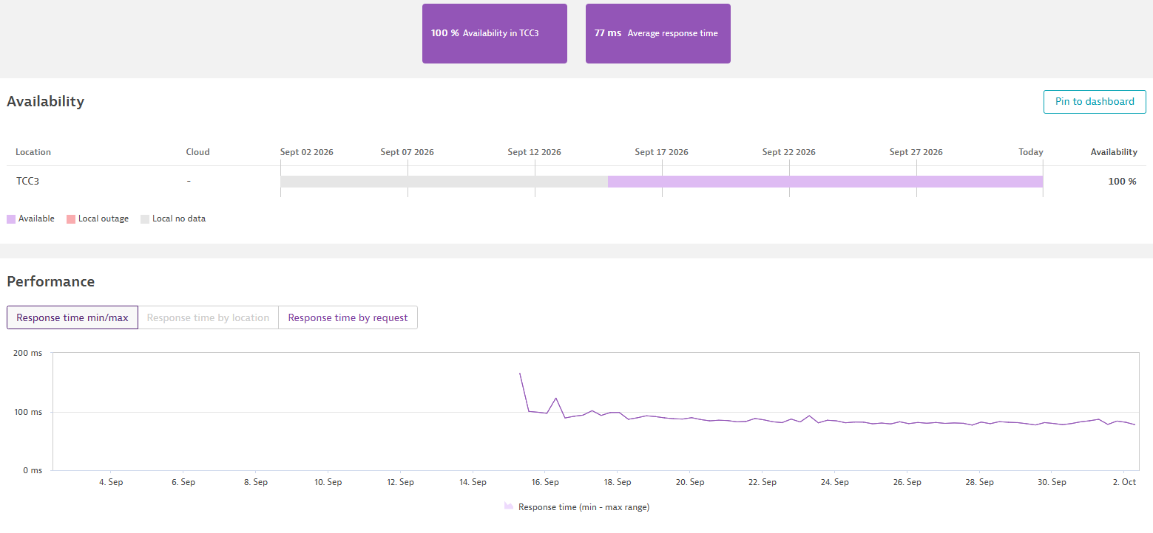

Example of monthly MarkeTrak UI Reporting

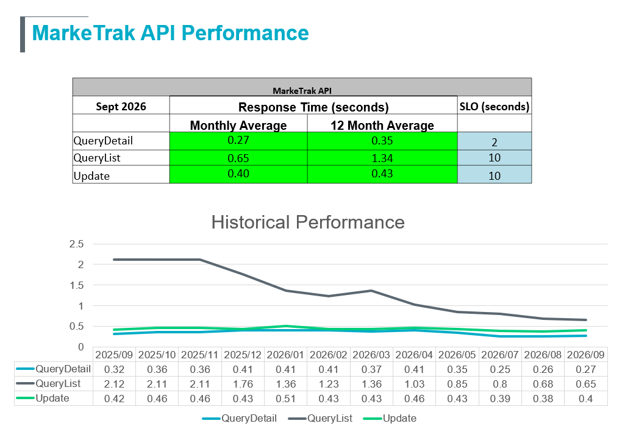

Example of monthly MarkeTrak API performance reporting

Maintenance:
Maintenance can be performed anytime outside of the availability timeframe (7:00am -7:00pm business days and Saturday 8:00am – 12:00pm). Market notices will be sent prior to performing any planned maintenance.

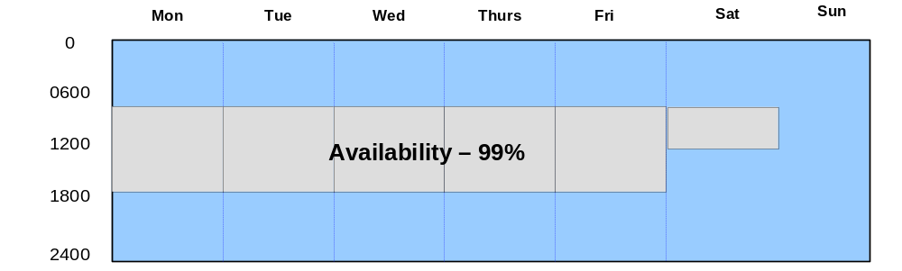

Availability Monitoring:
Availability for MarkeTrak is monitored through synthetic transactions which execute scripts against the IT applications at 5 minute intervals. Upon returning a valid response, and not exceeding the timeout threshold, the IT application will be considered available. If this method cannot be used due to issues with the monitor, the availability may be calculated by application or hardware uptime, and outage detection through operational monitoring tools.

2.2.3 Market Notification and Reporting

ERCOT will measure and report monthly MarkeTrak user interface service availability and performance and track annual service availability and performance for each calendar year. These results will be reported through the ERCOT governance process and includes the Texas Data Transport and MarkeTrak Systems Working Group, the Retail Market Subcommittee, the Technical Advisory Committee, and the ERCOT Board of Directors.

3.IT Services Reporting

Service availability and impacting events related to the IT services described in this document will be reported monthly to the Texas Data Transport and the Retail Market Subcommittee. The availability metrics and detailed market notice log will be updated monthly and posted to the Retail Market Subcommittee website on www.ercot.com.

Elements included in the detailed report are:

- Date of Market Notice
- Outage Date
- Market Notice Subject
- Market Notice ID
- Notice Status (Initial/Follow Up)
- Type (Planned/Unplanned)
- Incident Status (Complete/Upcoming/Ongoing)
- Business Service (Retail/Non-Retail)
- Notable Impacts

Market Participants may provide data and information regarding the notable impacts of an incident to ERCOT to be included in the monthly report detailed above. Information provided to ERCOT for the purposes of inclusion in the incident log will be treated as confidential and may be submitted to their client representative.

4. Service Availability Renegotiations and Change Control Process

Renegotiations of ERCOT retail market IT services can be initiated by either Market Participants or ERCOT management by making a request to the Retail Market Subcommittee.

Version control in the form of document version numbering will be maintained in this document as a means of providing a change control process.

5. Annual Review Process

ERCOT is committed to providing IT services to the competitive electric market in Texas. ERCOT intends that the IT services described in this document align with market participant requirements to the extent that is operationally feasible. To maintain alignment between the requirements of the market participants and the retail market IT services delivered by ERCOT, the service availability targets defined in this document will be reviewed at least annually.

6. Approvals

Area of Responsibility | Role for Approver | Reviewed / Approved | Date
ERCOT IT Operations | ERCOT IT Operations Manager | Approved
ERCOT Retail Business Operations | ERCOT Retail Business Operations Manager | Approved
Retail Market Subcommittee | RMS Chair | Approved

Appendix A: Definitions

This section contains definitions of the systems referred to in this document and of the commonly used acronyms.
- Availability: The ability of a component or IT service to perform its required function over a stated period of time
- Core Hours: 7am to 7pm Monday through Friday excluding ERCOT holidays
- Degradation: An event that causes the availability of ERCOT IT systems to be impacted while still allowing for processing of or access to these systems
- Extended Unplanned Outage: Outage greater than 1 hour during core hours (7am to 7pm Monday-Friday) and Saturday 7am to 7pm
- Electronic Data Interchange (EDI): the transfer of data electronically
- Gross minutes - total minutes in a month
- Incident: Any event that causes the agreed levels of service of ERCOT IT systems to be impacted
- Integration: The creation of links between previously separate computer systems, applications, services or processes
- NAESB: The North American Energy Standards Board (NAESB) serves as an industry forum for the development and promotion of standards which will lead to a seamless marketplace for wholesale and retail natural gas and electricity. The Texas electric market has implemented NAESB EDM v1.6 as the required data transport mechanism.
- Net minutes: gross minutes minus planned outage minutes
- Outage : a temporary period where ERCOT IT systems are unavailable
  - Planned Outage: a planned change in ERCOT IT systems that leads to them being unavailable
  - Unplanned Outage: any incident resulting in the unexpected failure of a computer or network hardware system or software application causing ERCOT IT systems to be unavailable. In determining if an incident is classified as an unplanned outage or a degradation, ERCOT may use the following benchmark:
    - Retail Processing: an unplanned outage would be declared if an incident leads to over 15% of transactions being out of protocol during the period the incident occurred
- Planned outage minutes: minutes used by ERCOT during the maintenance and release windows
- Proxy Server: a server which services the requests of its clients by forwarding requests to other servers
- Registration Application: ERCOT’s customer relationship management system (excluding eService application for Wholesale Settlement disputes)
- Retail Transactions:
  - 814 – Enrollment transaction used for registration in the retail market
  - 867 – Usage transaction used for reporting consumption or generation of electricity
  - 824 – Application advice transaction used for responding to errors on 867 usage transactions
  - 997 – Acknowledgement transaction
- Service availability percent: the percent of time that retail transaction processing services were available, not including planned outage minutes
- Unplanned Outage minutes: minutes retail transaction processing services were not available that are outside of the planned use of the maintenance and release windows

