NPRR Number | 1348 | NPRR Title | Telemetry Offsetting for Provisional Controllable Load Resources
Date |  | October 6, 2026
Submitter’s Information
Name |  | Arushi Sharma Frank
E-mail Address |  | contact@luminarystrategiesllc.onmicrosoft.com
Company |  | Luminary Strategies
Phone Number |  | 571-572-9037
Cell Number
Market Segment |  | Not applicable

Comments

COMMENTS OF LUMINARY STRATEGIES, LLC
IN SUPPORT OF Nodal Protocol Revision Request (NPRR) 1348
Submitted by: Luminary Strategies, LLC
Summary. Luminary Strategies supports NPRR1348 and supports the filing party’s request for urgent consideration. Telemetry Offset is effectively a holy grail solution to the speed-to-power problem for artificial intelligence and other large loads that need operationally bankable power while transmission, generation, storage, and other infrastructure catch up to demand. The most important market question it solves, is the following: if a Provisional Controllable Load Resource (PCLR) and a battery or generator are already co-located and separately visible to ERCOT, what additional information does Telemetry Offset provide? These comments answer that operating question first, then address the commercial, reliability, and public-policy consequences.

EXPLAINER: WHAT NPRR1348 CHANGES FOR ERCOT Security-Constrained Economic Dispatch (SCED)
THE MARKET QUESTION
If the PCLR and the battery or generator are already at the same substation and visible to ERCOT, why is Telemetry Offset necessary?
Same-node co-location establishes electrical equivalence. It does not, by itself, change the PCLR operating envelope that SCED receives. Under the current separate-Resource-ID structure, the PCLR still presents the entire band between Baseline Low Power Consumption (LPC) (its firm allocation) and Maximum Power Consumption (MPC) (the delta between LPC and MPC is the flex/grid headroom used by the PCLR load) as load flexibility available for curtailment. The paired Resource can relieve the same constraint and the PCLR can still remain fully available for a second action. NPRR1348 gives the Qualified Scheduling Entity (QSE) a Protocol-governed method to translate verified paired Resource capability into a temporary increase in the PCLR telemetered LPC, reducing the residual PCLR flexible band (i.e., increasing dynamic firming for the load) presented to SCED while the paired capability exists. Lower PCLR exposure, higher generation-battery exposure at the same node, means more data center and industrial loads can hedge their curtailment risk and ultimately sign up to be a grid asset in ERCOT.

1. The operating math is straightforward
For a standalone PCLR, the studied Baseline LPC is the grid-backed floor and MPC is the upper consumption limit. The difference between those two values is the PCLR flexible band available to SCED. NPRR1348 defines Offset LPC MW as the amount by which the telemetered LPC exceeds Baseline LPC and limits that increase to the paired Resource capability that is actually available. The practical result is a smaller residual PCLR flexible band for as long as the paired capacity is present.

Without Telemetry Offset | Residual PCLR flexible band = MPC - Baseline LPC
With Telemetry Offset | Residual PCLR flexible band = MPC - (Baseline LPC + Offset LPC MW)
Protocol limit | Offset LPC MW <= Aggregate Available Telemetry Offset Capacity
The formulas above describe the PCLR operating envelope. The paired Generation Resource or ESR remains a separate Resource and remains visible to ERCOT; the QSE is changing the PCLR LPC telemetry within the protocol-defined limit, not combining the two Resource IDs.
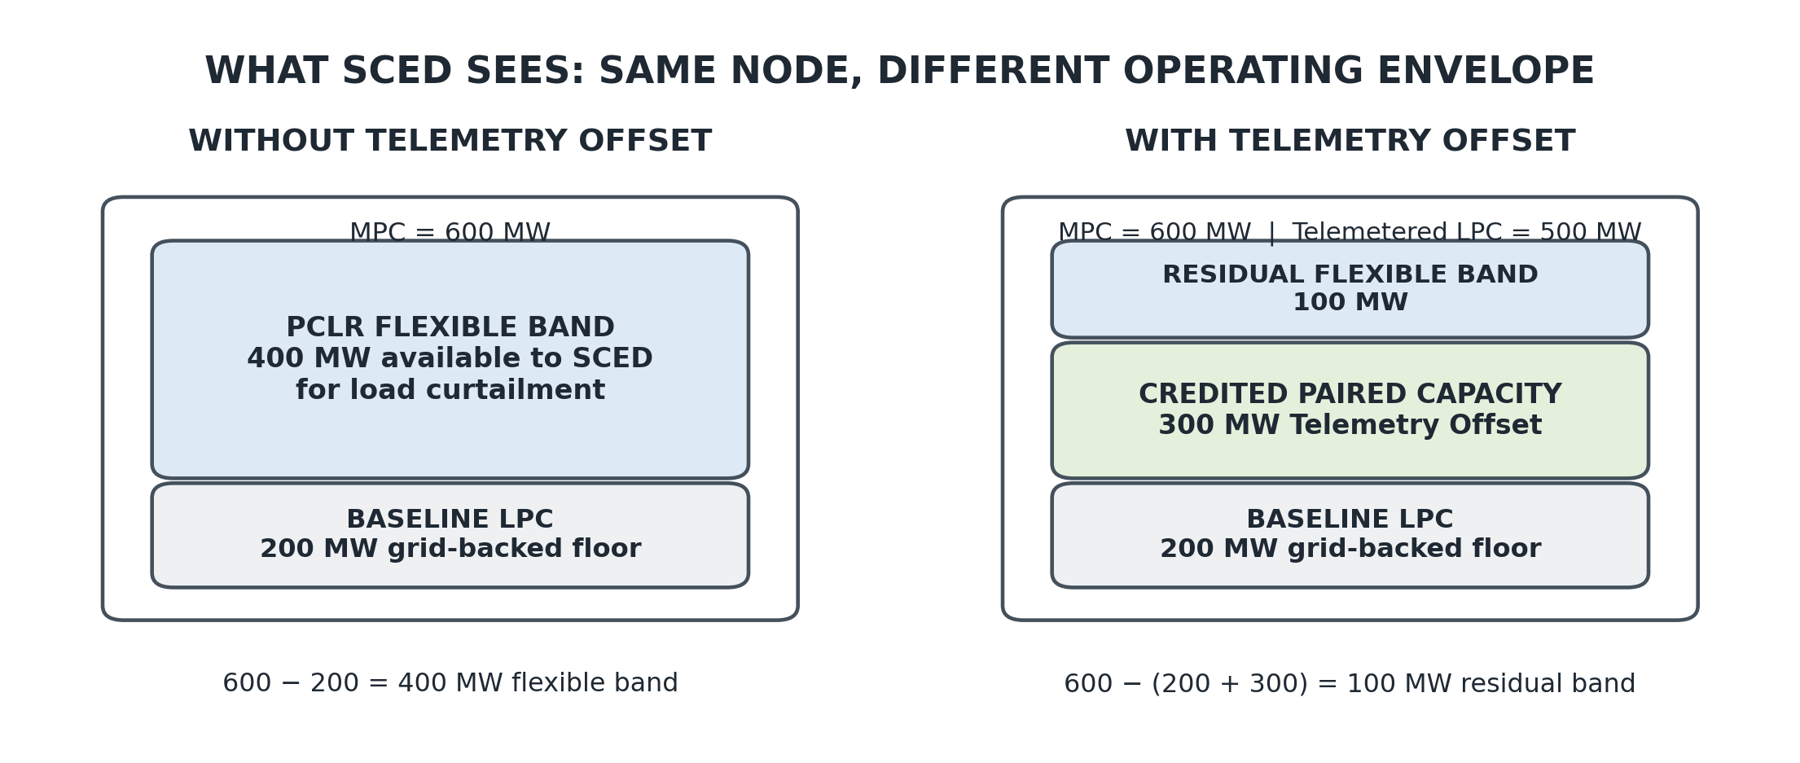
Figure 1. Illustrative only. The example shows the protocol mechanics using round numbers; it is not a project-specific operating case.
2. A worked example showing what changes
Assume an illustrative PCLR with MPC of 600 MW and Baseline LPC of 200 MW. Without Telemetry Offset, the PCLR presents a 400 MW flexible band to SCED. If 300 MW of paired BESS or Generation Resource capability qualifies and is available, the QSE may telemeter the PCLR LPC at 500 MW. The residual PCLR flexible band falls to 100 MW. If the paired capability derates to 100 MW, the telemetered LPC must fall to 300 MW and 300 MW of PCLR flexibility becomes available again. If the paired capability is unavailable, or the Energy Emergency Alert (EEA) provisions require the offset to terminate, the LPC returns to the 200 MW Baseline LPC and the full 400 MW PCLR flexible band is restored. These reliability guardrails are robustly addressed in filed NPRR1348 (September 29, 2026).

Operating state | Telemetered LPC | MPC | Residual PCLR flexible band
Standalone PCLR; no offset | 200 MW | 600 MW | 400 MW
300 MW paired capacity available | 500 MW | 600 MW | 100 MW
Paired capacity derates to 100 MW | 300 MW | 600 MW | 300 MW
Paired capacity unavailable / EEA | 200 MW | 600 MW | 400 MW restored

3. How the NPRR works in Real-Time

1 | PCLR and paired Generation Resource/ESR remain separate Resource IDs, separate meters, separate telemetry, and independently visible to ERCOT at the same Resource Node.
2 | The QSE calculates the paired Resource capacity that is actually available for Telemetry Offset in the current operating state.
3 | The QSE may raise the PCLR telemetered LPC above Baseline LPC by no more than that available paired capacity. The PCLR flexible band presented to SCED therefore becomes smaller.
4 | SCED continues its existing optimization against the operating envelope it receives. The paired Resource remains separately dispatchable and the PCLR remains a controllable Load Resource.
5 | If paired capability falls, the QSE lowers the PCLR LPC automatically; if the pair becomes unavailable or an EEA applies, the unsupported PCLR flexible band returns to ERCOT.

This sequence illustrated above is the core of NPRR1348. The qualifying architecture establishes the physical equivalence before the operating envelope reaches SCED. The QSE then carries the Real-Time obligation to represent the paired capability accurately. SCED continues to solve the same security-constrained economic dispatch problem against the operating envelope it receives, and ERCOT verifies after the Operating Day that the claimed Offset LPC MW were physically supported.
WHAT PROBLEM NPRR1348 SOLVES
The problem is operational attribution. ERCOT already knows where separately metered Resources are located, and same-node co-location gives the pair equivalent shift-factor impact. The missing market function is the ability to recognize, in the PCLR operating envelope, how much of the provisional-service obligation is currently being performed by the paired Resource. Without that attribution, a customer can finance exactly the battery or generation Texas should want built at the constrained location and still underwrite the full Baseline LPC-to-MPC PCLR curtailment band as though that mitigation had no customer-specific operating value.
That distinction matters especially for continuous-compute loads. Aurora Energy Research modeled a local congestion event in which a co-located but non-netted BESS provided essentially no preparation time because SCED immediately required more relief than the BESS could provide. In the netted case, a four-hour BESS fully shielded the PCLR during the first four hours of the event; after the battery discharged, the PCLR again became exposed to curtailment, now with four hours of lead time. The value proposition therefore includes preparation time as well as fewer modeled curtailment hours. A data center can design compute, cooling, and other site controls around a bounded residual exposure once the amount of paired-resource support is known.
This is also where commercial-to-power control plane- to compute control plane architecture becomes possible. A paired battery or generator can support a defined first layer of the provisional-service obligation, and the Load can engineer the remaining flexible band. The resulting pieces can be priced, contracted, insured, and financed separately while remaining operationally connected. The GCA public stakeholder briefing describes the same point in plain terms: the QSE raises the PCLR telemetered LPC to match available paired capability, one layer above SCED, and the unsupported portion of the load remains available for curtailment.
BACKGROUND: PCLR CREATED SPEED-TO-POWER; TELEMETRY OFFSET HARDENS THE FIRMING LAYER
Luminary Strategies originated the Provisional Controllable Load Resource architecture through Planning Guide Revision Request (PGRR) 134, later implemented through PGRR145, Batch Zero Process for Large Load Interconnections, and the related Protocol revisions. The original objective was to establish dispatchability in exchange for speed: a qualifying Large Load could energize before full transmission upgrades were complete, receive a studied grid-backed floor through the LPC, operate above that floor on a provisional basis, and remain visible and controllable through ERCOT SCED.
The original allocation of responsibility was also deliberate. The grid provides the floor. The customer assumes the delivery risk associated with the provisional band above that floor. Firm access replaces provisional access as the transmission upgrades come into service. NPRR1348 hardens that architecture by giving the customer a protocol-defined way to privatize a measurable portion of the provisional delivery risk with co-located, separately visible generation or storage. The filed NPRR describes PCLR as ERCOT's native grid-integrated speed-to-power mechanism and Telemetry Offset as the layer that converts open-ended PCLR curtailment exposure into a bankable obligation. We agree with that characterization and fully support a solution for Texans to keep the grid strong, loads powered, and investment coming inside ERCOT’s grid, not outside of it.
I. Dispatchability Created Speed-to-Power. Attribution Makes the Risk Financeable.
PCLR answered the threshold interconnection question: a large load can energize before every firm-service upgrade is complete if it accepts a studied floor and a dispatchable provisional band. NPRR1348 addresses the financial and operating consequence of that bargain. Without attribution, the Load must plan around the entire difference between Baseline LPC and MPC as open-ended curtailment exposure and the only tool it has to manage this risk is private bidding behavior that seeks to advance a battery or generator availability to SCED before SCED calls on the loads. Telemetry Offset allows a defined portion of that band to be supported by paired Resource capacity, leaving a measurable residual PCLR flexibility obligation for the Load to engineer and contract. This gives the load time, space, and shield to cover the risk it financed in the marketplace by sponsoring generators and/or batteries at the same node.
That bounded residual, reflected in grid policy as proposed in NPRR1348, is a commercial breakthrough. A load can finance longer-duration storage, grid-connected thermal generation, compute flexibility, cooling flexibility, IT/OT controls, or other site-response products against a defined operating obligation. These solutions all rely on an ability to connect their commercial value proposition to a delivered and measurable reliability outcome. Telemetry Offset supplies the attribution layer that makes the pieces additive rather than duplicative.
• A load can finance a co-located, separately metered and grid-visible battery, including duration that may be difficult to support from existing energy and ancillary-service revenues alone.
• A load can finance co-located, separately metered generation that remains available as an ERCOT Resource rather than moving the entire firming solution off-grid.
• A load can design compute, cooling, process, and other site-flexibility products around the residual PCLR flexible band that remains after credited paired capacity is accounted for.
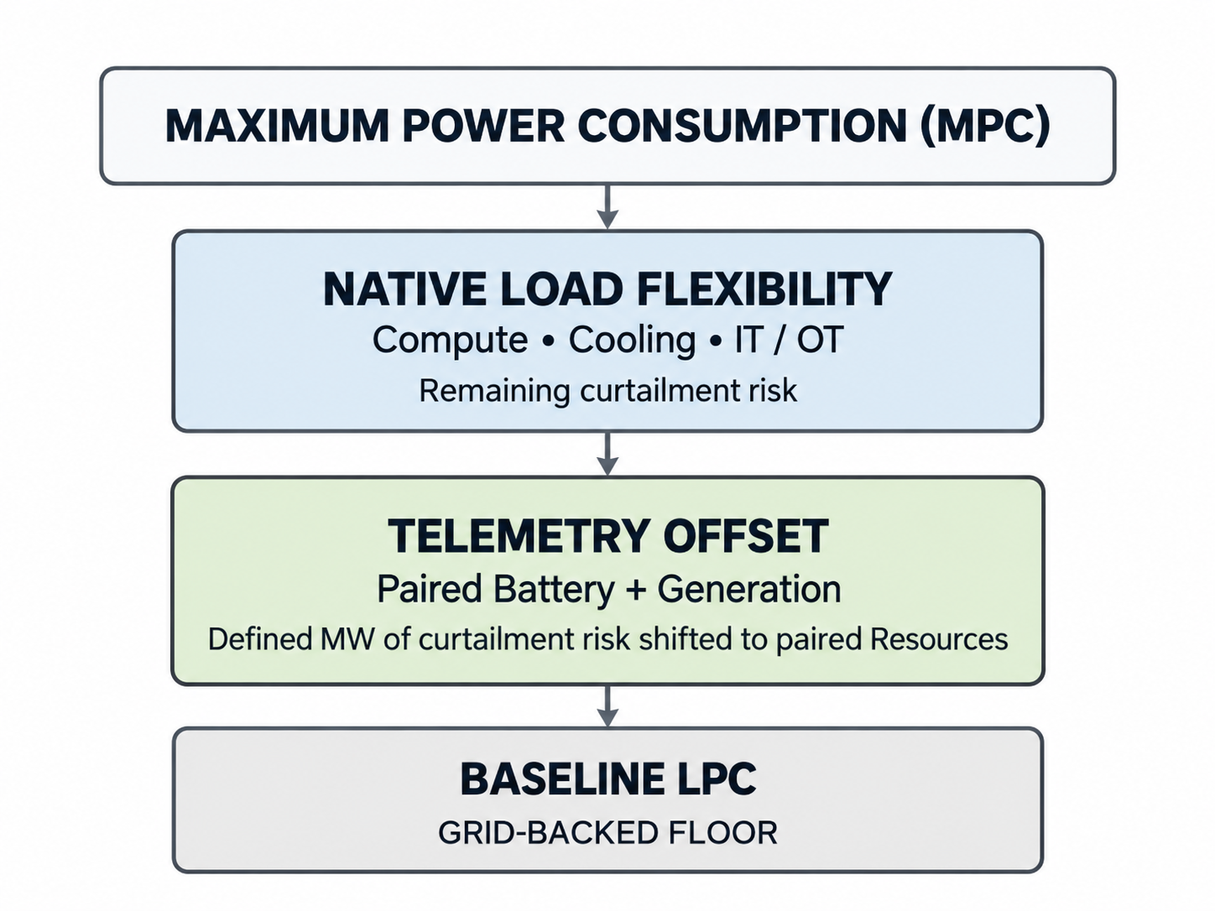

II. Steel Is Fuel for the ERCOT Grid and the Texas Economy.
Large loads are already evaluating behind-the-meter generation, private electrical systems, and fully off-grid configurations because those structures can offer operating certainty. NPRR1348 creates a market reason for the same private firming capital to remain inside the ERCOT ecosystem. A customer that needs speed-to-power can help finance a new battery or generator at the location where the reliability exposure exists, while that asset remains a separately visible ERCOT Resource.
The filed Business Case is explicit about the objective: Telemetry Offset gives Large Loads a commercial reason to finance co-located batteries and generation as separately metered ERCOT Resources, aligns short-term firming needs with longer-term merchant economics, and leaves those Resources positioned for broader market participation after the transmission upgrades are completed and the PCLR transitions to firm service.
This matters for resource duration and merchant development. A customer willing to pay for a defined quantity of localized firming can provide an incremental revenue stream for longer-duration storage or nimble generation. That private demand for reliability can support more physical infrastructure on the public grid, with the same asset retaining value to other market participants when it is not supporting the PCLR.
III. Co-Location Supplies the Physical Equivalence Required for One-for-One Attribution.
The physical boundary in NPRR1348 is essential. A Telemetry Offset Resource Pair consists of a PCLR and a Generation Resource or ESR represented by the same QSE, located at the same Resource Node, distinctly metered, and formally designated by ERCOT. Same-node location provides the shift-factor neutrality that makes one-for-one substitution defensible. Every MW temporarily removed from the PCLR dispatchable range must be backed by one MW of qualifying paired Resource capability.
ERCOT already recognizes a same-substation geographic relationship for certain settlement purposes. NPRR1348 extends that physical logic into operations and tightens the qualification to the same Resource Node. That distinction is important because planning tools can value distributed congestion relief across multiple locations, but real-time one-for-one operating attribution requires a stronger physical equivalence. The qualifying pair establishes that equivalence before the QSE changes the PCLR operating envelope.
IV. The QSE Is the Correct Place to Carry the Operating Responsibility.
NPRR1348 assigns meaningful responsibility to the private market participant that represents both sides of the relationship. The QSE calculates the available paired capability, raises the PCLR telemetered LPC only within that capability, updates the offset when paired capacity changes, and remains subject to ex-post verification. If paired capacity falls, the proposed Protocol requires an automatic control system to reduce the PCLR LPC without intentional delay and transmit the updated LPC to ERCOT within ten seconds.
This structure aligns the commercial promise with the operating promise. If a customer and Resource developer tell lenders that a battery or generator will support a defined quantity of provisional load, the QSE must represent that relationship in actual operating telemetry. A reduction in paired capability shrinks the supported portion of the PCLR operating envelope. The private parties receive the commercial benefit of attribution and accept the real-time obligation to keep the representation accurate.
V. NPRR1348 Preserves the SCED Architecture and Improves the Operating Representation.
The PCLR and paired Generation Resource or ESR remain separately registered, separately metered, and independently visible at the same Resource Node. The pair remains composed of distinct Resources. The QSE manages the PCLR operating envelope upstream of SCED, and SCED continues its existing optimization against the values and Protocol representation it receives. ERCOT then verifies after operation that each claimed Offset LPC MW was backed by sufficient paired capability.
This distinction is central to understanding the proposal. Telemetry Offset does not require SCED to discover a private commercial relationship or combine the pair into one Resource. The Protocol defines when the QSE may change the PCLR LPC, how much it may change, and when that change must be reversed. ERCOT keeps separate visibility into the generation, storage, and load while receiving a more accurate statement of the PCLR flexible band that remains available for curtailment.
VI. The Reliability Hand-back Is Automatic.
Private firming is useful only if ERCOT can recover the underlying PCLR flexibility when the substitute capability disappears. NPRR1348 builds that release back to SCED, directly into the operating rule. A derate, outage, depletion, or other loss of available paired capacity requires the PCLR LPC to fall. At EEA Level 1 or higher, the temporary offset terminates and the PCLR returns to Baseline LPC for the duration of the event, while the paired Resource remains separately visible and available to ERCOT.
The PCLR also remains responsible for demonstrating its underlying ability to reduce from its highest telemetered LPC back to Baseline LPC at the required Emergency Ramp Rate without relying on the paired Resource. The architecture therefore preserves the original PCLR reliability bargain while allowing private firming to carry a defined portion of the burden during normal operation.
VII. Telemetry Offset Provides a Private Firming Layer During the Transmission Buildout.
Texas will continue building transmission for years, and many projects that ultimately expect firm service will operate through a period in which the required network upgrades are incomplete. PCLR already allows productive consumption above a studied LPC subject to congestion. Telemetry Offset makes that provisional operating period more commercially usable by allowing qualifying co-located Resources to support a defined portion of the PCLR operating obligation while the long-term network solution proceeds.
The practical result is a private firming layer at the location where the congestion exposure exists. The customer can place more dispatchability and more steel in the ground, a battery or generator can support the Load during constraint conditions and participate more broadly when available, and the Resource can remain part of the Texas resource base after the provisional period ends. This is a powerful way to make speed-to-power additive to grid capability rather than a reason to retreat from the public system.
VIII. The Larger Opportunity Is Prosperous Infrastructure.
The durable answer to extraordinary load growth requires more private capital to assume more responsibility for the infrastructure consequences of that growth. Telemetry Offset aligns those incentives in a concrete operating architecture:
- The load wants speed-to-power and therefore has a reason to finance new generation or storage.
- The Resource developer gains an anchor customer for part of the project economics. ERCOT keeps the Resource visible inside its market.
- The QSE has an enforceable obligation to represent the relationship dynamically. The Load remains curtailable when the supporting capability disappears.
- Transmission upgrades continue toward the eventual firm-service condition.
The same investment that solves a private commercial problem can therefore expand the volume of dispatchable infrastructure available to the public system. That is the Prosperous Infrastructure outcome Luminary has advocated throughout the development of PCLR: market architecture that allows private investment to become more valuable because it makes the public grid stronger, larger, and more usable.
Conclusion
Luminary Strategies supports NPRR1348 and requests urgent consideration. PCLR established the first layer of dispatchability in exchange for speed-to-power. Telemetry Offset supplies the attribution layer required to make private firming of that dispatchability measurable and financeable. The PCLR and paired Resources remain separate and visible, the QSE carries the operating responsibility, SCED continues its existing optimization against a more accurate PCLR operating envelope, and the underlying PCLR flexibility returns when paired support is unavailable.
Texas can allow private capital to build around a clearly defined public-grid product, or it can watch that same private capital solve the problem outside the public system. NPRR1348 provides a disciplined path for the first outcome and should advance on an urgent timeline.
Respectfully submitted,
Arushi Sharma Frank
Founder & Principal
Luminary Strategies, LLC
Revised Cover Page Language
None
Revised Proposed Protocol Language
None

ERCOT, NPRR1348, Telemetry Offset for Provisional Controllable Load Resources, 1348NPRR-01, at 3-5 (posted Sept. 29, 2026) (explaining that separate Resource IDs and telemetry create the attributability gap, while the QSE may raise the PCLR telemetered LPC only to the extent verified paired capability exists). See also Global Capacity Alliance, NPRR1348 Telemetry Offsetting for PCLRs: Stakeholder Briefing Memo 1 (Oct. 5, 2026).
Filed NPRR1348, proposed Sections 2.1 and 3.8.9(1). The proposal defines Offset LPC MW as the amount by which telemetered LPC exceeds Baseline LPC and limits that increase to Aggregate Available Telemetry Offset Capacity.
Id. proposed Section 3.8.9(1)-(3). The numerical values in this worked example are illustrative only and are used to show the Protocol mechanics.
NPRR1348 at 4-5; Global Capacity Alliance, Stakeholder Briefing Memo 1-2. The filed proposal states that the Resources remain separate, the QSE manages the PCLR operating envelope upstream of SCED, SCED continues its existing optimization, and ERCOT verifies performance after operation.
NPRR1348 at 3-6. The filing explains that SCED evaluates the separately metered Resources independently and that, without attribution, the Load must plan around the entire difference between Baseline LPC and MPC as open-ended curtailment exposure.
Aurora Energy Research, Curtailment Mitigation for PCLRs: Modeling the Effects of Front-of-Meter Netting 35 (Sept. 2026) (prepared for Google and V-Wire). Aurora modeled an extended local-curtailment event in which the non-netted BESS provided no lead time, while a netted four-hour BESS provided up to four hours of lead time before the PCLR again became exposed.
Global Capacity Alliance, Stakeholder Briefing Memo 1-2 (Oct. 5, 2026) (describing the attribution gap, QSE-managed LPC adjustment, and the unsupported portion of the Load remaining available for curtailment).
NPRR1348 at 2-3 (describing PCLR as ERCOT's native grid-integrated speed-to-power mechanism and Telemetry Offset as the mechanism that converts open-ended PCLR curtailment exposure into a bankable obligation).
Id. at 3-4 (explaining that Telemetry Offset allows a defined portion of the Baseline LPC-to-MPC exposure to be supported by paired Resource capacity, leaving a measurable residual flexibility obligation).
Id. at 6 (Business Case) (describing incentives for Large Loads to finance co-located batteries and generation as separately metered ERCOT Resources, with broader market participation after the speed-to-power period).
Id. at 4-5; proposed Sections 2.1 and 16.5.6 (same Resource Node, same QSE, distinct metering, and one-for-one backing of each Offset LPC MW by qualifying paired capability).
Id. proposed Section 3.8.9(2) (requiring automatic LPC adjustment without intentional delay and transmission of the updated telemetered LPC to ERCOT no later than ten seconds after a decrease in available paired capacity).
Id. at 4-5 (Operational Architecture Integrates into Existing QSE-Managed SCED Telemetry; Ex-Post Verification Keeps the Real-Time Change Narrow).
Id. at 4-6; proposed Section 3.8.9(2)-(3) (automatic reduction of LPC when paired capability falls and return to Baseline LPC during EEA Level 1 or higher).

