
August 2026 ERCOT Monthly Operations Report
Reliability and Operations Subcommittee Meeting
October 1, 2026

Table of Contents
1. Report Highlights 2
2. Frequency Control 3
2.1. Frequency Events 3
2.2. Automatic/Manual Load Resource Deployments 4
3. Reliability Unit Commitment 5
4. IRR, Wind, and Solar Generation as a Percent of Load 8
5. Energy Storage Resource (ESR) Output and State of Charge (SOC) Profile 9
6. Largest Net-Load Ramps 10
7. Congestion Analysis 11
7.1. Notable Constraints 11
7.2. Generic Transmission Constraint Congestion 25
7.3. Manual Overrides 26
7.4. Congestion Costs for Calendar Year 2026 26
8. System Events 27
8.1. ERCOT Peak Load 27
8.2. Load Shed Events 27
8.3. Stability Events 27
8.4. Notable PMU Events 27
8.5. DC Tie Curtailment 27
8.6. TRE/DOE Reportable Events 28
8.7. New/Updated Constraint Management Plans 28
8.8. New/Modified/Removed RAS 28
8.9. New Procedures/Forms/Operating Bulletins 28
9. Emergency Conditions 28
9.1. OCNs 28
9.2. Advisories 28
9.3. Watches 28
9.4. Emergency Notices 29
10. Application Performance 29
10.1. TSAT/VSAT Performance Issues 29
10.2. Communication Issues 29
10.3. Market System Issues 29
11. Model Updates 29
Appendix A: Real-Time Constraints 32

Report Highlights
The unofficial ERCOT peak load for August 2026 was 90,817 MW and occurred on 08/24/2026 during hour ending 18:00, this is 7,110 MW higher than the August 2025 peak demand of 83,707 MW on 08/18/2025.
On 15-minute settlement interval basis, maximum demand of 91,055 MW occurred on 8/24/2026 during interval ending 17:00 and minimum demand of 53,602 MW occurred on 8/02/2026 during interval ending 07:15.
- There were 2 frequency events.
- There were no events which required automatic/manual deployment of Load Resources that were controlled by an Under-Frequency Relays.
- There were 2 DC Tie Curtailment Notices for the DC_R due to transmission congestion and faulty equipment.
- There was 1 DC Tie Curtailment Notice for the DC_E due to transmission congestion.
- There was 1 OCN issued for an extreme hot weather event due to predicted high temperatures in the ERCOT North Central and South Central regions.
- There were 0 Advisories.
- There were 0 Watches.
- There were 0 Emergency Notices.
- There were 119 RUC commitments.
- A Renewable Generation Record of 53,029 MW was set on 08/13/2026 at 10:25.
- The following GTCs saw congestion in August:
GTC | Days Congestion
South Texas Export Pawnee - Spruce | 30
Nelson Sharpe - Rio Hondo | 29
East Texas | 28
South Texas Export Pawnee - Tango | 28
North Edinburg - Lobo | 24
North - Houston | 15
Panhandle | 14
West Texas | 11
McCamey | 7
Kinney | 1
North – Far West | 1

Frequency Control

Frequency Events
The ERCOT Interconnection experienced 2 frequency events.
A summary of the frequency events is provided below. The reported frequency events meet one of the following criteria: Delta Frequency is 60 mHz or greater; the MW loss is 350 MW or greater; resource trip event triggered ECRS deployment. Frequency events that have been identified as Frequency Measurable Events (FME) for purposes of BAL-001-TRE-2 analysis are highlighted in blue. When analyzing frequency events, ERCOT evaluates PMU data according to industry standards. Events with an oscillating frequency of less than 1 Hz are inter-area, while higher frequencies indicate local events. Industry standards specify that damping ratio for inter-area oscillations should be 3.0% or greater. For the frequency event listed below, the ERCOT system met these standards and transitioned well after the disturbance. In the case of negative delta frequency, the MW Loss column could refer to load loss.

Date and Time | Delta Frequency | Max/  Min Frequency | Duration of Event | PMU Data |  | MW Loss | Load | IRR | Inertia
Date and Time | (Hz) | (Hz) | Duration of Event | Oscillation Mode (Hz) | Damping Ratio | MW Loss | (MW) | % | (MW-s)
8/7/2026 13:16:28 | 0.056 | 59.961 | 00:06:59 | 0.64 | 14% | 757 | 83,512 | 47% | 312,477
8/18/2026 5:57:15 | 0.049 | 59.961 | 00:04:43 | 0.71 | 5% | 626 | 60,415 | 26% | 327,739

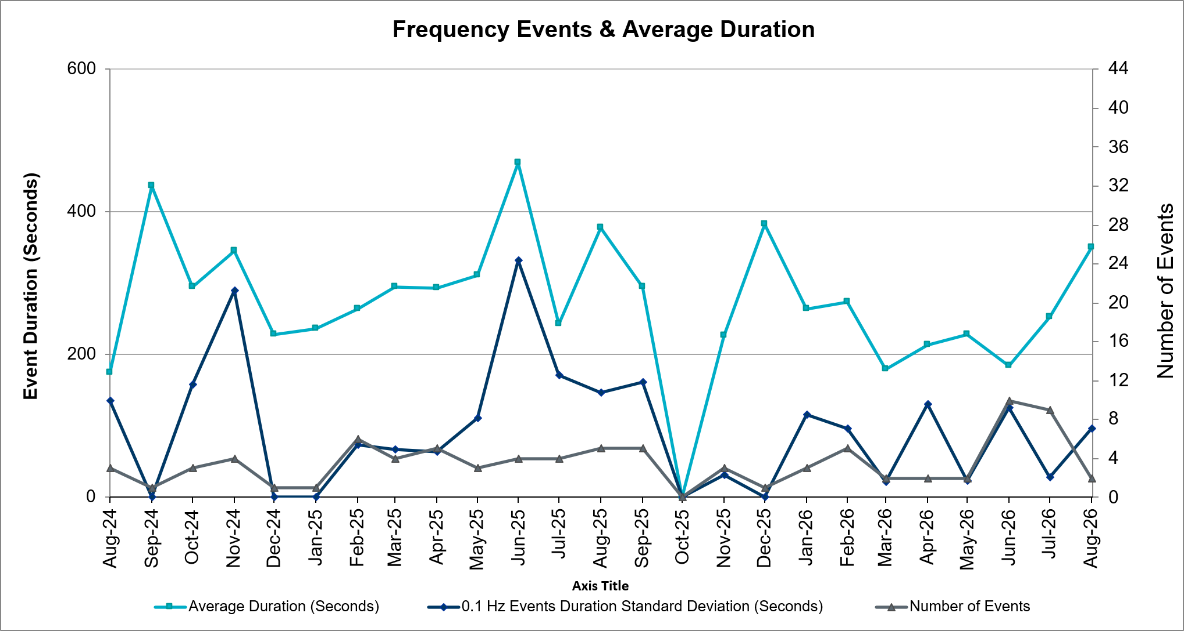
(Note: All data on this graph encompasses frequency event analysis based on BAL-001-TRE-2.)

Automatic/Manual Load Resource Deployments
There were no events which required automatic/manual deployment of Load Resources that were controlled by an Under-Frequency Relays.

Reliability Unit Commitment
ERCOT reports on Reliability Unit Commitments (RUC) monthly. Commitments are reported grouped by operating day and weather zone. The total number of hours committed is the sum of the hours for all the units in the specified region. Additional information on RUC commitments can be found on the MIS secure site at Grid Generation Reliability Unit Commitment.
There were 119 RUC commitments.
Resource Location | # of Resources | Operating Day | Total # of Hours Committed | Total MWhs | Reason for Commitment
NORTH_CENTRAL, SOUTH_CENTRAL | 7 | August 1, 2026 | 49 | 6,188.0 | Capacity AS, E_PASP
NORTH_CENTRAL | 6 | August 2, 2026 | 68 | 6,130.0 | Capacity AS
NORTH_CENTRAL | 7 | August 4, 2026 | 47 | 8,448.0 | Capacity AS
NORTH_CENTRAL | 7 | August 5, 2026 | 52 | 15,316.0 | Capacity AS
COAST, EAST, NORTH, NORTH_CENTRAL | 9 | August 6, 2026 | 59 | 16,678.0 | Capacity AS, DCDHTVW5, Min Run Time
COAST, EAST, NORTH_CENTRAL | 11 | August 7, 2026 | 65 | 10,066.0 | Capacity AS
EAST, NORTH_CENTRAL | 10 | August 8, 2026 | 104 | 24,654.0 | Capacity AS
EAST, NORTH_CENTRAL | 4 | August 9, 2026 | 13 | 4,927.0 | Capacity AS
EAST | 1 | August 10, 2026 | 4 | 2,008.0 | DCDHTVW5
EAST, NORTH_CENTRAL | 2 | August 12, 2026 | 8 | 3,656.0 | DCDHTVW5
NORTH_CENTRAL | 7 | August 16, 2026 | 48 | 3,896.0 | Capacity AS
NORTH_CENTRAL | 1 | August 17, 2026 | 4 | 48.0 | Capacity AS
NORTH_CENTRAL | 6 | August 18, 2026 | 31 | 2,197.0 | Capacity AS
COAST, NORTH_CENTRAL | 5 | August 19, 2026 | 35 | 2,126.0 | Capacity AS, Min Run Time
NORTH_CENTRAL | 1 | August 20, 2026 | 3 | 321.0 | Min Run Time
NORTH_CENTRAL | 2 | August 22, 2026 | 12 | 408.0 | Capacity AS
COAST, NORTH_CENTRAL, SOUTHERN | 7 | August 23, 2026 | 42 | 4,122.0 | Capacity AS
NORTH_CENTRAL | 4 | August 24, 2026 | 28 | 1,824.0 | Capacity AS
NORTH_CENTRAL | 3 | August 25, 2026 | 20 | 864.0 | Capacity AS
NORTH_CENTRAL | 4 | August 27, 2026 | 31 | 1,244.0 | Capacity, Capacity AS
NORTH_CENTRAL | 2 | August 28, 2026 | 8 | 192.0 | Capacity AS
EAST, NORTH_CENTRAL | 4 | August 30, 2026 | 16 | 2,876.0 | Capacity AS
EAST, NORTH_CENTRAL | 9 | August 31, 2026 | 74 | 17,859.0 | Capacity AS

IRR, Wind, and Solar Generation as a Percent of Load
The graph below shows the maximum, minimum and average aggregate solar, wind and IRR output as a percentage of total ERCOT load when evaluated as 10-minute averaged intervals, over the past 13 months. Current wind and solar generation and penetration records are listed in the footnote below. Maximum IRR penetration for August 2026 was 73.62% on 8/13/2026 interval ending 10:00 and minimum IRR penetration for August 2026 was 3.57% on 8/28/2026 interval ending 07:00.
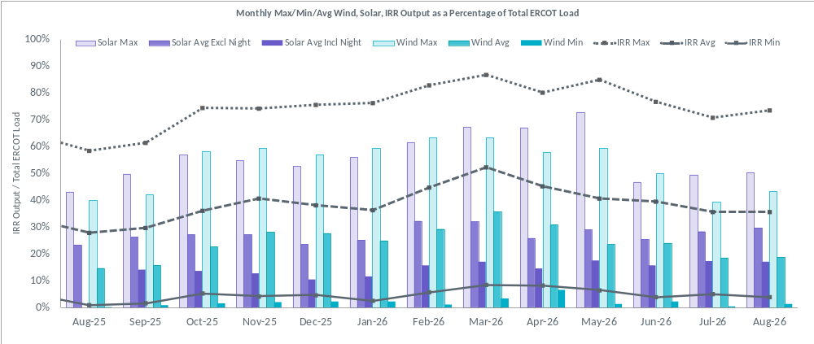
During the hour of peak load for the month, hourly integrated wind generation was 7,405 MW and solar generation was 29,705 MW. The graph below shows the wind and solar penetration percentage during the hour of the peak load in the last 13 months.
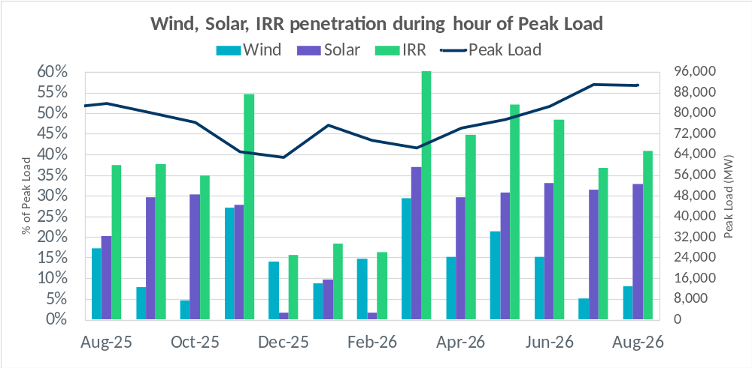

Lastly, the graph below shows the minimum wind, solar, and IRR output during the peak load hour as a percentage of the daily peak load for every day in the month.
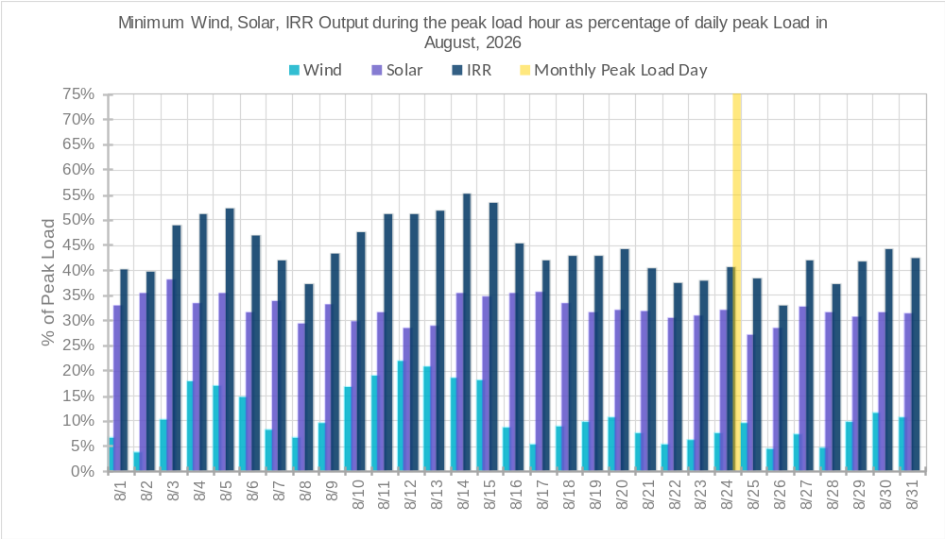

Energy Storage Resource (ESR) Output and State of Charge (SOC) Profile
The graph below shows how ESR SOC varies by Hour Ending (HE). The SOC is generally higher during the day and lower during night. During the month of August 2026, ESRs operated below 20% SOC for 26.49% of the time and below 10% SOC for 2.30% of the time. The minimum observed SOC was 6.96% on 8/26/2026 at interval ending 22:51, while the maximum was 94.63% on 8/28/2026 at interval ending 18:16.
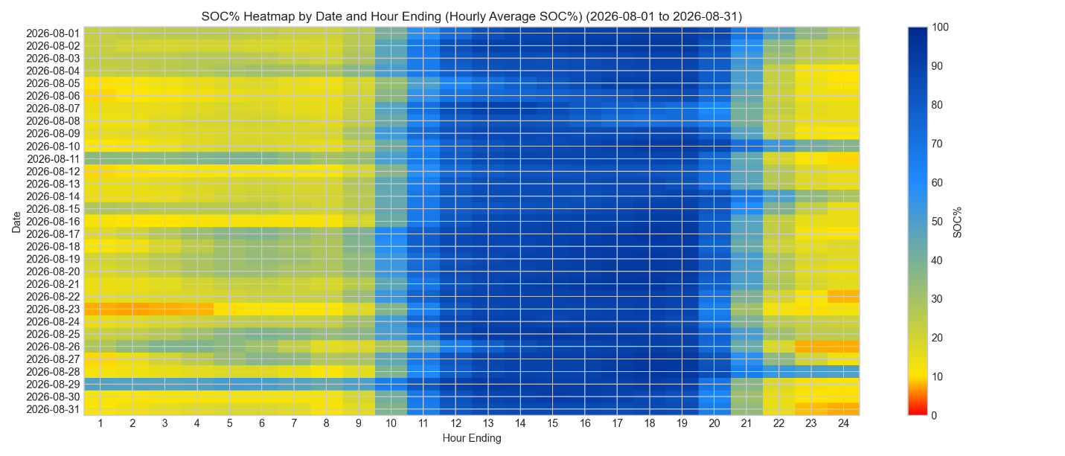
The chart below shows the maximum ESR output as a percentage of the total ERCOT Net Load. ESR penetration reached a maximum of 18.85% on 8/13/2026 at interval ending 20:10. The net load reached a peak of about 75702 MW on 8/26/2026 at interval ending 20:06.
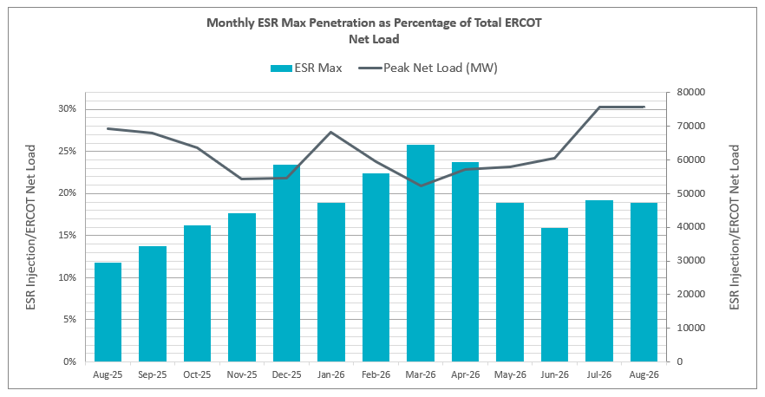

Largest Net-Load Ramps
The net-load ramp is defined as the change in net-load (load minus wind and PVGR generation) during the defined time horizon. Such a variation in net-load needs to be accommodated in grid operations to ensure that the reliability of the grid is satisfactorily maintained. The largest net-load ramps over 5-minute, 10-minute, 15-minute, 30-minute, and 60-minute intervals in August 2026 were 1,777 MW, 3,348 MW, 4,671 MW, 8,447 MW, and 15,338 MW respectively. A comparison with historical values is provided in the table below.
Month and Year | 5 min | 10 min | 15 min | 30 min | 60 min
14-Aug | 674 MW | 1,169 MW | 1,589 MW | 2,854 MW | 5,201 MW
15-Aug | 776 MW | 1,231 MW | 1,754 MW | 3,303 MW | 6,260 MW
16-Aug | 834 MW | 1,350 MW | 1,881 MW | 3,230 MW | 6,319 MW
17-Aug | 797 MW | 1,421 MW | 1,953 MW | 3,167 MW | 5,798 MW
18-Aug | 1,333 MW | 1,854 MW | 2,780 MW | 3,205 MW | 6,604 MW
19-Aug | 830 MW | 1,460 MW | 2,084 MW | 3,795 MW | 7,375 MW
20-Aug | 954 MW | 1,536 MW | 2,221 MW | 4,101 MW | 7,690 MW
21-Aug | 1,323 MW | 1,596 MW | 2,081 MW | 3,614 MW | 6,761 MW
22-Aug | 977 MW | 1,837 MW | 2,664 MW | 4,529 MW | 7,716 MW
23-Aug | 1,230 MW | 1,793 MW | 2,519 MW | 4,733 MW | 8,650 MW
24-Aug | 1,128 MW | 2,011 MW | 2,837 MW | 4,671 MW | 7,772 MW
25-Aug | 1,540 MW | 2,799 MW | 4,108 MW | 6,875 MW | 11,090 MW
 | 1,777 MW | 3,348 MW | 4,671 MW | 8,447 MW | 15,338 MW
26-Aug | 8/16/2026 | 8/27/2026 | 8/27/2026 | 8/20/2026 | 8/16/2026
 | (IE 19:07) | (IE 18:51) | (IE 18:56) | (IE 19:09) | (IE 19:34)
All Months in 2014-2026 | 3,797 MW | 3,562 MW | 4,671 MW | 8,901 MW | 16,522 MW
All Months in 2014-2026 | 5/28/2025 | 5/28/2025 | 8/27/2026 | 1/29/2024 | 1/29/2024
All Months in 2014-2026 | (IE 10:27) | (IE 10:27) | (IE 18:56) | (IE 17:11) | (IE 17:17)

Congestion Analysis

Notable Constraints
Nodal protocol section 3.20 specifies that ERCOT shall identify transmission constraints that are binding in Real-Time three or more Operating Days within a calendar month. As part of this process, ERCOT reports congestion that meets this criterion to ROS. In addition, ERCOT also highlights notable constraints that have an estimated congestion rent exceeding $1,000,000 for a calendar month. These constraints are detailed in the table below, including approved transmission upgrades from TPIT that may provide some congestion relief based on ERCOT’s engineering judgement. Rows highlighted in blue indicate the congestion was affected by one or more outages. For a list of all constraints activated in SCED, please see Appendix A at the end of this report.
Element Key | Contingency Name | Overloaded Element | Contingency Desc | Overloaded Element Desc | # of Days Constraint Binding | Congestion Rent | Transmission Project
STP_WAP_STPWAP39_1 | DWPWFWP5 | STPWAP39_1 | TWR(345) WAP-WLF64 & WAP-WLY72 | South Texas Project - Wa Parish 345kV | 29 | $23,951,154.74
HWRDTP_WELLBR_378T387_1 | DHUTGEA8 | 378T387_1 | HUTTO TO RNDRK 138 AND HUTTO TO GEORSO 138 DBLCKT | Wells Branch - Howard Lane 138kV | 8 | $16,829,440.01
SAMSW_VENSW_35055__A | SVENFTS5 | 35055__A | FORT SMITH SWITCH to FORT SMITH SWITCH LIN _B | Sam Switch - Venus Switch 345kV | 22 | $12,777,641.88 | Venus Switch to Sam Switch 345-kV Line Project (24RPG017)
TMPSW_FRYSW_1715__B | DSALHUT5 | 1715__B | SALSW - HUTTO 345KV | Temple Switch - Fryers Creek 138kV | 22 | $11,970,869.48 | Temple Area Project (24RPG001). Note that Fryers Creek is named Boggy Creek in planning cases.
MGSES_CATSW_6945__A | SRGRMGS5 | 6945__A | MORGAN CREEK SES to RANGER CAMP SWITCH LIN _A | Morgan Creek Ses - Cattleman Switch 345kV | 16 | $8,634,183.25 | West Texas 345-kV Infrastructure Rebuild Project (23RPG034)
PGTP1_PDSES_3610__G | DWTRWLV5 | 3610__G | WTRML TO WLVEE and TO SARRD 345KV | Parkdale Switch - Pleasant Grove Tap 1 138kV | 5 | $5,397,693.91
MARSW_DEVIT_6293__C | DEVRHLS8 | 6293__C | EVRSW TO HLSES 138 DBLCKT | Marrs Switch - Devitt Sub 138kV | 6 | $5,208,416.77
PAWNEE_CALAVERS_PAWNEE_SPRUCE_1 | DELMSAN5 | PAWNEE_SPRUCE_1 | Elmcreek-Sanmigl 345kV | Pawnee Switching Station - Calaveras 345kV | 24 | $4,938,475.58 | San Antonio South Reliability II Project (23RPG032) : Project rebuilds the existing Pawnee to Spruce 345-kV line with normal and emergency rating of 1746MVA
SEA_SEA_SEA_AAT1 | DFRYTM58 | SEA_AAT1 | DOUBLE FRYSW-TMPSW 138 & KNBSW-SALSW 345 | Seaton 138kV | 17 | $4,854,982.78
TMPSW_TMPSE_610__B | DPPRTEC8 | 610__B | PEPPER CREEK SW TO TEMPLE ELM CREEK 138 KV DOUBLE | Temple Switch - Temple Southeast 138kV | 3 | $4,234,655.23 | Temple Area Project (24RPG001).
HKBRY_VLYRN_1160__A | MCYPHKB8 | 1160__A | MANUAL CYPSW-HKBRY 138 LINE 747 | Hackberry - Valley Ranch 138kV | 4 | $3,806,611.27
VICTORIA_MAGRUDER_MAGRUD_VICTOR2_1 | XVIC89 | MAGRUD_VICTOR2_1 | VICTORIA TRX 69A2 138/69 | Magruder - Victoria 138kV | 9 | $3,188,594.88
TYPRK_PLYAM_6200__F | DCDHTVW5 | 6200__F | TVWSW TO CDHSW 345 AND CDHSW TO VENSW 345 DBLCKT | Poly-America - Tyre Park Sub 138kV | 13 | $3,112,691.57
MV_HBRG4_MV_WESL4_WESLCO_HIDLBRG_1 | MHARNED5 | WESLCO_HIDLBRG_1 | Manual dbl ckt for NEDIN-BONILLA 345kV & RIOH-PRIM138kV | Heidelburg Sub - Weslaco Sub 138kV | 26 | $3,063,738.29 | STEC_71928_Heidelberg_AEPWeslaco_Upgrade (MOD 71928)
JN_BI_BI_JN_64_A | DWAP_BI5 | BI_JN_64_A | TWR (345) WAP-BI50 & SMITHERS-BI98 | Bellaire - Jeanetta 345kV | 17 | $3,026,966.72 | TPIT#87479 upgrades this line Normal and emergency ratings of 1614 MVA and 1792 MVA
SEA_SEA_SEA_AAT1 | DFRYBC58 | SEA_AAT1 | DOUBLE KNBSW-SALSW 345 & FRYSW-BELCNTY 138 | Seaton 138kV | 5 | $2,866,245.23
HKBRY_VLYRN_1160__A | SCYPHKB8 | 1160__A | CYPRESS WATERS SWITCH to HACKBERRY LIN _A | Hackberry - Valley Ranch 138kV | 3 | $2,831,527.73
SMPST_BNTDR_3170__B | DWTRWLV5 | 3170__B | WTRML TO WLVEE and TO SARRD 345KV | Buntin Drive - Simpson Stuart 138kV | 1 | $2,829,780.30
n/a_n/a_EASTEX | BASE CASE | EASTEX | Basecase | EASTEX GTC | 22 | $2,790,831.63
BLTON_BLTSW_630__A | DSALKLN5 | 630__A | SALSW TO KLNSW 345 DBLCKT | Belton - Belton Southwest 138kV | 2 | $2,779,981.03 | Oncor Temple Area Project (24RPG001)
VICTORIA_MAGRUDER_MAGRUD_VICTOR2_1 | DELMSAN5 | MAGRUD_VICTOR2_1 | Elmcreek-Sanmigl 345kV | Magruder - Victoria 138kV | 14 | $2,710,169.13
BRUNI_BRUNI_BRUNI_69_1 | DFOAVLO5 | BRUNI_69_1 | FOWLERTON to LOBO & AVANZADA | Bruni Sub 138kV | 25 | $2,558,675.95
SALDS_SONTERRA_1710__A | DSALHUT5 | 1710__A | SALSW - HUTTO 345KV | Salado South - Sonterra 138kV | 10 | $2,555,489.45 | Oncor & LCRA TSC Resubmission for Salado Switch to Hutto Switch 138-kV Line Project (25RPG006, TPIT #80546D)
BALLINGE_BALLINGE_BALLINGE_FMRL | SCOLBAL8 | BALLINGE_FMRL | BALLINGER to COLEMAN LAKE IVIE TAP LIN 1 | Ballinger 69kV | 14 | $2,365,857.96
WAP_OB_OB_WAP98_A | SOBWAP5 | OB_WAP98_A | WA PARISH to OBRIEN LIN A | Wa Parish - Obrien 345kV | 13 | $2,332,284.48
CHIEBR_GEORGE_221T355_1 | SGEOHU48 | 221T355_1 | ROUND ROCK to GEORGETOWN SOUTH LIN _B | Chief Brady - Georgetown 138kV | 5 | $2,309,723.77
LPLMK_LPLNE_LPLMK_LPLNE_1 | SBWDDBM5 | LPLMK_LPLNE_1 | BLACKWATER DRAW SWITCH to DOUBLE MOUNTAIN SWITCH LIN 1 | Mackenzie Substation - Northeast Substation 115kV | 16 | $2,263,561.78
SCRCV_KNAPP_6437__F | DMTSCOS5 | 6437__F | DMTSW TO SCOSW 345 DBLCKT | Knapp - Scurry Chevron 138kV | 17 | $2,263,171.06 | Dermott Area 138 kV Like Upgrades (26RPG014)
n/a_n/a_NELRIO | BASE CASE | NELRIO | Basecase | NELRIO GTC | 27 | $2,224,779.04 | The Lower Rio Grande Valley (LRGV) System Enhancement Project (21RPG017)
MEXTP_ITALY_2270__B | SBLURDH8 | 2270__B | BLUM to RED HILL SWITCH LIN _G | Milford Exxon Tap - Italy 69kV | 28 | $2,206,061.74
n/a_n/a_WESTEX | BASE CASE | WESTEX | Basecase | WESTEX GTC | 6 | $2,031,818.36 | Permian Basin Relibility Plan (765-kV import paths) (The PUCT approved ,helps improve, but not fully exit, the GTC yet.)
CDCSW_OKCLS_3160__A | DCDHMCS8 | 3160__A | MCSES TO CDHSW 138 DBLCKT | Cedar Crest Switch - Oak Cliff South 138kV | 4 | $2,011,062.80
n/a_n/a_NE_LOB | BASE CASE | NE_LOB | Basecase | NE_LOB GTC | 18 | $1,761,942.99 | San Antonio South Reliability I Project (22RPG048)  LRGV Transmission Improvement Project (21RPG017)  San Antonio South Reliability II Project (23RPG032)
WAP_OB_OB_WAP99_A | SOBWA2P5 | OB_WAP99_A | WA PARISH to OBRIEN LIN A | Wa Parish - Obrien 345kV | 1 | $1,620,971.53
TREADWEL_YELWJCKT_TREADW_YELWJC1_1 | DBIGKEN5 | TREADW_YELWJC1_1 | Bighil-Kendal 345kV | Yellow Jacket - Treadwell 138kV | 11 | $1,518,265.43
LKPNT_LWVTI_591_B_1 | SLWSLW28 | 591_B_1 | HIGHLANDS TNP to HIGHLANDS TNP LIN 1 | Ti Tnp - Lakepointe Tnp 138kV | 1 | $1,398,448.77
n/a_n/a_E_PASP | BASE CASE | E_PASP | Basecase | E_PASP GTC | 25 | $1,360,764.31 | San Antonio South Reliability I Project (22RPG048)  LRGV Transmission Improvement Project (21RPG017)  San Antonio South Reliability II Project (23RPG032)
HLSES_RMTPW_6405__C | DBRHLIG8 | 6405__C | LIGGETT SWITCH to EXECUTIVE PARKWAY and INTERNATIONAL AIRPORT | Handley Ses - Randol Mill Tap West 138kV | 3 | $1,333,390.37
LONG_LIPAN_MIL_LIPAN_1 | SGRSMNW8 | MIL_LIPAN_1 | GRINDSTONE SWITCH to MILLER LIN _C | Lipan - Long 138kV | 6 | $1,230,760.85 | RW Miller Area Improvement Project (26RPG002)
FLTSW_PRSSW_1545__A | SPRSPAR8 | 1545__A | PARIS SWITCH to PARIS LIN _A | Paris Switch - Flying Tiger Switch 138kV | 28 | $1,128,486.68
VERS_SANDROAD_SANDRO_VERS1_1 | SVEROK28 | SANDRO_VERS1_1 | OKLAUNION to OKLAUNION LIN 1 | Southwest Vernon - Sand Road 69kV | 4 | $1,125,372.27
HOWARD_LEON_CRK_D5_S1_1 | SP5CAG8 | D5_S1_1 | CAGNON to CAGNON LIN 1 | Leon Creek - Howard 138kV | 13 | $1,086,393.17
COMFOR_RAYBAR_122T122_1 | SCOMCYP8 | 122T122_1 | COMFORT to CYPRESS CREEK LIN 1 | Raymond F Barker - Comfort 138kV | 1 | $1,064,320.09
WLY_WAP_WAPWLY72_A | DBLW2JC5 | WAPWLY72_A | TWR (345) JCK-WAT62 & BLY-JCK57 | Wa Parish - Whaley 345kV | 16 | $1,008,963.72
SOLSTICE_SOLSTICE_SOLSTICE_PST1 | STARLEO8 | SOLSTICE_PST1 | LEON CREEK TNP to TARBUSH TNP LIN 1 | Solstice 138kV | 28 | $964,475.21 | Fort Stockton Switch: Expand 345 kV Station (MOD 93226)
n/a_n/a_PNHNDL | BASE CASE | PNHNDL | Basecase | PNHNDL GTC | 10 | $946,472.75
ORNGROV_SNDIEGS_SND_ORAN_1 | SCALBAN9 | SND_ORAN_1 | BANQUETE to BANQUETE LIN 1 | San Diego Sub - Orange Grove Switching Station 69kV | 7 | $741,488.04
DUNLAP_DECKER_CKT_1027_1 | SDAFAUS8 | CKT_1027_1 | AUSTROP to DAFFIN GIN LIN 1 | Decker Power Plant - Aen Dunlap 138kV | 7 | $661,212.50
COLLEGE_JUPITER_COLLE_JUPIT_1 | SWALNAA8 | COLLE_JUPIT_1 | NAAMAN to NAAMAN LIN 1 | College - Jupiter 138kV | 3 | $639,951.71 | GPL_TPIT_110751_WylieSW_LCP_Upgrades_Jupiter_College_Line (MOD 110751)
KNBSW_SALSW_36040__A | DSNDBGR5 | 36040__A | DOUBLE SNDSW TO BCESW & BGRSW | Salado Switch - Knob Creek Switch 345kV | 6 | $634,454.08
WAP_BI_BI_WAP50_A | DWAP_JN5 | BI_WAP50_A | TWR (345) JN-WAP64 & JN-WAP72 | Bellaire - Wa Parish 345kV | 6 | $630,629.01
ZEN_THW_THWZEN98_A | DRNS_TB5 | THWZEN98_A | Rns-Rtw & Sng-Tb 345kV | Th Wharton - Zenith 345kV | 12 | $629,150.89
BGRSW_SNDSW_455__A | SBCESN35 | 455__A | BELL COUNTY EAST SWITCH to BELL COUNTY EAST SWITCH LIN _A | Badger Switch - Sandow Switch 345kV | 16 | $610,410.24
CMNSW_CMNTP_651__B | SCMNCPS5 | 651__B | COMANCHE SWITCH (Oncor) to COMANCHE PEAK SES LIN _A | Comanche Tap - Comanche Switch (Oncor) 138kV | 8 | $604,101.80
BCKSW_CGRSW_6215__A | DSCOTKW5 | 6215__A | SCOSW TO TKWSW 345 DBLCKT | Bluff Creek Switch - China Grove Switch 138kV | 4 | $590,779.84
BCESW_SNDSW_421__A | SSNDBGR5 | 421__A | SANDOW SWITCH to BADGER SWITCH LIN _A | Sandow Switch - Bell County East Switch 345kV | 15 | $576,194.73
DILLEYSW_DILLEYSW_DILLEYSW_XF1H | XPEA89 | DILLEYSW_XF1H | PEARSALL SWITCHING STATION TRX 69_4 138/69 | Dilley Switch Aep 138kV | 14 | $537,084.03
NUECES_B_WHITE_PT_NUECES_WHITE_2_1 | SMAYWHI8 | NUECES_WHITE_2_1 | GILA to MAYO LIN 1 | Nueces Bay - Whitepoint 138kV | 14 | $478,519.26
PRSSW_VLYSO_403__A | SPACVLS5 | 403__A | PACIFIC SWITCH to VALLEY SES LIN _B | Paris Switch - Valley South 345kV | 4 | $459,513.43
GABRIE_GABRIE_GABRIE_AT1 | DSALHUT5 | GABRIE_AT1 | SALSW - HUTTO 345KV | Gabriel 138kV | 6 | $445,753.17
CRDSW_OLNEY_6830__B | DGRMGRS8 | 6830__B | FIREROCK TO BRNWD 138 AND FIREROCK TO BANGS 69 DBLCKT | Cottonwood Road Switch - Olney Pod 69kV | 15 | $430,451.03
I_DUPSW_RESNIK_I_DUPS_RESNIK3_3 | SI_2RES8 | I_DUPS_RESNIK3_3 | DUPONT SWITCH - INGLESIDE to RESNIK LIN 1 | Dupont Switch - Ingleside - Resnik 138kV | 8 | $412,882.45
BEVO_CARIZOS_CARIZOSPG_BEVO_1 | XASH89 | CARIZOSPG_BEVO_1 | ASHERTON TRX 69A1 138/69 | Carrizo Springs Sub - Bevo 69kV | 9 | $403,219.52
SAMSW_FVLSW_35045__A | MBULNAV5 | 35045__A | Mnaual single contingency BULLOCK-NAVARRO 345kV | Sam Switch - Files Valley Switch 345kV | 3 | $362,366.19
STP_WAP_STPWAP39_1 | DBLBYWF5 | STPWAP39_1 | TWR (345) BLU-BLY72 & HLJ-WLF64 | South Texas Project - Wa Parish 345kV | 3 | $350,813.47
DUNLAP_DECKER_CKT_1027_1 | DSTOGAR8 | CKT_1027_1 | DOUBLE STONEY_R-GARFIELD and EASTONPA-GARFIELD 138KV 138KV | Decker Power Plant - Aen Dunlap 138kV | 3 | $328,643.92
n/a_n/a_E_PATA | BASE CASE | E_PATA | Basecase | E_PATA GTC | 12 | $326,716.19
BRUNI_BRUNI_BRUNI_69_1 | SLAQLOB8 | BRUNI_69_1 | LAQUINTA to LOBO LIN 1 | Bruni Sub 138kV | 28 | $312,389.72
TWINBU_HARGROVE_HARGRO_TWINBU1_1 | DBAKCED5 | HARGRO_TWINBU1_1 | BAKESW-CEDACA 345kV & BAKESW-CEDACA 345kV | Hargrove - Twin Buttes 138kV | 4 | $306,147.07
ENWSW_TMPTN_940__A | SPEBTRU8 | 940__A | GAMMA to GAMMA LIN _D | Ennis West Switch - Templeton 138kV | 14 | $296,741.65
FMRVL_RYSSW_381__A | SFMRRY25 | 381__A | Farmersville Switch to ROYSE SWITCH LIN _A | Farmersville Switch - Royse Switch 345kV | 5 | $282,950.84
CMNSW_CMNTP_651__B | DMBDRKC5 | 651__B | MBDSW-CMBSW & MBDSW-RKCRK 345_DBLCKT | Comanche Tap - Comanche Switch (Oncor) 138kV | 6 | $281,049.95
MDO_PHR_MDOPHR99_A | DWAP_OB5 | MDOPHR99_A | TWR (345) OB-WAP98 & OB-WAP99 | Meadow - Ph Robinson 345kV | 4 | $279,398.01 | CNP_28TPIT103344_PH_Robinson_to_WA_Parish_Hardening (MOD 103344 Phase 103435, 25RPG028)
FMRVL_RYSSW_400__A | SFMRRYS5 | 400__A | Farmersville Switch to Farmersville Switch LIN _A | Royse Switch - Farmersville Switch 345kV | 6 | $274,019.25
ABNTHWST_ABNTHWST_ABNTHW_SERDEV1_1 | SABSBLU8 | ABNTHW_SERDEV1_1 | BLUFF CREEK to ABILENE SOUTH LIN 1 | #N/A Missing Value | 4 | $262,335.74
PEARSALL_POTEETS_POT_PEAR_1 | SMOOPEA8 | POT_PEAR_1 | MOORE SWITCHING STATION to MOORE SWITCHING STATION LIN 1 | Poteet Sub - Pearsall Switching Station 69kV | 15 | $257,707.10
LA_PALMA_HAINE_DR_HAINE__LA_PAL1_1 | MHARNED5 | HAINE__LA_PAL1_1 | Manual dbl ckt for NEDIN-BONILLA 345kV & RIOH-PRIM138kV | Haine Drive - La Palma 138kV | 8 | $241,899.78
RS_FB_FB_RS_60_A | SEBATH8 | FB_RS_60_A | Athena to EAST BERNARD LIN A | Fort Bend - Rosenberg 138kV | 15 | $236,148.55
FRONTERA_S_MISSIN_BENTS_FRTER_1B_1 | SSHAFRO8 | BENTS_FRTER_1B_1 | FRONTERA to SHARYLAND LIN 1 | Frontera - South Mission 138kV | 15 | $235,214.52
BRUNI_BRUNI_BRUNI_69_1 | DLOFOAV5 | BRUNI_69_1 | Double LOBO - FOWLERTON & AVANZADA | Bruni Sub 138kV | 5 | $231,360.53
CRDSW_OLNEY_6830__B | SGRMGRS8 | 6830__B | GRAHAM EAST to GRAHAM EAST LIN _A | Cottonwood Road Switch - Olney Pod 69kV | 3 | $203,230.17
WEAVERRD_GREENLK_GREENL_WEAVER1_1 | MJOSPO89 | GREENL_WEAVER1_1 | Manual double contingency JOSLIN - NCARBIDE 138 & POINT COMFORT - BROOKHOLLOW 69 | Greenlake - Weaver Road 69kV | 4 | $196,093.37
GT_MID_MIDGT_90_A | DWO5_EU8 | MIDGT_90_A | TWR (345/138) EU-SF09 & WO-JN72 | Midtown - Garrott 138kV | 3 | $191,184.75
TNNALVIN_ALVIN_138_ALV_NAL_1 | SMDOPHR5 | 138_ALV_NAL_1 | MEADOW to PH ROBINSON LIN A | North Alvin Tnp - Alvin Tnp 138kV | 17 | $177,807.00
WLY_WAP_WAPWLY72_A | DOASSEB5 | WAPWLY72_A | TWR(345) DOW-OAS 18 & OAS-SEB 27 | Wa Parish - Whaley 345kV | 5 | $174,873.68
BERGHE_BERGHE_BERGHE_AT1H | DZORHAY5 | BERGHE_AT1H | ZORN - HAYSEN 345KV | Bergheim 345kV | 4 | $174,036.46
GN_PZ_GN_PZ_08_A | SMDOOAS5 | GN_PZ_08_A | MEADOW to OASIS LIN A | Grant - Plaza 138kV | 5 | $170,406.76
PALOUSE_WOLFCAMP_PALOUS_WOLFCA1_1 | DBIGSCH5 | PALOUS_WOLFCA1_1 | Big Hill - Schneeman Draw & Big Hill - Schneeman Draw 2 | Palouse - Wolfcamp 138kV | 4 | $169,549.81
FRONTERA_S_MISSIN_BENTS_FRTER_1B_1 | SBENS_M8 | BENTS_FRTER_1B_1 | SOUTH MCALLEN to BENTSEN LIN 1 | Frontera - South Mission 138kV | 22 | $166,024.69
MRVLY_ESTLD_6635__G | SCLCGTN8 | 6635__G | COLONY CREEK to GHOST TOWN SWITCH LIN _A | Morton Valley (Oncor) - Eastland 69kV | 5 | $160,892.63
PALOUSE_WOLFCAMP_PALOUS_WOLFCA1_1 | DBIGKEN5 | PALOUS_WOLFCA1_1 | Bighil-Kendal 345kV | Palouse - Wolfcamp 138kV | 3 | $145,251.32
MDO_PHR_MDOPHR99_A | DPHRCTR5 | MDOPHR99_A | Ctr-Phr&Cby 345kV | Meadow - Ph Robinson 345kV | 3 | $144,428.32 | CNP_28TPIT103344_PH_Robinson_to_WA_Parish_Hardening (MOD 103344 Phase 103435, 25RPG028)
FRWYPARK_MAINLAND_138_FWP_MNL_1 | SALVTNN8 | 138_FWP_MNL_1 | ALVIN TNP to ALVIN TNP LIN 1 | Mainland Tnp - Freeway Park Tnp 138kV | 7 | $143,855.84
CMNSW_CMNTP_651__B | DBUCRGP5 | 651__B | MANUAL DOUBLE RGPSW - KLNSW 345 KV & BUCSW - KLNSW 345 KV | Comanche Tap - Comanche Switch (Oncor) 138kV | 5 | $142,134.06
PILONCIL_NLARSW_NLARSW_PILONC1_1 | DLOFOAV5 | NLARSW_PILONC1_1 | Double LOBO - FOWLERTON & AVANZADA | North Laredo Switch - Piloncillo 138kV | 3 | $140,484.77
ORNGROV_ORNGROV_ORNGROV_69_1 | SGEOORN8 | ORNGROV_69_1 | GEORGE WEST to GEORGE WEST LIN 1 | Orange Grove Switching Station 138kV | 5 | $140,092.45
REVEILLE_COTULLA_COTULL_REVEIL1_1 | DFOWSMG5 | COTULL_REVEIL1_1 | FOWLRTON TO SAN MIGUEL DOUBLE CIRCUIT CONTINGENCY | Cotulla - Reveille 138kV | 8 | $137,762.40
LA_PALMA_HAINE_DR_HAINE__LA_PAL1_1 | SRAYRI38 | HAINE__LA_PAL1_1 | LAS PULGAS to RAYMONDVILLE 2 LIN 1 | Haine Drive - La Palma 138kV | 13 | $137,154.20
ASHERTON_CATARINA_ASHERT_CATARI1_1 | DLOFOAV5 | ASHERT_CATARI1_1 | Double LOBO - FOWLERTON & AVANZADA | Asherton - Catarina 138kV | 9 | $112,979.79
MV_HBRG4_MV_WESL4_WESLCO_HIDLBRG_1 | DCC1DUKE | WESLCO_HIDLBRG_1 | Loss of DUKE (train) | Heidelburg Sub - Weslaco Sub 138kV | 3 | $108,896.34 | STEC_71928_Heidelberg_AEPWeslaco_Upgrade (MOD 71928)
AE_STR_AE_STR26_A | SPETSNU8 | AE_STR26_A | PETSON to Snug LIN A | Angleton - Stratt 138kV | 3 | $100,482.08
LAKENASW_SAMATHIS_LAKENA_SAMATH1_1 | DBAKCED5 | LAKENA_SAMATH1_1 | BAKESW-CEDACA 345kV & BAKESW-CEDACA 345kV | Lake Nasworthy - San Angelo Mathis Field 69kV | 3 | $100,098.92
MADDUX_TREADWEL_MADDUX_TREADW1_1 | DBIGKEN5 | MADDUX_TREADW1_1 | Bighil-Kendal 345kV | Maddux - Treadwell 138kV | 4 | $82,828.69
POTEETS_OAKS9_POT_OAKS_1 | DELMSAN5 | POT_OAKS_1 | Elmcreek-Sanmigl 345kV | Poteet Sub - Oaks Sub 69kV | 3 | $77,136.75
PALOUSE_CROSSOVE_CROSSO_PALOUS1_1 | SWOLPAL8 | CROSSO_PALOUS1_1 | PALOUSE to Wolfcamp LIN 1 | Crossover - Palouse 138kV | 4 | $75,119.61
NVKSW_ANARN_6840__B | DMGSRIC8 | 6840__B | DBL_CKT_GRSES-RICSW_138 kV and GRSES-SGRAS_138 kV | Anarene - Navy Kickapoo Switch 69kV | 6 | $71,175.15
FBRSW_THSES_505__B | SSAMTCR5 | 505__B | SAM SWITCH to TIGER CREEK SWITCH LIN _B | Tradinghouse Ses - Four Brothers Switch 345kV | 3 | $62,773.81
YELWJCKT_FORTMA_FORTMA_YELWJC1_1 | DBIGKEN5 | FORTMA_YELWJC1_1 | Bighil-Kendal 345kV | Yellow Jacket - Fort Mason 138kV | 8 | $56,415.24
FURHMAN_MOURSUND_MOURSUND_FUR_1 | SFURVAN8 | MOURSUND_FUR_1 | FURHMAN to VANDERBILT SWITCHING STATION LIN 1 | Moursund - Furhman 138kV | 12 | $56,168.74
MEXTP_ITALY_2270__B | SBLAWDB8 | 2270__B | BLANTON to WOODBURY SWITCH LIN _C | Milford Exxon Tap - Italy 69kV | 8 | $55,267.73
HECKER_RESNIK_HECKER_RESNIK1_1 | DMCDUPS8 | HECKER_RESNIK1_1 | MCCAMPBE - RESNIK & I_DUPSW 138kV | Hecker - Resnik 138kV | 6 | $39,373.64
DILLEYSW_DILLEYSW_DILLEYSW_XF1H | DDILCOT8 | DILLEYSW_XF1H | Dilleysw-Sanmgsw&Cotulas 138kV | Dilley Switch Aep 138kV | 4 | $38,424.72
WC_DA_DA_WC_89_A | SEBHUG8 | DA_WC_89_A | EAST BERNARD to EAST BERNARD LIN A | Damon - West Columbia 138kV | 4 | $35,800.77
WDBSW_HLSBR_1275__A | SBLURDH8 | 1275__A | BLUM to RED HILL SWITCH LIN _G | Hillsboro - Woodbury Switch 138kV | 13 | $30,329.51
FTST_LEONCRK_138_FTS_LNC_1 | DTNFBCA8 | 138_FTS_LNC_1 | TNFXTAIL TO TARBUSH to BCATOKA 138KV | Leon Creek Tnp - Fort Stockton Plant 138kV | 13 | $18,279.19
IH20_TNCOLIET_138_IH2_COT_1 | SSTAWIC8 | 138_IH2_COT_1 | STAGHORN TNP to WICKETT TNP LIN 1 | Ih 20 Tnp - Collie Field Tap Tnp 138kV | 16 | $17,275.24
YELWJCKT_HEXT_HEXT_YELWJC1_1 | SJUNYEL9 | HEXT_YELWJC1_1 | MENARD PHILLIPS TAP to MENARD PHILLIPS TAP LIN 1 | Yellow Jacket - Hext Lcra 69kV | 6 | $14,131.00
YELWJCKT_HEXT_HEXT_YELWJC1_1 | DYETRJU8 | HEXT_YELWJC1_1 | Double for YellowJacket - Treadwell & Junction | Yellow Jacket - Hext Lcra 69kV | 7 | $13,919.75
TREADWEL_YELWJCKT_TREADW_YELWJC1_1 | DBIGSCH5 | TREADW_YELWJC1_1 | Big Hill - Schneeman Draw & Big Hill - Schneeman Draw 2 | Yellow Jacket - Treadwell 138kV | 3 | $13,715.70
FTST_LEONCRK_138_FTS_LNC_1 | STNFTAR8 | 138_FTS_LNC_1 | FOXTAIL TNP to TARBUSH TNP LIN 1 | Leon Creek Tnp - Fort Stockton Plant 138kV | 3 | $5,988.67
ANGLETON_WCOLLOCL_G138_15_1 | SWCOWCO8 | G138_15_1 | WEST COLUMBIA MAIN TNP to ANGLETON TNP LIN 1 | West Columbia Local Tnp - Angleton Tnp 138kV | 19 | $5,639.82
LON_HILL_CLARK_WD_CLARK__LON_HI1_1 | SCITWEI8 | CLARK__LON_HI1_1 | CHAMPLIN to CHAMPLIN LIN 1 | Clarkwood - Lon Hill 138kV | 8 | $5,261.88
FTST_LEONCRK_138_FTS_LNC_1 | BASE CASE | 138_FTS_LNC_1 | Basecase | Leon Creek Tnp - Fort Stockton Plant 138kV | 4 | $5,049.60
GAILS_KEYSB_6217__B | SBUZHMP8 | 6217__B | BUZZARD DRAW SWITCH to HARDY MORGAN POI LIN _B | Mushaway Peak Poi - Key Sub 138kV | 5 | $961.05
NLARSW_PILONCIL_NLARSW_PILONC1_1 | DFOAVLO5 | NLARSW_PILONC1_1 | FOWLERTON to LOBO & AVANZADA | North Laredo Switch - Piloncillo 138kV | 3 | $809.03
MPPOI_KEYSB_6217__B | SBUZHMP8 | 6217__B | BUZZARD DRAW SWITCH to HARDY MORGAN POI LIN _B | Mushaway Peak Poi - Key Sub 138kV | 5 | $168.12
FTST_LEONCRK_138_FTS_LNC_1 | DALASOA8 | 138_FTS_LNC_1 | Manual From ALAMO_ST To SOAPTREE 138kV | Leon Creek Tnp - Fort Stockton Plant 138kV | 3 | $140.86

Generic Transmission Constraint Congestion
GTC | Days Congestion
South Texas Export Pawnee - Spruce | 30
Nelson Sharpe - Rio Hondo | 29
East Texas | 28
South Texas Export Pawnee - Tango | 28
North Edinburg - Lobo | 24
North - Houston | 15
Panhandle | 14
West Texas | 11
McCamey | 7
Kinney | 1
North – Far West | 1

There was no activity on the remaining GTCs during the month.
Note: This is how many times a constraint has been activated to avoid exceeding a GTC limit, it does not imply an exceedance of the GTC occurred or that the GTC was binding.

Manual Overrides
- None

Congestion Costs for Calendar Year 2026
The following table represents the top twenty active constraints for the calendar year based on the estimated congestion rent attributed to the congestion. ERCOT updates this list on a monthly basis.
Contingency Name | Overloaded Element | # of 5-min SCED | Estimated | Transmission
BASE CASE | WESTEX | 17792 | $99,043,641.23 | Permian Basin Reliability Plan (765-kV import paths) (The PUCT approved ,helps improve, but not fully exit, the GTC yet.)
DWPWFWP5 | STPWAP39_1 | 9307 | $61,823,676.79
MHCKRA25 | HCKSW_MR2L | 1363 | $51,703,803.38
DBAKCED5 | 6965__A | 13081 | $50,101,641.18 | Oncor_FW_81268_Longshore – Consavvy 345 kV Double-Circuit Line Rebuild (MOD 81268)
BASE CASE | EASTEX | 10922 | $38,266,878.31
MRNKDHM5 | 587__A | 6658 | $34,162,852.87
SVENFTS5 | 35055__A | 5381 | $33,375,648.24 | Venus Switch to Sam Switch 345-kV Line Project (24RPG017)
SRGRMGS5 | 6945__A | 5981 | $32,947,892.34 | West Texas 345-kV Infrastructure Rebuild Project (23RPG034)
DSALKLN5 | 641__A | 2796 | $31,304,486.27 | ONCOR_SE_87703_Belton_Killeen_138 kV Line (via Nolanville) (MOD 87703, 24RPG001)
SBWDDBM5 | LPLMK_LPLNE_1 | 9110 | $31,234,483.38
DNAVOUT5 | 50__A | 504 | $26,063,843.65 | ONCOR_SE_99622_PIN_OAK_SWITCH (MOD 99622, 25RPG004)
DSALHUT5 | 1715__B | 4345 | $25,346,029.49 | Temple Area Project (24RPG001). Note that Fryers Creek is named Boggy Creek in planning cases.
DBAKCED5 | HARGRO_TWINBU1_1 | 5089 | $23,430,138.42
DMTSCOS5 | 6437__F | 12996 | $23,389,759.05 | Oncor_FW_102849_Union 138 kV Switch (MOD 102849)
BASE CASE | NE_LOB | 22448 | $22,485,318.12 | San Antonio South Reliability I Project (22RPG048)  LRGV Transmission Improvement Project (21RPG017)  San Antonio South Reliability II Project (23RPG032)
BASE CASE | E_PASP | 11681 | $21,822,567.41 | San Antonio South Reliability I Project (22RPG048)  LRGV Transmission Improvement Project (21RPG017)  San Antonio South Reliability II Project (23RPG032)
BASE CASE | HHGTOM_1 | 9100 | $21,147,903.99
DSALKLN5 | 630__B | 3897 | $18,080,705.66 | ONCOR_SE_87699_Belton - Killeen 138 kV_Line (MOD 87699, 24RPG001)
BASE CASE | NELRIO | 25129 | $17,549,792.65 | The Lower Rio Grande Valley (LRGV) System Enhancement Project (21RPG017)
DHUTGEA8 | 378T387_1 | 499 | $16,829,440.01 | Howard Lane_Wells Branch_TL_Upgrade (TPIT #91404)

System Events

ERCOT Peak Load
The unofficial ERCOT peak load for August 2026 was 90,817 MW and occurred on 08/24/2026 during hour ending 18:00, this is 7,110 MW greater than the August 2025 demand of 83,707 MW on 08/18/2025 during hour ending 18:00. Instantaneous peak for August 2026 was 91,048 MW. Actual instantaneous peak for the same month last year was 84,312 MW.

Load Shed Events
- None.

Stability Events
- None.

Notable PMU Events
ERCOT analyzes PMU data for any significant system disturbances that do not fall into the Frequency Events category reported in section 2.1. The results are summarized in this section once the analysis has been completed.
There were no PMU events outside of those reported in section 2.1.

DC Tie Curtailment
Date | DC Tie | Curtailing Period | # of Tags Curtailed | Initiating Event | Curtailment Reason^{2,3}
8/01/2026 | DC_R | 01:24 – 02:59 | 1 | Transmission Security Violation | Transmission congestion
8/06/2026 | DC_R | 20:11 – 21:01 | 3 | Faulty equipment | Bring tie within limit
8/17/2026 | DC_E | 19:10 – 20:02 | 5 | Transmission Security Violation | Transmission congestion

TRE/DOE Reportable Events
- Oncor submitted an EOP-004 for 08/24/2026 for Damage or destruction of a Facility.
- Oncor submitted a DOE-417 for 08/24/2026 for Damage or destruction of a Facility.

New/Updated Constraint Management Plans
- MOD: MP_2025_45_REV3, MP_2025_42_REV3, ON_SHELF_MP_2025_31_REV5, ON_SHELF_MP_2024_06_REV7, MP_2025_26_REV2, MP_2025_24_REV2, MP_2025_14_REV2, MP_2025_12_REV5, MP_2025_10_REV3, MP_2024_10_REV3, MP_2024_08_REV3

New/Modified/Removed RAS
- None

New Procedures/Forms/Operating Bulletins
Date | Subject | Bulletin No.
8/31/2026 | Transmission and Security Desk Operating Procedure V2 Rev 8 | 2038
8/31/2026 | Shift Supervisor V2 Rev 4 | 2037
8/31/2026 | Scripts V2 Rev 3 | 2036
8/31/2026 | Reliability Unit Commitment V2 Rev 5 | 2035
8/31/2026 | Real Time Desk V2 Rev 5 | 2034

Emergency Conditions

OCNs
Date and Time | Message
August 19, 2026 10:00 | ERCOT is issuing an OCN for an extreme hot weather event due to predicted high temperatures in the ERCOT North Central and South Central Regions starting Thursday, August 20th through Tuesday, August 25th, 2026.

Advisories
- None

Watches
- None

Emergency Notices
- None

Application Performance

TSAT/VSAT Performance Issues
- None.

Communication Issues
- None.

Market System Issues
- None.

Model Updates
The Downstream Production Change (DPC) process allows ERCOT to make changes in the one-line Network Operations Model without loading a completely new model. The purpose of this process is to allow for reliable grid operations as system conditions change between designated Network Operations Model database loads. The DPC process is limited in scope to just those items listed below, with equipment ratings updates being the most common. ERCOT has seen a rise in the use of the DPC process to make on-line updates to the Network Operations Model in recent years, instead of through the standard Network Operations Model Change Request process.
- Static Line ratings (Interim Update)
- Dynamic Line ratings (non-Interim Update)
- Autotransformer ratings (non-Interim Update)
- Breaker and Switch Normal status (Interim Update)
- Contingency Definitions (Interim Update)
- RAP and RAS changes or additions (Interim Update)
- Net Dependable and Reactive Capability (NDCRC) values (Interim Update)
- Impedance Updates (non-Interim)
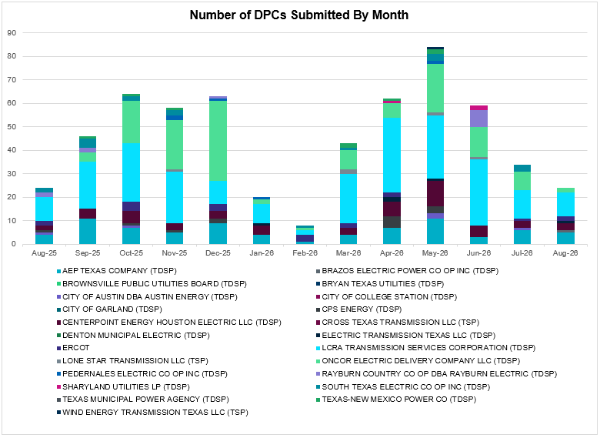

A total of 24 DPCs were implemented in August 2026. 334 DPCs have been implemented year to date. DPCs submitted by TDSPs are mainly updates to transmission element ratings. DPCs submitted by ERCOT are mainly updates to manual contingency definitions.
Transmission Operator | Number of DPCs
AEP TEXAS COMPANY (TDSP) | 5
BRAZOS ELECTRIC POWER CO OP INC (TDSP) | 1
BROWNSVILLE PUBLIC UTILITIES BOARD (TDSP) | 0
BRYAN TEXAS UTILITIES (TDSP) | 0
CENTERPOINT ENERGY HOUSTON ELECTRIC LLC (TDSP) | 3
CITY OF AUSTIN DBA AUSTIN ENERGY (TDSP) | 0
CITY OF COLLEGE STATION (TDSP) | 0
CITY OF GARLAND (TDSP) | 0
CPS ENERGY (TDSP) | 0
CROSS TEXAS TRANSMISSION LLC (TSP)) | 0
DENTON MUNICIPAL ELECTRIC (TDSP) | 0
ELECTRIC TRANSMISSION TEXAS LLC (TDSP) | 1
ERCOT | 2
LCRA TRANSMISSION SERVICES CORPORATION (TDSP) | 10
LONE STAR TRANSMISSION LLC (TSP) | 0
ONCOR ELECTRIC DELIVERY COMPANY LLC (TDSP) | 2
PEDERNALES ELECTRIC CO OP INC (TDSP) | 0
RAYBURN COUNTRY CO OP DBA RAYBURN ELECTRIC (TDSP) | 0
SHARYLAND UTILITIES LP (TDSP) | 0
SOUTH TEXAS ELECTRIC CO OP INC (TDSP) | 0
TEXAS MUNICIPAL POWER AGENCY (TDSP) | 0
TEXAS-NEW MEXICO POWER CO (TDSP) | 0
WIND ENERGY TRANSMISSION TEXAS LLC (TSP) | 0

Appendix A: Real-Time Constraints
The following is a complete list of constraints activated in SCED. Full contingency descriptions can be found in the Standard Contingencies List located on the MIS secure site at Grid Generation Reliability Unit Commitment.
Year | Month | Contingency Name | Overloaded Element | From Station | To Station | Count of Days
2026 | August | SLAQLOB8 | BRUNI_69_1 | BRUNI | BRUNI | 30
2026 | August | BASE CASE | E_PASP | n/a | n/a | 30
2026 | August | SBLURDH8 | 2270__B | MEXTP | ITALY | 29
2026 | August | BASE CASE | NELRIO | n/a | n/a | 29
2026 | August | DWPWFWP5 | STPWAP39_1 | STP | WAP | 29
2026 | August | BASE CASE | EASTEX | n/a | n/a | 28
2026 | August | STARLEO8 | SOLSTICE_PST1 | SOLSTICE | SOLSTICE | 28
2026 | August | BASE CASE | E_PATA | n/a | n/a | 28
2026 | August | SPRSPAR8 | 1545__A | FLTSW | PRSSW | 28
2026 | August | DFOAVLO5 | BRUNI_69_1 | BRUNI | BRUNI | 27
2026 | August | SFURVAN8 | MOURSUND_FUR_1 | FURHMAN | MOURSUND | 27
2026 | August | SFURVAN8 | MOURSUND_FUR_1 | MOURSUND | FURHMAN | 27
2026 | August | MHARNED5 | WESLCO_HIDLBRG_1 | MV_HBRG4 | MV_WESL4 | 26
2026 | August | DELMSAN5 | PAWNEE_SPRUCE_1 | PAWNEE | CALAVERS | 26
2026 | August | DSALHUT5 | 1715__B | TMPSW | FRYSW | 25
2026 | August | SBENS_M8 | BENTS_FRTER_1B_1 | FRONTERA | S_MISSIN | 24
2026 | August | SVENFTS5 | 35055__A | SAMSW | VENSW | 24
2026 | August | BASE CASE | NE_LOB | n/a | n/a | 24
2026 | August | SWCOWCO8 | G138_15_1 | ANGLETON | WCOLLOCL | 24
2026 | August | DBLW2JC5 | WAPWLY72_A | WLY | WAP | 23
2026 | August | SSTAWIC8 | 138_IH2_COT_1 | IH20 | TNCOLIET | 20
2026 | August | SBWDDBM5 | LPLMK_LPLNE_1 | LPLMK | LPLNE | 20
2026 | August | SEBATH8 | FB_RS_60_A | RS | FB | 19
2026 | August | SBCESN35 | 455__A | BGRSW | SNDSW | 18
2026 | August | DMTSCOS5 | 6437__F | SCRCV | KNAPP | 18
2026 | August | SMDOPHR5 | 138_ALV_NAL_1 | TNNALVIN | ALVIN | 18
2026 | August | DWAP_BI5 | BI_JN_64_A | JN | BI | 18
2026 | August | DFRYTM58 | SEA_AAT1 | SEA | SEA | 18
2026 | August | SRGRMGS5 | 6945__A | MGSES | CATSW | 18
2026 | August | DSALHUT5 | 1710__A | SALDS | SONTERRA | 17
2026 | August | SSHAFRO8 | BENTS_FRTER_1B_1 | FRONTERA | S_MISSIN | 17
2026 | August | SRAYRI38 | HAINE__LA_PAL1_1 | LA_PALMA | HAINE_DR | 17
2026 | August | SBLURDH8 | 1275__A | WDBSW | HLSBR | 17
2026 | August | SSNDBGR5 | 421__A | BCESW | SNDSW | 17
2026 | August | DFOWSMG5 | COTULL_REVEIL1_1 | REVEILLE | COTULLA | 17
2026 | August | DELMSAN5 | MAGRUD_VICTOR2_1 | VICTORIA | MAGRUDER | 16
2026 | August | DGRMGRS8 | 6830__B | CRDSW | OLNEY | 16
2026 | August | SMAYWHI8 | NUECES_WHITE_2_1 | NUECES_B | WHITE_PT | 16
2026 | August | SP5CAG8 | D5_S1_1 | HOWARD | LEON_CRK | 16
2026 | August | SOBWAP5 | OB_WAP98_A | WAP | OB | 16
2026 | August | SPEBTRU8 | 940__A | ENWSW | TMPTN | 15
2026 | August | BASE CASE | N_TO_H | n/a | n/a | 15
2026 | August | XPEA89 | DILLEYSW_XF1H | DILLEYSW | DILLEYSW | 15
2026 | August | DTNFBCA8 | 138_FTS_LNC_1 | FTST | LEONCRK | 15
2026 | August | SMOOPEA8 | POT_PEAR_1 | PEARSALL | POTEETS | 15
2026 | August | SALVTNN8 | 138_FWP_MNL_1 | FRWYPARK | MAINLAND | 14
2026 | August | BASE CASE | PNHNDL | n/a | n/a | 14
2026 | August | SCOLBAL8 | BALLINGE_FMRL | BALLINGE | BALLINGE | 14
2026 | August | DRNS_TB5 | THWZEN98_A | ZEN | THW | 14
2026 | August | DCDHTVW5 | 6200__F | TYPRK | PLYAM | 13
2026 | August | BASE CASE | FTST_SOLSTI1_1 | FTST | SOLSTICE | 13
2026 | August | DYETRJU8 | HEXT_YELWJC1_1 | YELWJCKT | HEXT | 12
2026 | August | BASE CASE | 138_FTS_LNC_1 | LEONCRK | FTST | 12
2026 | August | DYETRJU8 | HEXT_YELWJC1_1 | HEXT | YELWJCKT | 12
2026 | August | DBIGKEN5 | TREADW_YELWJC1_1 | TREADWEL | YELWJCKT | 12
2026 | August | BASE CASE | 138_FTS_LNC_1 | FTST | LEONCRK | 12
2026 | August | DLOFOAV5 | ASHERT_CATARI1_1 | ASHERTON | CATARINA | 12
2026 | August | SBUZHMP8 | 6217__B | GAILS | KEYSB | 11
2026 | August | SBUZHMP8 | 6217__B | MPPOI | KEYSB | 11
2026 | August | XASH89 | CARIZOSPG_BEVO_1 | BEVO | CARIZOS | 11
2026 | August | BASE CASE | WESTEX | n/a | n/a | 11
2026 | August | SJUNYEL9 | HEXT_YELWJC1_1 | YELWJCKT | HEXT | 11
2026 | August | SCLCGTN8 | 6635__G | MRVLY | ESTLD | 10
2026 | August | MHARNED5 | HAINE__LA_PAL1_1 | LA_PALMA | HAINE_DR | 10
2026 | August | DBIGKEN5 | FORTMA_YELWJC1_1 | YELWJCKT | FORTMA | 9
2026 | August | SCITWEI8 | CLARK__LON_HI1_1 | LON_HILL | CLARK_WD | 9
2026 | August | XVIC89 | MAGRUD_VICTOR2_1 | VICTORIA | MAGRUDER | 9
2026 | August | DSALHUT5 | GABRIE_AT1 | GABRIE | GABRIE | 8
2026 | August | DHUTGEA8 | 378T387_1 | HWRDTP | WELLBR | 8
2026 | August | DMCDUPS8 | HECKER_RESNIK1_1 | HECKER | RESNIK | 8
2026 | August | DWAP_OB5 | MDOPHR99_A | MDO | PHR | 8
2026 | August | DFOAVLO5 | NLARSW_PILONC1_1 | NLARSW | PILONCIL | 8
2026 | August | SCMNCPS5 | 651__B | CMNSW | CMNTP | 8
2026 | August | SDAFAUS8 | CKT_1027_1 | DUNLAP | DECKER | 8
2026 | August | SI_2RES8 | I_DUPS_RESNIK3_3 | I_DUPSW | RESNIK | 8
2026 | August | SBLAWDB8 | 2270__B | MEXTP | ITALY | 8
2026 | August | SHLSWDB8 | 810__G | RDHSW | BLUMS | 7
2026 | August | SCALBAN9 | SND_ORAN_1 | ORNGROV | SNDIEGS | 7
2026 | August | DMGSRIC8 | 6840__B | NVKSW | ANARN | 7
2026 | August | DSNDBGR5 | 36040__A | KNBSW | SALSW | 7
2026 | August | BASE CASE | MCCAMY | n/a | n/a | 7
2026 | August | SMDOOAS5 | GN_PZ_08_A | GN | PZ | 7
2026 | August | MSNDWCR5 | SNDSW_MR1H | SNDSW | SNDSW | 7
2026 | August | DLOFOAV5 | BRUNI_69_1 | BRUNI | BRUNI | 7
2026 | August | DEVRHLS8 | 6293__C | MARSW | DEVIT | 7
2026 | August | DMBDRKC5 | 651__B | CMNSW | CMNTP | 6
2026 | August | DBIGKEN5 | MADDUX_TREADW1_1 | MADDUX | TREADWEL | 6
2026 | August | SGEOORN8 | ORNGROV_69_1 | ORNGROV | ORNGROV | 6
2026 | August | DFRYBC58 | SEA_AAT1 | SEA | SEA | 6
2026 | August | SGEOHU48 | 221T355_1 | CHIEBR | GEORGE | 6
2026 | August | DCDHMCS8 | 3160__A | CDCSW | OKCLS | 6
2026 | August | SVEROK28 | SANDRO_VERS1_1 | VERS | SANDROAD | 6
2026 | August | DWAP_JN5 | BI_WAP50_A | WAP | BI | 6
2026 | August | DOASSEB5 | WAPWLY72_A | WLY | WAP | 6
2026 | August | DALASOA8 | 138_FTS_LNC_1 | FTST | LEONCRK | 6
2026 | August | DWTRWLV5 | 3610__G | PGTP1 | PDSES | 6
2026 | August | SFMRRYS5 | 400__A | FMRVL | RYSSW | 6
2026 | August | DWO5_EU8 | MIDGT_90_A | GT | MID | 6
2026 | August | SGRSMNW8 | MIL_LIPAN_1 | LONG | LIPAN | 6
2026 | August | DPHRCTR5 | MDOPHR99_A | MDO | PHR | 6
2026 | August | SFMRRY25 | 381__A | FMRVL | RYSSW | 5
2026 | August | DDILCOT8 | DILLEYSW_XF1H | DILLEYSW | DILLEYSW | 5
2026 | August | SABSBLU8 | ABNTHW_SERDEV1_1 | ABNTHWST | ABNTHWST | 5
2026 | August | DRYSALN5 | COLLE_JUPIT_1 | COLLEGE | JUPITER | 5
2026 | August | BASE CASE | SOLSTICE_PST1 | SOLSTICE | SOLSTICE | 5
2026 | August | DBUCRGP5 | 651__B | CMNSW | CMNTP | 5
2026 | August | SHONF38 | HON_DEVI_1 | HONDOCK | DEVINESW | 5
2026 | August | DBAKCED5 | LAKENA_SAMATH1_1 | LAKENASW | SAMATHIS | 5
2026 | August | SWALNAA8 | COLLE_JUPIT_1 | COLLEGE | JUPITER | 5
2026 | August | SPACVLS5 | 403__A | PRSSW | VLYSO | 4
2026 | August | DELMSAN5 | POT_OAKS_1 | POTEETS | OAKS9 | 4
2026 | August | DBIGKEN5 | PALOUS_WOLFCA1_1 | PALOUSE | WOLFCAMP | 4
2026 | August | SFURVAN8 | RAYBURN_69_2 | RAYBURN | RAYBURN | 4
2026 | August | DFOAVLO5 | ASHERT_CATARI1_1 | CATARINA | ASHERTON | 4
2026 | August | DLOFOAV5 | NLARSW_PILONC1_1 | PILONCIL | NLARSW | 4
2026 | August | SEBHUG8 | DA_WC_89_A | WC | DA | 4
2026 | August | DBIGSCH5 | PALOUS_WOLFCA1_1 | PALOUSE | WOLFCAMP | 4
2026 | August | MCYPHKB8 | 1160__A | HKBRY | VLYRN | 4
2026 | August | MTRYBRO8 | 6217__B | MPPOI | KEYSB | 4
2026 | August | DBRHLIG8 | 6405__C | HLSES | RMTPW | 4
2026 | August | MJOSPO89 | GREENL_WEAVER1_1 | WEAVERRD | GREENLK | 4
2026 | August | DBAKCED5 | HARGRO_TWINBU1_1 | TWINBU | HARGROVE | 4
2026 | August | DBLBYWF5 | STPWAP39_1 | STP | WAP | 4
2026 | August | DWPWFCK5 | STPWAP39_1 | STP | WAP | 4
2026 | August | DPPRTEC8 | 610__B | TMPSW | TMPSE | 4
2026 | August | DSCOTKW5 | 6215__A | BCKSW | CGRSW | 4
2026 | August | SWOLPAL8 | CROSSO_PALOUS1_1 | PALOUSE | CROSSOVE | 4
2026 | August | DLOFOAV5 | NLARSW_PILONC1_1 | NLARSW | PILONCIL | 4
2026 | August | DZORHAY5 | BERGHE_AT1H | BERGHE | BERGHE | 4
2026 | August | XPRS58 | 1561__C | HWKSW | DPREA | 3
2026 | August | SL_4RAY8 | RAYBURN_69_2 | RAYBURN | RAYBURN | 3
2026 | August | SGRMGRS8 | 6830__B | CRDSW | OLNEY | 3
2026 | August | SPETSNU8 | AE_STR26_A | AE | STR | 3
2026 | August | DCHBJO25 | CBYCVN86_A | CBY | CVN | 3
2026 | August | SBRAPIN8 | ESCOND_GANSO1_1 | ESCONDID | GANSO | 3
2026 | August | SFTLMES8 | PALOUS_WOLFCA1_1 | PALOUSE | WOLFCAMP | 3
2026 | August | DBIGSCH5 | TREADW_YELWJC1_1 | TREADWEL | YELWJCKT | 3
2026 | August | DVENFTS5 | 810__G | RDHSW | BLUMS | 3
2026 | August | XFTS89 | ALPINE_BRONCO1_1 | BRONCO | ALPINE | 3
2026 | August | DCC1DUKE | WESLCO_HIDLBRG_1 | MV_HBRG4 | MV_WESL4 | 3
2026 | August | SCYPHKB8 | 1160__A | HKBRY | VLYRN | 3
2026 | August | MBULNAV5 | 35045__A | SAMSW | FVLSW | 3
2026 | August | SBRABND8 | FAI_COLL_1 | FAIRDALE | COLLEGE | 3
2026 | August | SBGLTWI8 | LAKENA_SAMATH1_1 | LAKENASW | SAMATHIS | 3
2026 | August | DSTOGAR8 | CKT_1027_1 | DUNLAP | DECKER | 3
2026 | August | SBRAPIN8 | ESCOND_GANSO1_1 | GANSO | ESCONDID | 3
2026 | August | STNFTAR8 | 138_FTS_LNC_1 | FTST | LEONCRK | 3
2026 | August | SBWDDBM5 | LPLNW_LPLMD_1 | LPLNW | LPLMD | 3
2026 | August | SBLURDH8 | 1210__B | HUBRD | HAN1 | 3
2026 | August | SSAMTCR5 | 505__B | FBRSW | THSES | 3
2026 | August | SSOLALM8 | COCS_FTST1_1 | FTST | COCS | 2
2026 | August | DELMSAN5 | FURHMAN_VANDB_1 | FURHMAN | VANBLTSS | 2
2026 | August | DFOWSMG5 | FWLRTN_TILDEN_1 | FOWLRTON | TILDEN | 2
2026 | August | DYETRJU8 | HEXT_MASONS1_1 | HEXT | MASONSW | 2
2026 | August | SOXYIN28 | I_DUPP_I_DUPS2_1 | I_DUPP1 | I_DUPSW | 2
2026 | August | BASE CASE | RANDAD_ZAPATA1_1 | RANDADO | ZAPATA | 2
2026 | August | DSALKLN5 | 630__A | BLTON | BLTSW | 2
2026 | August | DLONPK25 | 6375__A | GRSES | GRMES | 2
2026 | August | DBLUBUF8 | ABNTHW_SERDEV1_1 | ABNTHWST | ABNTHWST | 2
2026 | August | SBENRAI8 | BENTS_FRTER_1B_1 | FRONTERA | S_MISSIN | 2
2026 | August | XLAS95 | COCS_FTST1_1 | FTST | COCS | 2
2026 | August | DBIGSCH5 | CROSSO_NORTMC1_1 | NORTMC | CROSSOVE | 2
2026 | August | SFURVAN8 | RAY_L_46_1 | RAYBURN | L_463S | 2
2026 | August | SODETES5 | 6052__C | QALSW | TESSW | 2
2026 | August | SOXYIN28 | I_DUPP_I_DUPS2_1 | I_DUPSW | I_DUPP1 | 2
2026 | August | STARLEO8 | 138_FTS_LNC_1 | LEONCRK | FTST | 2
2026 | August | DTHSFBR5 | 35045__A | SAMSW | FVLSW | 2
2026 | August | SECRDMT8 | 6215__A | BCKSW | CGRSW | 2
2026 | August | DCPSST58 | 651__B | CMNSW | CMNTP | 2
2026 | August | SSTPESP8 | BLESSI_PAVLOV1_1 | BLESSING | PAVLOV | 2
2026 | August | DJN_RO28 | CE_OB_25_A | OB | CE | 2
2026 | August | SBRAHAM8 | ESCOND_GANSO1_1 | ESCONDID | GANSO | 2
2026 | August | SAEDAB8 | FW_WEB04_A | FW | WEB | 2
2026 | August | BASE CASE | X5_ALAMO1_1 | OCI_ALM1 | X5 | 2
2026 | August | DFRYTM58 | 630__A | BLTON | BLTSW | 2
2026 | August | DSALKLN5 | 630__B | KLNSW | HHSTH | 2
2026 | August | DZORHAY5 | BERGHE_AT1L | BERGHE | BERGHE | 2
2026 | August | SCOLPAW5 | MAGRUD_VICTOR2_1 | VICTORIA | MAGRUDER | 2
2026 | August | STULBAS8 | MAGRUD_VICTOR2_1 | VICTORIA | MAGRUDER | 2
2026 | August | SSNYCGR8 | SNYDR_FMR1 | SNYDR | SNYDR | 2
2026 | August | DWLDSCO5 | 6217__B | MPPOI | KEYSB | 2
2026 | August | SJOSBRO8 | GREENL_WEAVER1_1 | WEAVERRD | GREENLK | 2
2026 | August | DBIGKEN5 | NEVILL_NORTMC_1 | NEVILLSW | NORTMC | 2
2026 | August | SFTSFVL5 | 35055__A | SAMSW | VENSW | 2
2026 | August | SBRAHAM8 | ESCOND_GANSO1_1 | GANSO | ESCONDID | 2
2026 | August | DELMSAN5 | F2_11_1 | KENEDSW | F2 | 2
2026 | August | DCRLLSW5 | LWSSW_FMR2 | LWSSW | LWSSW | 2
2026 | August | SFURVAN8 | RAY_MOURSUND_1 | MOURSUND | RAYBURN | 2
2026 | August | DWPWFWP5 | SN_STR26_A | SN | STR | 2
2026 | August | MDWTRWT5 | 30__A | RCHBR | BBSES | 2
2026 | August | DBUCRGP5 | 651__C | CMNTP | SHILO | 2
2026 | August | DSTPSTA5 | BLESSING_1382 | BLESSING | BLESSING | 2
2026 | August | XDIL89 | DILLEYSW_XF1H | DILLEYSW | DILLEYSW | 2
2026 | August | DFOAVLO5 | FREER_LOBO1_1 | LOBO | FREER | 2
2026 | August | DRENPLH8 | COLLE_JUPIT_1 | COLLEGE | JUPITER | 2
2026 | August | STNAALA8 | 138_FTS_LNC_1 | FTST | LEONCRK | 1
2026 | August | DTVWJON5 | 151__A | CPSES | WOFHO | 1
2026 | August | SHWKLBL8 | 1545__A | FLTSW | PRSSW | 1
2026 | August | SPRAWAL8 | 155T217_1 | BELLSO | PT | 1
2026 | August | DSNDBGR5 | 2340__D | MCFSW | MARAK | 1
2026 | August | STHSVE65 | 35045__A | SAMSW | FVLSW | 1
2026 | August | SSPRVAL8 | 595__A | BNTSW | DCATR | 1
2026 | August | MTRYBRO8 | 6217__D | KEYSB | LMESA | 1
2026 | August | DKLNRGP5 | 651__B | CMNSW | CMNTP | 1
2026 | August | DRGRPRM5 | 6945__A | MGSES | CATSW | 1
2026 | August | SWAPWLY5 | CE_OB_25_A | OB | CE | 1
2026 | August | BASE CASE | COCS_FTST1_1 | FTST | COCS | 1
2026 | August | BASE CASE | FURHMAN_VANDB_1 | FURHMAN | VANBLTSS | 1
2026 | August | SSPJFS8 | GP_NM_94_A | NM | GP | 1
2026 | August | SRAYRI28 | HAINE__LA_PAL1_1 | LA_PALMA | HAINE_DR | 1
2026 | August | SRAYRI38 | HAINE__OLEAND1_1 | HAINE_DR | OLEANDER | 1
2026 | August | DBIGSCH5 | NEVILL_NORTMC_1 | NEVILLSW | NORTMC | 1
2026 | August | SMOOPEA8 | PALDRO_DILLEY_1 | PALODURO | DILLEYSW | 1
2026 | August | STNFTAR8 | SOLSTICE_PST1 | SOLSTICE | SOLSTICE | 1
2026 | August | MJOSPO89 | VAN_VNDB_1 | VANBLTSS | VANBLT69 | 1
2026 | August | DDOWSEB5 | WAPWLY72_A | WLY | WAP | 1
2026 | August | MDWRTR25 | 30__A | RCHBR | BBSES | 1
2026 | August | DFER_WI8 | 37T187_1 | FERGUS | SHERSH | 1
2026 | August | DDHMLWS5 | 583__D | DCRSW | ALISN | 1
2026 | August | SMGIENW8 | 921__F | SHKSW | GAMMA | 1
2026 | August | SCARFRI8 | ATSO_SONR1_1 | SONR | ATSO | 1
2026 | August | DBAKCED5 | FORTMA_YELWJC1_1 | FORTMA | YELWJCKT | 1
2026 | August | BASE CASE | I_FW_N | n/a | n/a | 1
2026 | August | MCPRJCK8 | SN_STR26_A | SN | STR | 1
2026 | August | BASE CASE | YELWJCKT_PS_1 | YELWJCKT | YELWJCKT | 1
2026 | August | DBUCRGP5 | 325__A | BLFSW | TMPCR | 1
2026 | August | DVLSPAC5 | 389__A | WDDSW | MNSES | 1
2026 | August | SMYRSPR8 | 583__D | DCRSW | ALISN | 1
2026 | August | SANGSTA5 | BLESSING_1382 | BLESSING | BLESSING | 1
2026 | August | SDOWMOO8 | DOWNIES_AX1H | DOWNIES | DOWNIES | 1
2026 | August | SWAATH8 | FB_RS_60_A | RS | FB | 1
2026 | August | STARLEO8 | FTST_SOLSTI1_1 | FTST | SOLSTICE | 1
2026 | August | SLGDSAP8 | LAKENA_SAMATH1_1 | LAKENASW | SAMATHIS | 1
2026 | August | DBIGSCH5 | SANTAR_WOLFCA1_1 | WOLFCAMP | SANTARIT | 1
2026 | August | MSNDWEY5 | SNDSW_MR1H | SNDSW | SNDSW | 1
2026 | August | MBONNED5 | WESLCO_HIDLBRG_1 | MV_HBRG4 | MV_WESL4 | 1
2026 | August | SCYPCOM8 | 122T122_1 | COMFOR | RAYBAR | 1
2026 | August | DTCRTHS5 | 35045__A | SAMSW | FVLSW | 1
2026 | August | DSALHUT5 | 431__B | BCESW | BGRSW | 1
2026 | August | SVEAW_L5 | 6217__B | GAILS | KEYSB | 1
2026 | August | XSNY89 | 6690__D | SSFTP | SCURY | 1
2026 | August | SANACN25 | 835__G | GTRSW | EPPOI | 1
2026 | August | SPEBTRU8 | 940__B | TMPTN | WXHCH | 1
2026 | August | MAIRDAV8 | AIRLIN_B_DAVI2_1 | B_DAVIS | AIRLINE | 1
2026 | August | DDUNLOS5 | AUSTRO_AT2H | AUSTRO | AUSTRO | 1
2026 | August | SDAFDES8 | CKT_1027_1 | DUNLAP | DECKER | 1
2026 | August | DBAKCED5 | CROSSO_PALOUS1_1 | PALOUSE | CROSSOVE | 1
2026 | August | DFOWSMG5 | GEO_SIG_1 | GEOWEST | SIGMOR | 1
2026 | August | SCT2CAR8 | HAMILT_MAXWEL1_1 | MAXWELL | HAMILTON | 1
2026 | August | SSTILOM8 | LA_PAL_VCAVAZ1_1 | LA_PALMA | VCAVAZOS | 1
2026 | August | XMGS658 | MGSES_MR4H | MGSES | MGSES | 1
2026 | August | DOASSEB5 | SN_STR26_A | SN | STR | 1
2026 | August | BASE CASE | 138_ALV_NAL_1 | TNNALVIN | ALVIN | 1
2026 | August | DWTRWLV5 | 3170__B | SMPST | BNTDR | 1
2026 | August | DSALHUT5 | 455__A | BGRSW | SNDSW | 1
2026 | August | XCMB58 | 651__B | CMNSW | CMNTP | 1
2026 | August | SRYSCOM8 | 870__C | CMBTP | CLKPT | 1
2026 | August | SSANFER8 | CORONA_AT4 | CORONA | CORONA | 1
2026 | August | DVICEDN8 | FURHMAN_VANDB_1 | FURHMAN | VANBLTSS | 1
2026 | August | SSTPESP8 | LAN_CT_PAVLOV1_1 | PAVLOV | LAN_CTY | 1
2026 | August | XPRS58 | 1561__A | DPREA | RCSES | 1
2026 | August | MSTBELB5 | 31__A | RCHBR | TRSES | 1
2026 | August | SLWSLW28 | 591_B_1 | LKPNT | LWVTI | 1
2026 | August | SHOCHOC8 | BL_TAP05_1 | BL | BL | 1
2026 | August | DB_DAIR8 | B_DAVI_PHARAO1_1 | B_DAVIS | PHARAOH | 1
2026 | August | SILLFTL8 | CARVER_TINSLE1_1 | CARVER | TINSLEY | 1
2026 | August | DFERWIR8 | CORONA_AT4 | CORONA | CORONA | 1
2026 | August | DCAGMED8 | D5_S1_1 | HOWARD | LEON_CRK | 1
2026 | August | DADJNBY8 | DT_PK_91_A | PK | DT | 1
2026 | August | SESPK8 | DT_PK_91_A | PK | DT | 1
2026 | August | SBVFB8 | FB_FL_60_A | FB | FL | 1
2026 | August | DGABGEA8 | GABRIE_AT1 | GABRIE | GABRIE | 1
2026 | August | SSPJFS8 | GP_NM_94_A | GP | NM | 1
2026 | August | SHPDT9 | HOC_AT1 | HOC | HOC | 1
2026 | August | BASE CASE | KINNEY | n/a | n/a | 1
2026 | August | SMCEABS8 | MKLT_TRNT1_1 | TRNT | MKLT | 1
2026 | August | DLOFOAV5 | SND_ORAN_1 | ORNGROV | SNDIEGS | 1
2026 | August | SDIMBEV8 | UVALDE_W_BATE1_1 | W_BATESV | UVALDE | 1
2026 | August | SWCOW2C8 | _WC_WCO_1 | WC | WCOLMAIN | 1
2026 | August | SFRWMAI8 | 138_ALV_NAL_1 | TNNALVIN | ALVIN | 1
2026 | August | DTRSTRC5 | 1852__A | TRSES | NPKTP | 1
2026 | August | DMLSE123 | 31__A | RCHBR | TRSES | 1
2026 | August | SBCEBGR5 | 421__A | BCESW | SNDSW | 1
2026 | August | BASE CASE | 455__A | BGRSW | SNDSW | 1
2026 | August | BASE CASE | BAKRFLD_CEDCAN_1 | CEDACA | BAKESW | 1
2026 | August | BASE CASE | BENTS_FRTER_1B_1 | FRONTERA | S_MISSIN | 1
2026 | August | MKNGSTE5 | BENTS_FRTER_1B_1 | FRONTERA | S_MISSIN | 1
2026 | August | SPALFRO8 | BENTS_FRTER_1B_1 | FRONTERA | S_MISSIN | 1
2026 | August | BASE CASE | BL_TAP05_1 | BL | BL | 1
2026 | August | DWAP_JN5 | CE_OB_25_A | OB | CE | 1
2026 | August | DSKYCAL5 | D5_S1_1 | HOWARD | LEON_CRK | 1
2026 | August | DCALBEC8 | N3_U2_1 | CALAVERS | BRAUNIG | 1
2026 | August | SMOOPEA8 | POT_OAKS_1 | POTEETS | OAKS9 | 1
2026 | August | SWALWLN8 | SABIN_NEVAD_1 | NEVADA | SABNCRKT | 1
2026 | August | MDOGLN8 | SND_ORAN_1 | ORNGROV | SNDIEGS | 1
2026 | August | SRAYHAR8 | WESLCO_HIDLBRG_1 | MV_HBRG4 | MV_WESL4 | 1
2026 | August | SCOMCYP8 | 122T122_1 | COMFOR | RAYBAR | 1
2026 | August | DPHRAL58 | 138_ALV_NAL_1 | TNNALVIN | ALVIN | 1
2026 | August | DWPWFWP5 | 155T217_1 | BELLSO | PT | 1
2026 | August | DSALHUT5 | 1710__B | SONTERRA | JREST | 1
2026 | August | DSNDBGR5 | 2340__D | MARAK | MCFSW | 1
2026 | August | DWCSRAM5 | 35100__A | PKRSW | HCKSW | 1
2026 | August | DVENFTS5 | 505__B | FBRSW | THSES | 1
2026 | August | STCRTHS5 | 505__B | FBRSW | THSES | 1
2026 | August | DCDHTVW5 | 6200__E | PRKRW | TYPRK | 1
2026 | August | SRICGRS8 | 6840__B | NVKSW | ANARN | 1
2026 | August | DBAKCED5 | 6965__A | LNGSW | PRLSW | 1
2026 | August | XSA4N89 | BALLINGE_FMRL | BALLINGE | BALLINGE | 1
2026 | August | SHONMOO8 | FER_DOWNI_1 | DOWNIES | FERRISW | 1
2026 | August | SSCJFS8 | GP_NM_94_A | GP | NM | 1
2026 | August | SBRAPIN8 | HAMILT_MAVERI1_1 | HAMILTON | MAVERICK | 1
2026 | August | DRNS_TB5 | MIDGT_90_A | GT | MID | 1
2026 | August | SOBWA2P5 | OB_WAP99_A | WAP | OB | 1

Current Wind Generation Record: 29,031 MW on 06/29/2026 at 02:00 | Current Wind Penetration Record: 69.15% on 04/10/2022 at 01:43 Current Solar Generation Record: 35,427 MW on 07/30/2026 at 13:33 | Current Solar Penetration Record: 72.74% on 05/02/2026 at 11:28

