TDTMS Meeting
July 28, 2026, 9:30 AM
In Person & WebEx , ERCOT Met Center, Austin
Attendee | Company | Attendee | Company |  | Attendee | Company
Cindy Juarez | AEP | Steven Wilson* |  | Vistra | Chris Gayhart | CIM View
Dave Michelson | ERCOT | Vikrum Gupta* |  | ERCOT | Rob Bevill* | TNMP
Sheri Wiegand* | Vistra | Renato Filho |  | ? | Kathy Scott* | CNP
Elizabeth Morales* | ERCOT | Toney Gutierrez |  | AEP | Gabriel Martins | Grid Monitor
Mike Dameron* | ERCOT | Sam Pak* |  | Oncor | Tammy Stewart | ERCOT
Monica Jones* | CNP | Kim Wall |  | Hansen | Ludivina Hall | AEP
Jesse Macias | AEP | Vaibhav Parekh |  | New Project Media | Ayca Argetsinger | AEP
Richard Beasley* | CNP | Kyle Patrick* |  | NRG | Sarah Heselmeyer* | ERCOT
Heverton Ferreira | Grid Monitor | Bonnie Trevino |  | AEP | Dolores Villareal | AEP
Laura Gomez | LP&L | Michael Winegeart |  | LP&L | Rita Cardenas | AEP
Sylvia Garcia | AEP | William Butler |  | LP&L | Jim Wade | Vertex One
Garrett Hodge | AEP | Holly Haas |  | Accent Energy | Edelmira Pena | Revolution
Jack Campbell | ?
*denotes in person

Monica Jones opened the meeting, read the anti-trust admonition, and introduced attendees.
Minutes from the 6/18/26 meeting were reviewed and approved as posted.

ERCOT Updates

IT Report & SLAs
- Vikrum noted the market SLAs that were approved at the February RMS were not posted to ercot.com. SLAs will be posted to RMS and the SLA link.
- Vikrum presented the June IT report noting all SLAs were met, site failover was conducted, and the MT API go live completed on 6/28 with the new tooling capability. ERCOT will now monitor UI availability and new dashboard (see slide below) listing max/min response times. SLO thresholds of 10 seconds will set off an alert.
- Fewer deletes and unsubscribes were noted on the Weather Moratorium Listserv. ACTION: Dave was going to look into the logic for the deletes on the listserv – x bounce-backs over y time.
- There will be a listserv replacement with a different product. ERCOT recently brought platform control in-house, yet now considering external monitoring, however, would be 24x7 coverage. No timeline is available yet and is discussed in TWG.

ERCOT IT Projects
- MT API – go live occurred 6/28. SOAP structure is in place. Transition occurred relatively quickly. A few configuration issues were noted on the Monday and Tuesday following the go live. Dave commented the more customization of the product, the more time to adjust to the changes. It was noted testing the sandbox has been challenging, particularly obtaining access to the RMTE digital certificate. The process is different where Retail Operations and Client Services should be contacted for special access. ACTION: ERCOT will propose language for the RMTE User’s Guide for instructions on how to obtain access.
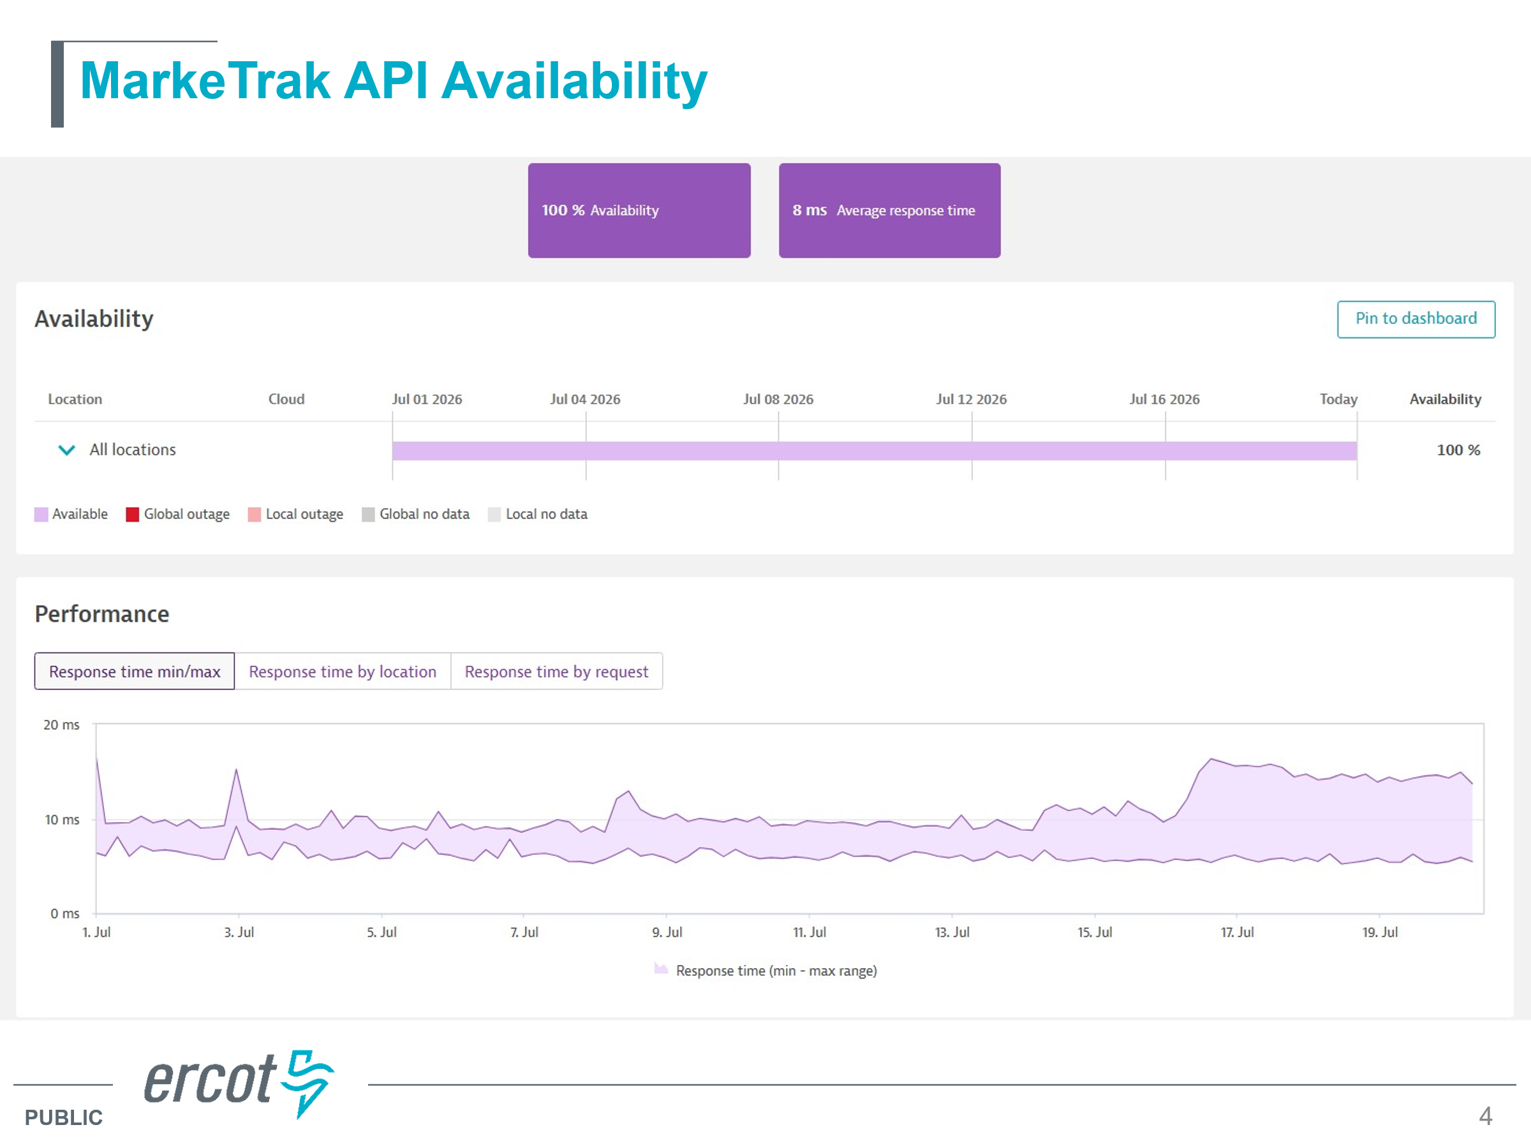
- MIS Updates – Retail API & UI – 2027+ project which is contingent on significant back architecture work and primarily access management (digital certificate project). This will likely be the end of 2027.
- Digital Certificates – access management is the “initial domino” for multiple other projects. Once this piece completes, the other API/UI projects will quickly follow. The question was asked if the transition will be a flash cut or a gradual process (as certs expire, they will move to new platform); however, it was noted supporting two systems is challenging.
- MarkeTrak and FlighTrak alternative platform – these are technology replacements and not enhancements. With market participant input, an SCR will likely need to be submitted for consideration.

- The above represents the phased ERCOT projects with DCs and MIS projects occurring first, with 2027 implementation followed by FlighTrak then MarkeTrak replacement projects.

MarkeTrak Replacement & Data Analysis
- As noted above, the list of enhancements TDTMS has been compiling will likely result in an SCR for consideration in the selection of the MarkeTrak replacement tool.
- TDTMS intends to continue to perform the bi-annual MT analysis yet would like to leverage AI to reduce the manual effort.
- Questions were brought forth regarding access of the ‘data dump’ of the anonymized data. Can market participants have access to the data on a monthly/bi-annual basis to be able to perform their own analysis? ACTION: Dave was to investigate posting the ‘data dump’ to MIS as a public report or if an SCR would be required.
- Sheri indicated the smaller group working on the MT analysis is attempting to recreate the 2025(2) data using copilot. The group is drafting prompts which will be made available for market participants, however, access to data is still required.
  - There are two phases of AI prompts to replicate the analysis:
    - Conditioning the raw data to be able to calculate the timing
    - Developing accurate prompts to analyze the data
The small group will continue to work on both phases with both general and very specific prompts. The next meeting will be after RMS on 8/11.
- During the discussion of the MarkeTrak replacement tool, Dave suggested TDTMS propose more high level business requirements such as what reports do we want keeping in mind the confidentiality of who can see what when. Dave felt some concepts may change with the new MT tool where ‘states’ may be translated to new descriptions, yet still maintain the same workflow.

TDTMS Meeting Dates were reminded and will work with TXSET/LP to add these to the ERCOT calendar
September 21st
October 19th
November 16th
No December date

DRAFT AGENDA for September 21st meeting – 1:30 PM, Monday
- ERCOT Updates
  - IT Report
  - MT performance issues
  - 2027 SLAs
  - Projects
    - MIS updates – Retail API & UI
    - Client Services – Market Participant Service Portal
    - Digital Certificates / Access Management update
- MarkeTrak Enhancements list – updates
- ERCOT Quarterly Review of IAS Report & Client Services
- MT Deep Dive – review Rescission results of 2025(2)
- MT Deep Dive – leveraging AI update

