

System Planning
Monthly Status Report

Report Highlights

- ERCOT is currently reviewing proposed transmission improvements with a total estimated cost of $22.802 billion as of August 31, 2026.
- Transmission Projects endorsed in 2026 total $12.266 billion as of August 31, 2026.
- All projects (in engineering, routing, licensing, and construction) total approximately $55.536 billion as of July 17, 2026.
- Transmission Projects energized in 2026 total approximately $595.737 million (as of July 17, 2026).
- Transmission Projects planned to energize during the remainder of 2026 total approximately $6.526 billion (as of July 17, 2026).

Regional Planning Group Reviews

RPG Projects under Review:

- Oncor and LCRA TSC have submitted the Muscovy and Voss Lake 345/138-kV Project (RPG Project ID: 25RPG009). This is a Tier 1 project that is estimated to cost $381.83 million. ERCOT has completed the independent review on May 15, and the recommended project is estimated to cost $1.457 billion. TAC voted to endorse the project on May 19, 2026. ERCOT Board of Directors endorsed the project on June 1, 2026, and ERCOT has issued the ERCOT endorsement letter.

- Oncor and LCRA TSC have submitted the Muscovy and Voss Lake 345/138-kV Project (RPG Project ID: 25RPG009). This is a Tier 1 project that is estimated to cost $381.83 million. Phase 2 of this project is currently under ERCOT’s independent review.

- CPS Energy has submitted the Large Load Additions Project (RPG Project ID: 25RPG020). This is a Tier 1 project that is estimated to cost $333.70 million. This project is currently under ERCOT’s independent review.

- LP&L has submitted the West Loop Project (RPG Project ID: 25RPG037). This is a Tier 1 project that is estimated to cost $309.00 million. This project is currently under ERCOT’s independent review.

- Oncor has submitted the Set 1 North & Central Texas Reliability Project (RPG Project ID: 25RPG040). This is a Tier 1 project that is estimated to cost $1.798 billion. ERCOT has completed the combined independent review on May 15, and the recommended project is estimated to cost $2.363 billion. TAC voted to endorse the project on May 19, 2026. ERCOT Board of Directors endorsed the project on June 1, 2026, and ERCOT has issued the ERCOT endorsement letter.

- Oncor has submitted the Set 1 North Central & South Central Texas Reliability Project (RPG Project ID: 25RPG041). This is a Tier 1 project that is estimated to cost $943.92 million. ERCOT has completed the combined independent review on May 15, and the recommended project is estimated to cost $381.09 million. TAC voted to endorse the project on May 19, 2026. ERCOT Board of Directors endorsed the project on June 1, 2026, and ERCOT has issued the ERCOT endorsement letter.

- Oncor has submitted the Set 1 North Central & South Central Texas Reliability Project (RPG Project ID: 25RPG041). This is a Tier 1 project that is estimated to cost $943.92 million. Group 3 of this project is currently under ERCOT’s independent review.

- Oncor has submitted the Set 2 North & Central Texas Reliability Project (RPG Project ID: 25RPG042). This is a Tier 1 project that is estimated to cost $1,330 million. ERCOT has completed the combined independent review on May 15, and the recommended project is estimated to cost $2,363 million. TAC voted to endorse the project on May 19, 2026. ERCOT Board of Directors endorsed the project on June 1, 2026, and ERCOT has issued the ERCOT endorsement letter.

- Oncor has submitted the Set 2 North Central & South Central Texas Reliability Project (RPG Project ID: 25RPG043). This is a Tier 1 project that is estimated to cost $440.79 million. ERCOT has completed the combined independent review on May 15, and the recommended project is estimated to cost $381.09 million. TAC voted to endorse the project on May 19, 2026. ERCOT Board of Directors endorsed the project on June 1, 2026, and ERCOT has issued the ERCOT endorsement letter.

- Oncor has submitted the Set 2 North Central & South Central Texas Reliability Project (RPG Project ID: 25RPG043). This is a Tier 1 project that is estimated to cost $440.79 million. Group 3 of this project is currently under ERCOT’s independent review.

- STEC has submitted the Medina County Large Load Additions Project (RPG Project ID: 25RPG046). This is a Tier 1 project that is estimated to cost $492.00 million. This project is currently under ERCOT’s independent review.

- LCRA TSC and CEHE have submitted the Euclid 765-kV Substation and Transmission Line Addition Project (RPG Project ID: 26RPG001). This is a Tier 1 project that is estimated to cost $1,830 million. ERCOT has completed the independent review on May 15, and the recommended project is estimated to cost $1.831 billion. TAC voted to endorse the project on May 19, 2026. ERCOT Board of Directors endorsed the project on June 1, 2026, and ERCOT has issued the ERCOT endorsement letter.

- AEPSC has submitted the Laredo Area Upgrade Project (RPG Project ID: 26RPG004). This is a Tier 2 project that is estimated to cost $178.00 million. This project is currently under ERCOT’s independent review.

- DME has submitted the Denton Area Transmission Improvements Project (RPG Project ID: 26RPG005). This is a Tier 1 project that is estimated to cost $222.44 million. This project is currently under ERCOT’s independent review.

- BEC has submitted the Cooke County Resiliency Project (RPG Project ID: 26RPG007). This is a Tier 2 project that is estimated to cost $147.13 million. This project is currently under ERCOT’s independent review.

- AEPSC has submitted the Panhandle Project (RPG Project ID: 26RPG008). This is a Tier 1 project that is estimated to cost $10.469 billion. This project is currently under ERCOT’s independent review.

- AEPSC has submitted the Rio Grande Valley System Improvement Project (RPG Project ID: 26RPG009). This is a Tier 1 project that is estimated to cost $4.870 billion. This project is currently under ERCOT’s independent review.

- Oncor has submitted the Rockhound to Longshore 345-kV Double-Circuit Line Project (RPG Project ID: 26RPG015). This is a Tier 2 project that is estimated to cost $144.00 million. This project is currently under ERCOT’s independent review.

- CTT has submitted the Panhandle Reliability Transmission Plan Project (RPG Project ID: 26RPG016). This is a Tier 1 project that is estimated to cost $4,100 million. This project is currently under ERCOT’s independent review.

- TNMP has submitted the Climax to Bells Area Transmission System Improvements Project (RPG Project ID: 26RPG017). This is a Tier 1 project that is estimated to cost $225.40 million. This project is currently under ERCOT’s independent review.

- PEC has submitted the Liberty Hill Area Capacity Improvement Project (RPG Project ID: 26RPG018). This is a Tier 2 project that is estimated to cost $80.00 million. This project is currently under ERCOT’s independent review.

- CNP has submitted the 138-kV Ckt.93 P.H. Robinson to Algoa Corner Hardening Project (RPG Project ID: 26RPG020). This is a Tier 3 project that is estimated to cost $104.25 million. The RPG review of this project was completed on June 10, and ERCOT has issued an acceptance letter.

- AEN has submitted the Dunlap to Decker 138-kV Line Project (RPG Project ID: 26RPG022). This is a Tier 2 project that is estimated to cost $61.61 million. This project is currently under ERCOT’s independent review.

- WETT has submitted the Nova Prime Second 345/138-kV Autotransformer Project (RPG Project ID: 26RPG025). This is a Tier 3 project that is estimated to cost $36.78 million. This project was withdrawn by WETT on August 31 and ERCOT concluded the RPG review on August 31. ERCOT will not issue an acceptance letter for this project.

- BEC has submitted the San Miguel to Marion 345-kV Line Rebuild Project (RPG Project ID: 26RPG026). This is a Tier 1 project that is estimated to cost $261.20 million. This project is currently under ERCOT’s independent review.

- CNP has submitted the Hockley Area Transmission System Improvement Project (RPG Project ID: 26RPG027). This is a Tier 3 project that is estimated to cost $155.21 million. The RPG review of this project was completed on August 31, and ERCOT will issue an acceptance letter.

- Oncor has submitted the Modification to the 345-kV Line Termination at the Ironwood Switching Station Project (RPG Project ID: 26RPG028). This is a Tier 3 project that is estimated to cost $10.1 million. This project is currently in the RPG comment period.

RPG Project Reviews Completed in 2026:
RPG Project ID | RPG Project Name | Submitted Entity | Tier | Estimated Cost ($ Millions) | Review Completion Month
25RPG044 | Whitney Autotransformer Upgrade Project | BEC | Tier 3 | 33.50 | January
25RPG045 | Alice Area Improvements Transmission Project | AEPSC | Tier 3 | 67.00 | January
25RPG012 | Ammonia Plant Load Project | STEC | Tier 1 | 117.38 | February
25RPG028 | P.H. Robinson to W.A. Parish 345-kV Hardening Project | CNP | Reclassified from Tier 1 to Tier 4 per Protocol | 511.31 | February
25RPG033 | Oncor Skyview 345/138-kV Switch Project | Oncor | Tier 2 | 56.82 | March
26RPG002 | RW Miller Area Improvement 138-kV Line Rebuild Project | BEC & Oncor | Tier 3 | 186.89 | March
26RPG003 | SAPS to SA Red Creek 138-kV Line Project | AEPSC | Reclassified from Tier 3 to Tier 4 per Protocol | 53.00 | March
26RPG006 | Modification to the Baytown Area Load Project | CNP | Tier 3 | 309.14 | March
26RPG010 | China Grove to Big Spring 138-kV Line Rebuild Project | Oncor | Tier 3 | 130.60 | March
26RPG011 | HOC to University 69-kV to 138-kV Conversion Project | CNP | Tier 3 | 65.09 | March
25RPG004 | Southern DFW Load Interconnection and General Grid Strengthening Project | Oncor | Tier 1 | 2,886 | April
25RPG016 | Nueces Green Ammonia Load Interconnection Project | STEC | Tier 1 | 161.10 | April
25RPG038 | Navarro and Ellis Area Reliability Project | Oncor & LST | Tier 1 (Combined with 25RPG004) | 759.95 | April
26RPG012 | 138-kV Angleton to Clute Upgrades Project | CNP | Tier 3 | 169.82 | April
26RPG013 | AJ Swope to Wallaby 345-kV Line Cut-In Project | Oncor | Tier 3 | 3.10 | April
25RPG039 | Southeast Brownsville Large Load Transmission System Improvements Project | STEC | Tier 2 | 96.60 | May
26RPG014 | Dermott Area 138-kV Line Upgrades Project | Oncor | Tier 3 | 78.00 | May
25RPG009 | Muscovy and Voss Lake 345/138-kV Project | Oncor & LCRA TSC | Tier 1 | 1,457 | June
25RPG013 | Reactive Power Planning Project | CPS | Tier 1 | 477.70 | June
25RPG017 | Helotes 345/138-kV Switching Station and Autotransformer Addition at Eastside Switching Station Project | CPS | Tier 1 (Combined with 25RPG013) | 110.00 | June
25RPG026 | Paris Switch to Monticello Switch 345-kV Line Rebuild Project | Oncor | Tier 1 | 233.30 | June
25RPG040 | Set 1 North & Central Texas Reliability Project | Oncor | Tier 1 | 2,363 | June
25RPG041 | Set 1 North Central & South Central Texas Reliability Project | Oncor | Tier 1 | 381.09 | June
25RPG042 | Set 2 North & Central Texas Reliability Project | Oncor | Tier 1 (Combined with 25RPG040) | 1,330 | June
25RPG043 | Set 2 North Central & South Central Texas Reliability Project | Oncor | Tier 1 (Combined with 25RPG041) | 440.79 | June
26RPG001 | Euclid 765-kV Substation and Transmission Line Addition Project | LCRA TSC & CEHE | Tier 1 | 1,830 | June
26RPG019 | 138-kV Newport to Jonte Ckt.86 Upgrade Project | CNP | Tier 3 | 104.82 | June
26RPG020 | 138-kV Ckt.93 P.H. Robinson to Algoa Corner Hardening Project | CNP | Tier 3 | 104.25 | June
26RPG021 | 138-kV Ckt.05A WAP to Missouri City Tap Partial Rebuild Project | CNP | Reclassified from Tier 3 to Tier 4 per Protocol | 65.00 | June
26RPG023 | North Houston and Tomball Area Upgrade Project | CNP | Tier 3 | 119.00 | June
26RPG024 | 138-kV Ckt.05D Missouri City to Westchase Upgrade Project | CNP | Tier 3 | 50.33 | June
26RPG027 | Hockley Area Transmission System Improvement Project | CNP | Tier 3 | 155.21 | July

More information on current and past RPG projects can be found on the ERCOT MIS Secure (digital certificate required): https://mis.ercot.com/secure/data-products/grid/regional-planning
Past email communication on RPG projects can be found on the ERCOT listserv by signing up for the REGPLANGROUP list: http://lists.ercot.com/scripts/wa-ERCOT.exe?A0=REGPLANGROUP

Planning Model Activities
The short-term calendar of major planning model events is as follows:
- By October 23, 2026 26SSWG_U1 Cases and TPIT will be posted
- By November 6, 2026 26SSWG_U1 Contingency and Planning Data Dictionary will be posted

The following table shows interconnection projects that met Planning Guide section 6.9(1) and 6.9(2) and were modeled in the SSWG cases as a full model or as a simple model in accordance with Planning Guide section 6.9.

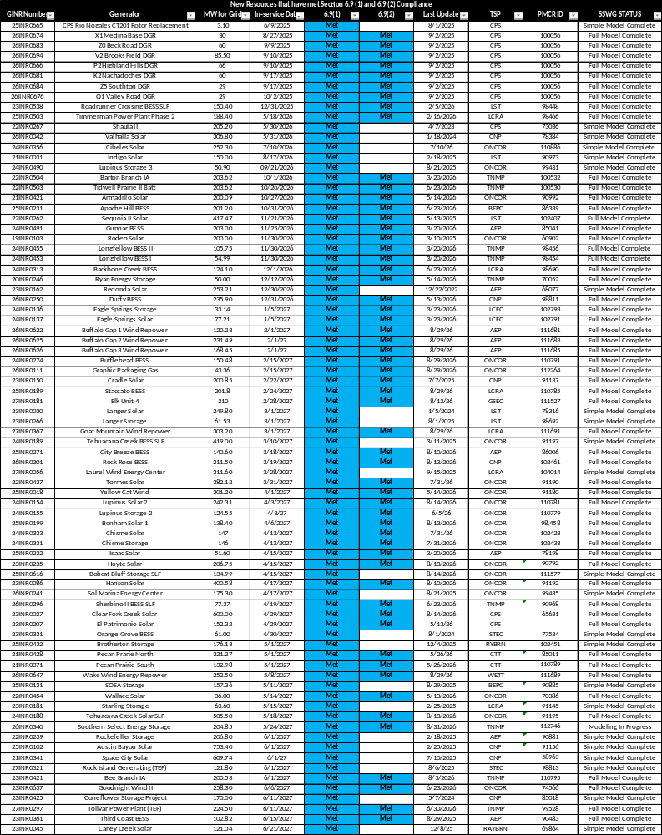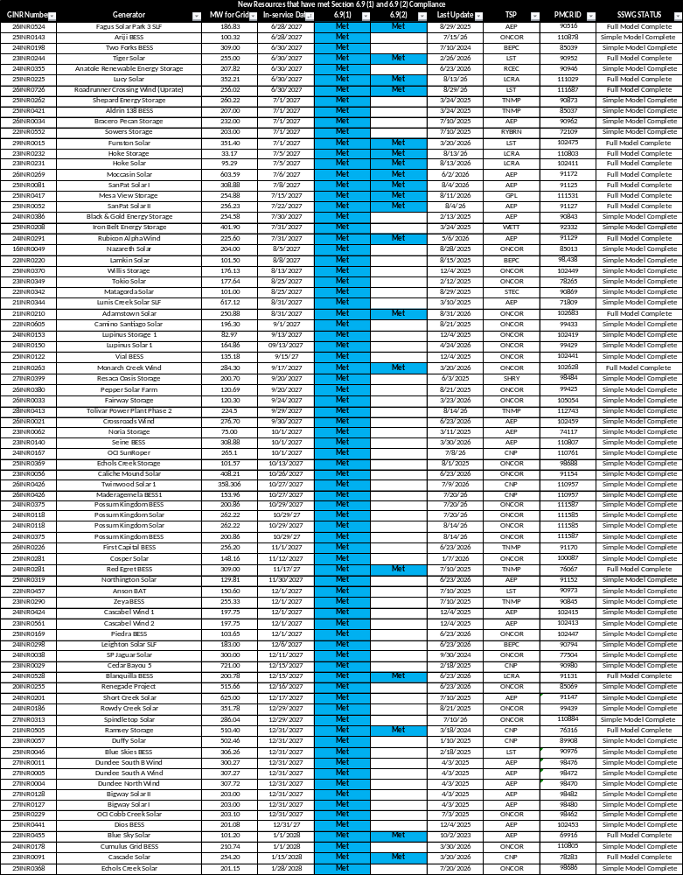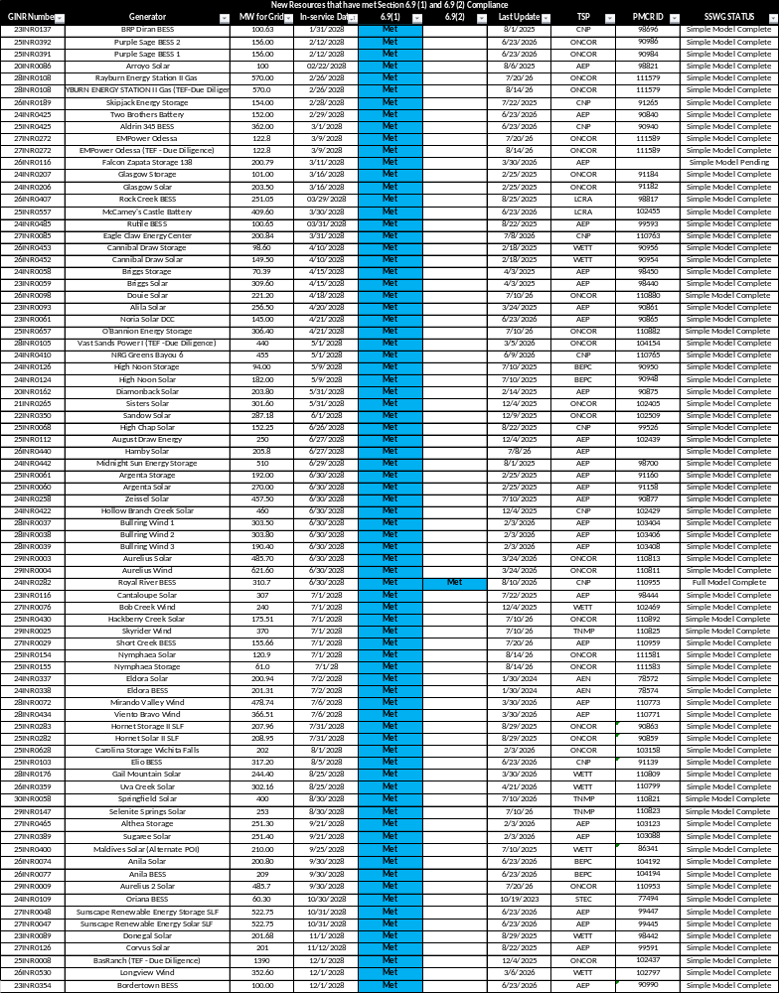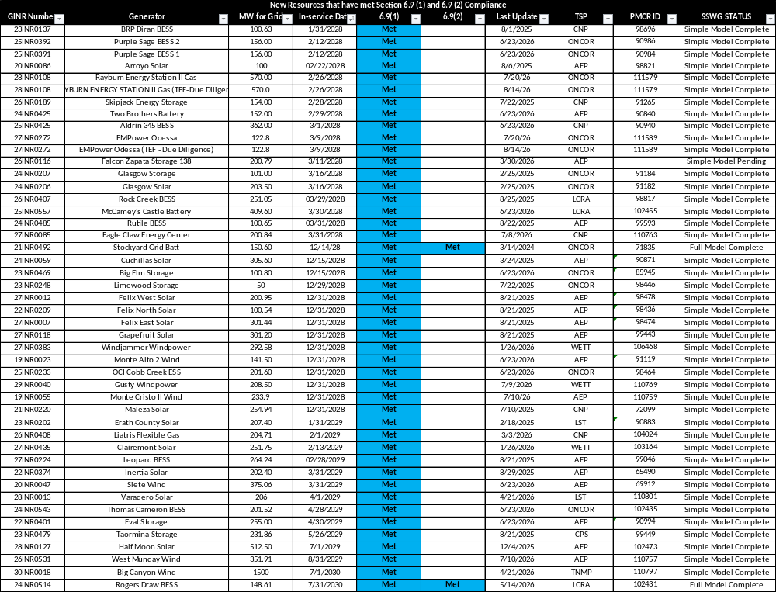

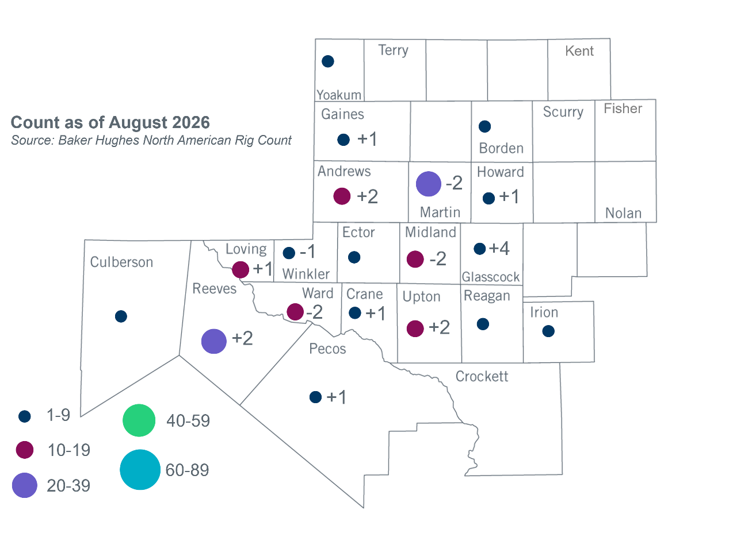
Permian Basin Oil Rig Count

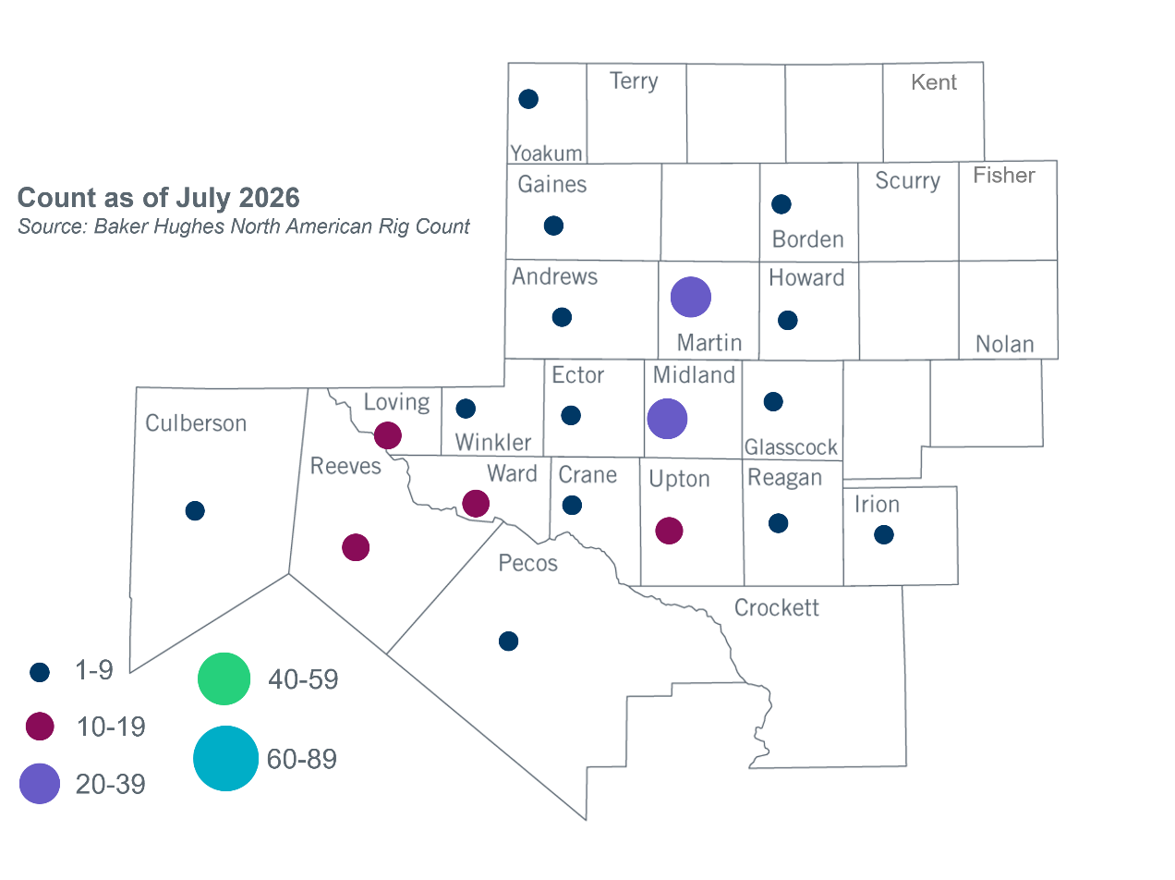

Other Notable Activities
- ERCOT presented an update on the 2026 economic study at the August 2026 RPG meeting.
- ERCOT presented an update on the 2026 Long-Term System Assessment (LTSA) at the August 2026 RPG meeting.

+/- symbol indicates the increase or decrease from the previous month in oil rigs present in each county. There are 172 rigs, including an increase of 9 oil rigs, in the Permian Basin from July to August 2026.

