
ERCOT
RFI Portal in RIOO — State and Community Impact
User Guide for Transmission Service Providers (TSPs),
Distribution Service Providers (DSPs), and
Load Entities
Version 1.0
September 14, 2026
ERCOT Public

Table of Contents

1. Overview
1.1 Background
1.2 Document Purpose
1.3 Who This Guide Is For
2. Getting Access to the RFI Portal in RIOO
2.1 Getting Access — TSPs and DSPs that Have RIOO Access Using a Digital Certificate
2.2 Getting Access — DSPs Without Existing RIOO Access
2.3 Getting Access — Load Entities
3. Logging In
3.1 Login Screen
3.2 Resetting Your Password
4. Your RFI Dashboard
4.1 Choosing the Community Impact RFI Tab
4.2 Status Tiles
4.3 RFI List Table
5. Opening an RFI
5.1 Left Navigation Menu
5.2 Key Points from the Instructions
6. Contact Invitation and Coordination
6.1 Understanding the Contact Workflow
6.2 How to Invite a Contact
7. Answering RFI Questions
8. Attestation
9. Review and Submit
9.1 Review and Submit — Load Entity
9.2 Complete, Review and Submit — Responsible TSP/DSP only
10. Message Center
11. Load Entity — Screens and Procedures
11.1 RFI Dashboard (Load Entity view)
11.2 Responding to a Returned RFI
12. Where to Get Help

1. Overview
1.1 Background
On August 3, 2026, the Governor of Texas directed the Public Utility Commission of Texas (PUCT) and ERCOT to collect information from developers of data center projects interconnecting in the ERCOT Region to understand the potential impacts of these data centers on the power grid, the state, and local communities. The State and Community Impact Request for Information (RFI) is issued to obtain that information.
This RFI applies to developers of data centers, including virtual currency mining facilities, with a planned power demand of 25 MW or greater that are proposed to operate within the ERCOT Region. The RFI is administered through ERCOT’s Resource Integration and Ongoing Operations (RIOO) portal.
ERCOT will send the RFI to each data center developer through the TSP or DSP that submitted information about the developer's load to ERCOT—referred to in this guide as the “Responsible TSP/DSP”. Using RIOO, the Responsible TSP/DSP submits contact information for the data center developer, triggering a RIOO notification to the developer to establish a RIOO login and complete the RFI. Once the developer has completed its response to the RFI, the Responsible TSP/DSP then submits the completed RFI to ERCOT through RIOO. In the RIOO dashboard and in this guide, the data center developer is referred to as the “Load Entity.” In the RFI questions, the developer is referred to as the “Data Center Developer.”
Note: Failure to respond to the RFI, or to any part of it, will be reported to the PUCT and the Office of the Governor. Additionally, failure to respond to the questions in Section C of the RFI, regarding water sources and consumption, may subject an RFI recipient to criminal penalties and other potential consequences under Texas Water Code § 16.012(m).
1.2 Document Purpose
This guide explains how TSPs, DSPs, and Load Entities use the RFI Portal in RIOO to respond to an assigned State and Community Impact RFI: how to get access, how to invite contacts, how to answer the questions in each section, how to provide the required attestation, how to submit, and how to communicate with ERCOT through the Message Center.
This guide covers the use of the RIOO interface only. For questions about the substance of the State and Community Impact RFI — what a specific question means or what information is required — contact ERCOT at DataCenterImpact@ercot.com.
Note: The RFI Portal in RIOO hosts two separate RFI workstreams: the Batch Zero Verification RFI and the State and Community Impact RFI. This guide covers the State and Community Impact RFI only. For the Batch Zero Verification RFI, refer to the Verification RFI User Guide.
1.3 Who This Guide Is For
Role | Responsibilities in RIOO
Responsible TSP or DSP | Receives the State and Community Impact RFI from ERCOT. Submits contact information for the Load Entity to enable the Load Entity to receive official notification of the RFI. May invite DSP contacts to have visibility of the RFI. Submits the completed RFI to ERCOT and ensures the Load Entity responds to any corrections requested by ERCOT.
Load Entity (data center developer) | Invited by the Responsible TSP/DSP to complete the RFI. Adds any additional Load Entity contacts to assist in completing the RFI. Reads the instructions and questions and provides a complete response to every section of the Community Impact RFI. Uploads the required supporting documentation and attestations. Submits the response to the Responsible TSP/DSP for review. Corrects and resubmits the response if it is returned by the Responsible TSP/DSP or ERCOT.

Note: Load Entity is the term you will see in the RIOO dashboard. It is the Contact Type you select when inviting someone, the wording on the status tiles, and the recipient option in the Message Center. The RFI itself refers to the responding organization as the “Data Center Developer.”
2. Getting Access to the RFI Portal in RIOO
2.1 Getting Access — TSPs and DSPs that Have RIOO Access Using a Digital Certificate
Employees of TSPs and DSPs that already have existing access to RIOO using Digital Certificates must request access through their ERCOT User Security Administrator (USA). The USA must establish an MPIM profile for the employee and then add the role to the user’s MPIM profile that allows access to RIOO. For more information on adding additional users for a TSP or DSP that already has access to RIOO, refer to the official ERCOT guide, TSP Sign-Up for RIOO Services: https://www.ercot.com/files/docs/2022/01/14/TSP-Sign-Up-for-RIOO-Services.pdf. ERCOT will send notice of the RFI to the primary contact designated by the Responsible TSP/DSP for the purposes of this State and Community Impact RFI.
Note: Employees of TSPs and DSPs that already have RIOO access using a Digital Certificate cannot be added using the “Invite Contacts” function in the RFI interface. Contact your ERCOT Client Service Representative if you have questions about the registration process.
2.2 Getting Access — DSPs Without Existing RIOO Access
Employees of DSPs that do not already have RIOO access using a Digital Certificate and have not already established an account in RIOO for purposes of completing the Batch Zero Verification RFI will need to establish an account in RIOO. Once ERCOT issues the RFI, the DSP will receive an email at the email address for the primary contact previously provided to ERCOT for the State and Community Impact RFI. The email will provide a link to the RFI. The DSP’s contact will also receive a separate email from ginr@ercot.com requesting verification of the email address. After clicking the link to verify the account, the user will receive an email asking the user to change the password for the account.
2.3 Getting Access —Load Entities
Employees of Load Entities must be invited by the Responsible TSP/DSP in RIOO, as follows:
- The Responsible TSP/DSP submits the name and email address of at least one representative of the Load Entity. RIOO then sends that representative a notification email with a link to access the RFI.
- If the Load Entity user’s email address is not already registered in RIOO, the user will receive two emails: an invitation email directing the user to the RFI, and a verification and change-password email allowing the user to set the password and complete registration. Users that have already established a RIOO account for the purposes of completing the Batch Zero Verification RFI (Large Loads only) can use their existing password.
- Registration is only required once per email address. If you are invited to more than one RFI, you can log in directly and see all the RFIs you have been invited to.
- Once an individual Load Entity user gains access to the RFI, they will be able to add additional Load Entity users to the RFI, as detailed in “6.2 How to Invite a Contact”.
To register:
- Open the verification email sent from ginr@ercot.com and click the link to set your password.
- Create a new password following the on-screen requirements.
- Return to the RIOO login page at https://sa.ercot.com/rioo-rs/ and log in with your email address and new password.
Note: Once you are working in the RFI, you may add other representatives of your organization to help complete the response. See Section 6, Contact Invitation and Coordination.
3. Logging In
3.1 Login Screen
Navigate to the RIOO login page at https://sa.ercot.com/rioo-rs/. You will see the ERCOT RIOO Services login screen.
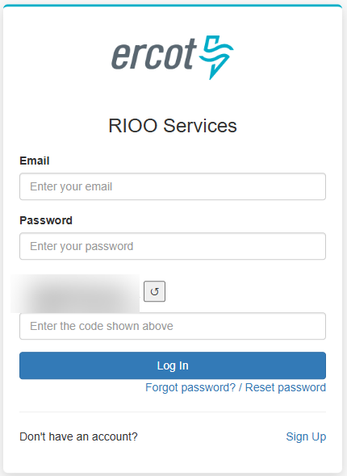
Figure 1 — RIOO Services login screen
To log in:
- Enter your registered email address in the Email field.
- Enter your password in the Password field.
- Enter the CAPTCHA code shown in the image into the 'Enter the code shown above' field. If the code is difficult to read, click the refresh button (↺) to generate a new one.
- Click Log In.
- You will be prompted to complete Multi-Factor Authentication (MFA). Enter the one-time code from your SMS text message or Google Authenticator app, then click Verify to complete the login.
Note: MFA is required every time you log in. The one-time code is delivered via SMS to your registered mobile number or through the Google Authenticator app — it is not sent by ERCOT. If you are unable to receive your MFA code, contact your company's IT administrator.
3.2 Resetting Your Password
If you have forgotten your password, click “Forgot password? / Reset password” below the Log In button. Enter your email address and follow the instructions in the reset email you receive.
Note: If you do not receive a reset email within a few minutes, check your spam or junk folder.
4. Your RFI Dashboard
After logging in, you are taken to the RFI Dashboard. For Load Entity users, this page shows all RFIs for which the user has been identified as a contact by the Responsible TSP/DSP or another Load Entity user. TSPs and DSPs see all loads for which they are the Responsible TSP/DSP. DSPs may also see RFIs that a Responsible TSP has invited them to see. However, Responsible TSP are not required to add DSPs to view State and Community Impact RFIs as the DSP is not required to provide any response.
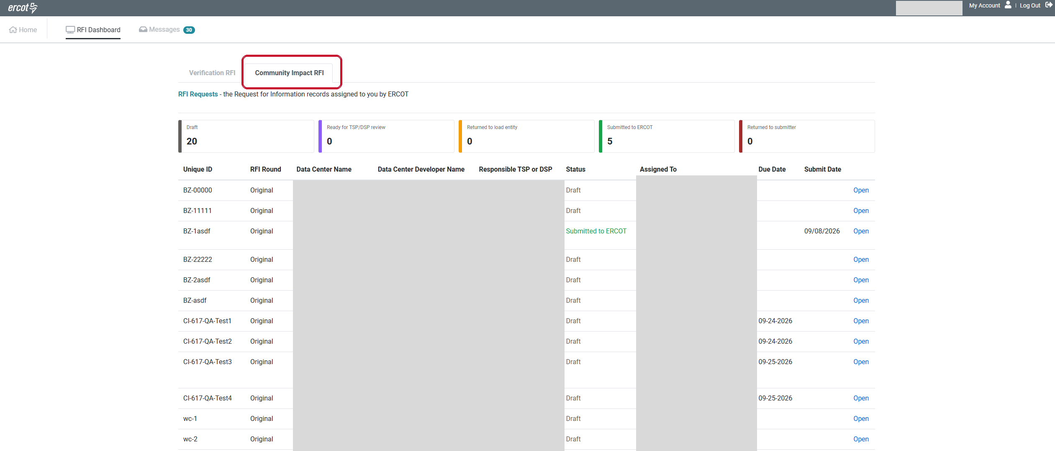
Figure 2 — RFI Dashboard with the Community Impact RFI tab selected (data center and developer names redacted)
4.1 Choosing the Community Impact RFI Tab
Two tabs appear above the RFI Requests heading:
- Verification RFI — This tab corresponds to the Batch Zero Verification RFI, which is covered by a separate User Guide.
- Community Impact RFI — This tab corresponds to the State and Community Impact RFI covered by this Guide.
Select the Community Impact RFI tab to see the State and Community Impact RFI(s) assigned to you. The two RFI workstreams are kept separate: a State and Community Impact RFI does not appear under the Verification RFI tab, and a Verification RFI does not appear under the Community Impact RFI tab.
Note: If you are responsible for loads in both workstreams, always confirm which tab you are on before opening and/or responding to an RFI. The two RFIs ask different questions and have different deadlines.
4.2 Status Tiles
At the top of the dashboard, five status tiles show how many of your State and Community Impact RFIs are in each stage. Selecting a tile filters the list below it.
Status | What it means
Draft | The RFI has been issued and is awaiting responses from the Load Entity.
Ready for TSP/DSP review | Load Entity has submitted its responses. The Responsible TSP/DSP must ensure each section of the RFI response has been completed (as indicated by the green status indicators for each section in the “Review” page for the RFI) before submitting to ERCOT.
Returned to Load Entity | The Responsible TSP/DSP has returned the RFI to the Load Entity for correction.
Submitted to ERCOT | The Responsible TSP/DSP has submitted the completed RFI to ERCOT for review.
Returned to submitter | ERCOT has returned the RFI to the Responsible TSP/DSP for correction.
4.3 RFI List Table
Each row in the table represents one State and Community Impact RFI. The columns show:
Column | Description
Unique ID | The ERCOT-assigned identifier for this facility, including a Batch Zero (BZ) or Medium Load (ML) number and a CI suffix (denoting “Community Impact.”).
RFI Round | Whether this is the first RFI (Original) or a Follow-up RFI issued by ERCOT.
Data Center Name | The name of the data center facility this RFI relates to.
Data Center Developer Name | The developer associated with this facility.
Responsible TSP or DSP | The TSP or DSP responsible for notifying the Load Entity and submitting this RFI to ERCOT when it is complete.
Status | The status of this RFI (see Section 4.2).
Assigned To | The contacts invited to this RFI, shown with their role (DSP, Load Entity).
Due Date | The deadline by which the completed RFI must be submitted to ERCOT.
Submit Date | The date the RFI was submitted to ERCOT (blank if not yet submitted).
Open | Click Open to begin, continue or review your response.
5. Opening an RFI
From the Community Impact RFI tab, click Open on any RFI row. The first screen you see is the Instructions section. The Load Entity must read the instructions carefully before starting your response — they explain the purpose of the RFI, who must respond, what is required, and the deadline for submission.
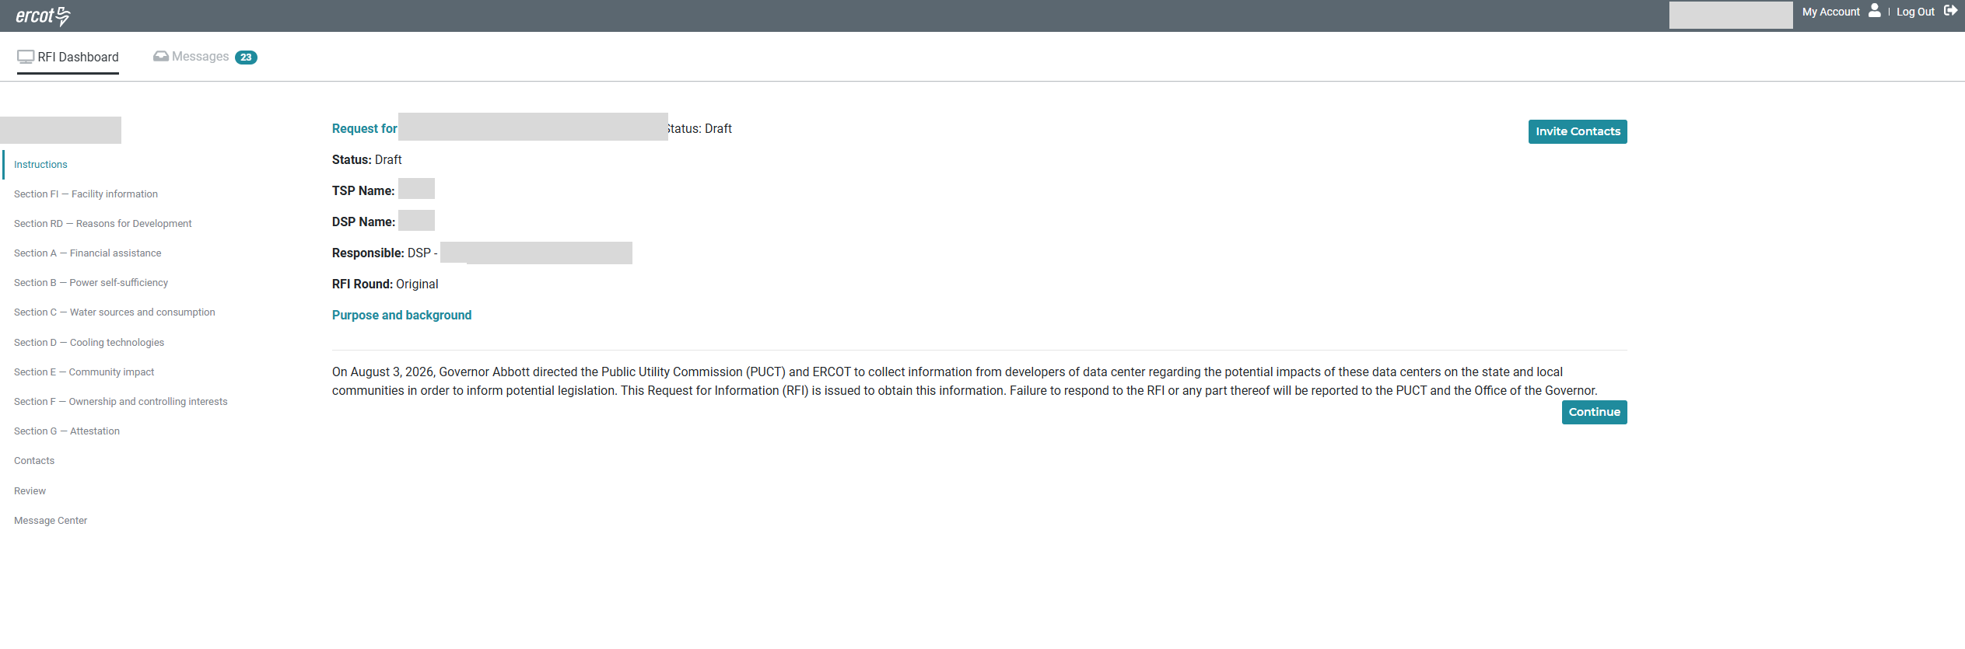
Figure 3 — Instructions section when opening a Community Impact RFI (unique ID and data center name redacted)
The header at the top of every screen shows the Status, the TSP Name (if applicable), the DSP Name (if any), the Responsible TSP/DSP and email, and the RFI Round.
5.1 Left Navigation Menu
The left navigation menu lists every section in the RFI. A State and Community Impact RFI typically contains the following:
Navigation item | Subject Matter of Questions
Instructions | The purpose, applicability, scope, respondents and instructions for this RFI. Read before starting.
Section FI — Facility information | Respondent contact details, the Data Center Facility project name, the Data Center Developer name, the unique identifier and the State Regional Water Planning Group.
Section RD — Reasons for Development | Why the facility is being developed at this location in Texas.
Section A — Financial assistance | The Data Center Developer's own capital investment, and any state, local, federal or other financial assistance received, applied for, or expected, plus publicly funded infrastructure serving the facility.
Section B — Power self-sufficiency | Load projections by year, on-site generation and storage, off-site power purchase arrangements, and curtailment or demand response participation.
Section C — Water sources and consumption | Water demand and efficiency, water supply by source, on-site recycling, water discharge, and the PUCT Energy and Water Use Survey.
Section D — Cooling technologies | Cooling equipment, electricity consumption, air and liquid cooling methods, heat rejection methods, and water-efficient cooling measures.
Section E — Community impact | Employment, labor incentives, community engagement, project footprint, construction lifecycle, off-site development, noise, setbacks, light controls, traffic and emergency response.
Section F — Ownership and controlling interests | The owner and operator model, foreign interests, affiliates, and any changes in ownership.
Section G — Attestation | Where the signed and notarized attestation for the response is provided.
Contacts | Invite or view the DSP and Load Entity contacts added to this RFI.
Review | Check that all sections are complete and submit your response.
Message Center | Send and receive messages with ERCOT and other contacts on this RFI.

5.2 Key Points from the Instructions
- This RFI applies to data centers and virtual currency mining facilities with a planned power demand of 25 MW or greater proposed to operate in the ERCOT Region.
- A separate response must be completed for each Data Center Facility.
- Respond to all questions. Where information is not available or not applicable, say so and explain why in the narrative field for that question.
- If you can answer only part of a question, answer that part and explain why you cannot answer the remainder.
- Provide supporting data and documentation where requested.
- The Load Entity must upload a signed and notarized attestation confirming the accuracy and completeness of the information provided.
- All information submitted will be treated as confidential to the greatest extent permitted by law. ERCOT may disclose aggregated or anonymized information that does not identify a specific Developer or Facility.
From the Instructions, click Continue to move to the first section of the RFI.
Note: The deadline for this RFI is stated in the Instructions section and is also shown in the Due Date column on your dashboard.
6. Contact Invitation and Coordination
6.1 Understanding the Contact Workflow
- ERCOT issues the State and Community Impact RFI to the Responsible TSP/DSP. TSPs and DSPs never initiate an RFI themselves.
- The TSP logs in, opens the State and Community Impact RFI tab on the dashboard, and clicks on “Invite Contacts” to invite contacts from the Load Entity and the DSP.
  - The name and email address of at least one Data Center Developer representative must be submitted by the end of the second Business Day after the day the RFI is released. RIOO then sends that representative a notification email automatically.
  - Additional contacts on the Load Entity side can be invited at any time while the response is still editable.
- The Load Entity reads the instructions, completes the questionnaire and attaches any required supporting documentation, uploads the notarized attestation, and then submits the response to the Responsible TSP/DSP for review [Ready for TSP/DSP review].
  - The Responsible TSP/DSP reviews the response. The Responsible TSP/DSP cannot edit the Load Entity’s answers.
  - If the TSP/DSP determines that the response is not complete, or if the Load Entity requests that the RFI response be returned, the TSP/DSP may return the response to the Load Entity with comments [Returned to load entity]. The Load Entity may correct the response and submit it again. This can be repeated as many times as needed.
- Once the Responsible TSP/DSP has confirmed the response is complete, the Responsible TSP/DSP may submit it to ERCOT [Submitted to ERCOT]. Only the Responsible TSP/DSP can submit an RFI response to ERCOT. Load Entities cannot submit the RFI to ERCOT directly.
- ERCOT reviews the submitted response. If corrections are needed, ERCOT returns it to the Responsible TSP/DSP with comments or notes [Returned to submitter], and the TSP/DSP works with the Load Entity to correct and resubmit.
- At any point in this flow, any party can raise a question or add a note in the Message Center for that RFI.
Note: If communication is needed between the parties working on an RFI, parties may use the Message Center (see Section 9) rather than email to ensure the exchange stays attached to the RFI.
6.2 How to Invite a Contact
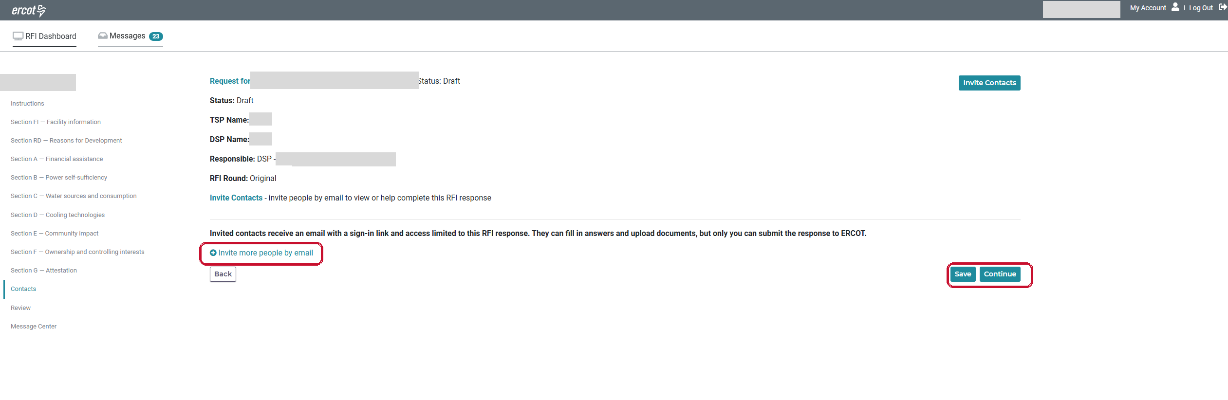
Figure 4 — Invite Contacts screen (unique ID and data center name redacted)
To invite a contact:
- Open the RFI from your dashboard. Click “Invite Contacts” at the top right of the screen, or Contacts in the left navigation menu.
- Click “+ Invite more people by email” to add a new contact row.
- Enter the contact's Email Address, First Name and Last Name.
- Select the Contact Type: Load Entity or DSP.
- Click Save. The contact receives an invitation email with a sign-in link.
Note: Once a contact has signed in, their fields are locked and the row shows 'Invited and signed in — fields are locked. Remove to revoke access.' with a green padlock. Click the remove control to revoke access. Contacts can only be changed while the response is still editable, before it is submitted to ERCOT.
7. Answering RFI Questions
Each RFI is divided into sections. Navigate between them using the left navigation menu or move forward and back using the Save & Continue and Back buttons at the bottom of each section.
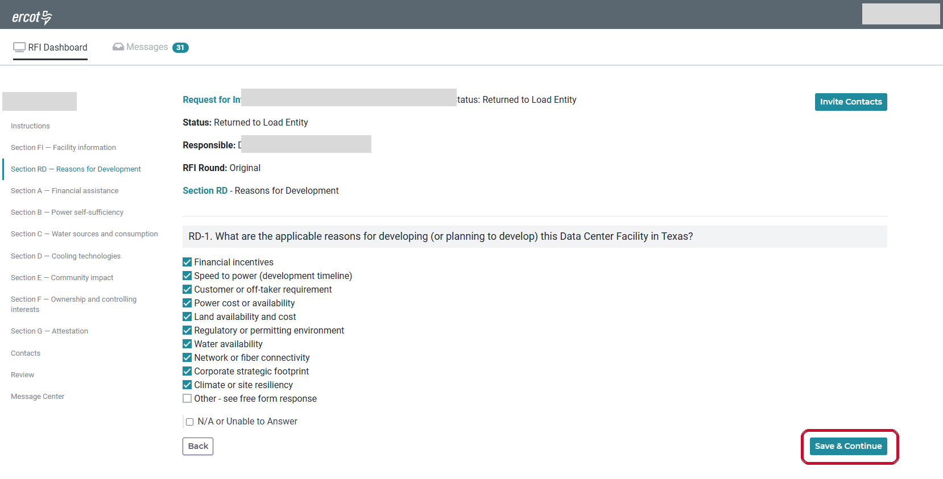
Figure 5 — Example RFI section showing a required question (unique ID and data center name redacted)
Question types you may see:
Question type | How to answer
Text or number field | Type your answer directly into the field. Number fields may show a unit, for example $, MW, MWh, gallons, acres or a percentage.
Date field | Enter the date in the format shown, usually MM/YYYY or MM/DD/YYYY.
Yes / No (radio button) | Select one option. Answering Yes often reveals additional follow-up questions.
Multiple choice / select all that apply | Select one or more options as applicable. Choosing “Other” usually reveals a free-response field.
Table entry | Fill in the data required in each row. Add rows where the table allows it.
Supporting document upload | Click “+ Choose File” to attach a file. PDF, Word, Excel and image files are accepted. Files appear in the Supporting Documents table once uploaded.
Narrative / Additional Information | A free-form field at the end of a question group where you can explain or add detail.

To complete a section:
- Click the section name in the left navigation menu.
- Answer every question in the section.
- Where a question does not apply, use the N/A or unable-to-answer option and select the reason: not determined, not applicable, dependent on a third party, or other. Explain an “other” response in the free-form field.
- For questions requiring supporting documents, select the document type and click “+ Choose File” to upload. The file is listed in the Supporting documents panel for that question, with details of who attached it and when.
- Click Save & Continue at the bottom right to save your answers and move to the next section. Click Back to return to the previous section.
Note: All uploaded files are scanned by ERCOT's security systems and will not upload if they are harmful or corrupt. Large files may take time to scan; the file can be viewed once scanning and upload are complete.
Note: Completing the questionnaire is the Load Entity's responsibility. The Responsible TSP/DSP cannot edit the Load Entity's answers. Where more than one Load Entity contact has been invited, they can work on the RFI response at the same time.
8. Attestation
Section G of the Community Impact RFI covers the attestation. ERCOT publishes the attestation form on its website at the link provided in the RFI. Download it, complete it, have it signed and notarized, and provide it with the response before submitting.
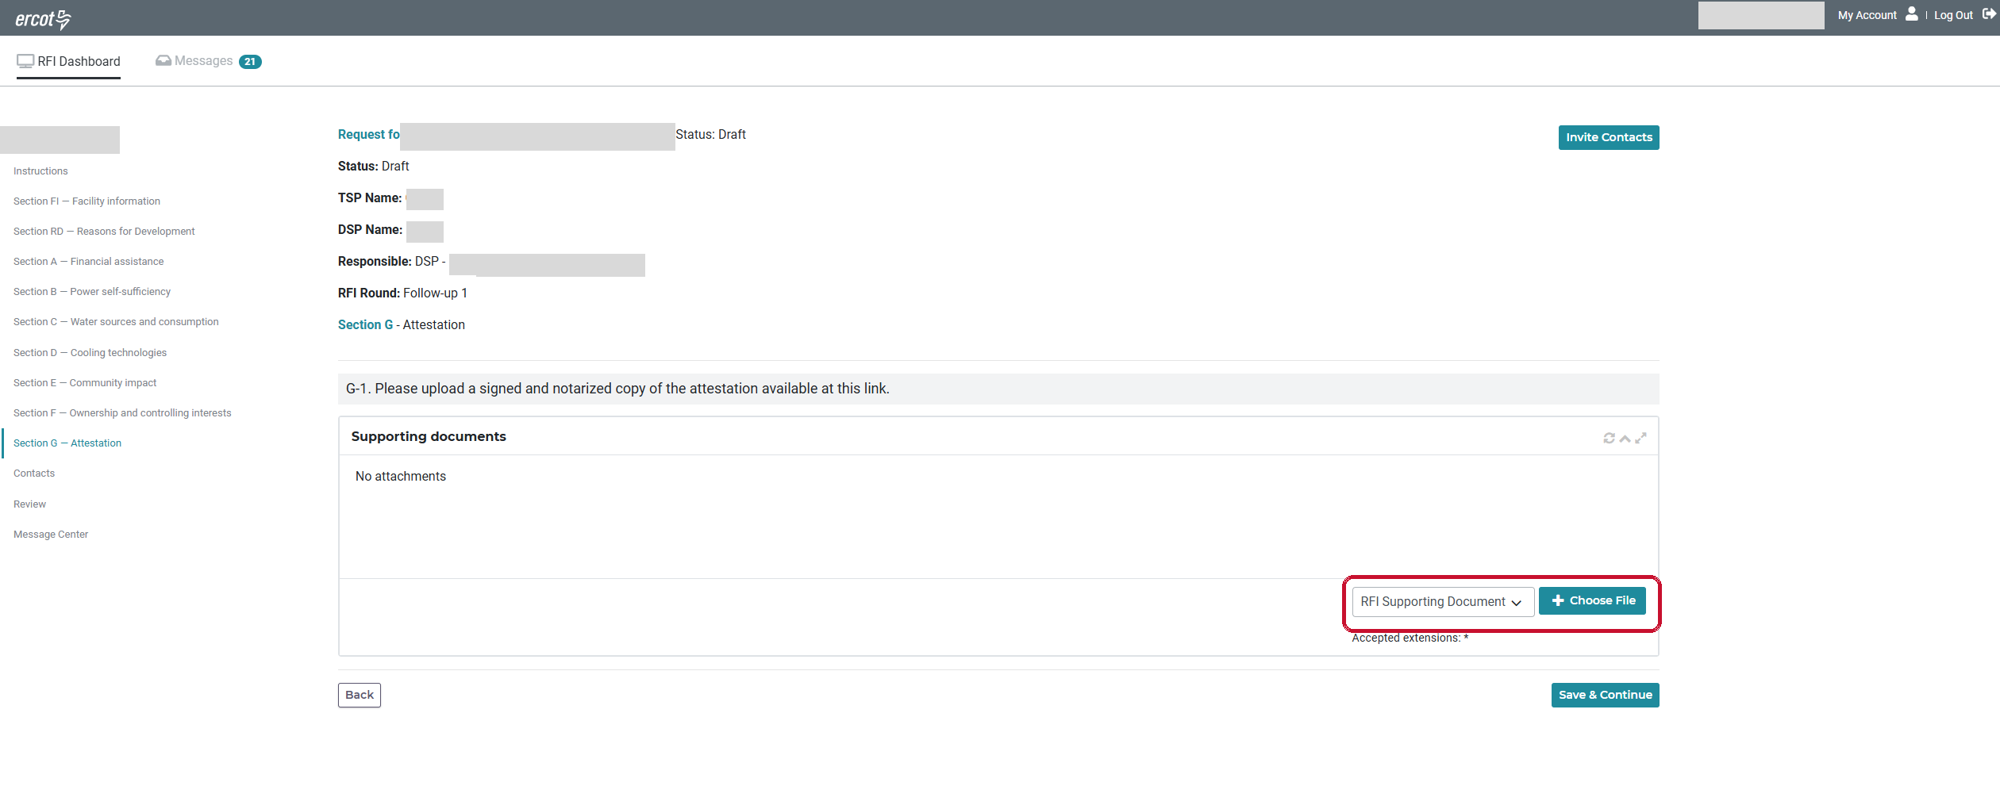
Figure 6 — Section G — Attestation (unique ID and data center name redacted)
To provide the attestation:
- Open the Attestation section from the left navigation menu. The Attestation question requires the Load Entity to upload a signed and notarized copy of the attestation and provides a link to the form.
- Follow the link to open the attestation form and complete it. It must be executed by an officer or other authorized person with authority to bind the responding entity, and it must be notarized.
- In the Supporting documents panel, choose the document type and click “+ Choose File” to upload the signed and notarized form. Click Save & Continue.
Note: The RFI cannot be submitted until the signed attestation form has been uploaded by the Load Entity. The Load Entity must use the form of the attestation provided.
9. Review and Submit
9.1 Review and Submit — Load Entity
Once you have completed the questionnaire, or at any point during completion, click Review in the left navigation menu to check that every section is complete. For each section that is complete, the “Edit” button on the right will be green. A red “Edit” button indicates that the response is not complete.
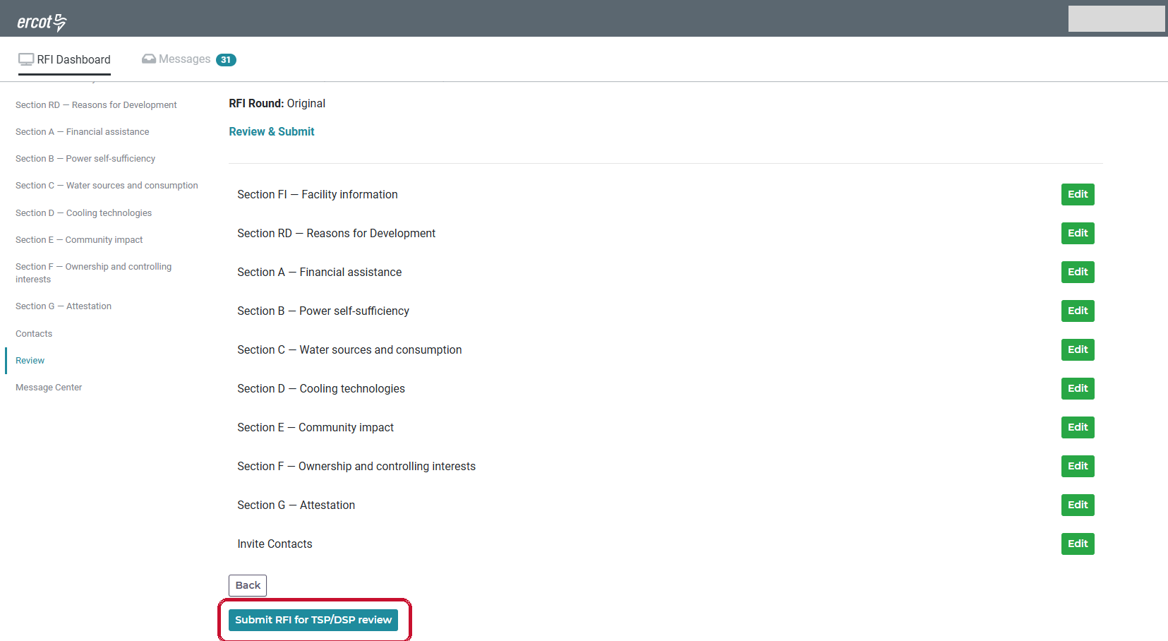
Figure 7 — Review & Submit screen listing every section, shown after the response has been submitted (unique ID and data center name redacted)
The Review screen lists every section of the RFI. Use the Edit button that corresponds to any section to return to the section and review or change your answers.
To submit your response to the Responsible TSP/DSP:
- Review every section listed on the screen and confirm each one is complete.
- If a section is still incomplete, click “Edit” to open it, complete the missing information, and return to Review.
- Confirm the signed attestation has been uploaded.
- Click the submit button to send your completed response to the Responsible TSP/DSP for review.
Note: Load Entities submit to the Responsible TSP/DSP, not to ERCOT. Once the Load Entity submits the RFI, the Review screen shows ‘This RFI response has been submitted’ and only a Back button is available. The Edit buttons display on the screen and remain green, but the response is read-only — clicking Edit will not reopen a section. The response becomes editable again only if the Responsible TSP/DSP or ERCOT returns it to the Load Entity, in which case the Load Entity must submit it again.
9.2 Complete, Review and Submit — Responsible TSP/DSP only
When the Load Entity has completed the RFI questionnaire and submitted it to the Responsible TSP/DSP, the TSP/DSP should open the RFI and click Review in the left navigation menu. The Responsible TSP/DSP should verify that each section has been completed by noting the green color of the “Edit” button by each section. The Responsible TSP/DSP cannot edit the Load Entity’s answers.
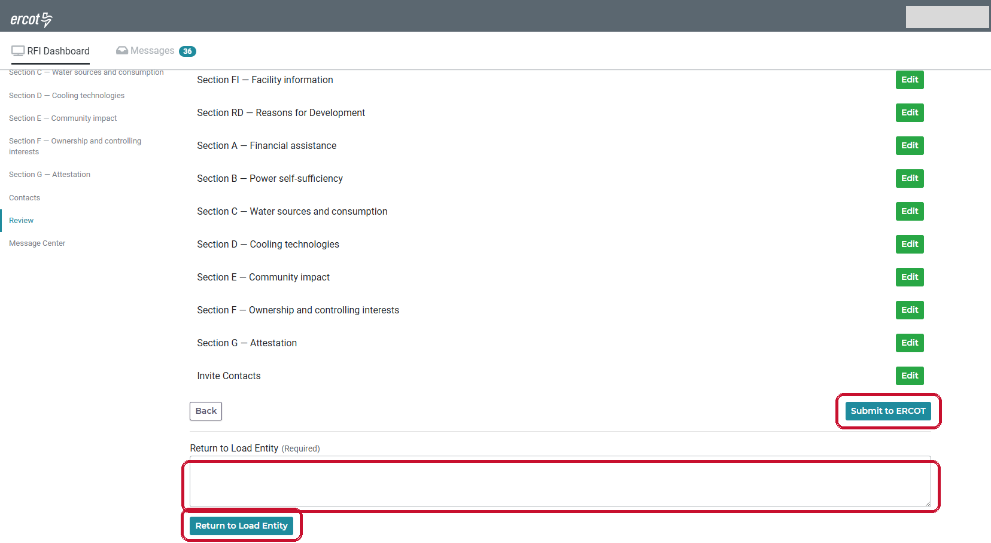
Figure 8 — Review screen as seen by the Responsible TSP/DSP, with Submit to ERCOT and Return to Load Entity
- Read through each section and confirm the response is complete.
- If the response is not complete, or if the Load Entity has requested that the RFI be returned, Responsible TSP/DSP user may return the RFI to the Load Entity. A comment must be entered in the Return to Load Entity box before the RFI can be returned to the Load Entity.
- Click “Return to Load Entity.” The status changes to “Returned to Load Entity,” the Load Entity is notified, and the response unlocks for them to correct. The Load Entity must then submit it to you again.
- When the Responsible TSP/DSP is satisfied that the response is complete, click “Submit to ERCOT.”
Note: Only the Responsible TSP/DSP has the “Submit to ERCOT” button. After submitting, the RFI status changes to “Submitted to ERCOT” and the response is locked. If ERCOT returns it, the status changes to “Returned to submitter” and it unlocks for the Responsible TSP/DSP again, who can then return it to the Load Entity if needed.
10. Message Center
The Message Center allows TSPs, DSPs, Load Entities and ERCOT to communicate about a specific RFI. You can create a message topic, set its type, set an optional due date for a response, and choose which parties receive it. DO NOT USE THE MESSAGE CENTER TO ASK ERCOT QUESTIONS ABOUT THE SUBSTANCE OF THE RFI; YOU MAY USE IT ONLY TO ASK QUESTIONS ABOUT THE ADMINISTRATION OF THE RFI IN RIOO. Questions about the substance of the RFI, including any of the questions in the RFI, must be sent to DataCenterImpact@ercot.com. Any questions about using or logging into the RIOO platform should be sent to servicedesk@ercot.com.
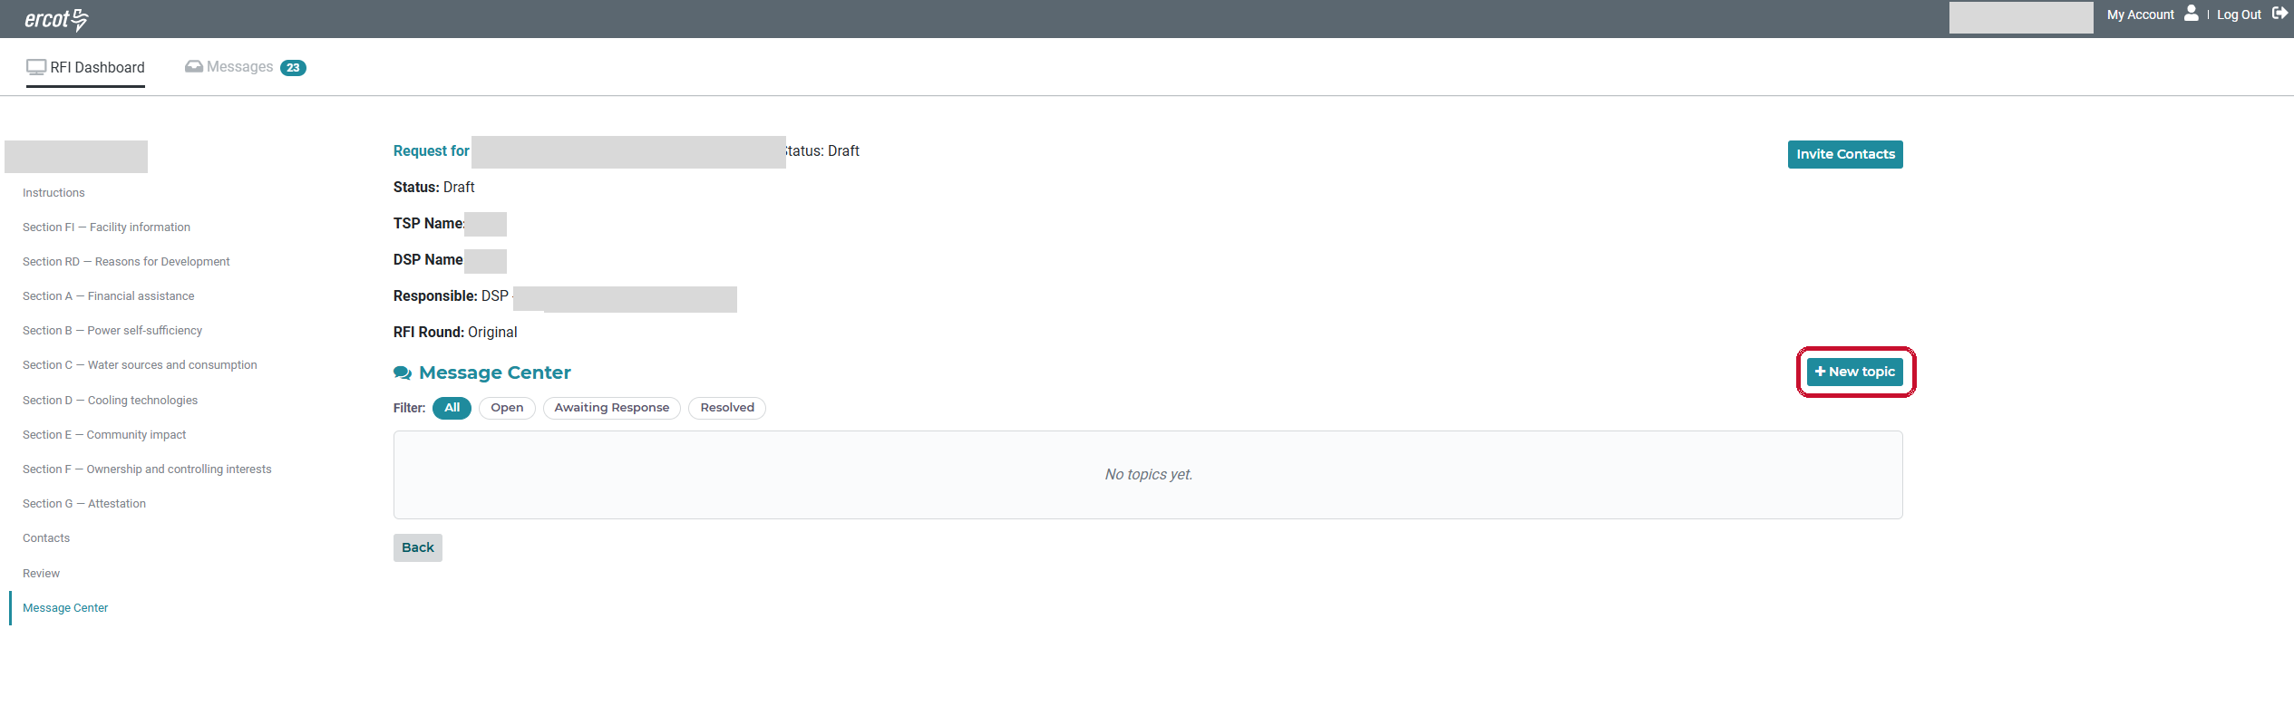
Figure 9 — Message Center inside an RFI (unique ID and data center name redacted)
To create a new message topic:
- Open the RFI and click Message Center in the left navigation menu.
- Click '+ New topic' in the top right.
- Enter a Subject and select a Type from the dropdown, for example Information, Action Required, Document Request, Review Complete, Milestone Update, Returned for Correction, Returned to Load Entity or Follow-up RFI Issued.
- Optionally set a Due date using the date picker (future dates only).
- Write your message, then use the Send to checkboxes to choose who receives it: All, ERCOT, TSP, DSP or Load Entity.
- Click 'Open topic' to send.
Filtering and tracking messages:
Use the filter buttons — All, Open, Awaiting Response, Resolved — to view threads by their current status. Click a thread to open it and reply.
The Messages tab in the top navigation shows every thread across all of your RFIs, with an unread count. From there you can filter by RFI and by status.
Note: Only the parties selected in Send can see a message thread. ERCOT can see all threads on every RFI.
11. Load Entity — Screens and Procedures
Note: The Load Entity completes the questionnaire. The Responsible TSP/DSP cannot edit the answers.
11.1 RFI Dashboard (Load Entity view)
The dashboard works as described in Section 4. A Load Entity sees only the RFIs it has been invited to.
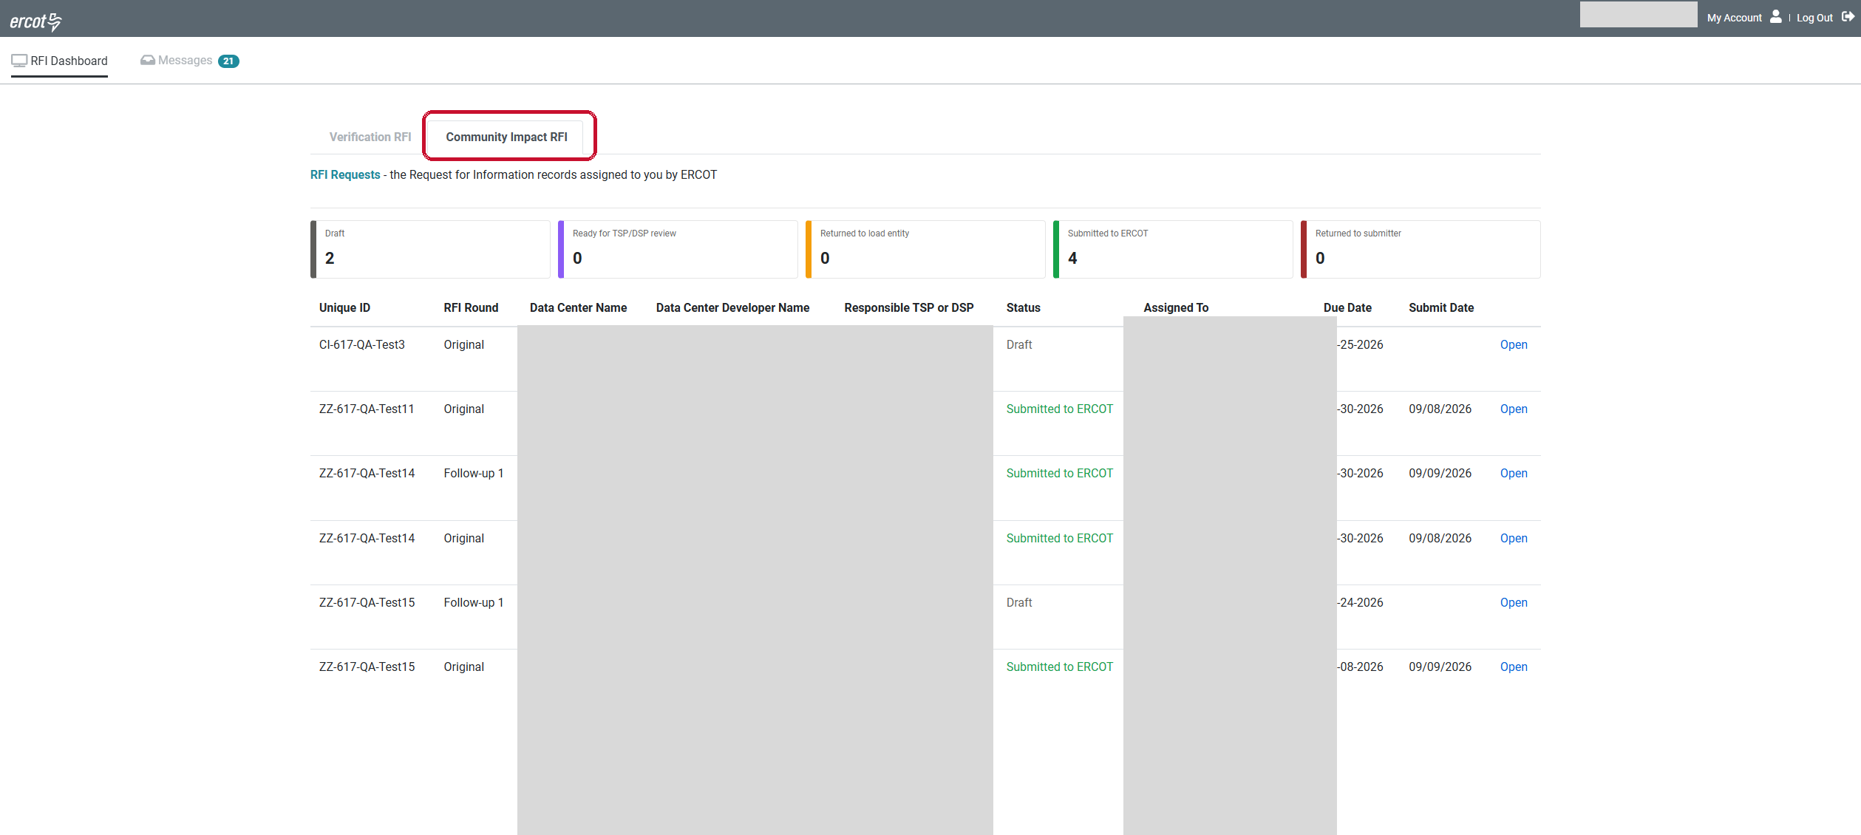
Figure 10 — RFI Dashboard as seen by a Load Entity (data center and developer names redacted)
11.2 Responding to a Returned RFI
If the Responsible TSP/DSP returns the response, the status changes to “Returned to Load Entity” and the response unlocks for editing.
- Open the RFI from the dashboard. The reason the TSP/DSP entered when returning it is available with the response, and any related discussion is in the Message Center.
- Make the corrections in the sections concerned, uploading any additional supporting documentation requested.
- Go to Review and submit the response to the Responsible TSP/DSP again.
Note: This can happen more than once. Each time the response is returned it becomes editable again, and each time you submit it locks and returns to the Responsible TSP/DSP for review.
12. Where to Get Help
- For questions about the substance of the Community Impact RFI—what a question mean or what information is required—contact ERCOT at DataCenterImpact@ercot.com.
- For technical questions or issues using the RIOO platform, contact the ERCOT service desk at servicdesk@ercot.com.

