Memorandum

To: ERCOT Technical Advisory Committee
From: Jeff McDonald; Andrew Reimers
Date: August 25, 2026
Re: IMM Commentary on the 2027 Ancillary Services Methodology

Executive Summary
- ERCOT’s own model predicted a significant number of Watch conditions for this year that did not materialize this year. We encourage greater scrutiny from stakeholders of ERCOT’s risk parameters.
- The 2027 AS Methodology (ASM) should optimize for a 1-in-10 probability of firm load shed while allowing shortage pricing needed to support efficient investment signals.
- Input parameters should accurately characterize the supply and demand risks present in the ERCOT system
- ERCOT should account for available headroom without applying redundant conservatism already captured by the stochastic model.
- ERCOT should relax the Regulation Up and RRS restoration constraint because substantial qualified ESR and NCLR capacity can restore those services directly.
- Excessive AS procurement targets suppress real-time energy prices and increase the likelihood and magnitude of RUC commitments.
- We have included our primary recommendation at the end of these comments
Last year, ERCOT developed a stochastic risk methodology to determine ECRS and Non-Spin procurement quantities based on a 1-in-10-year probability of Watch conditions. Last month, stakeholders learned that a modeling error caused ERCOT to procure, on average, approximately 3,700 MW, or over 32 million MWh across the year, less than the methodology intended. If the model accurately represented system risk, such a substantial shortfall should have produced a meaningful number of Watch hours. Instead, ERCOT has experienced no Watch conditions (not even any interval below 4 GW of reserves), despite a severe winter storm and summer demand that exceeded the previous peak record by approximately 6 GW. It is only reasonable to conclude that ERCOT’s model materially overstates system risk and produces excessive reserve targets that distort wholesale market outcomes.
This year, we are engaged in the same conversation, seeking stakeholder support in the hope that the blunder regarding the recent 2026 ASM discrepancy will encourage greater scrutiny of ERCOT’s claims of reasonable risk parameters. In these comments, we begin with our disagreements with ERCOT’s approach to the 2027 ASM, expand on those disagreements, and finish with recommendations moving forward.

Disagreements with ERCOT’s Approach to the ASM

Scenario Comparisons need to be Grounded in Empirical Observation
Slide 15 of ERCOT’s TAC presentation depicts model outputs that do not reasonably represent actual system conditions. The graphic places each scenario on the y-axis according to the procurement quantity produced by that scenario. ERCOT then estimates the hours of Watch, EEA1, and EEA3 conditions by testing each procurement quantity against a common risk outlook, rather than against the risk assumptions underlying the scenario that produced the quantity. Critically, the common risk outlook incorporates the most conservative assumptions tested, including an assumption that none of the headroom available outside the AS Plan will contribute to system reliability.
Slide 15 from ERCOT’s Presentation to TAC, August 26, 2026
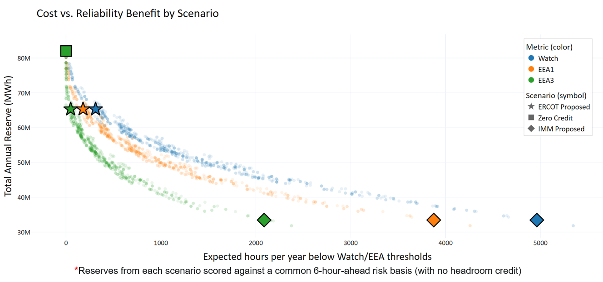
The resulting comparison effectively assumes that none of the headroom that is not procured through the AS Plan will be available when a contingency occurs and that ERCOT’s preferred risk inputs would result in 311 hours of Watch conditions. Such an assumption severely distorts actual system conditions, in which online headroom, offline capacity available within 30 minutes, and available ESR capacity can respond to system needs even when ERCOT has not procured that capacity as an Ancillary Service. Scenario comparisons should evaluate reliability outcomes using realistic assumptions about the capacity available to respond, not a deliberately conservative risk outlook that presumes the disappearance of all unprocured headroom.
This representation is misleading. ERCOT should instead reference the graphic from the AS Methodology Scenario Comparison tool that evaluates each scenario’s procurement target against the risk assumptions underlying that same scenario. Unlike the graphic on slide 15, the alternative comparison does not evaluate every procurement target solely against unduly conservative risk assumptions, including the unrealistic assumption that all unprocured headroom is necessarily unavailable. The following sections explain why some shortage conditions are necessary for proper market outcomes and why ERCOT’s risk parameters overstate actual system risk, resulting in excessive procurement targets.
Graphic from ERCOT’s AS Methodology Scenario Comparison Tool
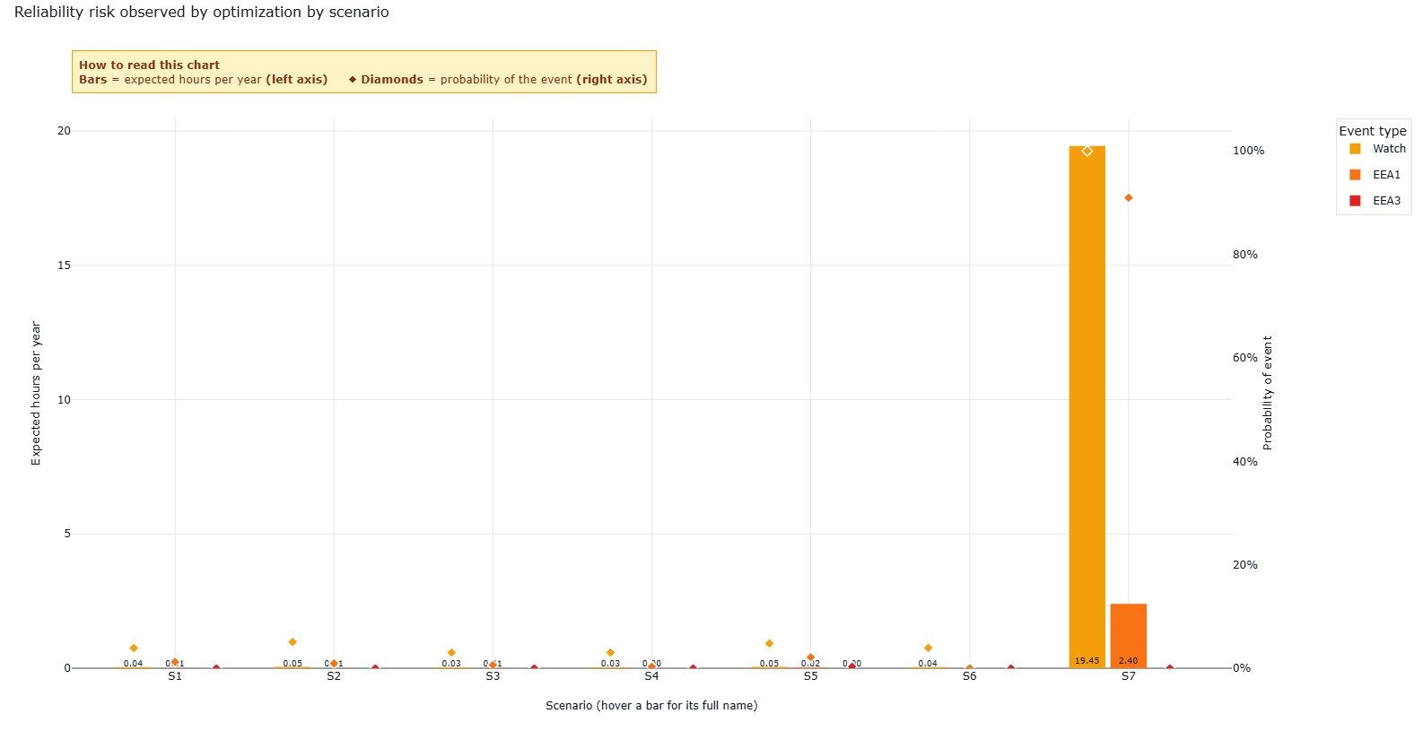
19.4 hours of Watch
2.4 hours of EEA1
0 hours of EEA3
Based on Scenario:
- TR= 1,500 MW, 1-in-10
- No Reg + RRS Restoration Requirement
- No Discounting Headroom
- 3HA Forecast Error

Avoid Load Shed, not Shortage Conditions
The scenario presented at the end of the previous section projects 19.4 hours of Watch conditions, 2.4 hours of EEA1 conditions, and no hours of firm load shed. The scenario solves for a 1-in-10-year probability of firm load shed, eliminates the Reg Up and RRS restoration requirement, credits all qualifying headroom, and uses a three-hour-ahead forecast-error horizon. Such an outcome, which allows some shortage conditions while avoiding firm load shed, represents the appropriate target for ERCOT and stakeholders. ERCOT’s energy-only market relies on shortage pricing to provide generators with the revenues and investment signals needed to support new capacity. A methodology designed to eliminate all shortage conditions would suppress those signals and undermine the market’s ability to attract investment, even if it reduced modeled operational risk.

The Headroom Fallacy
Some stakeholders have characterized headroom as “free capacity” and have argued that accounting for the availability of unprocured headroom would be reckless. That argument contains two conceptual flaws. First, the Monte Carlo simulation already accounts for the probabilistic variation in headroom by incorporating a range of historical headroom observations rather than assuming normal operating conditions in every modeled outcome. Applying an additional uniform discount to that capacity causes the model to overstate the probability of shortage conditions at a given level of operating reserves.
Second, available headroom is not “free.” Under RTC, SCED awards AS to qualified available capacity every five minutes. If a contingency requires ERCOT to dispatch reserve capacity for energy, SCED will seek replacement reserves from other qualified resources. Those resources will receive the applicable real-time Market Clearing Price for Capacity. The market therefore compensates resources that supply replacement reserves, even if ERCOT did not procure that capacity through the AS Plan before the contingency.

The Reg+RRS Restoration Issue
Restoring Regulation and RRS is not a NERC Requirement
One of ERCOT’s convergence criteria establishes a floor for ECRS and Non-Spin procurement based on restoring 100% of Regulation Up and RRS. ERCOT cites BAL-003-2, which requires ERCOT to achieve an annual Frequency Response Measure that meets or exceeds its Interconnection Frequency Response Obligation. The standard measures whether the system provides sufficient primary frequency response to arrest and stabilize frequency following a disturbance.
BAL-003-2 does not require ERCOT to procure enough ECRS and Non-Spin to restore 100% of deployed Regulation Up and RRS. NERC’s separate contingency-reserve standard allows ERCOT 90 minutes after the Contingency Event Recovery Period to restore its contingency reserves. During that period, ERCOT can dispatch slower-responding ECRS and Non-Spin capacity and return faster-responding resources to Regulation and RRS. Full restoration through the AS procurement floor may reflect ERCOT’s preferred operating posture, but ERCOT should not characterize that choice as a NERC requirement without identifying the specific provision that mandates it.
The System’s Replacement Capacity for Regulation and RRS is Enormous
ERCOT’s methodology substantially understates the amount of replacement capacity inherently available to restore Regulation Service and RRS, including capacity that is separate from the resources providing ECRS and Non-Spin. ESRs provide approximately 95% of Regulation Service, while ESRs and Non-Controllable Load Resources (NCLRs) provide a similar proportion of RRS. On average, only a minority of the capacity qualified to provide these services carries a Regulation or RRS award in any given interval. Significant qualified capacity therefore remains available to replace deployed reserves.
If a contingency causes resources carrying Regulation or RRS awards to convert reserve capacity to energy, SCED will award the vacated reserve obligations to other qualified ESRs and NCLRs in the next five-minute interval. Regulation and RRS would therefore be restored in as little as five minutes, rather than through the slower dispatch of ECRS and Non-Spin over 30 or 90 minutes. Because the penalty price caps for Regulation and RRS exceed those for ECRS and Non-Spin, SCED will prioritize restoring Regulation and RRS from available qualified capacity.
The shorter duration requirements for Regulation and RRS also make ESRs particularly well suited to replace those services directly. Similarly, most NCLRs qualify to provide RRS but not Non-Spin, making their available capacity relevant to RRS restoration even though ERCOT excludes it from the ECRS and Non-Spin risk credits. Once the methodology accounts for the qualified ESR and NCLR capacity available to replace Regulation and RRS, no basis remains for imposing an additional ECRS and Non-Spin procurement floor to accomplish the same objective.
There is a Case for an ECRS+Non-Spin Floor, but not for Restoring Regulation+RRS
A floor for ECRS and Non-Spin may be appropriate, but ERCOT should not base that floor on restoring Regulation Up and RRS. Given the volume of capacity available on the system, a probabilistic model that evaluates scenarios against reasonable risk criteria may produce some month-hour combinations with no modeled need for ECRS or Non-Spin above other reserves.
ERCOT could impose product-specific minimums in those hours to ensure that the market procures the capacity needed for each service’s core function. For example, the ECRS floor could reflect the capacity needed for frequency recovery, while the Non-Spin floor could reflect the Most Severe Single Contingency. The probabilistic methodology would then determine when risks from forecast error and forced outages require additional ECRS and Non-Spin above those minimums.

Impacts to the Wholesale Market
We believe our proposal for the 2027 ASM strikes a reasonable balance by allowing shortage conditions to occur while avoiding firm load shed. Procuring reserves beyond those levels would distort wholesale market outcomes and weaken efficient price formation without providing a commensurate reliability benefit. The following sections discuss several of those consequences, including the effects on the Real-Time Market and the frequency of Reliability Unit Commitment instructions.

Impact on the Real-Time Market
Excessive AS procurement targets may have a limited effect on market clearing prices because the system often carries excess operating reserves, largely from ESRs, that can satisfy those targets, particularly for ECRS. ERCOT also procures thousands of megawatts of Non-Spin above the target during most hours. As a result, excessive Non-Spin targets do not necessarily produce a corresponding increase in the quantity procured in real time.
Excessive targets may nevertheless increase average AS prices by increasing the frequency of small reserve shortages. The more significant concern, however, is their effect on energy prices over time. The revenue impact of suppressing the energy market with a consistent excess of operating reserves is much more significant than the modest intermittent increases in revenue going toward AS.
An energy-only market requires some frequency of substantial shortage pricing to support investment in new capacity. Maintaining excessive operating reserves reduces the frequency of those pricing events and weakens the investment signal. Right-sizing both the AS Methodology and the shortage pricing mechanism is therefore critical to the proper functioning of the energy-only market, particularly because the proposed AS Methodology would continue to produce excessive procurement targets.

Impact on Reliability Unit Commitments
Excessive AS procurement targets will likely produce more RUC instructions, not fewer. The RUC engine seeks to ensure that ERCOT has sufficient available capacity to satisfy the AS Plan. When the Current Operating Plans submitted by QSEs do not reflect sufficient capacity, the RUC engine recommends additional unit commitments. Accordingly, all else equal, excessive AS targets increase both the likelihood and potential magnitude of RUC commitments.
Some stakeholders argue that higher AS targets will encourage additional in-market commitments and thereby reduce ERCOT’s reliance on RUC. The historical experience does not support that premise. Since ERCOT increased the parameters used to determine AS quantities in 2022, RUC activity has remained approximately an order of magnitude higher than before Winter Storm Uri. ERCOT has also stated that it will use RUC to commit resources when scheduled capacity is insufficient to avoid AS shortages. Stakeholders should therefore reconsider the assumption that excessive AS procurement will reduce RUC and instead insist that ERCOT base both the AS Methodology and out-of-market RUC decisions on objective reliability criteria.

Recommendations for the 2027 AS Methodology

Primary Recommendation
We continue to recommend that stakeholders reject ERCOT’s currently proposed 2027 AS methodology on the basis that it (1) uplifts excessive procurement costs to consumers, (2) suppresses the price of energy in the long term, and (3) will increase the frequency of RUC instructions. Instead, we insist that ERCOT adopt more reasonable input parameters. We recommend the following alternative parameters for the 2027 ASM:
- One hour-ahead time horizon for supply and demand forecast error
- Use the probability of firm load shed instead of the probability of Watch conditions as the convergence criteria
- Remove the Regulation and RRS constraint from the convergence criteria
- Accredit ESR headroom based on sustainable output for 1-hour rather than 4-hours
- Account for 100% of the available headroom present in the system outside of what is procured through AS
We are not able to directly impact the direction of the 2027 AS Methodology. At the very least, we have made the case that ERCOT’s stance on Regulation and RRS replacement and discounting headroom are unfounded and result in excessive procurement that harms the market. We also continue to suggest a three hour-ahead time horizon for net load forecast error as a reasonable alternative to ERCOT’s very conservative proposal of six hours-ahead. For our proposed parameters to be incorporated into the 2027 AS Methodology, a voting member of the TAC would need to make such a motion at the TAC meeting on August 26, 2026. We have provided a set of reasonable parameters that may be used as a basis for such a motion.

