RMTTF Meeting

Wednesday, June 3, 2026
1:30 PM

Oncor Electric Delivery Company
1616 Woodall Rodgers Fwy. #5007
Dallas, TX 75202

This meeting is held in person and also WebEx
Meeting Notes
Tomas opened the meeting and welcomed everyone.
Tomas thanked Oncor for hosting, and proceeding with reading the antitrust admonition.
Introductions
Those in the room announced themselves; name and company
Those attending via WebEx, names were read off the list.
- Sheri Wiegand Vistra
- Sheri Gaston Oncor
- Melinda Eastern AEP
- Debbie McKeever Oncor
- Tomas Fernandez NRG
- Sarah Willmann
- Kathy Scott Centerpoint
- Edelmira Pena Revolution Energy
- Monica Jones Centerpoint
- Angela Ghormley Calpine Energy
- Ella Bruns
- Ghabriel Martins Grid Monitor
- Renato Filho
- Sarah Wilson
- Elizabeth Morales ERCOT
- Art Deller ERCOT
- Call in User 1
- Call in User 2 RMTTF
- Call in User 3

Agenda Review
Agenda was reviewed. Debbie asked if we could add an item. Debbie mentioned that ERCOT had contacted the RMTTF co-Chairs, and asked if any changes needed to be made. In particular, the contact information needed to be accurate.
One item that was discussed with ERCOT was the D2D – document - date is 2015 but has been updated since. TDTMS reviewed but the RMTTF page was never updated with the document.
Review Draft Notes from Last meeting
Meeting notes were reviewed.
No questions were asked.
None of the co-Chairs received requests for change or comments.
The notes are considered final.
Learning Management System
Art sent out the stats this morning. They are current up to today. Tomas went through the counts for the modules. 70 people have taken Retail 101 online module this year.
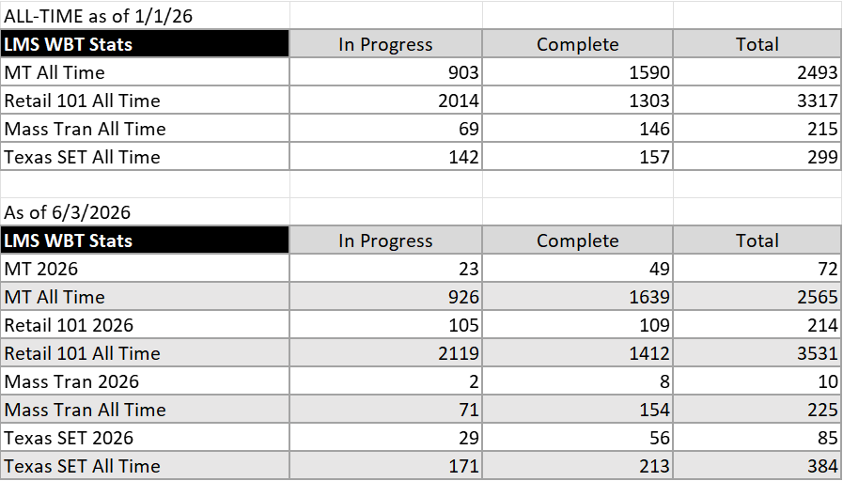

MarkeTrak Part 1 Survey Results
Art provided those today. Due to time constraints, we will be looking at those along with the MarkeTrak part 2 and the TX SET 5.0 (training scheduled for June 11th) at the next RMTTF meeting.
MarkeTrak Part 1 Training – held this morning
Class went well. Had about 33 participants. The checkpoint questions, had good responses. Sheri Wiegand asked Sheri Gaston, as a new person attending, what did she like.
Sheri responded:
Liked the checkpoint questions, and how those kept everyone engaged.
The training was excellent and instructors were knowledgeable.
Good explanation for each subtype and why it was used for and how.
She better understands processes involved in the specific type issue. Also, which area to reach out to internally for assistance if needed.
MPs might consider requiring new MarkeTrak users complete the training, if not in person, the Online modules. Any training would be beneficial.
Melinda and Kathy mentioned that for upcoming training, we should emphasize where the key materials are located; on the registration page and others on ERCOT such as the transaction reference card on the TXSET/LP page. Maybe include in the training notice sent from RMTTF.
Tomas mentioned that tomorrow we will have Kahoots before the end.
Kathy said we should look at slide 96 – this needs to be updated – this is in Monica’s part – Bulk insert. Tomas is changing the slide today. Per Monica, in the future, that will change. “Report will post to the Bulk Insert MarkeTrak issue”.
Info was merged to another slide and existing slide was deleted.
Title slide was also changed to remove IAG and leave as MarkeTrak training.
MarkeTrak Part 2 training – 6-4
Slides are ready. Presentation is posted.
Kahoots Questions – TXSET 5.0 Training
Questions were reviewed and updated. Goal for the Kahoots for TX SET is to have no more than 20 questions. Include questions that related to processes taught during the class.
Questions changed or deleted include;
Question 6 deleted
Question 7 deleted
Question 8 deleted
Question 13 deleted
Question 14 deleted
Question 15 deleted
Question 29 deleted
Question 30 deleted
All slides/questions will be finished in today’s meeting.
Dry run for Kahoots – started at 3:00 PM
Tomas will lead Kahoots
Each question will run for 10 seconds. Will be a few seconds between for a comment.

Key Dates through end of 2026
Date Time Activity
- Thursday, June 4 8:30 AM MarkeTrak Part 2
- Thursday, June 11th 8:30 AM TX SET 5.0 Training – WebEx only
Deb to complete AV Check June 10th
Instructors arrive at Oncor by 8:00 am
- July RMTTF No meeting
- Thursday, August 6th 9:30 AM RMTTF - WebEx only
- Thursday, September 17th 8:30 AM TX SET 5.0 Training – WebEx
Deb to complete AV check Sept 16th
Instructors arrive at Oncor by 8:00 am
- Friday, September 18th 9:30 AM RMTTF
- Wednesday, September 23rd TBD TNMP REP Appreciation event - evening
- Thursday, September 24th TBD TNMP REP Workshop
- Tuesday, October 20th ` 8:30 AM MarkeTrak part 1 – AEP Bldg. Corpus
Instructors arrive at AEP by 7:45 AM – check in
- Tuesday, October 20th 1:30 PM RMTTF
- Wednesday, October 21st 8:30 AM MarkeTrak Part 2 – AEP Bldg. Corpus
Instructors arrive at AEP by 7:45 AM – check in
- Wednesday, October 21st TBD AEP REP Appreciation - 5th and Elm in Portland
- Thursday, October 22nd TBD AEP REP Workshop – AEP Bldg. Corpus
- November N/A No RMTTF meeting
- Tuesday, December 1st 9:30 AM RMTTF WebEx only

Action Items
- Tomas to review the MarkeTrak Sub-types Quick Reference and bring changes to next meeting
- Sheri and Debbie to get with ERCOT – Sheri will email ERCOT now.
  - Remove doc from RMTTF page – TDTMS is the owner
  - Get the TDTMS web page updated with the current doc. One location has an older doc.
- Deb to get the training and meeting dates set and next RMTTF meeting posted.
- Art to post most current presentation.
- All presenters – review slides before training.

Adjourn
Tomas asked if there was any other business.
Meeting adjourned at 3:55 PM.

