Alternate Baseline Test (ABT) Interval Response Concept Paper

1. Purpose and Two-Step Process
This concept paper describes how ERCOT evaluates ERS Loads for baseline selection. The process is intended to identify whether a resource can use a default baseline or whether the Alternate Baseline Test (ABT) should be applied.
The evaluation is a two-step process:
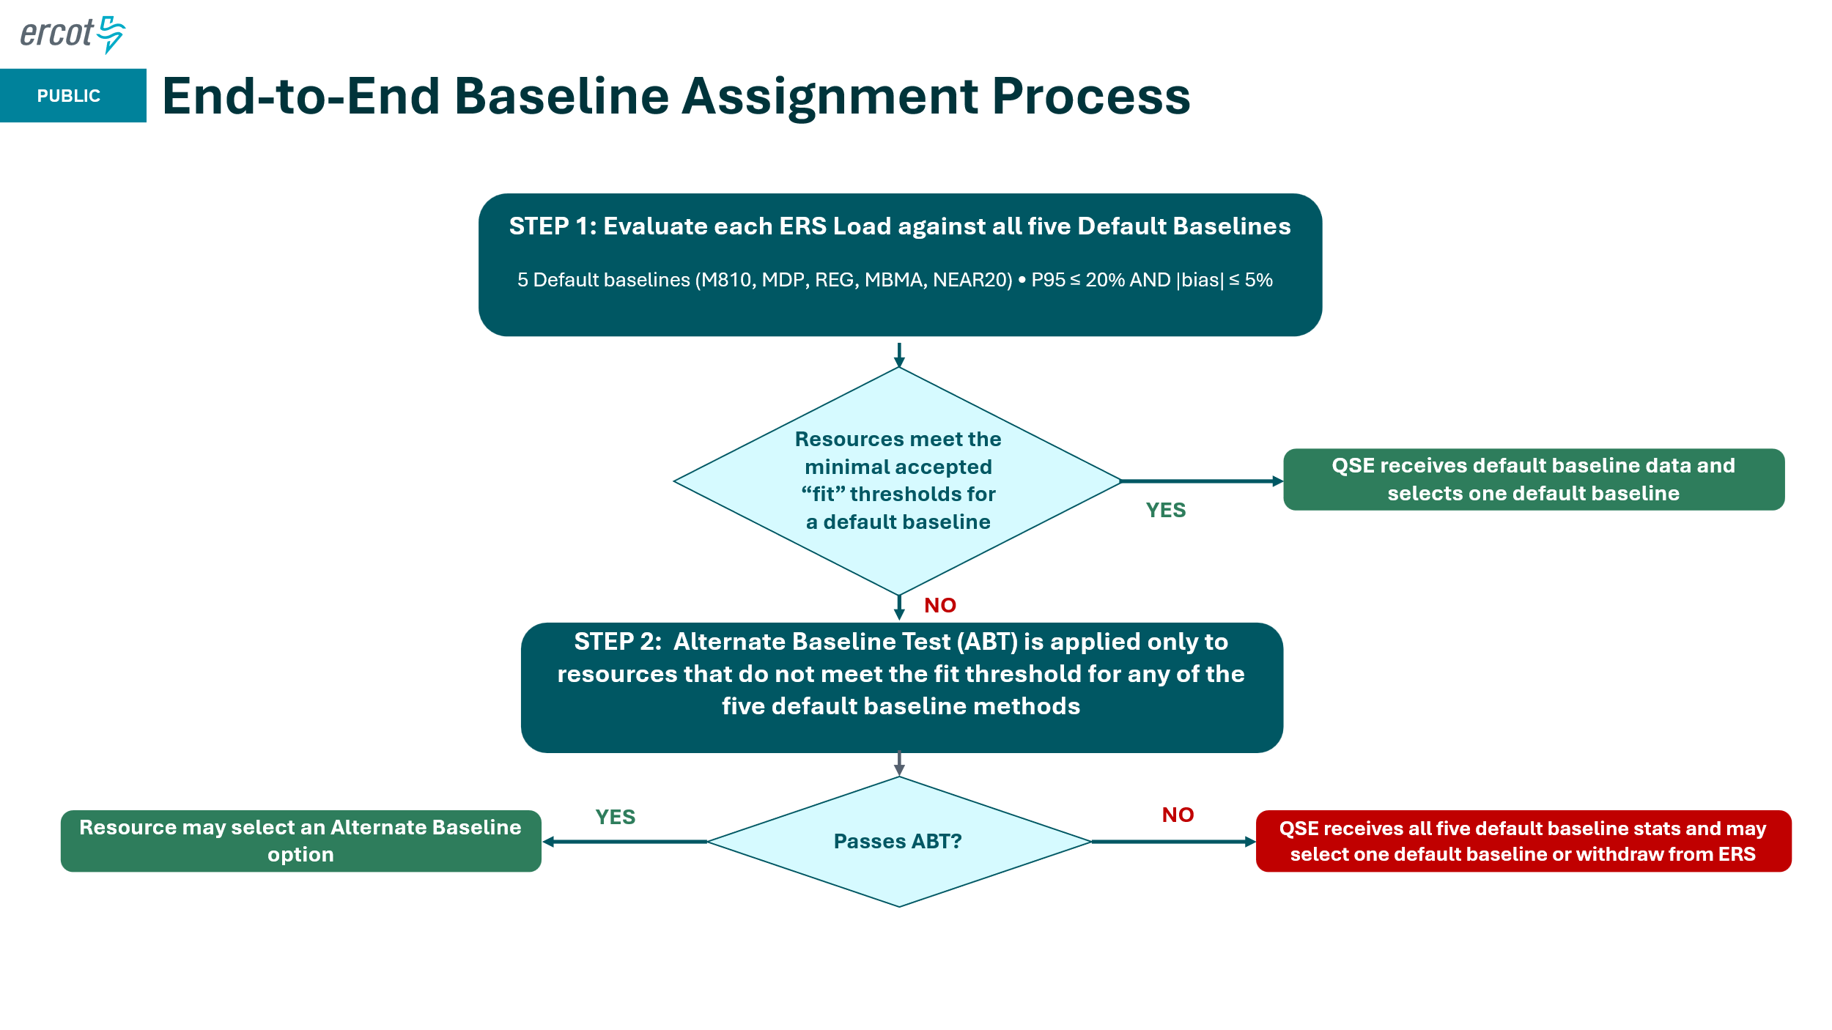
Figure 1. End-to-end baseline assignment process.
- Step 1 - Default baseline fit check: All ERS Loads are evaluated against the five default baseline methods: M810, MDP, REG, MBMA, and NEAR20. A default method meets the fit threshold when P95 is 20% or less and absolute bias is 5% or less. If at least one default method meets the threshold, ERCOT provides all five default baseline statistics to the QSE, and the QSE may select one default baseline.
- Step 2 - Alternate Baseline Test: ABT is applied only to resources that do not meet the fit threshold for any of the five default baseline methods. If the resource passes ABT, the QSE may select an Alternate baseline. If the resource fails ABT, ERCOT provides all five default baseline statistics to the QSE, and the QSE may select one default baseline or withdraw the resource from ERS participation.
- Both the Step 1 and Step 2 baseline analysis will be performed/calculated across all hours in which the QSE has selected as ‘yes’ for each time period during the ERID process for a SCT.

2. Step 1 - Default Baseline Fit Check
In Step 1, each default baseline method is compared to the actual load interval by interval. The comparison produces two statistics for each method: P95 and bias. A method meets the fit threshold only when both conditions are met: P95 <= 20% and |bias| <= 5%.

2.1 P95
For each interval, calculate the absolute percent error:
Absolute percent error (%) = |baseline estimate - actual load| / actual load x 100
P95 is the 95th percentile of those absolute percent errors across the evaluated intervals. In plain terms, P95 shows the largest absolute percent error for the best 95% of intervals measured; only 5% of absolute percent errors are larger. A default baseline method passes this check when the value of P95 is 20% or less.

2.2 Bias
For each interval, calculate the signed percent difference:
Signed percent difference (%) = (baseline estimate - actual load) / actual load x 100
Bias is the average of those signed percent differences across all evaluated intervals. Positive bias means the baseline usually estimates load higher than actual load. Negative bias means the baseline usually estimates load lower than actual load. ERCOT uses absolute bias because either direction can affect settlement. A default baseline method passes this part of the check when |bias| is 5% or less.

2.3 Step 1 Result
Each of the five default baseline methods is tested separately. If one or more default methods meet both thresholds, the resource completes Step 1. ERCOT provides the default baseline data to the QSE, and the QSE selects one default baseline. If all five default baseline methods fail at least one threshold, the resource moves to Step 2 and is evaluated using ABT.

3. Step 2 - Alternate Baseline Test (ABT)
ABT is applied only after all five default baseline methods fail the Step 1 fit threshold. ABT checks whether the resource tends to reduce load mainly during high-price intervals and does not show similar reductions during non-price intervals.

3.1 Reference Load
A reference load is the expected load for a specific 15-minute interval under normal, non-price conditions. It is used as the comparison point for deciding whether the actual load in that interval was materially reduced.

3.2 What Goes into the Reference Load
The reference load for each 15-minute interval is based on the average usage from the 10 most recent qualifying historical days at the same time of day. The following rules apply:
- Use the most recent 10 qualifying historical days for the resource.
- Match the day type: weekdays are compared with weekdays, and weekends or observed holidays are compared with weekends or observed holidays.
- Use the same interval of the day. For example, a 2:00 PM interval is compared with prior 2:00 PM intervals.
- Exclude any qualifying price-event day, defined as three or more consecutive 15-minute intervals above $80/MWh (For NOIE territory we use proxy prices).

These rules are intended to make the reference load reflect normal operating conditions for the same type of day and time interval.

3.3 Worked Example
Assume ERCOT needs the reference load for Tuesday, July 15 at the 2:00 PM interval. The calculation looks backward and uses the 10 most recent qualifying weekday, non-price-event days at 2:00 PM. Weekend days, holidays, price-event days, and days with the wrong day type are skipped. In this example, the 10 qualifying days average to about 130 MW.
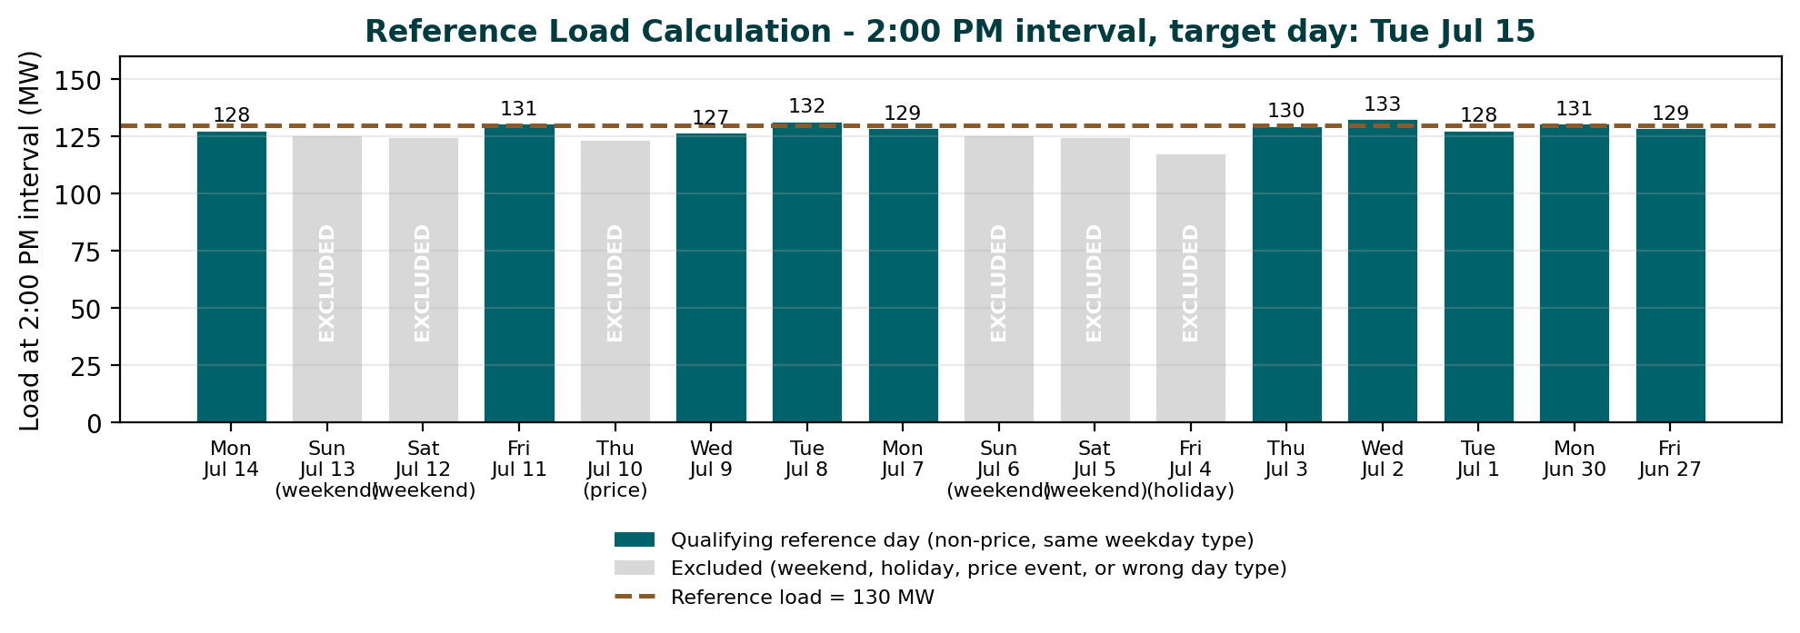
Figure 2. Reference load uses 10 qualifying same-day-type, non-price days at the same interval of day. Weekend days are excluded for this weekday example.

3.4 Data Quality Guards
- Quorum: A resource must have at least 85% of its constituent ESIIDs reporting valid data on a given day to count as a valid reference day.
- Minimum history: If fewer than 10 qualifying reference days are available for an interval, the ABT does not run for that interval. The interval is excluded rather than estimated.

4. Reduced Interval Rule
For the ABT, an interval is counted as reduced when the actual load is at or below 50% of the interval reference load.
Reduced interval rule: actual load <= 0.50 x reference load
For example, if the reference load is 130 MW, the reduced interval threshold is 65 MW. An actual load of 65 MW or lower is considered reduced. An actual load above 65 MW is not reduced.
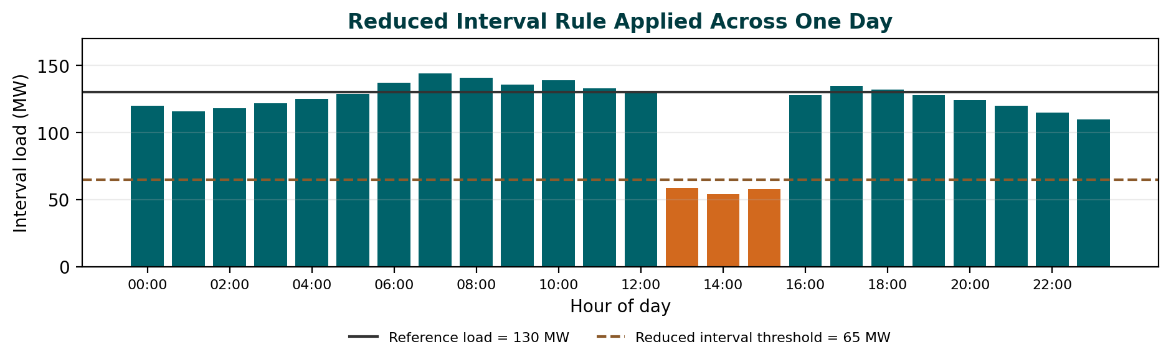
Figure 3. The 50% reduced interval rule applied across one day.

4.1 Boundary Conditions
- If actual load is higher than the reference load, the interval is not flagged as reduced.
- If actual load is missing or invalid, the interval is excluded from ABT.
- If the reference load is unavailable because there is not enough qualifying history, the interval is excluded from ABT.
- If actual load is zero, the interval is flagged as reduced.
- If the resource fails the ESIID quorum for the day, the entire day is excluded from the ABT calculation.

5. ABT Decision Rule
ABT uses two reduction rates:
- High-price reduction rate = number of reduced high-price intervals / number of all high-price intervals
- Non-price reduction rate = number of reduced non-price intervals / number of all non-price intervals
A resource fails ABT only when both conditions are true: the high-price reduction rate is more than 50%, and the non-price reduction rate is less than 5%. In all other cases, the resource passes ABT.
ABT Result | High-price reduction rate > 50%? | Non-price reduction rate < 20%?
Pass | No | No
Pass | Yes | No
Pass | No | Yes
Fail | Yes | Yes
Table 1. ABT decision rule. The resource fails only when both threshold conditions are met.

6. Final Baseline Outcome
- If the resource meets the Step 1 fit threshold for at least one default baseline, ERCOT provides the default baseline data to the QSE, and the QSE selects one default baseline.
- If the resource fails all five default baseline fit checks and passes ABT, the QSE may select the an Alternate baseline.
- If the resource fails all five default baseline fit checks and fails ABT, ERCOT provides all five default baseline statistics to the QSE, and the QSE may select one default baseline or withdraw the resource from ERS participation.

