NPRR Number | 1328 | NPRR Title | Establishment of Generation Firming Program
Date |  | June 22, 2026
Submitter’s Information
Name |  | Judd Messer, Texas Vice President / Charlie Hemmeline, Senior Director
E-mail Address |  | Judd.Messer@poweralliance.org / chemmeline@cleanpower.org
Company |  | Advanced Power Alliance / American Clean Power Association
Phone Number |  | 254-230-0620 / 202-383-2500
Cell Number
Market Segment |  | Independent Generator

Comments

The Advanced Power Alliance (APA) and American Clean Power Association (ACP) appreciate the opportunity to submit comments on Nodal Protocol Revision Request (NPRR) 1328.

APA and ACP also appreciate ERCOT’s April 14, 2026 comments clarifying that Firming Transfers between a pair of Qualified Scheduling Entities (QSEs) are limited to one per Resource per hour and are not capped for the entire QSE pair. This is a significant refinement.

To align the Protocols with regulatory mandates, we propose targeted revisions to ensure ERCOT’s Protocol amendments strictly conform to 16 Texas Administrative Code (TAC) § 25.65, adopted by the Public Utility Commission of Texas (PUCT) on December 18, 2025. These revisions clarify the structure and operation of the firming program while enhancing transparency, predictability, and compliance certainty for Market Participants.

- Modification of ERCOT's Proposed Formula in Section 28.8 to Align with the Commission's Day-Ahead Exemption.
ERCOT’s proposed formula in NPRR 1328, Section 28.8 (Firming Capacity Penalty Charge), fails to adequately exempt the portion of a Resource with a Day-Ahead Market (DAM) energy or Ancillary Service obligation from the firming requirement and improperly subjects that capacity to both a standard protocol performance penalty and a subsequent firming penalty for the same physical megawatt, effectively imposing a double penalty. In the Order Adopting the Rule (Order), the Commission was clear:
“The portion of capacity of an electric generation facility that is awarded energy or ancillary services in the Day-Ahead Market is exempt from assignment of a financial penalty during the applicable hour.”

The Commission also clarified in the Order:
“The Commission adopts Southern Power’s recommendation to clarify that only the portion of an electric generating facility that is subject to a performance obligation for capacity that cleared in the DAM is exempt from the performance requirements under the adopted rule.” (Order at 83).

And at 85:
“This approach ensures that the portion of the electric generating facility that is not awarded in the DAM is still subject to the performance requirements under the adopted rule and recognizes that for the portion awarded in the DAM, the electric generating facility is already incentivized to perform because of the risk of a financial penalty for failure to perform under its obligations in the DAM.” (Order at 85).

However, ERCOT’s proposed formula does not accurately exempt the portion of capacity that clears the DAM because it does not correctly account for capacity awarded in the DAM and therefore produces a result inconsistent with the Commission’s Rule. The Commission explicitly stated it would not subject capacity awarded in the DAM to a firming penalty because that portion already faces non-performance exposure under ERCOT Protocols.

Recommended Solution:
To correct the compounding effect described above and align the Protocols with the Commission’s Rule, we submit the following structural revision to reflect that capacity awarded in the DAM is not penalized under the firming program.

Proposed Formula:
FCPQ = Max (0, FCRQ – Max (FCAV, DAESR + DAASQ, RCCRS) – FTCP)
Where:
FCRQ= SAGC + FTCS
FCAV = HATHSL

2. Realigning ERCOT's Transfer Validation Window with PURA Non-Discrimination Mandates.
In Section 28.5, ERCOT proposes a window for each season during which Market Participants may submit Firming Transfers. This window begins at the start of each season and ends 30 days after the end of the Firming Season. All trades must be submitted and confirmed as valid by ERCOT within this window. If ERCOT notifies a QSE that its submitted transfers are invalid at any point, the QSE must modify, correct, and obtain ERCOT approval within that same timeline.

However, in a scenario where ERCOT determines a transfer is invalid on or near the last day of the window, Market Participants would lack adequate time to correct and resubmit the data within ERCOT’s window, potentially resulting in unfair financial penalties despite having appropriately firmed their capacity.

ERCOT’s current language does not provide a fair or reasonable opportunity for Market Participants to address issues identified by ERCOT near the end of the window and this could result in discriminatory outcomes depending on ERCOT’s internal timeline for validating trades.

We recommend two modifications:
- First, the firming trading window should be defined as the period beginning at the start of each season and ending 30 days after the end of each season.
- Second, if trades are submitted timely within the firming trading window, ERCOT must confirm the validity of the trades and communicate its determination within 10 calendar days of submission. Market Participants must then correct and resubmit their transfers within 10 calendar days of receiving ERCOT’s determination or the end of the firming trading window, whichever is later.

These modifications ensure that both ERCOT and Market Participants have transparent, functionally possible, and enforceable deadlines. This is particularly important if ERCOT issues a determination near the end of the window, because Market Participants reviewed later in the process must receive the same 10-day period to make corrections and resubmit as those evaluated near the beginning of the window; otherwise they are placed at a disadvantage and risk disparate treatment. This framework ensures that all transfers are finalized within 40 days of the seasonal close while guaranteeing that Market Participants retain an equal opportunity to correct a transfer regardless of when ERCOT issues its notification. Ultimately, this protects the non-discriminatory treatment of Resources, which is a core statutory mandate of PURA.

3. Modification of Section 28.4 to Define "High-Risk Hours" Consistent with MORA Criteria.
In Section 28.4 (Firming Baseline Period), paragraph (2), ERCOT defines the baseline period to include "high-risk hours" identified via ERCOT’s annual North American Electric Reliability Corporation (NERC) probabilistic assessment for that season. However, the Protocols lack a clear definition of what constitutes a "high-risk hour" in the probabilistic assessment.

Additionally, ongoing regulatory proceedings are evaluating the order of operations for curtailing large Loads in ERCOT pursuant to Senate Bill (SB) 6, 89th Texas Legislature, Regular Session (89th RS). Given the magnitude of projected large Loads, the ability of these Resources to respond, and the order in which they are used to maintain operating reserves, these large Loads could substantially influence Energy Emergency Alert (EEA) risk. Based on the latest NERC probabilistic assessment, conducted in 2025 for the 2027 and 2029 study years, ERCOT published reliability metrics and a monthly heatmap distributing Expected Unserved Energy (EUE) as shown in Tables 1 and 2 below.

Table 1 – 2025 Probabilistic Assessment Reliability Metrics
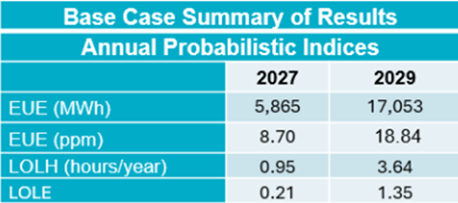

Table 2 – 2025 Probabilistic Assessment EUE Heatmap
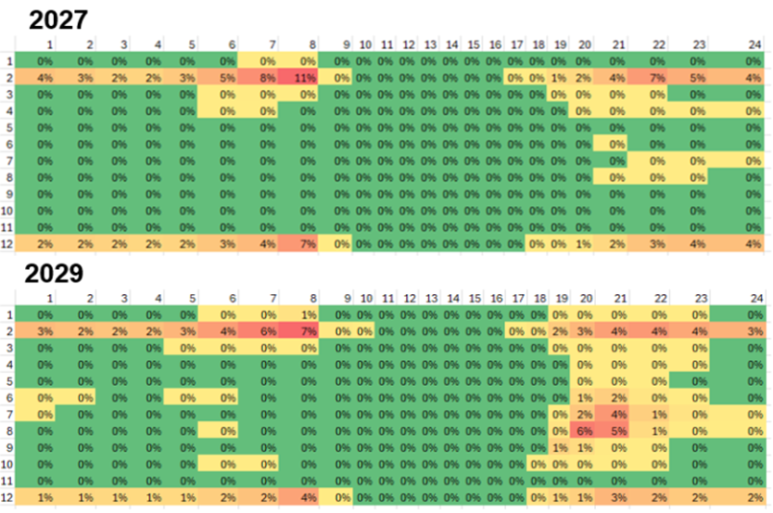
However, these results do not indicate which hours are considered "high-risk," nor do they define what level or percentage of annual EUE triggers that designation. The results also acknowledge significant uncertainty regarding large Load integration standards.

As ERCOT states in its presentation, the heatmaps show the percentage of annual EUE distributed during a particular hour of the day for a particular season. Consequently, the distribution may reflect the percentage of EUE risk, regardless of the absolute magnitude of the projected EUE.

Without mapping to the Commission-approved ERCOT Reliability Standard, the probabilistic assessment does not indicate whether the risk in any given hour or month is high, low, or moderate. This is due to the absence of both an acceptable level of EUE and defined probability thresholds to definitively isolate what constitutes a high-risk hour.

Recommended Modifications:
In the Monthly Operational Reliability Assessment (MORA) report, ERCOT publishes the probability of Capacity Available for Operating Reserves (CAFOR) falling below 2,500 MW for each hour, which correlates directly to an Energy Emergency Alert (EEA) risk. ERCOT states that an EEA probability above 10% indicates an elevated reserve adequacy risk. We recommend that ERCOT:
- Apply the same MORA criteria in the NERC probabilistic assessment to identify "high-risk hours" as those where the probability of an EEA or CAFOR dropping below 2,500 MW exceeds 10%.
- Consistent with Commission guidance in the Triennial Reliability Standard Assessment proceeding, treat large Load curtailments as a Resource prior to declaring an EEA in reliability assessments.
- Revisit this definition once the standards for integrating large Loads and large Load demand response rules are finalized in compliance with SB 6.

4. Modification of Section 28.2.1 to Eliminate Arbitrary Post-Commissioning Attestation Deadlines for Private Use Networks.
Section 28.2.1 requires an attestation form for Resources co-located with Load in a Private Use Network (PUN) to be filed within 30 days of the Resource's commissioning date. This arbitrary, fixed deadline unfairly imposes firming requirements on Resources that are not part of a PUN at commissioning, but later transition to a PUN during their operating life. Moreover, nothing in PUCT Rule 25.65 conditions the statutory firming exemption for PUN‑dedicated Resources on the timing of an attestation or on the submission of such an attestation within a specific post‑commissioning window. The exemption applies by operation of law when more than 50% of a Generation Resource’s nameplate capacity is dedicated to Load within a PUN.

ERCOT’s proposed deadline therefore creates a compliance barrier that does not exist in the Firming Rule and could improperly disqualify otherwise eligible Resources from an exemption the Commission expressly adopted. A Resource that becomes part of a PUN after commissioning would, under ERCOT’s proposal, lose an exemption it is legally entitled to solely because the attestation could not have been filed at commissioning. This outcome is inconsistent with the Firming Rule, impractical for evolving PUN configurations, and creates an unnecessary administrative hurdle that could lead to discriminatory treatment of similarly situated Resources.

Recommended Modification:
We recommend that ERCOT eliminate the 30-day post-commissioning deadline. Instead, a Resource that joins a PUN should qualify for the firming exemption upon providing notice that it will be co-located with Load in a PUN at or prior to the time of the transition, regardless of its original commissioning date. This approach aligns ERCOT’s Protocols with the Firming Rule, preserves the statutory exemption, and ensures that Resources are not penalized for legitimate operational or commercial decisions to transition into PUN arrangements after commissioning. This achieves ERCOT’s requirement for notification while ensuring Market Participants are not penalized for late-lifecycle transitions. Ultimately, nothing in the Commission’s Rule lends itself to punishing a Resource by withholding a valid Exemption simply because a Resource elects to join a PUN post-commissioning.

5. Modification of Sections 28.3.1 and 28.3.2 to Establish Firm Pre-Season and Post-Season Information Posting Timelines.
Section 28.3.1 (Pre-Season): We recommend that ERCOT post the Seasonal Average Generation Capability (SAGC) and Firming Baseline Period at least 30 days prior to the beginning of each firming season. This advance notice ensures Market Participants can adequately plan and prepare to meet seasonal firming obligations.

Section 28.3.2 (Post-Season): We recommend that ERCOT be required to post the final compliance data within 10 calendar days after the end of each season. This posting must indicate whether Resources subject to firming performance obligations were long or short during Low Operating Reserve Hours.

6. Response to TCPA’s Comments (submitted May 7, 2026).
We disagree with TCPA’s recommendation to prioritize high-risk hours within the baseline period over ramp hours for enforcing firming requirements when a season contains more than 15 Low Operating Reserve Hours. The Commission’s Order was clear that the firming requirements must apply strictly to the 15 hours with the lowest Physical Responsive Capability (PRC). TCPA’s recommended change is therefore inconsistent with the Commission's Order, as 16 TAC § 25.65(f)(1)(B) states:

“In seasons in which more than 15 low operating reserve hours occur during the seasonal baseline period, only the 15 low operating reserve hours with the lowest levels of PRC are subject to the financial penalty under this section.”

Conclusion.
While we support a robust framework to implement the Generation Firming Program and appreciate ERCOT’s clarifications to date, we strongly urge ERCOT to incorporate these targeted amendments. The current NPRR1328 proposal introduces critical computational gaps regarding DAM exemptions, creates unnecessary administrative risk for seasonal transfers, and lacks granular statistical benchmarks for defining high-risk periods. Adopting our recommendations will directly align the Nodal Protocols with 16 TAC § 25.65, eliminate redundant penalties, and secure the operational flexibility required for Market Participants to effectively Texas grid reliability.

As a matter of statutory compliance, the Nodal Protocols must strictly conform to the parameters established by the Commission to ensure full consistency with 16 TAC § 25.65 and provide regulatory certainty for the market.

We appreciate the opportunity to file comments on NPRR1328 and look forward to continuing to work with ERCOT and Stakeholders on these important matters.

Revised Cover Page Language
None at this time.
Revised Proposed Protocol Language
None at this time.

PUCT Project No. 58198, Rulemaking to Implement Firming Reliability Requirements for Electric Generating Facilities in the ERCOT Region Under PURA §39.1592, Order Adopting New 16 TAC §25.65 (December 18, 2025) (“Firming Rule”) which can be accessed at https://interchange.puc.texas.gov/search/documents/?controlNumber=58198&itemNumber=77.
16 TAC §25.65 (f)(2)(C).
ERCOT, “NERC 2025 Probabilistic Assessment,” (October 24, 2025), presented at the Supply Analysis Working Group.
For example, see the July 2026 MORA Report at https://www.ercot.com/files/docs/2026/05/01/MORA_July2026.pdf.
PUCT Project No. 58777, Triennial Reliability Assessment for the ERCOT Region Under 25.508. See, Staff Recommendation at 10 which can be accessed at https://interchange.puc.texas.gov/Documents/58777_37_1619958.PDF. The PUCT gave guidance to ERCOT to include this recommendation in its modeling during the April 17 Open Meeting.

