NPRR Number | 1214 | NPRR Title | Reliability Deployment Price Adder Fix to Provide Locational Price Signals, Reduce Uplift and Risk
Date |  | June 22, 2026
Submitter’s Information
Name |  | Andrew Reimers
E-mail Address |  | areimers@potomaceconomics.com
Company |  | Potomac Economics, Independent Market Monitor (IMM)
Phone Number
Cell Number
Market Segment |  | Not applicable

Comments
The IMM appreciates the opportunity to comment on Nodal Protocol Revision Request (NPRR) 1214 and supports its adoption, as it enhances reliability pricing, reduces unnecessary uplift, and resolves uneconomic dispatch instructions through an indifference payment. We encourage stakeholders to approve the current language of NPRR1214.
We begin by outlining the benefits of NPRR1214 and the improvements it introduces to ERCOT’s reliability pricing framework. We then identify remaining shortcomings, focusing on temporal pricing impacts created by out-of-market reliability actions that are not fully captured under either the current Reliability Deployment Price Adder (RDPA) or the NPRR1214 enhancements and explain how these gaps can arise in practice and affect price formation. We then describe how a Multi-Interval Real-Time Market could address these shortcomings by more effectively incorporating intertemporal system conditions. We encourage ERCOT and stakeholders to continue the conversation around reliability pricing and to consider MIRTM as a practical and effective solution.
NPRR1214 Benefits
Addressing Local Pricing Impacts
ERCOT’s prevailing reliability pricing construct, the RDPA, is meant to address the price suppressing effects of out-of-market reliability actions taken by the grid operators such as Reliability Unit Commitments (RUCs) or deployments of Emergency Response Service (ERS) Resources. The RDPA is intended to reflect the price that would have occurred counterfactually had out-of-market actions not been taken. The current design, however, only accounts for differences in system-wide prices (i.e., system lambda) rather than locational prices (i.e., Locational Marginal Prices (LMPs)). The RDPA sufficiently accounts for the pricing impact of reliability actions taken in response to system-wide scarcity conditions, but it is ineffective at accounting for the localized pricing impacts of reliability actions taken to address locational issues, e.g., RUC instructions to address localized congestion. NPRR1214 effectively addresses this shortcoming by producing LMPs that account for pricing impacts on a nodal basis.
Reducing Uplift
Out-of-market reliability actions can result in uplift if, for example, market revenues are insufficient to cover the startup and minimum generation costs of resources committed through RUC. Uplift is more likely if market revenues are suppressed because of reliability actions. NPRR1214 reduces the likelihood of such uplift by addressing the localized price suppression effects of reliability actions so that more of the cost of these actions is paid through wholesale market transactions.
Resolves Disparities between Dispatch and Pricing Runs
Like the RDPA, the reliability pricing construct proposed by NPRR1214 relies on two distinct runs of Security-Constrained Economic Dispatch (SCED) – a dispatch run and a pricing run. The dispatch run produces base points that Resources must follow, and the pricing run produces financially binding LMPs for energy and MCPCs for Ancillary Services. Disparities between these two instances of SCED can result in uneconomic instructions for some Resources, where the Base Points from the dispatch run are not aligned with the LMPs or MCPCs from the pricing run. NPRR1214 introduces an indifference payment to resolve these disparities so that Resources are not subject to uneconomic Dispatch Instructions.
Continuing the Conversation Around Reliability Pricing
Counterfactual Analysis of State of Charge (SOC)
NPRR1214 effectively addresses the locational price impacts of reliability actions, but it does not address the temporal impacts of such actions. Consider a situation where reliability actions are taken to avoid system-wide depletion of State of Charge (SOC) for Energy Storage Resources (ESRs). Counterfactually, if the reliability action were not taken, ESR SOC would have depleted over time, reducing the supply of operating reserves and resulting in elevated pricing as reserve scarcity as illustrated in Figure 1 at the end of these comments. This temporal dynamic is not captured by ERCOT’s reliability pricing mechanism, which only sees one interval at a time.
The Solution: A Multi-Interval Real-Time Market
Since our 2022 State of the Market report, we have recommended that ERCOT implement a multi-interval real-time market (MIRTM). A MIRTM produces a dispatch schedule based on forecasted system conditions across multiple future intervals called a “study period.” One of the primary benefits of a MIRTM is that it would schedule ESRs more efficiently by considering the value of preserving or adjusting SOC across the study period. A related secondary benefit is that it would be the most comprehensive way to incorporate temporal dynamics into reliability pricing. Replacing the current Real-Time Market (RTM) that looks ahead one interval (5 minutes) at a time with a MIRTM that looks ahead up to several hours would feature the following:
- Like in the current RTM, the MIRTM would include distinct dispatch and pricing runs of SCED, where the pricing run represents a counterfactual without the reliability actions.
- The MIRTM would have a sufficiently long study period, ideally at least two hours, to perceive the possibility of reserve shortages caused by ESR SOC depletion over time.
- Only the first interval of the MIRTM is physically or financially binding, but SCED optimizes dispatch instructions over the entire study period to account for forecasted changes in supply and demand.
Given these criteria, consider a scenario where reliability actions were taken to avoid excessive depletion of ESR SOC. The pricing run of the MIRTM would perceive the oncoming reserve shortages and produce a corresponding schedule of Dispatch Instructions and elevated prices throughout the study period. The resulting prices for the first interval of the pricing run of the MIRTM could then be used to produce reliability pricing that accounts for the temporal impact of reliability actions.
Given that a MIRTM would take years to develop and implement, an intermediate option could be to leverage the capabilities of the Look-Ahead SCED indicative pricing tool to incorporate some of these temporal dynamics into reliability pricing. We have been engaged with ERCOT’s Market Design principals on this topic and look forward to future opportunities to collaborate on improvements to the reliability pricing methodology.
In summary, we support NPRR 1214 as a significant improvement to ERCOT’s existing reliability pricing methodology and recommend that stakeholders and the PUC approve it. These comments are in no way meant to obstruct the approval or implementation of NPRR 1214, but, rather, are meant to encourage stakeholders to continue the conversation around reliability pricing and highlight the benefits of a MIRTM for the ERCOT market.
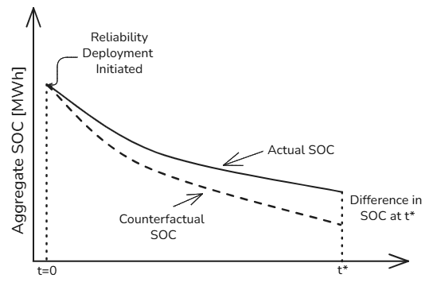
(a)
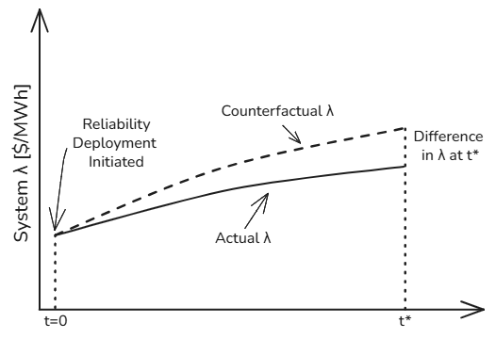
(b)
Figure 1. Reliability actions may be taken to avoid depletion of aggregate SOC (a) Counterfactually, such actions suppress prices in the future, when SOC depletion would have resulted in elevated prices (b)
Revised Cover Page Language
None
Revised Proposed Protocol Language
None

