RMTTF Meeting
April 14th, 2026
1:00 PM

ERCOT
8000 Metropolis Bldg. E Suite 100
Austin, TX 78744
Boardroom B

This meeting is held in person and via WebEx.
Meeting Notes
The meeting was called to order by Tomas.
Melinda and Debbie are taking notes today.
Tomas welcomed everyone and proceeded with reading the Anti-trust statement.
Those in the room announced themselves and those listed on the webex stated their name and company which included;
Introductions
- Tomas Fernandez NRG
- John Schatz Vistra
- Sheri Wiegand Vistra
- Guilherme Grid Monitor
- Monica Jones Centerpoint
- Andrew Soong
- Luisa Aiera
- Debbie McKeever Oncor
- Kathy Scott Centerpoint
- Melinda Earnest AEP
- Edelmira Pena Revolution Energy
- Art Deller ERCOT

Meeting Notes
Meeting Notes for past 2 meetings were posted 7 days in advance.

Today we are reviewing two sets of the meeting notes.

None of the co-Chairs received comments prior to today.
There were no comments voiced today.
Notes for both meetings are considered final.

LMS Training Stats
Art provided the counts from the Learning system and also noted Registration Counts for upcoming MarkeTrak classes
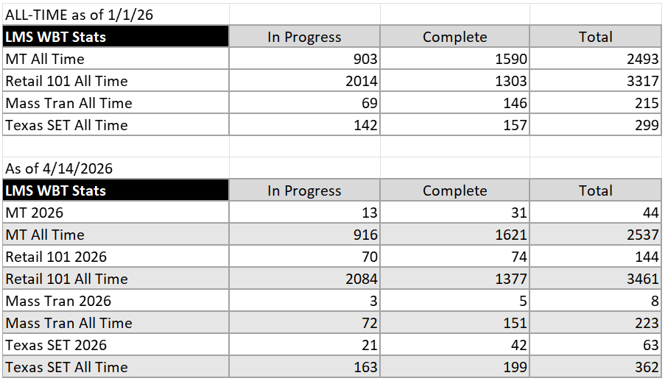
Enrollments for MarkeTrak received as of 4-13;
- MarkeTrak part 1 – 12 registered
- MarkeTrak part 2 – 10 registered

Survey Results
Art Deller provided the surveys for the past classes.
- MarkeTrak Part 1
- MarkeTrak Part 2
- TX SET 5.0
MarkeTrak Surveys
Very positive feedback.
Many surveys included they experienced some audio issues.
Going forward the audio will be checked the day before and at least 45 minutes before the training begins the following morning.
Most found the training applicable to their job and instructors were good at explaining and providing scenarios from real experience and explaining how those were resolved.
There was one comment that could have used more info for each of the subtype issues.
Those at the meeting today discussed.
We have not received this comment from past surveys.
It was thought that the slides provide sufficient information, so current content will not be changed.
TX SET 5.0 Surveys
Very positive feedback. Enjoyed the group exercise.
Feedback included; explanation of processes, transactions, instructors.
There were two that had very positive comments but didn’t include 5 – instead included 1 but believe since their comments were so positive that they possibly were confused by 1 and 5.
Kahoots
We reviewed the current questions in the Quiz. The correct answers are identified in Green. There will now be 20 questions in the Quiz. All either ABCD (or a combination of each letter) or True or False.
Note! Kahoots can rearrange the answers for A B C D, so it’s not possible for the answers for the instructors to be identified in advance of the start of the Kahoots quiz.
Green highlighting represents the correct answers.

1 – What is REP Rule 1? – answer options.
MO trumps switch
MI trumps MO with same day
814_22 upon receipt of Move out
Cancel future dated move out with Same REP
2 – Keeping the existing question.
Response transactions can be “Accepts or Rejects”? T or F
3 – Keeping the existing question.
What are the 3 initiating transactions?
814_16 - 814_01 - 814_24
4 – Point to Point Transactions
Disconnect/Reconnect 650_01
TDSP Invoice 810_02
Suspension of Delivery Service – 650_04
Remittance information for payment 820_02
5 – Keeping the existing question.
To change a date on a switch you need to send 814_12
True or False
6 – Keeping the existing question.
The transaction that ends liability with the REP
867_03 F
7 – Keeping the existing question.
The transaction used to update ESI id maintenance
814_PC
814_PD
814_20
814-26
8 – Keeping the existing question.
Transaction that contains scheduling information
867_02
814_05
814_06
814_03
9 – Keeping the existing question.
The transaction that starts liability with the REP
867_03 F
867_04
814_05
867_03
10 – Keeping the existing question.
Usage history is automatically sent on 814_01s and 814_16s
True or False
11 – Keeping the existing question.
Contains procedures and guidelines for operating in the ERCOT retail market
ERCOT MIS
Retail Market Guide
TX SET Swim Lanes
MarkeTrak Users Guide
12 – Keeping the existing question.
Transaction for CSA Move-in
814_22
814_01
814_16
814_18
13 – Keeping the existing question.
Transaction used to update customer contact information
814_PC
814_20
867_02
814_16
14 – Keeping the existing question.
The REP initiates a Tampering Switch Hold
True or False
15 – Keeping the existing question.
Reference documents outlining the transaction life cycle
TX SET Swim Lanes
Retail Market Guide
MarkeTrak Users Guide
ERCOT MIS
16 – Modified the existing question.
Transaction used to identify if the MVI energized the premise.
814_06
814_04
814_16
814_01
17 – Keeping the question.
Rejection reason for multiple MVIs with the same date
Duplicate Move in for the same premise
Not first in
Competing transaction already scheduled
Date conflict
18 – Transactions sent to complete an Inadvertent Gain
814_16
814_01
814_16 w/IA
814_16 w/CR
19 – What will a Move In do that a Switch won’t – check all that apply
Resets Critical Care Flag
Resets Demand Ratchet
Rescission
Permit may be required
20 – What two transactions are usually needed to trigger Customer Billing
867_04 and 814_05
867_04 and 810_02
867_03 and 810_02
867_03 and 814_28

Training Classes scheduled and confirmed RMTTF meetings.
Retail 101 TBD
MarkeTrak Part 1 June 3 AM
RMTTF June 3 PM – 1:30 PM, Oncor Electric Delivery
MarkeTrak Part 2 June 4 AM
TX SET 5.0 June 11th All day – WebEx only – Trainers in Dallas
Other Business
Action Items:
- Melinda to send email to Art indicating info for the June 11th class.
- Debbie to make sure meeting details are posted on ERCOT.com
- Debbie to create a stand alone document that includes some key dates/points.
Primary Agenda item for June 3rd meeting;
Review slides for checkpoint questions and slides for upcoming TX SET 5.0
Review Kahoots quiz questions - reconfirm
Adjourn
Co-chairs thanked everyone for coming.
Meeting adjourned at 2:50 PM

