NPRR Number | 1214 | NPRR Title | Reliability Deployment Price Adder Fix to Provide Locational Price Signals, Reduce Uplift and Risk
Date |  | May 28, 2026
Submitter’s Information
Name |  | Seth Cochran
E-mail Address |  | sco@vitol.com
Company |  | Vitol Inc.
Phone Number
Cell Number |  | 713-205-2257
Market Segment |  | Independent Power Marketer (IPM)

Comments
Vitol Inc. submits these comments to memorialize Vitol Inc.’s (“Vitol”) support for NPRR 1214 and to update the Contact Information section by adding Vitol as a sponsor.
NPRR1214 would improve the RTPDA by applying price adjustments at each nodal Settlement location based on the full re-pricing solution, rather than spreading the adjustment uniformly based on the system-level price change. This would accurately restore congestion price signals suppressed by out-of-market actions. This is increasingly important due to the high volume of Reliability Unit Commitment (RUC) commitments being driven by transmission constraints rather than system-wide capacity shortages.
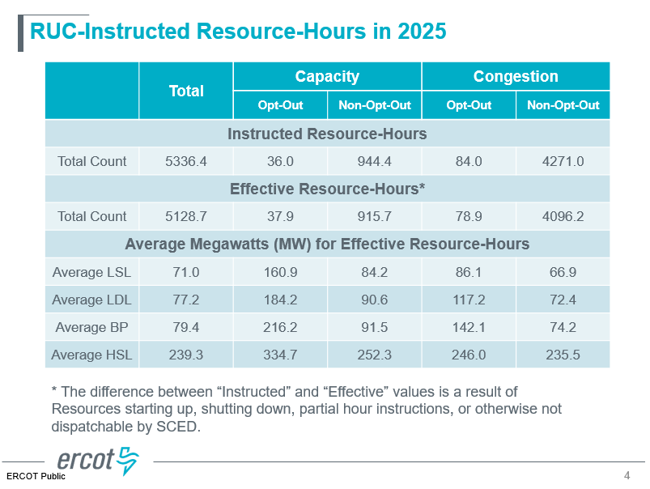
Source: Annual Review of the Market Impacts of Reliability Unit Commitments Analysis of 2025
In addition, the value of correct locational price signals is increasingly critical in the face of out-of-market-actions being undertaken. Two recent examples highlight this point:
- ERCOT has entered into Reliability Must Run (RMR) and contracts for capacity agreements to mitigate the risk of post-contingency overloading of transmission lines importing power into the greater San Antonio area.
- ERCOT-sponsored NPRR1315, Changes to Process of Evaluating the Potential Needs for Additional Capacity, seeks to expand ERCOT’s procurement authority to include local transmission constraints identified “up to two years into the future.” ERCOT indicated at the February 10, 2026 Board meeting that it is considering issuing a Request for Proposal for capacity in the far west region.
NPRR1214 would ensure that out-of-market actions do not dilute congestion price signals. Absent this change, incentives for market-based solutions are diminished, and continued reliance on out-of-market actions is likely. Potential market-based actions include voluntary load curtailment and long-term decisions to invest in generation or in capabilities to become price-responsive load.
In short, markets cannot solve what they are not permitted to solve. NPRR1214 seeks to preserve needed congestion price signals and prevent harm to the locational attributes of the ERCOT market caused by out-of-market interventions.
Revised Cover Page Language

Sponsor
Name | Shams Siddiqi, Seth Cochran, Don Blackburn, Michael Pohlod
E-mail Address | shams@crescentpower.net, cochran@dc-energy.com, dblackburn@huntenergynetwork.com, mpohlod@voltus.co, sco@vitol.com
Company | Rainbow Energy Marketing Corporation, DC Energy, Hunt Energy Network, Voltus, Inc., Vitol Inc. (“Joint Sponsors”)
Phone Number | 512-619-3532, 512-971-8767, 214-762-6159, 587-577-9994
Cell Number | 512-619-3532, 512-971-8767, 214-762-6159, 587-577-9994
Market Segment | Independent Power Marketer (IPM) and Consumer

Revised Proposed Protocol Language
None

See ERCOT presentation for Item 13: Far West Load Growth and Transmission Timing Issues at slide 9

