PGRR Number | 145 | PGRR Title | Batch Zero Process for Large Load Interconnections

Date | May 26, 2026

Submitter’s Information
Name | Clayton Greer
E-mail Address | Clayton@chollainc.com
Company | Cholla Petroleum (Cholla)
Phone Number
Cell Number | 512-497-2986
Market Segment | Industrial Consumer

Comments

CHOLLA, INC. COMMENTS TO THE ERCOT BOARD OF DIRECTORS REGARDING PGRR145
Who We Are
Cholla, Inc. is a family-owned, Dallas-based private exploration, development, and investment company with roots in Texas oil and gas dating back to 1957. Building on nearly seven decades of operating history, Cholla has evolved from a traditional independent energy operator into a Texas business-development platform at the intersection of energy infrastructure, large load development, flexible compute, and data center deployment.
Cholla's differentiation is its full-spectrum energy experience—operating across the supply chain from upstream production to grid-connected power delivery, leveraging oil-and-gas cash flow and Texas land positions to develop power campuses, and applying an operator's tolerance for uncertainty to emerging power and compute markets. Today, Cholla is positioned not merely as a market participant, but as a builder and investor advancing practical grid solutions: securing land and power for large-load growth, deploying flexible load and compute strategies, supporting early-stage energy technologies, and working constructively to improve reliability, affordability, and market design across ERCOT and the broader Texas power market.
Cholla has developed 2,000 MW in projects throughout Texas, currently has 26,500 MW in active development, and has invested over $100 million in those projects in reliance on the State's commitment to business development and on the interconnection processes, rules, and laws in place at the time those investment decisions were made.

What Happened
Cholla is developing a large computational load facility (Project Venus) in the Dallas-Fort Worth area, which is often referred to as “South Dallas” or “Southern DFW.” Cholla submitted this interconnection request to Oncor in October 2023 and has complied with every step required by Oncor and ERCOT. Yet, because PGRR145 turns on a single administrative date not tied to any statute, reliability finding, or meaningful planning milestone—March 4, 2026—this project and others like it could be pushed five or more (5+) years behind transmission upgrades that were planned, studied, and built afterwards specifically to serve the already-submitted projects.

How We Got Here
- On March 25, 2022, ERCOT issued a Market Notice establishing an “interim” large load interconnection process to “ensure compliance with existing NERC requirements and for the reliable interconnection of large loads to the ERCOT system” that sought to energize within two years. See W-A032522-01. That framework recognized multiple valid pathways for evaluating large load reliability impacts, including ERCOT planning assessments such as RPG review, RTP modeling, and other interconnection studies. The interconnection process for all other grid-facing large loads—e.g., those with initial energization dates after March 25, 2025—were subject to NERC Reliability Standards FAC-001, Facility Interconnection Requirements, and FAC-002, Facility Interconnection Studies. While Transmission Service Providers (TSPs) were required to coordinate with ERCOT prior to allowing a large load to energize, ERCOT would typically only review a TSP’s large load interconnection studies (LLIS) for a project that had “not yet been studied by ERCOT’s existing planning process (i.e., included in the RTP or an RPG review).” See ERCOT Review of Existing Load Interconnection Requirements (Mar. 3, 2022).
- In October 2023, Cholla submitted a large load interconnection request (LLIR) to Oncor for Project Venus, which contemplated a total peak demand of 400 MW. Shortly thereafter, Oncor informed Cholla that it was no longer studying large loads individually in the South Dallas region because the volume and interdependence of requests had overwhelmed the one-off LLIS process. Oncor therefore advised Cholla that the only available path was to group Project Venus and the other contributing loads in the area into a cluster study using ERCOT’s Regional Planning Group (RPG) process. Cholla did not choose that path; Oncor chose the path and required it.
- In February 2025, Oncor submitted the Southern DFW project (25RPG004) for RPG review.
- At the April 29, 2025 RPG meeting, Oncor described the Southern DFW project as a Tier 1, CCN-required transmission project “driven by new 4064 MW large loads in southern DFW” that had either executed interconnection agreements or demonstrated forward movement toward 2026–2028 interconnection dates. See Oncor Presentation: Overview of Southern DFW Load. Oncor identified a $1.219 billion cost estimate, multiple new switch stations, approximately 251 circuit miles of transmission work, and nine reactive devices needed to resolve violations and enhance load-serving capability. ERCOT likewise presented its independent review (EIR) scope confirming the same project fundamentals, including the reliability need driven by thermal overloads and voltage violations resulting from proposed load additions in Southern DFW. See EIR Scope: Oncor Southern DFW Load Interconnection and General Grid Strengthening Project.
- The Southern DFW project was not based on abstract growth assumptions. Oncor’s RPG materials included station-level load assumptions totaling 4,064 MW, including load at Loop Nine, Wilmer, Stainback, Ironwood, Alba, Greene Road, and other Southern DFW stations, and identified the specific transmission additions and upgrades needed to serve that load.
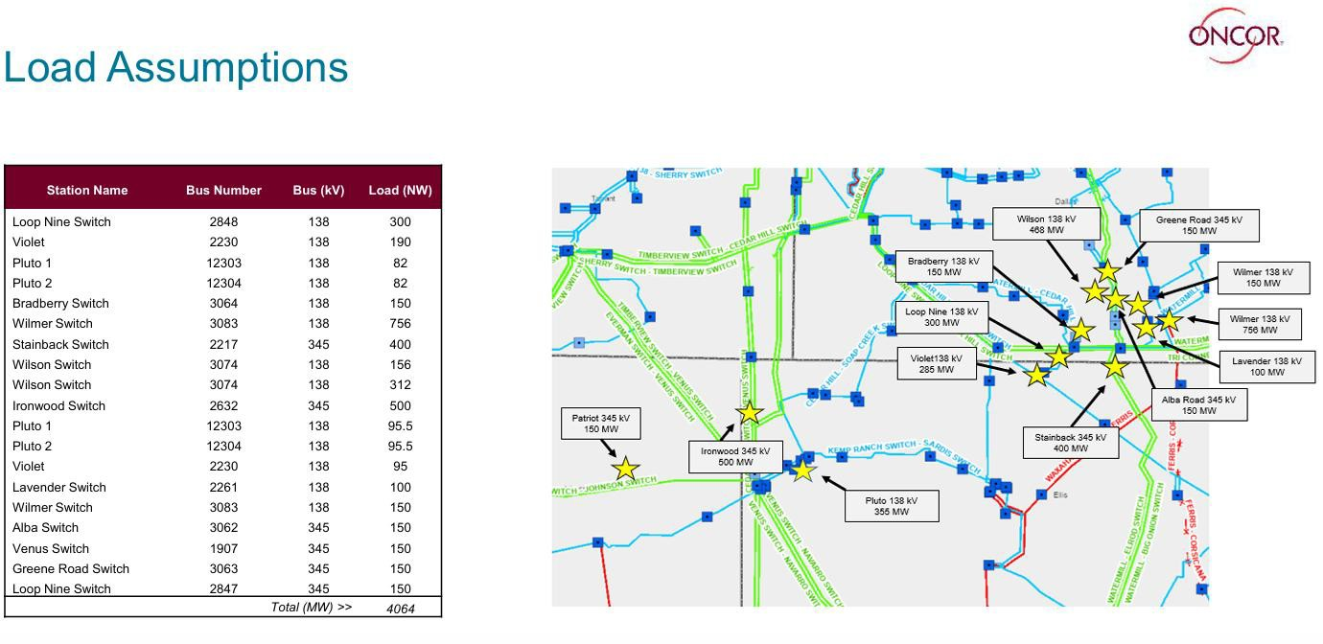
- ERCOT repeatedly validated the RPG pathway through its independent review. ERCOT’s July 29, 2025, August 26, 2025, and January 16, 2026 EIR RPG updates continued to treat the Southern DFW project as an active Tier 1 project with an expected December 2028 in-service date.
- By January 16, 2026, ERCOT had rerun the reliability need analysis, developed and evaluated alternatives, and identified extensive violations in the study base case, including 45 voltage violations, 77 thermal overloads, and 3 unsolved power-flow conditions. ERCOT also showed that Option 3 resolved the tested violations under N-1, G-1+N-1, and X-1+N-1 conditions. ERCOT’s January 2026 update confirmed that the Southern DFW project was studied around a defined set of Oncor-identified large loads, not generic system growth—i.e., the study case for Southern DFW was built around the large load additions Oncor identified as relevant to the project. ERCOT removed all 2024 RTP Officer Letter Loads (OLLs) in the study area from the base case and added approximately 4,046 MW of Oncor-provided large loads, including OLLs, plus approximately 50 MW of large loads from Brazos Electric Power Cooperative. Those assumptions include a 150 MW load at Venus Switch, which corresponds to Cholla’s Project Venus.
- On March 17, 2026, ERCOT completed its internal review of the Southern DFW project, and submitted its recommendation to TAC for approval.
- On March 25, 2026, TAC reviewed and ultimately endorsed ERCOT’s preferred ‘Option 3’ for the Southern DFW project. Importantly, ERCOT confirmed that it performed a dynamic stability analysis using the 2024 DWG 2026 Summer Peak dynamic case provided by Oncor, and evaluated the large loads included in Oncor’s RPG proposal within the study area, and “observed no adverse dynamic stability impacts resulting from the implementation of Option 3 (ERCOT’s preferred option).”
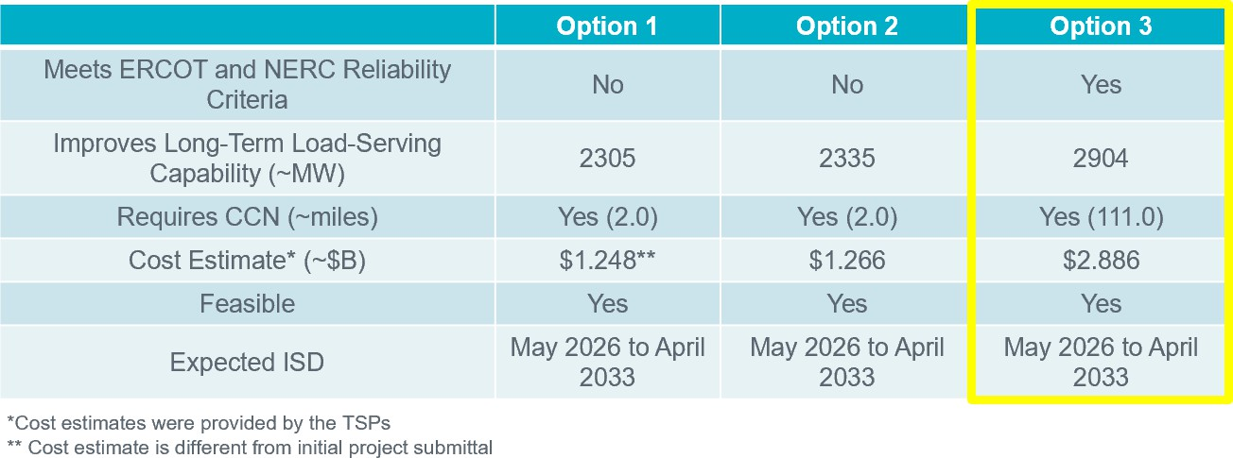
- ERCOT’s independent review of the Southern DFW project (RPG No. 25RPG004) took nearly three times the 150-day target established in the ERCOT Protocols. During that delay, Oncor continued to assure Cholla that Project Venus was being actively pursued through the established RPG process, while later-requested large loads were simultaneously advanced to ERCOT for approval against the same planned transmission capacity. Cholla’s reliance on Oncor’s assurances was reasonable. The RPG process was not an informal accommodation; it was the pathway Oncor required and ERCOT repeatedly recognized as the operative planning vehicle for serving the Southern DFW large-load additions, as shown through ERCOT’s various RPG status updates (July 29, 2025, August 26, 2025, and January 16, 2026).
- On April 9, 2026, Oncor testified publicly before the Texas House Committee on State Affairs, that projects like the “South Dallas project” is “a pretty pure” example of transmission built to serve new large customers. Oncor further testified “it’s important that the customers we have been planning for and building for get the benefit of those projects as part of this process” and cautioned that “[t]hey can’t have the rug pulled out from under them” while the batch process and new large load interconnection rules are finalized.
- At the April 20-21, 2026 ERCOT Board of Directors meeting, the Board approved the endorsement of the Southern DFW project
- At the May 13, 2026 Special TAC meeting, Oncor confirmed that it used the RPG process to bundle multiple Southern DFW customers into a single study in lieu of multiple individual LLIS studies. Cholla explained that this made the RPG process functionally comparable to cluster LLIS for the loads that supported the need for the project, but without the confidentiality protections of individual LLIS review. ERCOT staff acknowledged on the record that this issue largely pits large loads within the same utility service territory against one another.

Why This Matters
As presented for Board approval, PGRR145 uses March 4, 2026 as the cutoff date for Base Load eligibility. ERCOT completed its independent review of the Southern DFW project 13 days later, on March 17, 2026. That timing issue is not a technicality. It means the very loads for which the Southern DFW project was planned, studied and approved could fall on the wrong side of an arbitrary administrative line, while later-requested loads that pointed to the already-planned capacity could be positioned ahead of the loads that established the reliability need for the transmission projects in the first place.
That result would be especially inequitable here because the Southern DFW project was not generic system expansion. It was a load-driven RPG project anchored to a defined set of LLIRs, specific station-level assumptions, specific interconnection timing, and specific transmission upgrades—including upgrades needed to serve Project Venus. The contributing loads supplied the planning basis for more than $1,000,000,000 in transmission investment. They should not be disadvantaged merely because the TSP-required RPG process made the transmission solution visible to later-requested loads while ERCOT’s independent review remained pending.
Treating Project Venus as Studied and Allocated Load rather than Base Load could delay energization until 2033 or later—more than five (5) years beyond the December 2028 energization date Oncor communicated when allocating capacity for the project. Cholla has invested tens of millions of dollars in reliance on the process Oncor required, the capacity Oncor allocated, the timeline Oncor communicated, ERCOT’s repeated treatment of the RPG process as the operative planning pathway, the Board’s approval of the RPG project, and the ERCOT rules and procedures in place throughout the project’s development.
This was not a hidden, speculative, or late-emerging project. Cholla has been communicating with ERCOT about the project and its progression through the RPG process since Fall 2025. ERCOT has therefore been aware that retroactively excluding this project from Base Load treatment would not merely adjust a queue position; it would penalize a project that did exactly what ERCOT and Oncor required, followed the applicable rules, advanced through the process made available by the regulated utility and ERCOT, and committed substantial capital in reliance on ERCOT-reviewed transmission planning and capacity specifically planned to serve this load.
The issue is not whether Cholla or Project Venus should receive preferential treatment. The issue is whether PGRR145 should preserve the planning relationship between the loads that justified the Southern DFW project and the capacity planned, studied, and approved to serve them. A transition rule that allows later-requested loads to benefit from capacity revealed through the public RPG process, while subordinating the originating loads that supplied the need case for that capacity, would convert ERCOT’s review timing into a substantive priority rule with no clear statutory, reliability, or planning basis.
This is not a marginal scheduling issue. It is a fundamental question of whether the loads that followed the only process available through the regulated utility charged with processing their interconnection requests—and whose requests supplied the need case for more $1,000,000,000 in transmission investment that you approved—will receive the benefit of the capacity planned, studied, and approved for them, or whether that capacity will be diverted to later-requested loads that appeared only after the loads whose interconnection requests established the reliability need and supplied the planning justification for the transmission upgrades.

Requested Relief
In evaluating PGRR145 and any TAC-approved revisions, it is important that the Board recognize that large computational loads materially affected by Batch Zero do not have a dedicated ERCOT stakeholder segment and may be represented, if at all, through market segments with materially different incentives. The Board should therefore exercise critical independent judgment to ensure that PGRR145’s transition rule is not only administrable, but also fair, nondiscriminatory, and consistent the Public Utility Regulatory Act (PURA). Accordingly, Cholla respectfully requests that the ERCOT Board:
- Approve PGRR145 with a narrow proposed revision to Planning Guide §9.2.1.4(3)(a): replace “March 4, 2026” with “March 17, 2026.”
This single 13-day correction captures the Southern DFW project for which ERCOT completed its independent review on March 17, 2026 and the loads that supplied planning and reliability justification for it. The revision creates no exemption from Batch Zero, no exemption from reliability review, no exemption from financial-security or readiness requirements, and no broader change to PGRR145. It simply prevents an administrative cutoff date from excluding a load-driven RPG project that was already in ERCOT’s review process and completed 13 days later.
- Direct ERCOT to provide, by June 19, 2026, a focused validation report on the RTP-derived Oncor project sets scheduled for Board consideration or related Batch Zero treatment: 25RPG040, 25RPG042, 25RPG041, and 25RPG043.
ERCOT’s June Board agenda identifies 25RPG040 and 25RPG042 as the combined Oncor Set 1 North and Central Texas Reliability Project and Oncor Set 2 North and Central Texas Reliability Project under Agenda Item 5.4, and 25RPG041 and 25RPG043 as the combined Oncor Set 1 North Central and South Central Texas Reliability Project and Oncor Set 2 North Central and South Central Texas Reliability Project under Agenda Item 5.5.
- For each project, the report should identify: (i) the loads and load assumptions that originally supported the need for the project; (ii) any additional large loads subsequently approved, validated, or modeled for energization based on the same planned capacity; and (iii) the amount of capacity, if any, that remains available after accounting for those later additions.
A June 19, 2026 deadline gives ERCOT time to compile the record while still providing affected loads sufficient time before the next TAC meeting and before Batch Zero documentation deadlines to address any Base Load compliance issues.
- If TAC approves additional revisions to PGRR145 after the June Board meeting, direct ERCOT to place those TAC-approved revisions promptly before the Board for final action, including through a limited-purpose special Board meeting if necessary to preserve the Batch Zero implementation schedule.
ERCOT’s Bylaws allow a special Board meeting to be called by the Board Chair, Vice Chair, CEO, or designee, and require the notice to state the purpose, business to be transacted, location or access information, date, and time of the meeting. If the timing and implementation risks satisfy ERCOT’s urgent-matter standard, the meeting may be held on shortened notice and by remote means, subject to the Bylaws’ notice, quorum, public-access, voting, and ratification requirements. This direction is necessary because TAC may recommend revisions, but Board action is required for final approval of a Revision Request requiring Board approval.

The Bottom Line
Cholla did what it was asked to do; Cholla followed the rules. Oncor placed Project Venus on the cluster-study path because that was the only process Oncor made available for the Southern DFW LLIRs. ERCOT then reviewed that path through the public RPG process. During ERCOT’s extended review, the planned transmission capacity became visible to later-requested loads, which were able to position themselves against capacity that had been planned and justified for the originating loads. PGRR145, as drafted, would lock in that result based on an administrative March 4, 2026 cutoff date that falls only 13 days before ERCOT completed its review of the Southern DFW project.
The requested fix is narrow and administrable: move the cutoff in Section 9.2.1.4(3)(a) from March 4, 2026 to March 17, 2026, and require a focused validation report for the RTP-derived Oncor projects so ERCOT and stakeholders can see whether the same capacity has been double-counted. That approach uses ERCOT’s existing processes, aligns Batch Zero with the planning record ERCOT has already reviewed and the Board has already endorsed, and avoids penalizing the loads that followed the process ERCOT and Oncor made available. We respectfully ask the Board to approve these revisions.
Revised Cover Page Language
None
Revised Proposed Guide Language
None

