NPRR Number | 1330 | NPRR Title | Mitigated Offer Cap for RMR Units
Date |  | May 5, 2026
Submitter’s Information
Name |  | Katie Rich
E-mail Address |  | Katie.rich@vistracorp.com
Company |  | Vistra Operations Company
Phone Number |  | (737) 313-9351
Cell Number
Market Segment |  | Independent Generator

Comments
Vistra appreciates the opportunity to comment on this NPRR addressing the appropriate Mitigated Offer Cap (MOC) for Reliability Must-Run (RMR) Resources. While Vistra continues to support using the framework from NPRR784, Mitigated Offer Caps for RMR Units, as an interim bridge until NPRR826, Mitigated Offer Caps for RMR Resources, is implemented, recent operational experience—particularly during Winter Storm Fern and the dispatch of the Braunig unit—demonstrates that the current language in paragraph (1) of Section 4.4.9.4.1, Mitigated Offer Cap, of NPRR1315 is no longer sufficient to achieve its intended purpose.
The existing construct fails its core objective. The fundamental objective of the MOC framework is to ensure that Contracts for Capacity (“C4C”) and RMR Resources are dispatched only after all other Resources capable of economically resolving the relevant transmission constraint. The MOC for the C4C and RMR has to be set high enough that every economic helper is exhausted first — and that requires honest assumptions about what system lambda and the shadow price look like at the same time, not in isolation. Real-world outcomes show that the current formulation does not reliably produce that result.
Vistra’s analysis of the Braunig deployments during Winter Storm Fern shows that dispatch occurred well ahead of competitive Resources during peak scarcity conditions. This outcome is directly inconsistent with the intended “last-resort” role of C4C and RMR Resources. In fact, Braunig displaced 12,000 MWs or more of competitive Resources due to offers exceeding the MOC (with an assumed $0 System Lambda) on January 25, 2026 (see the table below). This demonstrates the unit would still have been reachable by Security-Constrained Economic Dispatch (SCED) at a much higher MOC value that reflected the true System Lambda. The objective of the MOC methodology is to have SCED rely on market resources to resolve the constraint ahead of the C4C and RMR unit, i.e. if the unit sits at the Low Sustained Limit (LSL) and the constraint is resolved, that’s a favorable outcome, not something to artificially avoid.
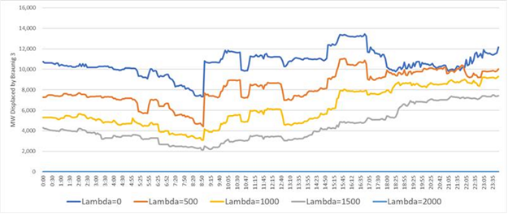
Please note that Vistra used a shift factor threshold of -1% and resource status exclude “EMR” “OUT” “SHUTDOWN” but include “OFF”, “OFFQS”.
How the methodology for developing the MOC works. Vistra developed a methodology for deriving static MOCs based on actual system conditions observed during Winter Storm Fern, specifically the interval when Braunig 3 was Reliability Unit Commitment (RUC) committed. The objective is to ensure the Resource is positioned behind all economically dispatchable constraint-relieving units (“helpers”). The approach consists of two steps: (1) determining the System Lambda required to reach the marginal helper; and (2) confirming whether that outcome is achievable under the applicable constraint limits.
Step 1 – Identify the Last Reachable Helper. Vistra first calculates the Shadow Price required to Dispatch each helper unit (i.e., online Resources with negative shift factors on the constraint). The highest required Shadow Price identifies the marginal (last) reachable helper. If the Shadow Price required to reach that unit exceeds the applicable cap, the cap becomes the binding constraint, indicating that SCED cannot economically reach that unit. An administrative buffer (e.g., $50–$100/MWh) is then added to ensure the RMR or C4C Resource is positioned behind all reachable helpers.
Applying this framework to Braunig 3 using a representative System Lambda of $1,500/MWh results in an MOC of approximately $3,446/MWh.
Step 2 – Validate Using Observed System Conditions. Vistra then validates the result using observed market data by grouping helper units into Shift Factor buckets (rounded to 0.5%) and determining, for each bucket, the System Lambda required to Dispatch the highest-priced unit, assuming the constraint is binding at its Shadow Price cap. These System Lambda values are translated into corresponding Braunig 3 Locational Marginal Prices (LMPs), and the maximum across all buckets defines the MOC.
This approach anchors the result in actual system behavior. For the Fern interval analyzed, the shallowest Shift Factor bucket (−0.5%) is binding, producing an MOC of approximately $3,797/MWh. Across all SCED intervals that day, the binding MOC falls within a narrow range of ~$3,700–$3,800/MWh (see the table below).
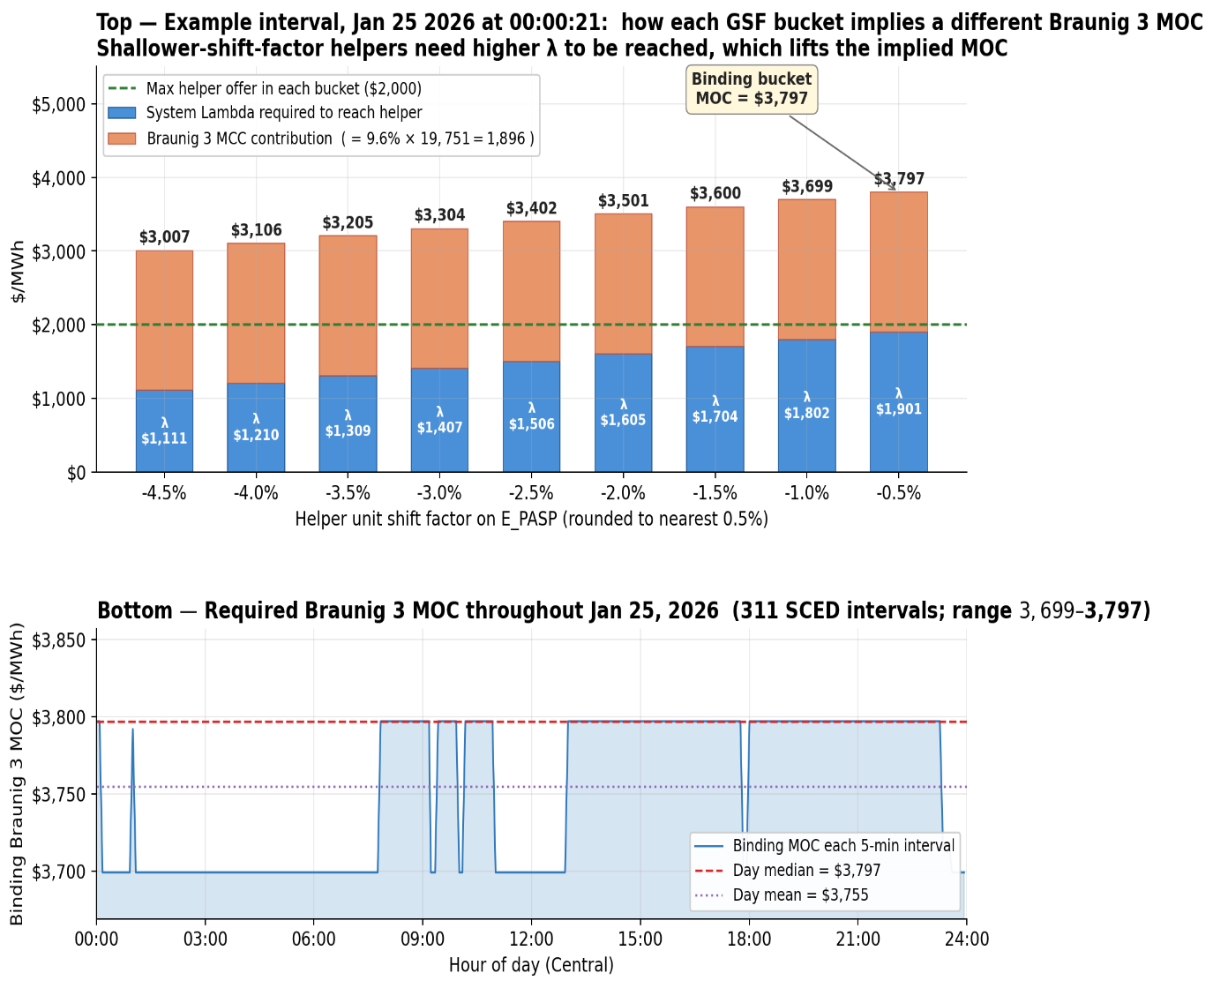
Top: example interval at 00:00:21 — each GSF bucket's $2,000 helper offer implies a different system lambda required and a different Braunig 3 MOC; the shallowest bucket binds at $3,797/MWh. Bottom: binding MOC across all 311 SCED intervals that day, sitting in a tight $3,699–$3,797 band with a daily median of $3,797.
In addition to the methodology, Vistra also observed that the System Lambda is not exogenous - it is the Shadow Price of the power-balance constraint, and it co-moves with congestion Shadow Prices because the same conditions (high net load, tight reserves, large flows on stressed corridors) drive both.
To illustrate, Vistra pulled every 5-minute SCED interval between March 9, 2024 and April 23, 2026 in which the E_PASP Shadow Price was strictly positive — 9,890 intervals across 280 operating days. The relationship between system lambda and the Shadow Price is monotone, tight (Pearson r = 0.92), and most importantly there is no historical precedent for a low system lambda when E_PASP is at meaningful shadow price levels (as shown in the table below).
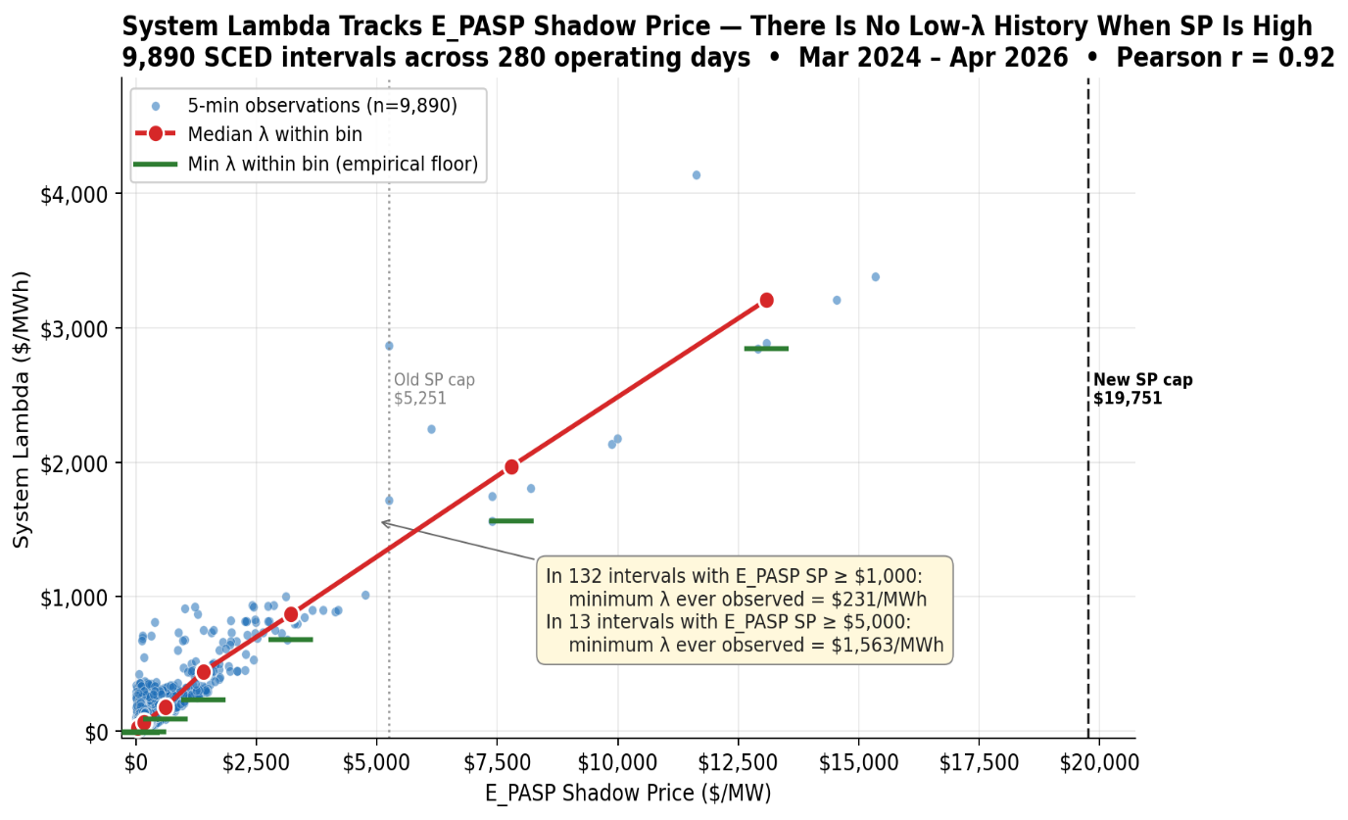
Key Takeaways from Vistra’s Analysis
- Both steps produce consistent results: Step 1 provides a mathematically grounded estimate, while Step 2 validates the outcome using real system conditions.
- The methodology is portable and can be applied to other constrained areas by substituting the relevant shadow price caps and shift factors.
- Results are highly sensitive to system conditions, making it critical to select representative “tight” intervals where C4C and RMR resources are needed.
- System Lambda and constraint shadow prices are not independent—they co-move under tight system conditions—reinforcing the internal consistency of the approach.
Protocol changes to incorporate methodology. To provide additional transparency to the market on how the MOC will be calculated, Vistra has revised paragraph (b) of Section 4.4.9.4.1 in NPRR1315 to state that ERCOT shall set the MOC such that the C4C Unit is economically positioned behind the highest-cost Resource capable of resolving the constraint within the applicable Shadow Price cap, as determined using the Resource’s Energy Offer Curve, Shift Factor, and the System Lambda. Based on the calculated MOC from Vistra’s example, the limitation of capping the MOC at the systemwide cap was also removed to allow the Energy Offer Curve to serve as the threshold (which was also supported in the NPRR1315 5/5/26 ERCOT comments).
Conclusion and next steps. Given the urgency of aligning this protocol language with observed system behavior, Vistra supports implementing this modification as part of NPRR 1330. Doing so will ensure that near-term reliability tools do not inadvertently distort market outcomes or undermine competitive signals.
Vistra looks forward to continued discussion of these issues at the May 6 PRS meeting.

Revised Cover Page Language
None.
Revised Proposed Protocol Language

4.4.9.4.3 Mitigated Offer Cap for RMR Resources
(1) For each Reliability Must-Run (RMR) Unit contracted by ERCOT under Section 3.14.1, Reliability Must Run, in consideration of the Shadow Price caps of the transmission constraints which the RMR Unit may be required to resolve and variations in transmission system topology, ERCOT shall set the Mitigated Offer Cap (MOC) such that the RMR unit is economically positioned behind the highest-cost Resource capable of resolving the constraint with the applicable Shadow Price Cap, as determined using the Resource’s Energy Offer Curve, Shift Factor, and System Lambda. The MOC values that will be used for the MOC curve shall be initially determined and communicated as part of the Market Notice issued for the status of the RMR Unit, as described in paragraph (6) of Section 3.14.1.2, ERCOT Evaluation Process. The MOC curve must be modified by ERCOT to ensure that the RMR Unit is Dispatched by SCED to help resolve transmission congestion in Real-Time after other Resources that can economically resolve the constraint. Any modification to the MOC curve by ERCOT shall be communicated by Market Notice.

[NPRR826: Replace Section 4.4.9.4.3 above with the following upon system implementation:]

4.4.9.4.3 Mitigated Offer Cap for RMR Resources
(1) For each Resource contracted by ERCOT under Section 3.14.1, Reliability Must Run, the Resource’s MOC curve for use in the SCED process is determined using the steps below when the Resource’s offer is subject to mitigation in accordance with Section 3.19, Constraint Competitiveness Tests. The single price ($/MWh) value determined below will be used as the MOC curve for the full operating range of the Resource. The calculations will occur between the first and second step within the SCED process as well as during the process for determining Real-Time On-Line Reliability Deployment Price Adder. This analysis will only be applied to active constraints for which the contracted Resource has a more than 2% unloading Shift Factor on the Transmission Facility(s), more than 5% unloading impact on the Transmission Facility(s) based on telemetered HSL, and if at least one other Resource not contracted by ERCOT under Section 3.14.1 has an unloading Shift Factor of 5% or more relative to the constraint(s). If this criteria is not met, the MOC curve for the Resource shall be calculated in accordance with Section 4.4.9.4.1, Mitigated Offer Cap, and Section 5.6.1, Verifiable Costs.
(a) For each Resource that is not a Resource contracted by ERCOT under Section 3.14.1 or paragraph (4) of Section 6.5.1.1 and that has an unloading Shift Factor of at least RMRSF percent relative to the constraint(s), determine the higher of zero or the difference between the price ($/MWh) at HSL from the Energy Offer Curves determined for use in SCED Step 2, which may or may not be mitigated, and system lambda from SCED Step 1 and divide that difference by the absolute value of that Resource’s Shift Factor for the corresponding constraint. The value of RMRSF will default to 5% until a different value is approved by TAC considering the analysis and data used by ERCOT to determine the need for the contracted Resource under Section 3.14.1. ERCOT shall post the current TAC-approved value(s) of RMRSF on the ERCOT website.
(b) For each constraint, identify the largest value that is less than maximum Shadow Price for the specific constraint.
(c) For each SCED interval for each constraint, determine a value equal to the minimum of:
(i) The value determined in paragraph (b) above plus $0.01/MWh; and
(ii) The maximum Shadow Price for the constraint minus $1/MWh.
(d) For each SCED interval for each constraint, multiply the resulting value from paragraph (c) above by the absolute value of the Shift Factor of the Resource contracted by ERCOT to the corresponding constraint. For SCED intervals in which there are multiple constraints which are being analyzed, the lowest value is used for the SCED interval.
(e) If the value from paragraph (b) above for any constraint analyzed is zero, the MOC curve for the RMR Resource shall be calculated in accordance with Section 4.4.9.4.1 and Section 5.6.1. If the value from paragraph (b) above for every constraint analyzed is greater than zero, the RMR Resource’s MOC curve for use in Step 2 of the SCED process is the sum of system lambda from Step 1 of SCED in the interval and the value from (d) above.

