NPRR Number | 1315 | NPRR Title | Changes to Process of Evaluating the Potential Needs for Additional Capacity
Date |  | May 5, 2026
Submitter’s Information
Name |  | Katie Rich
E-mail Address |  | Katie.rich@vistracorp.com
Company |  | Vistra Operations Company
Phone Number |  | (737) 313-9351
Cell Number
Market Segment |  | Independent Generator

Comments

Vistra appreciates the opportunity to comment on this NPRR addressing, in part, the appropriate Mitigated Offer Cap (MOC) for Contracts for Capacity (C4C). While Vistra continues to support using the framework from NPRR 784 as an interim bridge until NPRR 826 is implemented, recent operational experience—particularly during Winter Storm Fern and the dispatch of the Braunig unit—demonstrates that the current language in Section 4.4.9.4.1(1) is no longer sufficient to achieve its intended purpose.

The existing construct fails its core objective. The fundamental objective of the MOC framework is to ensure that C4C and RMR Resources are dispatched only after all other resources capable of economically resolving the relevant transmission constraint. The MOC for the C4C and RMR has to be set high enough that every economic helper is exhausted first — and that requires honest assumptions about what system lambda and the shadow price look like at the same time, not in isolation. Real-world outcomes show that the current formulation does not reliably produce that result.

Vistra’s analysis of the Braunig deployments during Winter Storm Fern shows that dispatch occurred well ahead of competitive resources during peak scarcity conditions. This outcome is directly inconsistent with the intended “last-resort” role of C4C and RMR Resources. In fact, Braunig displaced 12,000 MWs or more of competitive resources due to offers exceeding the MOC (with an assumed $0 system lambda) on January 25, 2026 (see the table below). This demonstrates the unit would still have been reachable by SCED at a much higher MOC value that reflected the true system lambda. The objective of the MOC methodology is to have SCED rely on market resources to resolve the constraint ahead of the C4C and RMR unit, i.e. if the unit sits at the low sustainable limit (LSL) and the constraint is resolved, that’s a favorable outcome, not something to artificially avoid.

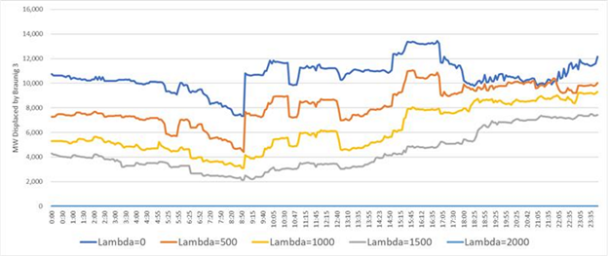
Please note that we use a shift factor threshold of -1% and resource status exclude “EMR” “OUT” “SHUTDOWN” but include “OFF”, “OFFQS”.

How the methodology for developing the MOC works. Vistra developed a methodology for deriving static MOCs based on actual system conditions observed during Winter Storm Fern, specifically the interval when Braunig 3 was RUC-committed. The objective is to ensure the resource is positioned behind all economically dispatchable constraint-relieving units (“helpers”). The approach consists of two steps: (1) determining the System Lambda required to reach the marginal helper; and (2) confirming whether that outcome is achievable under the applicable constraint limits.

Step 1 – Identify the Last Reachable Helper. Vistra first calculates the shadow price required to dispatch each helper unit (i.e., online resources with negative shift factors on the constraint). The highest required shadow price identifies the marginal (last) reachable helper. If the shadow price required to reach that unit exceeds the applicable cap, the cap becomes the binding constraint, indicating that SCED cannot economically reach that unit. An administrative buffer (e.g., $50–$100/MWh) is then added to ensure the RMR or C4C resource is positioned behind all reachable helpers.

Applying this framework to Braunig 3 using a representative System Lambda of $1,500/MWh results in an MOC of approximately $3,446/MWh.

Step 2 – Validate Using Observed System Conditions. Vistra then validates the result using observed market data by grouping helper units into shift-factor buckets (rounded to 0.5%) and determining, for each bucket, the System Lambda required to dispatch the highest-priced unit, assuming the constraint is binding at its shadow price cap. These System Lambda values are translated into corresponding Braunig 3 locational marginal prices (LMPs), and the maximum across all buckets defines the MOC.

This approach anchors the result in actual system behavior. For the Fern interval analyzed, the shallowest shift-factor bucket (−0.5%) is binding, producing an MOC of approximately $3,797/MWh. Across all SCED intervals that day, the binding MOC falls within a narrow range of ~$3,700–$3,800/MWh (see the table below).

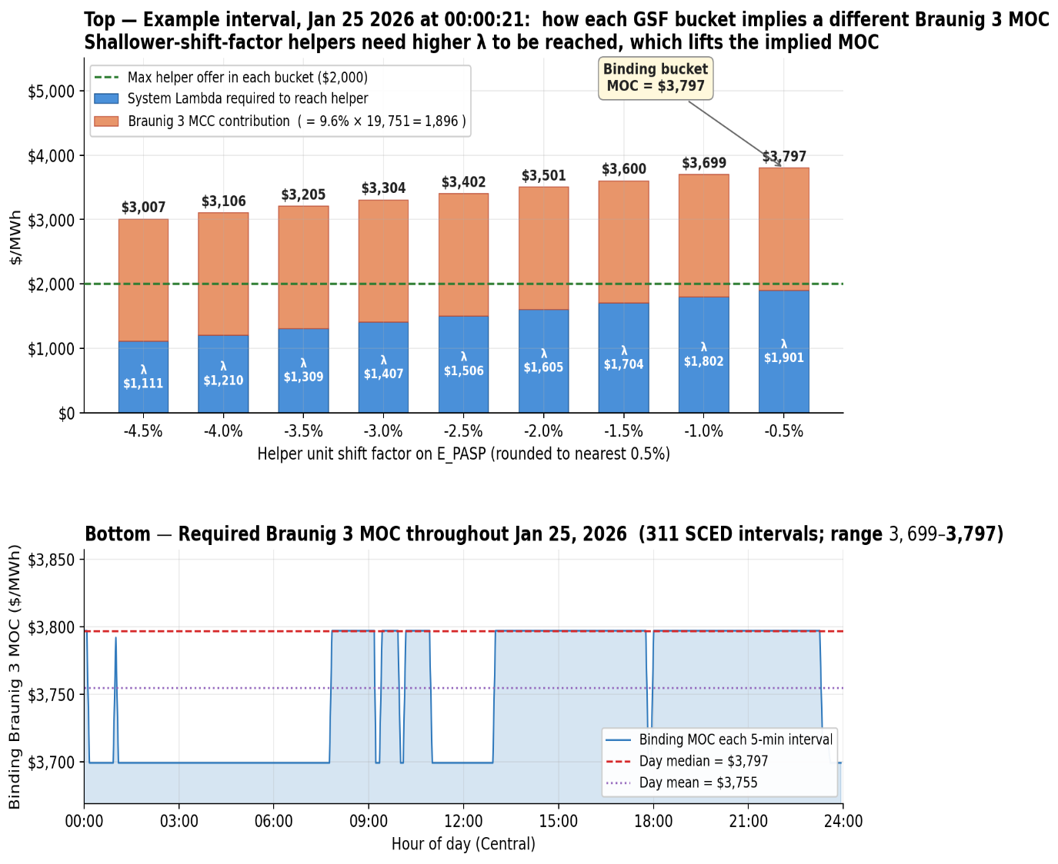
Top: example interval at 00:00:21 — each GSF bucket's $2,000 helper offer implies a different system lambda required and a different Braunig 3 MOC; the shallowest bucket binds at $3,797/MWh. Bottom: binding MOC across all 311 SCED intervals that day, sitting in a tight $3,699–$3,797 band with a daily median of $3,797.
In addition to the methodology, Vistra also observed that the system lambda is not exogenous - it is the shadow price of the power-balance constraint, and it co-moves with congestion shadow prices because the same conditions (high net load, tight reserves, large flows on stressed corridors) drive both.
To illustrate, Vistra pulled every 5-minute SCED interval between March 9, 2024 and April 23, 2026 in which the E_PASP shadow price was strictly positive — 9,890 intervals across 280 operating days. The relationship between system lambda and the shadow price is monotone, tight (Pearson r = 0.92), and most importantly there is no historical precedent for a low system lambda when E_PASP is at meaningful shadow price levels (as shown in the table below).
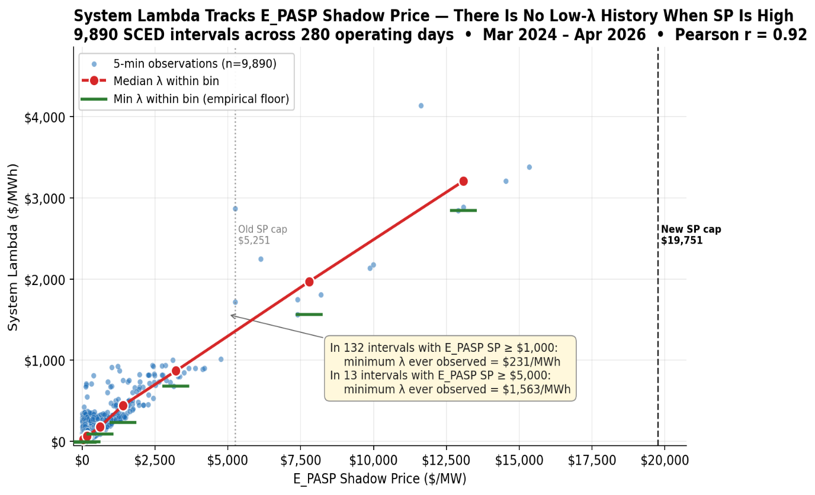

Key Takeaways from Vistra’s Analysis
- Both steps produce consistent results: Step 1 provides a mathematically grounded estimate, while Step 2 validates the outcome using real system conditions.
- The methodology is portable and can be applied to other constrained areas by substituting the relevant shadow price caps and shift factors.
- Results are highly sensitive to system conditions, making it critical to select representative “tight” intervals where C4C and RMR resources are needed.
- System Lambda and constraint shadow prices are not independent—they co-move under tight system conditions—reinforcing the internal consistency of the approach.

Protocol changes to incorporate methodology. To provide additional transparency to the market on how the MOC will be calculated, Vistra has revised Section 4.4.9.4.1(b) to state that ERCOT shall set the MOC such that the C4C Unit is economically positioned behind the highest-cost Resource capable of resolving the constraint within the applicable Shadow Price Cap, as determined using the Resource’s Energy Offer Curve, Shift Factor, and the System Lambda. Based on the calculated MOC from Vistra’s example, the limitation of capping the MOC at the systemwide cap was also removed to allow the EOC to serve as the threshold (which was also supported in ERCOT’s April 30 comments).

Potential gap. Vistra observes ERCOT’s intent is to expand the class of resources eligible to participate in a C4C; however, if that does occur then ERCOT and stakeholders must confirm that no gap exists between the resources covered under Sections 6.5.7.3.1(b), (j), and (k) and those deemed eligible. For example, it is unclear whether mobile generation, targeted Energy Storage Resources (ESRs), and backup generation are encompassed by these provisions. Similarly, clarification is needed on whether subparagraph (2)(a) captures all remaining resource types, excluding Settlement-Only Generators (SOGs) and Demand Response (DR).

Other clarifications. Vistra proposed targeted revisions to clarify the intended application of the MOC in Section 4.4.9.4.1(1)(a) and (b). In paragraph (a), Vistra removed the added language to avoid creating a gap that would limit ERCOT’s use of the MOC solely to emergency conditions, further constrained to transmission issues. For example, if ERCOT were to direct a C4C resource to run for any other reason than “an anticipated Emergency Condition related to ERCOT-Wide capacity insufficiency” or “an anticipated Emergency Condition related to a transmission constraint concern” (e.g., as a conservative operations measure), Vistra’s intent is that it be positioned behind all competitive resources. In addition, while the current language appears to accommodate subsection (b), it may inadvertently create broader scope for interference with price formation through the inappropriate use of out-of-market capacity. Vistra’s proposed language addresses this by deleting the limiting language in (a) and explicitly tying subsection (b) back to paragraph (a) as a specific exception.

Conclusion and next steps. Given the urgency of aligning this protocol language with observed system behavior, Vistra supports implementing this modification as part of NPRR 1315. Doing so will ensure that near-term reliability tools do not inadvertently distort market outcomes or undermine competitive signals.

Vistra looks forward to continued discussion of these issues at the May 6 PRS meeting.

Revised Cover Page Language

NPRR Number | 1315 | NPRR Title | Changes to Process of Evaluating the Potential Needs for Additional Capacity and Mitigated Offer Cap
Nodal Protocol Sections Requiring Revision |  | 4.4.9.4.1, Mitigated Offer Cap  6.5.1.1, ERCOT Control Area Authority
Revision Description |  | This Nodal Protocol Revision Request (NPRR) adds notification requirements for ERCOT to follow when ERCOT has determined that additional capacity is needed to prevent an imminent Emergency Condition or to restore the ERCOT Transmission Grid to a secure state in the event of an ERCOT Transmission Grid Emergency Condition. Under the revisions, ERCOT would notify the Public Utility Commission of Texas (PUCT) when it has made such a determination and would also notify the PUCT prior to entering into any contract for additional capacity.  To address additional capacity that is needed to address local constraint issues, this NPRR also extends the study horizon for evaluating and potentially contracting for capacity to prevent anticipated Load shed events. ERCOT proposes this study horizon extend up to two years instead of just the current or next Season. This NPRR specifies that ERCOT shall present its study assumptions (including Load forecast assumptions) to the ERCOT Board of Directors before any awards are made through the “Request for Proposal” (RFP) process. This NPRR also expands the set of eligible Resources that can respond to the RFPs to include new Resources and not be limited to existing Resources. Additionally, these revisions explain that an eligible Resource could be a Resource that is already planned to be interconnected and that, in such a case, if ERCOT is paying for an acceleration of such a Resource to interconnect, ERCOT must be provided with a detailed explanation that demonstrates that any payments to accelerate planned capacity is justifiable and reasonable, and that the acceleration would not have occurred otherwise.  Additionally, this NPRR provides language that specifies contract length limit considerations for contracts to address local constraint issues.  This NPRR also proposes edits to provide more information on the expected Settlement for Resources that were not previously mothballed, retired, or decommissioned.  Finally, this NPRR modifies Section 4.4.9.4.1 and revises the Mitigated Offer Cap (MOC) calculation for those same Resources procured through Section 6.5.1.1. This approach sets the MOC curve so Security-Constrained Economic Dispatch (SCED) can dispatch contracted Resources if needed, with offers priced to ensure these Resources are dispatched after Resources in the market. The calculation factors in Shadow Price caps for relevant transmission constraints and system topology variations, targeting contracted Resource dispatch only after Resources in the market.
Justification of Reason for Revision and Market Impacts |  | The Public Utility Regulatory Act (PURA) §39.151 (a)(2) requires that ERCOT must “ensure the reliability and adequacy of the regional electrical network.” Section 6.5.1.1 authorizes ERCOT to perform specific actions for the limited purpose of securely operating the ERCOT Transmission Grid under the standards specified in North American Electric Reliability Corporation (NERC) Standards, the Nodal Operating Guides and the Protocols. These additional actions noted under Section 6.5.1.1 might be needed to prevent an imminent Emergency Condition or to restore the ERCOT Transmission Grid to a secure state in the event of an ERCOT Transmission Grid Emergency Condition.  ERCOT has utilized Section 6.5.1.1 to seek additional capacity four times since Nodal Market go-live: summer of 2011; winter of 2023-2024; summer of 2024; and the period from April 1, 2025, through March 31, 2027. The first two times were regarding an ERCOT-wide insufficiency; the last two times were regarding relief on relevant transmission facilities (South Texas Interconnection Reliability Operating Limits (IROLs)), with the final time specifically seeking alternatives to the provision of service by one or more of the Life Cycle Power mobile units or by an RMR Agreement for Braunig Units 1 & 2. During the latter of those requests, ERCOT committed to revise its Protocols to more formally provide the PUCT with notice when ERCOT was either seeking additional capacity through Section 6.5.1.1 or through statute. Revisions in this NPRR therefore include language that provides greater transparency and notice to the PUCT.  Additionally, in evaluating and procuring capacity needs to prevent an Emergency Condition, the current Protocols limit ERCOT to evaluating only the current or next Season and only considering existing capacity that may be used to maintain ERCOT System reliability in a manner not otherwise delineated in the Protocols and the Nodal Operating Guides. This limitation could prevent ERCOT from taking the necessary steps to secure capacity that could avert an anticipated Emergency Condition. To this end, ERCOT has provided language to specify that to alleviate local constraint issues, the study period to evaluate and potentially contract for capacity be extended up to a two-year period, if ERCOT studies support the need, potentially resulting in the following benefits:  - Helps prevent an anticipated Emergency Condition by assessing the necessity of a contract for capacity and to identify any potential grid reliability risks associated with the identified capacity shortfall;  - Provides more time for ERCOT to develop the RFP for services;  - Allows more time for ERCOT to carefully evaluate offers;  - Allows Market Participants more time to develop suitable Resource proposals and submit contract for capacity offers that meet specifications identified in the RFP;  - Awards Resources more time to get ready to meet their contractual obligations; and  - Possibly reduces the need to RMR (and Must-Run Alternative (MRA)) Resources that might be considering permanently mothballing the Generation Resource, potentially resulting in an overall lower cost.  In extending this look-out period to two years for local constraint issues, ERCOT is also proposing language to require an exit strategy for the local constraint issue and the reevaluation of need of any capacity contract that lasts for more than one year, both of which will help ensure that the contract is still cost effective, necessary, and of a reasonable duration.  In addition, the current Protocol language limits ERCOT to procuring only existing capacity in order to exercise its authority to prevent an anticipated Emergency Condition relating to serving Load in the current or next Season. However, there may be scenarios where cost-effective new alternatives that are not “planned” capacity reflected in a Report on Capacity, Demand and Reserves in the ERCOT Region (CDR), such as mobile generation or Energy Storage Resources (ESRs), can be procured to help maintain ERCOT System reliability. If those options are more cost effective than existing capacity, which likely requires repairs and modifications before being ready to deploy, it seems prudent to consider other Resources in addition to existing Resources. In addition, there could be situations where it is most economical to pay for the acceleration of Resources reflected in a CDR but which has not yet reached its Commercial Operations Date. In some situations, this may be more economical than procuring new, unplanned generation or paying for repairs and modifications of existing generation. However, in this situation, ERCOT would need to be provided with a detailed explanation that demonstrates that any payments made to accelerate planned capacity is justifiable and reasonable, and that the capacity would not have been accelerated otherwise. Particularly for new, planned generation, ERCOT would want to ensure that there is no gaming of the system and, for example, ensure that a Resource Commercial Operations Date acceleration would not have occurred absent the acceleration incentive payment.  The Protocols state that, for Settlement purposes, Generation Resources contracted under Section 6.5.1.1 will include substantially the same terms and conditions as an RMR Unit under an RMR Agreement,. This is appropriate for Resources contracted for that were previously mothballed, retired or decommissioned. However, for units not previously mothballed, retired or decommissioned that are being contracted under Section 6.5.1.1, an awarded contract should be limited to the price offered in response to the RFP.  Finally, the proposed edits in Section 4.4.9.4.1 set the MOC curve so SCED can dispatch contracted Resources if needed, with offers priced to ensure these contracted Resources are dispatched after Resources in the market. This will allow the contracted-for-Resource to help manage the constraint and minimize market distortion. Although the impact of these contracted-for-Resources depends on procurement volume and deployment frequency, this NPRR helps maintain higher prices for existing resources and loads in specific areas, encouraging more injection and less withdrawal in key locations.

Revised Proposed Protocol Language

4.4.9.4.1 Mitigated Offer Cap
(1) Energy Offer Curves and Energy Bid/Offer Curves may be subject to mitigation in Real-Time operations under Section 6.5.7.3, Security Constrained Economic Dispatch, using a Mitigated Offer Cap (MOC). For Generation Resources, ERCOT shall construct an incremental MOC curve in accordance with Section 6.5.7.3 such that each point on the MOC curve is calculated as follows:
MOC _{q, r, h} = Max [GIHR _{q, r} * Max(FIP, WAFP _{q, r, h}), (IHR _{q, r} * FPRC _{q, r} + OM _{q, r})]
Where,
If a QSE has submitted an Energy Offer Curve on behalf of a Generation Resource and the Generation Resource has approved verifiable costs, then
FPRC _{q, r} = Max(WAFP _{q, r, h}, FIP + FA _{q, r}) * RTPERFIP _{q, r} / 100 + FOP * RTPERFOP _{q, r} / 100
If a QSE has not submitted an Energy Offer Curve on behalf of a Generation Resource and the Generation Resource has approved verifiable costs, then
FPRC _{q, r} = Max(WAFP _{q, r, h}, FIP + FA _{q, r}) * GASPEROL _{q, r} / 100 + FOP * OILPEROL _{q, r} / 100 + (SFP + FA _{q, r}) * SFPEROL _{q, r} / 100
The above variables are defined as follows:
Variable | Unit | Definition
MOC _{q, r, h} | $/MWh | Mitigated Offer Cap per Resource—The MOC for Resource r, for the hour. Where for a Combined Cycle Train, the Resource r is a Combined Cycle Generation Resource within the Combined Cycle Train.
GIHR _{q, r} | MMBtu/MWh | Generic Incremental Heat Rate—The generic, single-value, incremental heat rate. For Generation Resources with a Commercial Operations Date on or before January 1, 2004, the generic incremental heat rate shall be set to 10.5. For Generation Resources that have a Commercial Operations Date after January 1, 2004, this value shall be set to 14.5. Where for a Combined Cycle Train, the Resource r is a Combined Cycle Generation Resource within the Combined Cycle Train.
IHR _{q, r} | MMBtu/MWh | Verifiable Incremental Heat Rate per Resource—The verifiable incremental heat rate curve for Resource r, as approved in the verifiable cost process. Where for a Combined Cycle Train, the Resource r is a Combined Cycle Generation Resource within the Combined Cycle Train.
FIP | $/MMBtu | Fuel Index Price—The natural gas index price as defined in Section 2.1, Definitions.
RTPERFIP _{q, r} | none | Fuel Index Price Percentage—The percentage of natural gas used by Resource r to operate above LSL, as submitted with the energy offer curve.
FOP | $/MMBtu | Fuel Oil Price—The fuel oil index price as defined in Section 2.1.
RTPERFOP _{q, r} | none | Fuel Oil Price Percentage—The percentage of fuel oil used by Resource r to operate above LSL, as submitted with the energy offer curve.
SFP | $/MMBtu | Solid Fuel Price—The solid fuel index price is $1.50.
FPRC _{q, r} | $/MMBtu | Fuel Price Calculated per Resource—The calculated index price for fuel for the Resource based on the Resources fuel mix. Where for a Combined Cycle Train, the Resource r is a Combined Cycle Generation Resource within the Combined Cycle Train.
GASPEROL _{q, r} | none | Percent of Natural Gas to Operate Above LSL—The percentage of natural gas used by Resource r to operate above LSL, as approved in the verifiable cost process. Where for a Combined Cycle Train, the Resource r is a Combined Cycle Generation Resource within the Combined Cycle Train.
OILPEROL _{q, r} | none | Percent of Oil to Operate Above LSL—The percentage of fuel oil used by Resource r to operate above LSL, as approved in the verifiable cost process. Where for a Combined Cycle Train, the Resource r is a Combined Cycle Generation Resource within the Combined Cycle Train.
SFPEROL _{q, r} | none | Percent of Solid Fuel to Operate Above LSL—The percentage of solid fuel used by Resource r to operate above LSL, as approved in the verifiable cost process. Where for a Combined Cycle Train, the Resource r is a Combined Cycle Generation Resource within the Combined Cycle Train.
FA _{q, r} | $/MMBtu | Fuel Adder—The fuel adder is the average cost above the index price Resource r has paid to obtain fuel. Where for a Combined Cycle Train, the Resource r is a Combined Cycle Generation Resource within the Combined Cycle Train. See the Verifiable Cost Manual for additional information.
OM _{q, r} | $/MWh | Variable Operations and Maintenance Cost above LSL—The O&M cost for Resource r to operate above LSL, including an adjustment for emissions costs, as approved in the verifiable cost process. Where for a Combined Cycle Train, the Resource r is a Combined Cycle Generation Resource within the Combined Cycle Train. See the Verifiable Cost Manual for additional information.
WAFP _{q, r, h} | $/MMBtu | Weighted Average Fuel Price—The volume-weighted average intraday, same-day and spot fuel price, the projected incremental fuel consistent with a fuel supply contract(s), or a combination of these two prices, submitted to ERCOT during the Adjustment Period for a specific Resource and specific hour within the Operating Day, as described in paragraph (1)(e) below.
  [NPRR1279: Replace the definition above with the following on April 1, 2027:]
  Weighted Average Fuel Price—The volume-weighted average intraday, same-day and spot price of fuel submitted to ERCOT during the Adjustment Period for a specific Resource and specific hour within the Operating Day, as described in paragraph (1)(e) below.
Q | none | A QSE.
R | none | A Generation Resource.
H | none | The Operating Hour.
(a) For a Resource contracted by ERCOT under paragraph (4) of Section 6.5.1.1, ERCOT Control Area Authority, ERCOT shall increase the O&M cost such that every point on the MOC curve is greater than the effective Value of Lost Load (VOLL) in $/MWh.
(b) Notwithstanding paragraph (a) above, for a Resource contracted by ERCOT under paragraph (4) of Section 6.5.1.1 to address an anticipated Emergency Condition related to a transmission constraint concern, ERCOT shall set the MOC such that the Contract for Capacity (C4C) unit is economically positioned behind the highest-cost Resource capable of resolving the constraint within the applicable Shadow Price Cap, as determined using the Resource’s Energy Offer Curve, Shift Factor, and the System Lambda. The value that will be used for the MOC curve shall be initially determined and communicated as part of a Market Notice issued when the Resource is first available for ERCOT deployment. The MOC curve must be modified by ERCOT to ensure that the Resource is Dispatched by SCED to help resolve transmission congestion in Real-Time after other Resources that can economically resolve the constraint. Any modification to the MOC curve by ERCOT shall be communicated by Market Notice.
(c) Notwithstanding the MOC calculation described in paragraph (1) above, the MOC for ESRs shall be set at the RTSWCAP. No later than December 31, 2023, ERCOT and stakeholders shall submit a report to TAC that includes a recommendation to continue the existing approach or a proposal to implement an alternative approach to determine the MOC for ESRs.
(d) For Quick Start Generation Resources (QSGRs) the MOC shall be adjusted in accordance with Verifiable Cost Manual Appendix 7, Calculation of the Variable O&M Value and Incremental Heat Rate used in Real Time Mitigation for Quick Start Generation Resources (QSGRs).
(e) For hydro Generation Resources, the MOC shall be adjusted in accordance with Verifiable Cost Manual, Appendix 10, Setting the variables used in Mitigated Offer Cap for Hydro Generating Resources.
(f) During the Adjustment Period, a QSE representing a Resource may submit Exceptional Fuel Cost as a volume-weighted average fuel price for use in the MOC calculation for that Resource. To qualify as Exceptional Fuel Cost, the submission must meet the following conditions:
(i) For all Resources, the weighted average fuel price must exceed FIP for the applicable Operating Day, plus a threshold parameter value of $1/MMBtu, plus the applicable fuel adder. For Resources without approved verifiable costs, the fuel adder will be set to the default value assigned to Resources with approved verifiable costs, as defined in the Verifiable Cost Manual. The threshold parameter value in this paragraph shall be recommended by the Wholesale Market Subcommittee (WMS) and approved by the TAC. ERCOT shall update the threshold value on the first day of the month following TAC approval unless otherwise directed by the TAC. ERCOT shall provide a Market Notice prior to implementation of a revised parameter value.
(ii) Fixed cost (fees, penalties and similar non-gas costs) may not be included in the calculation of the weighted average fuel price.
(iii) The weighted average fuel price in paragraph (1) above must be a single value and based on the following fuel price options:
(A) A volume-weighted price considering all intra-day, same day, and spot fuel purchases for the Resource; or
(B) A projected incremental fuel price for a Resource with a fuel supply contract(s) that also has submitted an Energy Offer Curve for the Operating Hour where the Energy Offer Curve is calculated as the incremental heat rate times the incremental fuel price plus O&M cost; or
(C) A combination of the above two options.
(iv) A weighted average fuel price based on actual fuel purchases must be included in the calculation of the weighted average fuel price in paragraph (1) above. These must account for at least 10% of the total fuel volume burned by the applicable Resource for the hour for which the weighted average fuel price is computed. A projected incremental fuel price must be consistent with the terms of the fuel supply contract(s). A weighted average fuel price based on a combination of the options in paragraph (iii) above must meet the requirements described for each of the options. As noted in paragraph (l) below, the methodology used in the allocation of the cost and volume of fuel to the Resource for the hour is subject to validation by ERCOT.
(v) Weighted average fuel prices must be submitted individually for each Operating Hour for which they are applicable. Values submitted outside of the Adjustment Period will be rejected and not used in the calculation of the MOC for the designated Operating Hour.
(vi) A projected volume-weighted average fuel price must be consistent with the Energy Offer Curve for each Operating Hour for which they are applicable, and consistent with the signed and executed fuel supply contract(s) for each Resource.
(vii) An Exceptional Fuel Cost submitted based on projected fuel prices may not match with the actual volume-weighted average fuel price due to prospective costs and/or contractual costs.

[NPRR1279: Replace paragraph (f) above with the following on April 1, 2027:]
(f) During the Adjustment Period, a QSE representing a Resource may submit Exceptional Fuel Cost as a volume-weighted average fuel price for use in the MOC calculation for that Resource. To qualify as Exceptional Fuel Cost, the submission must meet the following conditions:
(i) For all Resources, the weighted average fuel price must exceed FIP for the applicable Operating Day, plus a threshold parameter value of $1/MMBtu, plus the applicable fuel adder. For Resources without approved verifiable costs, the fuel adder will be set to the default value assigned to Resources with approved verifiable costs, as defined in the Verifiable Cost Manual. The threshold parameter value in this paragraph shall be recommended by the Wholesale Market Subcommittee (WMS) and approved by the TAC. ERCOT shall update the threshold value on the first day of the month following TAC approval unless otherwise directed by the TAC. ERCOT shall provide a Market Notice prior to implementation of a revised parameter value.
(ii) Fixed cost (fees, penalties and similar non-gas costs) may not be included in the calculation of the weighted average fuel price.
(iii) All intra-day, same day, and spot fuel purchases must be included in the calculation of the weighted average fuel price in paragraph (1) above. These must account for at least 10% of the total fuel volume burned by the applicable Resource for the hour for which the weighted average fuel price is computed. As noted in paragraph (l) below, the methodology used in the allocation of the cost and volume of purchased fuel to the Resource for the hour is subject to validation by ERCOT.
(iv) Weighted average fuel prices must be submitted individually for each Operating Hour for which they are applicable. Values submitted outside of the Adjustment Period will be rejected and not used in the calculation of the MOC for the designated Operating Hour.
(g) ERCOT may notify the Independent Market Monitor (IMM) if a QSE submits an Exceptional Fuel Cost.
(h) The day following an Operating Day for which an Exceptional Fuel Cost is submitted, ERCOT shall post a report on the ERCOT website indicating the affected Operating Hours and the number of Resources for which a QSE submitted Exceptional Fuel Cost for a particular Operating Day.
(i) No later than 1700 Central Prevailing Time (CPT) on the 15th day following an Exceptional Fuel Cost submission, the submitting QSE shall provide ERCOT with the calculation of the weighted average fuel price, intraday or same-day fuel purchases, if applicable, and any available supporting documentation. Such information may include, but is not limited to, documents of the following nature: relevant contracts between the QSE or Resource Entity and fuel supplier, trade logs, transportation, storage, balancing and distribution agreements, calculation of the weighted average fuel price, or any other documentation necessary to support the Exceptional Fuel Cost price and volume for the applicable period(s).
(j) No later than 1700 Central Prevailing Time (CPT) on the 60th day following an Exceptional Fuel Cost submission, the submitting QSE shall provide ERCOT with all supporting documentation not previously provided to ERCOT. No supporting documentation will be accepted after the 60th day.
(k) The accuracy of submitted Exceptional Fuel Cost and the need for purchasing intraday or same-day gas must be attested to by a duly authorized officer or agent of the QSE representing the Resource. The attestation must be provided in a standardized format acceptable to ERCOT and submitted with the other documentation described in paragraph (i) above. An attestation for Exceptional Fuel Costs must state that the costs are accurate and variable, based on the dispatch of the Resource.
[NPRR1279: Replace paragraph (k) above with the following on April 1, 2027:]
(k) The accuracy of submitted Exceptional Fuel Cost and the need for purchasing intraday or same-day gas must be attested to by a duly authorized officer or agent of the QSE representing the Resource. The attestation must be provided in a standardized format acceptable to ERCOT and submitted with the other documentation described in paragraph (i) above.
(l) ERCOT will use the supporting documentation to validate the Exceptional Fuel Cost for the applicable period. Validation will include, but not be limited to, the cost and the quantity of purchased fuel, Resource-specific heat rates, and the methodology used in the allocation of the cost and volume of purchased fuel, if applicable, to the Resource for the applicable hour used in the weighted average fuel price calculation. In connection with the validation process ERCOT may request additional documentation or clarification of previously submitted documentation. Such requests must be honored within ten Business Days.
(m) At ERCOT’s sole discretion, submission and follow-up information deadlines may be extended on a case-by-case basis.
(n) The documentation described in paragraphs (k) through (l) above is only required for the hours for which Exceptional Fuel Costs were submitted and the Resource was subject to mitigation.
(o) For Resources submitting Exceptional Fuel Costs based on projected incremental fuel prices based on a contract(s) the QSE must submit to ERCOT all applicable fuel supply contracts at least ten Business Days in advance of submitting Exceptional Fuel Costs. ERCOT may, at any time, notify the QSE of any cost identified in the contract that is ineligible for inclusion in any Exceptional Fuel Cost submission. Upon receiving such notification, the QSE shall ensure that such cost is not included in any Exceptional Fuel Cost submission or in any Energy Offer Curve submission for any hours for which Exceptional Fuel Costs are submitted. The absence of any such notification shall not imply that such cost is eligible for inclusion in any Exceptional Fuel Cost submission or in any Energy Offer Curve submission.
[NPRR1279: Delete paragraphs (n) and (o) above on April 1, 2027.]

6.5.1.1 ERCOT Control Area Authority
(1) ERCOT, as Control Area Operator (CAO), is authorized to perform the following actions for the limited purpose of securely operating the ERCOT Transmission Grid under the standards specified in North American Electric Reliability Corporation (NERC) Standards, the Nodal Operating Guides and these Protocols, including:
(a) Direct the physical operation of the ERCOT Transmission Grid, including circuit breakers, switches, voltage control equipment, and Load-shedding equipment;
(b) Dispatch Resources that have been awarded Ancillary Services;
(c) Direct changes in the operation of voltage control equipment;
(d) Direct the implementation of Reliability Must-Run (RMR) Service, Remedial Action Plans (RAPs), Automatic Mitigation Plans (AMPs), Remedial Action Schemes (RASs), and transmission switching to prevent the violation of ERCOT Transmission Grid security limits; and
[NPRR1198: Replace paragraph (d) above with the following upon system implementation and renumber accordingly:]
(d) Direct the implementation of Reliability Must-Run (RMR) Service;
(e) Direct the implementation, disabling, or reversal of implementation of Remedial Action Plans (RAPs), Automatic Mitigation Plans (AMPs), Remedial Action Schemes (RASs), Pre-Contingency Action Plans (PCAPs), Extended Action Plans (EAPs), and transmission switching to prevent the violation of ERCOT Transmission Grid security limits; and
(e) Perform additional actions required to prevent an imminent Emergency Condition or to restore the ERCOT Transmission Grid to a secure state in the event of an ERCOT Transmission Grid Emergency Condition.
(2) Unless the ERCOT Protocols or Other Binding Documents explicitly provide otherwise, ERCOT shall not model, monitor, direct operation of, or otherwise exercise any operational authority over any facility that operates on the low voltage side of the distribution transformer except as may be necessary for the following purposes:
(a) To ensure the reliable interconnection, dispatch, operation, and Settlement of any Generation Resource, Energy Storage Resource (ESR), Load Resource, or Emergency Response Service (ERS) Resource that is, or is proposed to be, interconnected at distribution voltage, and to ensure the reliable operation and Settlement of any other ERCOT-registered generator;
(b) To provide ERCOT information about all generators interconnected at distribution voltage as requested by ERCOT pursuant to these Protocols or Other Binding Documents for the purposes of ensuring accurate Settlement and operating and planning the ERCOT Transmission Grid; and
(c) To effectuate automatic or manual Load-shedding as prescribed by these Protocols or Other Binding Documents.
(3) Nothing in paragraph (2) above limits ERCOT’s authority to require that a Transmission Service Provider (TSP) or Transmission Operator (TO) disconnect any Facility operated at distribution voltage from the ERCOT System if ERCOT determines such action is necessary to address a reliability concern on the ERCOT Transmission Grid. Additionally, nothing in paragraph (2) above limits ERCOT’s authority to require appropriate modeling and telemetry of transmission Loads that may represent multiple distribution-level Loads, as provided in Section 3.10.7.2, Modeling of Resources and Transmission Loads.
(4) Consistent with paragraph (1)(e) above, ERCOT may seek to exercise its authority to prevent an anticipated Emergency Condition relating to addressing a local constraint identified by ERCOT up to two years into the future by procuring additional capacity. Additionally, consistent with paragraph (1)(e) above, ERCOT may seek to exercise its authority to prevent an anticipated Emergency Condition relating to serving Load for an ERCOT-wide capacity shortage identified in the current or next Season by procuring additional capacity. Such capacity for either purpose may include:
(a) Capacity that was either mothballed, retired, or decommissioned and is capable of being brought back into service;
(b) Demand Response capacity that can be baselined and was absent from the ERCOT market in the last three years;
(c) Capacity excluded from ERCOT’s Report on Capacity, Demand and Reserves in the ERCOT Region (CDR) but that can be quickly interconnected at a useful location, such as energy storage or mobile generation;
(d) Capacity included in the CDR issued by ERCOT, that has not yet reached its Commercial Operations Date (COD), but can accelerate its COD during the period additional capacity is needed; or
(e) Capacity from Settlement Only Generators (SOGs) that is not expected to be available to ERCOT during the period additional capacity is needed.
(5) Capacity procured under paragraph (4) may be used to maintain the ERCOT System reliability in a manner not otherwise delineated in these Protocols and the Nodal Operating Guides, provided ERCOT takes the following actions:
- ERCOT shall conduct an analysis to determine if any additional capacity is needed to prevent an anticipated Emergency Condition. ERCOT may conduct an analysis if deemed appropriate by ERCOT following consultation with affected TSP(s).
- ERCOT shall present its study assumptions (including Load forecast assumptions) to the ERCOT Board of Directors before any “Request for Proposal” (RFP) awards are made.
(c) Upon determination by ERCOT that additional capacity is needed to prevent an Emergency Condition, and 30 days prior to any procurement activity associated with such additional capacity, ERCOT shall notify the Public Utility Commission of Texas (PUCT) of ERCOT’s determination. This notification shall include the analysis of capacity needed to prevent the anticipated Emergency Condition.
(d) Upon determination by ERCOT that additional capacity is needed to prevent an Emergency Condition and prior to any procurement activity associated with such additional capacity, ERCOT shall issue a Notice as soon as practicable with the following information:
(i) A detailed description of the reliability condition and need for additional capacity as determined by ERCOT, including the analysis in subsection (5)(a) above, and the timing of the proposed procurement;
(ii) Justification for the quantity of additional capacity to be requested;
(iii) Identification of potential Generation Resources, ESRs, SOGs or Load providing capacity considered by ERCOT to be acceptable for providing the additional capacity. Load capacity may be provided by Entities who, at ERCOT’s direction, would interrupt consumption of electric power and remain interrupted until released by ERCOT; and
(iv) A schedule of activities associated with the proposed procurement.
(e) If ERCOT identifies a specific Entity with which it will negotiate the terms for procurement of additional capacity, then ERCOT shall issue a Notice as soon as practicable that includes the Entity name and, as applicable, the Resource mnemonic, the Resource MW rating by Season, the name of the Resource Entity, and the potential duration of any contract, including anticipated start and end dates. Such notice shall also be filed with the PUCT. No final contract for additional capacity may be executed until at least one PUCT Open Meeting has taken place seven or more days after that date of such notice.
(f) ERCOT shall, to the fullest extent practicable, ensure that any actions taken to procure additional capacity meet the following criteria:
(i) Any capacity procured pursuant to this Section will be procured using an open process, and the terms of the procurement between ERCOT and the Entity will be memorialized in contracts that will be publicly available for inspection on the ERCOT website.
(ii) Each contract will include specified financial terms and termination dates. For purposes of Settlement, any contract associated with a Resource that was previously mothballed, retired or decommissioned will include substantially the same terms and conditions as an RMR Unit under an RMR Agreement, including the Eligible Cost budgeting process. For purposes of Settlement, for any contract associated with a Resource that was not previously mothballed, retired or decommissioned, the payment will be based on the offer information provided and included in the contract, subject to performance reductions.
(iii) In order to address a local constraint, ERCOT may execute a contract for a term longer than 12 months if the local constraint is shown to remain for more than a period of 12 months. The term of a contract under this Section must take into account the appropriate exit strategy that will resolve the local constraint that necessitated the contract. In the event ERCOT chooses to contract for capacity for a period longer than one year, ERCOT shall annually re-evaluate the need for the capacity.
(iv) ERCOT shall provide notice to the ERCOT Board, at the next ERCOT Board meeting after ERCOT has signed the contract, that the actions required prior to execution of the contract, pursuant to paragraphs (5)(a) through (f) above, were completed by ERCOT before the contract was executed.
(v) Any information submitted by the Entity to ERCOT through the procurement process may be designated as Protected Information and treated in accordance with the provisions of Section 1.3, Confidentiality, provided that final contract terms must be made available for public inspection.
(g) A Resource that has received capital contributions from ERCOT pursuant to a contract executed under paragraph (4) may not participate in the energy or Ancillary Services markets until such capital contributions have been refunded to ERCOT. For the purposes of this Section, capital contributions are defined as improvements with an asset life greater than one year under the applicable federal tax rules. The Resource Entity’s refund of capital contributions shall be a lump sum payment calculated as follows:
(i) If the Resource chooses to participate in the energy or Ancillary Service markets after the termination date of the contract executed under paragraph (4), the Qualified Scheduling Entity (QSE) representing the capacity shall repay, in a lump sum payment, 100% of the book value of the capitalized equipment and all installation charges leading to turn key, one-time startup based on a linear depreciation over the estimated life of the capitalized component(s) in accordance with Generally Accepted Accounting Principles (GAAP) standards for electric utility equipment. The estimated life shall be based on documentation provided by the manufacturer; if installing used equipment, the estimated life may be based on an approximation agreed to by the Resource Entity and ERCOT.
(ii) If the Resource chooses to participate in the energy or Ancillary Services markets as contemplated in item (5)(g)(i) above, and its participation requires a lump sum payment of capital contributions, ERCOT will issue a notice to all registered Market Participants announcing the Resource’s decision to participate in the market(s) and identifying the amount of the lump sum payment due pursuant to item (5)(g)(i) above. ERCOT will also issue a notice to all registered Market Participants after completion of the collection and disbursement of the capital contributions, as described in item (5)(g )(iii) below, and after resolution of any disputes related to these capital contributions.
(iii) After ERCOT receives a Notification of Change of Resource Designation (Section 22, Attachment H, Notification of Change of Resource Designation) changing the Resource designation to “operational” at a future date, ERCOT shall charge the QSE representing the Resource Entity for capital expenditures incurred and previously paid to the Resource Entity as a result of the Resource’s return to service pursuant to this Section.
(A) For months in the contract term where notice is received more than five Business Days prior to True-Up Settlement of the first Operating Day of that month, ERCOT shall claw back any payments made for the capital expenditure associated with that month and subsequent months of the term, on the next practical Settlement but no later than the True-Up Settlement.
(B) For months in the contract term where notice is received five Business Days or less prior to True-Up Settlement of the first Operating Day of that month, ERCOT shall claw back any payments made for the capital expenditures within 45 days of receipt of the notice.
(C) ERCOT shall distribute the repayment to QSEs representing Load on the same basis used to collect the monthly capital expenditures, using a monthly Load Ratio Share (LRS). A QSE’s monthly LRS shall be the QSE’s total Real-Time Adjusted Metered Load (AML) for the month divided by the total ERCOT Real-Time AML for the same month.
(h) ERCOT shall endeavor to minimize the deployment of capacity procured pursuant to this Section with the goal of reducing the potential distortion of markets. Resources and Loads deployed to alleviate imminent Emergency Conditions will not be offered into the Day-Ahead Market (DAM). Rather, ERCOT will determine whether to use the capacity as part of the Hourly Reliability Unit Commitment (HRUC) process based on system conditions and the ability to meet Demand. In the event Generation Resources are committed and On-Line, ERCOT systems will generate a proxy offer for the Generation Resource at the Real-Time System-Wide Offer Cap (RTSWCAP). The default offer will place the Generation Resources among the last for economic Dispatch, so as not to displace Generation Resources that are On-Line and offering into the market. To the extent practicable, the capacity deployed to alleviate imminent Emergency Conditions will not be used solely for the purpose of reducing local congestion.
(i) For any capacity procured under paragraph (4)(d), ERCOT must be provided with a detailed explanation that demonstrates that any payments made to accelerate the Commercial Operations Date is justifiable and reasonable, and that, absent the payments, the acceleration would not have occurred otherwise.
(j) An Entity cannot be compelled to enter into a contract under this Section.

Vistra is not taking a position on the inclusion of these potential capacity sources, only reflecting observed interest. ERCOT’s May 9, 2026 comments to NPRR1315 specifically mention “capacity excluded from ERCOT’s [CDR Report] but that can be quickly interconnected at a useful location, such as energy storage or mobile generation” in edits to propose new Protocol Section 6.5.1.1(4)(c). While this does not specify backup generation, ERCOT has voiced interest in diesel gensets from recently-energized Far West Texas oil & gas customers as a potential “capacity” source.
To be clear, Vistra is not endorsing the use of C4C resources for purposes other than Emergency Conditions, and only offers this as a hypothetical to demonstrate that price formation safeguards for C4C (or any other out-of-market) capacity utilization must be in place for any use of that capacity.

