

System Planning
Monthly Status Report

Report Highlights

- ERCOT is currently reviewing proposed transmission improvements with a total estimated cost of $26.520 billion as of March 31, 2026.
- Transmission Projects endorsed in 2026 total $1.531 billion as of March 31, 2026.
- All projects (in engineering, routing, licensing, and construction) total approximately $32.631 billion as of February 1, 2026.
- Transmission Projects energized in 2026 total approximately $8.900 million (as of February 1, 2026).
- Transmission Projects planned to energize during the remainder of 2026 total approximately $7.525 billion (as of February 1, 2026).

Regional Planning Group Reviews

RPG Projects under Review:

- Oncor has submitted the Southern DFW Load Interconnection and General Grid Strengthening Project (RPG Project ID: 25RPG004). This is a Tier 1 project that is estimated to cost $1,219 million. ERCOT has completed the independent review on March 19, and the recommended project is estimated to cost $2,886 million. TAC voted to endorse the project on March 25, 2026. ERCOT will present the recommendation for Board of Directors endorsement on April 20, 2026.

- Oncor and LCRA TSC have submitted the Muscovy and Voss Lake 345/138-kV Project (RPG Project ID: 25RPG009). This is a Tier 1 project that is estimated to cost $381.83 million. This project is currently under ERCOT’s independent review.

- CPS Energy has submitted the Reactive Power Planning Project (RPG Project ID: 25RPG013). This is a Tier 1 project that is estimated to cost $116.50 million. This project is currently under ERCOT’s independent review.

- STEC has submitted the Nueces Green Ammonia Load Interconnection Project (RPG Project ID: 25RPG016). This is a Tier 2 project that is estimated to cost $74.00 million. ERCOT has completed the independent review on March 19. The recommended project is estimated to cost $161.1 million and was reclassified as a Tier 1 project. TAC voted to endorse the project on March 25, 2026. ERCOT will present the recommendation for Board of Directors endorsement on April 20, 2026.

- CPS Energy has submitted the Helotes 345/138-kV Switching Station and Autotransformer Addition at Eastside Switching Station Project (RPG Project ID: 25RPG017). This is a Tier 1 project that is estimated to cost $110.00 million. This project is currently under ERCOT’s independent review.

- CPS Energy has submitted the Large Load Additions Project (RPG Project ID: 25RPG020). This is a Tier 1 project that is estimated to cost $333.70 million. This project is currently under ERCOT’s independent review.

- Oncor has submitted the Paris Switch to Monticello Switch 345-kV Line Rebuild Project (RPG Project ID: 25RPG026). This is a Tier 1 project that is estimated to cost $231.75 million. This project is currently under ERCOT’s independent review.

- Oncor has submitted the Oncor Skyview 345/138-kV Switch Project (RPG Project ID: 25RPG033). This is a Tier 2 project that is estimated to cost $56.82 million. ERCOT completed the independent review on March 19, and the recommended project is estimated to cost $56.82 million. ERCOT will issue the ERCOT endorsement letter.

- LP&L has submitted the West Loop Project (RPG Project ID: 25RPG037). This is a Tier 1 project that is estimated to cost $309.00 million. This project is currently under ERCOT’s independent review.

- Oncor and LST have submitted the Navarro and Ellis Area Reliability Project (RPG Project ID: 25RPG038). This is a Tier 1 project that is estimated to cost $759.95 million. This project is currently under ERCOT’s independent review.

- STEC has submitted the Southeast Brownsville Large Load Transmission System Improvements Project (RPG Project ID: 25RPG039). This is a Tier 2 project that is estimated to cost $96.35 million. This project is currently under ERCOT’s independent review.

- Oncor has submitted the Set 1 North & Central Texas Reliability Project (RPG Project ID: 25RPG040). This is a Tier 1 project that is estimated to cost $1,798 million. This project is currently under ERCOT’s independent review.

- Oncor has submitted the Set 1 North Central & South Central Texas Reliability Project (RPG Project ID: 25RPG041). This is a Tier 1 project that is estimated to cost $943.92 million. This project is currently under ERCOT’s independent review.

- Oncor has submitted the Set 2 North & Central Texas Reliability Project (RPG Project ID: 25RPG042). This is a Tier 1 project that is estimated to cost $1,330 million. This project is currently under ERCOT’s independent review.

- Oncor has submitted the Set 2 North Central & South Central Texas Reliability Project (RPG Project ID: 25RPG043). This is a Tier 1 project that is estimated to cost $440.79 million. This project is currently under ERCOT’s independent review.

- STEC has submitted the Medina County Large Load Additions Project (RPG Project ID: 25RPG046). This is a Tier 1 project that is estimated to cost $492.00 million. This project is currently under ERCOT’s independent review.

- LCRA TSC and CEHE have submitted the Euclid 765-kV Substation and Transmission Line Addition Project (RPG Project ID: 26RPG001). This is a Tier 1 project that is estimated to cost $1,830 million. This project is currently under ERCOT’s independent review.

- BEC and Oncor have submitted the RW Miller Area Improvement 138-kV Line Rebuild Project (RPG Project ID: 26RPG002). This is a Tier 3 project that is estimated to cost $186.89 million. The RPG review of this project was completed on March 2, and ERCOT has issued an acceptance letter.

- AEPSC has submitted the SAPS to SA Red Creek 138-kV Line Project (RPG Project ID: 26RPG003). This is a Tier 3 project that is estimated to cost $53.00 million. The RPG review of this project was completed on March 4. Pursuant to the Protocol Section 3.11.4.3.1 (d), this project has been reclassified as a Tier 4 neutral project.

- AEPSC has submitted the Laredo Area Upgrade Project (RPG Project ID: 26RPG004). This is a Tier 2 project that is estimated to cost $178.00 million. This project is currently under ERCOT’s independent review.

- DME has submitted the Denton Area Transmission Improvements Project (RPG Project ID: 26RPG005). This is a Tier 1 project that is estimated to cost $222.44 million. This project is currently under ERCOT’s independent review.

- CNP has submitted the Modification to the Baytown Area Load Project (RPG Project ID: 26RPG006). This is a Tier 3 project that is estimated to cost $309.14 million. The RPG review of this project was completed on March 25, and ERCOT will issue an acceptance letter.

- BEC has submitted the Cooke County Resiliency Project (RPG Project ID: 26RPG007). This is a Tier 2 project that is estimated to cost $147.13 million. This project is currently under ERCOT’s independent review.

- AEPSC has submitted the Panhandle Project (RPG Project ID: 26RPG008). This is a Tier 1 project that is estimated to cost $10,469 million. This project is currently in the RPG study mode.

- AEPSC has submitted the Rio Grande Valley System Improvement Project (RPG Project ID: 26RPG009). This is a Tier 1 project that is estimated to cost $4,870 million. This project is currently in the RPG study mode.

- Oncor has submitted the China Grove to Big Spring 138-kV Line Rebuild Project (RPG Project ID: 26RPG010). This is a Tier 3 project that is estimated to cost $130.60 million. The RPG review of this project was completed on March 30, and ERCOT will issue an acceptance letter.

- CNP has submitted the HOC to University 69-kV to 138-kV Conversion Project (RPG Project ID: 26RPG011). This is a Tier 3 project that is estimated to cost $65.09 million. The RPG review of this project was completed on March 30, and ERCOT will issue an acceptance letter.

- CNP has submitted the 138-kV Angleton to Clute Upgrades Project (RPG Project ID: 26RPG012). This is a Tier 3 project that is estimated to cost $169.82 million. This project is currently in the RPG comment period.

- CNP has submitted the AJ Swope to Wallaby 345-kV Line Cut-In Project (RPG Project ID: 26RPG013). This is a Tier 3 project that is estimated to cost $3.10 million. This project is currently in the RPG comment period.

RPG Project Reviews Completed in 2026:
RPG Project ID | RPG Project Name | Submitted Entity | Tier | Estimated Cost ($ Millions) | Review Completion Month
25RPG044 | Whitney Autotransformer Upgrade Project | BEC | Tier 3 | 33.50 | January
25RPG045 | Alice Area Improvements Transmission Project | AEPSC | Tier 3 | 67.00 | January
25RPG012 | Ammonia Plant Load Project | STEC | Tier 1 | 117.38 | February
25RPG028 | P.H. Robinson to W.A. Parish 345-kV Hardening Project | CNP | Reclassified from Tier 1 to Tier 4 per Protocol | 511.31 | February
25RPG033 | Oncor Skyview 345/138-kV Switch Project | Oncor | Tier 2 | 56.82 | March
26RPG002 | RW Miller Area Improvement 138-kV Line Rebuild Project | BEC & Oncor | Tier 3 | 186.89 | March
26RPG003 | SAPS to SA Red Creek 138-kV Line Project | AEPSC | Reclassified from Tier 3 to Tier 4 per Protocol | 53.00 | March
26RPG006 | Modification to the Baytown Area Load Project | CNP | Tier 3 | 309.14 | March
26RPG010 | China Grove to Big Spring 138-kV Line Rebuild Project | Oncor | Tier 3 | 130.60 | March
26RPG011 | HOC to University 69-kV to 138-kV Conversion Project | CNP | Tier 3 | 65.09 | March

More information on current and past RPG projects can be found on the ERCOT MIS Secure (digital certificate required): https://mis.ercot.com/secure/data-products/grid/regional-planning
Past email communication on RPG projects can be found on the ERCOT listserv by signing up for the REGPLANGROUP list: http://lists.ercot.com/scripts/wa-ERCOT.exe?A0=REGPLANGROUP

Planning Model Activities
The short-term calendar of major planning model events is as follows:
- By June 5, 2026 26SSWG Cases and TPIT will be posted
- By June 12, 2026 26SSWG Contingency and Planning Data Dictionary will be posted

The following table shows interconnection projects that met Planning Guide section 6.9(1) and 6.9(2) and were modeled in the SSWG cases as a full model or as a simple model in accordance with Planning Guide section 6.9.

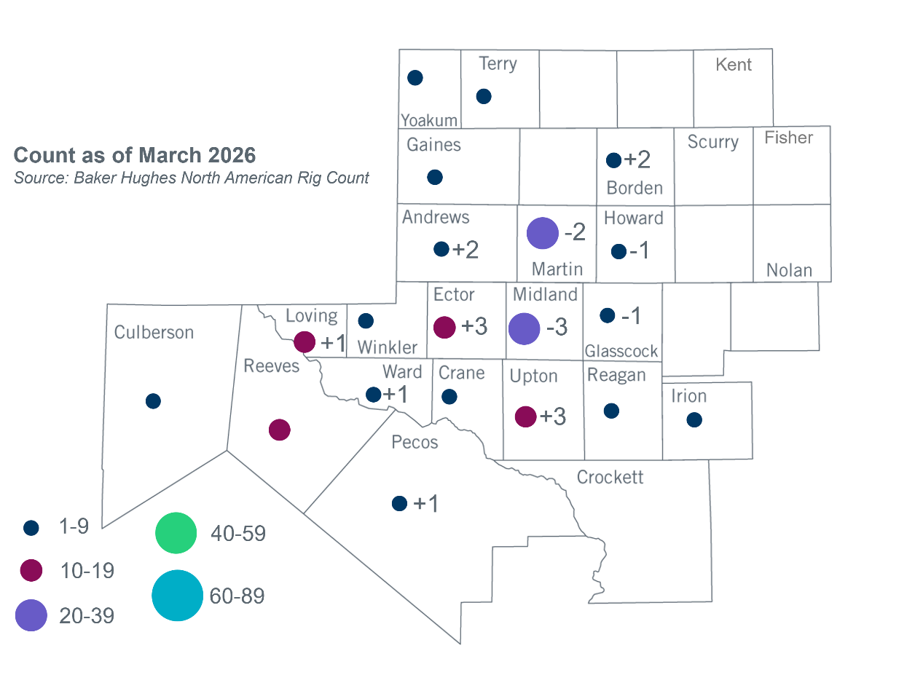
Permian Basin Oil Rig Count

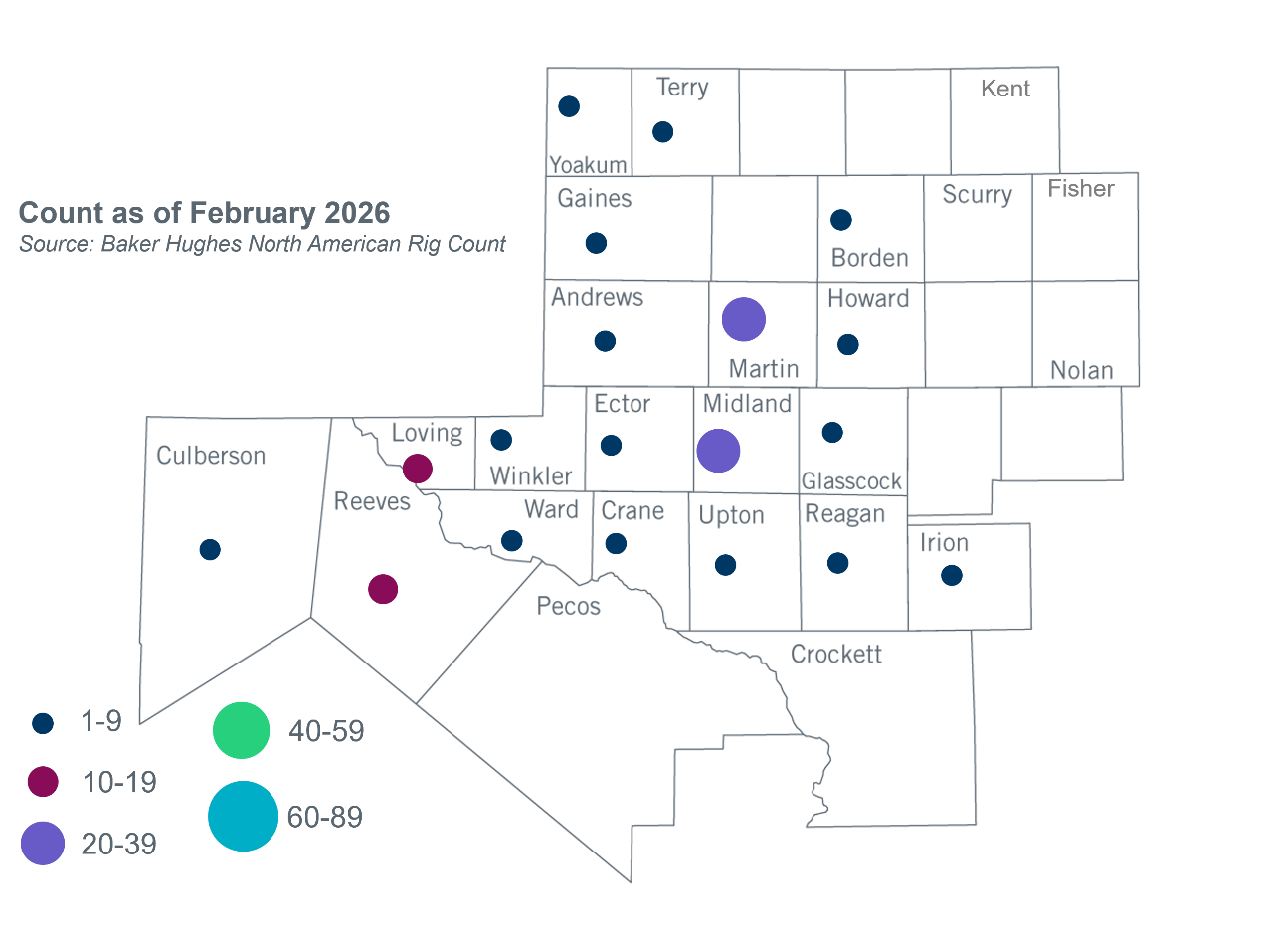

Other Notable Activities

None

Based on the Total Project Estimated Cost for all future projects listed in the Transmission Project Information and Tracking (TPIT) report. TPIT is updated three times each year based on information TSPs provide in Model on Demand (MOD) as specified in the ERCOT Steady State Working Group Procedure Manual. The latest TPIT is available at https://www.ercot.com/gridinfo/planning.
+/- symbol indicates the increase or decrease from the previous month in oil rigs present in each county. There are 144 rigs, including an increase of 6 oil rigs, in the Permian Basin from February to March.

