Screenshots for Other MT Subtypes 2025(2)
Canel w/Approval
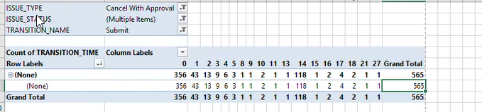
63% are completed same day
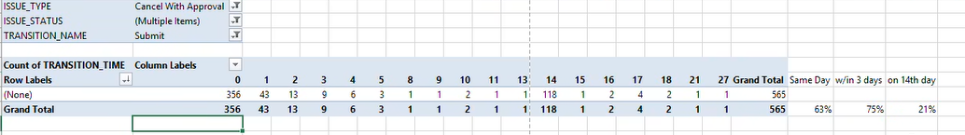
REP submissions
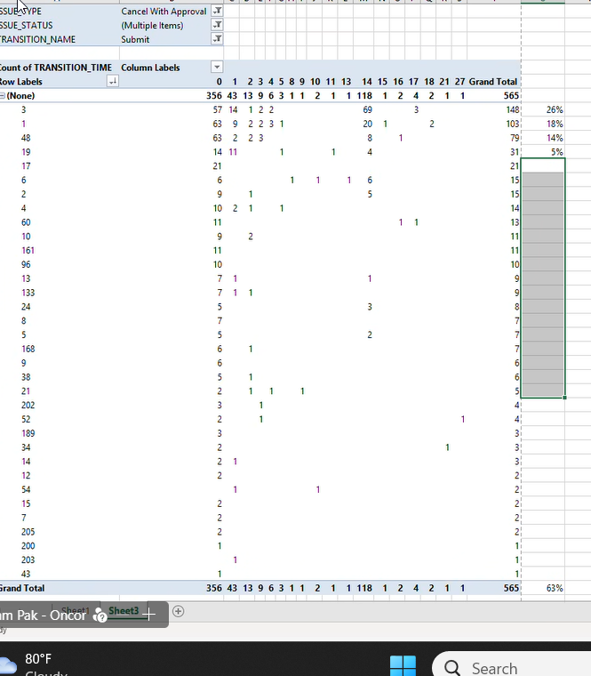

Reasons for unable to cancel
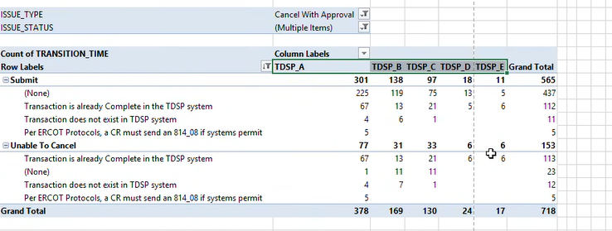
By REP
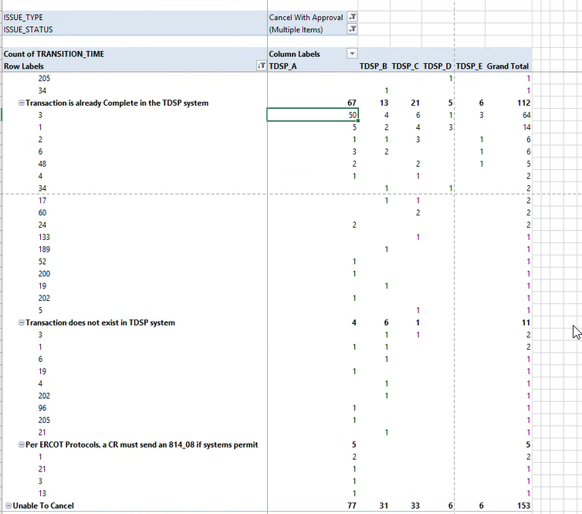

% unable to cancel by REP

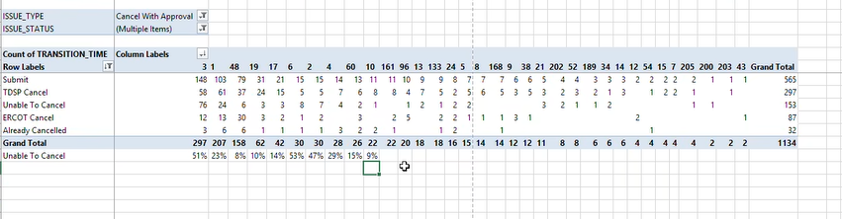
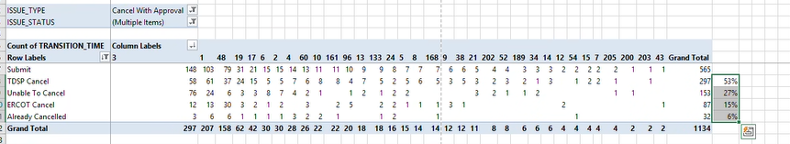
Submission timing by month
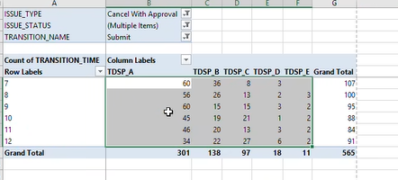

Missing Enrollment Transactions
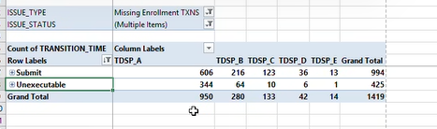
425/994 is unexecutable = 43%
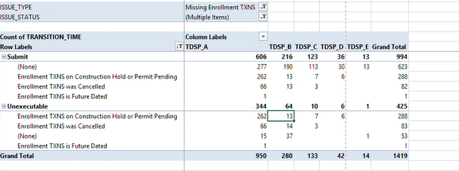

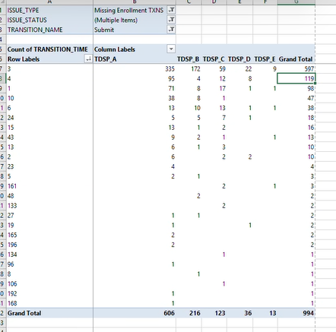

REP unexecutable reasons
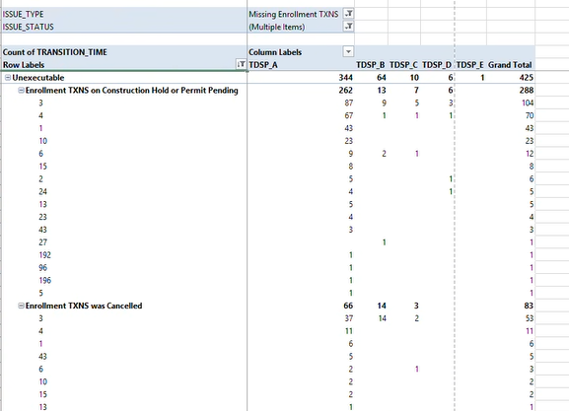

Timing
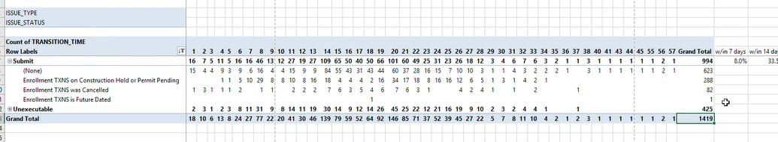

Meter Cycle Change Requests
Overall executed/unexecuted
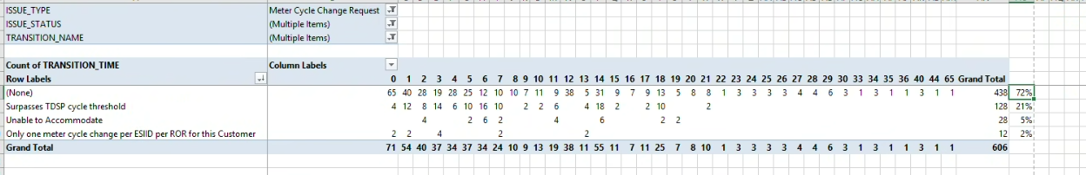
Timing to complete
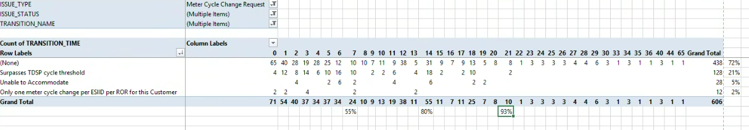
By TDSP & unexecutable reason
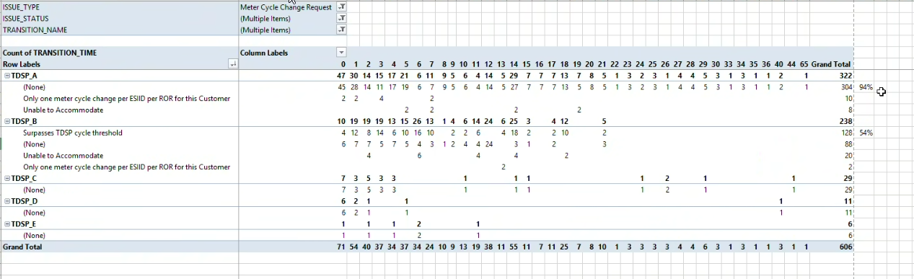
By REP – who is submitting?
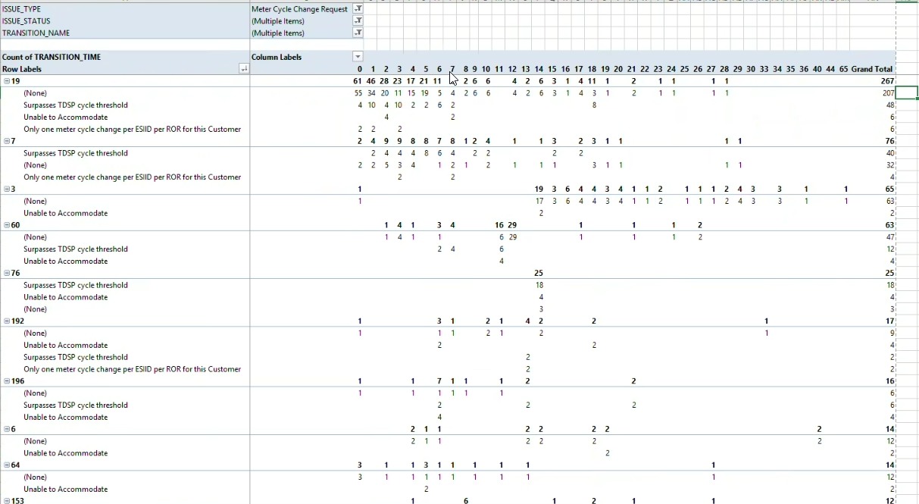
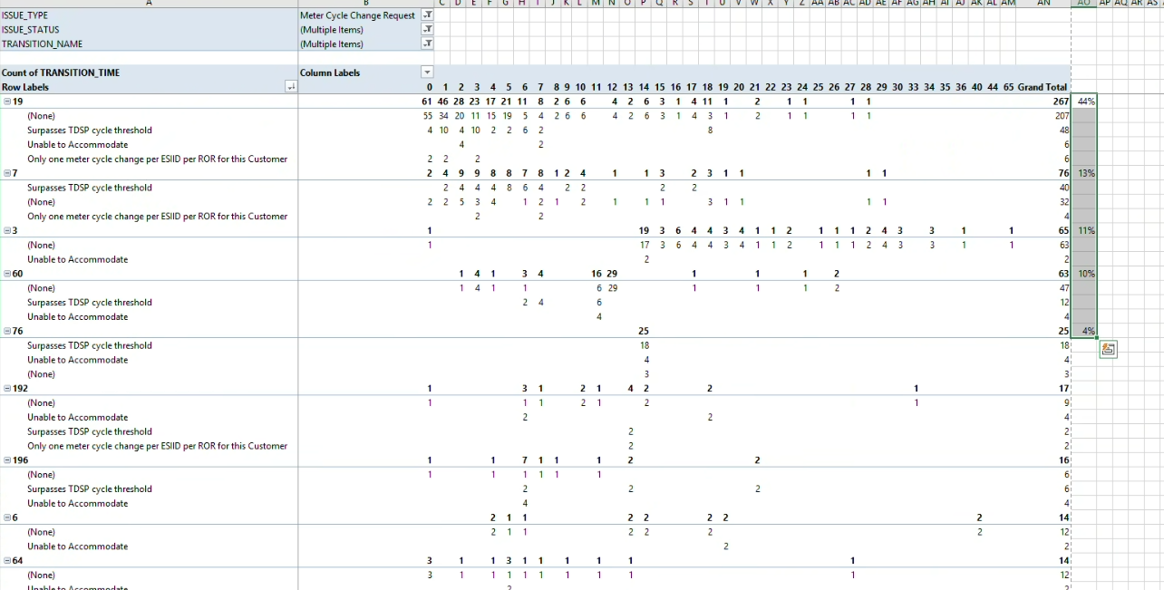

Usage & Billing – Dispute
Total 5314 – unexec is included in the submit # - do not double count
New attribute on changes expected
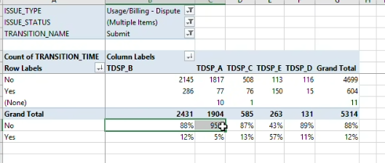

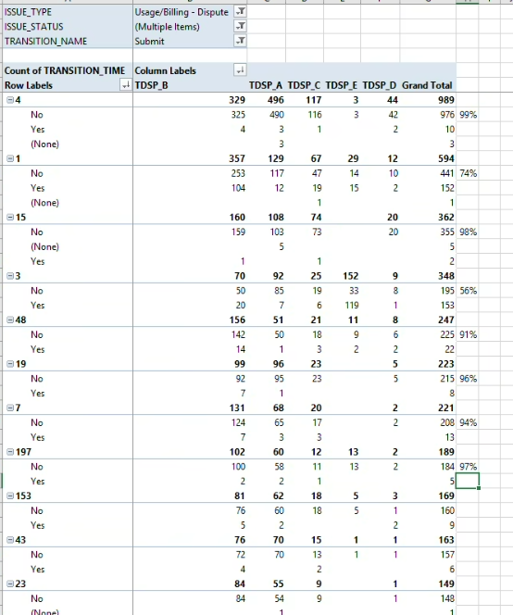

Complete and Unexecuted – 40% unexecuted
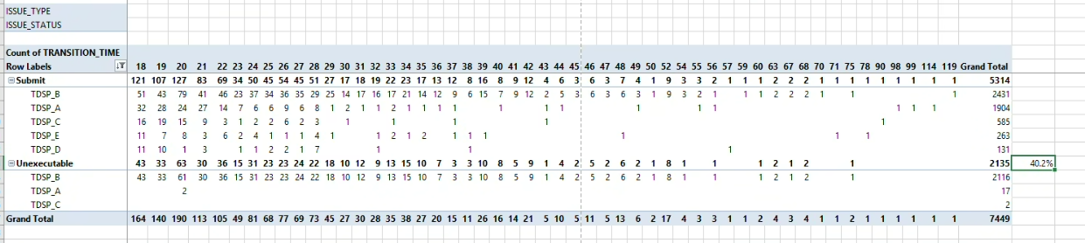
Submitting REP
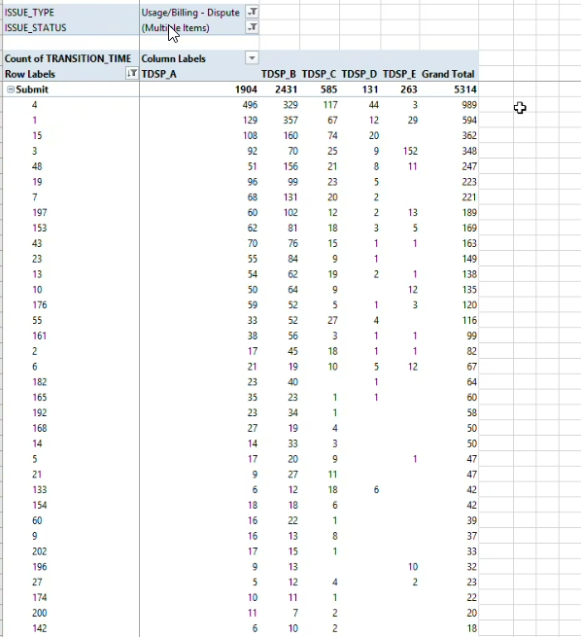
Unexecutable reason
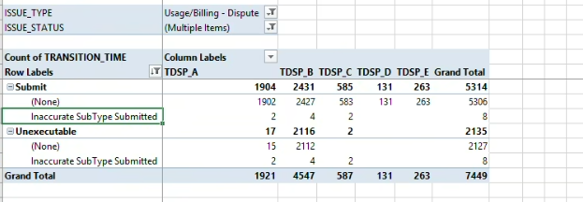
Timing to complete
Timing falls off after 21 days
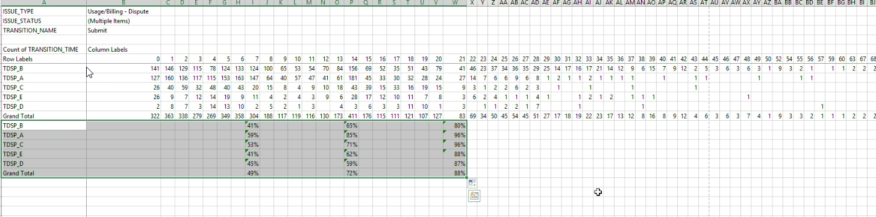

Usage & Billing – Missing
Total is 5486 – do not double count the unexec in total
Unexecuted
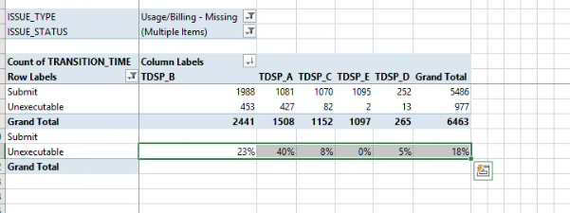
REPs submitting and unexecuted
Top 10 REPs represent 90% of total submitted
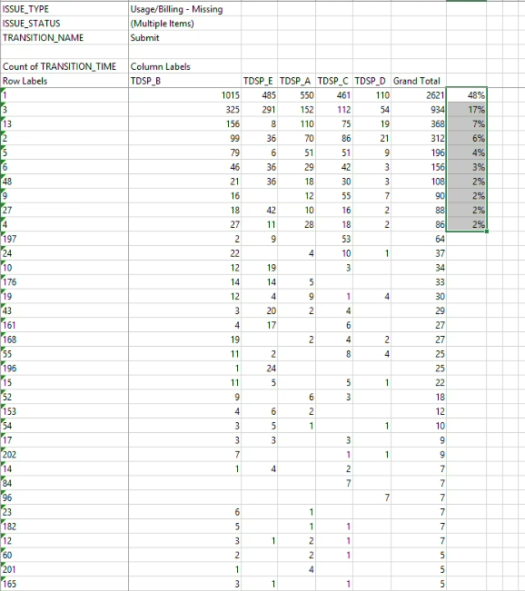
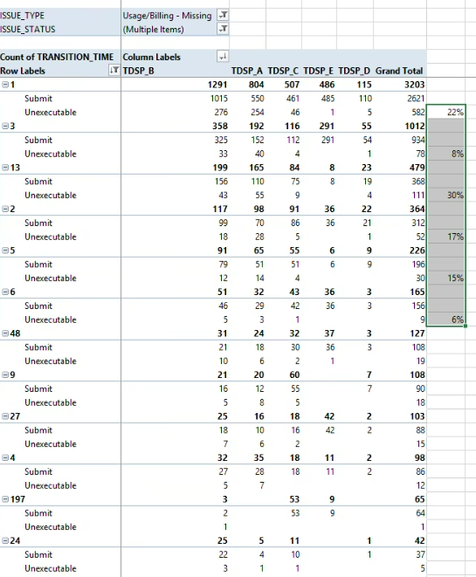

Unexecutable reasons by REP
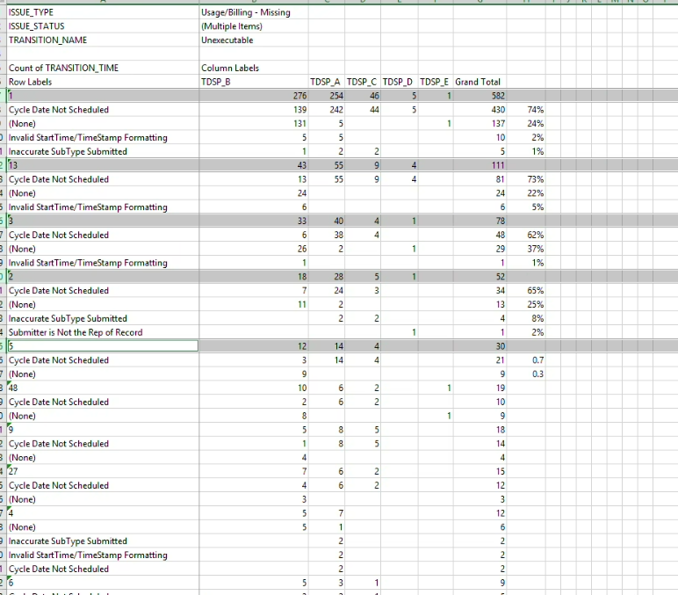
Overall unexecutable reason
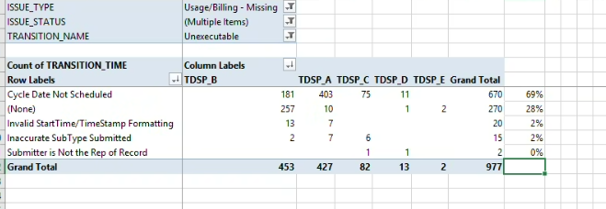

Timing
