TEXAS SET/LP Working Group
2/24/26
Attendees
Kyle Patrick - NRG | Sheri Wiegand- Vistra | Stephen Wilson - Vistra
Vaibhav Parekh- New Proj | Steve Pliler - Vistra | Paul Yockey - ERCOT
Viviana Valdez-LPL | Kathy Scott - CenterPoint | Sarah Hesselmeyer - ERCOT
Robert Bevill - TNMP | Rita Cardenas - AEP | Kathryn Thurman - ERCOT
Gary Walcott - TNMP | Martisa - LPL | Sylvia Garcia - AEP
Elizabeth Morales - ERCOT | Carrie Rohrer - Big Data Energy | Grace G- CimView
Sam Pak - Oncor | Frank Nunez - Vertex One | William Butler - LP&L
Bill Snyder - AEP | Toney Gutierrez - AEP | Dolores Villareal - AEP
Bonnie Trevino - AEP | Brandon Korte - Constellation | Garrett Hodge - AEP
Amar Khalifeh - ERCOT | Nathan Gonzales - ERCOT | Joe Lindsay - Systrends
Simon Ahn - ERCOT | Nick Reedy - CimView | Kim Wall - Hansen
Michael Winegeart - LP&L
Matheus Souza - Grid Monitor | Laura Gomez - LP&L

2. SET/LP Website Updates
EM – No updates right now. Waiting for feedback about putting the links on the website. Wilson noted some links are there as of this morning. Sam there a couple of other tweaks ERCOT is “while the hood is up”. Elizabeth confirmed nothing is needed from the WG to finalize the work. Kathryn noted a non-working link which Elizabeth added to the to-do list.
Sam said on the LP/SET landing page, he thought moving the Load Profiling Guide to the bottom section would be better grouping. Move RMG to the top “On this site” section.

Paul Yockey Flight Update – Today is Day 2. 1st day was bumpy but they are nearly caught up, just two transactions left. On schedule to complete on 3/6.
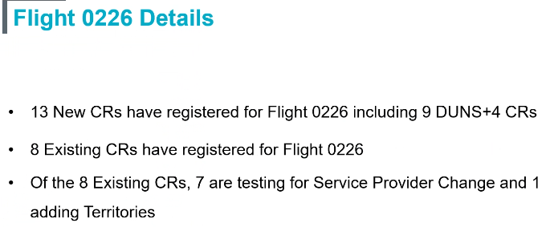
3. CNP System Updates
KS – Migration will not occur until mid-March. The stacking logic item to prevent “leap-frogging” is also targeted for mid-March. The PMVI is now implemented. REP notification of CC re-energization on 650s is also in place. Kathy also advised the 3/1 outage is a “midnight outage”; safety nets s/b emailed to CNP REP Relations Team/liaison.
4. TMTP RMGRR Review
KP – Last meeting the thought was to add sections 6 & 7 in the appendix. The ERCOT stance was subsequently fluid and advised there are two options as a possibility although further consultation in ongoing within ERCOT. Will probably not be an appendix document but rather an expanded document. We should know the direction prior to the 3/24 meeting, although the document will likely be unavailable. Brittany is complimentary of the working group’s level of effort on this item.
SW: Just to clarify, the two options are putting TMTP as a new section in either Retail Market Guide or Protocols? KP: Yes.
5. 2026 AV Kickoff
MISSED
6. LPGRR Review
Sam – Converting Decision Tree to Word from Excel. A small group of around six people have plowed through a good amount of the conversion work. The group will meet on 3/10. Sam invited interested parties to reach out to attend. We’ve taken a 2-stage approach. The document is complex. 1st stage – Review the formatting and minor tweaks for submission to RMS by June. 2nd stage – Continue to review complex changes like methodology for submission in the later part of 2026.
7. Goals and Accomplishments
Sam – New text on the document is blue. KP – I took the 2025 boilerplate goals and updated as needed. Should the working group procedures continue to exist? SP – I would like to retain a reference to the procedures, as it served a purpose for people unfamiliar with ERCOT working group procedures. Sheri – The information available in the protocols, although more generic.

Other Business
Letter of Authorization – SW: Are the TDSPs receiving accurate LOAs for usage requests? Sam: Nothing noted, no issues. Kathy: Since it is automated in CRIP, we have not heard about any issues.
LP&L returned data should be in the same format. – Michael: We are more demanding in regard to LOAs, mainly due to broker issues. I want to see the LOA match the market example. I have not had a chance to discuss with our counsel the Calpine concerns; we may have been too stringent in that example. We can show more leniency with the check box; I advised the team if the customer signature is there, the box does not need to be checked. If it is a broker signature, the box should be checked.

