NPRR Number | 1310 | NPRR Title | Dispatchable Reliability Reserve Service Plus Energy Storage Resource Participation and Release Factor
Date |  | March 6, 2026
Submitter’s Information
Name |  | Caitlin Smith / Bob Helton
E-mail Address |  | Caitlin.Smith@jupiterpower.io / Robert.Helton@engie.com
Company |  | Jupiter Power LLC / Engie North America (“Joint Commenters”)
Phone Number
Cell Number |  | 832-326-1238 / 832-435-7815
Market Segment |  | Independent Generator

Comments
**These comments are identical to the comments filed in NPRR1309 by Joint Commenters on March 6, 2026**
Jupiter Power LLC and Engie North America (“Joint Commenters”) appreciate the opportunity to submit these comments to Nodal Protocol Revision Request (NPRR) 1309 ahead of discussions regarding both NPRR1309 and NPRR1310 at the TAC DRRS Workshop on March 9th, and the Protocol Revision Subcommittee meeting on March 11th.
The Technical Advisory Committee has already held two workshops during which there were detailed discussions on NPRR1309 and NPRR1310, and Joint Commenters previously submitted comments on January 30, regarding the inclusion of ESRs in NPRR1309. Ahead of discussion at the February 4th DRRS Workshop, there were four sets of comments filed (in addition to Joint Commenters’ comments) in favor of ESR inclusion in DRRS. Since that workshop (through March 6th), an additional three sets of comments have been filed supporting inclusion of ESRs in NPRR1309 as well as five sets of comments in NPRR1310.
Consistent with both the statutory framework and ERCOT’s established market design approach, eligibility under DRRS should be determined by whether a resource can meet the statutory duration, availability, and dispatchability requirements, rather than by resource technology type.
The Joint Commenters request now that the PRS vote to recommend approval of NPRR 1309 as amended by the January 30 Joint Commenters’ comments at the March 11 PRS meeting.
These comments additionally respond to stakeholder questions in ERCOT’s comments to NPRR1310 on February 27, 2026, as well as TCPA’s comments filed to NPRR1309 on March 2, 2026.
- ERCOT Question One -- Public Utility Regulatory Act (PURA) § 39.159(d)(2)(A) states that the criteria for resource participation [in DRRS] must require a resource to: “be capable of running for at least four hours at the resource’s high sustained limit.” If ESRs were to participate in DRRS, how should that statutory reference to High Sustained Limit (HSL) be interpreted for ESRs’ participation in DRRS? Please also describe the pros and cons to the ERCOT System of your interpretation compared to the pros and cons if an opposing interpretation were adopted.
Response to ERCOT Question One

“High Sustained Limit” (HSL) is a defined term in Section 2 of the ERCOT protocols and is a long know and used operational parameter:

High Sustained Limit (HSL)

High Sustained Limit (HSL) for an Energy Storage Resource (ESR)
The limit established by the Qualified Scheduling Entity (QSE), expressed as a MW value that may be less than, equal to, or greater than zero, continuously updated in Real-Time. A positive HSL for an ESR describes the maximum sustained energy discharging capability of the ESR. A negative HSL for an ESR describes the minimum temporary energy charging capability of the ESR.

High Sustained Limit (HSL) for a Generation Resource
The limit established by the Qualified Scheduling Entity (QSE), continuously updated in Real-Time, that describes the maximum sustained energy production capability of the Resource.
Both “high sustained limit” and “nameplate capacity” are technical terms with well-established definitions, and the statute uses the term “high sustained limit” without qualification or modification. Superimposing concepts such as nameplate that are not present in the plain language of the statute is inconsistent with the statute regarding resource qualification.
Further, the substantive importance of the parameter of HSL is to inform ERCOT of the actual output limit of a facility, at any given time, and is adjusted as needed. This adjustment does not have an adverse effect on operational reliability as it informs ERCOT of the resources available output.
Reading the statute in a way that comports with the plain language of the statute offers numerous advantages:
- Cost to Consumers: expanding the supply-side participation in DRRS beyond the small universe of resources with both ≥4-hour duration at nameplate and a time of 2 hours from deployment to being online, increases competition, which has a positive effect on the liquidity and overall cost to consumers.
- Dispatchable Flexibility: ESRs are uniquely well-suited to meet the statute’s goal of providing “dispatchable flexibility to address inter-hour operational challenges,” as their response time is not only sub-hour but sub-second.
- Technology-Neutrality: it evaluates all resources by the same functional criterion (sustained output for four hours) without structurally favoring any one type of resource over another, consistent with qualifications for other ERCOT ancillary services.
- Operational Reliability: Consistency with ERCOT's general approach of letting resources offer into markets at their actual operational capabilities rather than nameplate specifications.

- ERCOT Question Two -- If the reference to HSL in PURA § 39.159(d)(2)(A) were interpreted to mean an ESR’s nameplate HSL (e.g., that a 100 megawatt (MW) / 100 megawatt hour (MWh) ESR is not permitted under that interpretation to adjust its HSL down such that a one-hour ESR can operate as a four-hour ESR), would DRRS participation likely provide sufficient incentive for ESR developers to build longer, four-hour-plus duration ESRs in the ERCOT Region (e.g., a 100 MW / 400 MWh ESR)? If your response depends on what the value of the DRRS Ancillary Service Demand Curve (ASDC) is, please describe what value would be appropriate to help to provide such incentives.

Response to ERCOT Question Two

Jupiter and Engie believe that the focus of DRRS design should remain the deliverability of operational flexibility to the ERCOT system to respond to forecast errors and forced outages and not on market incentives to ensure resource adequacy. The resource adequacy issues should be reserved for the Reliability Standard review that is currently underway. Further, there are a number of variables unrelated to ancillary service market signals, including effects on forward markets, supply chain costs and regulatory certainty, that contribute to incentivizing investment decisions.

- ERCOT Question Three - PURA § 39.159(d)(2)(B) states another criterion for participation in DRRS requiring a resource to “be online and dispatchable not more than two hours after being called on for deployment.” Should subsections (d)(2)(A) and (B) be read together such that a Resource is only qualified to provide DRRS at the amount of MW that it can ramp to within two hours and then sustain for at least four hours?

Response to ERCOT Question Three

Joint Commenters Jupiter and Engie have no response to question three at this time.

- ERCOT Question Four -- PURA § 39.159(e) states that ERCOT “may require a resource to be capable of running for more than four hours as [ERCOT] determines is needed.” Should DRRS’s duration requirement be extended beyond four hours, for instance to eight hours, twelve hours, or even longer? Please explain the operational or reliability-related reasons that the DRRS duration should or should not be extended as well as the likely financial impacts of such a longer duration requirement on the current ESR fleet and how that longer duration requirement would impact incentives for future investments in the ESR fleet.

Response to ERCOT Question Four
PURA § 39.159(e) states that ERCOT "may require a resource to be capable of running for more than four hours as [ERCOT] determines is needed." Both operative clauses matter. "May" grants discretionary authority and "as ERCOT determines is needed" conditions any extension on an affirmative operational determination by ERCOT itself, grounded in system need. Before any extension is adopted, ERCOT is required to articulate the specific operational or reliability basis for its determination that extended duration is needed, supported by evidence from ERCOT operations. At present, Jupiter and Engie are aware of no such analysis and no such determination.

Nor do Joint Commenters believe that the analysis offered by TCPA in support of longer duration requirements supports such action. First, DRRS is an ancillary service intended to address “dispatchable flexibility to address inter-hour operational challenges” due to forecast errors or forced outages. A multi-day winter reserve product is an entirely different concept. If the perceived problem is a lack of reserves during Winter, TCPA should advocate for a larger quantity of DRRS to be procured in Winter. But more importantly, TCPA’s argument presents only the duration of recent winter weather events without examining the levels of reserves during those events. Except for Winter Storm Uri, the root causes of which have been significantly addressed through enhanced weatherization of resources, all other winter events show substantial available Physical Responsive Capability (PRC) throughout the events, as summarized below:

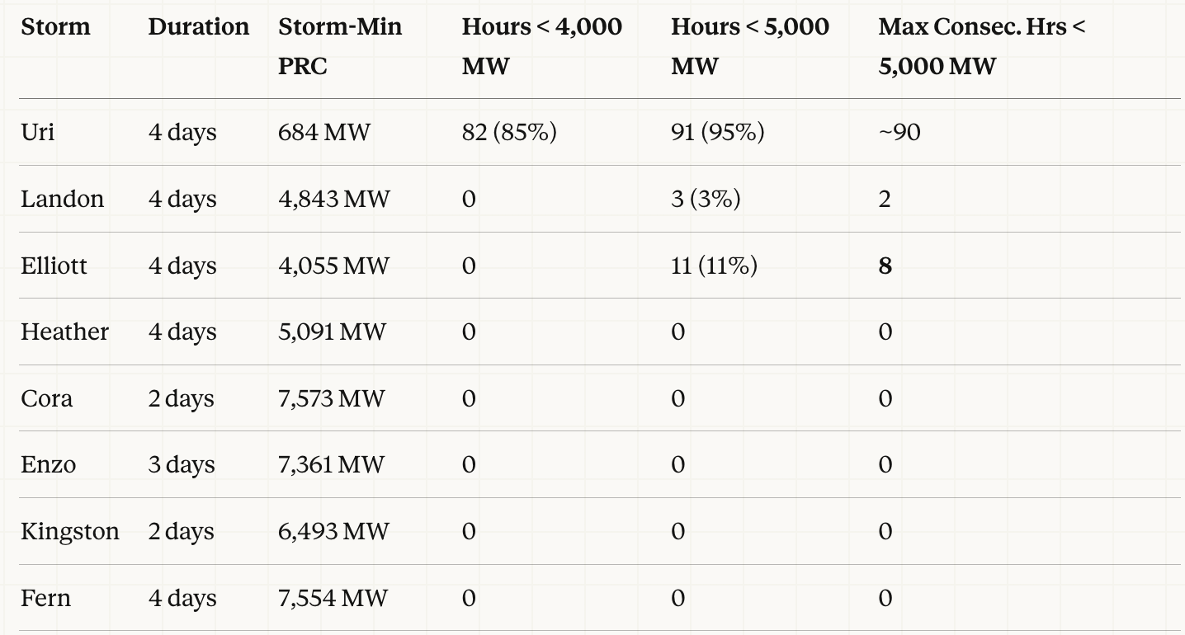

The appropriate duration standard for DRRS is one that addresses the actual distribution of uncertainty events ERCOT has experienced, which ERCOT’s own analysis of historical Non-Spin deployment record confirms is concentrated at four hours or less. See AS Duration Under RTC: ERCOT Recommendation (March 25, 2025). Using a duration requirement that would exclude the majority of currently operating ESRs in ERCOT from a product they can meaningfully support would be both unnecessarily costly and inefficient.
Jupiter and ENGIE recommend that ERCOT retain the four-hour duration requirement, design the ASDC to reflect the full event duration distribution as supported by analysis, and exercise its § 39.159(e) discretionary authority only if and when operational data demonstrates that the existing fleet, ASDC-driven market signals, and portfolio dispatch across the qualifying resource pool are insufficient to address extended events reliably based on observed operational outcomes.
Based on the foregoing, Joint Commenters request that the PRS vote to endorse NPRR1309 as amended by Joint Commenters’ January 30 comments.

Revised Cover Page Language

None.

Revised Proposed Protocol Language

None.

Under RTC+B, the share of each AS product a battery can qualify for is now formally linked to its energy-to-power ratio. This is a change from the prior market where qualification was based on the registered HSL without this duration adjustment. It directly addresses TCPA's concern that "awarding DRRS based on instantaneous HSL rather than sustained capability can overstate ESR deliverability" as the RTC+B framework builds the duration constraint into the procurement, not just the qualification.

