NPRR Number | 1310 | NPRR Title | Dispatchable Reliability Reserve Service Plus Energy Storage Resource Participation and Release Factor
Date |  | March 5, 2026
Submitter’s Information
Name |  | Shams Siddiqi
E-mail Address |  | shams@crescentpower.net
Company |  | Hunt Energy Network
Phone Number |  | 512-619-3532
Cell Number |  | 512-619-3532
Market Segment |  | Independent Power Marketer (IPM)

Comments
Hunt Energy Network (HEN) submits these comments to Nodal Protocol Revision Request (NPRR) 1310 in response to the request in 2/27/26 ERCOT comments. The impetus for developing Dispatchable Reliability Reserve Service (DRRS) comes from Public Utility Regulatory Act (PURA) §39.159(d)-(e):
(d) The commission shall require the independent organization certified under Section 39.151 for the ERCOT power region to develop and implement an ancillary services program to procure dispatchable reliability reserve services on a day-ahead and real-time basis to account for market uncertainty. Under the required program, the independent organization shall:
- determine the quantity of services necessary based on historical variations in generation availability for each season based on a targeted reliability standard or goal, including intermittency of non-dispatchable generation facilities and forced outage rates, for dispatchable generation facilities;
- develop criteria for resource participation that require a resource to:
  - be capable of running for at least four hours at the resource's high sustained limit;
  - be online and dispatchable not more than two hours after being called on for deployment; and
  - have the dispatchable flexibility to address inter-hour operational challenges; and
- reduce the amount of reliability unit commitment by the amount of dispatchable reliability reserve services procured under this section.
(e) Notwithstanding Subsection (d)(2)(A), the independent organization certified under Section 39.151 for the ERCOT power region may require a resource to be capable of running for more than four hours as the organization determines is needed.
PURA §39.159 was primarily driven by post-Winter Storm Uri legislation (HB 1500 approved by the 88th Texas Legislature) to ensure electric grid reliability by incentivizing "dispatchable" generation.
HEN’s answers to ERCOT’s questions are based on the legislative prerogatives behind DRRS.
- Public Utility Regulatory Act (PURA) § 39.159(d)(2)(A) states that the criteria for resource participation [in DRRS] must require a resource to: “be capable of running for at least four hours at the resource’s high sustained limit.” If ESRs were to participate in DRRS, how should that statutory reference to High Sustained Limit (HSL) be interpreted for ESRs’ participation in DRRS? Please also describe the pros and cons to the ERCOT System of your interpretation compared to the pros and cons if an opposing interpretation were adopted.
The legislative impetus behind DRRS is to address the long-duration winter storm or extended scarcity event(s) by incentivizing long-duration dispatchable generation. The statutory purpose and framework of the DRRS reliability product is not about how fast a resource can respond rather than how long it can stay on. High Sustained Limit (HSL) represents the maximum MW output a resource can physically and reliably sustain under normal operating conditions and therefore reflects the resource’s true sustained operating capability rather than a product- specific operating preference. Because of the remarkably specific language in PURA requiring DRRS-qualified Resources to “be capable of running for at least four hours at the resource's high sustained limit,” the duration requirement must be evaluated against the resource’s true sustained capability as reflected by its nameplate HSL. The legislative focus is on sustained dispatchable capability during extended system stress and reliability events. There are currently a substantial number of less than 4-hour duration ESRs in the interconnection queue. Allowing a shorter duration ESR to artificially lower its true HSL to qualify to provide DRRS while simultaneously allowing it to qualify to provide other Ancillary Services and Energy using its higher nameplate HSL is inappropriate and is akin to manipulating the system. Resources should not be allowed to manipulate HSL in this manner, since HSL manipulation is typically associated with physical withholding of capacity in the Real-Time Market (RTM).
- If the reference to HSL in PURA § 39.159(d)(2)(A) were interpreted to mean an ESR’s nameplate HSL (e.g., that a 100 megawatt (MW) / 100 megawatt hour (MWh) ESR is not permitted under that interpretation to adjust its HSL down such that a one-hour ESR can operate as a four-hour ESR), would DRRS participation likely provide sufficient incentive for ESR developers to build longer, four-hour-plus duration ESRs in the ERCOT Region (e.g., a 100 MW / 400 MWh ESR)? If your response depends on what the value of the DRRS Ancillary Service Demand Curve (ASDC) is, please describe what value would be appropriate to help to provide such incentives.
Yes. Interpreting PURA §39.159(d)(2)(A) to require the four-hour duration requirement be measured at a resource’s nameplate HSL would create a meaningful investment signal for the development of longer-duration ESRs for DRRS participation. If shorter duration ESRs are permitted to artificially lower their HSL solely for the purpose of qualifying for DRRS, those resources would likely satisfy the majority of the DRRS procurement requirement because such assets are already economically attractive investments even without DRRS revenues. Allowing short-duration ESRs to qualify in this manner would therefore weaken the investment signal for both longer duration ESRs and thermal resources capable of sustained operation during extended reliability events. Because DRRS is intended to support reliability during extended system stress events and reduce reliance on Reliability Unit Commitment (RUC), the resources providing the service should be capable of sustaining output over timeframes consistent with those events.
If the DRRS Ancillary Service Demand Curve (ASDC) is designed to recover net Cost of New Entry (CONE) of thermal generation and four-hour ESRs are allowed to provide DRRS, it’s likely that four-hour ESRs would crowd out thermal generation. This is problematic as the statutory intent of DRRS is to address extended reliability events such severe winter storms, that are inherently a resource adequacy problem; not an instantaneous capacity problem. Therefore, the relevant reliability attribute for duration is how long a resource can sustain output; not simply how quickly it can respond. To address the resource adequacy goal of DRRS, ESRs should be required to have a minimum of 8- to 12-hour duration.
- PURA § 39.159(d)(2)(B) states another criterion for participation in DRRS requiring a resource to “be online and dispatchable not more than two hours after being called on for deployment.” Should subsections (d)(2)(A) and (B) be read together such that a Resource is only qualified to provide DRRS at the amount of MW that it can ramp to within two hours and then sustain for at least four hours?
No. Subsections (d) (2) (A) and (d) (2) (B) establish separate qualification requirements rather than a combined ramp and duration standard. Therefore, it does not make sense to read (A) and (B) together. Under PURA §39.159(d)(2), a DRRS-qualified resource must (i) “be online and dispatchable not more than two hours after being called on for deployment” and, separately, (ii) “be capable of running for at least four hours at the resource's high sustained limit.” Read together, these provisions reflect the legislature's intent to incentivize dispatchable resources that can be made available to the system within a relatively short timeframe and then sustain output long enough to contribute meaningfully during extended reliability events. This interpretation is also consistent with the statute’s directive that DRRS procurement should “reduce the amount of reliability unit commitment by the amount of dispatchable reliability reserve services procured”. During extended system stress events, such as severe winter storms, RUC is often used to bring online resources capable of sustaining output for many hours. For DRRS capacity to meaningfully offset these commitments on a MW for MW basis, the resources providing DRRS must likewise be capable of sustained operation over comparable timeframes. From an operational perspective, this highlights the distinction between instantaneous capacity and sustained energy capability. A resource that can respond quickly but cannot sustain output over the duration of the reliability event may still provide valuable system services, but it may not fully substitute for the dispatchable capability RUC is intended to secure. As a result, the longer duration capability potentially in the range of 8- to 12- hours (or longer) would better align DRRS participation with the statute’s objective of addressing resource adequacy during extended reliability events.
Additionally, the statute aims to incentivize dispatchable Resources with no longer than 2-hour cold start times that can run at least four hours at their HSLs, which implies that Resources with greater than 2-hour cold start times should not be qualified to provide DRRS, even if such Resources are online. Allowing any dispatchable Resource that is online to provide DRRS will create the perverse incentive for Resources with longer than 2-hour start times to self-commit to receive DRRS payments even though such commitment would be highly inefficient and significantly distort market prices as well as thwart the legislative goal of incentivizing dispatchable Resources with no longer than 2-hour start times.
- PURA § 39.159(e) states that ERCOT “may require a resource to be capable of running for more than four hours as [ERCOT] determines is needed.” Should DRRS’s duration requirement be extended beyond four hours, for instance to eight hours, twelve hours, or even longer? Please explain the operational or reliability-related reasons that the DRRS duration should or should not be extended as well as the likely financial impacts of such a longer duration requirement on the current ESR fleet and how that longer duration requirement would impact incentives for future investments in the ESR fleet.
Yes. PURA §39.159(e) expressly authorizes ERCOT to require resources Participating in DRRS to be capable of sustaining output for more than four hours when necessary to support system reliability. Operational reliability consideration suggests that a longer duration requirement potentially in the range of 8- to 12- hours would better align DRRS with reliability risk facing the ERCOT system. The PowerGem presentation at the January 23, 2026, Supply Adequacy Working Group (SAWG) titled “Reliability Standards Trial Assessment Results” shows the following Expected Unserved Energy (EUE) for months 1-12 of 2026 and hours 1-24 of each month:
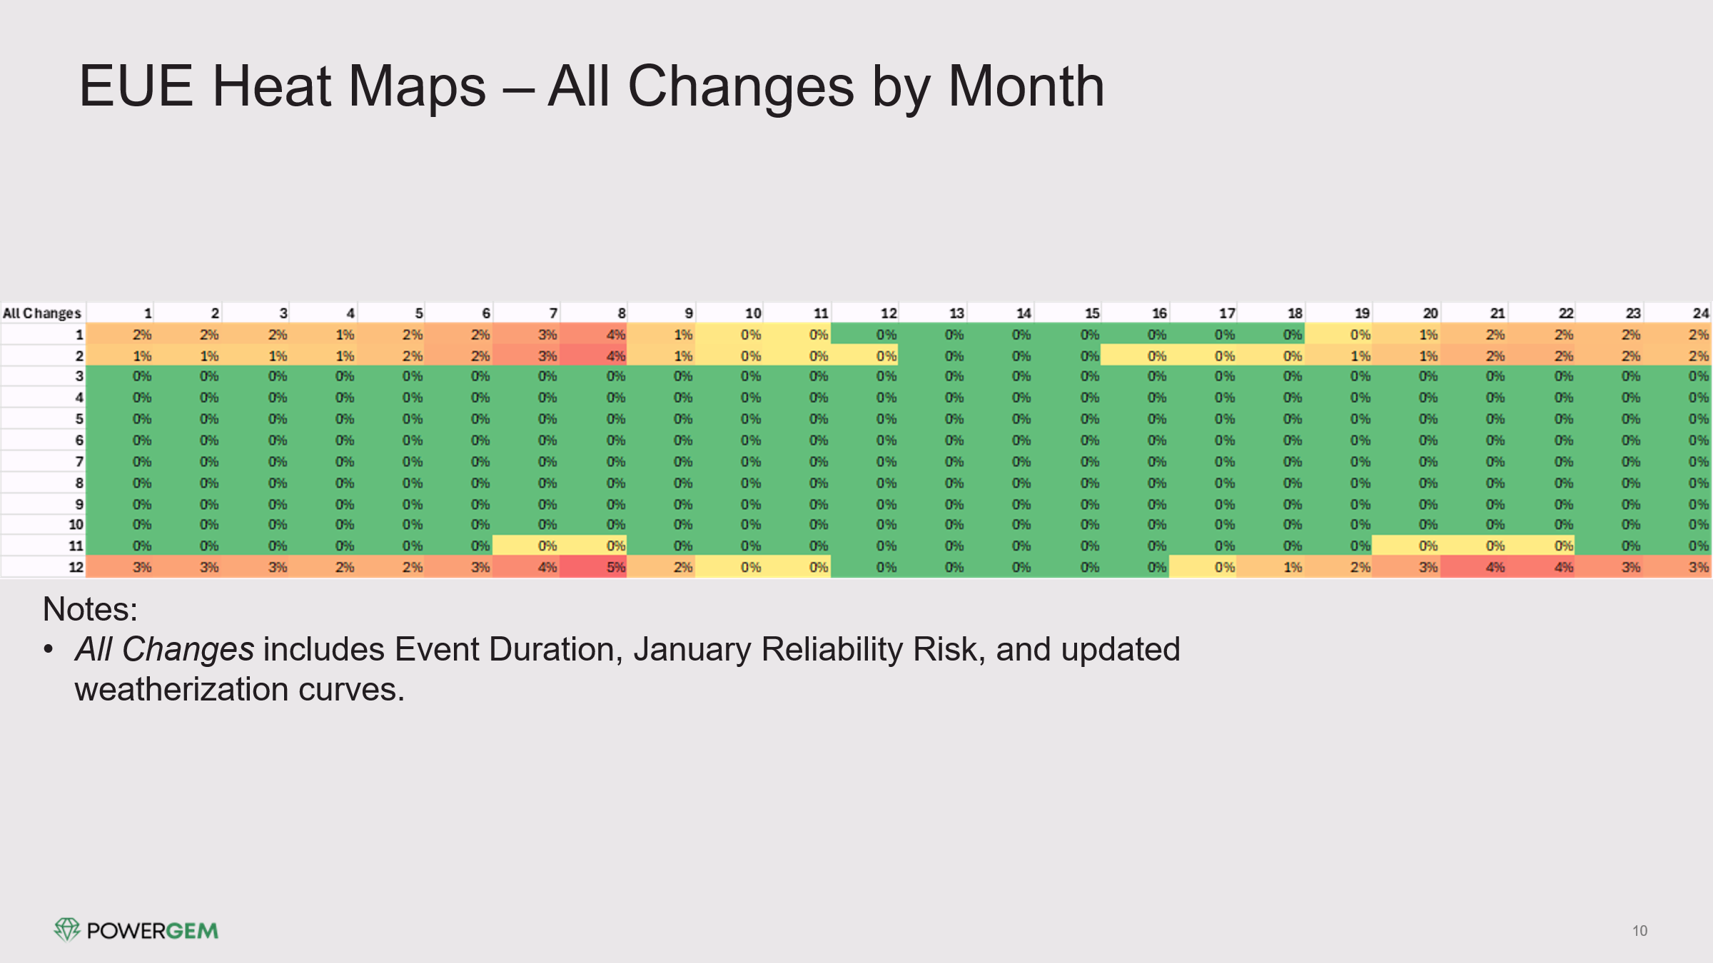

As shown in the chart above, the greatest reliability risk and thus dispatchable Resource need in the ERCOT system is during the winter months (December to February). This risk is tied to very infrequent yet prolonged and incredibly costly exposure to winter storm events, such as Winter Storm Uri in February 2021 with its low freezing temperatures, cloud cover and limited wind generation. Because such events occur infrequently, market revenues during most winter periods are generally insufficient to support investment in dispatchable Resources capable of sustaining output over the full duration of these events. As a result, the market tends to favor resources that address shorter duration reliability risks, such as evening solar ramp periods during non-winter months when system demand remains high. In those conditions, shorter duration resources such as one- and two-hour ESRs can provide valuable system flexibility and already attract significant investment within the ERCOT market; for that reason, no additional DRRS incentive is required.

Consistent with this operational reality, HEN believes a minimum of 8- to 12-hour DRRS duration requirement would better align the product with the reliability risk identified in the PowerGem analysis. Longer-duration capability would ensure that DRRS capacity can meaningfully contribute during extended reliability events and support the reliability standard during winter storm conditions.

This conclusion is further supported by the statutory requirement that DRRS procurement should “reduce the amount of reliability unit commitment by the amount of dispatchable reliability reserve services procured” during severe winter grid stress events. Again, RUC is often used to bring online resources capable of sustained multi- hour operation. For DRRS capacity to meaningfully offset those commitments on a MW for MW basis, the resources providing DRRS must likewise be capable of sustaining output for comparable durations which unequivocally supports an 8- to 12-hour duration (or longer) to qualify for DRRS.

In addition to the DRRS qualifications above, DRRS design should reflect the market design principles identified in the Aurora Energy Research study. Specifically, that DRRS ASDCs should be calibrated such that a dispatchable Resource can expect to recover its net-CONE (defined as CONE minus net revenues the dispatchable Resource earns by providing other services in the ERCOT market) over the long term.

Additionally, DRRS procurement quantities and pricing should be concentrated during hours of highest system stress. These design features were central to Aurora’s conclusion that “an enhanced version of DRRS that supports resource adequacy provides the greatest reliability benefit at the lowest cost.”

Revised Cover Page Language
None.
Revised Proposed Protocol Language
None.

https://www.ercot.com/files/docs/2026/01/23/2__SAWG_Trial_Simulation_Results_20260123.pptx
Assessment of Resource Adequacy Needs in ERCOT and Impact of Market Design Changes, November 10, 2025.

