RMTTF Meeting
February 18, 2026
1:30 PM

This meeting is being held in person and via WebEx.

Oncor Electric Delivery
1616 Woodall Rodgers Fwy. Conference room 5007
Dallas, TX 75202

Tomas is Chairing. Melinda is attendees and webex and chat and Debbie is taking notes today.
Tomas welcomed everyone and thanked Oncor for hosting and proceeded with reading the antitrust statement.
Introductions
List of attendees - * designates In person attendee
- Kathy Scott* Centerpoint
- Debbie McKeever* Oncor
- Monica Jones* Centerpoint
- Tomas Fernandez* NRG
- Melinda Earnest* AEP
- Elizabeth Morales ERCOT
- Heverton Ferreira Grid monitor
- Grace Graham Cim View
- Nick Reddy Cim View
- Art Deller ERCOT
- Viviana Valdez LP&L
- Natalie Montano AEP
- Fiza Shaikh

Meeting Agenda
Agenda was reviewed.
No questions were asked. No changes were made.
Meeting Notes
Meeting notes from the last meeting will be reviewed at the next meeting.

LMS Counts for Online Training Modules
Art provided the latest LMS Counts.
Tomas ran through each count. No questions were asked.
Was noted that Retail 101 is still doing good. A slight increase across some modules.
West Lake Drive, Taylor, TX 76574 O: 512-248-6505 | M: 512-657-9775 ‍ ‍ ‍ ‍ ‍ ‍ ‍ ‍ ‍ ‍ ‍ ‍ ‍ ‍ ‍ ‍ ‍ ‍ ‍ ‍ ‍ ‍ ‍ ‍ ‍ ‍ ‍ ‍ ‍ ‍ ‍ ‍ ‍ ‍ ‍ ‍ ‍ ‍ ‍ ‍ ‍ ‍ ‍ ‍ ‍ ‍ ‍ ‍ ‍ ‍ ‍ ‍ ‍ ‍ ‍ ‍ ‍ ‍ ‍ ‍ ‍ ‍ ‍ ‍ ‍ ‍ ‍ ‍ ‍ ‍ ‍ ‍ ‍ ‍ ‍ ‍ ‍ ‍ ‍ ‍ ‍ ‍ ‍ ‍ ‍ ‍ ‍ ‍ ‍ ‍ ‍ ‍ ‍ ‍ ‍ ‍ ‍ ‍ ‍ ‍ ‍ ‍ ‍ ‍ ‍ ‍ ‍ ‍ ‍ ‍ ‍ ‍ ‍ ‍ ‍ ‍ ‍ ‍ ‍ ‍ ‍ ‍ ‍ ‍ ‍ ‍ ‍ ‍ ‍ ‍ ‍
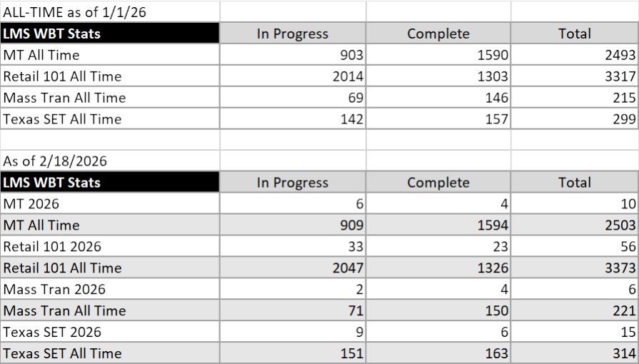
Registration number for tomorrow’s MarkeTrak part 2 training – about 30 signed up. Similar count as today. About 20+ seats remain for TX SET 5.0

MarkeTrak part 1 Training - held this morning.

Technical issues were experienced. WebEx stopped working – may have been related to bandwidth issues of hot spot being used. In any case Debbie will check to see that guest webex can be provided to each instructor.

Think at one time 33 were on the webEx.
Comments or Changes were discussed and accepted or will be discussed prior to the next review of MarkeTrak training materials.

One thing that needs to be considered. The Supplemental AMS Interval Data Extract User guide is included on the slide but couldn’t find anything except an old version dated 2011. Think a more current version may be available.

Debbie will check with ERCOT.
Should we put a link on a slide where this can be located? Also a link in the training where we reference the RMG? Currently not listed in any slide.

2026 Training Dates
Make the following date changes to our list of training and events (below).
May MarkeTrak – change dates to;
June 3rd – MarkeTrak part 1 and RMTTF in the afternoon
June 4th – MarkeTrak part 2 – morning
Instructors should attend collectively and will be at Oncor in Dallas.
Reminder! Training should not be scheduled on the day prior or day of a PUCT meeting. Also not on a subcommittee or retail WG meeting date.

2026 Schedule for RMTTF

* Designates instructors meet in person at the noted location.

February 18th 8:30 AM MarkeTrak Part1* ONCOR – DALLAS – complete
February 18th 1:30 PM RMTTF ONCOR – DALLAS - complete
February 19th 8:30 AM MarkeTrak Part 2* ONCOR - DALLAS

March 3rd 8:30 AM TX SET 5.0* CENTERPOINT – HOUSTON March 4th 9:30 AM RMTTF CENTERPOINT – HOUSTON
April 2nd 9:30 AM RMTTF – WebEx only
PLEASE NOTE THE LANGUAGE HIGHLIGHTED IN GREEN CONTAINS THE MOST CURRENT INFORMATION OF TIMES, DATES, LOCATIONS, AS WELL AS WHETHER IT IS WEBEX OR IN PERSON.
ALL LOCATIONS NOTED INCLUDE FOR MARKETRAK ARE WEBEX ONLY. INSTRUCTORS WILL MEET COLLECTIVELY AT THE LOCATION NOTED.

June 3rd 8:30 AM MarkeTrak part 1* Oncor – Dallas
June 3rd 1:30 PM RMTTF meeting Oncor - Dallas
June 4th 8:30 AM MarkeTrak part 2* Oncor - Dallas
DATES ABOVE WERE CHANGED FROM MAY 5, 6, 7 TO JUNE 3, 4
July RMTTF – no meeting
August 6th 9:30 AM RMTTF - WebEx only
September 23 8:30 AM TX SET 5.0 - WebEx only* ONCOR
WAS PREVIOUSLY NOTED AS IN PERSON – CHANGED TO WEBEX ONLY

September 24 9:30 AM RMTTF ONCOR - DALLAS

October ??? RMTTF meeting - coordinate with AEP REP Workshop
MARKETRAK TRAINING WILL BE SCHEDULED – FOR OCTOBER – DEFINITELY AND ALIGNED WITH THE AEP REP WORKSHOP DATE, CURRENTLY TBD, AS WELL AS THE RMTTF MEETING. THAT WILL BE THE 3RD AND FINAL SESSIONS OF MARKETRAK PART 1 AND 2 FOR THE YEAR.
November No RMTTF meeting
December 1st 9:30 AM RMTTF WebEx only
TX SET 5.0 Training Materials and Assignments
TX SET 5.0 – refreshed and info verified.
Instructors should bring with them to CNP prior to the start of 5.0 training on 3-3.
- Answer Key Tomas
- Black and white inventory card – regular paper Tomas
- Markers and pens Melinda
- Overview of Transaction flow Kathy
- Transaction names inventory card Kathy
- Swim lanes Kathy
- ERCOT help reference sheet Kathy
- Training Books Kathy
- Candy for tables Kathy
- Candy for winners of the game Kathy
- Process Flow Kathy
- Blue cards Kathy
- Lunch Kathy, Debbie and Melinda to order
- Final TXSET 5.0 PPT Tomas to email to presenters and Art
Post final ppt with other docs to training page Art
List of registered attendees to Kathy for CNP security Art
Room Setup - March 2nd Kathy will schedule us as needed.

TX SET 5.0 PPT – Slides per presenter…
  - Debbie slides 1 through 14
  - Kathy slides 15 through 39
  - BREAK Tomas will set up dual screens during the break – 10 minutes
  - Sheri Slide 40 through 43
      - For slide 44 – dual screen through 52 – dual screens-needed for WebEx
  - Sheri Checkpoint question
  - Monica Slide 56 through 64
  - LUNCH 45 minutes – bc of in person, could go to an hour
  - Melinda 65 through 72
  - Tomas 73 through 95
  - Kathy 96 through 100
  - BREAK 10 minutes – usually refreshments are provided at 1st afternoon break.
  - Sheri 101 through 113
  - Kat and Deb 114 through 117
  - Tomas Talk about the break and scan for survey on page 126, display QR code
  - BREAK 10 minutes
  - Tomas Group exercise is 118 – 123.
  - Tomas 123 through the end.
MarkeTrak Day 2 – Training tomorrow;
Deb to check with technology and make sure technical issues will not be experienced. All instructors have been provided a Guest Wifi to be used in the building.
Other Business:
Reminder that the next meeting will be held on March 4th in person and via WebEx in Houston at Centerpoint. Usual start time 9:30 AM. Will be a short meeting. probably review surveys if available and expect it to be noted that technical issues were experienced.
Debbie will make sure that the details are provided to ERCOT and correct on the website.
Adjourn
Meeting was adjourned at 4:35 PM

