
January 2026 ERCOT Monthly Operations Report
Reliability and Operations Subcommittee Meeting
March 5, 2026

Table of Contents
1. Report Highlights 2
2. Frequency Control 3
2.1. Frequency Events 3
2.2. ERCOT Contingency Reserve Deployments/Releases 4
2.3. Responsive Reserve Deployments/Releases 4
2.4. Load Resource Deployments 5
3. Reliability Unit Commitment 6
4. IRR, Wind, and Solar Generation as a Percent of Load 7
5. Largest Net-Load Ramps 9
6. Congestion Analysis 10
6.1. Notable Constraints 10
6.2. Generic Transmission Constraint Congestion 19
6.3. Manual Overrides 19
6.4. Congestion Costs for Calendar Year 2025 20
7. System Events 22
7.1. ERCOT Peak Load 22
7.2. Load Shed Events 22
7.3. Stability Events 22
7.4. Notable PMU Events 22
7.5. DC Tie Curtailment 22
7.6. TRE/DOE Reportable Events 23
7.7. New/Updated Constraint Management Plans 23
7.8. New/Modified/Removed RAS 23
7.9. New Procedures/Forms/Operating Bulletins 23
8. Emergency Conditions 23
8.1. OCNs 23
8.2. Advisories 24
8.3. Watches 24
8.4. Emergency Notices 24
9. Application Performance 24
9.1. TSAT/VSAT Performance Issues 24
9.2. Communication Issues 24
9.3. Market System Issues 25
10. Model Updates 25
Appendix A: Real-Time Constraints 28

Report Highlights
The unofficial ERCOT peak load for January 2026 was 75,572 MW and occurred on 1/26/2026 during hour ending 09:00, this is 1,910 MW less than the January 2025 peak demand of 77,482 MW on 1/22/2025 during hour ending 08:00.
- There were 2 frequency events.
- There were no ERCOT Contingency Reserve Service (ECRS) events.
- There were no Responsive Reserve Service (RRS) events.
- 2 Advisories due to geomagnetic disturbances of K-7 or greater levels and 2 Advisories due to geomagnetic disturbances of K-8 or greater levels .
- 2 Watches.
- 1 Emergency Notices.
- There were 54 HRUC commitments.
- The following GTCs saw congestion in January:
GTC | Days Congestion
South Texas Export Pawnee - Spruce | 15
Panhandle | 24
West Texas | 13
Nelson Sharpe - Rio Hondo | 22
Valley Export | 18
North Edinburg - Lobo | 23
South Texas Import Katoen - Lonhill | 10
South Texas Export Pawnee - Tango | 10
Treadwell | 6
Kinney | 1
Wharton | 2
South Texas Import Pawnee - Spruce | 1
South - Far West | 4

Frequency Control

Frequency Events
The ERCOT Interconnection experienced 2 frequency event.
A summary of the frequency event is provided below. The reported frequency event meets one of the following criteria: Delta Frequency is 60 mHz or greater; the MW loss is 350 MW or greater; resource trip event triggered ECRS deployment. Frequency events that have been identified as Frequency Measurable Events (FME) for purposes of BAL-001-TRE-2 analysis are highlighted in blue. When analyzing frequency events, ERCOT evaluates PMU data according to industry standards. Events with an oscillating frequency of less than 1 Hz are inter-area, while higher frequencies indicate local events. Industry standards specify that damping ratio for inter-area oscillations should be 3.0% or greater. For the frequency event listed below, the ERCOT system met these standards and transitioned well after the disturbance. In the case of negative delta frequency, the MW Loss column could refer to load loss.

Date and Time | Delta Frequency | Max/Min Frequency | Duration of Event | PMU Data |  | MW Loss | Load | IRR | Inertia
Date and Time | (Hz) | (Hz) | Duration of Event | Oscillation Mode (Hz) | Damping Ratio | MW Loss | (MW) | % | (MW-s)
1/21/2026 7:06:20 | 0.016 | 59.955 | 00:05:47 | 0.81 | 15% | 702 | 51,802 | 26% | 264,154
1/25/2026 20:37:12 | 0.022 | 59.968 | 00:05:14 | 0.61 | 7% | 445 | 73,596 | 9% | 370,498

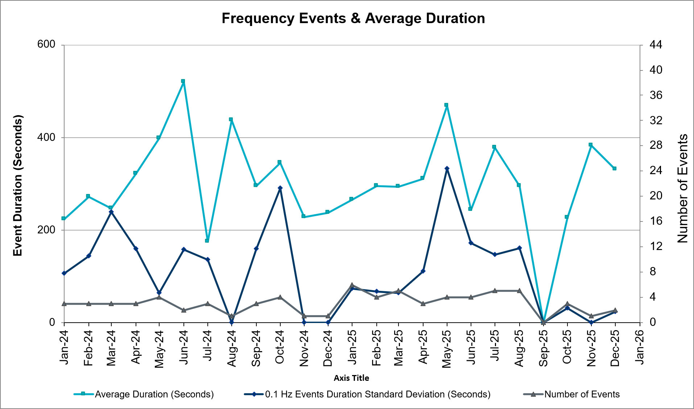
(Note: All data on this graph encompasses frequency event analysis based on BAL-001-TRE-2.)

ERCOT Contingency Reserve Deployments/Releases
There were 0 events where ERCOT Contingency Reserve MWs were released to SCED. The events highlighted in blue were related to frequency events reported in Section 2.1 above.
Date and Time Released to SCED | Date and Time Recalled | Duration of Event | Maximum MWs Released | Comments
N/A | N/A | N/A | N/A | N/A

Responsive Reserve Deployments/Releases
There were no events where Responsive Reserve MWs were released to SCED.
Date and Time Released to SCED | Date and Time Recalled | Duration of Event | Maximum MWs Released | Comments
N/A | N/A | N/A | N/A | N/A

Load Resource Deployments
Resource Location | # of Resources | Operating Day | Total # of Hours Committed | Total MWhs | Reason for Commitment

There were no Load Resources events that were controlled by an Under-Frequency Relays that deployed for an emergency event.

Reliability Unit Commitment
ERCOT reports on Reliability Unit Commitments (RUC) monthly. Commitments are reported grouped by operating day and weather zone. The total number of hours committed is the sum of the hours for all the units in the specified region. Additional information on RUC commitments can be found on the MIS secure site at Grid Generation Reliability Unit Commitment.
There were 0 DRUC commitments.
There were 54 HRUC commitments.

Resource Location | # of Resources | Operating Day | Total # of Hours Committed | Total MWhs | Reason for Commitment
FAR_WEST | 7 | January 9, 2026 | 26 | 2,644.7 | MCATMG25, Short Start
SOUTH_CENTRAL | 1 | January 24, 2026 | 6 | 2,400.0 | RMR for E_PASP
EAST, SOUTH_CENTRAL | 16 | January 25, 2026 | 30 | 15,082.4 | RMR for congestion, System Capacity
EAST, SOUTH_CENTRAL | 16 | January 26, 2026 | 34 | 18,824.1 | RMR for congestion, System Capacity
SOUTH_CENTRAL | 1 | January 27, 2026 | 10 | 4,000.0 | RMR For Congestion
EAST, FAR_WEST, NORTH_CENTRAL, SOUTHERN | 7 | January 28, 2026 | 12 | 2,277.7 | DNAVOUT5, Weather Uncertainty
COAST, EAST, NORTH, NORTH_CENTRAL | 6 | January 30, 2026 | 49 | 15,756.5 | DNAVOUT5, Weather Uncertainty

IRR, Wind, and Solar Generation as a Percent of Load
The graph below shows the maximum, minimum and average aggregate solar, wind and IRR output as a percentage of total ERCOT load when evaluated as 10-minute averaged intervals, over the past 13 months. Current wind and solar generation and penetration records are listed in the footnote below. Maximum IRR penetration for January 2026 was 76.37% on 1/16/2026 interval ending 11:10 and minimum IRR penetration for January 2026 was 2.65% on 1/11/2026 interval ending 18:00.
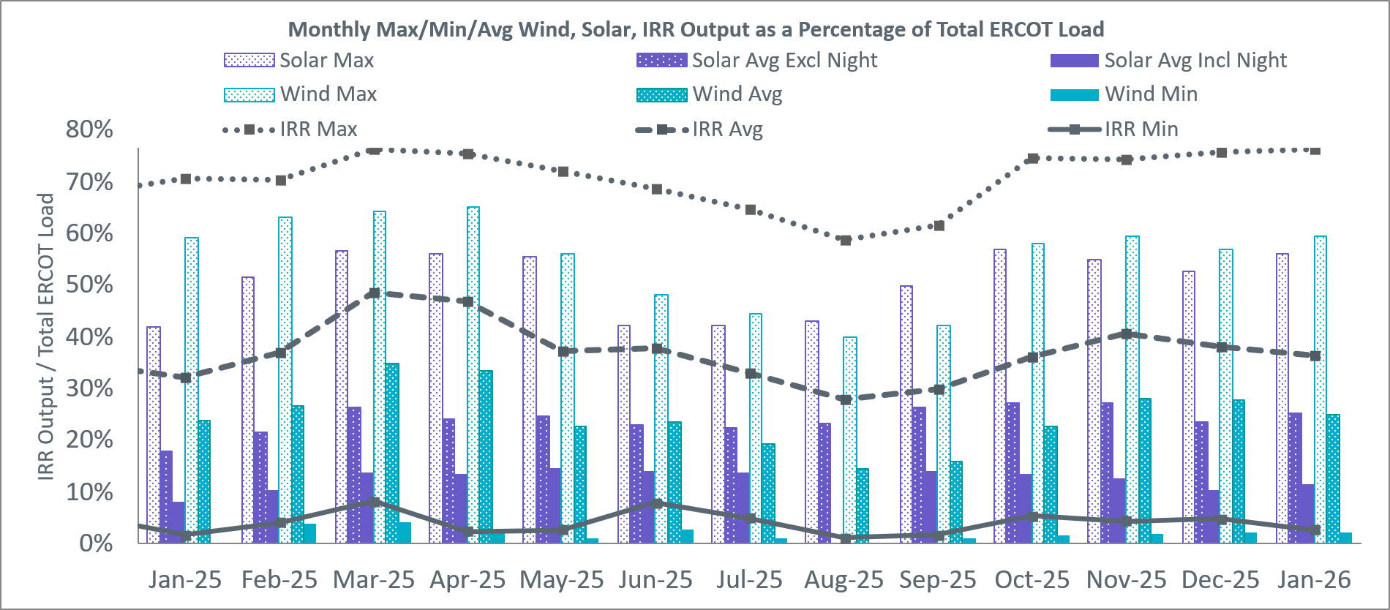
During the hour of peak load for the month, hourly integrated wind generation was 6,588 MW and solar generation was 7,335 MW. The graph below shows the wind and solar penetration percentage during the hour of the peak load in the last 13 months.
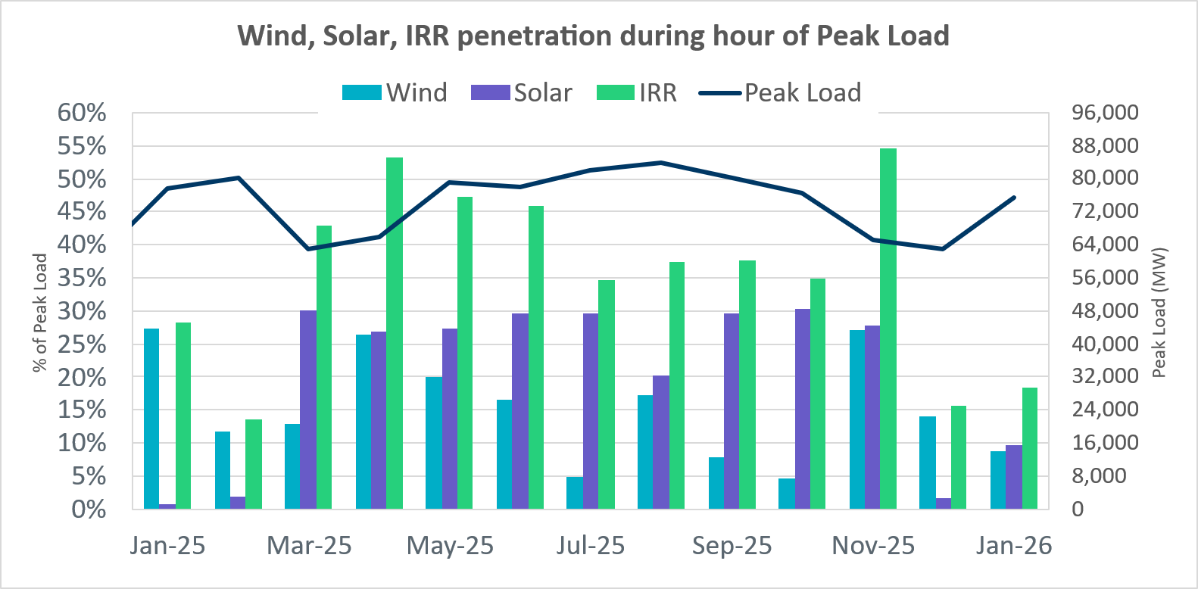

Lastly, the graph below shows the minimum wind, solar, and IRR output during the peak load hour as a percentage of the daily peak load for every day in the month.
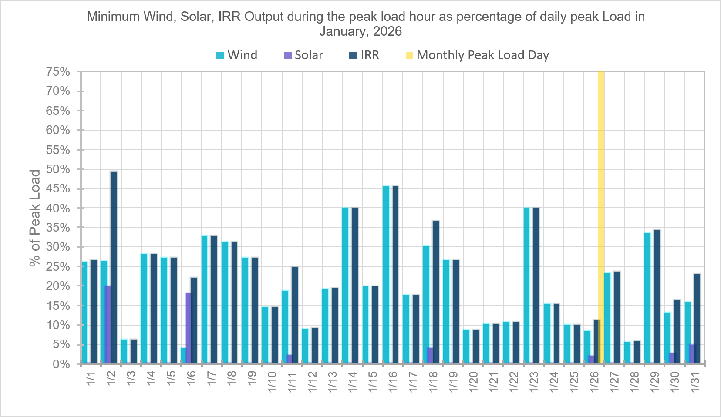

Largest Net-Load Ramps
The net-load ramp is defined as the change in net-load (load minus wind and PVGR generation) during the defined time horizon. Such a variation in net-load needs to be accommodated in grid operations to ensure that the reliability of the grid is satisfactorily maintained. The largest net-load ramps over 5-minute, 10-minute, 15-minute, 30-minute, and 60-minute intervals in January 2026 were 2,161 MW, 4,010 MW, 5,747 MW, 11,316 MW, and 19,909 MW respectively. A comparison with historical values is provided in the table below.
Month and Year | 5 min | 10 min | 15 min | 30 min | 60 min
January 2015 | 1,025 MW | 1,609 MW | 2,150 MW | 3,737 MW | 6,496 MW
January 2016 | 950 MW | 1,547 MW | 2,076 MW | 3,736 MW | 6,213 MW
January 2017 | 959 MW | 1,680 MW | 2,160 MW | 3,511 MW | 6,181 MW
January 2018 | 1,091 MW | 1,824 MW | 2,497 MW | 3,901 MW | 6,824 MW
January 2019 | 1,087 MW | 1,718 MW | 2,308 MW | 4,033 MW | 7,786 MW
January 2020 | 1,009 MW | 1,610 MW | 2,124 MW | 3,700 MW | 6,100 MW
January 2021 | 966 MW | 1,744 MW | 2,359 MW | 4,458 MW | 7,842 MW
January 2022 | 1,049 MW | 1,879 MW | 2,834 MW | 5,455 MW | 10,333 MW
January 2023 | 1,296 MW | 2,506 MW | 3,431 MW | 6,468 MW | 11,133 MW
January 2024 | 1,722 MW | 3,107 MW | 4,588 MW | 8,901 MW | 16,522 MW
January 2025 | 1,960 MW | 3,454 MW | 4,997 MW | 9,438 MW | 17,697 MW
January 2026 | 2,161 MW | 4,010 MW | 5,747 MW | 11,316 MW | 19,909 MW
January 2026 | 1/31/2026 | 1/26/2026 | 1/26/2026 | 1/26/2026 | 1/18/2026
January 2026 | (IE 17:05) | (IE 17:05) | (IE 17:11) | (IE 17:25) | (IE 17:27)
All Months in 2015-2025 | 3,797 MW | 4,010 MW | 5,747 MW | 11,316 MW | 19,909 MW
All Months in 2015-2025 | 5/28/2025 | 1/26/2026 | 1/26/2026 | 1/26/2026 | 1/18/2026
All Months in 2015-2025 | (IE 10:27) | (IE 17:05) | (IE 17:11) | (IE 17:25) | (IE 17:27)

Congestion Analysis

Notable Constraints
Nodal protocol section 3.20 specifies that ERCOT shall identify transmission constraints that are binding in Real-Time three or more Operating Days within a calendar month. As part of this process, ERCOT reports congestion that meets this criterion to ROS. In addition, ERCOT also highlights notable constraints that have an estimated congestion rent exceeding $1,000,000 for a calendar month. These constraints are detailed in the table below, including approved transmission upgrades from TPIT that may provide some congestion relief based on ERCOT’s engineering judgement. Rows highlighted in blue indicate the congestion was affected by one or more outages. For a list of all constraints activated in SCED, please see Appendix A at the end of this report.

Contingency Name | Overloaded Element | Contingency Name | Overloaded Element | # of Days Constraint Binding | Congestion Rent | Transmission Project
DNAVOUT5 | 50__A | MANUAL DOUBLE NVARO-LEG & NVARO-OUTSW 345 KV | Big Brown Ses - Jewett 345kV | 6 | $25,983,774.17
DELMSTP5 | STPELM27_1 | STP-Elmcreek&WAP 345kV | South Texas Project - Elmcreek 345kV | 2 | $15,792,038.58
DKENBA89 | COLETO_ROSATA1_1 | KENEDSW - TULETA (138) & PETTUS - BAEZ (69) | Coleto Creek - Rosata Tap 138kV | 3 | $13,949,894.56 | Coleto Creek to Kenedy SS 138 kV Transmission Project (20RPG014) approved Tier 3 project (MOD 50870) is supposed to be in service in June 2025, but Grid Geo still reflects original line ratings.
MRNKDHM5 | 587__A | MANUAL RNKSW TO DHMSW 345&KRWSW TO DHMSW 345 DBLCKT | Argyle - Highlands Tnp 138kV | 12 | $13,838,994.20
BASE CASE | E_PASP | Basecase | E_PASP GTC | 12 | $12,918,371.67 | The following RPG-endorsed projects will help improve the GTC but not fully exit the GTC yet:  San Antonio South Reliability I Project (22RPG048)  LRGV Transmission Improvement Project (21RPG017)  San Antonio South Reliability II Project (23RPG032)
DBAKCED5 | HARGRO_TWINBU1_1 | BAKESW-CEDACA 345kV & BAKESW-CEDACA 345kV | Hargrove - Twin Buttes 138kV | 21 | $10,938,825.50
SBWDDBM5 | LPLMK_LPLNE_1 | BLACKWATER DRAW SWITCH to DOUBLE MOUNTAIN SWITCH LIN 1 | Mackenzie Substation - Northeast Substation 115kV | 18 | $9,386,643.73
DBAKCED5 | 6965__A | BAKESW-CEDACA 345kV & BAKESW-CEDACA 345kV | Longshore Switch - Prairieland Switch 345kV | 16 | $9,146,442.48 | West Texas 345-kV Infrastructure Rebuild Project (23RPG034) approved Tier 1 project (MOD 81268)
DSALKLN5 | 610__B | SALSW TO KLNSW 345 DBLCKT | Temple Switch - Temple Southeast 138kV | 1 | $7,406,847.65 | Belton - Temple 138 kV Line 24RPG001 approved Tier 1 project (MOD 87709)
DLYTTUR8 | CKT_943_1 | Lytton - Slaughtr & Turner 138 kV | Lytton Springs - Pilot Knob 138kV | 2 | $7,104,066.88 | AEN_26TPIT71408_PMCR_LY_PK_CKT943_Recond_3000A Tier 4 project (MOD 71408)
BASE CASE | PNHNDL | Basecase | PNHNDL GTC | 22 | $6,953,138.84
DFOAVLO5 | LASCRU_MILO1_1 | FOWLERTON to LOBO & AVANZADA | Las Cruces - Milo 138kV | 20 | $5,765,549.81 | AEP_TCC_Las Cruces - Milo Rebuild Tier 4 project (MOD 76076) is supposed to be in service in August 2025, but Grid Geo still reflects original line ratings.
SVENFTS5 | 35055__A | FORT SMITH SWITCH to FORT SMITH SWITCH LIN _B | Sam Switch - Venus Switch 345kV | 8 | $5,738,872.15 | Venus Switch to Sam Switch 345-kV Line Project (24RPG017) approved Tier 1 project (MOD 78369)
STM2TMP5 | 315__A | TEMPLE PECAN CREEK to TEMPLE SWITCH LIN _A | Temple Pecan Creek - Temple Switch 345kV | 8 | $5,737,047.93
MXMUB58 | ABNTHW_SERDEV1_1 | manual ABILENE MULBERRY CREEK TRX 345/138 1 | #N/A | 2 | $4,670,406.80
XCRD58 | CRD_CRD2 | CONCORD TRX CRD1 345/138 | Concord 345kV | 2 | $4,335,447.88
DBIGKEN5 | FORTMA_YELWJC1_1 | Bighil-Kendal 345kV | Yellow Jacket - Fort Mason 138kV | 9 | $4,266,539.53
MCATMG25 | 6945__A | MAN_SGL_CATSW-MGSES_2_345KV | Morgan Creek Ses - Cattleman Switch 345kV | 15 | $4,222,615.96 | West Texas 345-kV Infrastructure Rebuild Project (23RPG034) approved Tier 1 project
DLEGOUT5 | 50__A | MANUAL DOUBLE NVARO-LEG & OUTSW-LEG 345 KV | Big Brown Ses - Jewett 345kV | 3 | $3,862,154.88
BASE CASE | WESTEX | Basecase | WESTEX GTC | 10 | $3,480,433.22 | 3 765-kV Permian Basin paths help to improve WTX transfer capability
DMTSCOS5 | 6437__F | DMTSW TO SCOSW 345 DBLCKT | Knapp - Scurry Chevron 138kV | 11 | $3,095,108.62
STURCRO8 | 531T531_1 | TURNERSVILLE to CROSSWINDS LIN 1 | Hunter - Purgatory Road 138kV | 1 | $3,086,445.52 | PEC_T531_Purgatory_Hunter_Upgrade Tier 4 project (MOD 99524)
SEL_ARR8 | BLESSING_69A1 | EL CAMPO to ARROZ LIN 1 | Blessing 138kV | 2 | $2,558,966.47 | AEP_TCC_Tidehaven station_2 Tier 4 project (MOD 71002)
DELMSAN5 | MAGRUD_VICTOR2_1 | Elmcreek-Sanmigl 345kV | Magruder - Victoria 138kV | 3 | $2,524,103.67
DFOWSMG5 | GEO_SIG_1 | FOWLRTON TO SAN MIGUEL DOUBLE CIRCUIT CONTINGENCY | George West Switching Station - Sigmor 138kV | 8 | $2,188,018.35
SBAKCED5 | BAKRFLD_CEDCAN_1 | BAKERSFIELD SWITCHYARD to CEDAR CANYON LIN 1 | Cedar Canyon - Bakersfield 345kV | 5 | $2,153,949.02
SCLCGTN8 | 6635__G | COLONY CREEK to GHOST TOWN SWITCH LIN _A | Morton Valley (Oncor) - Eastland 69kV | 8 | $2,090,889.16
SN_SLON5 | LOYOLA_69_1 | LON HILL to NELSON SHARPE LIN 1 | Loyola Sub 138kV | 4 | $2,068,035.19 | STEC_76816_upgradeLoyolaAuto Tier 4 project (MOD 76816)
MRGRPR25 | 6945__A | MAN_DBL_RGRSW-PRMSW+MGSES-RGRSW_345KV | Morgan Creek Ses - Cattleman Switch 345kV | 3 | $1,973,668.67 | West Texas 345-kV Infrastructure Rebuild Project (23RPG034) approved Tier 1 project
DFOAVLO5 | BRUNI_69_1 | FOWLERTON to LOBO & AVANZADA | Bruni Sub 138kV | 6 | $1,930,596.71
SCRDJON5 | 915__E | CONCORD to CONCORD LIN G1 | Decordova Dam - Carmichael Bend Switch 138kV | 2 | $1,913,471.21
DLOFOAV5 | LASCRU_MILO1_1 | Double LOBO - FOWLERTON & AVANZADA | Las Cruces - Milo 138kV | 4 | $1,810,530.51 | AEP_TCC_Las Cruces - Milo Rebuild Tier 4 project (MOD 76076) supposed to be in service in August 2025, but Grid Geo still reflects original line ratings.
SPAWCAL5 | MAGRUD_VICTOR2_1 | CALAVERAS to CALAVERAS LIN 1 | Magruder - Victoria 138kV | 2 | $1,726,116.05
BASE CASE | STPELM27_1 | Basecase | South Texas Project - Elmcreek 345kV | 1 | $1,577,295.81
BASE CASE | NELRIO | Basecase | NELRIO GTC | 21 | $1,515,944.38 | The Lower Rio Grande Valley (LRGV) System Enhancement Project (21RPG017) will improve the NorthEd_LoboGTC to support up to 80% of total wind and solar generation capacity in the LRGV area.
SDAFAUS8 | CKT_1027_1 | AUSTROP to DAFFIN GIN LIN 1 | Decker Power Plant - Aen Dunlap 138kV | 1 | $1,397,351.43 | AEN_24TPIT67091_PMCR_CKT1034_DUNLAP_DECKER_138 KV Tier 4 project (MOD 67091)
SFORYEL8 | KATEMC_MASN1_1 | FORT MASON to FORT MASON LIN 1 | Katemcy - Mason Aep 69kV | 6 | $1,359,554.14 | Mason to North Brady Line Rebuild Transmission Project (19RPG019) approved Tier 3 project (MOD 50900) is supposed to be in service in June 2025, but Grid Geo still reflects original line ratings.
MLNGPR25 | 16050__B | MAN_DBL_CATSW-PRLSW+LNGSW-PRLSW_345KV | Carterville - Hillger Sub 138kV | 3 | $1,172,625.92
BASE CASE | HHGTOM_1 | Basecase | Omega - Horse Hollow Generation Tie 345kV | 8 | $1,091,037.42
BASE CASE | VALEXP | Basecase | VALEXP GTC | 16 | $1,016,909.70 | The Lower Rio Grande Valley (LRGV) System Enhancement Project (21RPG017) will improve but not eliminate the need for this GTC.
DTCRTHS5 | 35065__A | THSES TO FBRSW & TCRSW 345 DBLCKT | Fort Smith Switch - Files Valley Switch 345kV | 6 | $965,748.25
BASE CASE | NE_LOB | Basecase | NE_LOB GTC | 12 | $948,680.23
SNADRIC8 | NAD_ELCM_1 | NADA to NADA LIN 1 | Nada - El Campo Sub 69kV | 5 | $923,740.36
SRAYRI38 | HAINE__LA_PAL1_1 | LAS PULGAS to RAYMONDVILLE 2 LIN 1 | Haine Drive - La Palma 138kV | 5 | $852,010.96
SBRAHAM8 | ESCOND_GANSO1_1 | BRACKETTVILLE to HAMILTON ROAD LIN 1 | Escondido - Ganso 138kV | 12 | $770,312.69
DBIGSCH5 | PALOUS_WOLFCA1_1 | Big Hill - Schneeman Draw & Big Hill - Schneeman Draw 2 | Palouse - Wolfcamp 138kV | 7 | $768,684.20
BASE CASE | I_KALO | Basecase | I_KALO GTC | 9 | $768,118.12
DCPSES12 | 35045__A | Comanche Peak 1 & 2 | Sam Switch - Files Valley Switch 345kV | 4 | $738,826.71
DTCRTHS5 | 35045__A | THSES TO FBRSW & TCRSW 345 DBLCKT | Sam Switch - Files Valley Switch 345kV | 8 | $706,717.98
MPRLLNG5 | 6053__C | MAN_SGL_PRLSW-LNGSW_345KV | Cattleman Switch - Prairieland Switch 345kV | 3 | $676,642.62
DHUGWR_8 | ARROZ_EL_CAM1_1 | TWR (138) DYN-WR60 & HUG-WR60 | Arroz - El Campo 138kV | 4 | $640,435.84
SKLELOY8 | LOYOLA_69_1 | KLEBERG AEP to KLEBERG AEP LIN 1 | Loyola Sub 138kV | 6 | $606,421.68
XBAL89 | CONCHO_VRBS1_1 | BALLINGER TRX BALLINGE_3_1 138/69 | San Angelo Concho - Veribest 69kV | 5 | $580,246.06
MHARNED5 | HAINE__LA_PAL1_1 | Manual dbl ckt for NEDIN-BONILLA 345kV & RIOH-PRIM138kV | Haine Drive - La Palma 138kV | 9 | $481,526.14
DFOAVLO5 | NLARSW_PILONC1_1 | FOWLERTON to LOBO & AVANZADA | North Laredo Switch - Piloncillo 138kV | 8 | $458,744.56
MCATPRL5 | 6965__A | MAN_SGL_CATSW-PRLSW_345KV | Longshore Switch - Prairieland Switch 345kV | 3 | $433,514.08
SDIMBEV8 | UVALDE_W_BATE1_1 | BEVO to BEVO LIN 1 | Uvalde Aep - West Batesville 138kV | 4 | $413,151.54
DTHSFBR5 | 35065__A | SAMSW to TCRSW 345kV & FBRSW to THSES 345_DBLCKT | Fort Smith Switch - Files Valley Switch 345kV | 4 | $364,871.81
SCMNCPS5 | 651__B | COMANCHE SWITCH (Oncor) to COMANCHE PEAK SES LIN _A | Comanche Tap - Comanche Switch (Oncor) 138kV | 5 | $318,557.75
SBIGV_D8 | GREENL_WEAVER1_1 | VICTORIA DUPONT SWITCH to BIG THREE LIN 1 | Greenlake - Weaver Road 69kV | 4 | $303,703.68
DRESMCL8 | I_DUPS_RESNIK1_1 | I_DUPS - RESNIK & MCCAMPBE 2 138KV | Dupont Switch - Ingleside - Resnik 138kV | 4 | $296,394.48
SBRAPIN8 | ESCOND_GANSO1_1 | BRACKETTVILLE to BRACKETTVILLE LIN 1 | Escondido - Ganso 138kV | 9 | $256,178.99
SCARFRI8 | ATSO_SONR1_1 | Carver to Carver LIN 1 | Atlantic Sonora - Sonora 69kV | 14 | $248,006.91
DYETRJU8 | HEXT_YELWJC1_1 | Double for YellowJacket - Treadwell & Junction | Yellow Jacket - Hext Lcra 69kV | 3 | $232,410.56
SJUNYEL9 | HEXT_YELWJC1_1 | MENARD PHILLIPS TAP to MENARD PHILLIPS TAP LIN 1 | Yellow Jacket - Hext Lcra 69kV | 6 | $209,545.00
DCPSES12 | 35065__A | Comanche Peak 1 & 2 | Fort Smith Switch - Files Valley Switch 345kV | 4 | $174,354.76
DNOESGT5 | HARGRO_TWINBU1_1 | NOELKE - SINGLE TREE & NOELKE- SINGLE TREE 2 | Hargrove - Twin Buttes 138kV | 4 | $173,467.51
SN_SAJO5 | LASPUL_RAYMND1_1 | AJO to AJO LIN 1 | Las Pulgas - Raymondville 2 138kV | 15 | $155,510.55
DTHSFBR5 | 35045__A | SAMSW to TCRSW 345kV & FBRSW to THSES 345_DBLCKT | Sam Switch - Files Valley Switch 345kV | 5 | $114,728.10
SMA2SAP8 | MADDUX_SAPOWE1_1 | MADDUX to SAN ANGELO POWER STATION LIN 1 | Maddux - San Angelo Power Station 138kV | 10 | $107,821.87
BASE CASE | E_PATA | Basecase | E_PATA GTC | 3 | $98,775.43
SN_SAJO5 | HAINE__LA_PAL1_1 | AJO to AJO LIN 1 | Haine Drive - La Palma 138kV | 3 | $92,058.55
DELMTEX5 | BLESSING_1382 | Elmcreek-STP 345kV | Blessing 345kV | 10 | $91,839.24
DLOFOAV5 | ASHERT_CATARI1_1 | Double LOBO - FOWLERTON & AVANZADA | Asherton - Catarina 138kV | 5 | $65,790.63
DBIGKEN5 | TREADW_YELWJC1_1 | Bighil-Kendal 345kV | Yellow Jacket - Treadwell 138kV | 3 | $52,221.11
SSNYCGR8 | SNYDR_FMR1 | SNYDER to CHINA GROVE SWITCH LIN _A | Snyder 138kV | 3 | $51,657.16
BASE CASE | TRDWEL | Basecase | TRDWEL GTC | 6 | $50,069.82
DWAP_OB5 | MDOPHR99_A | TWR (345) OB-WAP98 & OB-WAP99 | Meadow - Ph Robinson 345kV | 4 | $45,919.46
MSSNDBG5 | 421__A | MANUAL SINGLE SANDOW SWITCH to BADGER SWITCH 345 | Sandow Switch - Bell County East Switch 345kV | 4 | $40,547.59
SBRAPIN8 | HAMILT_MAVERI1_1 | BRACKETTVILLE to BRACKETTVILLE LIN 1 | Hamilton Road - Maverick 138kV | 6 | $37,487.91
SFURRAY8 | VAN_VNDB_1 | FURHMAN to SAM RAYBURN SWITCHYD LIN 1 | Vanderbilt Switching Station - Vanderbilt 69 Sub 69kV | 3 | $27,891.58
SLAQLOB8 | BRUNI_69_1 | LAQUINTA to LOBO LIN 1 | Bruni Sub 138kV | 4 | $25,217.46
DSTEXP12 | BLESSI_LOLITA1_1 | South Texas # 1 & # 2 | Blessing - Lolita 138kV | 3 | $23,025.26
SEUSWLT8 | BLASCOFE_RC_1 | EUSTACE SOUTHEAST to WALTON LIN 1 | Coffee - Blackburn Switch 138kV | 18 | $18,570.12
SLKTCGR9 | 6695__B | SCURY SANTA FE to SCURY SANTA FE LIN _F | Amoco Tap - Snyder 69kV | 4 | $16,632.44
SDOWMOO8 | DOWNIES_AX1H | DOWNIE SWITCHING STATION to DOWNIE SWITCHING STATION LIN 1 | Downie Switching Station 138kV | 5 | $11,033.79
SSTAWIC8 | 138_IH2_COT_1 | STAGHORN TNP to WICKETT TNP LIN 1 | Ih 20 Tnp - Collie Field Tap Tnp 138kV | 8 | $10,989.71
SLOLFOR8 | GOHLKE_JOSLIN1_1 | LOLITA to FORMOSA LIN 1 | Gohlke - Joslin 138kV | 3 | $6,725.84
SFURVAN8 | RAYBUR_FURHMAN_1 | FURHMAN to VANDERBILT SWITCHING STATION LIN 1 | Sam Rayburn Switchyd - Furhman 138kV | 3 | $6,015.41
SBLACOF8 | EUSTWLTN_RC_1 | BLACKBURN SWITCH to BLACKBURN SWITCH LIN 1 | Eustace Southeast - Walton Switching Station 138kV | 13 | $5,502.68
SBRAPIN8 | HAMILT_MAVERI1_1 | BRACKETTVILLE to BRACKETTVILLE LIN 1 | Hamilton Road - Maverick 138kV | 6 | $4,651.24
DSLKSOL5 | 138_FLT_FXT_1 | Sand Lake - Solstice line 1 and 2 | Foxtail Tnp - Flat Top Tnp 138kV | 5 | $3,762.37
DGLDDMT8 | 6474__B | DMTSW-BCKSW&ECRSW-GLDSW 138 DBLCKT | Sun Switch - Ranger Camp Switch 138kV | 3 | $3,327.87
SWLTBRT8 | EUSTWLTN_RC_1 | BARTON CHAPEL to BARTON CHAPEL LIN 1 | Eustace Southeast - Walton Switching Station 138kV | 6 | $1,927.83

Generic Transmission Constraint Congestion
GTC | Days Congestion
South Texas Export Pawnee - Spruce | 15
Panhandle | 24
West Texas | 13
Nelson Sharpe - Rio Hondo | 22
Valley Export | 18
North Edinburg - Lobo | 23
South Texas Import Katoen - Lonhill | 10
South Texas Export Pawnee - Tango | 10
Treadwell | 6
Kinney | 1
Wharton | 2
South Texas Import Pawnee - Spruce | 1
South - Far West | 4

There was no activity on the remaining GTCs during the month.
Note: This is how many times a constraint has been activated to avoid exceeding a GTC limit, it does not imply an exceedance of the GTC occurred or that the GTC was binding.

Manual Overrides
None

Congestion Costs for Calendar Year 2025
The following table represents the top twenty active constraints for the calendar year based on the estimated congestion rent attributed to the congestion. ERCOT updates this list on a monthly basis.
Contingency | Overloaded Element | # of 5-min SCED | Estimated | Transmission
MANUAL DOUBLE NVARO-LEG & NVARO-OUTSW 345 KV | Big Brown Ses - Jewett 345kV | 478 | 25,996,857.33
STP-Elmcreek&WAP 345kV | South Texas Project - Elmcreek 345kV | 355 | 15,792,038.58
KENEDSW - TULETA (138) & PETTUS - BAEZ (69) | Coleto Creek - Rosata Tap 138kV | 538 | 14,029,054.48 | Coleto Creek to Kenedy SS 138 kV Transmission Project (20RPG014) approved Tier 3 project (MOD 50870) is supposed to be in service in June 2025, but Grid Geo still reflects original line ratings.
MANUAL RNKSW TO DHMSW 345&KRWSW TO DHMSW 345 DBLCKT | Argyle - Highlands Tnp 138kV | 1,810 | 13,838,994.20
Basecase | E_PASP GTC | 1,675 | 12,918,371.67 | The following RPG-endorsed projects will help improve the GTC but not fully exit the GTC yet:  San Antonio South Reliability I Project (22RPG048)  LRGV Transmission Improvement Project (21RPG017)  San Antonio South Reliability II Project (23RPG032)
BAKESW-CEDACA 345kV & BAKESW-CEDACA 345kV | Hargrove - Twin Buttes 138kV | 2,272 | 10,938,825.50
BLACKWATER DRAW SWITCH to DOUBLE MOUNTAIN SWITCH LIN 1 | Mackenzie Substation - Northeast Substation 115kV | 1,547 | 9,386,643.73
BAKESW-CEDACA 345kV & BAKESW-CEDACA 345kV | Longshore Switch - Prairieland Switch 345kV | 2,118 | 9,146,442.48 | West Texas 345-kV Infrastructure Rebuild Project (23RPG034) approved Tier 1 project (MOD 81268)
TEMPLE PECAN CREEK to TEMPLE SWITCH LIN _A | Temple Pecan Creek - Temple Switch 345kV | 771 | 8,788,969.36
SALSW TO KLNSW 345 DBLCKT | Temple Switch - Temple Southeast 138kV | 119 | 7,406,847.65 | Belton - Temple 138 kV Line (24RPG001) approved Tier 1 project (MOD 87709)
Lytton - Slaughtr & Turner 138 kV | Lytton Springs - Pilot Knob 138kV | 356 | 7,104,066.88 | AEN_26TPIT71408_PMCR_LY_PK_CKT943_Recond_3000A Tier 4 project (MOD 71408)
Basecase | PNHNDL GTC | 3,369 | 6,953,138.84
FORT SMITH SWITCH to FORT SMITH SWITCH LIN _B | Sam Switch - Venus Switch 345kV | 829 | 6,097,552.35 | Venus Switch to Sam Switch 345-kV Line Project 24RPG017 approved Tier 1 project (MOD 78369)
FOWLERTON to LOBO & AVANZADA | Las Cruces - Milo 138kV | 2,054 | 5,970,721.97 | AEP_TCC_Las Cruces - Milo Rebuild Tier 4 project (MOD 76076) is supposed to be in service in August 2025, but Grid Geo still reflects original line ratings.
manual ABILENE MULBERRY CREEK TRX 345/138 1 | #N/A | 319 | 4,670,406.80
CONCORD TRX CRD1 345/138 | Concord 345kV | 200 | 4,335,447.88
Bighil-Kendal 345kV | Yellow Jacket - Fort Mason 138kV | 798 | 4,266,539.53
MAN_SGL_CATSW-MGSES_2_345KV | Morgan Creek Ses - Cattleman Switch 345kV | 1,264 | 4,222,615.96 | West Texas 345-kV Infrastructure Rebuild Project (23RPG034)
MANUAL DOUBLE NVARO-LEG & OUTSW-LEG 345 KV | Big Brown Ses - Jewett 345kV | 201 | 3,862,154.88
Basecase | WESTEX GTC | 983 | 3,624,085.03 | The PUCT approved Permian Basin Relibility Plan (765-kV import paths) helps improve, but not fully exit, the GTC yet.

System Events

ERCOT Peak Load
The unofficial ERCOT peak load for January 2026 was 75,572 MW and occurred on 01/26/2026 during hour ending 09:00, this is 1,910 MW less than the January 2025 demand of 77,482 MW on 01/22/2025 during hour ending 08:00. Instantaneous peak for January 2025 was 75,922 MW. Actual instantaneous peak for the same month last year was 77,758 MW.

Load Shed Events
- None.

Stability Events
- None.

Notable PMU Events
ERCOT analyzes PMU data for any significant system disturbances that do not fall into the Frequency Events category reported in section 2.1. The results are summarized in this section once the analysis has been completed.
There were no PMU events outside of those reported in section 2.1.

DC Tie Curtailment

Date | DC Tie | Curtailing Period | # of Tags Curtailed | Initiating Event | Curtailment Reason,
1/8/2026 | DC_R | 20:34 – 21:57 | 5 | Faulty equipment | Tie deration
1/9/2026 | DC_R | 15:22 – 22:00 | 5 | Faulty equipment | Tie deration
1/12/2026 | DC_R | 17:52 – 18:10 | 1 | Not ramping to schedule | Tie not responding to remote control
1/24/2026 | DC_R | 09:29 – 10:56 | 2 | Control issues
1/24/2026 | DC_R | 23:24 – 23:48 | 3 | DC_R derated
1/29/2026 | DC_R | 15:08 – 15:21 | 3 | Operational Issues | Tie deration

TRE/DOE Reportable Events
- BPUB Submitted a DOE-417 for 1/10/2026 – Unexpected Transmission loss within its are, contrary to design, of 3 or more Bulk Electric System Facilities caused by a common disturbance.

New/Updated Constraint Management Plans
- None

New/Modified/Removed RAS
- None

New Procedures/Forms/Operating Bulletins
Date | Subject | Bulletin No.
1/29/2026 | Real Time Desk V2 Rev 1 | 2011
1/29/2026 | Reliability Risk Desk Operating Procedure V2 Rev 1 | 2012
1/29/2026 | Reliability Unit Commitment V2 Rev 2 | 2013
1/29/2026 | Resource Desk V2 Rev 1 | 2014
1/29/2026 | Shift Supervisor V2 Rev 1 | 2015
1/29/2026 | Transmission and Security Desk V2 Rev 2 | 2016

Emergency Conditions

OCNs
Date and Time | Message
January 17, 2026 01:30 | At 01:30, ERCOT is issuing an OCN due to a potential wildfire risk for Saturday, January 17, 2026 for a large portion of South Central Texas areas in the ERCOT region until further notice.
January 19, 2026 13:00 | ERCOT is issuing an OCN for an extreme cold weather system approaching the ERCOT Region late this week with temperatures anticipated to remain below freezing and the possibility of precipitation Saturday January 24, 2026, and Sunday, January 25, 2026.
January 27, 2026 14:00 | ERCOT is issuing an OCN for an extreme cold weather system approaching the ERCOT Region with temperatures and wind chills anticipated to remain below freezing for Saturday January 31, 2026 and Sunday, February 1, 2026. Additional updates will be made as weather information becomes available.

Advisories
Date and Time | Message
January 19, 2026 13:49 | Advisory issued for a geomagnetic disturbance of K-8 or greater until 23:59.
January 20, 2026 02:56 | Advisory issued for a geomagnetic disturbance of K-8 or greater until 12:00.
January 20, 2026 14:22 | Advisory issued for a geomagnetic disturbance of K-7 or greater until 23:59.
January 20, 2026 15:30 | ERCOT is issuing an Advisory for an extreme cold weather system approaching the ERCOT Region late this week with temperatures anticipated to remain below freezing and the possibility of frozen precipitation Saturday, January 24, 2026, through noon on Tuesday, January 27, 2026.
January 20, 2026 20:29 | The Space Weather Prediction Center has issued a GMD Warning of K-7 or greater until January 21, 2026, 06:00.
January 29, 2026 13:00 | ERCOT is issuing an Advisory for an extreme cold weather system approaching the ERCOT Region with temperatures and wind chills anticipated to remain below freezing for Saturday January 31, 2026, and Sunday, February 1, 2026. Additional updates will be made as weather information becomes available.

Watches
Date and Time | Message
January 23, 2026 09:00 | ERCOT is issuing a Watch for the extreme cold weather system approaching the ERCOT Region with temperatures anticipated to remain below freezing and the possibility of frozen precipitation Saturday, January 24, 2026, through noon on Tuesday, January 27, 2026.
January 30, 2026 10:00 | ERCOT is issuing a Watch for an extreme cold weather system approaching the ERCOT Region with temperatures and wind chills anticipated to remain below freezing for Saturday January 31, 2026, and Sunday, February 1, 2026.

Emergency Notices
Date and Time | Message
January 25, 2026 21:04 | ERCOT is issuing a Transmission Emergency due to the loss of generation and transmission line issues in the San Antonio and Houston area.

Application Performance

TSAT/VSAT Performance Issues
None

Communication Issues
None.

Market System Issues
None.

Model Updates
The Downstream Production Change (DPC) process allows ERCOT to make changes in the one-line Network Operations Model without loading a completely new model. The purpose of this process is to allow for reliable grid operations as system conditions change between designated Network Operations Model database loads. The DPC process is limited in scope to just those items listed below, with equipment ratings updates being the most common. ERCOT has seen a rise in the use of the DPC process to make on-line updates to the Network Operations Model in recent years, instead of through the standard Network Operations Model Change Request process.
- Static Line ratings (Interim Update)
- Dynamic Line ratings (non-Interim Update)
- Autotransformer ratings (non-Interim Update)
- Breaker and Switch Normal status (Interim Update)
- Contingency Definitions (Interim Update)
- RAP and RAS changes or additions (Interim Update)
- Net Dependable and Reactive Capability (NDCRC) values (Interim Update)
- Impedance Updates (non-Interim)
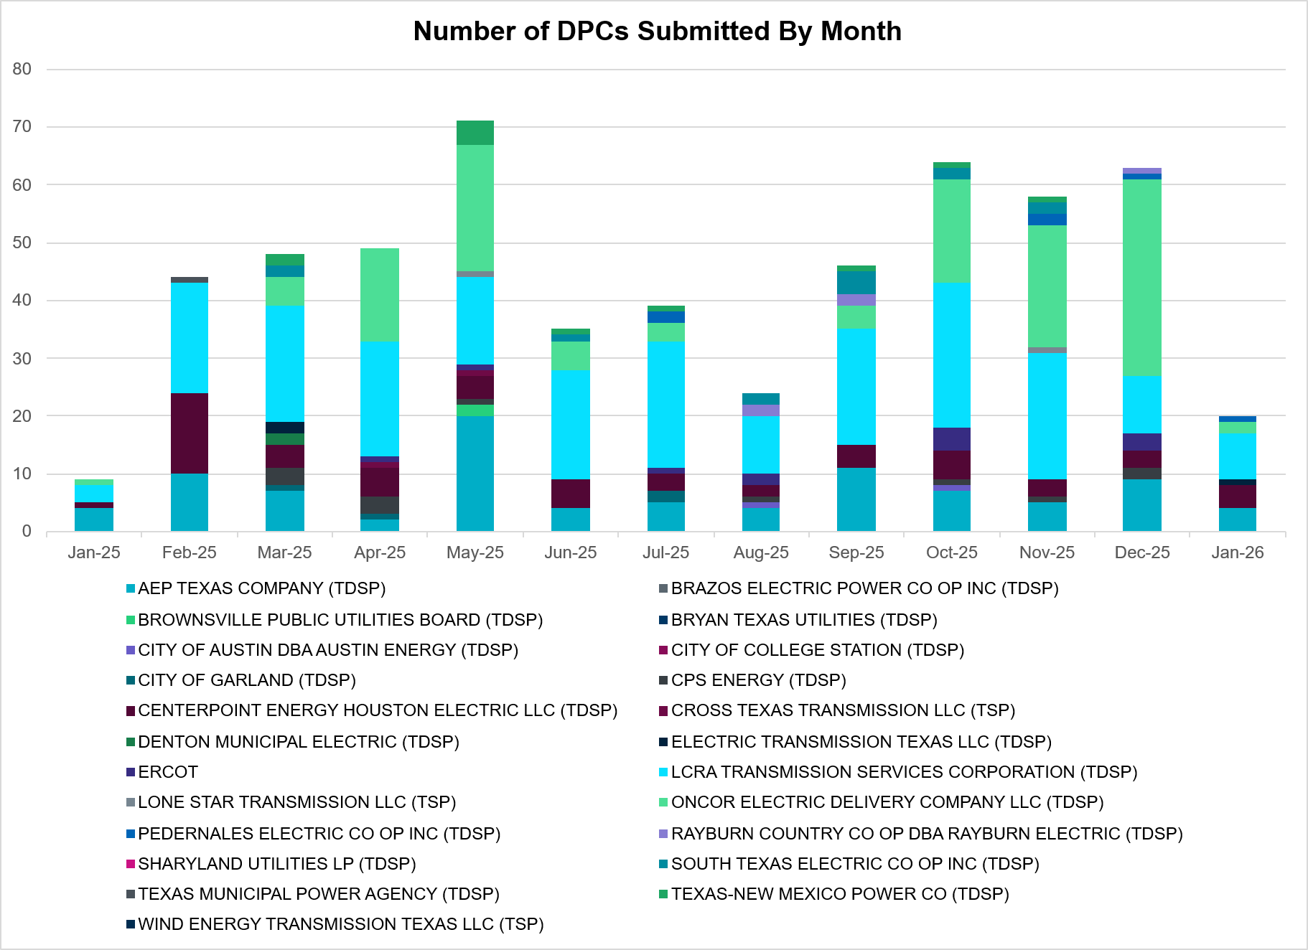
A total of 20 DPCs were implemented in January 2026. 570 DPCs have been implemented year to date. DPCs submitted by TDSPs are mainly updates to transmission element ratings. DPCs submitted by ERCOT are mainly updates to manual contingency definitions.
Transmission Operator | Number of DPCs
AEP TEXAS COMPANY (TDSP) | 4
BRAZOS ELECTRIC POWER CO OP INC (TDSP) | 0
BROWNSVILLE PUBLIC UTILITIES BOARD (TDSP) | 0
BRYAN TEXAS UTILITIES (TDSP) | 0
CENTERPOINT ENERGY HOUSTON ELECTRIC LLC (TDSP) | 4
CITY OF AUSTIN DBA AUSTIN ENERGY (TDSP) | 0
CITY OF COLLEGE STATION (TDSP) | 0
CITY OF GARLAND (TDSP) | 0
CPS ENERGY (TDSP) | 0
CROSS TEXAS TRANSMISSION LLC (TSP)) | 0
DENTON MUNICIPAL ELECTRIC (TDSP) | 0
ELECTRIC TRANSMISSION TEXAS LLC (TDSP) | 1
ERCOT | 0
LCRA TRANSMISSION SERVICES CORPORATION (TDSP) | 8
LONE STAR TRANSMISSION LLC (TSP) | 0
ONCOR ELECTRIC DELIVERY COMPANY LLC (TDSP) | 2
PEDERNALES ELECTRIC CO OP INC (TDSP) | 1
RAYBURN COUNTRY CO OP DBA RAYBURN ELECTRIC (TDSP) | 0
SHARYLAND UTILITIES LP (TDSP) | 0
SOUTH TEXAS ELECTRIC CO OP INC (TDSP) | 0
TEXAS MUNICIPAL POWER AGENCY (TDSP) | 0
TEXAS-NEW MEXICO POWER CO (TDSP) | 0
WIND ENERGY TRANSMISSION TEXAS LLC (TSP) | 0

Appendix A: Real-Time Constraints
The following is a complete list of constraints activated in SCED. Full contingency descriptions can be found in the Standard Contingencies List located on the MIS secure site at Grid Generation Reliability Unit Commitment.
Year | Month | Contingency Name | Overloaded Element | From Station | To Station | Count of Days
2026 | January | SEUSWLT8 | BLASCOFE_RC_1 | COFESSRC | BLASW | 26
2026 | January | SEUSWLT8 | BLASCOFE_RC_1 | BLASW | COFESSRC | 26
2026 | January | BASE CASE | PNHNDL | n/a | n/a | 24
2026 | January | DBAKCED5 | HARGRO_TWINBU1_1 | TWINBU | HARGROVE | 23
2026 | January | BASE CASE | NE_LOB | n/a | n/a | 23
2026 | January | BASE CASE | NELRIO | n/a | n/a | 22
2026 | January | SBWDDBM5 | LPLMK_LPLNE_1 | LPLMK | LPLNE | 21
2026 | January | DFOAVLO5 | LASCRU_MILO1_1 | LASCRUCE | MILO | 20
2026 | January | SBLACOF8 | EUSTWLTN_RC_1 | EUSTSERC | WALTSSRC | 19
2026 | January | SBLACOF8 | EUSTWLTN_RC_1 | WALTSSRC | EUSTSERC | 19
2026 | January | DBAKCED5 | 6965__A | LNGSW | PRLSW | 18
2026 | January | BASE CASE | VALEXP | n/a | n/a | 18
2026 | January | SN_SAJO5 | LASPUL_RAYMND1_1 | LASPULGA | RAYMND2 | 16
2026 | January | BASE CASE | E_PASP | n/a | n/a | 15
2026 | January | SWLTBRT8 | EUSTWLTN_RC_1 | WALTSSRC | EUSTSERC | 15
2026 | January | MCATMG25 | 6945__A | MGSES | CATSW | 15
2026 | January | SWLTBRT8 | EUSTWLTN_RC_1 | EUSTSERC | WALTSSRC | 15
2026 | January | SCARFRI8 | ATSO_SONR1_1 | SONR | ATSO | 14
2026 | January | SBRAHAM8 | ESCOND_GANSO1_1 | ESCONDID | GANSO | 14
2026 | January | BASE CASE | WESTEX | n/a | n/a | 13
2026 | January | SMA2SAP8 | MADDUX_SAPOWE1_1 | MADDUX | SAPOWER | 12
2026 | January | MRNKDHM5 | 587__A | ARGYL | LWSVH | 12
2026 | January | SBRAPIN8 | ESCOND_GANSO1_1 | ESCONDID | GANSO | 11
2026 | January | MHARNED5 | HAINE__LA_PAL1_1 | LA_PALMA | HAINE_DR | 11
2026 | January | DMTSCOS5 | 6437__F | SCRCV | KNAPP | 11
2026 | January | DFOAVLO5 | NLARSW_PILONC1_1 | NLARSW | PILONCIL | 10
2026 | January | SJUNYEL9 | HEXT_YELWJC1_1 | YELWJCKT | HEXT | 10
2026 | January | DELMTEX5 | BLESSING_1382 | BLESSING | BLESSING | 10
2026 | January | DBIGKEN5 | FORTMA_YELWJC1_1 | YELWJCKT | FORTMA | 10
2026 | January | BASE CASE | E_PATA | n/a | n/a | 10
2026 | January | DBIGKEN5 | FORTMA_YELWJC1_1 | FORTMA | YELWJCKT | 10
2026 | January | BASE CASE | I_KALO | n/a | n/a | 10
2026 | January | DFOWSMG5 | GEO_SIG_1 | GEOWEST | SIGMOR | 9
2026 | January | SVENFTS5 | 35055__A | SAMSW | VENSW | 9
2026 | January | DTCRTHS5 | 35045__A | SAMSW | FVLSW | 9
2026 | January | SFORYEL8 | KATEMC_MASN1_1 | MASN | KATEMCY | 9
2026 | January | STM2TMP5 | 315__A | TMPSW | TMPCR | 9
2026 | January | SCLCGTN8 | 6635__G | MRVLY | ESTLD | 9
2026 | January | BASE CASE | HHGTOM_1 | HHGT | OMEGA | 9
2026 | January | SBAKCED5 | BAKRFLD_CEDCAN_1 | CEDACA | BAKESW | 8
2026 | January | SSTAWIC8 | 138_IH2_COT_1 | IH20 | TNCOLIET | 8
2026 | January | DTCRTHS5 | 35065__A | FVLSW | FTSSW | 7
2026 | January | DBIGSCH5 | PALOUS_WOLFCA1_1 | PALOUSE | WOLFCAMP | 7
2026 | January | SBRAPIN8 | HAMILT_MAVERI1_1 | HAMILTON | MAVERICK | 7
2026 | January | DLOFOAV5 | ASHERT_CATARI1_1 | ASHERTON | CATARINA | 7
2026 | January | DFOAVLO5 | BRUNI_69_1 | BRUNI | BRUNI | 7
2026 | January | SBRAPIN8 | HAMILT_MAVERI1_1 | MAVERICK | HAMILTON | 7
2026 | January | DNAVOUT5 | 50__A | JEWET | BBSES | 6
2026 | January | SKLELOY8 | LOYOLA_69_1 | LOYOLA | LOYOLA | 6
2026 | January | SRAYRI38 | HAINE__LA_PAL1_1 | LA_PALMA | HAINE_DR | 6
2026 | January | BASE CASE | TRDWEL | n/a | n/a | 6
2026 | January | DSLKSOL5 | 138_FLT_FXT_1 | TNFXTAIL | FLAT_TOP | 6
2026 | January | SCMNCPS5 | 651__B | CMNSW | CMNTP | 5
2026 | January | SFURVAN8 | RAYBUR_FURHMAN_1 | RAYBURN | FURHMAN | 5
2026 | January | SLAQLOB8 | BRUNI_69_1 | BRUNI | BRUNI | 5
2026 | January | BASE CASE | EUSTWLTN_RC_1 | WALTSSRC | EUSTSERC | 5
2026 | January | DFRYTM58 | SEA_AAT1 | SEA | SEA | 5
2026 | January | SLKTCGR9 | 6695__B | SNYDR | AMOTP | 5
2026 | January | MRGRPR25 | 6945__A | MGSES | CATSW | 5
2026 | January | SBRAHAM8 | GANSO_MAVERI1_1 | GANSO | MAVERICK | 5
2026 | January | DLOFOAV5 | LASCRU_MILO1_1 | LASCRUCE | MILO | 5
2026 | January | BASE CASE | EUSTWLTN_RC_1 | EUSTSERC | WALTSSRC | 5
2026 | January | DW_CNVA5 | FARMLAND_LONGD_1 | FARMLAND | W_LD_345 | 5
2026 | January | SBIGV_D8 | GREENL_WEAVER1_1 | WEAVERRD | GREENLK | 5
2026 | January | SNADRIC8 | NAD_ELCM_1 | ELCMPOS | NADAS | 5
2026 | January | DMGSBTR5 | 6036__A | TKWSW | MGSES | 5
2026 | January | SFURVAN8 | RAYBUR_FURHMAN_1 | FURHMAN | RAYBURN | 5
2026 | January | SDOWMOO8 | DOWNIES_AX1H | DOWNIES | DOWNIES | 5
2026 | January | DTHSFBR5 | 35045__A | SAMSW | FVLSW | 5
2026 | January | XBAL89 | CONCHO_VRBS1_1 | CONCHO | VRBS | 5
2026 | January | SLKTCGR9 | 6695__B | AMOTP | SNYDR | 5
2026 | January | DHUGWR_8 | ARROZ_EL_CAM1_1 | ARROZ | EL_CAMPO | 4
2026 | January | BASE CASE | I_FW_S | n/a | n/a | 4
2026 | January | SDIMBEV8 | UVALDE_W_BATE1_1 | W_BATESV | UVALDE | 4
2026 | January | DFOAVLO5 | ASHERT_CATARI1_1 | CATARINA | ASHERTON | 4
2026 | January | DBIGKEN5 | TREADW_YELWJC1_1 | TREADWEL | YELWJCKT | 4
2026 | January | MKRWDHM5 | 109__A | EXCSW | RNKSW | 4
2026 | January | DCPSES12 | 35045__A | SAMSW | FVLSW | 4
2026 | January | DCAGCO58 | 656T656_1 | KENDAL | BERGHE | 4
2026 | January | SGRIRAP5 | BIGTRE_V_DUPS1_1 | V_DUPSW | BIGTRE | 4
2026 | January | DWAP_OB5 | MDOPHR99_A | MDO | PHR | 4
2026 | January | DCPSES12 | 35065__A | FVLSW | FTSSW | 4
2026 | January | DTHSFBR5 | 35065__A | FVLSW | FTSSW | 4
2026 | January | SN_SLON5 | LOYOLA_69_1 | LOYOLA | LOYOLA | 4
2026 | January | MCATPRL5 | 6965__A | LNGSW | PRLSW | 4
2026 | January | DGRMGRS8 | 6635__G | ESTLD | MRVLY | 4
2026 | January | DNOESGT5 | HARGRO_TWINBU1_1 | TWINBU | HARGROVE | 4
2026 | January | SGRIRAP5 | NCARBI_SEADRF1_1 | NCARBIDE | SEADRFTC | 4
2026 | January | MSSNDBG5 | 421__A | BCESW | SNDSW | 4
2026 | January | MANGGRI5 | BIGTRE_V_DUPS1_1 | V_DUPSW | BIGTRE | 4
2026 | January | DBIGSCH5 | CROSSO_PALOUS1_1 | CROSSOVE | PALOUSE | 4
2026 | January | DYETRJU8 | HEXT_YELWJC1_1 | YELWJCKT | HEXT | 4
2026 | January | DRESMCL8 | I_DUPS_RESNIK1_1 | I_DUPSW | RESNIK | 4
2026 | January | SCOMHA38 | MAXWEL_WHITIN1_1 | MAXWELL | WHITING | 4
2026 | January | DJEWBAL5 | 35045__A | SAMSW | FVLSW | 3
2026 | January | DLEGOUT5 | 50__A | JEWET | BBSES | 3
2026 | January | MPRLLNG5 | 6053__C | CATSW | PRLSW | 3
2026 | January | DGLDDMT8 | 6474__B | RGRSW | SUNSW | 3
2026 | January | XFTS89 | ALPINE_BRONCO1_1 | BRONCO | ALPINE | 3
2026 | January | SCOLBAL8 | BALLINGE_FMR1 | BALLINGE | BALLINGE | 3
2026 | January | DCC1_VIC | BLESSING_1382 | BLESSING | BLESSING | 3
2026 | January | DKENBA89 | COLETO_ROSATA1_1 | COLETO | ROSATA | 3
2026 | January | DMCEBUT8 | MKLT_TRNT1_1 | TRNT | MKLT | 3
2026 | January | SSNYCGR8 | SNYDR_FMR1 | SNYDR | SNYDR | 3
2026 | January | DELMSTP5 | STPELM27_1 | STP | ELMCREEK | 3
2026 | January | MLNGPR25 | 16050__B | CRTRVLLE | HILGR | 3
2026 | January | DGLDDMT8 | 6474__B | SUNSW | RGRSW | 3
2026 | January | DLYTTUR8 | CKT_943_1 | LYTTON_S | PILOT | 3
2026 | January | DDMTMHO5 | FARMLAND_LONGD_1 | FARMLAND | W_LD_345 | 3
2026 | January | SN_SAJO5 | HAINE__LA_PAL1_1 | LA_PALMA | HAINE_DR | 3
2026 | January | DSGTSCH5 | HARGRO_TWINBU1_1 | TWINBU | HARGROVE | 3
2026 | January | SFURRAY8 | VAN_VNDB_1 | VANBLTSS | VANBLT69 | 3
2026 | January | SN_SLON5 | ALAZAN_B_DAVI1_1 | ALAZAN | B_DAVIS | 3
2026 | January | DELMSAN5 | MAGRUD_VICTOR2_1 | VICTORIA | MAGRUDER | 3
2026 | January | BASE CASE | MAXWEL_WHITIN1_1 | MAXWELL | WHITING | 3
2026 | January | DWPWFWP5 | STPWAP39_1 | STP | WAP | 3
2026 | January | MCONPRL5 | 6470__E | PCTSW | FRSTP | 3
2026 | January | MPRLCO25 | 6960__A | PRLSW | CONSW | 3
2026 | January | SLOLFOR8 | GOHLKE_JOSLIN1_1 | JOSLIN | GOHLKE | 3
2026 | January | DMTSCOS5 | 6240__C | SACRC | DPCRK | 3
2026 | January | MXMUB58 | ABNTHW_SERDEV1_1 | ABNTHWST | ABNTHWST | 3
2026 | January | MLNGPR25 | CRTVLE_EINSTEN_1 | EINSTEIN | CRTRVLLE | 3
2026 | January | SFORYEL8 | HEXT_MASONS1_1 | MASONSW | HEXT | 3
2026 | January | DFOAVLO5 | MINES__NLARSW1_1 | MINES_RD | NLARSW | 3
2026 | January | SGEOORN8 | ORNGROV_69_1 | ORNGROV | ORNGROV | 3
2026 | January | DWO5_EU8 | BI_KB_37_A | BI | KB | 3
2026 | January | DSTEXP12 | BLESSI_LOLITA1_1 | LOLITA | BLESSING | 3
2026 | January | DBIGSCH5 | HARGRO_TWINBU1_1 | TWINBU | HARGROVE | 3
2026 | January | SFORYEL8 | HEXT_MASONS1_1 | HEXT | MASONSW | 3
2026 | January | SHONF38 | HON_DEVI_1 | HONDOCK | DEVINESW | 3
2026 | January | XFTS89 | ALPINE_BRONCO1_1 | ALPINE | BRONCO | 3
2026 | January | DWAP_OB5 | MIDGT_90_A | GT | MID | 3
2026 | January | DZORHAY5 | BERGHE_AT1H | BERGHE | BERGHE | 2
2026 | January | MLONOR58 | ORNGROV_69_1 | ORNGROV | ORNGROV | 2
2026 | January | DLOFOAV5 | BRUNI_69_1 | BRUNI | BRUNI | 2
2026 | January | DCHBJO25 | CTRPHR97_A | CTR | PHR | 2
2026 | January | SCABWES8 | HOLLY4_WESTSI1_1 | HOLLY4 | WESTSIDE | 2
2026 | January | DELMSAN5 | PAWNEE_SPRUCE_1 | PAWNEE | CALAVERS | 2
2026 | January | MLNGPR25 | 5010__A | PRMSW | RCKSW | 2
2026 | January | MBERCO58 | 531T531_1 | HUNTER | PURGRO | 2
2026 | January | SECRDMT8 | 6215__A | BCKSW | CGRSW | 2
2026 | January | SFTCGAR8 | BALLINGE_FMR1 | BALLINGE | BALLINGE | 2
2026 | January | SBRTANT8 | EUSTWLTN_RC_1 | WALTSSRC | EUSTSERC | 2
2026 | January | SBRAPIN8 | GANSO_MAVERI1_1 | GANSO | MAVERICK | 2
2026 | January | DBAKSOL5 | NEVILL_NORTMC_1 | NEVILLSW | NORTMC | 2
2026 | January | SPHRHDN8 | 138_NAL_HAS_1 | TNNALVIN | HASTINGS | 2
2026 | January | BASE CASE | 35045__A | SAMSW | FVLSW | 2
2026 | January | DNAVOUT5 | 40__A | JEWET | BBSES | 2
2026 | January | DTRSRCH5 | MEXIA_AT1 | MEXIA | MEXIA | 2
2026 | January | DBAKCED5 | STCO_STER1_1 | STER | STCO | 2
2026 | January | SMVRLA_8 | VERTRE_WESLAU1_1 | VERTREES | WESLAU | 2
2026 | January | SILLFTL8 | CARVER_TINSLE1_1 | CARVER | TINSLEY | 2
2026 | January | SBRAHAM8 | HAMILT_MAVERI1_1 | MAVERICK | HAMILTON | 2
2026 | January | DBWNAMO5 | HIGHLA_SAST1_1 | HIGHLAND | SAST | 2
2026 | January | DYELHE89 | KATEMC_MASN1_1 | MASN | KATEMCY | 2
2026 | January | DDUNLOS5 | AUSTRO_AT1L | AUSTRO | AUSTRO | 2
2026 | January | DBIGSCH5 | LAKENA_SAMATH1_1 | LAKENASW | SAMATHIS | 2
2026 | January | SBIGV_D8 | VAN_VNDB_1 | VANBLTSS | VANBLT69 | 2
2026 | January | MRGRMGS5 | 6474__B | SUNSW | RGRSW | 2
2026 | January | DODEMOS5 | 6513__A | ODESA | ODNTH | 2
2026 | January | SCRDJON5 | 915__E | CMBSW | DCDAM | 2
2026 | January | SEL_ARR8 | BLESSING_69A1 | BLESSING | BLESSING | 2
2026 | January | XCRD58 | CRD_CRD2 | CRD | CRD | 2
2026 | January | DRAZSA89 | UVALDE_W_BATE1_1 | UVALDE | W_BATESV | 2
2026 | January | BASE CASE | VENSW_MR1H | VENSW | VENSW | 2
2026 | January | DFRIILL8 | CARVER_TINSLE1_1 | CARVER | TINSLEY | 2
2026 | January | DNOETWL5 | HARGRO_TWINBU1_1 | TWINBU | HARGROVE | 2
2026 | January | DYETRJU8 | HEXT_MASONS1_1 | HEXT | MASONSW | 2
2026 | January | DLOFOAV5 | NLARSW_PILONC1_1 | NLARSW | PILONCIL | 2
2026 | January | DLOFOAV5 | NLARSW_PILONC1_1 | PILONCIL | NLARSW | 2
2026 | January | DSANBEU5 | SNDSW_MR1H | SNDSW | SNDSW | 2
2026 | January | BASE CASE | WHARTN | n/a | n/a | 2
2026 | January | SEBHUG8 | ARROZ_EL_CAM1_1 | ARROZ | EL_CAMPO | 2
2026 | January | SBISMI5 | BI_WAP50_A | WAP | BI | 2
2026 | January | SPAWCAL5 | MAGRUD_VICTOR2_1 | VICTORIA | MAGRUDER | 2
2026 | January | DKG_NB_5 | MDOPHR99_A | MDO | PHR | 2
2026 | January | DELMSAN5 | BLESSING_1382 | BLESSING | BLESSING | 2
2026 | January | DDNEDBP5 | FREER_LOBO1_1 | LOBO | FREER | 1
2026 | January | DWO5_EU8 | GT_KB_37_A | KB | GT | 1
2026 | January | SRAYRI28 | HAINE__LA_PAL1_1 | LA_PALMA | HAINE_DR | 1
2026 | January | DKENBA89 | KENEDS_ROSATA1_1 | ROSATA | KENEDSW | 1
2026 | January | XMGS658 | MGSES_MR4H | MGSES | MGSES | 1
2026 | January | XRUS89 | SANORTH_69T1 | SANORTH | SANORTH | 1
2026 | January | DBIGSCH5 | SANTAR_WOLFCA1_1 | WOLFCAMP | SANTARIT | 1
2026 | January | MHARNED5 | VERTRE_WESLAU1_1 | WESLAU | VERTREES | 1
2026 | January | SBIGV_D8 | VND_PLCE_1 | VANBLT69 | PLCEDOS | 1
2026 | January | DJEWBAL5 | 35065__A | FVLSW | FTSSW | 1
2026 | January | STURCRO8 | 531T531_1 | HUNTER | PURGRO | 1
2026 | January | SLWVLWS8 | 588_A_1 | LWSVW | LWVTI | 1
2026 | January | DSWECCR5 | 6036__A | TKWSW | MGSES | 1
2026 | January | DSALKLN5 | 610__B | TMPSW | TMPSE | 1
2026 | January | SHAYZO25 | 6T227_1 | HAYSEN | ZORN | 1
2026 | January | MLWSWDE5 | AIR_W_DE_1 | W_DENT | JCHRSTL | 1
2026 | January | SMDOOAS5 | BI_KB_37_A | BI | KB | 1
2026 | January | DELMTEX5 | CKT_3123_1 | HLJ | HOLMAN | 1
2026 | January | DFOWSMG5 | COTULL_REVEIL1_1 | REVEILLE | COTULLA | 1
2026 | January | SLSPRGR8 | ESKSW_TRNT1_1 | ESKSW | TRNT | 1
2026 | January | SJUNYEL9 | HEXT_MASONS1_1 | HEXT | MASONSW | 1
2026 | January | BASE CASE | I_PASP | n/a | n/a | 1
2026 | January | SLP2LPL0 | LPLNW_LPLMD_1 | LPLNW | LPLMD | 1
2026 | January | XVIC89 | MAGRUD_VICTOR2_1 | VICTORIA | MAGRUDER | 1
2026 | January | SILLFTL8 | MAXWEL_WHITIN1_1 | MAXWELL | WHITING | 1
2026 | January | SWALWLN8 | SWI_OLIN_1 | OLINGR | SWINDELL | 1
2026 | January | MSUNESC8 | UVALDE_W_BATE1_1 | UVALDE | W_BATESV | 1
2026 | January | DCPSES12 | 35050__B | FTSSW | VENSW | 1
2026 | January | DTHSFBR5 | 35050__B | FTSSW | VENSW | 1
2026 | January | DLNCSWE5 | 6380__D | MURRAY | PAINTCRE | 1
2026 | January | DSTEXP12 | ARROZ_LANCTY1_1 | ARROZ | LANCTYPM | 1
2026 | January | STURCRO8 | BERGHE_AT1H | BERGHE | BERGHE | 1
2026 | January | DCPRJCK8 | BLESSING_69A1 | BLESSING | BLESSING | 1
2026 | January | SCOFNYS8 | EUSTWLTN_RC_1 | EUSTSERC | WALTSSRC | 1
2026 | January | SGOHJOS8 | FORMOS_LOLITA1_1 | FORMOSA | LOLITA | 1
2026 | January | DFOAVLO5 | FREER_LOBO1_1 | LOBO | FREER | 1
2026 | January | SPITFOR8 | FRPHIL_MASN1_1 | FRPHILLT | MASN | 1
2026 | January | BASE CASE | GALOW_MUSTNGCK_1 | MUSTNGCK | GALOW | 1
2026 | January | SGBYSD25 | GBYLYD70_A | LYD | GBY | 1
2026 | January | SRAYRI38 | HAINE__OLEAND1_1 | HAINE_DR | OLEANDER | 1
2026 | January | SCARLVO8 | LAKENA_SAMATH1_1 | LAKENASW | SAMATHIS | 1
2026 | January | SLGDSAP8 | LAKENA_SAMATH1_1 | LAKENASW | SAMATHIS | 1
2026 | January | DRAZSA89 | LAPRYO_UVALDE1_1 | UVALDE | LAPRYOR | 1
2026 | January | SHA2MAX8 | MAXWEL_WHITIN1_1 | MAXWELL | WHITING | 1
2026 | January | SMCEABS8 | MKLT_TRNT1_1 | TRNT | MKLT | 1
2026 | January | SMCEESK8 | MKLT_TRNT1_1 | TRNT | MKLT | 1
2026 | January | MCATMG45 | STCO_STER1_1 | STER | STCO | 1
2026 | January | SMOOPEA8 | UVALDE_W_BATE1_1 | W_BATESV | UVALDE | 1
2026 | January | MCATMG55 | 16050__B | CRTRVLLE | HILGR | 1
2026 | January | SROCRIN8 | ARANSA_GREGOR1_1 | GREGORY | ARANSASP | 1
2026 | January | DGARHIC8 | CKT_1027_1 | DUNLAP | DECKER | 1
2026 | January | BASE CASE | CORONA_AT4 | CORONA | CORONA | 1
2026 | January | BASE CASE | CTHR_TINSLE1_1 | CTHR | TINSLEY | 1
2026 | January | SBIGOR45 | FORTMA_YELWJC1_1 | YELWJCKT | FORTMA | 1
2026 | January | SMDOOAS5 | GT_KB_37_A | KB | GT | 1
2026 | January | DCC1DUKE | HAINE__LA_PAL1_1 | LA_PALMA | HAINE_DR | 1
2026 | January | DTWLCED5 | HARGRO_TWINBU1_1 | TWINBU | HARGROVE | 1
2026 | January | UJUNBES1 | HEXT_YELWJC1_1 | YELWJCKT | HEXT | 1
2026 | January | DBAKCED5 | LAKENA_SAMATH1_1 | LAKENASW | SAMATHIS | 1
2026 | January | SW_LFAR5 | LPLNE_LPLDB_1 | LPLDB | LPLNE | 1
2026 | January | DBAKSOL5 | NEVILL_BAKESW_1 | BAKESW | NEVILLSW | 1
2026 | January | SORNLON8 | ORNGROV_69_1 | ORNGROV | ORNGROV | 1
2026 | January | SKENBER5 | R0_FAIR_1 | FAIROA | R0 | 1
2026 | January | DNAVOUT5 | 35045__A | SAMSW | FVLSW | 1
2026 | January | DSAMFBR5 | 35065__A | FVLSW | FTSSW | 1
2026 | January | SCOMHA38 | CTHR_TINSLE1_1 | CTHR | TINSLEY | 1
2026 | January | MHARNED5 | LASPUL_RAYMND1_1 | LASPULGA | RAYMND2 | 1
2026 | January | SBUCCOR9 | PITSBU_AT1 | PITSBU | PITSBU | 1
2026 | January | SMV_PAR8 | RIOHND_ERIOHND_1 | MV_RIOHO | RIOHONDO | 1
2026 | January | DDL_STF8 | STFWAP09_A | WAP | STF | 1
2026 | January | DRILKRW5 | 109__A | EXCSW | RNKSW | 1
2026 | January | MLNGPR25 | 16050__A | HILGR | EILAND | 1
2026 | January | MDWRTR25 | 3050__A | WTRML | LPNSW | 1
2026 | January | SRICEL_8 | ARROZ_LANCTY1_1 | ARROZ | LANCTYPM | 1
2026 | January | SDAFAUS8 | CKT_1027_1 | DUNLAP | DECKER | 1
2026 | January | SCITWEI8 | CLARK__LON_HI1_1 | LON_HILL | CLARK_WD | 1
2026 | January | SSANFER8 | CORONA_AT4 | CORONA | CORONA | 1
2026 | January | DBIGSCH5 | CROSSO_NORTMC1_1 | NORTMC | CROSSOVE | 1
2026 | January | DKG_RTW5 | DQ_NB_67_A | NB | DQ | 1
2026 | January | SLGDSAP8 | FDR_OZNC_1 | FRIEND_R | OZNC | 1
2026 | January | DVICDUP8 | GREENL_NCARBI1_1 | NCARBIDE | GREENLK | 1
2026 | January | BASE CASE | KINNEY | n/a | n/a | 1
2026 | January | DMK_YH95 | LPLNW_LPLMD_1 | LPLNW | LPLMD | 1
2026 | January | SOBWAP5 | OB_WAP98_A | WAP | OB | 1
2026 | January | DHILPAN8 | P3_P1TAP_1 | SKYLINE | P1 | 1
2026 | January | SAMOTWI5 | SAPOWE_SAST1_1 | SAPOWER | SAST | 1
2026 | January | DFRYBC58 | SEA_AAT1 | SEA | SEA | 1
2026 | January | SHC2EXC5 | 107__B | HCKSW | EXCSW | 1
2026 | January | SCOMKEN8 | 115T123_1 | KENDAL | KERRST | 1
2026 | January | SSGRJEW5 | 35065__A | FVLSW | FTSSW | 1
2026 | January | SBCESN35 | 455__A | BGRSW | SNDSW | 1
2026 | January | SMYRSPR8 | 595__A | BNTSW | DCATR | 1
2026 | January | MTRYBRO8 | 6217__A | WLVSW | GAILS | 1
2026 | January | DMTSCOS5 | 6474__B | SUNSW | RGRSW | 1
2026 | January | SRICGRS8 | 6840__B | NVKSW | ANARN | 1
2026 | January | SZORAUS5 | 7T246_1 | ZORN | LYTTON_S | 1
2026 | January | SBROCOC9 | ALPINE_BRONCO1_1 | BRONCO | ALPINE | 1
2026 | January | DSTPREF5 | BLESSING_1382 | BLESSING | BLESSING | 1
2026 | January | UCOLCOL1 | BLESSING_1382 | BLESSING | BLESSING | 1
2026 | January | SPAWCAL5 | COLETO_ROSATA1_1 | COLETO | ROSATA | 1
2026 | January | SVICCO28 | COLETO_VICTOR2_1 | COLETO | VICTORIA | 1
2026 | January | SHASTNN8 | G138_8A_1 | PHR | HDNLAKES | 1
2026 | January | DDMTMHO5 | LPLMK_LPLNE_1 | LPLMK | LPLNE | 1
2026 | January | MHAPSTX8 | MAXWEL_WHITIN1_1 | MAXWELL | WHITING | 1
2026 | January | DLOFOAV5 | MINES__NLARSW1_1 | MINES_RD | NLARSW | 1
2026 | January | DFOAVLO5 | NLARSW_PALAFO1_1 | NLARSW | PALAFOX | 1
2026 | January | BASE CASE | PALOUS_WOLFCA1_1 | PALOUSE | WOLFCAMP | 1
2026 | January | MLONOR58 | SND_ORAN_1 | ORNGROV | SNDIEGS | 1
2026 | January | SSO2SLK5 | 138_FLT_FXT_1 | TNFXTAIL | FLAT_TOP | 1
2026 | January | SSCLWF18 | 6840__B | NVKSW | ANARN | 1
2026 | January | SCRMSAR8 | CONCHO_VRBS1_1 | CONCHO | VRBS | 1
2026 | January | SHA2MAX8 | CTHR_TINSLE1_1 | CTHR | TINSLEY | 1
2026 | January | DLOBCEN5 | FALFUR_RACHAL1_1 | RACHAL | FALFUR | 1
2026 | January | MBONNED5 | HAINE__LA_PAL1_1 | LA_PALMA | HAINE_DR | 1
2026 | January | DBIGKEN5 | HAMILT_MAXWEL1_1 | MAXWELL | HAMILTON | 1
2026 | January | SN_SLON5 | HOLLY4_WESTSI1_1 | HOLLY4 | WESTSIDE | 1
2026 | January | SOXYIN28 | I_DUPP_I_DUPS1_1 | I_DUPP1 | I_DUPSW | 1
2026 | January | DSGTSCH5 | LAKENA_SAMATH1_1 | LAKENASW | SAMATHIS | 1
2026 | January | DBBSRCH5 | MEXIA_AT1 | MEXIA | MEXIA | 1
2026 | January | MBONMAN5 | PANTER_WESMER1_1 | WESMER | PANTERA | 1
2026 | January | DRICCOR8 | RAYBUR_FURHMAN_1 | FURHMAN | RAYBURN | 1
2026 | January | BASE CASE | STPELM27_1 | STP | ELMCREEK | 1
2026 | January | DODEMOS5 | 6540__A | ODEHV | RTRSW | 1
2026 | January | SEUSWLT8 | ANTSCRSP_RC_1 | CRSPOLRC | ANTSS_RC | 1
2026 | January | XSA4N89 | BALLINGE_FMR1 | BALLINGE | BALLINGE | 1
2026 | January | SDANBLE8 | BLESSING_69A1 | BLESSING | BLESSING | 1
2026 | January | DVICVI89 | COLETO_VICTOR2_1 | COLETO | VICTORIA | 1

Current Wind Generation Record: 28,550 MW on 03/03/2025 at 20:42 | Current Wind Penetration Record: 69.15% on 04/10/2022 at 01:43 Current Solar Generation Record: 29,877 MW on 09/09/2025 at 11:54 | Current Solar Penetration Record: 56.80% on 10/30/2025 at 11:05
All DC Tie Curtailments are posted publicly on the ERCOT Market Information System. See that posting for additional details for the event(s) in question.
See DC Tie Operating Procedure (http://www.ercot.com/mktrules/guides/procedures) for more details.

