NPRR Number | 1310 | NPRR Title | Dispatchable Reliability Reserve Service Plus Energy Storage Resource Participation and Release Factor
Date |  | January 28, 2026
Submitter’s Information
Name |  | Blake Holt, Trevor Safko
E-mail Address |  | blake.holt@lcra.org, trevor.safko@lcra.org
Company |  | Lower Colorado River Authority (LCRA)
Phone Number |  | 254-913-8096
Cell Number
Market Segment |  | Cooperative

Comments
LCRA submits these comments to support development of Nodal Protocol Revision Request (NPRR) 1310 as a resource adequacy tool enabling ERCOT to better meet its PUC-mandated reliability standard. As of this date, ERCOT has not yet completed its first reliability standard assessment, so the exact dimensions of its resource adequacy challenges remain unknown. Nevertheless, numerous resource adequacy studies, have indicated that ERCOT lacks sufficient long-duration capacity to meet the reliability standard in the absence of significant market design improvements. The seriousness of this reliability challenge threatens the competitive design of the ERCOT wholesale market. LCRA commits to collaborating with ERCOT and stakeholders in the development of a holistic resource adequacy solution, of which Dispatchable Reliability Reserve Service (DRRS) may play a significant role. To that end, LCRA offers several initial recommendations to improve NPRR1310 as a resource adequacy tool and requests additional quantitative analysis of DRRS price formation to assist stakeholders and policymakers in calibrating DRRS to solve for resource adequacy.
ERCOT’s current market design is insufficient to meet expected demand growth.
ERCOT’s energy-only market design relies on price signals from its wholesale energy and Ancillary Service markets to attract new investment in generation. In a well-designed market, these spot market price signals influence prices in forward markets and are subsequently reflective of the system’s reliability needs. Over time, this necessary sequence would attract investment in the most efficient resources to meet those needs. However, the current design of ERCOT’s energy and Ancillary Service markets relies on an outdated shortage pricing mechanism (i.e., the aggregated operating reserve demand curve (AORDC)) calibrated to an inappropriate planning Value of Lost Load (VOLL). Market design is further distorted by federal subsidies to intermittent renewables and a conservative operations policy enforced by grid operators. In totality, these dynamics have dampened investment signals for resource adequacy to such an extent that ERCOT is now seeking to expand non-competitive procurement of capacity to meet growing demand.
The resource adequacy portion of the DRRS plan and DRRS release factors should be determined explicitly by the triennial reliability standard assessment.
Although it is unrealistic to expect NPRR1310 to fully address the structural challenges listed above, its design should be modified to maximize its value as a resource adequacy tool. DRRS is designed as an Ancillary Service under both NPRR1309, Board Priority - Dispatchable Reliability Reserve Service Ancillary Service, and NPRR1310. ERCOT has indicated in stakeholder workshops that procurement of DRRS can achieve a resource adequacy goal if the Ancillary Service plan size is increased beyond operational quantities (e.g., 1 – 4 GW) to resource adequacy quantities (e.g., 80 – 100 GW) as determined by ERCOT’s triennial reliability standard assessment. Under NPRR1310, awards of DRRS will be allowed to overlap with a Resource’s energy awards and the awards of other operational Ancillary Services based upon an ERCOT-determined DRRS release factor (DRRSRF). Because energy and Ancillary Service procurement is co-optimized in the Day-Ahead Market (DAM) and Real-Time Market (RTM), price formation for DRRS will reflect shortage pricing calculated with an Ancillary Service Demand Curve (ASDC) from competitive offers failing to fill the DRRS plan for that operating hour. Thus, the efficacy of ERCOT’s proposed resource adequacy tool (i.e., NPRR1310) will depend on ERCOT’s annual Ancillary Service methodology for DRRS to correctly predict the appropriate DRRS plan size and DRRSRF combination for each hour of the upcoming year that, in tandem with the ASDC, will send the appropriate investment signal to the appropriate resources. Perhaps the most impactful parameter on DRRS price formation is the currently unrestricted DRRSRF (value ranging from 0 to 1) which can be adjusted based on variables such as season, day, or hour, and is presumably determined during ERCOT’s annual review of its ancillary service methodology. Adjustments to the DRRSRF will directly impact the capacity awarded on dispatchable units to meet ERCOT’s DRRS operational and resource adequacy plans. Because DRRS is an Ancillary Service, ERCOT would have sole discretion to recommend a change to the Commission to modify the strength of this investment signal through its annual Ancillary Service methodology or by adjusting the DRRS plan size or DRRSRFs at any time throughout the year. It’s worth noting that stakeholders do not have the formal ability to suggest updates to changes in the Ancillary Service plan or presumably the value of the DRRSRF as envisioned in NPRR1310.
This ‘black box’ approach to resource adequacy creates unnecessary regulatory uncertainty and is unlikely to create a stable investment signal sufficient to incentivize new market entrants as investors must evaluate the risks and impacts associated with ERCOT changing its DRRS plan size or DRRSRFs during the hypothetical lifetime of a new generation asset. To improve the durability and predictability of the investment signal generated by NPRR1310, ERCOT and stakeholders should consider including controlling language for the resource adequacy portion of the DRRS plan and DRRSRF methodology in Nodal Protocols or Other Binding Documents. Not only will this improve certainty to drive investment, but it will also limit ERCOT’s ability to modify the resource adequacy portion of the DRRS plan without thorough vetting by ERCOT stakeholders. Alternatively, it may be useful instead to require the DRRS plan size for resource adequacy, DRRSRF values, and associated methodologies to be fixed for a set period of time based on the results of ERCOT’s most recent triennial reliability standard assessment. This assessment should be designed in a way to reveal ‘the missing MW’ needed to meet the reliability standard and the value should remain fixed until subsequent probabilistic assessments reveal the need has changed.
Stakeholders must consider resource adequacy holistically. DRRS may dampen prices for energy and online reserves.
An inherent risk of the NPRR1310 design that should also be recognized is the impact to shortage pricing from increasing average On-Line capacity in the RTM. On balance, replacing out-of-market Reliability Unit Commitments (RUCs) with competitively procured DRRS deployments is a positive change for ERCOT market design. It is not yet known how resource owners will respond to the new operational price signal, but the net-impact may be to increase On-Line reserves during mild operational conditions, further dampening prices for energy and other On-Line reserve services. LCRA encourages ERCOT to consider the holistic impacts of DRRS on energy prices and other Ancillary Service prices in evaluating the value of DRRS as a resource adequacy tool. Furthermore, LCRA supports efforts to recalibrate the current ASDC-based shortage pricing mechanism to more accurately reflect VOLL and ERCOT’s expected operational baseline for On-Line reserves.
To meet the reliability standard the DRRS ASDC must be calibrated to support new investment in dispatchable resources.
Unlike other markets which require load serving entities to enter into forward capacity contracts (directly or indirectly through forward capacity markets), ERCOT’s energy-only design relies on price signals from its wholesale energy and Ancillary Service markets to incentivize new investment when reserve margins are tight, and to retire inefficient resources when the system is over-built. The cost of new entry (CONE) for generation therefore becomes an important threshold for market performance. In the absence of a capacity contract requirement, the market must produce prices above this threshold, to not only recover costs associated with development and operation of a new generation facility, but also to provide a risk-adjusted return on that investment. As the IMM noted in a recent presentation to ERCOT and stakeholders “There is no avoiding CONE…whether the market produces revenue to cover CONE or LSEs contract and must pay CONE for new capacity”. LCRA supports ERCOT’s recommendation to complete a truncated CONE study to support its reliability standard assessment. The Brattle Group previously calculated a $293/kW-Year CONE for an Aeroderivative LM6000 in its 2024 CONE study for the ERCOT market and this value is likely already outdated due to inflation and supply chain shortages. It is also worth emphasizing that ERCOT’s current market design has resulted in revenues below this outdated threshold for nine out of the last ten years (Figure 1).
Figure 1: Historic accumulated peaker net margin for ERCOT wholesale markets.
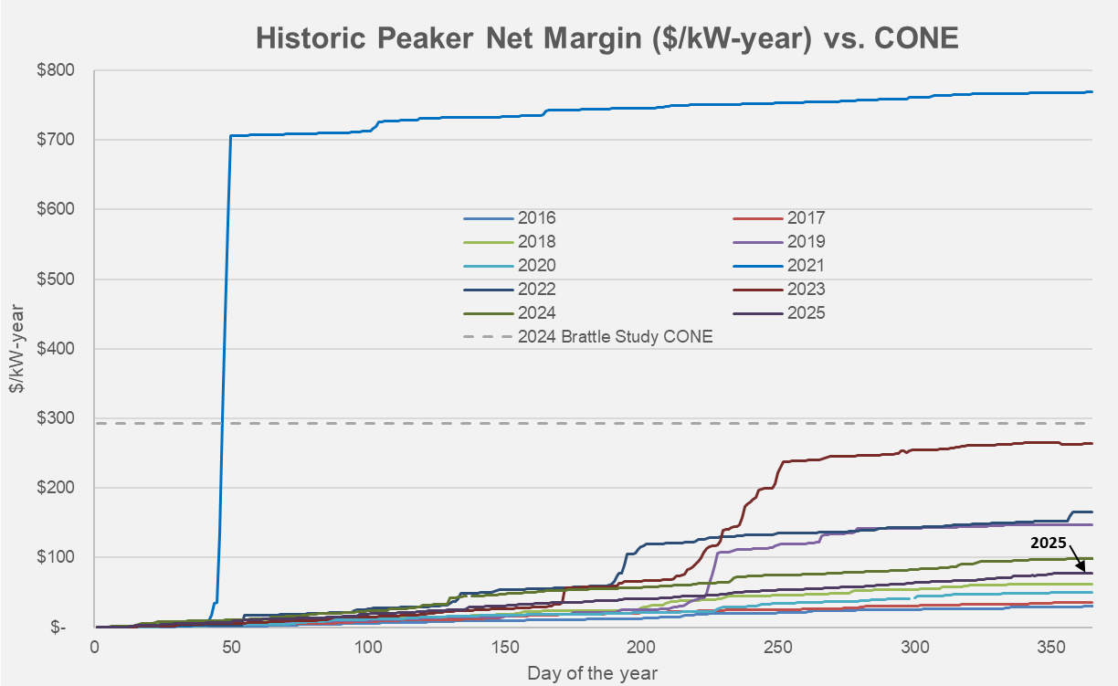

For DRRS to improve ERCOT’s resource adequacy outlook, the co-optimized energy and AS prices must result in generator revenues that at a minimum match the updated CONE value with some predictable frequency. If calibrated inappropriately, NPRR1310 may serve to increase Ancillary Service costs for consumers while remaining insufficient to attract new investment. In the worst case, this would lead to spiraling costs and tighter reserve margins as ERCOT is forced to rely on out-of-market capacity contracts to maintain existing resources, further dampening the resource adequacy signal and deepening the structural problems of its wholesale markets. As noted above, the first step to calibrating DRRS for resource adequacy is to provide a durable and predictable signal to investors of the capacity requirement. The triennial reliability standard assessment provides that predictable cadence upon which to update this requirement. Because DRRS is designed as a co-optimized Ancillary Service, price formation will depend not just on the plan size and DRRSRFs, but on the shape of the ASDC. The second step therefore to calibrating DRRS for resource adequacy is to ensure that price formation is linked, in some manner, to a specific resource adequacy goal through the DRRS ASDC.
If DRRS alone is meant to achieve a specific resource adequacy goal, it is necessary to link the parameters or shape of the DRRS ASDC to historical peaker net margin or to recalibrate this signal dynamically. Conversely, if the market design of DRRS is not linked to CONE, it is likely that NPRR1310 could fall short of the mark needed to improve resource adequacy. LCRA encourages stakeholders to consider language in Nodal Protocols requiring the DRRS ASDC be calibrated to meet a specific resource adequacy target, informed by either historic analysis or probabilistic assessment of peaker net margin relative to a reference CONE. In the absence of this requirement, it is unclear how NPRR1310 (or any market design) can meet the reliability standard with any degree of certainty. If DRRS is designed without a direct linkage to a certain metric, it will be necessary to recalibrate energy scarcity pricing through modification of the AORDC which can also be explored during the upcoming Reliability Standard assessment.
Cost allocation of DRRS for resource adequacy should be reconsidered.
It is possible that any resource adequacy product will receive criticism from Load Serving Entities (LSEs) that hedge their expected load obligation in advance of RTM operations. These entities might argue that it is inappropriate to directly subsidize new generation when their customers’ load has been covered through alternative arrangements (e.g., power purchase agreements, energy trades, DAM activity). As such, it may be appropriate to consider allocating the resource adequacy portion of DRRS payments to the market through a capacity-short methodology which minimizes charges for balanced Qualified Scheduling Entities (QSEs). In such an approach, LSEs that fail to come to the market with a balanced capacity position would pay for all (or a portion) of the resource adequacy procurements based on their shortage. A move in this direction would require significant changes to NPRR1310 as drafted but may be more easily supported along cost causation principles.
Additional quantitative analysis of DRRS price formation is necessary to evaluate its usefulness of NPRR1310 as a resource adequacy tool.
Finally, LCRA recommends that ERCOT conduct an analysis of DRRS price formation under different ASDC parameterizations and with different operating conditions to support stakeholder deliberations in calibrating the DRRS ASDC to meet the reliability standard. The analysis should consider the impact of DRRS ASDC design on prices for energy and other Ancillary Services to reflect the holistic impact of DRRS on resource adequacy. At a minimum ERCOT should evaluate changes to the operational DRRS price cap, changes to the operational DRRS price floor (to create a ramped resource adequacy curve), and changes to the overall resource adequacy DRRS plan. These analyses are necessary to support stakeholder deliberations on the resource adequacy benefits of NPRR1310, and to narrow discussions to practical solutions for meeting the reliability standard at the lowest cost to consumers. These analyses may also be well suited as companion studies complimenting this year’s triennial reliability standard assessment.

Figure 2: Current market design of DRRS as implemented by NPRR1310. “Operational DRRS Plan” refers to the DRRS quantities necessary to meet inter-hour operational challenges caused from net-load forecast error and forced outages. “Resource Adequacy DRRS Plan” refers to the DRRS quantities necessary to meet the reliability standard as assessed by the triennial reliability standard assessment.
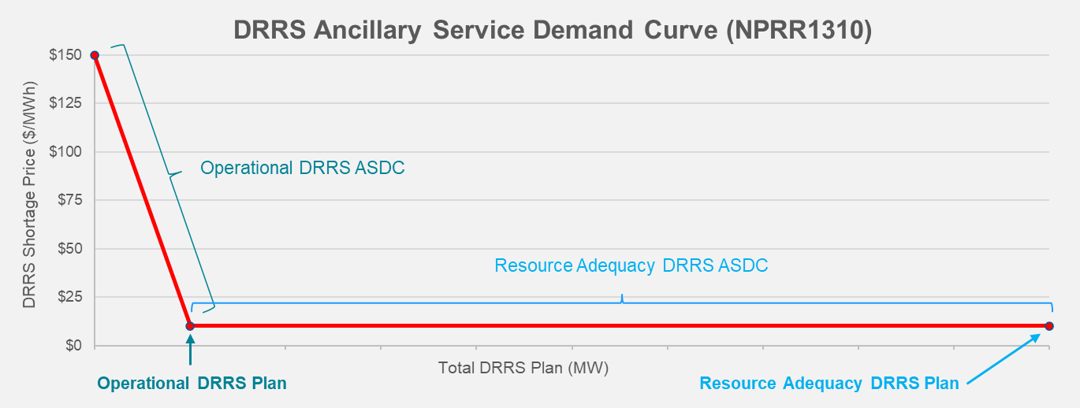

Figure 3: Recommended price formation analysis of DRRS ASDCs to meet a targeted reliability standard.
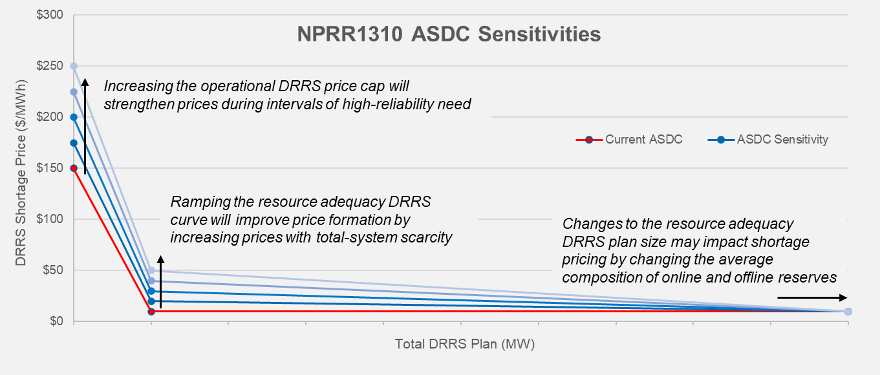

NPRR1310 meets statutory requirements and may serve as a useful resource adequacy tool if calibrated appropriately.
As noted in LCRA’s Comments to NPRR1309, ERCOT’s DRRS design appears to implement the full statutory requirements of PURA §39.159 (with or without the release factor). Despite meeting these requirements, it is not yet evident that the design of NPRR1310 is sufficient to solve ERCOT’s resource adequacy challenges. ERCOT’s references to a study commissioned by Aurora Energy have not been compelling as the studied DRRS resource adequacy market design is fundamentally different than ERCOT’s NPRR1310 proposal. Additional quantitative analysis of DRRS price formation will be necessary to justify this claim and modifications to protocol language may be required to strengthen design based on this information. LCRA looks forward to collaborating with ERCOT and stakeholders in continuing to refine the design of NPRR1310 for use as a resource adequacy tool.
Revised Cover Page Language
None at this time.
Revised Proposed Protocol Language
None at this time.

See Assessment of Resource Adequacy Needs in ERCOT and Impact of Market Design Changes (Aurora Energy’s analysis of ERCOT’s current wholesale market design indicates a reasonable probably of long-duration (i.e., >12 hours) load shed events in both winter and summer peak seasons of 2030), available at https://www.ercot.com/files/docs/2025/12/10/Aurora-Assessment-of-Resource-Adequacy-Needs-in-ERCOT-Region-and-Impact-of-Market-Design-Changes-2025.11.10-.pdf
See Staff’s Review of the ERCOT and E3 PCM Assessments and Staff’s Final Recommendation on the PCM (PUC Staff acknowledge “The long-term equilibrium of the ERCOT market design is well below the frequency criterion of the Commission's reliability standard”), available at https://interchange.puc.texas.gov/Documents/55000_47_1449541.PDF
See NPRR1315, Changes to Process of Evaluating the Potential Needs for Additional Capacity (filed by ERCOT) (Dec. 19 2025)
PURA § 28.508(3)(C)(i)
See NPRR1310, Dispatchable Reliability Reserve Service Plus Energy Storage Resource Participation and Release Factor, Section 2.1 Definitions (Dispatchable Reliability Reserve Service Release Factor) (filed by ERCOT) (Nov. 20 2025)
PJM, MISO, ISONE, and NYISO all require load serving entities to pay for capacity proportional to the expected peak demand of their customers.
See Role of CONE in Wholesale Markets (presented by IMM) available at https://www.ercot.com/files/docs/2025/11/21/Role-of-CONE-in-Wholesale-Markets.pdf
See ERCOT Proposal To Update Cost of New Entry For The 2026 Reliability Assessment, available at https://interchange.puc.texas.gov/Documents/58777_5_1575180.PDF
The RUC-Capacity Short Charge calculation allocates costs in a similar manner Nodal Protocols §5.7.4.1
PURA §25.508(3)(C)(i) requires ERCOT to “provide the commission with a summary explanation of any identified deficiencies and its supporting analysis. ERCOT must also provide the commission with a menu of proposed recommended market design changes, including a primary recommendation, that are intended to address the identified deficiencies.”
See Assessment of Resource Adequacy Needs in ERCOT and Impact of Market Design Changes, available at https://www.ercot.com/files/docs/2025/12/10/Aurora-Assessment-of-Resource-Adequacy-Needs-in-ERCOT-Region-and-Impact-of-Market-Design-Changes-2025.11.10-.pdf

