ERCOT AVR Test for a Small Conventional DGRs
Resource Integration Department, ERCOT
1/26/2026

Conventional DGR - AVR Test Objective: The purpose of the AVR test is to test the DGRs ability to go from LSL to HSL and back while the AVR keeps the reactive power to 0 MVAr (unity power factor) at the Point of Common Coupling (PCC).

The AVR test is to be conducted during a continuous period of time with the unit ramping from LSL to HSL at the registered ramp rate shown in the table below and reported on 4 second intervals or less.

During the AVR test, the Unit will ramp from LSL to 25%, 50%, 75% and 100% of the HSL at the registered ramp rate to reach a steady state. Once it reaches a steady state, the Unit should maintain its output for 5 minutes before ramping down to LSL. The HSL should match the max registered HSL with ERCOT, taking into account any system limitations (distribution system limits, stability limits, or other limits). Measurements must be taken and recorded at each of the following levels, including the ramping up and down periods (For example, MW levels for a maximum HSL of 10 MW):

- 25% output - 2.5 MW for 5 minutes, go to LSL output for at least 1 minute
- 50% output - 5 MW for 5 minutes, go to LSL output for at least 1 minute
- 75% output - 7.5 MW for 5 minutes, go to LSL output for at least 1 minute
- 100% output - 10 MW for 5 minutes, go to LSL output for at least 1 minute

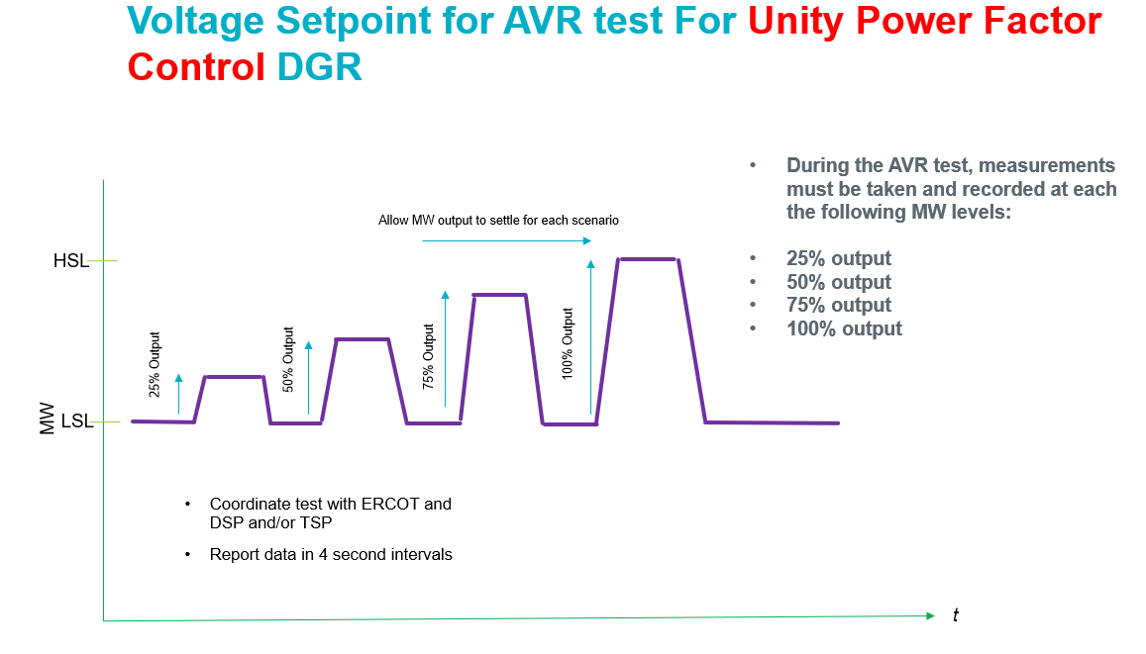

AVR test data will be entered on an Excel worksheet using the following template.

- Column A is for the time-stamp (CPT) using MM/DD/YYYY HH:MM:SS AM/PM
- Column B is for PCC voltage in kV
- Column C is for MW flow at the PCC (+ for flow from the DGR to the PCC)
- Column D is for MVAr flow at the PCC (+ for flow from the DGR to the PCC)

AVR Test PASS/FAIL Criteria:

- ERCOT will consult the DSP/TSP and exercise engineering judgement if there is a question of the AVR Test passing based on the following criteria.

- Each test point is evaluated using the following rules:
  - For when the absolute value of the DGR MW PCC flow is > 30% of maximum MW DGR capability
    - A test measurement will “pass” if the absolute value of the DGR MVAr PCC flow is <= 3.5% of absolute value of the DGR MW PCC flow

  - For when the absolute value of the DGR MW PCC flow is <= 30% of maximum installed MW DGR capability
    - A test measurement will “pass” if the absolute value of the DGR MVAr PCC flow is <= 1.3% of the maximum installed MW DGR capability
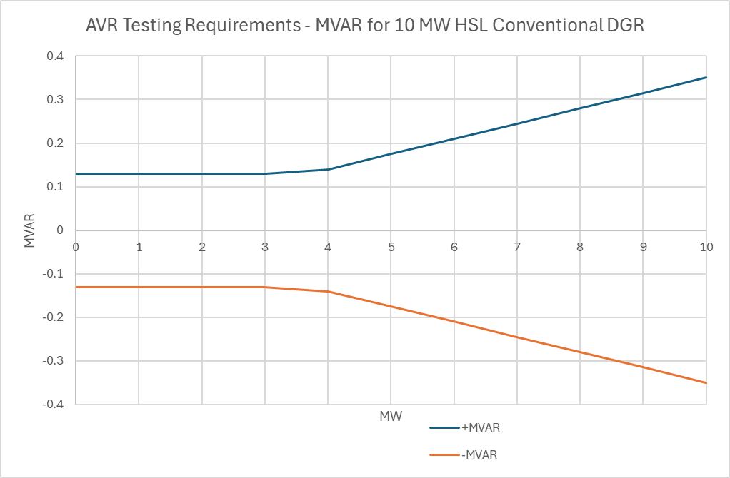

For the test points that “fail” the above 2 rules, the voltage dips (flicker) must be less than the following to minimize MVAr transients to the PCC. (Refer to IEEE Std 1453-2015 IEEE Recommended Practice for the Analysis of Fluctuating Installations on Power Systems – Figure 1 --- GE flicker curve.)
    - Voltage dips resulting in a <= 3% change in PCC voltage will “pass” if the frequency of voltage dips is <= 10 voltage dips per hour (for typical operations)
    - Voltage dips resulting in a <= 2% change in PCC voltage will “pass” if the frequency of voltage dips is <= 1 voltage dip per minute (for typical operations)
    - Voltage dips resulting in a <= 1% change in PCC voltage will “pass” if the frequency of voltage dips is <= 15 voltage dips per minute (for typical operations)
    - Voltage dips resulting in a <= 0.5% change in PCC voltage will “pass” regardless of frequency of voltage dips (for typical operations)

The AVR test data spreadsheet is to be submitted as an attachment in the NDCRC application on MIS in the section for AVR Tests.

References:

- Initial discussions with Oncor, TNMP and PEC.
- IEEE Std 1453-2015 IEEE Recommended Practice for the Analysis of Fluctuating Installations on Power Systems

