
November 2025 ERCOT Monthly Operations Report
Reliability and Operations Subcommittee Meeting
January 8, 2026

Table of Contents
1. Report Highlights 2
2. Frequency Control 3
2.1. Frequency Events 3
2.2. ERCOT Contingency Reserve Deployments/Releases 4
2.3. Responsive Reserve Deployments/Releases 4
2.4. Load Resource Deployments 4
3. Reliability Unit Commitment 4
4. IRR, Wind, and Solar Generation as a Percent of Load 6
5. Largest Net-Load Ramps 8
6. Congestion Analysis 8
6.1. Notable Constraints 8
6.2. Generic Transmission Constraint Congestion 14
6.3. Manual Overrides 14
6.4. Congestion Costs for Calendar Year 2025 14
7. System Events 16
7.1. ERCOT Peak Load 16
7.2. Load Shed Events 16
7.3. Stability Events 17
7.4. Notable PMU Events 17
7.5. DC Tie Curtailment 17
7.6. TRE/DOE Reportable Events 17
7.7. New/Updated Constraint Management Plans 17
7.8. New/Modified/Removed RAS 17
7.9. New Procedures/Forms/Operating Bulletins 17
8. Emergency Conditions 17
8.1. OCNs 17
8.2. Advisories 17
8.3. Watches 18
8.4. Emergency Notices 18
9. Application Performance 18
9.1. TSAT/VSAT Performance Issues 18
9.2. Communication Issues 18
9.3. Market System Issues 18
10. Model Updates 18
Appendix A: Real-Time Constraints 20

Report Highlights
- The unofficial ERCOT peak load for November 2025 was 64,698 MW and occurred on 11/17/2025 during hour ending 16:00, this is 4,524 MW more than the November 2024 peak demand of 60,174 MW on 11/04/2024 during hour ending 14:00.
- There were 3 frequency events.
- There were no ERCOT Contingency Reserve Service (ECRS) events.
- There were no Responsive Reserve Service (RRS) events.
- 1 OCN due to potential wildfire risk for a large portion of South-Central Texas in the ERCOT region.
- 2 Advisories due to geomagnetic disturbances of K-7 or greater levels.
- 0 Watches due to SCED failure.
- 0 Emergency Notices
- There were 72 HRUC commitments.
- The following GTCs saw congestion in November:
GTC | Days Congestion
North Edinburg – Lobo | 25
Panhandle | 16
West Texas | 18
Nelson Sharpe – Rio Hondo | 24
McCamey | 19
Valley Export | 14
South Texas Export Pawnee-Spruce | 10
North to Far West | 22
South Texas Export Pawnee-Tango | 15
Kinney | 1
South Texas Import Katoen-Lonhill | 4
Hamilton | 3
South to Far West | 7

Frequency Control

Frequency Events
The ERCOT Interconnection experienced 3 frequency events.
A summary of the frequency event is provided below. The reported frequency event meets one of the following criteria: Delta Frequency is 60 mHz or greater; the MW loss is 350 MW or greater; resource trip event triggered ECRS deployment. Frequency events that have been identified as Frequency Measurable Events (FME) for purposes of BAL-001-TRE-2 analysis are highlighted in blue. When analyzing frequency events, ERCOT evaluates PMU data according to industry standards. Events with an oscillating frequency of less than 1 Hz are inter-area, while higher frequencies indicate local events. Industry standards specify that damping ratio for inter-area oscillations should be 3.0% or greater. For the frequency event listed below, the ERCOT system met these standards and transitioned well after the disturbance. In the case of negative delta frequency, the MW Loss column could refer to load loss.
Date and Time | Delta Frequency | Max/Min Frequency | Duration of Event | PMU Data |  | MW Loss | Load | IRR | Inertia
Date and Time | (Hz) | (Hz) | Duration of Event | Oscillation Mode (Hz) | Damping Ratio | MW Loss | (MW) | % | (MW-s)
11/3/2025 6:56:22 | 0.064 | 59.953 | 00:04:17 | 0.75 | 13% | 721 | 46,550 | 38% | 177,745
11/18/2025 2:27:25 | 0.039 | 59.962 | 00:03:15 | 0.78 | 10% | 459 | 47,800 | 32% | 248,050
11/21/2025 12:07:50 | 0.095 | 59.901 | 00:03:49 | 0.61 | 15% | 1323 | 57,414 | 49% | 241,314

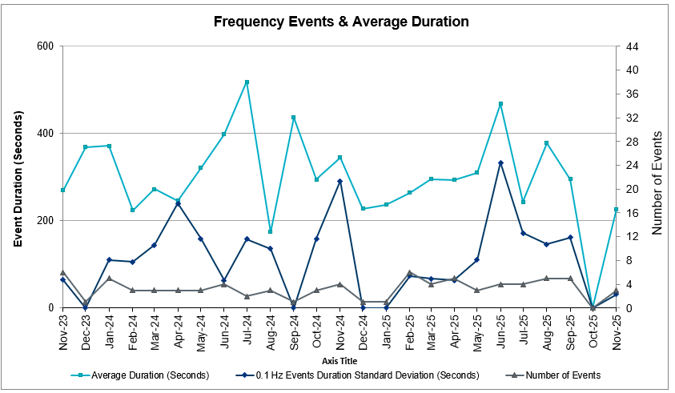
(Note: All data on this graph encompasses frequency event analysis based on BAL-001-TRE-2.)

ERCOT Contingency Reserve Deployments/Releases
There were 0 events where ERCOT Contingency Reserve MWs were released to SCED. The events highlighted in blue were related to frequency events reported in Section 2.1 above.
Date and Time Released to SCED | Date and Time Recalled | Duration of Event | Maximum MWs Released | Comments
N/A | N/A | N/A | N/A | N/A

Responsive Reserve Deployments/Releases
There were no events where Responsive Reserve MWs were released to SCED.
Date and Time Released to SCED | Date and Time Recalled | Duration of Event | Maximum MWs Released | Comments
N/A | N/A | N/A | N/A | N/A

Load Resource Deployments
There were no events where Load Resources that are controlled by Under-Frequency Relays were deployed for an Emergency Condition.

Reliability Unit Commitment
ERCOT reports on Reliability Unit Commitments (RUC) monthly. Commitments are reported grouped by operating day and weather zone. The total number of hours committed is the sum of the hours for all the units in the specified region. Additional information on RUC commitments can be found on the MIS secure site at Grid Generation Reliability Unit Commitment.
There were 0 DRUC commitments.
There were 72 HRUC commitments.
Resource Location | # of Resources | Operating Day | Total # of Hours Committed | Total MWhs | Reason for Commitment
NORTH_CENTRAL | 1 | November 1, 2025 | 4 | 1,580.0 | E_PATA
SOUTHERN | 1 | November 6, 2025 | 6 | 1,554.0 | DSALHUT5
NORTH_CENTRAL, SOUTH_CENTRAL | 7 | November 11, 2025 | 43 | 11,144.0 | E_PASP, Min run time
EAST, NORTH_CENTRAL | 5 | November 12, 2025 | 20 | 6,251.0 | E_PASP, Min Offline Time
EAST, NORTH, NORTH_CENTRAL | 8 | November 13, 2025 | 37 | 11,131.0 | E_PATA
EAST, NORTH, NORTH_CENTRAL, SOUTHERN | 9 | November 14, 2025 | 45 | 11,662.9 | E_PATA
NORTH_CENTRAL | 4 | November 16, 2025 | 29 | 2,810.0 | E_PATA
EAST, NORTH_CENTRAL | 3 | November 17, 2025 | 16 | 2,320.0 | MRNKDHM5
NORTH_CENTRAL | 2 | November 18, 2025 | 16 | 856.0 | E_PASP
NORTH_CENTRAL | 4 | November 19, 2025 | 31 | 3,006.0 | E_PASP
NORTH_CENTRAL | 2 | November 21, 2025 | 12 | 1,136.0 | E_PASP
EAST, NORTH_CENTRAL | 6 | November 24, 2025 | 48 | 13,355.0 | E_PASP
EAST, NORTH_CENTRAL | 3 | November 26, 2025 | 16 | 4,556.0 | E_PASP
NORTH_CENTRAL, SOUTH_CENTRAL | 3 | November 27, 2025 | 13 | 5,252.0 | E_PASP
EAST, NORTH_CENTRAL, SOUTH_CENTRAL | 8 | November 29, 2025 | 39 | 12,477.0 | E_PASP
EAST, NORTH_CENTRAL | 6 | November 30, 2025 | 43 | 11,295.0 | E_PASP

IRR, Wind, and Solar Generation as a Percent of Load
The graph below shows the maximum, minimum and average aggregate solar, wind and IRR output as a percentage of total ERCOT load when evaluated as 10-minute averaged intervals, over the past 13 months. Current wind and solar generation and penetration records are listed in the footnote below. Maximum IRR penetration for November 2025 was 74.34% on 11/04/2025 interval ending 10:50 and minimum IRR penetration for November 2025 was 4.34% on 11/25/2025 interval ending 07:00.
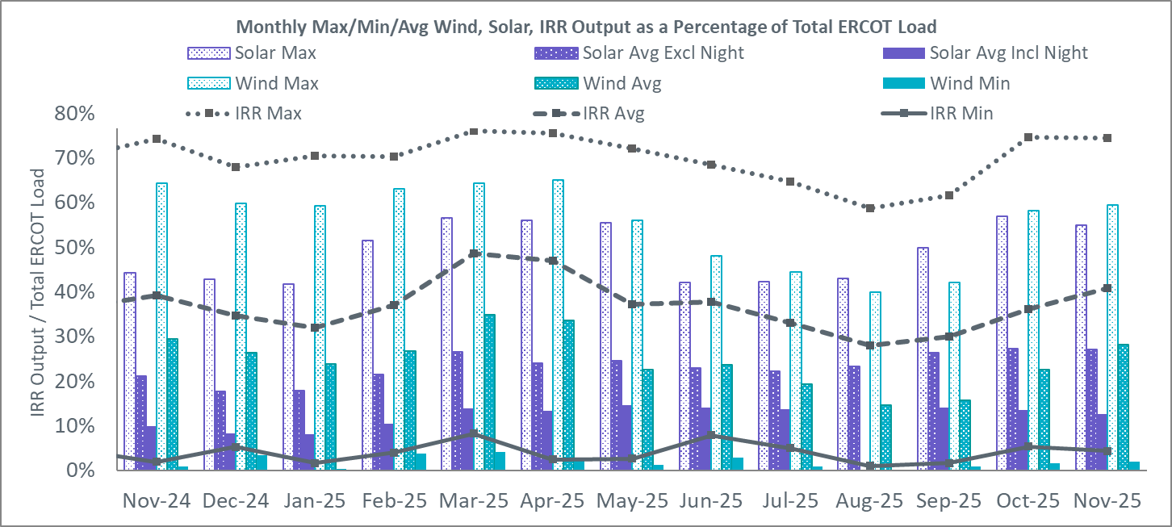
During the hour of peak load for the month, hourly integrated wind generation was 17,634 MW and solar generation was 18,082 MW. The graph below shows the wind and solar penetration percentage during the hour of the peak load in the last 13 months.
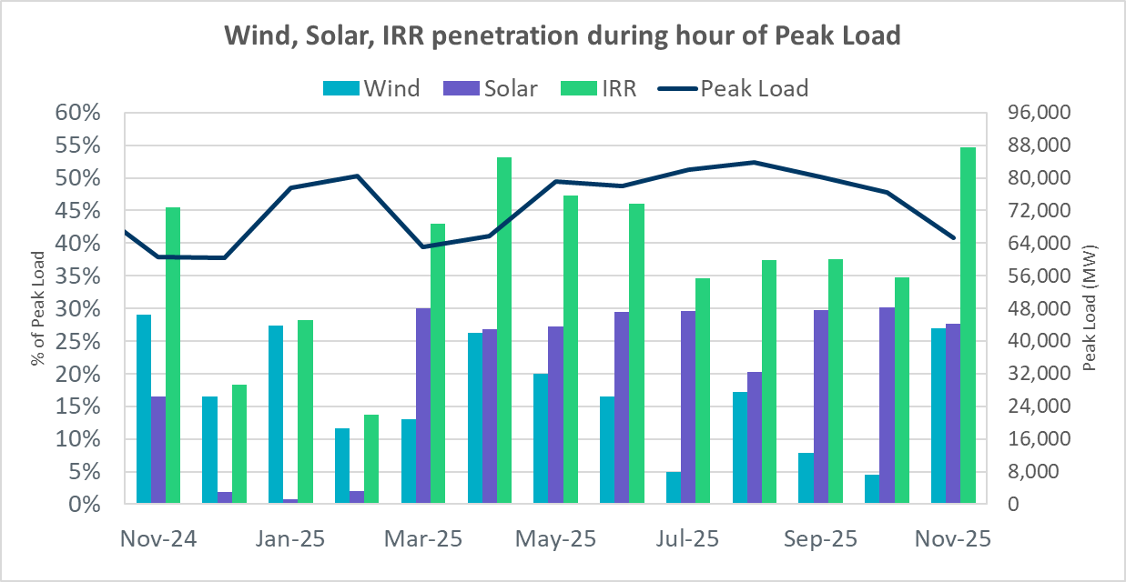

Lastly, the graph below shows the minimum wind, solar, and IRR output during the peak load hour as a percentage of the daily peak load for every day in the month.
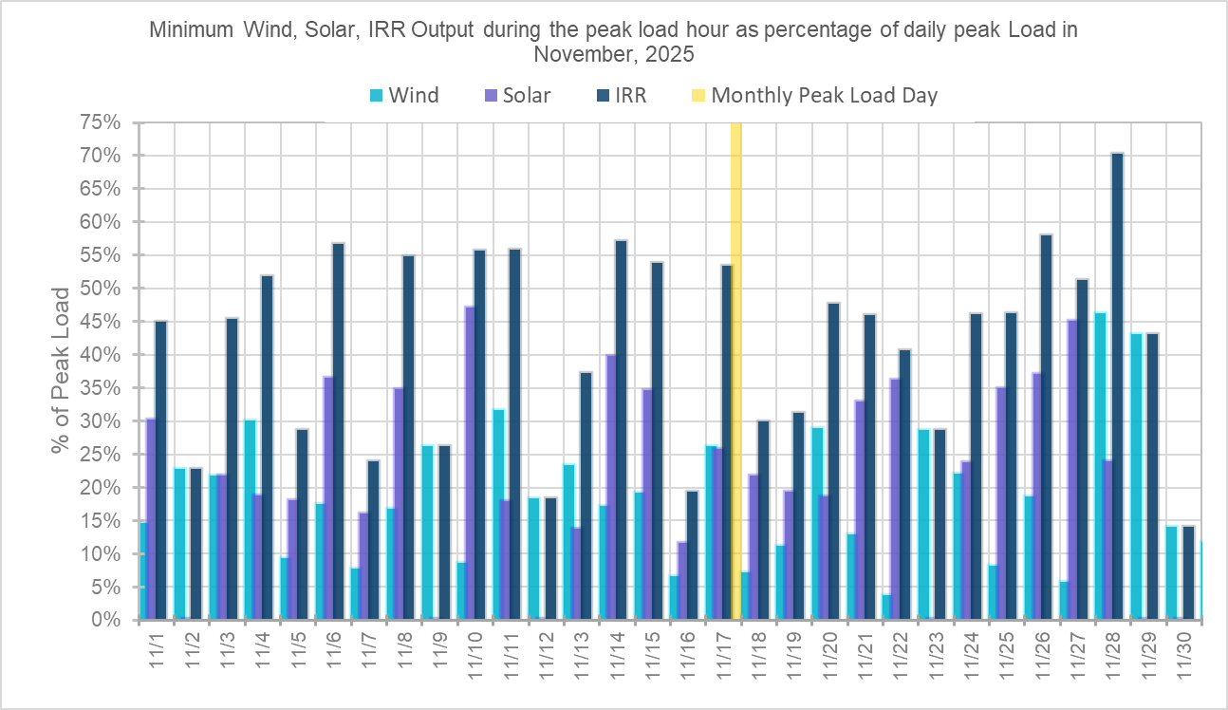

Largest Net-Load Ramps
The net-load ramp is defined as the change in net-load (load minus wind and PVGR generation) during the defined time horizon. Such a variation in net-load needs to be accommodated in grid operations to ensure that the reliability of the grid is satisfactorily maintained. The largest net-load ramps over 5-minute, 10-minute, 15-minute, 30-minute, and 60-minute intervals in November 2025 were 1,832 MW, 3,412 MW, 5,024 MW, 9,795 MW, and 17,392 MW respectively. A comparison with historical values is provided in the table below.
Month and Year | 5 min | 10 min | 15 min | 30 min | 60 min
November 2014 | 991 MW | 1,689 MW | 2,112 MW | 3,289 MW | 5,392 MW
November 2015 | 915 MW | 1,637 MW | 1,995 MW | 3,241 MW | 5,516 MW
November 2016 | 821 MW | 1,404 MW | 1,827 MW | 3,166 MW | 5,866 MW
November 2017 | 877 MW | 1,581 MW | 2,078 MW | 3,393 MW | 5,708 MW
November 2018 | 814 MW | 1,553 MW | 2,148 MW | 4,109 MW | 7,218 MW
November 2019 | 940 MW | 1,606 MW | 2,269 MW | 3,934 MW | 6,317 MW
November 2020 | 971 MW | 1,264 MW | 1,655 MW | 3,061 MW | 5,751 MW
November 2021 | 1,311 MW | 1,639 MW | 2,281 MW | 3,781 MW | 6,587 MW
November 2022 | 1,107 MW | 1,907 MW | 2,764 MW | 5,166 MW | 9,218 MW
November 2023 | 1,426 MW | 2,810 MW | 3,991 MW | 6,762 MW | 10,976 MW
November 2024 | 1,603 MW | 2,870 MW | 3,994 MW | 7,629 MW | 13,811 MW
Nov-25 | 1832 MW | 3,412 MW | 5,024 MW | 9,795 MW | 17,392 MW
Nov-25 | 11/9/2025 | 11/9/2025 | 11/9/2025 | 11/9/2025 | 11/10/2025
Nov-25 | (IE 17:02) | (IE 17:02) | (IE 17:02) | (IE 17:05) | (IE 17:15)
All Months in 2014-2025 | 3,797 MW | 3,562 MW | 5,024 MW | 9,795 MW | 17,392 MW
All Months in 2014-2025 | 5/28/2025 | 5/28/2025 | 11/9/2025 | 11/9/2025 | 11/10/2025
All Months in 2014-2025 | (IE 10:27) | (IE 10:27) | (IE 17:02) | (IE 17:05) | (IE 17:15)

Congestion Analysis

Notable Constraints
Nodal protocol section 3.20 specifies that ERCOT shall identify transmission constraints that are binding in Real-Time three or more Operating Days within a calendar month. As part of this process, ERCOT reports congestion that meets this criterion to ROS. In addition, ERCOT also highlights notable constraints that have an estimated congestion rent exceeding $1,000,000 for a calendar month. These constraints are detailed in the table below, including approved transmission upgrades from TPIT that July provide some congestion relief based on ERCOT’s engineering judgement. Rows highlighted in blue indicate the congestion was affected by one or more outages. For a list of all constraints activated in SCED, please see Appendix A at the end of this report.
Contingency Name | Overloaded Element | Contingency Name | Overloaded Element | # of Days Constraint Binding | Congestion Rent | Transmission Project
DTVWJON5 | 6033__A | TVWSW TO CPSES 345 AND CPSES TO JONSW 345 DBLCKT | Comanche Peak Ses - Mitchell Bend Switch 345kV | 7 | $11,484,739.60
MRNKDHM5 | 587__A | MANUAL RNKSW TO DHMSW 345&KRWSW TO DHMSW 345 DBLCKT | Argyle - Highlands Tnp 138kV | 13 | $10,649,216.33
DSALHUT5 | 421__A | SALSW - HUTTO 345KV | Sandow Switch - Bell County East Switch 345kV | 12 | $10,578,724.62
SW_LVLT5 | 15060__B | wett_long_draw to Volta LIN 1 | Koch Tap - Vealmoor 138kV | 16 | $9,244,761.22
DODEMOS5 | 6513__A | ODEHV-MOSSW 345&ODEHV-WLFSW 345_DBLCKT | Odessa North - Odessa 138kV | 8 | $9,221,285.68
MPRLCO25 | 6960__A | MAN_SGL_PRLSW-CONSW_345KV_2 | Consavvy Switch - Prairieland Switch 345kV | 13 | $5,798,913.99
MRGRMG25 | 6945__A | MAN_DBL_RGRSW-FLCNS+RGRSW-MGSES+FLCNS_XFMR1_345KV | Morgan Creek Ses - Cattleman Switch 345kV | 5 | $5,785,514.98
DFOAVLO5 | LASCRU_MILO1_1 | FOWLERTON to LOBO & AVANZADA | Las Cruces - Milo 138kV | 22 | $5,405,660.06
DFRYTM58 | SEA_AAT1 | DOUBLE FRYSW-TMPSW 138 & KNBSW-SALSW 345 | Seaton 138kV | 9 | $5,326,694.02
BASE CASE | NE_LOB | Basecase | NE_LOB GTC | 20 | $4,626,785.50
DBAKSOL5 | 6965__A | Bakersfield - Solstice line 1 and 2 | Longshore Switch - Prairieland Switch 345kV | 7 | $4,268,970.00
BASE CASE | PNHNDL | Basecase | PNHNDL GTC | 13 | $3,988,020.24
DBAKCED5 | 6965__A | BAKESW-CEDACA 345kV & BAKESW-CEDACA 345kV | Longshore Switch - Prairieland Switch 345kV | 13 | $3,875,180.23
BASE CASE | WESTEX | Basecase | WESTEX GTC | 8 | $3,637,984.94
BASE CASE | NELRIO | Basecase | NELRIO GTC | 24 | $3,555,351.70
DELMSAN5 | PAWNEE_SPRUCE_1 | Elmcreek-Sanmigl 345kV | Pawnee Switching Station - Calaveras 345kV | 3 | $3,554,578.45
SBWDDBM5 | LPLMK_LPLNE_1 | BLACKWATER DRAW SWITCH to DOUBLE MOUNTAIN SWITCH LIN 1 | Mackenzie Substation - Northeast Substation 115kV | 14 | $3,488,492.07
XARA89 | NAVALB_N_PADR1_1 | ARANSAS PASS TRX 69A1 138/69 | Naval Base - North Padre 69kV | 6 | $3,405,502.83
DMTSCOS5 | 6437__F | DMTSW TO SCOSW 345 DBLCKT | Knapp - Scurry Chevron 138kV | 19 | $3,380,595.39
DELMSTP5 | STPELM27_1 | STP-Elmcreek&WAP 345kV | South Texas Project - Elmcreek 345kV | 4 | $3,198,193.86
BASE CASE | MCCAMY | Basecase | MCCAMY GTC | 12 | $2,992,948.38
DTHSFBR5 | 35050__B | SAMSW to TCRSW 345kV & FBRSW to THSES 345_DBLCKT | Venus Switch - Fort Smith Switch 345kV | 7 | $2,676,324.50
DBIGKEN5 | TREADW_YELWJC1_1 | Bighil-Kendal 345kV | Yellow Jacket - Treadwell 138kV | 13 | $2,661,241.82
DSALGA58 | 630__A | SALSW TO KNBSW 345 AND SALSW TO BELCNTY 138 DBLCKT | Belton - Belton Southwest 138kV | 3 | $2,487,694.34
XEIN58 | 6470__D | EINSTEIN TRX 7TR1 345/138 | Forest Creek And Sand Bluff Wind Farms - Glasscock County North 138kV | 3 | $2,392,821.94
SBCESND5 | 421__A | BELL COUNTY EAST SWITCH to BELL COUNTY EAST SWITCH LIN _A | Sandow Switch - Bell County East Switch 345kV | 5 | $1,928,721.16
SEL_ARR8 | BLESSING_69A1 | EL CAMPO to ARROZ LIN 1 | Blessing 138kV | 4 | $1,919,446.92
DBBSRCH5 | 1210__C | BBSES TO RCHBR 345 DBLCKT | Haney Bepc - Navarro 138kV | 6 | $1,846,289.39
DCPSES12 | 35055__A | Comanche Peak 1 & 2 | Sam Switch - Venus Switch 345kV | 5 | $1,830,069.88
MLWSWDE5 | 587__A | MANUAL RNKSW TO WDENT 345&KRWSW TO DHMSW 345 DBLCKT | Argyle - Highlands Tnp 138kV | 5 | $1,778,257.83
DKG_NB_5 | HL_PSA08_A | TWR(345) JOR-KG97 & JOR-NB99 | Highlands - Power Systems Arco Cogen 138kV | 9 | $1,639,957.74
SKLELOY8 | LOYOLA_69_1 | KLEBERG AEP to KLEBERG AEP LIN 1 | Loyola Sub 138kV | 22 | $1,590,378.93
DSWELNC5 | BLUF_C_MULBER1_1 | SWESW TO MULBERRY AND SWESW TO LNCRK 345 DBLCKT | Bluff Creek - Abilene Mulberry Creek 345kV | 4 | $1,561,992.82
MRNKDHM5 | 570__A | MANUAL RNKSW TO DHMSW 345&KRWSW TO DHMSW 345 DBLCKT | Argyle - Corinth (Oncor) 138kV | 4 | $1,515,120.73
DTCRTHS5 | 35050__B | THSES TO FBRSW & TCRSW 345 DBLCKT | Venus Switch - Fort Smith Switch 345kV | 3 | $1,511,216.37
DAUSLOS5 | CKT_3121_1 | Lostpi-Austro&Dunlap 345kV | Lytton Springs - Cistern 345kV | 3 | $1,508,653.90
SW_BW_25 | 16050__A | Bernoulli to Bernoulli LIN 1 | Eiland - Hillger Sub 138kV | 1 | $1,503,555.64
DRENCRL5 | 1160__A | CRLNW TO RENSW 345 AND CRLNW TO PTENN 345 DBLCKT | Hackberry - Valley Ranch 138kV | 1 | $1,416,029.06
MCONPRL5 | 16050__B | MAN_DBL_PRLSW-CONSW_345KV | Carterville - Hillger Sub 138kV | 5 | $1,262,919.08
DTCRTHS5 | 35045__A | THSES TO FBRSW & TCRSW 345 DBLCKT | Sam Switch - Files Valley Switch 345kV | 5 | $1,237,589.38
SRAYRI38 | HAINE__LA_PAL1_1 | LAS PULGAS to RAYMONDVILLE 2 LIN 1 | Haine Drive - La Palma 138kV | 2 | $1,194,446.39
BASE CASE | VALEXP | Basecase | VALEXP GTC | 11 | $1,163,490.44
SFRYTMP8 | SEA_AAT1 | FRYERS CREEK to TEMPLE SWITCH LIN _B | Seaton 138kV | 2 | $1,138,182.83
DBIGKEN5 | FORTMA_YELWJC1_1 | Bighil-Kendal 345kV | Yellow Jacket - Fort Mason 138kV | 10 | $1,094,149.14
DBIGKEN5 | FORTMA_YELWJC1_1 | Bighil-Kendal 345kV | Yellow Jacket - Fort Mason 138kV | 10 | $994,608.61
DKG_NB_5 | BCVPSA03_A | TWR(345) JOR-KG97 & JOR-NB99 | Bigvue - Power Systems Arco Cogen 138kV | 1 | $992,917.71
DBAKSOL5 | 6056__Z | Bakersfield - Solstice line 1 and 2 | Longshore Switch - Consavvy Switch 345kV | 1 | $981,716.71
MSTPSTA5 | BLESSING_1382 | Manual Double STP to HLJ & Static 345 KV | Blessing 345kV | 8 | $947,219.66
SCARFRI8 | ATSO_SONR1_1 | Carver to Carver LIN 1 | Atlantic Sonora - Sonora 69kV | 17 | $869,038.29
XST2E89 | 2270__B | STERRETT TRX FMR1 138/69 | Milford Exxon Tap - Italy 69kV | 4 | $844,887.29
DSALHUT5 | 1710__E | SALSW - HUTTO 345KV | Salado Switch - Salado South 138kV | 3 | $844,565.17
DFRYTM58 | 421__A | DOUBLE FRYSW-TMPSW 138 & KNBSW-SALSW 345 | Sandow Switch - Bell County East Switch 345kV | 4 | $833,037.09
DODEMOS5 | 6525__A | ODEHV-MOSSW 345&ODEHV-WLFSW 345_DBLCKT | Odessa Ehv Switch - Reiter Switch 138kV | 3 | $803,400.61
DBAKCED5 | STCO_STER1_1 | BAKESW-CEDACA 345kV & BAKESW-CEDACA 345kV | Sterling City - Sterling County 69kV | 4 | $797,249.47
DBIGKEN5 | MADDUX_TREADW1_1 | Bighil-Kendal 345kV | Maddux - Treadwell 138kV | 7 | $768,167.09
DAUSLOS5 | 196T171_1 | Lostpi-Austro&Dunlap 345kV | Settlers - Sim Gideon 138kV | 2 | $755,694.87
SMDOOAS5 | GN_PZ_08_A | MEADOW to OASIS LIN A | Grant - Plaza 138kV | 9 | $725,443.30
DLOFOAV5 | LASCRU_MILO1_1 | Double LOBO - FOWLERTON & AVANZADA | Las Cruces - Milo 138kV | 3 | $695,894.97
DFRYBC58 | SEA_AAT1 | DOUBLE KNBSW-SALSW 345 & FRYSW-BELCNTY 138 | Seaton 138kV | 2 | $661,849.78
SRCHBBS5 | 30__A | BIG BROWN SES to BIG BROWN SES LIN _A | Big Brown Ses - Richland Chambers 345kV | 2 | $644,079.61
DAUSLOS5 | CKT_3136_1 | Lostpi-Austro&Dunlap 345kV | Cistern - Holman Aen 345kV | 2 | $636,089.93
SGILLIM5 | 1661__A | GILLELAND CREEK to Limmer LIN 1 | Round Rock - Round Rock Northeast 138kV | 4 | $625,175.24
DFOAVLO5 | NLARSW_PILONC1_1 | FOWLERTON to LOBO & AVANZADA | North Laredo Switch - Piloncillo 138kV | 5 | $613,183.43
MDENBCP8 | 6270__D | MANUAL BCPSW TO DENSW 138 DBLCKT | Wagley Robertson - Hicks Switch 138kV | 1 | $575,861.15
DTWIDIV5 | NICOLE_TENNYS1_1 | TWINBU-DVIDE 345KV | Tennyson - Nicole 138kV | 3 | $550,914.45
DBAKSOL5 | STCO_STER1_1 | Bakersfield - Solstice line 1 and 2 | Sterling City - Sterling County 69kV | 4 | $542,365.53
DFRYTM58 | BELCNTY_XFMR | DOUBLE FRYSW-TMPSW 138 & KNBSW-SALSW 345 | Bell County 138kV | 1 | $536,022.73
DGILHIW8 | MORRIS_NUECES1_1 | Gila - Highway 9 138KV | Morris Street - Nueces Bay 138kV | 4 | $522,217.97
DBAKCED5 | 6056__Z | BAKESW-CEDACA 345kV & BAKESW-CEDACA 345kV | Longshore Switch - Consavvy Switch 345kV | 2 | $499,786.06
DBIGKEN5 | CARVER_TINSLE1_1 | Bighil-Kendal 345kV | Carver - Tinsley Tap 138kV | 2 | $486,062.40
SCOLBAL8 | SANA_FMR1 | BALLINGER to COLEMAN LAKE IVIE TAP LIN 1 | Santa Anna 138kV | 2 | $476,676.83
SBBSRCH5 | 20__A | RICHLAND CHAMBERS to BIG BROWN SES LIN _A | Big Brown Ses - Richland Chambers 345kV | 1 | $445,317.69
SZENTH35 | THWZEN71_A | TH WHARTON to Zenith LIN A | Th Wharton - Zenith 345kV | 1 | $437,911.33
SN_SLON5 | CELANE_KLEBER1_1 | LON HILL to NELSON SHARPE LIN 1 | Celanese Bishop - Kleberg Aep 138kV | 2 | $427,240.43
DHUTLIM5 | HUTTO_MR1L | HUTTO-LIMMER & HUTTO-LIMMER 345kV | Hutto Switch 138kV | 2 | $426,274.83
SCOLPAW5 | MAGRUD_VICTOR2_1 | COLETO CREEK to COLETO CREEK LIN 1 | Magruder - Victoria 138kV | 2 | $424,791.54
DMOSME25 | 6345__L | MOSSW-METSW_345_AND_ODEHV-WLFSW_345_DBLCKT | Wolf Switching Station - Sandhills Tap 138kV | 4 | $418,244.36
SFRYTMP8 | BELCNTY_XFMR | FRYERS CREEK to TEMPLE SWITCH LIN _B | Bell County 138kV | 1 | $399,491.72
MHARNED5 | HAINE__LA_PAL1_1 | Manual dbl ckt for NEDIN-BONILLA 345kV & RIOH-PRIM138kV | Haine Drive - La Palma 138kV | 5 | $387,131.81
DCAGCO58 | 656T656_1 | Cagnon-Kendal 345 & Cico-Comfor 138 | Bergheim - Kendall 345kV | 6 | $372,551.04
DDMTMHO5 | FARMLAND_LONGD_1 | MHOS - DMTSW ckt 1 and 2 345 kV | Farmland - Wett_Long_Draw 345kV | 2 | $362,502.72
SN_SAJO5 | LASPUL_RAYMND1_1 | AJO to AJO LIN 1 | Las Pulgas - Raymondville 2 138kV | 11 | $355,998.56
DCPSES12 | 35050__B | Comanche Peak 1 & 2 | Venus Switch - Fort Smith Switch 345kV | 1 | $326,641.57
DTCRTHS5 | 35055__A | THSES TO FBRSW & TCRSW 345 DBLCKT | Sam Switch - Venus Switch 345kV | 3 | $319,200.48
MLNGCA25 | 16050__B | MAN_DBL_CATSW-PRLSW+MGSES-LNGSW_345KV | Carterville - Hillger Sub 138kV | 1 | $312,209.01
SZENTHW5 | THWZEN98_A | TH WHARTON to Zenith LIN A | Th Wharton - Zenith 345kV | 1 | $305,370.72
SKGJOR5 | HL_PSA08_A | KING to JORDAN LIN A | Highlands - Power Systems Arco Cogen 138kV | 2 | $290,714.69
DFOWSMG5 | GEO_SIG_1 | FOWLRTON TO SAN MIGUEL DOUBLE CIRCUIT CONTINGENCY | George West Switching Station - Sigmor 138kV | 9 | $284,528.53
BASE CASE | E_PASP | Basecase | E_PASP GTC | 5 | $275,039.29
SHAYZO25 | 6T227_1 | HAYS ENERGY to ZORN LIN 1 | Zorn - Hays Energy 345kV | 3 | $271,597.36
SPRCPDS8 | 3665__B | PRAIRIE CREEK to PRAIRIE CREEK LIN _A | Prairie Creek Switch - Prairie Creek 138kV | 1 | $265,686.74
DFRYTM58 | OLS_JNES_1 | DOUBLE FRYSW-TMPSW 138 & KNBSW-SALSW 345 | Olsen Tnp - Jonesboro Tnp 69kV | 3 | $260,835.66
BASE CASE | I_FW_N | Basecase | I_FW_N GTC | 7 | $251,138.15
DLHSCNR8 | 3660__A | LHSES TO CNRSW 138 DBLCKT | Prairie Creek Switch - Lake Hubbard Ses 138kV | 3 | $243,136.97
DRESMCL8 | I_DUPS_RESNIK1_1 | I_DUPS - RESNIK & MCCAMPBE 2 138KV | Dupont Switch - Ingleside - Resnik 138kV | 2 | $233,249.63
DFOAVLO5 | FREER_LOBO1_1 | FOWLERTON to LOBO & AVANZADA | Lobo - Freer 69kV | 1 | $232,240.63
DEXCHCK5 | 6270__D | EXCSW TO HCKSW 345 KV DBLCKT | Wagley Robertson - Hicks Switch 138kV | 2 | $223,240.70
DCNSLHS8 | 3660__A | CNRSW-LHSES 138kV | Prairie Creek Switch - Lake Hubbard Ses 138kV | 1 | $222,165.77
DBIGSCH5 | PALOUS_WOLFCA1_1 | Big Hill - Schneeman Draw & Big Hill - Schneeman Draw 2 | Palouse - Wolfcamp 138kV | 5 | $217,745.13
DHUGWR_8 | ARROZ_EL_CAM1_1 | TWR (138) DYN-WR60 & HUG-WR60 | Arroz - El Campo 138kV | 4 | $206,962.91
SLCSTH25 | 505__B | LAKE CREEK SES to LAKE CREEK SES LIN _A | Tradinghouse Ses - Four Brothers Switch 345kV | 1 | $203,299.90
SDBLBN28 | BNK_MIL_1 | LIPAN to LONG LIN 1 | Bunker - Long 138kV | 2 | $187,684.04
DLOFOAV5 | NLARSW_PILONC1_1 | Double LOBO - FOWLERTON & AVANZADA | North Laredo Switch - Piloncillo 138kV | 2 | $183,948.55
DSALGA58 | 421__A | SALSW TO KNBSW 345 AND SALSW TO BELCNTY 138 DBLCKT | Sandow Switch - Bell County East Switch 345kV | 3 | $181,574.20
SGRSMNW8 | MIL_LIPAN_1 | GRINDSTONE SWITCH to MILLER LIN _C | Lipan - Long 138kV | 1 | $169,455.99
SDANBLE8 | BLESSING_69A1 | BLESSING to BLESSING LIN 1 | Blessing 138kV | 3 | $168,838.63
SN_SAJO5 | LASPUL_RIOHON1_1 | AJO to AJO LIN 1 | Las Pulgas - Rio Hondo 138kV | 3 | $159,111.00
DSNG_TB5 | NB_THW97_A | Sng-Tb&Rns 345kV | North Belt - Th Wharton 345kV | 1 | $155,268.77
SBRAHAM8 | ESCOND_GANSO1_1 | BRACKETTVILLE to HAMILTON ROAD LIN 1 | Escondido - Ganso 138kV | 4 | $143,650.34
DMGSBTR5 | 6036__A | MGSES TO CCRSW 345 AND BTRCK TO MGSES 345 DBLCKT | Tonkawa Switch - Morgan Creek Ses 345kV | 3 | $143,267.61
SWXOSTE9 | 2270__B | WAXAHACHIE OCF to STERRETT LIN _A | Milford Exxon Tap - Italy 69kV | 2 | $138,002.72
DBWNAMO5 | BENFIC_REDCRE1_1 | Twinbu-Sarc&Amoscr 345kV | San Angelo Red Creek - San Angelo Ben Ficklin 138kV | 2 | $132,513.05
SBRAPIN8 | ESCOND_GANSO1_1 | BRACKETTVILLE to BRACKETTVILLE LIN 1 | Escondido - Ganso 138kV | 4 | $132,282.70
DVENFTS5 | 2270__B | VENSW-FTSSW & VENSW-SAMSW 345 DBLCKT | Milford Exxon Tap - Italy 69kV | 4 | $129,060.91
MCONPR25 | 16050__B | MAN_DBL_CONSW-MGSES+CONSW-PRLSW_345KV | Carterville - Hillger Sub 138kV | 1 | $123,526.40
DMGSBTR5 | CEDRHI_SILT1_1 | MGSES TO CCRSW 345 AND BTRCK TO MGSES 345 DBLCKT | Cedar Hills - Silver Tap 69kV | 2 | $123,003.40
SL_4RAY8 | RAYBURN_69_2 | LOOP 463 SUB to LOOP 463 SUB LIN 1 | Sam Rayburn Switchyd 138kV | 4 | $107,980.79
MBONNED5 | HAINE__LA_PAL1_1 | Manual BONILLA to NEDIN 345kV | Haine Drive - La Palma 138kV | 2 | $107,231.52
SCLCGTN8 | 6635__G | COLONY CREEK to GHOST TOWN SWITCH LIN _A | Morton Valley (Oncor) - Eastland 69kV | 1 | $102,535.52

Generic Transmission Constraint Congestion
GTC | Days Congestion
North Edinburg – Lobo | 25
Panhandle | 16
West Texas | 18
Nelson Sharpe – Rio Hondo | 24
McCamey | 19
Valley Export | 14
South Texas Export Pawnee-Spruce | 10
North to Far West | 22
South Texas Export Pawnee-Tango | 15
Kinney | 1
South Texas Import Katoen-Lonhill | 4
Hamilton | 3
South to Far West | 7

There was no activity on the remaining GTCs during the month.
Note: This is how many times a constraint has been activated to avoid exceeding a GTC limit, it does not imply an exceedance of the GTC occurred or that the GTC was binding.

Manual Overrides
None

Congestion Costs for Calendar Year 2025
The following table represents the top twenty active constraints for the calendar year based on the estimated congestion rent attributed to the congestion. ERCOT updates this list on a monthly basis.

Contingency | Overloaded Element | # of 5-min SCED | Estimated | Transmission
wett_long_draw to Volta LIN 1 | Koch Tap - Vealmoor 138kV | 41,245 | 211,724,370.83 | Oncor_FW_Expanse - Tredway 138 kV Line (MOD 81305, 24RPG029)
BAKESW-CEDACA 345kV & BAKESW-CEDACA 345kV | Hargrove - Twin Buttes 138kV | 18,497 | 119,547,479.68
Basecase | WESTEX GTC | 17,489 | 87,103,642.96 | The PUCT approved Permian Basin Relibility Plan (765-kV import paths) helps improve, but not fully exit, the GTC yet.
BAKESW-CEDACA 345kV & BAKESW-CEDACA 345kV | Longshore Switch - Consavvy Switch 345kV | 18,038 | 80,274,251.11 | Oncor_FW_81268_Longshore – Consavvy 345 kV Double-Circuit Line Rebuild (MOD 81268, 23RPG034 (note that RPG number in TPIT is wrong))
SALSW - HUTTO 345KV | Bell County - Salado Switch 138kV | 11,756 | 79,062,767.69 | ONCOR_SE_87673_Salado_Bell_County_138 kV Line (MOD 87673, 24RPG001)
DMTSW TO SCOSW 345 DBLCKT | Knapp - Scurry Chevron 138kV | 25,064 | 67,456,222.41 | Oncor_FW_87653 Bluff Creek to Scurry Chevron PRJ (MOD 87653)
TWR(345) WAP-WLF64 & WAP-WLY72 | South Texas Project - Wa Parish 345kV | 10,470 | 50,872,133.78
double FOWLERTON to AVANZADA & LOBO to FOWLERTON | Laredo Vft North - Las Cruces 138kV | 16,274 | 49,030,467.72 | AEP_TCC_Laredo VFT North - Las Cruces 138 kV Line Rebuild (MOD 58008); In service date 5/4/2023, However, the rating has not updated yet in the Network Operations Model.
Manual dbl ckt for NEDIN-BONILLA 345kV & RIOH-PRIM138kV | Haine Drive - La Palma 138kV | 18,732 | 43,329,648.75
Basecase | E_PASP GTC | 18,439 | 39,549,364.76 | The following RPG-endorsed projects will help improve the GTC but not fully exit the GTC yet:  San Antonio South Reliability I Project (22RPG048)  LRGV Transmission Improvement Project (21RPG017)  San Antonio South Reliability II Project (23RPG032)
Basecase | PNHNDL GTC | 19,183 | 35,663,404.25
BLACKWATER DRAW SWITCH to DOUBLE MOUNTAIN SWITCH LIN 1 | Mackenzie Substation - Northeast Substation 115kV | 11,886 | 32,456,258.56
Basecase | NE_LOB GTC | 29,429 | 31,674,410.39 | The Lower Rio Grande Valley (LRGV) System Enhancement Project (21RPG017) will improve the NorthEd_LoboGTC to support up to 80% of total wind and solar generation capacity in the LRGV area.
CONSAVVY SWITCH to CONSAVVY SWITCH LIN _A | Morgan Creek Ses 345kV | 1,331 | 30,533,298.96 | West Texas Infrastructure Project (23RPG034)
RNKSW TO LWSSW 345 AND RNKSW TO W DENT 345 DBLCKT | Roanoke Switch 138kV | 1,319 | 27,256,955.51
STP-Elmcreek&WAP 345kV | South Texas Project - Elmcreek 345kV | 908 | 25,385,147.05
MAN_DBL_WLFSW-METSW+ODEHV-WLFSW_345KV | Odessa Ehv Switch - Yarbrough Sub 138kV | 2,175 | 22,188,043.75
Bighil-Kendal 345kV | Yellow Jacket - Fort Mason 138kV | 3,194 | 21,564,989.00
Basecase | I_FW_N GTC | 9,856 | 20,688,457.95
Bighil-Kendal 345kV | Yellow Jacket - Treadwell 138kV | 12,592 | 19,952,164.26

System Events

ERCOT Peak Load
The unofficial ERCOT peak load for November 2025 was 64,698 MW and occurred on 11/17/2025 during hour ending 16:00, this is 4,524 MW more than the November 2024 demand of 60,174 MW on 11/04/2024 during hour ending 14:00. Instantaneous peak for November 2025 was 65642 MW. Actual instantaneous peak for the same month last year was 61,496 MW.

Load Shed Events
- None.

Stability Events
- None.

Notable PMU Events
ERCOT analyzes PMU data for any significant system disturbances that do not fall into the Frequency Events category reported in section 2.1. The results are summarized in this section once the analysis has been completed.
There were no PMU events outside of those reported in section 2.1.

DC Tie Curtailment
- None

TRE/DOE Reportable Events
- LCRA Submitted a DOE-417 for 11/5/2025 - Unplanned evacuation from its Bulk Electric System control center for 30 continuous minutes or more.
- DME Submitted a DOE-417 for 11/12/2025 - Complete loss of monitoring and control capability that lasted more than 30 continuous minutes.

New/Updated Constraint Management Plans
- UPDATED: MP_2011_08 REV35

New/Modified/Removed RAS
- None

New Procedures/Forms/Operating Bulletins
- None

Emergency Conditions

OCNs
Date and Time | Message
November 9, 2025 6:30 | At 06:30 ERCOT is issuing an OCN due to a potential wildfire risk for Sunday, November 9, 2025, for a large portion of South-Central Texas in the ERCOT region until further notice.

Advisories
Date and Time | Message
November 5, 2025 23:51 | The Space Weather Prediction Center has issued a GMD Alert of K7 until 0600, Nov 6, 2025.
November 11, 2025 18:53 | The Space Weather Prediction Center has issued a GMD Alert of K7 until 0300, Nov 13, 2025.

Watches
None.

Emergency Notices
None.

Application Performance

TSAT/VSAT Performance Issues
None

Communication Issues
None.

Market System Issues
None.

Model Updates
The Downstream Production Change (DPC) process allows ERCOT to make changes in the one-line Network Operations Model without loading a completely new model. The purpose of this process is to allow for reliable grid operations as system conditions change between designated Network Operations Model database loads. The DPC process is limited in scope to just those items listed below, with equipment ratings updates being the most common. ERCOT has seen a rise in the use of the DPC process to make on-line updates to the Network Operations Model in recent years, instead of through the standard Network Operations Model Change Request process.
- Static Line ratings (Interim Update)
- Dynamic Line ratings (non-Interim Update)
- Autotransformer ratings (non-Interim Update)
- Breaker and Switch Normal status (Interim Update)
- Contingency Definitions (Interim Update)
- RAP and RAS changes or additions (Interim Update)
- Net Dependable and Reactive Capability (NDCRC) values (Interim Update)
- Impedance Updates (non-Interim)
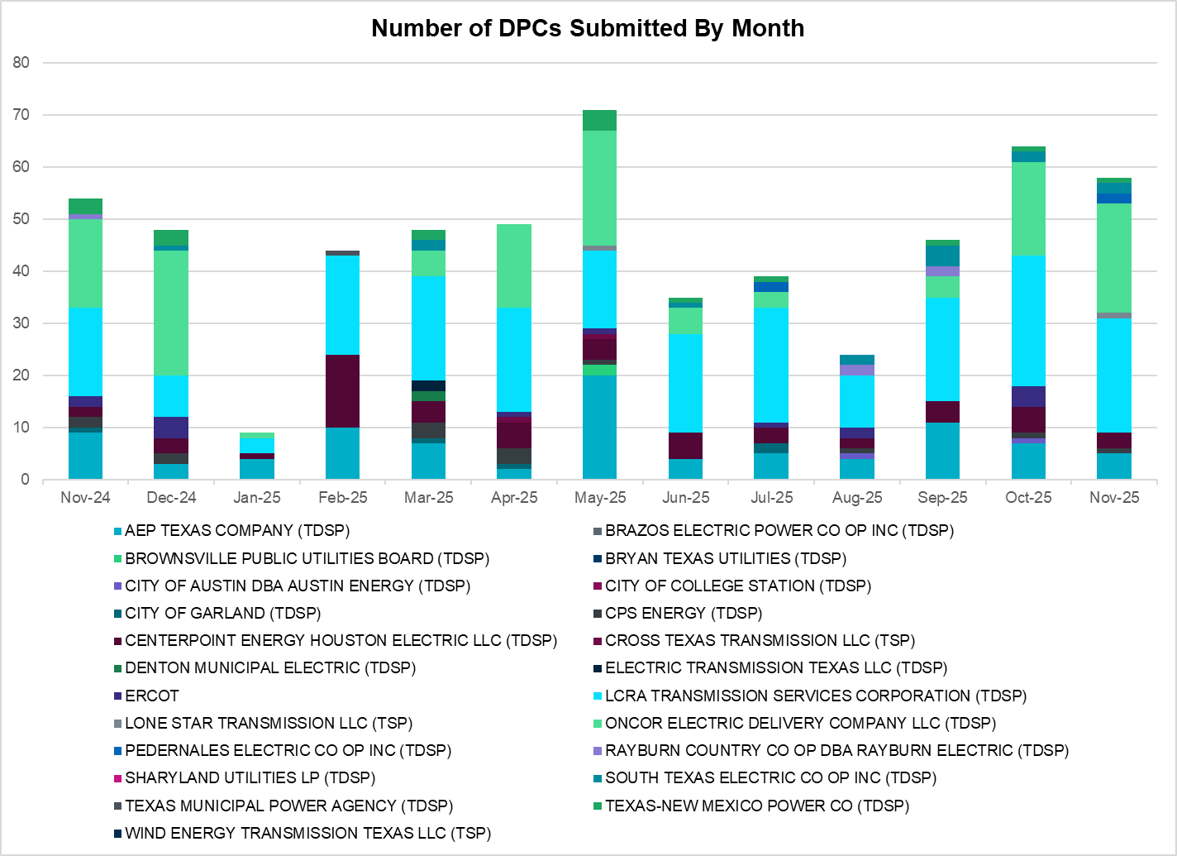
A total of 58 DPCs were implemented in November 2025. 487 DPCs have been implemented year to date. DPCs submitted by TDSPs are mainly updates to transmission element ratings. DPCs submitted by ERCOT are mainly updates to manual contingency definitions.
Transmission Operator | Number of DPCs
AEP TEXAS COMPANY (TDSP) | 5
BRAZOS ELECTRIC POWER CO OP INC (TDSP) | 0
BROWNSVILLE PUBLIC UTILITIES BOARD (TDSP) | 0
BRYAN TEXAS UTILITIES (TDSP) | 0
CENTERPOINT ENERGY HOUSTON ELECTRIC LLC (TDSP) | 3
CITY OF AUSTIN DBA AUSTIN ENERGY (TDSP) | 0
CITY OF COLLEGE STATION (TDSP) | 0
CITY OF GARLAND (TDSP) | 0
CPS ENERGY (TDSP) | 1
CROSS TEXAS TRANSMISSION LLC (TSP)) | 0
DENTON MUNICIPAL ELECTRIC (TDSP) | 0
ELECTRIC TRANSMISSION TEXAS LLC (TDSP) | 0
ERCOT | 0
LCRA TRANSMISSION SERVICES CORPORATION (TDSP) | 22
LONE STAR TRANSMISSION LLC (TSP) | 1
ONCOR ELECTRIC DELIVERY COMPANY LLC (TDSP) | 21
PEDERNALES ELECTRIC CO OP INC (TDSP) | 2
RAYBURN COUNTRY CO OP DBA RAYBURN ELECTRIC (TDSP) | 0
SHARYLAND UTILITIES LP (TDSP) | 0
SOUTH TEXAS ELECTRIC CO OP INC (TDSP) | 2
TEXAS MUNICIPAL POWER AGENCY (TDSP) | 0
TEXAS-NEW MEXICO POWER CO (TDSP) | 1
WIND ENERGY TRANSMISSION TEXAS LLC (TSP) | 0

Appendix A: Real-Time Constraints
The following is a complete list of constraints activated in SCED. Full contingency descriptions can be found in the Standard Contingencies List located on the MIS secure site at Grid Generation Reliability Unit Commitment.
Year | Month | Contingency Name | Overloaded Element | From Station | To Station | Count of Days
2025 | November | SKLELOY8 | LOYOLA_69_1 | LOYOLA | LOYOLA | 25
2025 | November | BASE CASE | NE_LOB | n/a | n/a | 25
2025 | November | BASE CASE | NELRIO | n/a | n/a | 24
2025 | November | DFOAVLO5 | LASCRU_MILO1_1 | LASCRUCE | MILO | 23
2025 | November | DMTSCOS5 | 6437__F | SCRCV | KNAPP | 22
2025 | November | BASE CASE | I_FW_N | n/a | n/a | 22
2025 | November | BASE CASE | MCCAMY | n/a | n/a | 19
2025 | November | DBAKCED5 | 6965__A | LNGSW | PRLSW | 19
2025 | November | SCARFRI8 | ATSO_SONR1_1 | ATSO | SONR | 18
2025 | November | SCARFRI8 | ATSO_SONR1_1 | SONR | ATSO | 18
2025 | November | SW_LVLT5 | 15060__B | VEALMOOR | KOCHTAP | 18
2025 | November | BASE CASE | WESTEX | n/a | n/a | 18
2025 | November | SBWDDBM5 | LPLMK_LPLNE_1 | LPLMK | LPLNE | 17
2025 | November | BASE CASE | PNHNDL | n/a | n/a | 16
2025 | November | BASE CASE | E_PATA | n/a | n/a | 15
2025 | November | MRNKDHM5 | 587__A | ARGYL | LWSVH | 15
2025 | November | SN_SAJO5 | LASPUL_RAYMND1_1 | LASPULGA | RAYMND2 | 14
2025 | November | BASE CASE | VALEXP | n/a | n/a | 14
2025 | November | MPRLCO25 | 6960__A | PRLSW | CONSW | 14
2025 | November | DBIGKEN5 | FORTMA_YELWJC1_1 | YELWJCKT | FORTMA | 13
2025 | November | DBIGKEN5 | TREADW_YELWJC1_1 | TREADWEL | YELWJCKT | 13
2025 | November | DBIGKEN5 | FORTMA_YELWJC1_1 | FORTMA | YELWJCKT | 13
2025 | November | DSALHUT5 | 421__A | BCESW | SNDSW | 12
2025 | November | DSLKSOL5 | 138_FLT_FXT_1 | TNFXTAIL | FLAT_TOP | 12
2025 | November | DFRYTM58 | SEA_AAT1 | SEA | SEA | 12
2025 | November | SEUSWLT8 | BLASCOFE_RC_1 | COFESSRC | BLASW | 12
2025 | November | SPEBTRU8 | 940__A | ENWSW | TMPTN | 12
2025 | November | SEUSWLT8 | BLASCOFE_RC_1 | BLASW | COFESSRC | 12
2025 | November | DFOWSMG5 | GEO_SIG_1 | GEOWEST | SIGMOR | 11
2025 | November | BASE CASE | E_PASP | n/a | n/a | 10
2025 | November | SMDOOAS5 | GN_PZ_08_A | GN | PZ | 10
2025 | November | DTVWJON5 | 6033__A | CPSES | MBDSW | 9
2025 | November | DBIGKEN5 | MADDUX_TREADW1_1 | MADDUX | TREADWEL | 9
2025 | November | DKG_NB_5 | HL_PSA08_A | PSA | HL | 9
2025 | November | SBRAPIN8 | HAMILT_MAVERI1_1 | HAMILTON | MAVERICK | 9
2025 | November | DCAGCO58 | 656T656_1 | KENDAL | BERGHE | 8
2025 | November | SSTAWIC8 | 138_IH2_COT_1 | IH20 | TNCOLIET | 8
2025 | November | SLAQLOB8 | BRUNI_69_1 | BRUNI | BRUNI | 8
2025 | November | DTHSFBR5 | 35050__B | FTSSW | VENSW | 8
2025 | November | DBAKSOL5 | 6965__A | LNGSW | PRLSW | 8
2025 | November | DODEMOS5 | 6513__A | ODESA | ODNTH | 8
2025 | November | SHAYZO25 | 6T227_1 | HAYSEN | ZORN | 8
2025 | November | SEL_ARR8 | BLESSING_69A1 | BLESSING | BLESSING | 8
2025 | November | MHARNED5 | LASPUL_RAYMND1_1 | LASPULGA | RAYMND2 | 8
2025 | November | MSTPSTA5 | BLESSING_1382 | BLESSING | BLESSING | 8
2025 | November | DSALKLN5 | 630__B | KLNSW | HHSTH | 7
2025 | November | XARA89 | NAVALB_N_PADR1_1 | NAVALBAS | N_PADRE | 7
2025 | November | DBIGSCH5 | PALOUS_WOLFCA1_1 | PALOUSE | WOLFCAMP | 7
2025 | November | SMA2SAP8 | MADDUX_SAPOWE1_1 | SAPOWER | MADDUX | 7
2025 | November | BASE CASE | I_FW_S | n/a | n/a | 7
2025 | November | SMA2SAP8 | MADDUX_SAPOWE1_1 | MADDUX | SAPOWER | 7
2025 | November | DMOSME25 | 6345__L | SNDHT | WLFSW | 6
2025 | November | DTCRTHS5 | 35045__A | SAMSW | FVLSW | 6
2025 | November | SBRAPIN8 | ESCOND_GANSO1_1 | ESCONDID | GANSO | 6
2025 | November | SBRAPIN8 | ESCOND_GANSO1_1 | GANSO | ESCONDID | 6
2025 | November | DFOAVLO5 | BRUNI_69_1 | BRUNI | BRUNI | 6
2025 | November | DBBSRCH5 | 1210__C | NVARO | HAN1 | 6
2025 | November | SBRAHAM8 | ESCOND_GANSO1_1 | ESCONDID | GANSO | 6
2025 | November | MCONPRL5 | 16050__B | CRTRVLLE | HILGR | 6
2025 | November | MRGRMG25 | 6945__A | MGSES | CATSW | 6
2025 | November | XFTS89 | ALPINE_BRONCO1_1 | ALPINE | BRONCO | 6
2025 | November | DGILHIW8 | MORRIS_NUECES1_1 | NUECES_B | MORRIS | 6
2025 | November | XFTS89 | ALPINE_BRONCO1_1 | BRONCO | ALPINE | 6
2025 | November | DHUGWR_8 | ARROZ_EL_CAM1_1 | ARROZ | EL_CAMPO | 6
2025 | November | DFOAVLO5 | NLARSW_PILONC1_1 | NLARSW | PILONCIL | 6
2025 | November | DBAKSOL5 | STCO_STER1_1 | STER | STCO | 6
2025 | November | SBRAHAM8 | ESCOND_GANSO1_1 | GANSO | ESCONDID | 6
2025 | November | XST2E89 | 2270__B | MEXTP | ITALY | 5
2025 | November | SWLTBRT8 | EUSTWLTN_RC_1 | WALTSSRC | EUSTSERC | 5
2025 | November | DRAZSA89 | 2585_1 | DOWNIES | MOORE | 5
2025 | November | SBCESND5 | 421__A | BCESW | SNDSW | 5
2025 | November | SDANBLE8 | BLESSING_69A1 | BLESSING | BLESSING | 5
2025 | November | DBAKCED5 | STCO_STER1_1 | STER | STCO | 5
2025 | November | SWLTBRT8 | EUSTWLTN_RC_1 | EUSTSERC | WALTSSRC | 5
2025 | November | DODEMOS5 | 6525__A | ODEHV | RTRSW | 5
2025 | November | MHARNED5 | HAINE__LA_PAL1_1 | LA_PALMA | HAINE_DR | 5
2025 | November | DCPSES12 | 35055__A | SAMSW | VENSW | 5
2025 | November | MLWSWDE5 | 587__A | ARGYL | LWSVH | 5
2025 | November | SBRAHAM8 | HAMILT_MAVERI1_1 | HAMILTON | MAVERICK | 5
2025 | November | SHGRSTN8 | 1590__E | STNSW | SHMNE | 5
2025 | November | DLOFOAV5 | LASCRU_MILO1_1 | LASCRUCE | MILO | 4
2025 | November | MRNKDHM5 | 570__A | CRNTH | ARGYL | 4
2025 | November | DTWIDIV5 | NICOLE_TENNYS1_1 | NICOLE | TENNYSON | 4
2025 | November | DLOFOAV5 | NLARSW_PILONC1_1 | NLARSW | PILONCIL | 4
2025 | November | DTRSENT5 | 1920__B | ATHNS | TRNDD | 4
2025 | November | DVENFTS5 | 2270__B | MEXTP | ITALY | 4
2025 | November | DBAKCED5 | HARGRO_TWINBU1_1 | TWINBU | HARGROVE | 4
2025 | November | DLOFOAV5 | NLARSW_PILONC1_1 | PILONCIL | NLARSW | 4
2025 | November | DELMSTP5 | STPELM27_1 | STP | ELMCREEK | 4
2025 | November | SGILLIM5 | 1661__A | RRNES | RNDRK | 4
2025 | November | DELMSAN5 | PAWNEE_SPRUCE_1 | PAWNEE | CALAVERS | 4
2025 | November | SL_4RAY8 | RAYBURN_69_2 | RAYBURN | RAYBURN | 4
2025 | November | DFRYTM58 | 421__A | BCESW | SNDSW | 4
2025 | November | DSALGA58 | 421__A | BCESW | SNDSW | 4
2025 | November | SFRYTMP8 | SEA_AAT1 | SEA | SEA | 4
2025 | November | SSNYCGR8 | SNYDR_FMR1 | SNYDR | SNYDR | 4
2025 | November | DMGSBTR5 | 6036__A | TKWSW | MGSES | 4
2025 | November | MCONPR25 | 16050__B | CRTRVLLE | HILGR | 4
2025 | November | SLCSTH25 | 506__A | SAMSW | FBRSW | 4
2025 | November | DSWELNC5 | BLUF_C_MULBER1_1 | MULBERRY | BLUF_CRK | 4
2025 | November | DSALHUT5 | 1710__E | SALSW | SALDS | 3
2025 | November | SCOLBAL8 | SANA_FMR1 | SANA | SANA | 3
2025 | November | SW_LVLT5 | 6217__A | WLVSW | GAILS | 3
2025 | November | DHUTLIM5 | HUTTO_MR1L | HUTTO | HUTTO | 3
2025 | November | SN_SLON5 | LOYOLA_69_1 | LOYOLA | LOYOLA | 3
2025 | November | MHARNED5 | PANTER_WESMER1_1 | WESMER | PANTERA | 3
2025 | November | DMTSCOS5 | 6240__C | SACRC | DPCRK | 3
2025 | November | SENWSHK8 | 940__A | ENWSW | TMPTN | 3
2025 | November | XALM689 | ALMC_T2 | ALMC | ALMC | 3
2025 | November | BASE CASE | I_KALO | n/a | n/a | 3
2025 | November | SCOLPAW5 | MAGRUD_VICTOR2_1 | VICTORIA | MAGRUDER | 3
2025 | November | DFRYTM58 | OLS_JNES_1 | OLSEN | JNESBORO | 3
2025 | November | DLHSCNR8 | 3660__A | LHSES | PRCSW | 3
2025 | November | DSALGA58 | 630__A | BLTON | BLTSW | 3
2025 | November | XEIN58 | 6470__D | MCDLD | GLSCN | 3
2025 | November | SBROALP9 | COCS_FTST1_1 | FTST | COCS | 3
2025 | November | BASE CASE | HMLTN | n/a | n/a | 3
2025 | November | SEUSWLT8 | BRTNWLTN_RC_1 | BRTNSSRC | WALTSSRC | 3
2025 | November | DBAKSOL5 | HARGRO_TWINBU1_1 | TWINBU | HARGROVE | 3
2025 | November | SRIOKEL8 | LASPUL_RAYMND1_1 | LASPULGA | RAYMND2 | 3
2025 | November | MHARNED5 | VERTRE_WESLAU1_1 | WESLAU | VERTREES | 3
2025 | November | DTCRTHS5 | 35050__B | FTSSW | VENSW | 3
2025 | November | SN_SAJO5 | LASPUL_RIOHON1_1 | RIOHONDO | LASPULGA | 3
2025 | November | MHARNED5 | VERTRE_WESLAU1_1 | VERTREES | WESLAU | 3
2025 | November | DZORHAY5 | BERGHE_AT1H | BERGHE | BERGHE | 3
2025 | November | DBIGKEN5 | HAMILT_MAXWEL1_1 | MAXWELL | HAMILTON | 3
2025 | November | DSCOTKW5 | 6215__A | BCKSW | CGRSW | 3
2025 | November | DAUSLOS5 | CKT_3121_1 | CISTERN | LYTTON_S | 3
2025 | November | DFOAVLO5 | MINES__NLARSW1_1 | MINES_RD | NLARSW | 3
2025 | November | DTCRTHS5 | 35055__A | SAMSW | VENSW | 3
2025 | November | DDILPE89 | BIG_FO_PLEASA1_1 | BIG_FOOT | PLEASANT | 3
2025 | November | DWELONL8 | CLARK__LON_HI1_1 | LON_HILL | CLARK_WD | 3
2025 | November | DDILCOT8 | DILLEYSW_XF1H | DILLEYSW | DILLEYSW | 3
2025 | November | DTHSFBR5 | 35045__A | SAMSW | FVLSW | 3
2025 | November | SSNDAUS5 | 445__A | BLHSW | AUSTRO | 2
2025 | November | SZENTH35 | THWZEN71_A | ZEN | THW | 2
2025 | November | DZORHAY5 | BERGHE_AT1L | BERGHE | BERGHE | 2
2025 | November | SFURRAY8 | VAN_VNDB_1 | VANBLTSS | VANBLT69 | 2
2025 | November | SWCAE8 | AE_STR26_A | AE | STR | 2
2025 | November | SN_SLON5 | ALAZAN_B_DAVI1_1 | ALAZAN | B_DAVIS | 2
2025 | November | DKG_NB_5 | BCVPSA03_A | PSA | BCV | 2
2025 | November | SRAYRI28 | HAINE__LA_PAL1_1 | LA_PALMA | HAINE_DR | 2
2025 | November | SRAYRI38 | HAINE__LA_PAL1_1 | LA_PALMA | HAINE_DR | 2
2025 | November | SFURVAN8 | RAYBUR_FURHMAN_1 | FURHMAN | RAYBURN | 2
2025 | November | DAUSLOS5 | 196T171_1 | GIDEON | SETTLE | 2
2025 | November | SLCSTH25 | 505__B | FBRSW | THSES | 2
2025 | November | MCATPRL5 | 6965__A | LNGSW | PRLSW | 2
2025 | November | DSWECBF5 | BLUF_C_MULBER1_1 | MULBERRY | BLUF_CRK | 2
2025 | November | SKGJOR5 | HL_PSA08_A | PSA | HL | 2
2025 | November | SFURVAN8 | RAYBUR_FURHMAN_1 | RAYBURN | FURHMAN | 2
2025 | November | SBTPBNT8 | 2115__B | TOWER | BNTSW | 2
2025 | November | SWXOSTE9 | 2270__B | MEXTP | ITALY | 2
2025 | November | SRCHBBS5 | 30__A | RCHBR | BBSES | 2
2025 | November | MCATMGS5 | 6965__A | LNGSW | PRLSW | 2
2025 | November | SPETSNU8 | AE_STR26_A | AE | STR | 2
2025 | November | SN_SLON5 | CELANE_KLEBER1_1 | CELANEBI | KLEBERG | 2
2025 | November | DFOAVLO5 | FREER_LOBO1_1 | LOBO | FREER | 2
2025 | November | STCRTHS5 | 505__B | FBRSW | THSES | 2
2025 | November | MLWSWDE5 | 570__A | CRNTH | ARGYL | 2
2025 | November | DBAKCED5 | 6056__Z | LNGSW | CONSW | 2
2025 | November | DRESMCL8 | I_DUPS_RESNIK1_1 | I_DUPSW | RESNIK | 2
2025 | November | MLONWAR5 | NAISMITH_XF2H | NAISMITH | NAISMITH | 2
2025 | November | DFRYBC58 | SEA_AAT1 | SEA | SEA | 2
2025 | November | DRENCRL5 | 1160__A | HKBRY | VLYRN | 2
2025 | November | MLNGPR25 | 16050__B | CRTRVLLE | HILGR | 2
2025 | November | SDBLBN28 | BNK_MIL_1 | LONG | BNK | 2
2025 | November | DLOFOAV5 | BRUNI_69_1 | BRUNI | BRUNI | 2
2025 | November | DAUSLOS5 | CKT_3136_1 | HOLMAN | CISTERN | 2
2025 | November | DRAZSA89 | READIN_UVALDE1_1 | UVALDE | READING | 2
2025 | November | DEXCHCK5 | 6270__D | HCKSW | WGROB | 2
2025 | November | DBUCRGP5 | 629T629_1 | GOLDTH | SASASW | 2
2025 | November | DHONHON8 | BIG_FO_PLEASA1_1 | BIG_FOOT | PLEASANT | 2
2025 | November | DBIGKEN5 | CARVER_TINSLE1_1 | CARVER | TINSLEY | 2
2025 | November | XFER85 | CARVER_TINSLE1_1 | CARVER | TINSLEY | 2
2025 | November | DMGSBTR5 | CEDRHI_SILT1_1 | CEDRHILL | SILT | 2
2025 | November | DDMTMHO5 | FARMLAND_LONGD_1 | FARMLAND | W_LD_345 | 2
2025 | November | MBONNED5 | HAINE__LA_PAL1_1 | LA_PALMA | HAINE_DR | 2
2025 | November | XBLU58 | OAKC_SERDEV1_1 | OAKC | OAKC | 2
2025 | November | DCAGCI58 | 255T279_1 | PIPECR | MEDILA | 2
2025 | November | SPRCPDS8 | 3665__B | PRCSW | PRCRK | 2
2025 | November | DBWNAMO5 | BENFIC_REDCRE1_1 | REDCREEK | BENFICKL | 2
2025 | November | DELMSTP5 | BLESSING_1382 | BLESSING | BLESSING | 2
2025 | November | DCRLLSW5 | LWSSW_FMR2 | LWSSW | LWSSW | 2
2025 | November | SEBHUG8 | ARROZ_EL_CAM1_1 | ARROZ | EL_CAMPO | 2
2025 | November | MTRSRCH5 | 1210__B | HUBRD | HAN1 | 1
2025 | November | DREDNC85 | 1350__E | NCSTP | LFKSW | 1
2025 | November | SW_BW_25 | 16050__A | HILGR | EILAND | 1
2025 | November | SBBSRCH5 | 20__A | RCHBR | BBSES | 1
2025 | November | DFMRCYC5 | 385__A | TTRSW | MNSES | 1
2025 | November | SBCESN35 | 431__A | BCESW | SNDSW | 1
2025 | November | SMYRSPR8 | 583__D | DCRSW | ALISN | 1
2025 | November | DPKRBNB5 | 6033__A | CPSES | MBDSW | 1
2025 | November | DMTSCOS5 | 6437__A | KNAPP | BCKSW | 1
2025 | November | XEI258 | 6470__H | GLSCN | FRSTP | 1
2025 | November | SCLCGTN8 | 6635__G | ESTLD | MRVLY | 1
2025 | November | DW_CNVA5 | FARMLAND_LONGD_1 | FARMLAND | W_LD_345 | 1
2025 | November | SLOLFOR8 | GREENL_WEAVER1_1 | WEAVERRD | GREENLK | 1
2025 | November | SOXYIN28 | I_DUPP_I_DUPS2_1 | I_DUPP1 | I_DUPSW | 1
2025 | November | DSTERI89 | L_MILP_STEWAR1_1 | STEWART | L_MILPAS | 1
2025 | November | DBBSRCH5 | MEXIA_AT1 | MEXIA | MEXIA | 1
2025 | November | SMCEESK8 | MKLT_TRNT1_1 | TRNT | MKLT | 1
2025 | November | BASE CASE | MLB_SLR_TLINE_1 | MLB_SLR | QUASAR | 1
2025 | November | SLONSAX8 | MORRIS_NUECES1_1 | NUECES_B | MORRIS | 1
2025 | November | DSALHUT5 | TRIMR_KLNSW_1 | KLNSW | TRIMMIER | 1
2025 | November | DBAKSOL5 | 6945__A | MGSES | CATSW | 1
2025 | November | SD1Z18 | BIG_FO_PLEASA1_1 | BIG_FOOT | PLEASANT | 1
2025 | November | BASE CASE | EUSTWLTN_RC_1 | EUSTSERC | WALTSSRC | 1
2025 | November | SKGJOR5 | GBYUV_03_A | GBY | UV | 1
2025 | November | SRAYHAR8 | HAINE__LA_PAL1_1 | LA_PALMA | HAINE_DR | 1
2025 | November | SBRAESC8 | HAMILT_MAVERI1_1 | HAMILTON | MAVERICK | 1
2025 | November | SLGDSAP8 | LAKENA_SAMATH1_1 | LAKENASW | SAMATHIS | 1
2025 | November | MBONNED5 | LASPUL_RAYMND1_1 | LASPULGA | RAYMND2 | 1
2025 | November | DLOFOAV5 | MINES__NLARSW1_1 | MINES_RD | NLARSW | 1
2025 | November | SNUEWHI8 | MORRIS_NUECES1_1 | NUECES_B | MORRIS | 1
2025 | November | STBSNG5 | NB_THW97_A | THW | NB | 1
2025 | November | SOAKNIC8 | NICOLE_TENNYS1_1 | NICOLE | TENNYSON | 1
2025 | November | SORNLON8 | ORNGROV_69_1 | ORNGROV | ORNGROV | 1
2025 | November | DTWIDIV5 | PALOUS_WOLFCA1_1 | PALOUSE | WOLFCAMP | 1
2025 | November | SORNLON8 | SND_ORAN_1 | ORNGROV | SNDIEGS | 1
2025 | November | DSALHUT5 | 13T219_1 | EBABES | BURNET | 1
2025 | November | MCONPR25 | 16050__A | HILGR | EILAND | 1
2025 | November | STNPTO25 | 345_TWN_WLO_1 | TNWILLOW | TOKSW | 1
2025 | November | DCPSES12 | 35050__B | FTSSW | VENSW | 1
2025 | November | DBAKSOL5 | 6056__Z | LNGSW | CONSW | 1
2025 | November | MDENBCP8 | 6270__D | HCKSW | WGROB | 1
2025 | November | DBAKCED5 | 6945__A | MGSES | CATSW | 1
2025 | November | MBURSTR8 | CEDRHI_SILT1_1 | CEDRHILL | SILT | 1
2025 | November | MLNGPR25 | CRTVLE_EINSTEN_1 | EINSTEIN | CRTRVLLE | 1
2025 | November | SRT2WC8 | G138_17_1 | BRAZORIA | RT | 1
2025 | November | SFORYEL8 | HEXT_YELWJC1_1 | YELWJCKT | HEXT | 1
2025 | November | DBAKSOL5 | LAKENA_SAMATH1_1 | LAKENASW | SAMATHIS | 1
2025 | November | SPAWCAL5 | MAGRUD_VICTOR2_1 | VICTORIA | MAGRUDER | 1
2025 | November | SCOMHA38 | MAXWEL_WHITIN1_1 | MAXWELL | WHITING | 1
2025 | November | SKGJOR5 | MDOPHR99_A | MDO | PHR | 1
2025 | November | SGRSMNW8 | MIL_LIPAN_1 | LONG | LIPAN | 1
2025 | November | SRAZDRY8 | READIN_UVALDE1_1 | UVALDE | READING | 1
2025 | November | MLONOR58 | SND_ORAN_1 | ORNGROV | SNDIEGS | 1
2025 | November | STARLEO8 | SOLSTICE_PST1 | SOLSTICE | SOLSTICE | 1
2025 | November | SZENTHW5 | THWZEN98_A | ZEN | THW | 1
2025 | November | DVLSPAC5 | 1561__A | DPREA | RCSES | 1
2025 | November | SW_BW_25 | 16050__A | EILAND | HILGR | 1
2025 | November | DAUSLOS5 | 190T152_1 | WINCHES | GIDEON | 1
2025 | November | DSALHUT5 | 431__A | BCESW | SNDSW | 1
2025 | November | XEIN58 | 6470__E | FRSTP | PCTSW | 1
2025 | November | DLOFOAV5 | ASHERT_CATARI1_1 | ASHERTON | CATARINA | 1
2025 | November | DCPRJCK8 | BLESSING_69A1 | BLESSING | BLESSING | 1
2025 | November | SSHIMCC8 | CNT_MCCR_1 | MCCREE | CENTRVIL | 1
2025 | November | DBIGSCH5 | CROSSO_NORTMC1_1 | NORTMC | CROSSOVE | 1
2025 | November | SBLACOF8 | EUSTWLTN_RC_1 | EUSTSERC | WALTSSRC | 1
2025 | November | SN_SAJO5 | HAINE__LA_PAL1_1 | LA_PALMA | HAINE_DR | 1
2025 | November | DMCDUPS8 | HECKER_RESNIK1_1 | HECKER | RESNIK | 1
2025 | November | SW_LFAR5 | LPLPY_T1S | LPLPY | LPLPY | 1
2025 | November | SMV_RI28 | SCARBI_TITAN_1_1 | SCARBIDE | TITAN_SU | 1
2025 | November | SDIMBEV8 | UVALDE_W_BATE1_1 | W_BATESV | UVALDE | 1
2025 | November | SGILTRI8 | 211T147_1 | GILLCR | MCNEIL_ | 1
2025 | November | DTCRTHS5 | 35065__A | FVLSW | FTSSW | 1
2025 | November | MDHMLWS5 | 587__A | ARGYL | LWSVH | 1
2025 | November | SBSPBUZ8 | 6135__F | GUNSW | HPPOD | 1
2025 | November | MCATMG25 | 6945__A | MGSES | CATSW | 1
2025 | November | SKGJOR5 | BCVPSA03_A | PSA | BCV | 1
2025 | November | DBAKSOL5 | HARGRO_PUMPJA1_1 | HARGROVE | PUMPJACK | 1
2025 | November | DCC1DUKE | L_MILP_STEWAR1_1 | STEWART | L_MILPAS | 1
2025 | November | DELMSAN5 | MAGRUD_VICTOR2_1 | VICTORIA | MAGRUDER | 1
2025 | November | STULBAS8 | MAGRUD_VICTOR2_1 | VICTORIA | MAGRUDER | 1
2025 | November | DVLSPAC5 | PRSSW_MR1H | PRSSW | PRSSW | 1
2025 | November | SMV_PAR8 | RIOHND_ERIOHND_1 | MV_RIOHO | RIOHONDO | 1
2025 | November | DCRLCN35 | 1160__A | HKBRY | VLYRN | 1
2025 | November | MLNGCA25 | 16050__B | CRTRVLLE | HILGR | 1
2025 | November | DSALHUT5 | 1730__B | TINPD | ROGRS | 1
2025 | November | DSANBEU5 | 2340__D | MCFSW | MARAK | 1
2025 | November | DCNSLHS8 | 3660__A | LHSES | PRCSW | 1
2025 | November | MKRWDHM5 | 6085__E | WFSSW | NSTAR | 1
2025 | November | SNORODE5 | 612T612_1 | ODEHV | PLEAFA | 1
2025 | November | SCMNCPS5 | 651__B | CMNSW | CMNTP | 1
2025 | November | SSCLWF18 | 6840__B | NVKSW | ANARN | 1
2025 | November | DCDHTVW5 | 951__A | SARDIS | STERT | 1
2025 | November | SCOLBAL8 | BALLIN_HUMBLT1_1 | BALLINGE | HUMBLTAP | 1
2025 | November | DFRYTM58 | BELCNTY_XFMR | BELCNTY | BELCNTY | 1
2025 | November | DAMOTWI5 | CEDRHI_SILT1_1 | CEDRHILL | SILT | 1
2025 | November | DBIGSCH5 | CROSSO_PALOUS1_1 | CROSSOVE | PALOUSE | 1
2025 | November | SGILNU78 | GILA_HIWAY_1_1 | GILA | HIWAY_9 | 1
2025 | November | BASE CASE | KINNEY | n/a | n/a | 1
2025 | November | DBAKCED5 | LAKENA_SAMATH1_1 | LAKENASW | SAMATHIS | 1
2025 | November | SW_LFAR5 | LPLPY_T1P | LPLPY | LPLPY | 1
2025 | November | MHAPSTX8 | MAXWEL_WHITIN1_1 | MAXWELL | WHITING | 1
2025 | November | SJAYHAN8 | MIL_LIPAN_1 | LONG | LIPAN | 1
2025 | November | DCBFBLU5 | OAKC_SERDEV1_1 | OAKC | OAKC | 1
2025 | November | SHAYZOR5 | 388T388_1 | HAYSEN | ZORN | 1
2025 | November | DCRLLSW5 | 588_A_1 | LWSVW | LWVTI | 1
2025 | November | DMGSBIT5 | 6036__A | TKWSW | MGSES | 1
2025 | November | SCOCBAR9 | ALPINE_BRONCO1_1 | BRONCO | ALPINE | 1
2025 | November | SCARFRI8 | ATSO_OZNC1_1 | ATSO | OZNC | 1
2025 | November | SFRYTMP8 | BELCNTY_XFMR | BELCNTY | BELCNTY | 1
2025 | November | SANGSTA5 | BLESSING_1382 | BLESSING | BLESSING | 1
2025 | November | SBRTANT8 | EUSTWLTN_RC_1 | WALTSSRC | EUSTSERC | 1
2025 | November | DCOTWR25 | FARMLAND_LONGD_1 | FARMLAND | W_LD_345 | 1
2025 | November | DSALGA58 | GABRIE_AT1 | GABRIE | GABRIE | 1
2025 | November | SBRAPIN8 | GANSO_MAVERI1_1 | MAVERICK | GANSO | 1
2025 | November | STANPAW5-F | I_KALO | n/a | n/a | 1
2025 | November | SFORYEL8 | KATEMC_MASN1_1 | MASN | KATEMCY | 1
2025 | November | SKELLA_8 | LASPUL_RAYMND1_1 | LASPULGA | RAYMND2 | 1
2025 | November | DVLSPAC5 | 1650__G | RCSES | TALTP | 1
2025 | November | DZORLIM5 | 1661__A | RRNES | RNDRK | 1
2025 | November | DBBSRCH5 | 2310__C | NVARO | RCHLD | 1
2025 | November | SCOBBOM5 | 35020__B | GRVSW | GRSES | 1
2025 | November | SJONCPS5 | 6033__A | CPSES | MBDSW | 1
2025 | November | XEIN58 | 6470__H | GLSCN | FRSTP | 1
2025 | November | SEUSWLT8 | ANTSCRSP_RC_1 | CRSPOLRC | ANTSS_RC | 1
2025 | November | SSPUSLT8 | ASPM_CONA1_1 | ASPM | CONA | 1
2025 | November | SLANARR8 | BLESSING_69A1 | BLESSING | BLESSING | 1
2025 | November | DLOFOAV5 | CATARI_PILONC1_1 | PILONCIL | CATARINA | 1
2025 | November | XBLU58 | CEDRHI_SILT1_1 | CEDRHILL | SILT | 1
2025 | November | SEUSWLT8 | COFENYSS_RC_1 | COFESSRC | NYSS_RC | 1
2025 | November | SNBTHW5 | DT_PK_91_A | PK | DT | 1
2025 | November | BASE CASE | EUSTWLTN_RC_1 | WALTSSRC | EUSTSERC | 1
2025 | November | BASE CASE | MAXWEL_WHITIN1_1 | MAXWELL | WHITING | 1
2025 | November | DFOAVLO5 | MILO_MINES_1_1 | MILO | MINES_RD | 1
2025 | November | DSNG_TB5 | NB_THW97_A | THW | NB | 1
2025 | November | MBONMAN5 | PANTER_WESMER1_1 | WESMER | PANTERA | 1
2025 | November | SFURVAN8 | RAY_L_46_1 | RAYBURN | L_463S | 1
2025 | November | DFOWSMG5 | TILDEN_GEOWEST_1 | TILDEN | GEOWEST | 1
2025 | November | SVICCO28 | VICTORIA_69A2 | VICTORIA | VICTORIA | 1

Current Wind Generation Record: 28,550 MW on 03/03/2025 at 20:42 | Current Wind Penetration Record: 69.15% on 04/10/2022 at 01:43 Current Solar Generation Record: 29,877 MW on 09/09/2025 at 11:54 | Current Solar Penetration Record: 56.80% on 10/30/2025 at 11:05

