NPRR Number | 1292 | NPRR Title | Granular Product Type for CRR TOU
Date |  | December 30, 2025
Submitter’s Information
Name |  | Monica Jha; Ned Bonskowski
E-mail Address |  | Monica.jha@vistracorp.com; ned.bonskowski@vistracorp.com
Company |  | Vistra Operations Company LLC
Phone Number
Cell Number |  | 832-215-5713; 214-288-2456
Market Segment |  | Independent Generator

Comments
Vistra appreciates the opportunity to engage on Nodal Protocol Revision Request (NPRR) 1292 and offers the following comments in response to recent stakeholder discussions:
- Goal of the NPRR: NPRR1292 seeks to enhance the Congestion Revenue Rights (CRR) market by introducing more granular Time-of-Use (TOU) blocks. This proposal is a direct response to observed shifts in generation mix and congestion patterns between solar and non-solar hours, as presented at the April 14, 2025 Congestion Management Working Group (CMWG) Meeting. The observed and anticipated continued increase in solar generation, as supported by interconnection requests totaling 158 GW by 2030 in the queue, further underscores the inadequacy of the current on-peak TOU structure for capturing congestion price variability. The absence of finer granularity in CRR products impedes effective hedging against congestion risk for all Market Participants, irrespective of their portfolio mix. By implementing additional CRR TOU blocks, NPRR1292 will enable participants to align hedging strategies with specific intervals of congestion, thereby improving risk mitigation and market efficiency.
- Current state of CRR auction process: Vistra acknowledges the importance of finding effective solutions to resolve performance concerns of the CRR engine being raised by multiple stakeholders. In addition, Vistra is appreciative of the significant effort being taken by ERCOT to find a solution along with the transparency with which it is sharing the progress on their effort.
- As shared by ERCOT during the September 22, 2025 CMWG Meeting (below), ERCOT is taking multiple steps to improve CRR performance.
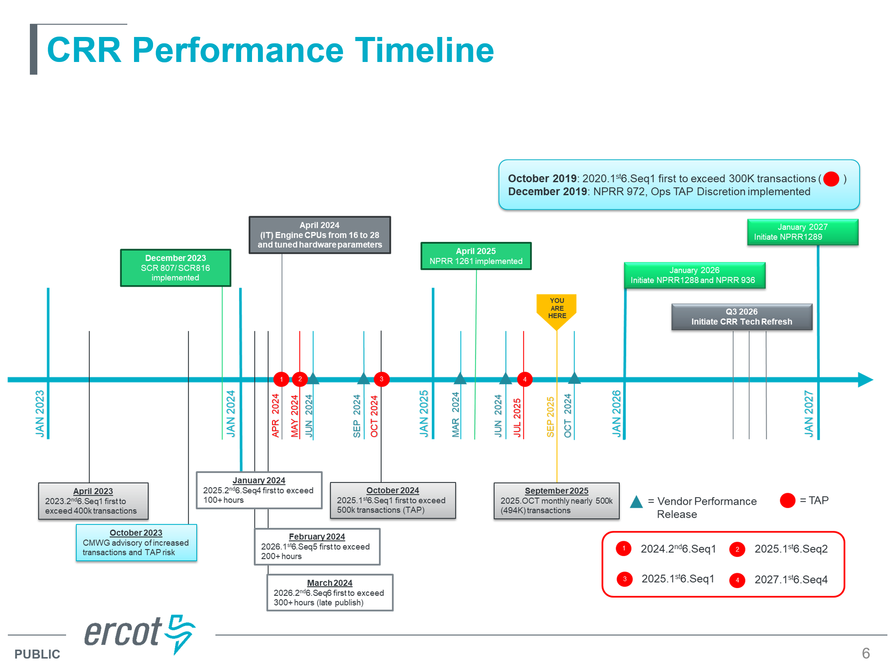
ERCOT has indicated that the earliest practical application of NPRR1292 in CRR auctions will occur no sooner than three years post-implementation, resulting in an effective timeline of at least four years following Public Utility Council of Texas (PUCT) approval. It is imperative that the proposed enhancements are incorporated into future CRR auction products to achieve both improved system performance and expanded market functionality.
Vistra supports ERCOT’s plan to restructure Long-Term Auction Sequence auctions and remove budget constraints along with the implementation of NPRR1292, as these steps will simplify optimization and improve auction efficiency.
Vistra looks forward to continued collaboration as ERCOT brings forward their removal of budget constraint NPRR and shares additional feedback from their vendor on implementation pathways of NPRR1292 as Vistra supports PeakWD and PeakWE remaining distinct products, preserving stakeholders’ ability to transact using their preferred TOUs.
Revised Cover Page Language
None
Revised Proposed Protocol Language
None

