TDTMS/TXSET Joint Meeting
October 7th, 2025, 9:30 AM
WebEx
Attendee | Company | Attendee | Company |  | Attendee | Company
Toney Guitterrez | AEP | Steven Wilson |  | Vistra | Monica Jones | CNP
Rob Bevill | TNMP | Dave Michelson |  | ERCOT | Eric Lotter | GridMonitor
Sheri Wiegand | Vistra | Kim Wall |  | Hansen | Kathy Scott | CNP
Jim Wade | CES | Guillermo Rico |  |  | Bill Snyder | AEP
Yvette Perez | Octopus | Sam Pak |  | Oncor | Steven Pliler | Vistra
John Schatz | Vistra | Jordan Troublefield |  | ERCOT | Carrie Rohrer | BDE
Elizabeth Morales | ERCOT | Joe Lindsay |  | Systrends | Nicholas Jessett | ERCOT
Kyle Patrick | NRG | Leo Angele |  | ERCOT | Walis Shaikh | New Pa
Kathryn Thurman | ERCOT | Heather Henderson |  |  | Bruce Grey | Samsung
Frank Nunes | Vertex One | Grace Graham |  | CimView | Nick Reedy | CimView
Sarah Heselmeyer | ERCOT | Angela Ghormley |  | Calpine | Gary Walcott | TNMP
Heverton Ferreira | Grid Monitor | Andrew Keefer |  | City of Denton

Monica Jones opened the joint TXSET/TDTMS meeting, read the Antitrust Admonition, and introduced attendees.

TDTMS Scope
TDTMS scope received one final review and will be presented at November RMS for a vote. Below is the final proposed draft:
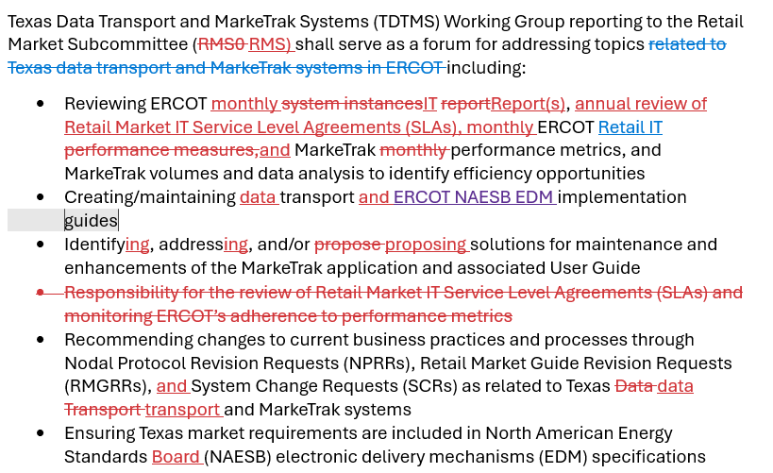

ERCOT IT Report & 2026 SLAs
Updated report was not available. TDTMS has already reviewed the proposed release dates and SLAs for 2026. Final draft versions will be provided by Mick Hanna for a vote at the November RMS.

ERCOT IT Projects
- MT API – rewrite is planned tentatively for Q3 2026 and remains in the planning phase. No external impacts are expected other than possible new end point change. One foreseen change is Background Reports will no longer be posted to MIS as an option. No market participants have used this option for 2 years.
- MIS Retail API & UI – future rewrite in EWS where “look and feel” of MIS will be updated/standardized – Find ESI and Find Transaction. Some functionalities such as link to reject codes and updated ‘key dates’ will be included. As with other projects slated behind RTC+B, timing is tentative and possibly end of 2026 into 2027.
- FlighTrak rewrite – ERCOT is still reviewing scope and will seek input from users. Project likely will not kick off until late 2026.
- Public Website Cipher Security Hardening – upgrading from TLS 1.2 to 1.3 – ERCOT plans to update cipher suites to tighten security protocols. Currently, ERCOT utilizes TLS v 1.2 for UIs and APIs. The goal is to move to TLS v 1.3 in 4 to 6 months. As with the change from 1.1 to 1.2 (which occurred in 2019/2020), both versions will be available for a transition period and v1.2 will ultimately be deprecated. With expected changes to APIs , market notices and updates in working groups will be provided when v 1.3 is available in the MOTE as v1.3 is not yet available at ERCOT.
- Digital Certificates – ERCOT plans to move from digital certificates to multi-factor authentication (MFA) with a single sign on. A few notes regarding the project that is expected to take a couple of years to fully complete:
  - APIs may continue to need digital certificates
  - All applications will move to a new system/platform which is currently being reviewed for a vendor
  - “super users” will be created to manage multiple DUNS with a single log on
  - More detailed road map will be presented at various working groups to keep the market apprised of changes
  - Market participant input will be sought during the project
  - Backend application will be overhauled to support the changes
  - NPRR1302 is the guidance for changes to be considered on project plan
- New Root CA for Digital Certificates – October 1st a new version of the root CA for digital certificates was put in place. For 2025 -26, both old and new DCs will be accepted while renewals are occurring. Process does not change for users. Some may have to import the new root CA which is machine to machine. No impacts for USAs. It was noted attestations should be easier for USAs.

NEXT TDTMS Meeting – December 9th, 2025. There will be no TDTMS meeting on October 14th. TXSET will however, continue to meet as planned to review the TMTP.

DRAFT AGENDA for December 9th meeting
- ERCOT Updates
  - IT Report
  - RMS follow up, if necessary
  - Project Updates
- MarkeTrak Subtype Volumes
  - Inadvertent Gains 2024(2) and 2025(1)
  - Other Subtypes
- ERCOT Inadvertent Gain Report – review
- TDTMS Main Meeting Page - housekeeping

