PGRR Number | 134 | PGRR Title | Interconnection Studies Reform for Dispatchable Loads

Date | November 17, 2025

Submitter’s Information
Name | Arushi Sharma Frank
E-mail Address | Arushisharmafrank@live.com
Company | Luminary Strategies, LLC
Phone Number | 571.572.9037
Cell Number
Market Segment | Not applicable

Comments

Re: Responsive Comments from Sponsor to ERCOT PLWG Presentation posted on Nov. 17, 2025

The following are Luminary Strategies responsive comments to help facilitate a productive discussion at PLWG and provide context for PLWG and the broader stakeholders following PGRR134. For organizational clarity, these comments excerpt the slides of ERCOT’s PLWG deck one by one, use a green font to indicate the ERCOT bulleted comment being responded to, and response from Sponsor in black line under each item so-identified. Excerpts from the revised PGRR134 filing, made on Nov. 14, 2025, are included where needed, to show that certain ERCOT comments applied to the first (originally filed) version, not the redline that replaces it as of Nov. 14, 2025.

We look forward to the stakeholder discussion and thank ERCOT staff for its engagement on a productive path forward and for its support in principle of the concept of accounting for the flexibility offered by Controllable Load Resources (CLRs) in the planning and interconnection processes with the reforms provided by NPRR1188.

Sincerely,

Arushi Sharma Frank
Luminary Strategies LLC

Responsive Comments

Firstly, a visual of what the current PGRR134 redline from sponsor enables, helps set the stage for the simplicity of the policy change intended through this proposal. This slide is excerpted from Sponsor’s overview deck, to be presented at PLWG on Nov. 18, 2025:

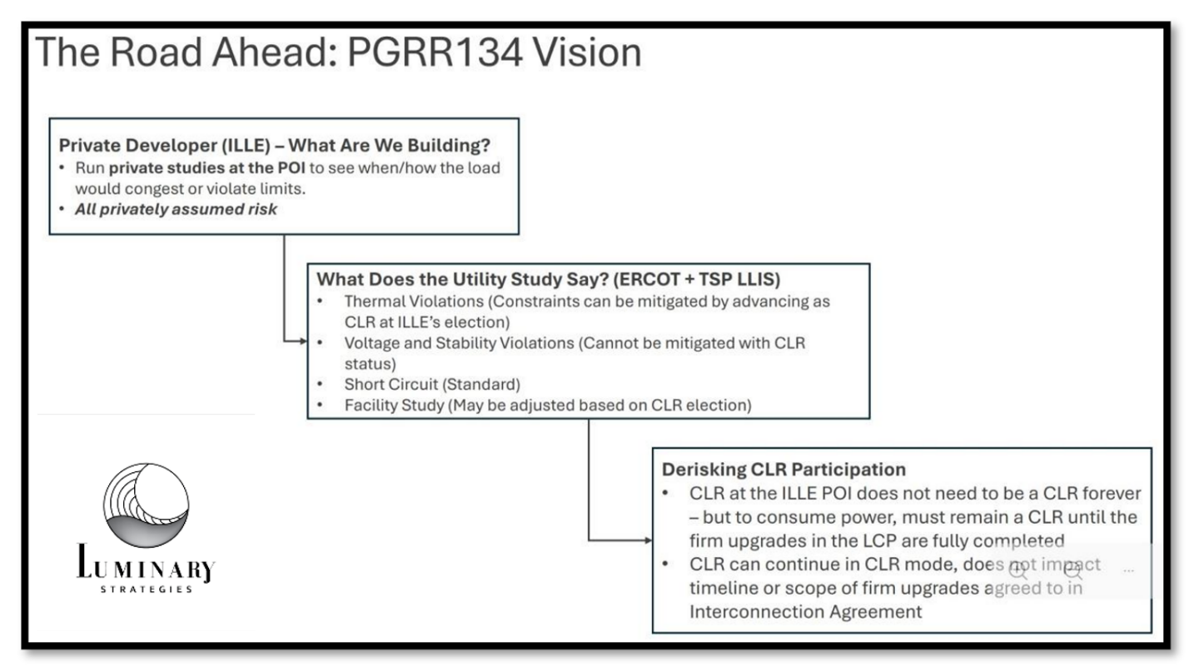

Accordingly, the following responses are provided in consideration of ERCOT’s PLWG presentation notes:

ERCOT Slide 1:
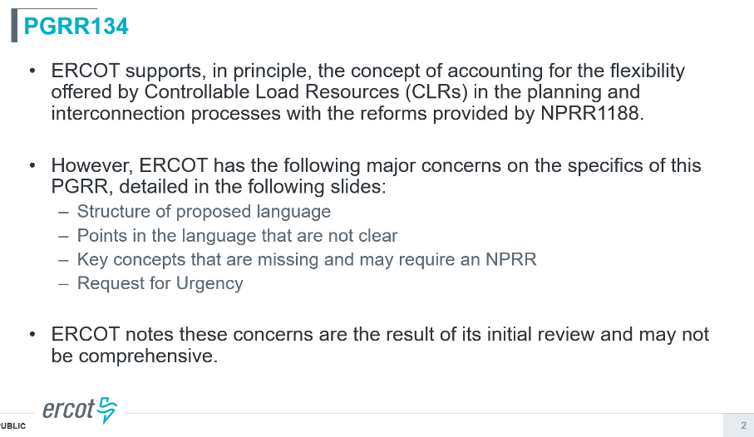

- Sponsor and the commenters look forward to working with ERCOT staff to turn the cited “major concerns” into minor fixes. We believe the final product of PGRR134 will be a consensus draft led by redlining from stakeholder parties with ERCOT’s leadership, to further simply and actuate planning guide revisions that make sense to enable a CLR construct in planning, put operations issues into the correct buckets of NPRR or NOGRR treatment as necessary, and otherwise evolve to support a case for urgency at the January ROS and TAC meeting. If for some reason we cannot create bankable urgency by January, 2026, sponsor and supporting commenters will facilitate an appropriate timeline solution to enable the market to feel comfortable – and enthusiastic – about passing PGRR134 as revised and approved.

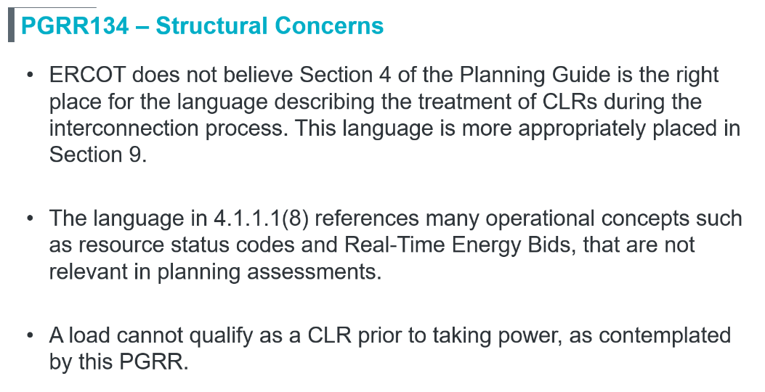
- “ERCOT does not believe Section 4 of the Planning Guide is the right place for the language describing the treatment of CLRs during the interconnection process. This language is more appropriately placed in Section 9. “
  - Sponsor notes that before filing, PGRR134 was drafted as a proposed redline and presented on September 19 at the LLWG as a Section 9 redline. Thereafter, we received information indicating that as drafted, by putting a lot of critical content in grey boxes that are in Section 9 of the Planning Guide, the draft makes the CLR planning criteria dependent on NPRR 1234’s implementation, potentially delaying implementation. The CLR policy intended in PGRR134 can be accomplished independently of NPRR 1234 – the latter which could be implemented months after NPRR 1188. To derisk this outcome, Sponsor would like ERCOT to clarify that if there is a chance Planning Guide Section 9 never gets implemented as drafted (is revised substantially first delaying its ultimate implementation), does that put PGRR134 in a doom loop? If this question can be resolved, moving the language from Section 4 to Section 9 is certainly a minor change we would welcome.
- “The language in 4.1.1.1(8) references many operational concepts such as resource status codes and Real-Time Energy Bids, that are not relevant in planning assessments.”
    - Sponsor notes this issue is already addressed in the Revised PGRR134 redline filed on Nov. 14, 2025.

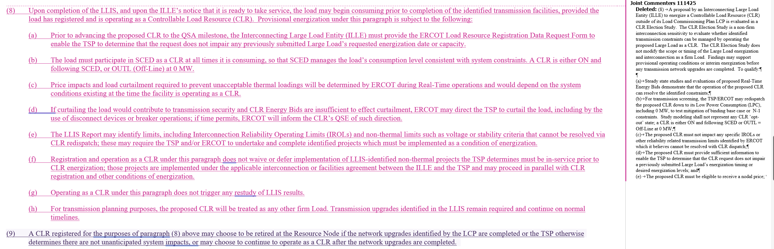
  - ERCOT’s concern appears (as noted on the ERCOT comment cover slide, the points in ERCOT’s deck cover the original draft and the revision together), to be based on the earlier or initial draft of 4.1.1.1(8). In the November 14 redline, the sponsor deleted the prior “CLR Election Study” construct and any attempt to embed Real-Time study methodology in the Planning Guide. The revised paragraph no longer adds operational requirements for planning assessments; it simply sets a condition for provisional energization: the ILLE must register and operate as a Controllable Load Resource. The remaining references to SCED participation, ON/OUTL status, and CLR Energy Bids are not planning criteria; they are high-level cross-references to existing CLR obligations under NPRR1188 and Real-Time Protocols. They clarify that once energized, the load is treated as a normal firm Large Load for planning purposes, while its dispatch and curtailment are governed entirely by ERCOT’s operational rules. If stakeholders feel comfortable removing those references and leaving the compliance clarification out of the explicit language (perhaps moving it to the explanatory revision description), this is a minor redlining action.
  - With this revision—and especially once 4.1.1.1(8) is relocated to Section 9, as ERCOT proposes and we hope can be effectuated without delay risk related to grey boxing of Section 9 —we believe the concern about “operational concepts” in the Planning Guide is addressed and no additional change to 4.1.1.1(8) is necessary unless substantive issues arise in the stakeholder redlining process.
  - In general, we agree with ERCOT: any further detail on SCED behavior or offer mitigation is appropriately handled in a companion NPRR at WMS/WMWG, not in the Planning Guide. Further, we’d note that the Planning Guide changes of PGRR134 are the beacon for investors and developers to consider their interconnection decisions now with TSPs (where to run studies to consider CLR approaches); PGRR134 can and should proceed on a timeline that is concurrent but independent of timelines needed for NPRRs and NOGRRs related to operations.
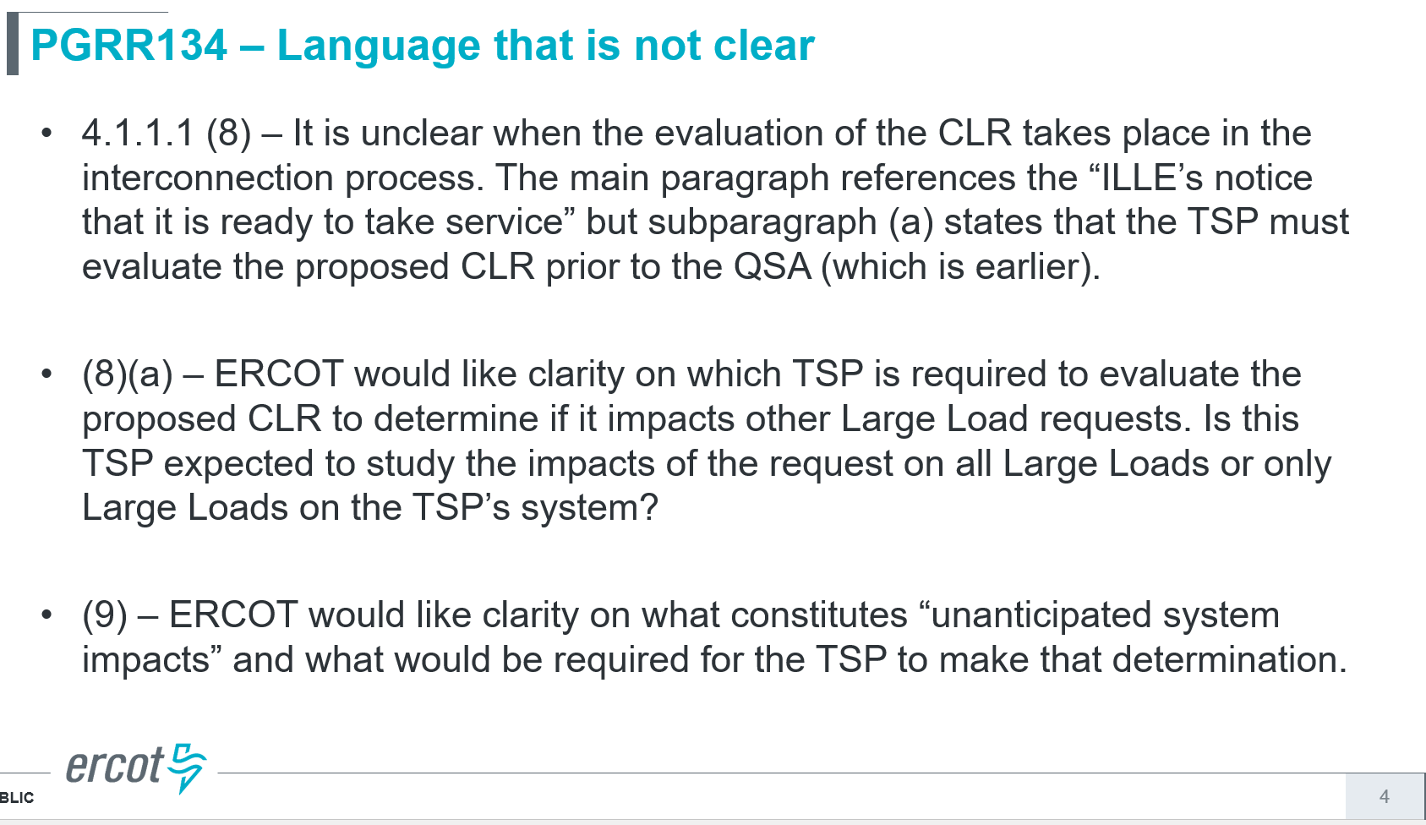

- “4.1.1.1 (8) – It is unclear when the evaluation of the CLR takes place in the interconnection process. The main paragraph references the “ILLE’s notice that it is ready to take service” but subparagraph (a) states that the TSP must evaluate the proposed CLR prior to the QSA (which is earlier).”
  - Sponsor notes that ERCOT’s concern reflects a textual ambiguity in the earlier draft. Paragraph (8) in the revised proposal sets the condition for provisional energization: completion of the LLIS and the ILLE’s notice that it is ready to take service, provided the load is registered and operating as a CLR. Subparagraph (a), by contrast, governs only the timing of the “no-impairment” review for previously submitted Large Loads. That review appropriately occurs prior to the QSA milestone, which is earlier in the process and does not authorize energization.
  - At this juncture, seeing as the revised PGRR134 redline, drafted after consultation with TSP and load study engineering third parties, moves away entirely from the concept that the TSP or ERCOT is running any sort of model or separate study requirements (there is nothing incremental required) the “no impairment” language may not even be necessary. It is quite likely the market consensus that clarifies this issue for TSP and EROT should be: strike (8) subpart (a)…
…and rely on (8) subpart (h), which provides the obvious answer to the fundamental issue that we tried to address with (a), to make it extremely clear this is the normal LLIS (load study) + a CLR registration application with ERCOT after the LLIS results.
- “(8)(a) – ERCOT would like clarity on which TSP is required to evaluate the proposed CLR to determine if it impacts other Large Load requests. Is this TSP expected to study the impacts of the request on all Large Loads or only Large Loads on the TSP’s system?”
    - Consistent with the response immediately above, Sponsor believes this language is not required at this point and should be struck. We look forward to PLWG feedback.
- “(9) – ERCOT would like clarity on what constitutes “unanticipated system impacts” and what would be required for the TSP to make that determination.”
    - Sponsor looks forward to hearing from TSPs whether this language in (9), replicated below, is viably reflective of the intent of the language – to ensure that the resource electing CLR treatment continues to operate in that mode until the TSP can finish upgrades or special projects needed to address non-thermal issues identified in the LLIS (ultimately, the conditions tied to the ILLE’s Load Commissioning Plan).

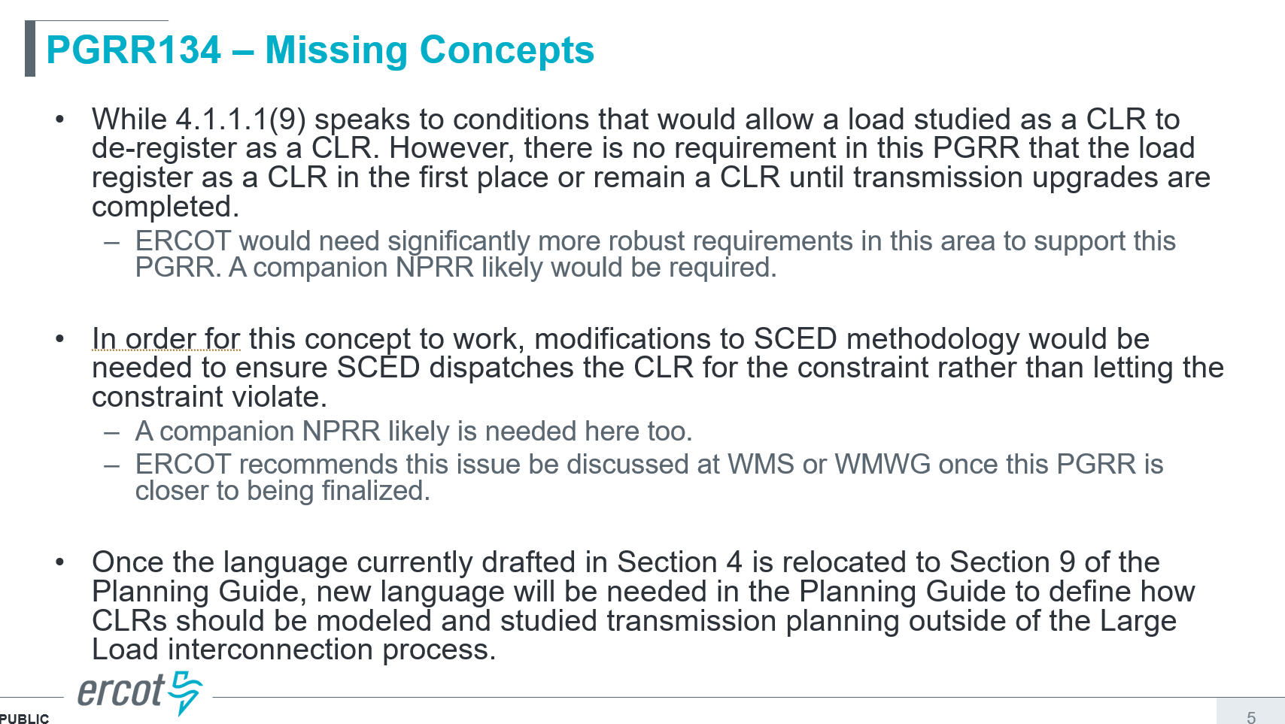
- “While 4.1.1.1(9) speaks to conditions that would allow a load studied as a CLR to de-register as a CLR. However, there is no requirement in this PGRR that the load register as a CLR in the first place or remain a CLR until transmission upgrades are completed.
    - ERCOT would need significantly more robust requirements in this area to support this PGRR. A companion NPRR likely would be required.”

- Sponsor notes that ERCOT’s comment suggests that PGRR134 does not require a load to register as a CLR or remain a CLR until transmission upgrades are completed. We respectfully disagree. Paragraph (8) already makes CLR registration a condition of any provisional energization: “the load may begin consuming… provided the load has registered and is operating as a Controllable Load Resource (CLR).” Subparagraph (b) then requires that “the load must participate in SCED as a CLR at all times it is consuming,” i.e., it must either be ON and following SCED Base Points or OUTL at 0 MW. Taken together, these provisions mean that any load using this pathway must both register and operate as a CLR for the entire period it is provisionally energized. Paragraph (9) further limits when such a load may de-register: only once the network upgrades identified by the LCP are completed or the TSP determines there are no unanticipated system impacts. To address ERCOT’s desire for a more explicit “thou shalt” statement, the Joint Commenters are willing to revise 4.1.1.1(9) to state that a CLR “shall remain registered and operated as a CLR while it is consuming power until the network upgrades identified by the LCP are completed or the TSP otherwise determines there are no unanticipated system impacts,” after which the ILLE may choose either to retire the CLR at the Resource Node or to continue operating as a CLR. Any similar redline is a minor fix stakeholders can agree to.
- ERCOT also states that “a companion NPRR likely would be required.” We do not understand why additional Protocol changes are a precondition for this Planning Guide revision. PGRR134 simply specifies when a Large Load may be provisionally energized based on LLIS outcomes, contingent on registration and operation as a CLR under existing Protocols and NPRR1188. Any further detail on SCED dispatch, offer mitigation, or SPC treatment of CLRs is appropriately addressed, if needed, through a separate NPRR at WMS/WMWG. We would welcome ERCOT identifying any specific aspect of PGRR134 that they believe cannot be implemented under the current Protocol framework, so stakeholders can evaluate whether an NPRR is truly necessary or whether those concerns can be resolved within existing authority.

- “In order for this concept to work, modifications to SCED methodology would be needed to ensure SCED dispatches the CLR for the constraint rather than letting the constraint violate. A companion NPRR likely is needed here too. ERCOT recommends this issue be discussed at WMS or WMWG once this PGRR is closer to being finalized.”
    - Sponsor (and we believe many commenters) agree with ERCOT that there are important Real-Time implementation questions about how CLRs will be dispatched on binding constraints, and that WMS/WMWG are the right venues to address any changes to SCED offer mitigation or SPC treatment. The core concept of PGRR134 does not depend on a new SCED methodology to function: it is in enable of the operations conversation ERCOT describes and we look forward to supporting that. PGRR134 is deliberately limited to planning and energization pre-conditions. It requires that any load using this pathway be registered and operated as a nodal, SCED-dispatchable CLR under NPRR1188, and it leaves dispatch and curtailment entirely to ERCOT’s existing Real-Time tools: CLRs will be dispatched on their nodal shift factors, and if CLR Energy Bids do not clear, ERCOT may already direct the TSP to curtail the load, including by use of disconnects or breakers Set up this way, the planning guide change operates as a runway for markets and operations issues to get resolved while the market can respond to the passage of consensus language by starting to move capital, engineering, and process resources to actually commission the right studies at ERCOT locations where CLR registration could be a future reality for large loads.

- “Once the language currently drafted in Section 4 is relocated to Section 9 of the Planning Guide, [new language will be needed in the Planning Guide to define how CLRs should be modeled and studied transmission planning outside of the Large Load interconnection process.]” (brackets added).
    - This comment is partially moot (the hard part is moot, the easy part is solvable by redlining the content to Section 9 as discussed above). The moot portion of this comment is in brackets added above – the comment applies to the first filed version of PGRR134, which has been revised to remove language around a CLR-specific election study. There is no longer a basis for “new language…to define how CLRs should be modeled and studied…”.
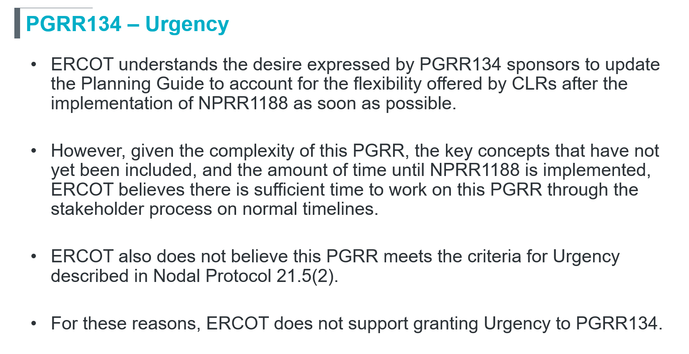

- Sponsor response: this last slide should be read in tandem with two items.
    - ERCOT also states in the opening slide of this deck, that “ERCOT notes these concerns are the result of its initial review and may not be comprehensive.” Certainly, if all of the concerns in the deck were major concerns we could not resolve together with efficiency in the stakeholder process, it may have been viewed as complexity that prevents a rapid schedule for review, consensus redlining, and passage. However, Sponsor has demonstrated in these responsive comments that the concerns noted in ERCOT’s preliminary review are partially resolved by the Sponsor’s own redline of Nov. 14, 2025, by the simplicity of moving language to Section 9 of the Planning Guide, and similar agreeable changes and refinements that are credibly achievable in the next 8-10 weeks. The end game for this proposal is to enact simplicity, not complexity. We do think there is a reasonable path for ERCOT to support urgency in the future with further review and consensus-driven simplification of the planning guide solution proposed in PGRR134.
    - Accordingly, Sponsor expects that ERCOT and stakeholders will, upon consideration of a reasonable and simple path to consensus language, be capable of sticking to the following schedule proposed in Sponsor’s slides for PLWG Nov. 18, 2025, as follows:

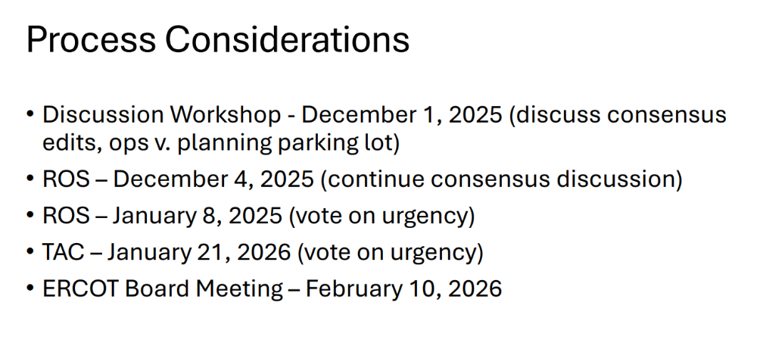
- We also think that with the effective clarifications made in this process, a workshop in December, and more consensus discussion at December ROS, this is a reasonable consensus timeline. In particular, we think that there will be load planners who strongly support the simplicity of the planning guide change as a way to help them address the difficulties of the current load interconnection challenge in ERCOT. In other words, we hope that other parties – loads, developers, consumers, and utilities in particular— will pitch into the effort to make an ultimate case for urgency in January 2026.

Revised Cover Page Language
None
Revised Proposed Guide Language
None

The opening slide (title slide) of the ERCOT presentation states, “These comments address both the original PGRR and the redlines proposed by the Joint Commenters in comments dated November 14, 2025.” See ERCOT PGRR134 ERCOT feedback, PLWG, Nov. 18, 2025, at: https://www.ercot.com/files/docs/2025/11/17/PLWG_ERCOT_PGRR134.pptx.

