PGRR Number | 134 | PGRR Title | Interconnection Studies Reform for Dispatchable Loads

Date | November 3, 2025

Submitter’s Information
Name | Sam Brandin
E-mail Address | sbrandin@agenticinfra.com
Company | Agentic Infrastructure LLC
Phone Number
Cell Number | (603) 315-2383
Market Segment | Not applicable

Comments

Agentic Infrastructure submits the following content as an illustrative narrative speaking to the commercial and procedural intent behind Planning Guide Revision Request (PGRR) 134. This effort is intended to be directly aligned with the spirit of Senate Bill 6 by fostering economic development in the state of Texas while preserving reliability and minimizing stranded cost risk in the transmission planning process. Enabling private capital investment to energize with dispatchable service ahead of the timeline required for expansion of firm network service ensures the risks of serving rapid load growth are managed privately while the economics benefits of load growth are socialized to the public rate base.

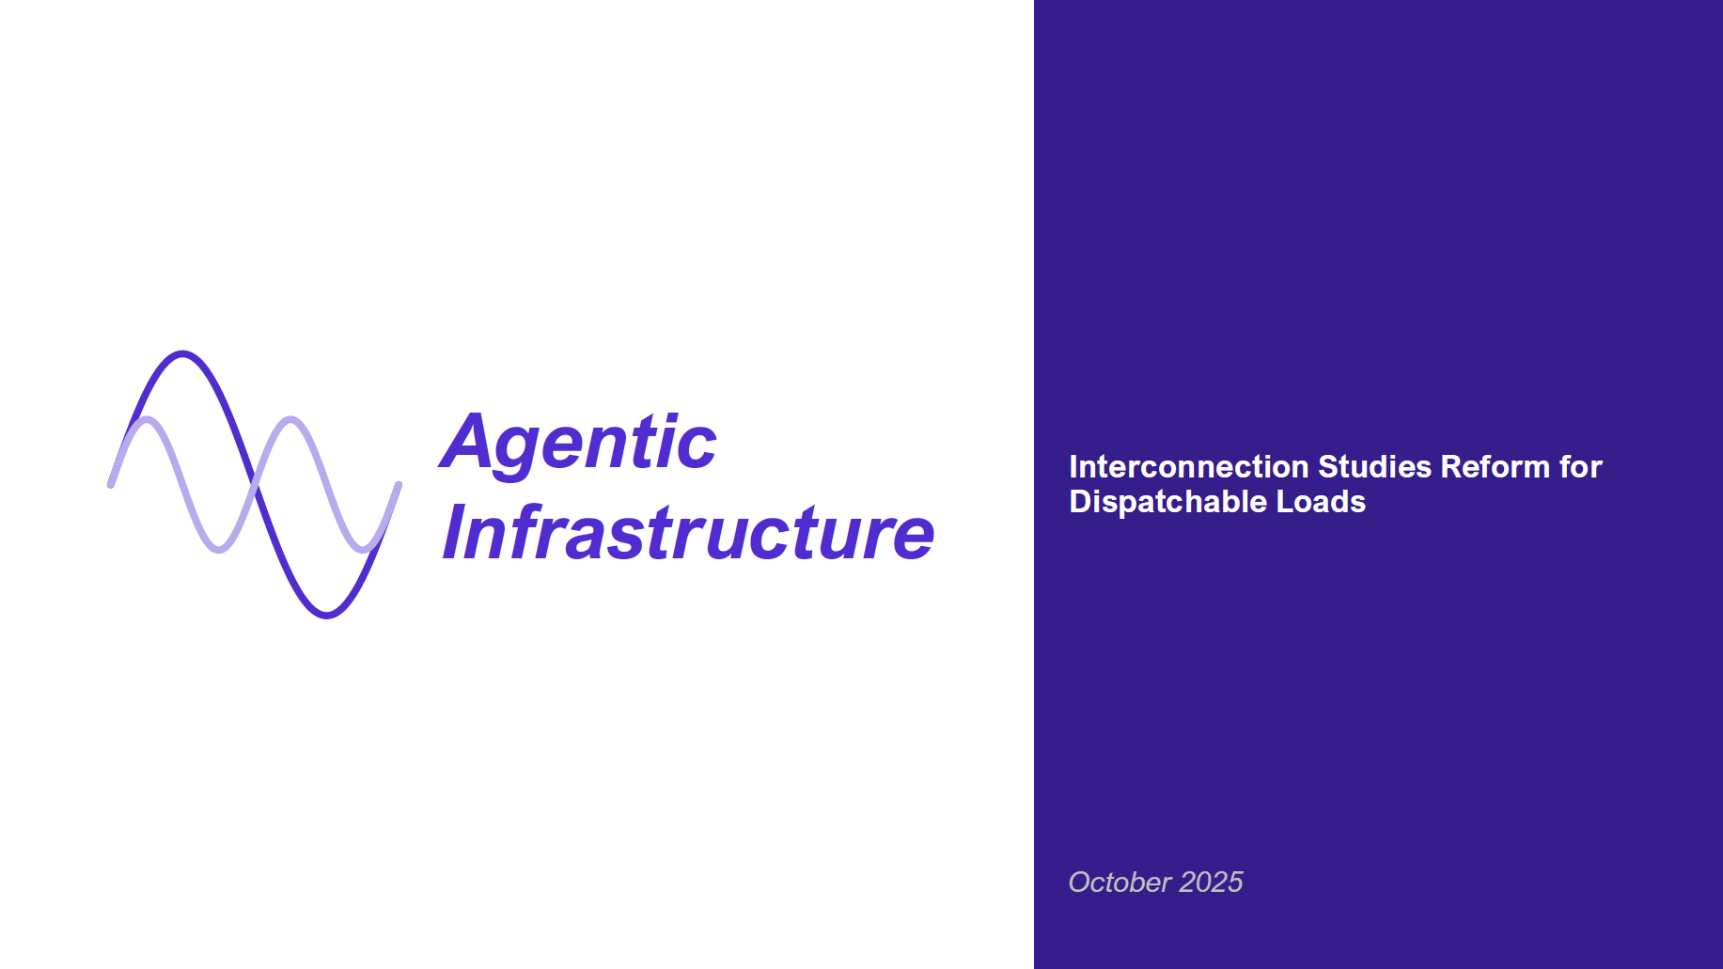
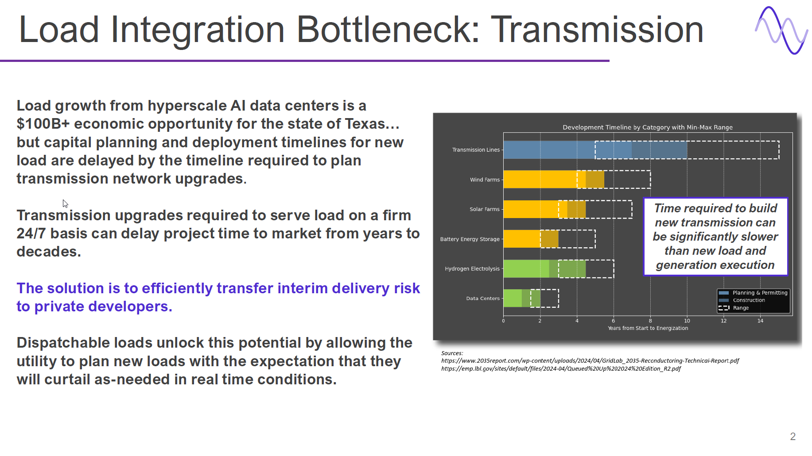

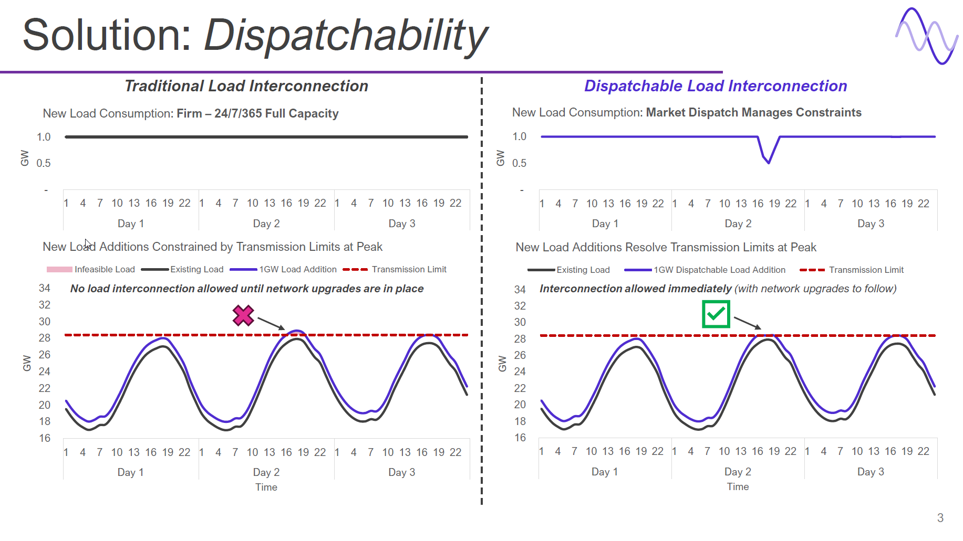
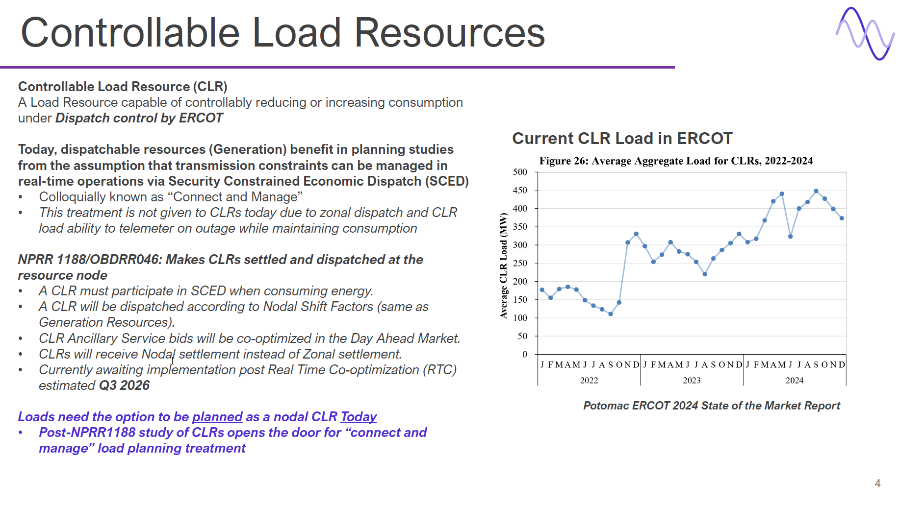

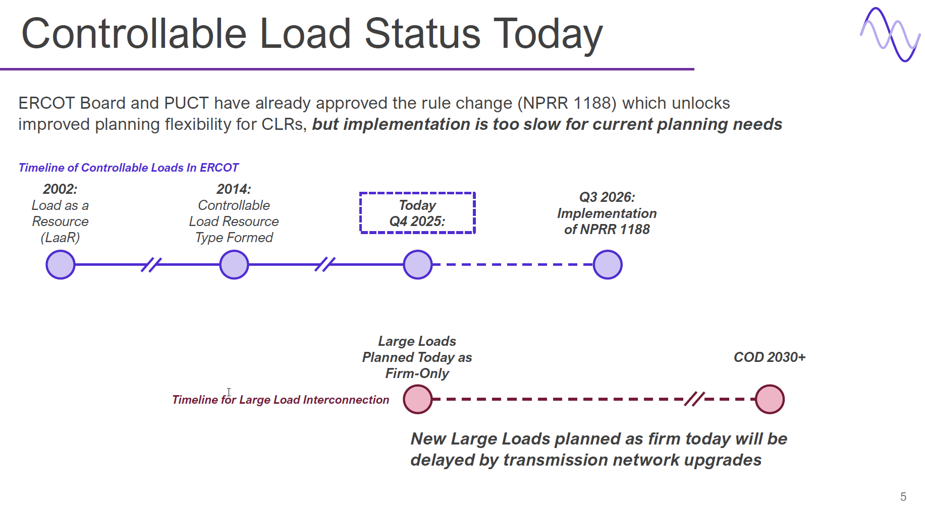

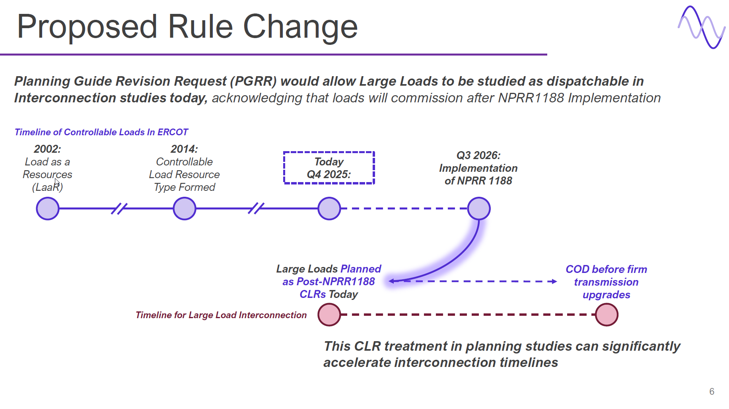

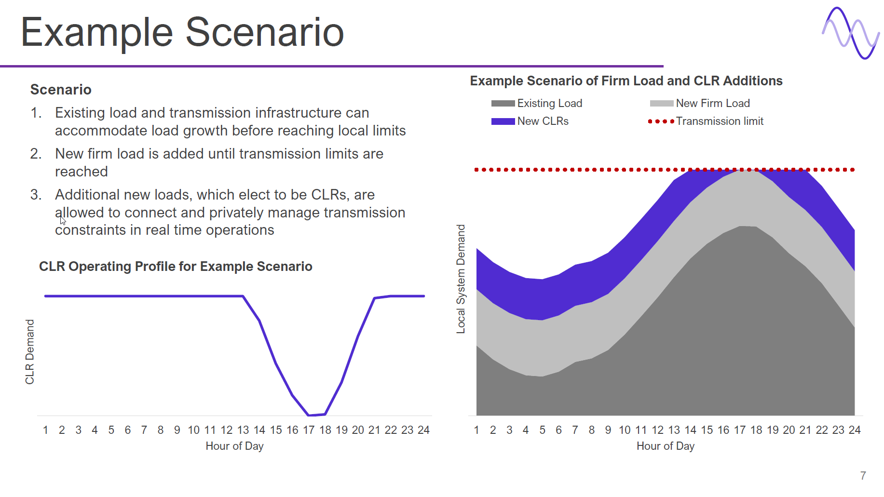

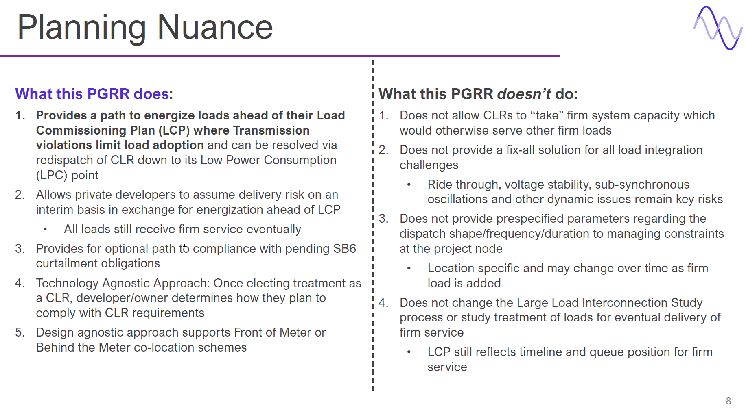
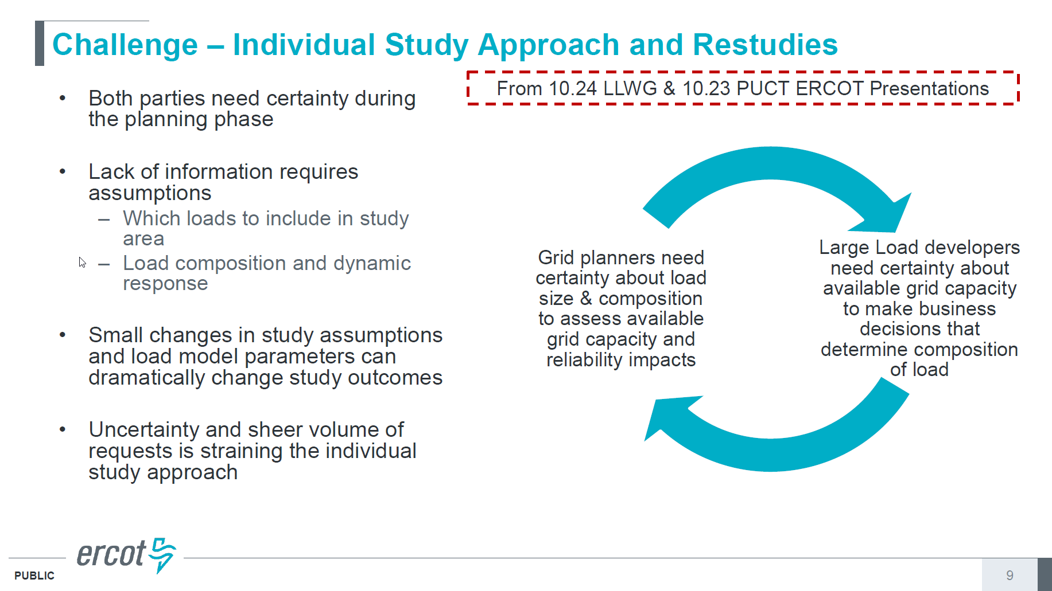

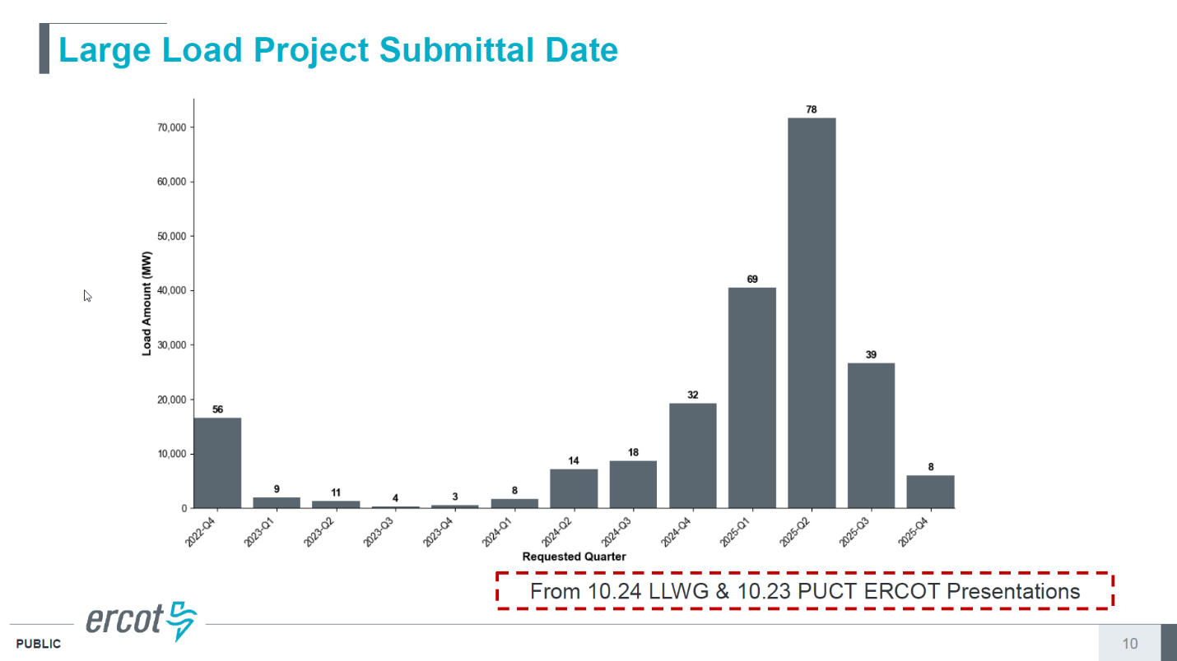

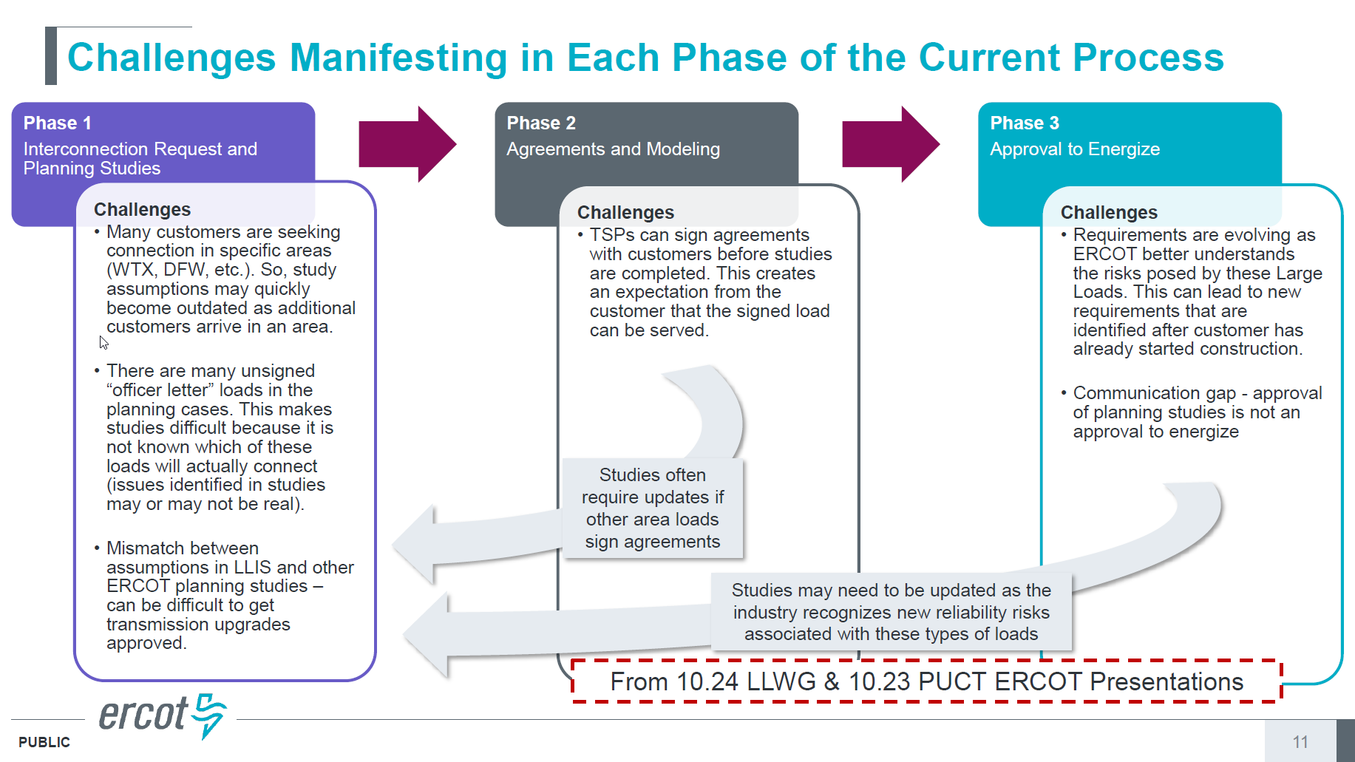

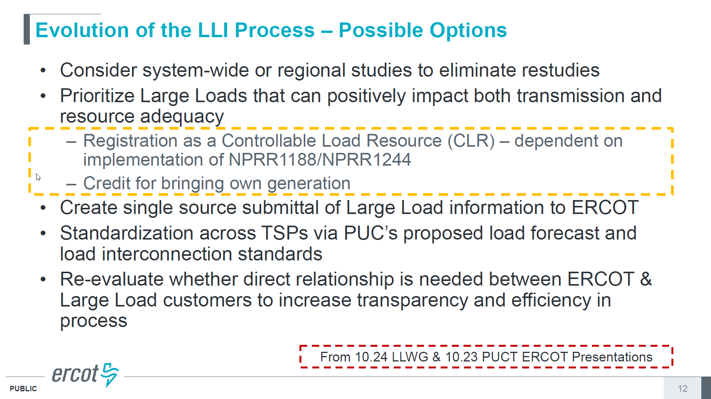

Revised Cover Page Language
None
Revised Proposed Guide Language
None

