NPRR Number | 1296 | NPRR Title | Residential Demand Response Program
Date |  | November 3, 2025
Submitter’s Information
Name |  | Andrew Reimers
E-mail Address |  | areimers@potomaceconomics.com
Company |  | Potomac Economics, Independent Market Monitor (IMM)
Phone Number |  | 512-225-7253
Cell Number |  | 409-656-4403
Market Segment |  | Not applicable

Comments

We appreciate the opportunity to comment on Nodal Protocol Revision Request (NPRR) 1296, which would establish an ERCOT administrated demand response program for residential consumers. The current proposal for NPRR1296 would compensate participants for reducing their Demand during a set number of peak net load intervals per season. We oppose this program and recommend that stakeholders reject it. We first summarize our key concerns, then provide detailed explanations and supporting analysis for each.
Main Points
- This program compensates participants without reference to the market value of their demand reductions, creating payments that do not reflect the true contribution of the response to reliability or price formation. The administratively set cost of this program represents a reduction of revenue from generators across the arguably highest-revenue hours across each season, ultimately undermining resource adequacy.
- Demand reductions are fundamentally about avoiding costs rather than earning revenue. A scheme for paying for demand reductions necessarily introduces measurement error and gaming opportunities for determining demand response volumes and baseline consumption.
- This program amounts to competition against the ADER program, in which distributed resources can respond directly to wholesale market signals. The ADER program may face technical challenges to upgrade it from its current pilot phase to a fully incorporated market tool. We expect that the resources that will be sunk into the RDR program will discourage ERCOT from making the necessary improvements and investments to expand the ADER program.
Further Explanation
- RDR compensation is decoupled from market prices and reliability.
Peak net demand does not necessarily correspond to elevated energy prices, particularly in seasons that do not experience particularly tight system conditions. Compensating demand response according to CONE in the absence of elevated wholesale prices results in over-charging the load base through uplift while reducing revenue to generators by uneconomically reducing load and/or prices. The long-term effect of such a revenue reduction undermines resource adequacy.
Basing the program’s budget and compensation on CONE is unjustified, as CONE relates to generation investment and long-term resource adequacy, not to valuing demand response during seasonal net demand peaks that may be well below the existing load serving capacity of the system. Although both concepts aim to support reliability, there is no meaningful link that would justify using CONE as the foundation for this program’s design.
We appreciate Reliant’s suggestion that the price formation impacts of this program could be muted through the RDPA in the same fashion as with ERS deployments. This workaround isn’t likely to be effective, because the volume of residential demand response isn’t known in real time, and the intervals over which demand response would be compensated through this program are only known at the end of the season once the peak net demand intervals have been identified.
ERS deployments, by contrast, are initiated by ERCOT operators during EEAs and are then accounted for in the reliability pricing run of SCED in a consistent, formulaic manner. Even granting that distinction, the remediation of the impact of ERS deployments on price formation through the RDPA is imperfect at best, and straightforward improvements to that methodology such as NPRR1006, Update Real-Time On-Line Reliability Deployment Price Adder Inputs to Match Actual Data, have been long delayed in their implementation. Thus, we are skeptical that the RDPA could effectively overcome the price formation impacts of this out of market demand response program.
- Treating demand reductions differently through above market payments is fundamentally flawed.
Demand reduction is inherently about cost avoidance. While the trigger price for avoiding cost varies across demand sources, it is ultimately a financial decision to reduce consumption to avoid cost. The cost avoidance is the compensation for the reduction and there is no need to pay for demand reduction beyond the avoided cost. Paying for demand reductions separately and differently than energy production is a fundamentally flawed premise. This approach mirrors problems seen in FERC-regulated load response programs, where payments for estimated reductions have led to overcompensation, inaccurate baselines, and distorted price signals. Instead, a well-designed wholesale market for electricity will incentivize Load Serving Entities and their consumers to reduce their demand to reduce their exposure to elevated energy costs that result from higher prices in the energy market. ERCOT’s market is already well-suited to this kind of price response.
Compensating consumers for demand reductions promotes two problematic outcomes. First, it incentivizes load reductions at a lower price level than what would be strictly economical based on the customer’s VOLL. Second, demand reductions are measured against a counterfactual baseline, which introduces significant uncertainty. It is difficult to know what a customer’s load would have been without the program, making the calculated reductions prone to error. This structure also invites manipulation, as participants can inflate their baselines to exaggerate the size of their demand response and increase compensation.
- The RDR program will outcompete the ADER Pilot Program
The ADER pilot program allows DERs to participate directly in the wholesale market as ALRs in SCED, making it a market-based mechanism that aligns participation and compensation with established market design principles. Unfortunately, the proposed design of the RDR program offers an outsized revenue opportunity for current and potential participants of the ADER program, which is going to discourage participation in ADER and stall necessary investments to expand the ADER program.

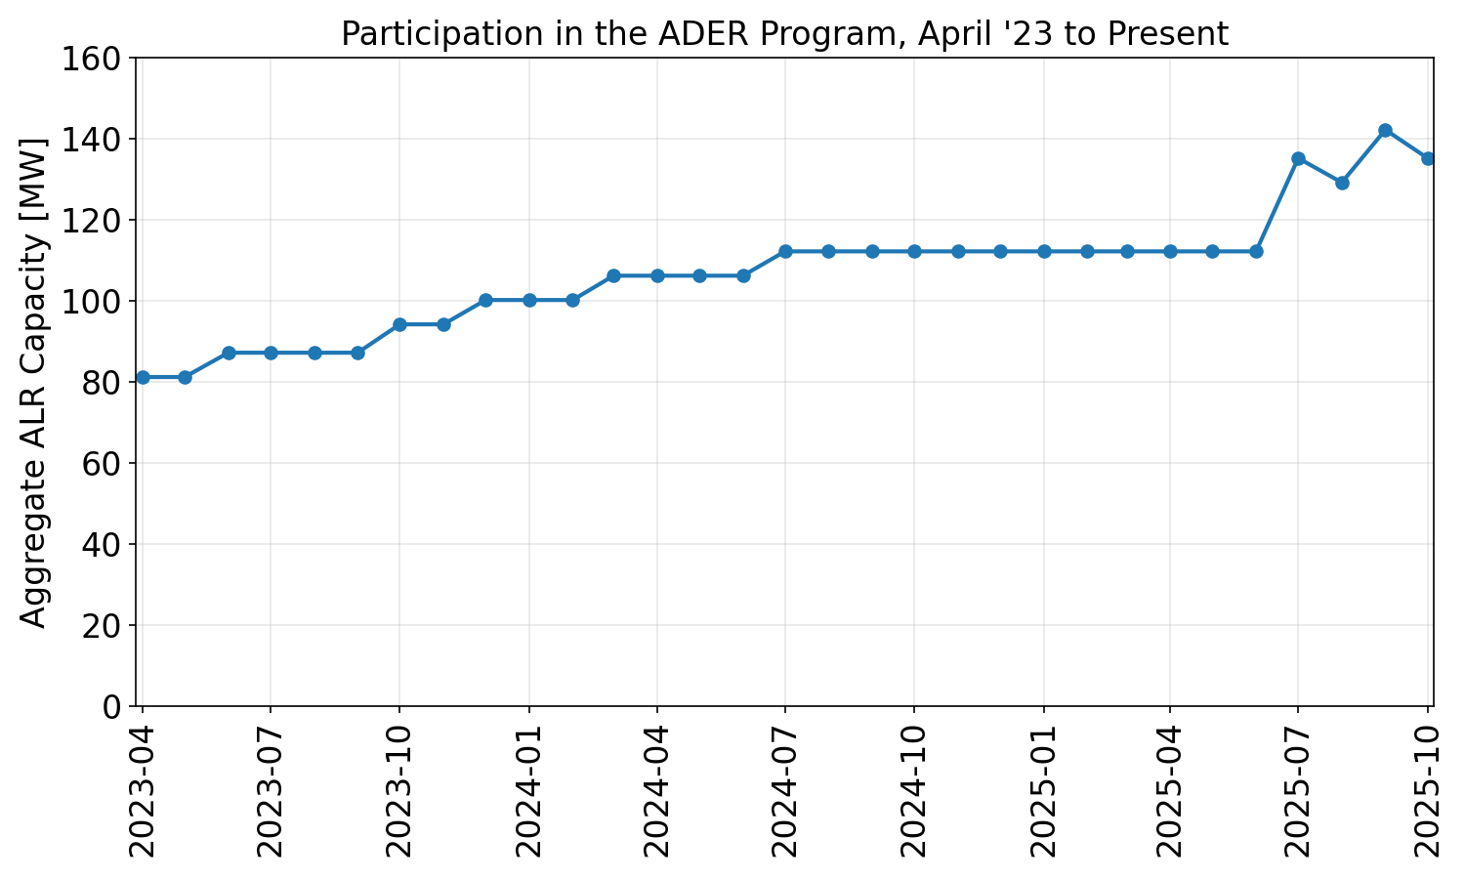

For the ADER program to continue to grow, several technical challenges will need to be addressed, including but not limited to:
- Dispatching and settling ALRs on a nodal rather than zonal basis to achieve efficient dispatch solutions and prices that accurately reflect congestion.
- Modeling ALRs as ESRs so that they can be dispatched for net injections of energy in SCED.
These changes would require significant effort and investment from ERCOT. Such investments only make sense if the ADER program is expected to grow substantially, and this residential DR program could severely limit participation in the ADER program. The tradeoff at hand is a more expensive, less effective, out of market demand response program versus a promising program for incorporating DERs directly into the wholesale market.
Revised Cover Page Language
None
Revised Proposed Protocol Language
None

