RMTTF Meeting
September 24, 2025
1:30 PM

This meeting is being held in person and via WebEx.

Oncor Electric Delivery
1616 Woodall Rodgers Fwy #125
Dallas, TX 75202

Melinda Earnest is Chairing the meeting with Tomas Fernandez. Tomas is running the WebEx, and Debbie is taking notes today.
Melinda thanked Oncor for hosting and welcomed everyone.
Tomas proceeded with reading the antitrust statement.

Introductions

Attending in person
- Kathy Scott Centerpoint
- Debbie McKeever Oncor
- Melinda Earnest AEP
- Sheri Wiegand Vistra
- Monica Jones Centerpoint
- Tomas Fernandez NRG
Attending via WebEx
- Heverton Andrate Grid monitor
- Bill Snyder AEP
- Jordan Troublefield ERCOT
- Yvette Perez Octopus
- Edelmira Revolution
- Nick Reddy Cim View
- Art Deller ERCOT
- Elizabeth Morales ERCOT
- Amy Sue Stirland LP&L
- Bruce Grey

Meeting Agenda
Agenda was read. No questions were asked. No changes were made.
Meeting Notes
Meeting notes from the last meeting were not ready to be reviewed. Attendees are being verified.

Meeting notes for our last meeting and today’s meeting will be reviewed at our next meeting in October.

LMS Counts for Online Training Modules
ERCOT Learning Management System (LMS) counts for Web Based training modules were provided by Art this morning. They are displayed below.
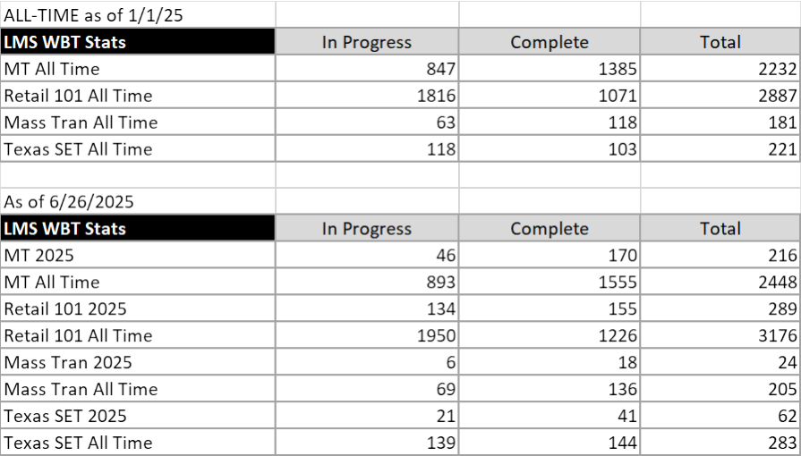
Comments for the counts for LMS included that there is some increase in the counts. May need to promote the modules in RMTTF notes or training reminders. Maybe take up method for communicating that at one of the upcoming meetings. Important that MPs know what’s available. There’s a lot of change of employees amongst Market Participants and new people may not know. Should ensure to include that the modules are at no cost and can be taken anytime. Unless there’s a system outage affecting the LMS, modules are available 24 x 7. The modules are included in the RMTTF updates to RMS but most likely those that work MarkeTrak issues don’t attend RMS or see the postings.

Notes from today’s MarkeTrak Part 1 Training
Prior to today’s training, we verified that the latest presentations were posted. Tips and Tricks document was not changed.

Instructors:
Debbie, Monica, Sheri, Tomas, Melinda, Kathy

Attendees 84 registered – 66 or less attended. Count includes 6 instructors.

Comments and questions:
• Art had technical difficulties assigning us as the host. Start was delayed. – Verified with Art this will not be an issue for tomorrow’s Part 2 training.

• Action item for RMTTF
Slide 26 – add the two new subtypes, send the updated ppt to Art for posting. – we will make the change but go through the entire ppt before sending to Art for posting.
• Break started at 9:53 AM – end 10:05 AM
• Question for Tomas, who deferred to Sheri. Question: – “instead of it saying “pending complete” it says new? Goes to a state of new.
• When or if we talk about the blue transaction reference card, or other resource or tools, we should put the link in chat.
• For Bulk insert: Submit – slide 93, add about deleting being a manual process. Cancel is not system generated.

Retail Jeopardy Game
Reviewed the draft of the Jeopardy game. For TX SET training, Jeopardy will possibly replace the “transaction dot/circle” group activity. Maybe possible to have both. Could extend the class if having both.
Tomas noted the items that will be needed for the attendees. We will tell them in advance.
- Print the ppt – will help to review prior to training.
- Transaction Inventory card and if it’s not posted where it can be found.
- Updated swim lanes
- Tell them when to get their pen and paper…will be helpful to take notes.

TX SET 5.0 TRAINING
Will be held via WebEx. AEP is hosting instructors.
Amy Sue cannot attend in-person. She will verify if she is able to instruct her sections remote.
--------------------------------------------------------------------------------------------
Key Dates for upcoming activities include:
- Sept 25 MarkeTrak Part 2 Training instructors will be at Oncor
- October 28 RMTTF meeting In person and WebEx
- October 29 TX SET 5.0 Training instructors will be at AEP
- October 29 AEP REP social TBD
- October 30 AEP Workshop AEP Service Center, Corpus Christi
Melinda/AEP is hosting October 28th and 29th – All activities including:
Tuesday late morning:
Who ever is available, AV check. This can be done before the RMTTF meeting. Melinda will have someone available if AV issues are experienced.
Instructors for 5.0 training and RMTTF and meeting will be held at the AEP main building at the address below.
Tuesday afternoon:
RMTTF meeting. Need a practice/dry run. Will be a quick run through but can be done during the meeting. will give those on the phone an opportunity to chime in.
Wednesday morning:
Training instructors should arrive at 7:45 AM, or not later than 8:00 AM. Training will start at 8:30 AM and we need to make sure the ERCOT Webex for training is working. If not, call Art. Debbie to remind Art that he or one of his team should be available to assist with resolving technical issues. This is the first time TX SET 5.0 will be done via WebEx and we don’t want to have issues.
Melinda will order refreshments and meals for each day.
AEP
539 N. Caranchahua
Corpus Christi, TX

If planning to attend, please email Melinda at mdearnest@aep.com
Please note that agenda items not addressed today due to time constraints will be taken up at the October 28th RMTTF meeting.
Other business
There was no Other Business.
RMTTF co-Chairs thanked everyone for attending.
Adjourn
Everyone was reminded if attending the next RMTTF meeting in person to please email mdearnest@AEP.com and she will add you to the list for Security. Very important! Need to bring ID.
Meeting was adjourned.

