|  |  |  |  |
| --- | --- | --- | --- |
| NPRR Number | [1298](https://www.ercot.com/mktrules/issues/NPRR1298) | NPRR Title | Timing Requirements for Comments to Subcommittee Reports |
|  | |  | |
| Date | | September 29, 2025 | |
|  | |  | |
| Submitter’s Information | | | |
| Name | | Katie Rich | |
| E-mail Address | | [katie.rich@vistracorp.com](mailto:katie.rich@vistracorp.com) | |
| Company | | Vistra Corporate Service Company LLC | |
| Phone Number | |  | |
| Cell Number | | 737-313-9351 | |
| Market Segment | | Independent Generator | |

|  |
| --- |
| Comments |

Vistra appreciates the September 17, 2025 PRS discussion of this NPRR. The thoughtful feedback received has been instrumental in refining the proposal, and Vistra would like to respond to several comments while highlighting revisions designed to improve clarity, fairness, and consistency for all stakeholders.

## Opportunity to Present Comments

Oncor raised the importance of ensuring that every party who files comments has a meaningful opportunity to present them at the applicable Subcommittee meeting. The proposed revisions preserve that opportunity. While Subcommittees may determine whether late-filed written comments are addressed at the current or a future meeting, parties always retain the ability to present their comments verbally during the current meeting by entering the queue. This ensures that no stakeholder is excluded from the discussion, regardless of timing.

## ERCOT Stakeholder Services Review Period

ERCOT Stakeholder Services emphasized the need to maintain its three Business Day review period prior to posting a revision request or set of comments. The proposal directly supports this requirement. Current Section 21.4.5(1) already recognizes ERCOT staff’s responsibility to complete its review before posting, and the updated language clarifies this by referring to comments as “posted” rather than “submitted.” This small but important adjustment ensures ERCOT staff have the necessary time for review while enabling stakeholders to rely on a consistent and predictable posting process.

## Clarity on Handling Late-Filed Comments

ERCOT staff also noted concerns about the clarity of the process for considering late-filed comments. To provide both transparency and flexibility, the proposal envisions Subcommittees reviewing a list of late-filed comments at the beginning of each meeting under the Agenda Review item. Members could then collectively decide whether to take up specific items. This approach avoids unnecessary votes on individual comments while still ensuring that the Subcommittee as a whole—not just the chair—determines how best to proceed and the discussion can be captured in the meeting minutes. Incorporating this step into the standard Agenda Review item establishes a consistent and transparent process across all Subcommittees, strengthening stakeholder confidence in the fairness of the discussions. To accomplish this goal, language outlining this process should be added to the TAC Procedures as follows:

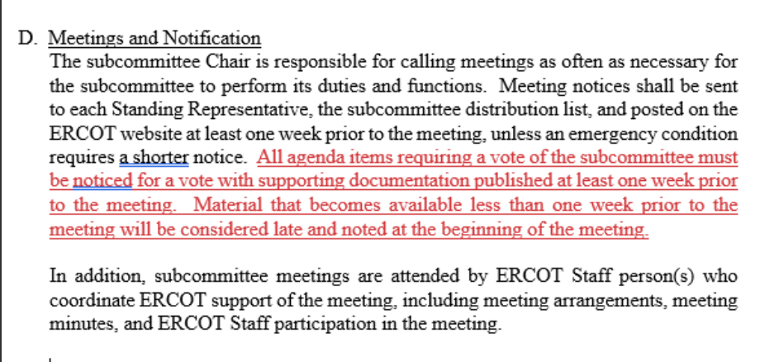

## Decision-Making Authority

Finally, to reinforce accountability and shared governance, the proposal elevates decision-making authority from individual Subcommittee chairs to the Subcommittee membership as a whole. This change, reflected in Sections 21.4.4(2) and 21.4.5(2), ensures that decisions are made collectively and with full stakeholder participation.

Vistra believes these revisions address the key concerns raised while strengthening the overall process. By providing clarity, preserving stakeholder opportunities, and promoting consistency across Subcommittees, this proposal enhances both fairness and efficiency. Vistra looks forward to working with stakeholders at the October 8, 2025 PRS meeting to advance this important improvement.

|  |
| --- |
| Revised Cover Page Language |

|  |  |
| --- | --- |
| Related Documents Requiring Revision/Related Revision Requests | Commercial Operation Guide  4.3.3, WMS Review and Action  4.3.4, Comments to the WMS Report  Load Profiling Guide  2.3.3, RMS Review and Action  2.3.4, Comments to the RMS Report  Nodal Operating Guide  1.3.3.3, ROS Review and Action  1.3.3.4, Comments to the ROS Report  Planning Guide  1.2.3.3, ROS Review and Action  1.2.3.4, Comments to the ROS Report  Resource Registration Glossary  1.2.3.3, ROS Review and Action  1.2.3.4, Comments to the ROS Report  Retail Market Guide  3.3.3, Retail Market Subcommittee Review and Action  3.3.4, Comments to the Retail Market Subcommittee Report  Settlement Metering Operating Guide  10.3.3, Wholesale Market Subcommittee Review and Action  10.3.4, Comments to the Wholesale Market Subcommittee Report  Verifiable Cost Manual  13.3.3, Wholesale Market Subcommittee Review and Action  13.3.4, Comments to the Wholesale Market Subcommittee Report  Electric Reliability Council of Texas Technical Advisory Committee Procedures |
| Revision Description | This Nodal Protocol Revision Request (NPRR) extends discretion to review comments to the PRS Report that are posted less than six days in advance of the "next regularly scheduled" PRS meeting. Paragraph (2) of Section 21.4.4, Protocol Revision Subcommittee Review and Action, allows PRS the discretion to consider comments on a new NPRR if they are posted after the 14-day comment period. |
| Justification of Reason for Revision and Market Impacts | This NPRR would help Market Participants make more informed decisions on NPRRs by having timely comments. It provides Subcommittees with the discretion to consider late-filed comments. The process for reviewing late-filed comments at the beginning of each subcommittee meeting will be outlined in the TAC Procedures, which will go through a separate approval process from this NPRR. |

|  |
| --- |
| Revised Proposed Protocol Language |

21.4.4 Protocol Revision Subcommittee Review and Action

(1) Any ERCOT Member, Market Participant, the Public Utility Commission of Texas (PUCT) Staff, the Reliability Monitor, the North American Electric Reliability Corporation (NERC) Regional Entity, the Independent Market Monitor (IMM), or ERCOT may comment on a Revision Request.

(2) To receive consideration, comments must be delivered electronically to ERCOT in the designated format provided on the ERCOT website within 14 days from the posting date of the Revision Request. Comments posted after the 14-day comment period may be considered at the discretion of the PRS. Comments submitted in accordance with the instructions on the ERCOT website—regardless of date of submission—shall be posted to the ERCOT website and distributed to the PRS within three Business Days of submittal.

(3) The PRS shall consider the Revision Request at its next regularly scheduled meeting after the end of the 14-day comment period. At such meeting, the PRS may take action on the Revision Request. The quorum and voting requirements for PRS action are set forth in the Technical Advisory Committee Procedures. In considering action on a Revision Request, PRS may:

(a) Recommend approval of the Revision Request as submitted or as modified;

(b) Reject the Revision Request;

(c) Table the Revision Request; or

(d) Refer the Revision Request to another TAC subcommittee, working group, or task force as provided in Section 21.3, Protocol Revision Subcommittee.

(4) If a motion is made to recommend approval of a Revision Request and that motion fails, the Revision Request shall be deemed rejected by PRS unless at the same meeting PRS later votes to recommend approval of, table, or refer the Revision Request. If a motion to recommend approval of a Revision Request fails via e-mail vote according to the Electric Reliability Council of Texas Technical Advisory Committee Procedures, the Revision Request shall be deemed rejected by PRS unless at the next regularly scheduled PRS meeting or in a subsequent e-mail vote prior to such meeting, PRS votes to recommend approval of, table, or refer the Revision Request. The rejected Revision Request shall be subject to appeal pursuant to Section 21.4.12.1, Appeal of Protocol Revision Subcommittee Action.

(5) Within three Business Days after PRS takes action, ERCOT shall post a PRS Report reflecting the PRS action on the ERCOT website. The PRS Report shall contain the following items:

(a) Identification of submitter of the Revision Request;

(b) Protocol language or summary of requested changes to ERCOT systems, recommended by the PRS, if applicable;

(c) Identification of authorship of comments;

(d) Proposed effective date(s) of the Revision Request;

(e) Priority and rank for any Revision Requests requiring an ERCOT project for implementation; and

(f) PRS action.

(6) The PRS chair shall notify TAC of Revision Requests rejected by PRS.

21.4.5 Comments to the Protocol Revision Subcommittee Report

(1) Any ERCOT Member, Market Participant, PUCT Staff, the Reliability Monitor, the NERC Regional Entity, the IMM, or ERCOT may comment on the PRS Report. Comments submitted in accordance with the instructions on the ERCOT website—regardless of date of submission—shall be posted on the ERCOT website and distributed to the committee(s) (i.e., PRS and/or TAC) considering the Revision Request within three Business Days of submittal.

(2) The comments to the PRS Report will be considered at the next regularly scheduled PRS meeting that is at least six days from the posting date. Comments posted less than six days prior to the next regularly scheduled PRS meeting may be considered at the discretion of the PRS.

(3) For TAC, the comments to the PRS Report will be considered at the next regularly scheduled TAC meeting where the Revision Request is being considered.